A NEW PERSPECTIVE FOR DEVELOPMENT OF COMPUTER AIDED DESIGN CURRICULUM IN ARCHITECTURE: A CASE STUDY OF, FEDERAL UNIVERSITY OF TECHNOLOGY, MINNA, NIGER STATE
By
Arc. Muhammad I. B. ¹ & Arc. Sani A. M ²
Department of Architecture
School of Environmental Technology
Federal University Of Technology, Minna Niger State
Nigeria
¹ mibdoko@yahoo.com, ² arcsammy2008@yahoo.com
Abstract:
The twenty first century saw the development and increased use of high speed personal computers due to the development in technology. This has resulted in the development of software in different disciplines such as architecture. This development has created a fast shift from manual drafting on drawing boards to the use of computers. The university environment which serves as the nerve centre for the training of future professionals is challenged by these developments. The teaching of computer aided design in schools of architecture is dearth of curriculum which makes it insufficient for students to meet up with what is required to practice after graduation. Research questionnaires were administered to students of department of Architecture, Federal University of Technology Minna. The respondents raised some issues which helped in the development of curriculum for the teaching of Computer Aided Design (CAD) in schools of architecture.
Key words
CAD, Curriculum, Teaching, Technology, Learning.

1. INTRODUCTION
The development of CAD software by Ivan Sutherland in his doctorial thesis when he was attending Massachusetts Institute of Technology in 1972, this brought about a revolution in which the designer was able to interact with the computer graphically by using a light pen to draw on the computer monitor. This development led to the gradual replacement of drawing tables, pens and pencils with computers. This later generated into the development of various CAD software such as Archi -Cad, Autodesk 3d max and Auto CAD, Revit architecture, Chief architect, 3Dhome Architect, to mention but a few. Amongst this software AutoCAD and 3Dmax top the list in terms of popularity and usage in a survey carried out in over 123 countries (Jeff 2004).
The craftsmanship of the past has left its place to the electronic machine in this modern era of 21st century. There is a growing need for tools that enable architects to cope with the increasing complexity in design and with the increasing efficient communication with many partners in the building industry. The twenty first century saw a lot of development in the application of computers in various fields of endeavour and the architectural profession is not left out of this race. However the use of computers in architecture came much later than in any other discipline as the very first AutoCAD program was developed for the mechanical engineers. The twenty first century had seen the massive deployment of computers in the construction industry, robots are now being used through inputs from the computer in construction as can be seen being practice in the present day Japan (Sevil & Peter 2010).
Computer aided design has become a significant input in architectural design practice and will therefore continue to play a crucial role in architectural practice. Computer aided design education is therefore not a luxury but an absolute necessity for architects (Turk 2006).The schools of architecture where students are trained to become architects have computer aided design as one of the newest courses taught and therefore is still undergoing experimentations in terms of teaching syllabus, this can be observed in the department of architecture, federal university of technology minna.
A curriculum entails the total behavioural change and experience expected from a learner after he or she has been exposed to a particular training. It is therefore important that adequate curriculum is developed for teaching and learning of computer aided design in Nigerian schools of architecture.

2. THE CHALLENGES OF TEACHING CAD
Some challenges of teaching and learning CAD have been the non development of comprehensive curriculum, the non availability of man power and also the unavailability and unstable power supply.(Suleiman 2006), (Adejimi, 2007)
However the problem of non availability of computers and man power is gradually improving as can be seen in the department of architecture federal university of technology Minna. The study shows an increase in the number of lecturers teaching CAD from one lecturer in 2007 to three lecturers in 2010, and also the numbers of students with access to computer have increased from 25% to 75% over the same period.
According to (Ogunsote et-al 2007), stated that, the number of lecturers that have access to computers and are computer literate have increased over time.
There has been an enhancement in the course content of all architectural courses especially in 1989 by Nigerian university commission which published the minimum standard expected of all environmental sciences (Simeon 2007). To this end it is therefore important to develop a comprehensive CAD curriculum.
Dudley (1994) and as quoted by ( Mas’ud & Badiru 2004 ) stated that the role of architects have changed and that architects are destined to practice their profession in a kind of world that is composed of revolutionary advances in technology and with degree of complexities never dreamt of. For the new generation of architects to cope with the ever changing world they have to embrace the new technology.
Computer aided design is the future of architectural drafting and some schools of architecture do not have a computer studio and worse still the architectural educators are not skilled in the various CAD software for them to be able to impart on the students (Anunobi 2006). Nigerian architects who travel abroad find it difficult to adapt to practice outside the shores of the continent, because they cannot apply computers in their designs and there are no more drawing boards in existence. (Ogunrayewa and Agbo 2000) as quoted by (Suleiman 2006).
The tools of globalization is the information super highway, the computer forms the basis upon which ideas are exchanged and therefore the need to equip the present and future architects with the skill of drafting using computers has become necessary.
It has therefore become necessary for the Nigerian architect to be properly trained in computer applications in architecture. Knowledge can only be said to have been imparted unto the learner only if the objectives of such knowledge has been attained. The attainment of these objectives can only be got through a well designed curriculum.
3. AIM.
The aim of this research is to develop a comprehensive curriculum for the teaching and learning of Computer Aided Design (CAD) in schools of architecture in Nigeria.
4. OBJECTIVES.
The objectives of the research are:
1. To train students of architecture to be able to cope with the new trend of architectural practice.
2. To have a curriculum that can be adoptable in all schools of architecture in Nigeria.
3. To develop a teaching methodology that will be most effective for teaching CAD.
5. CURRICULUM DEVELOPMENT.
There are various types of curricula, some of which are enumerated as follows
I. Subject centred curriculum
II. Activity centred curriculum
III. Student centred curriculum
However for the purpose of this research the curriculum to be studied is the subject centred curriculum which entails the detail breakdown of the various aspect of the course, here the course is subdivided into a systematic learning sequence upon which the learner is expected to understand what is taught.
The development of curriculum requires four major stages which are interdependent and interrelated in the process of curriculum development (NTI 2004).
i. The selection of aims, goals and objectives,
ii. The selection of appropriate learning experience
iii. The organization of the learning experience
iv. The evaluation of the extent to which all the objectives (i-iii) mentioned above.
The philosophy of the department of Architecture, Federal University of Technology Minna is “Creativity and Technology in Cultural Context.” The situation found in F.U.T Minna is similar to what is obtainable in Abubakar Tafawa Belewa University Bauchi, where computer related courses are taught at 100 levels and in 600 levels only (Suleiman 2006).However this situation changed in 2007 when CAD was introduced across all levels from 100 levels to 500 levels in the department of architecture federal university of technology Minna, this is outlined in table 1.
Table 1, showing the CAD distribution from 100 level -500 levels in Department of Architecture FUT. Minna.
SN | Course code | Course title | Level | Semester | Credit unit
1 | ARC 115 | Computer Aided Design I | 100 | 1ST | 1
2 | ARC 125 | Computer Aided Design II | 100 | 2ND | 2
3 | ARC 215 | Computer Aided Design III | 200 | 1ST | 2
4 | ARC 225 | Computer Aided Design IV | 200 | 2ND | 2
5 | ARC 315 | Computer Aided Design V | 300 | 1ST | 1
6 | ARC 325 | Computer Aided Design VI | 300 | 2ND | 1
7 | ARC 415 | Computer Aided Design VII | 400 | 1ST | 1
8 | ARC 510 | Computer Aided Design VIII | 500 | 1ST | 1
Source: Dept of Architecture F.U.T Minna Academic Brief 2010.
6. RESEARCH METHODOLOGY.
Random Sampling :The random sampling data analysis method was adopted by the researchers in administering questionaires to students of department of architecture in 400, 500 and 600 level.The choice of these levels was made in order to have responses from students who had been taught CAD for a minimum of 3 years.
The population of study is made up of 40 students in 400 level which represents 73% of the students in the class, 40 students in 500 level which represents 76% of the students in 500 level and 20 students in 600 level which represents 74% of students in that level.The sample population is made up of 100 student, which generally represents 75% of the total population of students studying architecture in 400, 500 and 600 levels in federal university of technology minna.
The data collected from the respondents were analysed and organised into tables and graphs .

6.1The Most Prefered CAD Software.
The respondents prefered Autocad as the main drafting software for 2 dimentional drawings. AutoCAD was chosen with 97% of the respondent, while Archi CAD and Autodesk Architecture followed with 2% and 1% respectively.(see fig 1). The reasons given by the respondents for the choice of Auto CAD is the ease of use and availability.
However the choice of 3 dimensional drafting software by the respondents cut across different softwares (see fig II). AutoCAD took 29% followed by google sketchup and archicad which both measured 18%.while 3Dmax, cimema 4D and maya also recorded some population.
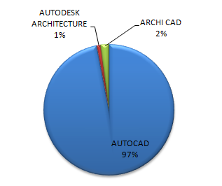
Fig 1. Showing the most preferred software for 2dimensional drawings Source: field studies by authors in FUT minna 2010
Fig 2. Showing the software choice for 3 dimensional drafting software .Source: field studies by authors in FUT minna 2010
The respondents were also asked on the most preferred software of choice for rendering and the distribution across different software. (Fig 3.) The distribution shows Revit as the most preferred software for rendering, followed by 3DS Max, AutoCAD, Google sketch up and V-ray.
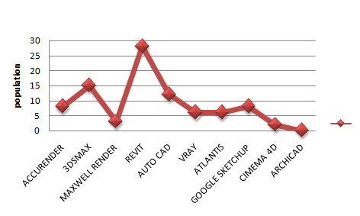
Fig 3, showing the most preferred software for rendering: source author’s field studies 2010.
6.2 Access to computers and printers.
The students were also asked on how they do their assignments and the response shows that 75% of the students have computers, while 22% of the respondents borrow from their friends, while the remaining 3% use the family computer system. See fig 4. However the printing of assignments takes a great toll on the students as most of the assignments are printed commercially. See fig 5
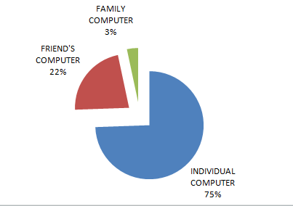
Fig 4 showing access to computer for assignments: source author’s field studies 2010.
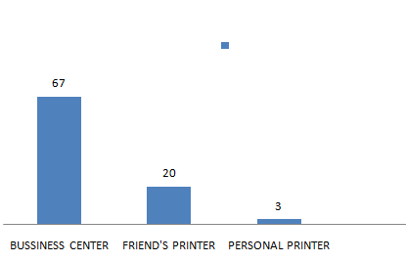
Fig 5. Access to printers. Source field survey 2010
6.3 The Teaching Method Preference.
The analysis shows that 73% of the respondents learn very well from the lecturer during the practical demonstration with the aid of the projector. However 27% of the respondents stated that they learn better with assignments.
7. DEDUCTIONS
1. The analysis shows that AutoCAD can be used as the software for drafting in 2 dimensions because of its popularity, ease of use and availability. However for 3 dimensional drawings the software of choice as gathered from the study are AutoCAD and Google sketch up.
2. From the analysis, the design of CAD curriculum will have to be flexible to allow the use of different software for rendering. Here it is suggested that the students will be taught the basics of, one rendering software and then grouped to explore the various software. Each group will therefore be asked to take the class in turns.
3. The assessment shows that access to personal computers is good and therefore the take home assignment can be explored. However the submission of hard copies of assignments by the students takes a great toll on them as 67% of the students print their assignment commercially. It is therefore suggested that most assignments should be assessed in softcopies and where hard copies will be required the department should make provision for the printing at a subsidized rate.

8. TEACHING METHODS.
There are various types of teaching methods, however for the purpose of this paper, four types will be discussed.
8.1 The lecture method. This is the most popular and most common method of teaching in tertiary institutions. It involves the presentation of information and teaching through oral exposition.
8.2 Problem solving method. This method involves the ability of reasoning from the students; here the students are given assignments upon which they learn during the course of carrying out the task.
8.3 Demonstration method. This method relies on sight and hearing, here the students are taught through practical demonstration.
8.4 Project method. This method involves given similar assignment with what has been taught in the class so that the students will perfect the skill learned.
For the purpose of effective learning and teaching of CAD, the analysis got from the respondents suggests that the combination of the following three types of teaching will be the most effective; they are ‘problem solving method’, ‘demonstration method’ and ‘project method’. This method of teaching is hereby termed the CAD effective teaching triangle as shown in fig 5
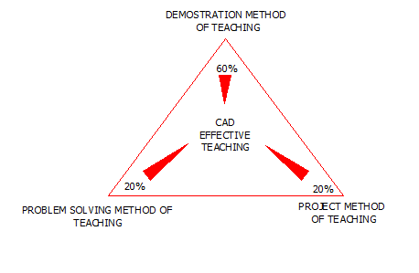
Fig 5. Showing the CAD effective teaching triangle: source authors field work 2010

Here it is expected that 60% of the input of teaching should be on demonstration method of teaching while the problem and project solving method should have 20% each. The new curriculum is aimed at developing a functional, relevant and flexible curriculum that will cope with the changing trend in information, technology and communication.
The following (table 2) is an outline of the proposed curriculum for the teaching of CAD using the Department of Architecture Federal University of Technology Minna as the template upon which various schools of architecture are expected to adopt.
Table 2: showing the proposed course distribution
SN | Course Code/Title | Software | Level | Course Description and topics to be taught
1 | Arc 115, computer aided design I | None | 100 | An introduction to computer aided design drafting and general computer applications in architecture
2 | Arc 125, computer aided design II | AutoCAD | 100 | -The starting up of AutoCAD environment.  -AutoCAD screen components  - file management  -Drawing of lines and shapes
3 | Arc 215 computer aided design III | AutoCAD | 200 | -The management of drawing properties  -Editing of objects  -Creating texts and tables  -dimensioning
4 | Arc 225, computer aided design IV | AutoCAD | 200 | -Model space layout  -Drawing of simple plan, elevations and sections.  -Hatching and simple 2d rendering  -Plotting of drawings
5 | Arc 315, computer aided design V | AutoCAD | 300 | -Definition of block attributes  -Working with advanced drawing options  -The co-ordinate systems in CAD  -Drawing of complex 2d plans, elevations and sections  -landscaping
6 | Arc 325, computer aided design VI | AutoCAD and Google sketch- up | 300 | -Introduction to 3D environment of AutoCAD  -Changing of viewports to view 3D objects in AutoCAD  -3D coordinate system  -Creating 3D simple objects.  *All of the above sequence should be treated in Google Sketch up
7. | Arc 415 | AutoCAD and Google sketch- up | 400 | -Solid models in 3D space  -Editing of models in 3D space  -Modeling of designs, landscaping in 3D  -*All of the above sequence should be treated in Google Sketch-up
8 | Arc 510 | AutoCAD  Revit  3DMax | 500 | -The transfer of drawings and models between compatible software  -Rendering with the application of lights in AutoCAD, Revit and 3DMax, all treated one after the other  -Script writing in AutoCAD
9 | arc 610 | Multiple software | 600 | Advance modelling and rendering techniques using different cad modelling and rendering software. The choice should be based upon the student’s specialization and the assessment should be based upon the reality of model generated.
10 | Arc 625 | Multiple software | 600 | Animations in 3D environment with the inclusion of sounds. This will be a complete semester project.
9. CONCLUSION.
The need for the development of computer aided design curriculum for the teaching and learning of CAD in schools of architecture in Nigeria has become important in order to meet up with the 21st century global architectural practice. The research shows that the curriculum will need to be updated periodically in order to meet up with the technological developments in software and hardware. The lecturers will also need to use special teaching method which entails the combination of demonstration, problem solving and project method in order to have an effective teaching. The lecturers of CAD are also expected to be equipped with the skills of teaching different software since no single software gives a complete output.

References
Abdulrahman M.E. and Lawal L.A.T (2007). The Use of Computers as Alternative To Drawing Boards for the Training of Architecture Students In Nigeria. Journal of Association of Architectural Educators in Nigeria, vol. 6 (2)pp 106-109.
Adejimi A (2007). Architecture as distance learning in Nigeria: Possibilities, Opportunities, and Challenges. Journal of Association of Architectural Educators in Nigeria, vol. 6 (2) pp 55-63
Anunobi A.I. (2006) Training of Architects to Meet the Challenges of the 21st Century: A Case for a New Curriculum Approach. Journal of Association of Architectural Educators in Nigeria, 5(1) pp 1-6.
Jeff M (2006) Architectural Visualization Industry Survey 2006, Architectural Visualization Magazine 3D supplement. Vol 1, pp 19-24. UK. Future publishing, UK
Mas’ud A.& Badiru Y.Y (2004) Architectural Education And Practice In The 21st Century: New Trends And Challenges. Journal of Association of Architectural Educators in Nigeria, 3, (1) pp 44-55.
National Teacher’s Institutes (2004): Principles of Curriculum Design and Development Course Ware. Pub N.T.I. Kaduna. Kaduna press
Ogunsote O.O, Ogunsote P.B & Umaru N.A (2007) Curricular Anatomy of CAD Proficient Architecture Graduates In Nigeria. Journal of Association of Architectural Educators in Nigeria, 6 (1) pp 99-109.
Sevil S and Peter V.V. (2010) The Role of ICT as A Partner in Architectural Design Education. Available: http://www.eaae.be/eaae/workshops/cdst98/ [Accessed on 28th June 2010.]
Simeon O.O (2007) Architectural education in Nigeria: An X-ray .Journal of Association of Architectural Educators in Nigeria, 6 (1) pp 1-8.
Suleiman I.K (2006) Computer Aided Design Drafting: Professional Applications and the University Curriculum. Journal of Association of Architectural Educators in Nigeria, 5 (1) pp 18-25.
Turk Z (2006) Computing in Architectural Design: Reflections and An Approach to New Generation of CADD (E-Journal), Available: http//www.itcon.org.[ Accessed on 16th July 2010]

