# Study and Development of an Automated Staff Shift Duty Roster for Federal University of Technology Minna Library

Patience U.Adejo, Fasola P. Abifarin* and Godwin Ilemuda

Department of Library and Information Technology

Federal University of Technology, Minna.

*[fp.abifarin@futminna.edu.ng](mailto:fp.abifarin@futminna.edu.ng)

**Abstract**

*The aim of the research work was to study the current shift duty roster system in Federal University of Technology Minna Library with a view to improving upon it through automation. The system analysis design and development approach was adopted for the study. Fact finding techniques adopted include observation, interview, record inspection and decision analysis. The study found that the current rostering practice at Federal University of Technology Minna Library was slow, tedious boring and error prone. An automated duty roster system was recommended, developed and implemented. The new system automatically produces weekly, monthly and quarterly rosters once input is provided.*

***Keywords:****Automation, Shift duty roster, University library, Nigeria*

**Introduction**

A well planned duty roster serves as a major tool for achieving stated goals and objectives in production and service organisations. It helps in improving effectiveness, increasing work output and length of working time. A roster can be defined as a schedule which assigns task or leave to people working in an organisation or establishment The Library as a service organisation plays a very sensitive role in the University and a very high standard must be maintained when allocating shifts in order to ensure that proper track recording of all Library staff are kept, duties are being fairly distributed without collisions and also the right combination of staff are assigned to work together. Taking advantage of the presence of Information and Communication Technology (ICT), the present manual method of scheduling shifts in Federal University of Technology(FUT) Minna Library which was observed to be repetitive, enervating and poor in record keeping, can be improved into a more efficient, reliable, and easy to use system.The aforementioned reasons inspired this study to be carried out, with the aim of designing and implementing an automated shift duty roster system for Federal University of Technology Minna Library. The success of this research work will provide significant changes and improvement to the current manual rostering system used in the Library. This research will provide implementable solutions to the current challenges faced by FUT Minna Library when scheduling shifts among the staff.

The study will also be of great help to the Circulation Librarian who is saddled with the responsibility of preparing the manual shift duty roster in the FUT Minna Library. The outcome of this research work will be an improved duty roster system that will enable automated shift scheduling, easy storage and retrieval of information, from the database and manipulation of records. This new system can be adopted for use in the Federal University of Technology Minna Library.

**Objectives of the Study**

The study is aimed at studying the existing manualshift duty roster in Federal University of Technology Minna Library and develop an automated system to replace it. The specific objectives are, to:

1. examine the processes involved in shift duty scheduling/preparation in FUT Minna Library.
2. identify in detail, the problems that are encountered with the current method of preparing shift duty roster in FUT Minna Library.
3. develop an automated duty rostering system for FUT Minna Library.

**Review of Related Literature**

The International Labour Organization (1998) defined shift duty as a method of organising working time in which workers succeed each other at work places so that the establishment can operate longer than the hours individual workers have worked.European Parliament and Council of EU(2003) opines that regarding organisations working time, shift dutydenotes ways of organising work in shifts whereby workers succeed each other at the same work place following a particular pattern. A shift worker is a worker that his or her work schedule is part of a shift work.A roster can also be defined as a list which gives details of the order in which different people have to do a particular job (www.collinsdictionary.com/dictionary/english/roster). It is a list of plan that shows turns of duty or leave for individuals or group in an organisation. The hours that staff are required to work are usually designated in a shift roster ([www.learnersdictionary.com](http://www.learnersdictionary.com)). Staff on duty vary more widely to accommodate the volume of business) or split(s used when staff works two separate periods in a shift with a long break in between).

**Types of Rosters**

Miller (2013) opines that shift patterns are as diverse as the organizations in which they are practiced. For instance shift patterns may range in number of shift days from 3-10-day through weekly and fortnightly to monthly; by number of shift groups from two, three to four, and duration in hours from 8, 16, 21, 24 to 42. Shift duty rosters may be staggered (used where start times, shift lengths and amount of staff on duty vary more widely to accommodate the volume of business) or split(s used when staff works two separate periods in a shift with a long break in between). According to Kerr and Timothy (2009), roster preparation methods include Fixed/Cyclical rostering (repeated constantly over a period). Others areDemand driven rostering which focuses on placing the right combination of staff to work and it is allocated randomly while Supply driven rostering is built around available staff. Staff are able to choose when or not they are to be on shift duty.

**Factors to be considered while Designing Rosters**

Factors to be considered before developing staff rosters as approved by the Institute for Work and Health (2010) include: gender and marital status of staff( especially because of female staff who are married, when they get pregnant and have to go on maternity leave);the health condition of staff; Date of cultural/religious activity and family considerations. Best practice in developing rosters as enunciated by Department of Education, Employment and Workplace relations of the Australian Government (2012) include developing rosters according to positions in an organization, combining duties are appropriate to ensure effective use of staff, presentation of rosters in required formats to ensure clarity of information according to organizations standards, among others.

**Role of Computers in Rostering**

Manual roster preparation is being replaced by computers. Miller(2013) stated that computers ? offerflexibility, speed, accuracy, efficiency, consistency and improved work control, reduction of repetitive clerical work, among others. Rostering applications like FindMyShift (www.findmyshift.com), ShiftCalendar (www.firehouse.com), ABC Roster (www.abc-roster,com) and Rotaview(www.rostering.co.uk) are being offered by software developers to solve the problems of manual shift planning and preparation. These application software let you organizations group their employees who should ideally work together,help to export the resulting schedule for easy distribution and reduces errors and conflicts. There is however no previous application that is designed to automate shift for Library staff.

**Research Methodology (Materials and Procedures)**

System analysis design and development (SADD) methodology was adopted for the study. According to Dennis, Wixom and Roth (2012) system analysis and design involves careful planning, evaluation, feasibility studies, development, deployment/implementation and support required to develop a new system.First, the existing manual shift duty rostering system of FUT Minna Library was studied and analysed using observation, interview schedule, record inspection and decision analysis. The proposed automated shift duty rostering system was developed using Visual Basic Programming language and Microsoft Access database for storing information.

**Results and Discussion**

* + 1. **Study and Analysis of the Current Manual Rostering System**

The current manualshift duty roster approach began in 1983 at the inception of Federal University of Technology Minna Library. The Library has been operating the seven-day (Monday to Saturday) morning (8:00am-3:00 pm) and afternoon(3:00pm-10:00pm), two-shift weekly duty roster. Shift duty occurs during session only as the Library reverts to one stream of duty(8:00am-3:00pm) for all staff during semester holidays. During session and semester break, shift is not operated on Sundays. Gidan-Kwanu and Bosso duty roster is prepared concurrently.There are seven working days in a week, but each staff is only entitled to one day off duty every. Senior library staff do not normally run shift but supervise junior staff on shift duty. Staff on morning shift in a particular week will be on afternoon shift the next week. Shift duty rosters are produced manually on month-by-month basis on paper and circulated to staff concerned. Copies of the monthly rosters are filed in office files and stored in file cabinet. The basic information needed about each staff of the library that runs shift are: First Name, Surname and Rank (hierarchical position of the staff, which is either an operator or a supervisor).

**Decision processes in the manual rostering approach at FUT Minna Library**

The decision processes in the current manual rostering approach in Federal University of Technology Minna Library, are depicted using decision trees (Fig.1,2,3 and 4). A typical decision tree is a diagram used to describe decision alternatives, chances and event. It is also a support tool that uses a tree like graph or model of decision and their possible consequences, including chance, event outcomes, resource cost and utility. The decision trees show the flow of the schedule processes in the library, from a particular origin to its destination.

.

1day off foreach staff

*Staff duty roster*

Supervisor

Operators

No shift

1day off foreach staff

On shift

**Fig 1: G**eneral rules and decisions on staff duty roster preparation in FUT Minna Library,.

1:00pm-10:00pm

1day off foreach staff

*Supervisors workflow*

Always on duty

Not on shift

**Fig. 2:**Processes and decisions involved in supervisor shift duty preparation in FUT Minna Library,

On shift

1day off foreach staff

Staff on PM to AM shift

Staff on AM to PM shift

*Operator’s roster*

Staff onAM. Shift

Staff onPM .Shift

8:00AM-3:00PM

3:00pm-10:00pm

**Fig3:**Processes and decisions involved inoperators duty roster preparation in FUT MinnaLibrary.

Annual leave

Casual leave

*Exceptional cases*

Leave

Growth from operator to supervisor seniostaff

**Fig 4:** Conditions under which staff is off duty aside the usual Weekly off duty

**Conditions and rules of the current shift duty approach at FUT Minna Library**

The conditions and rules of the current shift duty roster are presented using decision tables. Decision tables associate condition within corresponding actions that is to be performed (Hoffer, George, & Valacich, (n.d.).Decision tables are composed of rows and columns. Each row corresponds to a single rule, with the column defining the conditions and actions of the rules.

Table 1 shows the entire decision on job schedule for the operators in FUT Minna library.

Table1:Operators general job scheduling table at FUT Minna Library.

**Conditional statement** RULE

| **Shift pattern** |  | **Morning shift (M)** |  | **Afternoon shift (A)** |
| --- | --- | --- | --- | --- |
| Library staff works on morning shift (M) |  | Y Y |  | N N |
| Library staff works on afternoon shift (A) |  | N N |  | Y Y |
| IF staff is on ‘M’ shift one week, THEN |  | Y Y |  | N N |
| IF staff on ‘A’ shift one week, THEN |  | N N |  | Y Y |
| IF staff is not on ‘M’ shift for one day in a week, THEN |  | Off off |  | Y Y |
| IF staff is not on ‘A’ shift for one day in a week, THEN |  | Y Y |  | Off off |
| ELSE, |  | Emergency/exceptional cases |  | Emergency/exceptional cases |
| **Action statement** |  |  |  |  |
| Management/personnel grant |  | Annual leave/casual leave |  | Casual leave/annual leave |
|  |  | Promotion to senior staff |  | Promotion to senior staff |

Table 2 shows operators job scheduling process for morning shift and their respective off duty days at FUT MInna Library

Table 2: Names of staff on morning (M) shift (Group ‘A’) at FUT Minna Library

|  |  |  |  |  |  |  |  |  |  |  |  |
| --- | --- | --- | --- | --- | --- | --- | --- | --- | --- | --- | --- |
| S/N | Name | Unit | Mon | Tue | Wed | Thur | Fri | Sat | Sun | Time | |
| 1 | Mohammed, T. |  | Y | Y | Y | Y | Y | Y | N | 8:00am-3:00pm | |
| 2 | Musa, A. Muhammed |  | Y | Y | Y | Y | Y | Y | N | 8:00am-3:00pm | |
| 3 | Fausat, Abdulkareem |  | Y | Y | Y | Y | Y | Y | N | 8:00am-3:00pm | |
| 4 | Naomi, Jiya |  | Y | Y | Y | Y | Y | Y | N | 8:00am-3:00pm | |
| 5 | Musa Adamu |  | Y | Y | Y | Y | Y | Y | N | 8:00am-3:00pm | |
| 6 | Yusuf, D.A |  | Y | Y | Y | Y | Y | Y | N | 8:00am-3:00pm | |
| 7 | Kolo, A. |  | Y | Y | Y | Y | Y | Y | N | 8:00am-3:00pm | |
|  |  |  |  |  |  |  |  |  |  |  |
|  | IF group ‘A’ is on morning (M) shift, THEN name. s/no1 |  | Off duty | Y | Y | Y | Y | Y | N |  |
|  | IF group ‘A’ are on morning (M)shift, THEN name .s/no2 |  | Y | Off duty | Y | Y | Y | Y | N |  |
|  | IF group ‘A’ are on morning (M)shift, THEN name .s/no3 |  | Y | Y | Off duty | Y | Y | Y | N |  |
|  | IF group ‘A’ is on morning (M) shift, THEN name. s/no4 |  | Y | Y | Y | Off duty | Y | Y | N |  |
|  | IF group ‘A’ is on morning (M) shift, THEN name. s/no5 |  | Y | Y | Y | Y | Off duty | Y | N |  |
|  | IF group ‘A’ is on morning (M) shift, THEN name. s/no6 |  | Y | Y | Y | Y | Y | Off duty | N |  |
|  | IF group ‘A’ is on morning (M) shift, THEN name. s/no7 |  | Y | Y | Y | Y | Y | Y | Off duty |  |

Table 3 shows junior staff scheduling process for afternoon shift and their respective off duty days.

|  |  |  |  |  |  |  |  |  |  |  |  |
| --- | --- | --- | --- | --- | --- | --- | --- | --- | --- | --- | --- |
| S/N | Name | Unit | Mon | Tue | wed | Thu | Fri | Sat | Sun |  | Time |
| 1 | Aishat, Suleiman |  | Y | Y | Y | Y | Y | N | Y |  | 3:00pm-10:00pm |
| 2 | Shaibu, Abdulazeez |  | Y | Y | Y | Y | Y | N | Y |  | 3:00pm-10:00pm |
| 3 | Fatima, A.S |  | Y | Y | Y | Y | Y | N | Y |  | 3:00pm-10:00pm |
| 4 | Yinusa, Ndagi |  | Y | Y | Y | Y | Y | N | Y |  | 3:00pm-10:00pm |
| 5 | Abdulahi,S.D |  | Y | Y | Y | Y | Y | N | Y |  | 3:00pm-10:00pm |
| 6 | Musa, Jiya |  | Y | Y | Y | Y | Y | N | Y |  | 3:00pm-10:00pm |
| 7 | Ibrahim, Sule |  | Y | Y | Y | Y | Y | N | Y |  |  |
|  | IF group ’B’ are on afternoon(A) shift THEN,name.s/no1 |  | Y | Y | Off duty | Y | Y | N | Y |  |
|  | IF group ’B’ are on afternoon(A) shift THEN,name.s/no2 |  | Off duty | Y | Y | Y | Y | N | Y |  |
|  | IF group ’B’ are on afternoon(A) shift THEN,name.s/no3 |  | Y | Y | Y | Y | Y | Off duty | Y |  |
|  | IF group ’B’ are on afternoon(A) shift THEN,name.s/no4 |  | Y | Off duty | Y | Y | Y | N | Y |  |
|  | IF group ’B’ are on afternoon(A) shift THEN,name.s/no5 |  | Y | Y | Y | Off duty | Y | N | Y |  |
|  | IF group ’B’ are on afternoon(A) shift  THEN,name.s/no6 |  | Y | Y | Y | Y | Off duty | N | Y |  |
|  | IF group ’B’ are on afternoon(A) shift THEN,name.s/no7 |  | Y | Y | Y | Y | Y | N | Off duty |  |

**Table 4:** Conditions and actions for staff on morning shift at FUT Minna Library

Table 4 represents the exception cases in morning (M) shift job scheduling for operators.

|  |  |  |  |  |  |  |  |
| --- | --- | --- | --- | --- | --- | --- | --- |
| IF any staff in group ’A’ works for < or = four days in a week | Y | Y | Off duty | Off duty | Off duty | Y | N |
| THEN, | the | Staff | Is on | Casual | Leave |  |  |
| IF any staff in group ’A’ is off duty for > or = 7days in a month | Off duty | Off duty | Off duty | Off duty | Off duty | Off duty |  |
| THEN, | the | Staff | Is on | Annual | Leave |  |  |
| ELSE |  |  |  |  |  |  |  |
|  | Emergency |  |  | Emergency |  |  |  |

**The Process Logic of the Current Duty Roster System in FUT Minna Library**

The current shift duty roster at FUT Minna Library is presented in structured English. Structured English isa modified form of English used to depict the information or content of process boxes in a dataflow diagram. It differs from regular English in that it uses a subset of regular English vocabulary. Structured English uses noun phrase vocabulary to describe data structure and action verbs to describe data structure. (De Marco, 2012)**.**  Structured English is used to present the various rule and decisions in preparing library staff duty roster. It is an excellent description of an algorithm, particularly when user’s communication is essential. Structured English is useful for planning or designing program routines, modules, and manual procedure.

**Conditions for number of day’s staff are expected to work**

From a non-participatory observation carried out in the library, the rules and decision involved in staff rostering is as thus;

IF staff works on morning ‘M’ shift for week1

THEN, the staff will work on afternoon ‘A’ shift in week2

IF staff works on afternoon ‘A’ shift for week1

THEN, staff automatically works on morning ‘M’ shift in week2

ELSE

Management staff only

DO for each week

END DO

END IF

Conditions For the number of days staff are expected to work per week.

IF staff on ‘M’ work for six days in a week

THEN, the staff is due for one day off duty

IF staff on ‘A’ works for six days in a week

THEN, staff is due for one day off duty

ELSE

Emergency/exception cases

DO for each week

END DO

ENDIF

Condition that shows the time for resumption and closing for library staff.

IF staff works between 8:00am-3:00pm

THEN, the staff is said to be on morning shift

IF staff works between 3:00pm-10:00pm

THEN, the staff is said to be on afternoon ‘A’ shift

IF staff is not always on duty by 8:00am-3:00pm but only by 3:00pm-10:00pm only

THEN, staff is said to be a management staff

ELSE

The staff is either on casual leave or annual leave

DO for each week

END DO

END IF

**Shortcomings of the Current Manual Duty Roster System in FUT Minna Library**

The following shortcomings were identified in the current manual shiftduty rostering approach at FUT Minna Library: .

1. The process of planning and preparing the roster is mentally tasking as the officer in charge has to remember names, rules, conditions and exceptions, leave cases and ensure that these are reflected in the roster.
2. A lot of paperwork is involved in preparing the shift duty roster and non-availability of records pertaining to staff leave and other movements has led to make-shift rosters which had to be amended when the records became available
3. The process of planning and preparation of the shift duty roster is repeated every week making it labour-intensive, boring and error-prone.

The past duty rosters were filed in office files in no particular order and stored in steel cabinets where retrieving them on demand posed some difficulty

1. Shift duty documents do not carry any identification number (Reference Number) posing the difficulty of registering and recognizing it as an official document.

**Overview of the Proposed System**

The proposed automated shift duty rostering system will overcome all the shortcomings of the existing system by providing the following features:

1. Provision of a user interface for record management that is user friendly and easy to use
2. Easy creationof personal profile of shift operators and supervisors that includes name, unit, phone no, and rank
3. Secured databases for saving the major details of supervisors, operators and rosters
4. Restricted access only by the Circulation Librarian/Officer-in-Charge of Shift preparation
5. Automatic generation of rosters for the Library staff once the right input is inserted
6. On demand production of shift Report that showcases the entire shift done for the Library per week and per month.

**Design and Implementation of the Proposed Automated Staff Duty Roster System**

Thedesign and implementation of the proposed automated shif duty roster system is outlined below:

**Output Design**

The Output of any computerized system is a yardstick to prove its accuracy and efficiency. The following output design were identified:

1. Main menu
2. Shift Operator’s duty roster form
3. Supervisor’s duty roster form
4. About
5. User manual

**Input Design**

The following input design was identified for the study:

1. Operator’s name, Shift, Week, Sex, Phone no, and Unit.
2. Supervisors name, Library, Week, Day.

**Design of System’s Database Tables**

Both Shift operator database table (Table 4) and Supervisors’ database table (Table 5) were designed for the proposed automated duty roster system for Federal University of Technology Minna Library.

**Table 4: Operator’s database table (Operators’ DBT)**

|  |  |  |  |  |
| --- | --- | --- | --- | --- |
| **Field no** | **Field name** | **Field type** | **Width** | **Key** |
| 1 | FULLNAME | TEXT | 20 | PRI |
| 2 | SEX | TEXT | 8 |  |
| 3 | PHONE NUMBER | NUMBER | 20 |  |
| 4 | POSITION | TEXT | 20 |  |
| 5 | UNIT | TEXT | 15 |  |
| 6 | SHIFT | TEXT | 10 |  |

**Table: 5 Supervisor’s database table (Supervisors’ DBT)**

|  |  |  |  |  |
| --- | --- | --- | --- | --- |
| **Field no** | **Fieldname** | **Field type** | **Width** | **Key** |
| 1 | FULLNAME | TEXT | 20 | PRI |
| 2 | LIBRARY | TEXT | 10 |  |
| 3 | DAY | TEXT | 10 |  |

**Program Description**

The name given to this application is E-ROSTER. A splash screen is displayed first when the application is started before the login form pops up. When the correct username and password is inserted, a welcome form known as menu is displayed along with the corresponding submenus. It is further explained below:

1. MAIN MENU :This form showcases the pathways to the applications functionality
2. E-ROSTER FILE: This menu enables the system operator to create new staff open staff record and exit the application at any time.
3. E-ROSTER SCHEDULE: This form contains the following

* New schedule: This form enables the creation of new rosters and stores them in the database.
* View schedule: This form enables viewing and adjustment to be made to an already existing database file of employee record.

1. E-ROSTER REPORT: This form is used to note daily report on the libraries daily activities.
2. E-ROSTER HELP: This menu displays information about e-roster and provides a short guide to the application.

**System Implementation and Testing**

1. **Functional Requirements:** The system is computer based. It is aimed at taking care of all the processes involved in collecting and storing information about the Library staff of Federal University of Technology Minna Library as well as scheduling shifts for them. Its function will provide the following outcome:
   1. Produce a Report that showcases the entire shift done for the Library for per week and per month.
   2. Restricted access only by the circulation Librarian or operator
   3. Provision of a user friendly interface for record management
   4. Production of printed copy of all rosters
   5. Provision of all the details of the Library staff
   6. Easy retrieval of all database
2. **Software Requirement**

The programming language: Visual Basic 6.0; Microsoft Visual Studio, Operating System: MS-Windows 7; Database: MS Access. Others include MS-Word for printing documents, MS-Excel

**Hardware Requirements**

Hardware required for the application are:Processor: Intel Memory 512MB; Hard Disk: At least1GB. Other devices are Laserjet printer

**Screen Shots**

The screenshots of the developed automated shift duty roster developed for FUT Minna Library are showed.

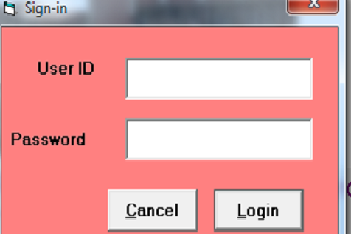

**FIG. 5: ADMIN LOGIN**

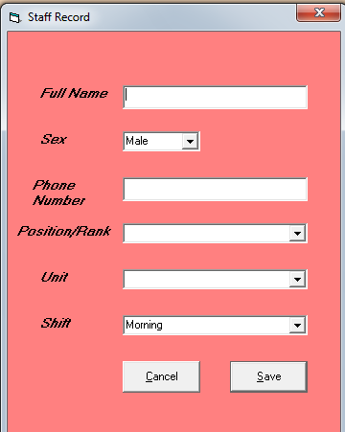

**FIG. 6: CREATE STAFF RECORD**

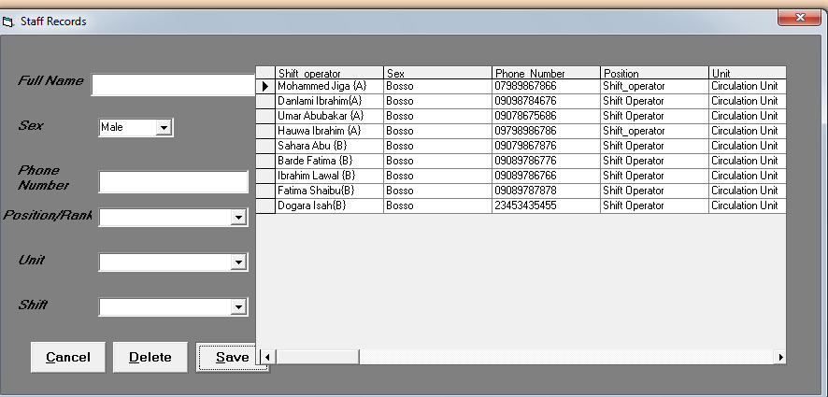

**FIG. 7: OPEN STAFF RECORD**

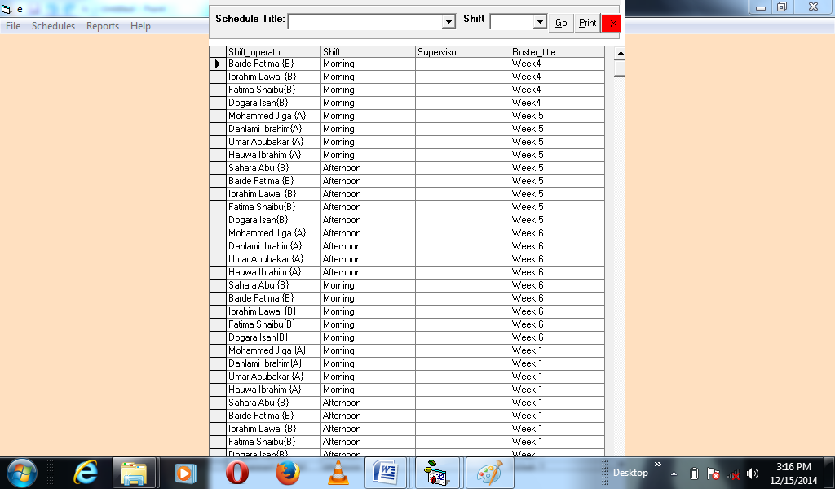

**FIG. 8: MONTHLY SHIFT OPERATORS’ DUTY ROSTER OUTPUT**

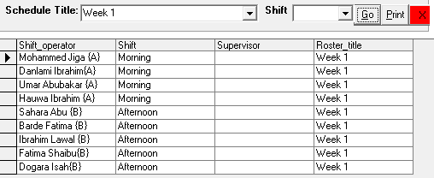

**FIG. 9: WEEK 1: SHIFT OPERATORS’ SHIFT DUTY ROSTER**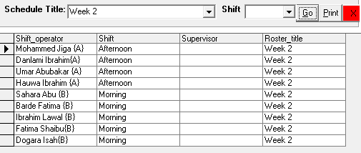

**FIG. 10: WEEK 2: SHIFT OPERATORS’ DUTY ROSTER**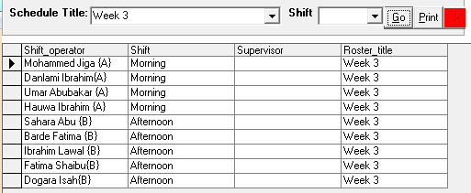

**FIG. 10: WEEK 3: SHIFT OPERATORS’ DUTY ROSTER**

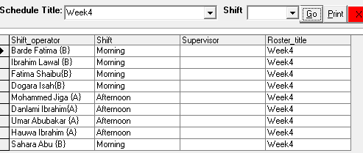

**FIG. 11: WEEK 4: SHIFT OPERATORS’ DUTY ROSTER**

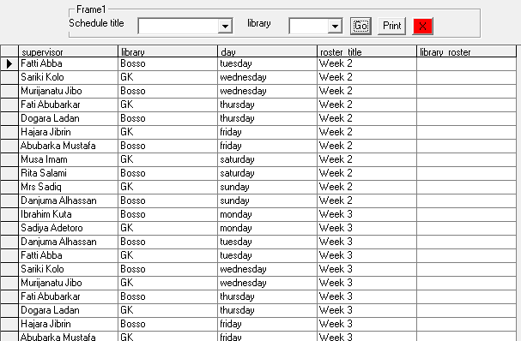

**FIG.12: SUPERVISORS’ SHIFT DUTY ROSTER**

**Summary, Conclusion and Recommendation**

A computer based system that eliminates the shortcomings was designed, developed and tested. The new system automatically produces the weekly roster once input is provided.The computer based system has eliminated manual shift roster preparation. All the physical efforts exerted in scheduling shift manually and all inaccuracy has been put to stop.

The following are recommendations for the implementation of the new computer based system.

1. The Federal University of Technology Library, Minna should adopt the use of the automated shift scheduling system.
2. Essential hardware and software should be produced for the use of the Library.
3. The parallel running system approach is to be adopted in the program implementation. The old manual system and the automated system can work together until after some time when the new system is proven to be stable and reliable. This approach affords the Library something to depend on if the new system is faulty.
4. This application is very user friendly. Training is however needed to make the user familiar with the system. All the documented comments in the coding section will guide in showing how the application works.

**References**

Australian Government, Department of Education (May 2012). ‘Employment and workplace relations “ Available at www.au.gov.com.

European Parliament and Council of EU(2003). *Directive 2003/88/EC of November 4, 2003*. Retrieved from www.eumonitor,eu.

Dennis, A., Wixom, B. H. & Roth, R. M. (2012). System analysis and design. 5th Ed. USA: John Wiley & Sons, Inc. Retrieved from: <http://www.saigontech.edu.vn/faculty/huynq/SAD/Systems_Analysis_Design_UML_5th%20ed.pdf>

De Marco, Dov Teni (2012) Information Systems: Crossroads for Organization Management. Valentino 591p.

Hoffer, Jeffery A., George, J. F. and s Valacich, Joseph (n.d). Modern system analysis and Design, 4th ed. Pp. 247-257.

Federal University of Technology Minna(2012)*. Students Handbook*,2012/2013*Session*

Federal University of Technology Minna(2013)*. Students Handbook*, *2013/2014 Session*

Institute for Work and Health (2010) *Shift work and Health.* Available at www

International Labour Organisation (1998). *Declaration on Fundamental Principles and Rights at Work.* Available at [www.ilo.org](http://www.ilo.org).

Miller, J.C. (2013). *Fundamentals of Shift work Scheduling*, 3rd ed. Fixing Stupid, Smaswords

Wasson, C.S. (2005). *System Analysis, Design and Development: Concepts, Principles and Practice*. New Jersey, John Wiley,818

FindMyShift. Available at [www.findmyshift.com](http://www.findmyshift.com). Retrieved on 29/10/2019

Duty roster. Available at www.merriam-webster.com/dictionary/duty%20roster. Retrieved on 29/10/2019

Rotaview. Available at [www.rostering.co.uk](http://www.rostering.co.uk). Retrieved on 29/10/2019.

Roster. Available at[www.collinsdictionary.com/dictionary/english/roster. Retrieved on 29/10/2019](http://www.collinsdictionary.com/dictionary/english/roster.%20Retrieved%20on%2029/10/2019).

Shift roster. Available at[www.learnersdictionary.com/definition/roster. Retrieved on 29/10/2019](http://www.learnersdictionary.com/definition/roster.%20Retrieved%20on%2029/10/2019)

Shiftcalendar. Available at www,firehouse.com. Retrieved on 29/10/2019

msdn.microsoft.com/en.us.v studio/ms788229.aspx

.monographs.iarc.fr/../mono98-8A.pdf

monographs.iarc.fr/98-8 pdf