CONFLICT PREVENTION THROUGH PEACE BUILDING AMONG AGRARIAN COMMUNITIES.
Abstract
This study highlights a concise steps to preventing conflict among agrarian community, using the principle of a peace building as a measure to forestall occurrences of conflict majorly among farmers. It aims to defining the term conflict, conflict prevention and atypical agrarian community; identify the importance and types of conflict in an agrarian community, explicit the processes of peace building in an agrarian community and give a classical strategy applicable to preventing conflicts in rural community through the process of peace building. The study identifies and explain types of conflict in agrarian community as pastoral-agricultural conflict / crop farmers-herdsmen conflict, town-country conflict, inter family and inter-clan-conflict, conflict of wages, and conflict of land and person-person conflict. It explains the concept of peace building and the process involved in building peace. The study concluded with a concise strategy for peace building and recommended the adoption of the method and process as explained taking into consideration the activities of spoilers and their proper handling.
Keywords: Conflict, peacebuilding, spoilers, Local leaders.

INTRODUCTION
Conflict is a very well-known term in the global world among all levels and worth of life, there are varieties of word that could be used to mean conflict, such terms as clash, be at variance, in opposition, disagreeing, contrasting and antithetical to mention but a few.
By definition conflict implies a fight, battle or struggle especially a prolonged struggle; strife, controversy, quarrel, discard of action, feelings or effect, in management archive conflict is defined as a clash between individuals arising out of differences in thought, process, attitudes, understanding, interest e.t.c. In layman language when individuals opine in different way a conflict arise, it is nothing but a fight either between two individual or among group members, conflict arises whenever individuals have different values, opinions, needs, interest and are unable to find a middle way.
Conflict prevention is a broad term that refers to a variety of activities and strategies within the field of peace building that are deployed to empts and subsequently neutralize potential triggers to widespread violent. Ackerman; 2020.
An agrarian community by definition, is any community whose economy is based on producing and monitoring crops and farmland.
Another way to define agrarian community is by seeing how much of the total production is in agriculture. In an agrarian community cultivation of land is the primary source of wealth, such society may acknowledge other means of livelihood and work habits but stresses the importance of agriculture and farming.
This paper aims at:
1. Defining the terms conflict, conflict prevention peace building and an agrarian community.
2. Identify the importance and types of conflicts in an agrarian community.
3. State the process of peace building in an agrarian community.
4. Give a classical strategy applicable to preventing conflicts in rural community through the process of peace building.
THEORETICAL CONSIDERATION AND IMPLICATION FOR ACTION
Conflict prevention among agrarian communities using a concise peace building strategy is best conceptualised using Human Need Theory by John Burton 1990 which pointed that conflict arise when basic human needs are frustrated or unmet. These needs include safety, protection, Identity, sense of belonging cultural recognition, respect dignity, participation, involvement in decision making and distributive justice. However by underlying these needs conflict prevention strategies can identify and meet unmet needs, fosters dialogue and collaborations, promote inclusive decision making and reduce tensions and grievances.

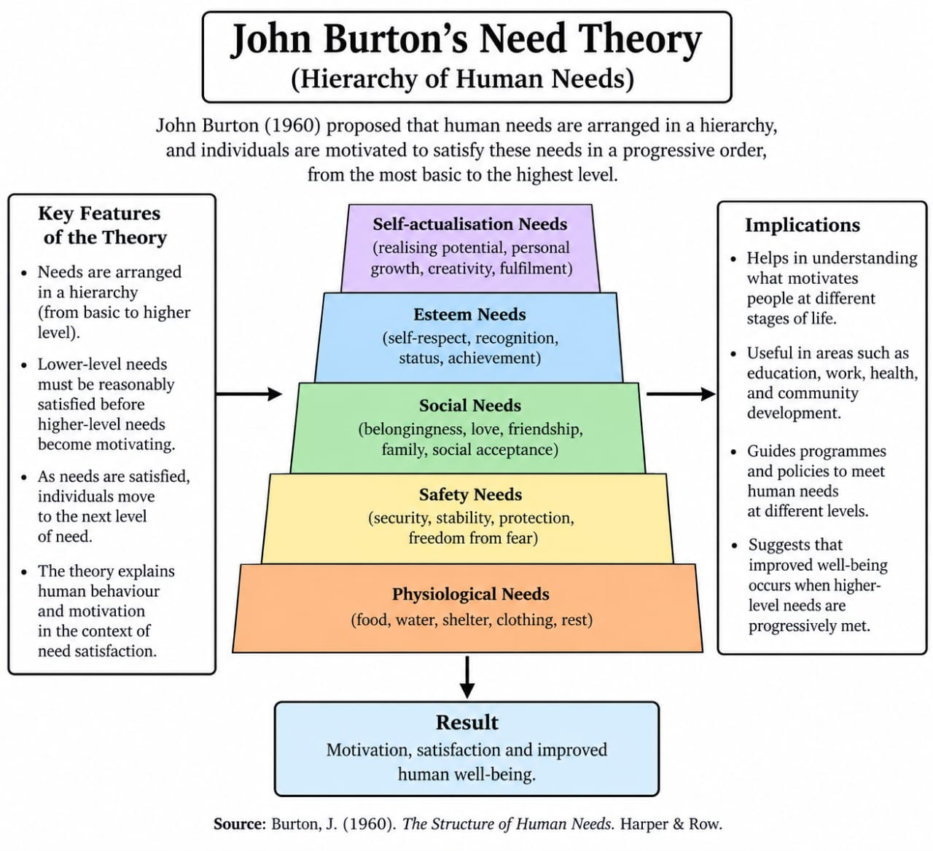

Implication for Action.
The theory indicated an unplanned action leading to an action that could involve pre planned actions, the latter is considered preventable if with strategies identified with peace building are followed Sunday M (2023). The Theory showed the interconnectedness of the cause and followed up actions with a clear view of prevention procedures.
FORMS OF CONFLICTS IN AGRARIAN COMMUNITY
Conflict takes many forms in rural areas. These are:
1. pastoral-agricultural conflict/crop farmers-herdsmen conflict
2. town-country conflict;
3. Inter-family and inter-clan-conflict;
4. Conflict over wages;
5. Conflict over land, and person-person conflict.
1. Pastoral-agricultural conflict/crop farmers-herdsmen conflict
The pastoral-agricultural conflict is that between the farmer who raises crops and the livestock keeper who rears his sheep, goats, cattle or horses from one place to another in search of pasture and water. While the farmer constructs irrigation channel, fences and storage facilities, the livestock rearer sees these as obstacle in his way in trying to secure grazing areas for his animals. This has been a common source of conflict in the agrarian community. A pattern of accommodation in which the agriculturists paid part of their crops to the nomadic herdsmen for protection of their crops from the animals was achieved, this too is a form of preventing conflicts by peace building.
Where conflict had arisen between herdsmen and crop producers, the former had often won. Their cattle had trample upon the crops of the farmers, who often had lacked adequate political and economic power to change the position. As aspiration of the farmers rise and their helplessness increased, a situation of absolute intolerance would be reached which might result into violent conflict.
In Nigeria, the pastoral-agricultural conflicts had taken similar patterns to those reported in other countries. The cattle rearers had often let their herd into the field for grasses. Sometimes, these animals had broken loose into the cultivated fields of farmers, whose crops had frequently been eaten up and trampled upon by the herd. Regardless of occasional conflicts between the herdsman and the crop farmers, the situation had continued. To arrest this, some farmers had made fences, some cattle had often broken down the fences. It must, however, be stated that the incident takes place often in isolated situations in many part of the country. This is because there is often a large area of grassland for the herdsman to move cattle around, hence the need to allow the herds to break into other peoples farms had often not arisen. Secondly, the herdsmen often follow their herds and had frequently restrained their animals from breaking into other peoples farms. However, the conflicts situation could be common in parts of Northern Nigeria where nomadism predominates.
In Southern Nigeria, the pastoral-agricultural conflict has frequently been between the sheep and goat rearers and the annual crop farmers. These animals are frequently reared on free-range systems. Under this system, they are left outside by the owners to cater for themselves. The animals frequently go to farms during the day to look for food. They frequently break into other people’s cropped farms and eat much of their annual crops. Even when the animals are beaten and scared out of the farm by the farm owners on one occasion, the animals return to the field to do similar damages on other occasions. The goats are particularly stubborn. This situation had frequently led to conflict between crop owners and livestock owners. Some sheep and goats had been beaten to death, others had been trapped or injured. These actions had not prevented the animals from damaging the crops. Even when crop farmers erected fences to prevent the animals from entering their farms, the animals had frequently broken the fences and entered the farms to destroy the crops.
The above was the situation up to the early 1990’s. Since late 1990 many village communities had made regulations to prevent damage of crops by sheep and goat. Some villages completely prohibited rearing of these animals, while others made tethering of the animals in the farms a condition for rearing the animals. Prohibition of sheep and goat rearing was effective in some villages. For instance, in many villages in Nigeria, rearing of sheep and goats is totally prohibited.
THE TOWN-COUNTRY CONFLICT:
Conflict arises in both the town and the county in all societies over all the ages because the social and economic environment have molded their personalities differently. The difference frequently result in conflict. Conflict also often arises between the farmers and the village traders.
Conflict between the farmer and the country people is frequently due to clash of interest. This arises from several areas of their lives. City men are specialized as labourers, entrepreneurs or managers. Farmers combine the three aspects. These and other reasons result in possessions of different attitudes about wage rates, hours of work and prices from the townsmen. The village trader and the town people are interested in making profit as middlemen. The village trader is frequently in contact with the farmer so as to buy his produce. This contact often results in conflict because the farmer often perceives the village trader as milking him. In South Western Nigeria, for example, the cocoa farmer does not always smile at the village cocoa buyer who is seen as coming up with various sizes of measurement instruments so as to exploit him.
The causes of town-country conflict are many and diverse. Factors that lead to town-country conflict include;
1. Differences in occupations creates different modes of thinking. The farmer has learned his skills from the parent; he sees no need for management training because he does not place much premium on his own training by parents. The village trader does not understand the psychology of the farmer, who is constantly price-conscious and parsimonious. The villager even under-rates the mentality of the farmer because he is ignorant of the various entrepreneurial and managerial skill which the farmer possesses.
2. The difference between the rural and town levels of living is obvious. The farmer knows that the townsmen spend less hours at work, wear neat dresses every day, enjoy the services of major institutions and infrastructural facilities. The townsmen look down on the farmer as inferior and unpolished, because of the difference in living conditions. The farmer resents these situations, a feeling which sometimes leads to conflict.
3. The people from small towns or large villages often show the characteristics of the metropolitan areas in their interactions with people from the hinterland. The rural people resent these because they consider the people from small towns as being closer to the farmer than to the urban people. This resentment sometimes results in conflict.
4. The farmer deals with rich people from the village and towns. He realizes that they are more polished than he is. He therefore convinces himself that the townspeople are exploiting the farmers to live a higher level of living. He therefore dislikes the townspeople.
5. Industrial workers in the town regard farmers as competitors who might come to the town to take up their industrial jobs. Such suspicious could lead to conflict when there is contact between the two, particularly if the industrial worker carries out part-time industrial work and part-time farming.
6. The farmer is often unhappy at the impersonal type of relationship with which he is treated by the urban people. The commercial and superficial values of the town businessman often irritate him. His own institutions are frequently woven into an intimate pattern of relationship with him, as these are frequently close to his dwelling.
7. The village trade mediates between the farmers from whom he buys farm products and the city economic interests to whom he sells the product. The farmer distrusts the city economic interests. The farmer has to pay city charges for all city transactions and services, yet city prices are not paid for his products on the farm. The farmer does not feel easy in dealing with the village trader and the city interests differently. When village banks and other services charge rates which make the farmer to spend more, he dislikes these.
8. As the farmers are conscious of their class, they have cooperated to provide services for themselves in rural area. This had made village businessmen uneasy. Vested interests in the town had often made farmers’ cooperation to fall. The farmers had often resented this.
FAMILY AND CLAN CONFLICT:
Family solidarity in rural areas had often resulted in conflict with other families. An assault of a member of the family is taken by other members as being against them. Clan conflict can also take place over many generations where life is traditionally oriented. The fued may flare up periodically into violent conflict. The cause of conflicts might even be most forgotten while the conflict continues. In feuds, arms are frequently employed to terminate the other party. Relatives by blood, marriage, and even friends of families concerned might be affected.
CONFLICT OVER LAND
Much of the conflict which arises among farmers is conflict over land. There had been claims and counter-claims of who are the legitimate owners of various parcels of land. Boundary dispute is very frequent. Farmers disagree with one another over working into the farms of others. Among the “Egba” dialectic group who live in Abeokuta area of Ogun State of Nigeria, such fights had sometimes been referred to the “Ogboni” society who is in charge of land allocation among the offsprings. However, majority of land dispute in rural areas are now settled in court after a terrible physical combats. Some of the land conflicts often resulted to loss of lives. Many of the conflicts in agrarian communities have their roots in poverty and despair.
CONFLICT OVER WAGES AND PERSON TO PERSON CONFLICTS
Wages earner frequently agitate for higher wages, most of the labourers often migrate for wage labour from other parts of the country. The volunteers for job often exceed the vacancies available their wages have often been low. No sooner do they take up such jobs than they start to agitate for higher wages. The labourers may organize labour union, the representatives of which are sent to the employers to ask for improved wages, often no such increase was granted because the employers are often conscious of the need to make profit.
Person to person conflict arises during games, over marital relationship, jealousies and among associates to mentions a few.
THE CONCEPT; PEACE BUILDING
Peace building is not a phenomenal that can only be jumped started within the agrarian community except through understanding that in the early stages of disputes among agrarian dwellers, parties tends to be less polarized and more flexible and thus more inclined to settle their disputes peacefully than after violent conflict has become entrenched. Prevention also offers the best possible chance to address the root causes of a conflict and not just its consequences, this providing a real opportunities to sow the seeds of a durable peace.
Peace building is an activities that arms to resolve injustice in non-violent ways and to transform the cultural and structural conditions that generate deadly or destructive conflict, it is a long term process encouraging people to talk, repairing relationships and reforming institutions for positive change to last, it is a process intended to resolve current conflicts and prevent future conflicts by addressing the cause of the problem. Peace building is a long term process that occurs after violent conflict has showed down or come to a halt, thus is the phase of the peace.
Peace building can include conflict prevention, conflict management conflict resolution and transformation post conflict reconciliation among agrarian communities. Peace building becomes strategic when it works over the long run and at all levels of the society to establish and sustain relationships among people locally and globally. Peace building is the process of working with two or more conflicting parties to resolve differences peacefully.
In summary peace building among the agrarian communities refers to the process, and methods taken by concerned stakeholders, leaders, government and every organization involved to maintain a peaceful atmosphere within an agrarian communities, between all dwellers and ability to allow various practices in agriculture to co-exist despites their diversity in needs, to produce successfully in their areas of specialization.
Peace building in Agrarian community should facilitate a life that entail them work and sharing of opportunity among rural dwellers, making them to see and view each other as a complimentary need of each one.
PROCESS OF PEACE BUILDING IN AN AGRARIAN COMMUNITY
- Water and land management training
- Improving the quality of life of the agrarian;
- Providing adaptability and diversification training to rural dwellers, to forestall effects of political instabilities and vulnerability to severe climatic shocks such as drought, flood and extreme temperature.
- Poverty reduction and the empowerment of community based resource management.
- Considering the impact of conflict and plan the interventions accordingly.
- Improving the living conditions, income and productivities of the agrarian communities.
- Addressing food insecurity, natural based disputes and conflicts.
- Investing in rural areas during protracted conflict, building resilience, social cohesion and self-reliance and at the same time helping agrarian communities cope with reduced access to jobs, services and to saving credit and investment opportunities (IPAD).
Peace building include a wide range of initiatives from mediation protection, reintegration, trauma healing and reconciliation through to longer term investments in farmer access to governance, education, health, justice security and livelihoods.
Approaches to peace building in agrarian community is aimed at activities that build peace among conflicting groups hence help to restore relationships, prevent conflict and at the same time work towards achievement of lasting peace between these groups.
PEACE BUILDING IN AGRARIAN COMMUNITY THE CONCISE STRATEGY
Peace building aim to resolve conflict and prevent future tension by addressing the causes for the problems at hand, explore the techniques used in building a comprehensive and lasting peace.
It does not need to stop or prevent conflicts among rural dwellers alone but it will also changes the way disagreement among dwellers are handled, rather than rushing to violence. Peace building teaches different dwellers in agrarian communities with different agricultural related operations how to address their problems in a logical way, finding a co-operative solution and how to acknowledge new and intending problems early enough to look for way out before it looms.
This session however looked into the seven components of strategic peace building according to the United States institute of peace, and apply the principles to a typical agrarian community.
i. Burdens of long term violence
Professional peace builders will organize a local meeting in a place that is central or neutral to both parties in a conflict into negotiations when they realize how detrimental long-term violence or conflicts among rural dwellers could be for the agrarian community as a phase and the effect on food security as a whole. In most time the results of conflicts among rural dwellers overwhelmed the very causes of the conflicts within the two parties, this might make their fight completely meaningless and leaving them worse off in the end. In majority of the cases handed with such step, the parties involved in conflict often realizing this truth spark a desire to resolve the conflict, embrace peace building and avoid future ranchos.
Critical examples for the above is negotiating peace building between crop farmers and herdsmen in an agrarian community, the land and water resources available could be used, by both the farmers and the herdsmen, timely intervention to distribute usage among the two different practitioners, making them to see possible outcomes of conflict on their localities like loss of lives and properties could spur them to accepting to co-habitat peacefully and the conflict resolved quickly.
ii. Incorporating the local leaders
Regional and urban government do organize peace talks when conflict arise among developed and developing nations, but how does an average farmer and an agrarian community dweller feel about the issue of peace talk even if it’s organize for them, how willing is a vegetable farmer whose vegetables has just been eaten up by a herd of goats being reared semi-intensively, or a herder whose cow had just suffered severe deaths due to crop farmers attack listen to such peace agreement talk.
Then, there should be a comprehensive plans for peace building involving asking the local leaders to identify the real causes of the problems and offer agrarian specific solution or plans to support peace process. This does not only increase the chances of success because the rural dwellers know and identify their credible leaders, it also engage the local leaders in the process and emotionally invests in them the desire for peace, stability and peace building.
iii. Conflict as an identifier
These strategy involves training various actors in the agrarian community’s e.g the community leader, the youth leader, women wing and leaders, herdsmen association, farmer’s councils, market women leaders and others, to see a rising conflict as a means to identify a social problem that might otherwise remain below the surface. Doing these will automatically turn conflicts into an opportunity to improve relations between dwellers with different agric-related jobs and initiate positive changes in an agrarian community. In this process the various actors and peace builders would have to be trained at identifying current causes of conflict as well as deeper causes that create these surface problems.
iv. Obtaining and using succor links
There are various organization among the world that focused on conflict resolution and peace building from the global level-National level to state and local government level, example of such are: Peace Brigade international (PBI), Bergh of foundation, CINEP/PPP, CMI, Centre for humanitarian dialogue among others, they are active in conflict transformation and identification of causes and solutions to conflicts. It's really important for agrarian community leaders, and actors in peace building to connect with these organization and to share their programmes and resources when needed. This enables large international peace building groups to engage with smaller locally knowledgeable groups. This also bring the international and national resources to the process while creating plans that address the specific needs of a conflict summation.
In an agrarian community the heavy presence of international and National organization and meetings between the groups has always proven to be a great conflict preventing method. The feelings of belonging and self-importance by the local dwellers tends to deflate conflict tendencies.
v. Handling the Spoilers
Spoilers exist only when the parties involves in conflicts have signed a peace agreement. Spoilers are both leaders and parties who believe the emerging peace within the agrarian community is a threat to their power. They tend to see peace agreement as a betrayal to key values and from excluded parties who seek either to alter the process or destroy it.
The process to handle them mostly in agrarian, community after having identified the type of the spoiler, (limited, greedy and total) through their goals in agrarian community. The cost and benefit of their actions, risk involved, should be highlighted. Custodian and actors in the process of peace building could use these three methods.
a. inducement or given the spoiler what it wants.
b. Socializations or changing the behavior of the spoiler to adhere to a set of established norms.
c. Coercion or punishing spoiler behaviour or reducing the capacity of the spoiler to destroy the peace process.
Examples of agrarian dwellers spoilers in peace building efforts are local leaders, factional leaders, union leaders, professional leaders, local chiefs, “Baale” who deserve pleasure in local conflict among rural dwellers based on their negative accrued backdoor wealth or reward they gain.
vi. Identification of Obstacles to peace building in Agrarian communities
Given the ambiguity of conflict in agrarian communities, peace building processes tends to be complex, multifaceted and messy, with several processes overlapping or running concurrently. These include: Local/community administration and leadership; the actors must sort their differences, level the playing field and work together in a common geographical territory. In most agrarian communities the leadership may not be in favour of co-existence and may instead be pursuing the goals of self-rule, in the examples of crop farmers and animal farmers. Secondly the use of arms by certain faction of the agrarian communities, they should be persuaded to lay down their arms in the cases of herdsmen and local hunters towards peaceful co-existence, in this case, disarment, demobilization and the re-integration of the armed dwellers into the community can equally be a testing affairs, this could be handled by the peace builders, custodians or the actors. Authority must never be weak if not peace building activities would be void, parallel machineries of control should be avoided. Peace agreement signed by parties to conflict must be followed in the communities, and perpetrators against it should be brought to book. Offenders should be punished within the community. The involvement of international, National and State stakeholders in peace building too should be checkmated to avoid their self-wills to taunt the communities interest for in cases these are not checkmate it may often lead to a more worsen conflict than being tried to prevent.
vii. Elicit, Evaluate, Elicit, Evaluate
Peacemaker, custodians and actors need to always seek information and suggestion from all involved parties and follow up with them continually and regularly. It is crucial to recognize that demands can vary over time and that peace building strategies may need to be updated frequently in agrarian communities to remain effective.
Thank you for listening.
Conclusion:
This research concluded that careful implementation of procedures highlighted both theoretically and practically in this study would clearly lead to prevention of majority of the identified forms of conflict. Executors of peacebuilder programs should be conversant with the detailed principles. The study concluded that burdens of long-term conflict should be eliminated among rural dwellers, incorporation of local leaders into building peace process will effectively help to prevent conflicts, obtaining succor and external links, handling the spoilers and identification of obstacles to peace buildings are the major steps to achieving the goals of conflict prevention. This research concludes that following this strategy will reduce the cost of preventions.
Recommendation:
In the course of clear analysis of conflict prevention using peace building strategy this study recommend that:
1. Government should induce the findings of this research for policy recommendations and formulations.
2. Non-governmental organization should consider the strategies into curriculum of conflict prevention module in teaching at higher levels of education as conflict prevention and solution.
3. The outcome of this research should be subjected to various administrative aspects and recommended by scholars & researchers for implementational trials.
References
Burton, J.W. (1990). Violence Explained: The sources of conflict violence and crime and their prevention. Washington D.C. pp. 3-10
George Lopez et al 2022, An introduction to strategic peace building, United States institute of peace, Washington DC, pg. 78, 89-90.
Jibowu A.A 1986, essentials of rural sociology. A textbook in Rural sociology OGS University press pg. 77-78.
Kofi Annan 2000: Common destiny new resolve annual report on the work of the organization UN pg. 1-21.
Kofi Annan 2011, Peace building, conciliation resources London page 10-13.
Rebecca Ebenezer – Abiola, 2023, Youth- centred peace building framework, United State institute for peace Washington DC.
Smith T.L and P.E Zoph (1970) Principle of Induction to Rural Sociology F.A Davies company Philadelphia pp. 89-90.
Sunday Moulton 2023, Peace building; definition and strategies, [www.study.com](https://www.study.com).

