TRANSPORTATION MODES AND THEIR IMPLICATIONS FOR DISTRIBUTION EFFICIENCY OF LEAFY VEGETABLES IN MINNA METROPOLIS, NIGERIA
NAME OF AUTHORS: ANOZIE, Regina Nkechinyere & OWOEYE, Adelanke Samuel
Contact Address of Authors: Department of Logistics and Transport Technology, School of Innovative Technology, Federal University of Technology, Minna, Niger State, Nigeria
Contact phone number: 08035888282 email: regina.anozie@futminna.edu.ng

Abstract
Efficient transport minimises post-harvest losses and improves market access for perishable leafy vegetables in rapidly urbanising Nigerian cities like Minna. However, empirical evidence on how transport mode choice affects distribution efficiency in medium-sized Nigerian cities remains limited. This study examines transport modes used in leafy vegetable distribution in Minna Metropolis and their implications for distribution efficiency. This was assessed using a mixed-method approach involving both objective and subjective measures in order to triangulate findings and improve analytical validity. Combining direct operational measurements with respondents perceived experiences helped to provide a more comprehensive understanding of transportation implications on leafy vegetable distribution efficiency in Minna. A descriptive survey design was used, collecting primary data from farmers and distributors via questionnaires, observations, and interviews across major distribution corridors. Findings show that transport is dominated by informal, low-capacity modes motorcycles (51%) and tricycles (41%), preferred due to availability (32%), load capacity (22%), affordability (18%), and accessibility (17%). Most distribution occurs over short distances, with over half of respondents travelling less than 2 km to market. While flexible and accessible, these modes constrain delivery speed, load consolidation, and product preservation, reducing distribution efficiency. Key constraints include poor road conditions (28%), produce damage during transit (17%), and transport delays (11%). The study concludes that informal transport systems provide critical last-mile connectivity between farms and urban markets but are inadequate for efficient, large‑volume distribution of highly perishable vegetables. Recommendations include improving feeder road infrastructure, increasing access to appropriate intermediate vehicles, and developing coordinated short‑haul agricultural transport systems to enhance distribution efficiency and reduce post‑harvest losses in Minna Metropolis.

Keywords: Leafy vegetable distribution; Transport modes; Perishable food logistics; Post-harvest losses; Distribution efficiency

- INTRODUCTION
Leafy vegetables are important components of household diets in Nigeria due to their nutritional and economic value. They provide essential vitamins and minerals while also serving as a major source of income and livelihood for farmers, traders, and transport operators (Mukaila et al., 2022; Liverpool-Tasie et al., 2023). However, because leafy vegetables are highly perishable, efficient transportation is critical to maintaining their freshness, quality, and market value during distribution. Transportation modes play a significant role in the distribution efficiency of leafy vegetables, particularly in developing countries where road transport dominates agricultural logistics systems. In Nigeria, vegetables are commonly transported using motorcycles, tricycles, minibuses, pickup vans, and trucks depending on distance, road conditions, transport cost, and accessibility of production areas (Tsado et al., 2020). While these transport modes provide flexibility and accessibility, many are characterized by poor loading conditions, inadequate ventilation, and rough handling practices that contribute to spoilage and post-harvest losses.
Minna Metropolis, the capital of Niger State, is an important urban market for leafy vegetables supplied from surrounding rural farming communities. The distribution system within the metropolis is largely informal and heavily dependent on road transport. However, poor road infrastructure, traffic congestion, high transportation costs, and seasonal inaccessibility of some farming areas continue to affect the efficiency of vegetable distribution (Oladosun et al., 2018) These challenges often result in delays, reduced product quality, increased spoilage, and higher market prices for consumers. According to FAO (2011), transportation and handling inefficiencies are major causes of post-harvest losses in perishable agricultural commodities. Similarly, Sheahan and Barrett (2017) noted that inefficient transportation systems reduce the availability of fresh produce in urban markets and negatively affect farmer and trader incomes. Despite the importance of transportation in vegetable distribution, empirical studies examining the implications of transportation modes for distribution efficiency of leafy vegetables in Minna Metropolis remain limited. Therefore, this study examines the transportation modes used in the distribution of leafy vegetables in Minna Metropolis and evaluates their implications for distribution efficiency.
2.0 LITERATURE REVIEW
2.1 Conceptual Review
2.1.1 Concept of Vegetables and Vegetable Products
Vegetables are edible plant parts consumed as food, including leaves, stems, roots, flowers, and fruits. They are highly perishable agricultural commodities that require efficient handling, transportation, and storage systems to maintain quality and reduce post-harvest losses. Leafy vegetables in particular are characterized by high moisture content, short shelf life, and sensitivity to temperature and mechanical damage, making their distribution highly logistics-dependent (Onuk et al., 2019). The conceptual framework begins with the farm-level production and handling of vegetables such as tomatoes, onions, and leafy greens in Minna metropolis. Tsado et al., 2020 noted that this stage involves harvesting using family or hired labour followed by packaging in basic containers including baskets, sacks, or bowls. Preservation methods such as sprinkling water and maintaining cool conditions at this stage are essential for reducing initial product degradation and preparing the produce for transit (Tsado et al., 2020; Idah et al., 2007). This component establishes the baseline quality of vegetables before entering the distribution chain.

2.1.2 Concept of Agricultural Logistics and Transportation
Transportation refers to the movement of goods from production points to consumption centres using different transport modes such as road, rail, air, or inland waterways. In agricultural logistics, transportation plays a critical role in determining product freshness, cost, availability, and market value. For perishable goods like vegetables, road transport is most dominant but often inefficient due to poor infrastructure, inadequate vehicles, and high fuel costs (Tsado et al., 2020). As explained by Zego and Husny (2024), the logistics and transportation concept encompass all activities related to moving the harvested vegetables from farms to markets. In Minna, transportation typically utilizes motorcycles, tricycles, small trucks, or manual carrying, with mode selection predicated on factors such as distance, product type, and road conditions. Efficient coordination between growers, transporters, and market agents is vital to optimize delivery schedules and reduce delays, thereby minimizing spoilage (Zego and Husny 2024).
2.2 Theoretical Framework
2.2.1 Logistics Systems Theory
The study is anchored on the Logistics Systems Theory. According to Mecalux (2023), Logistics Systems Theory emphasizes the coordinated flow of materials, information, transportation, storage, and distribution activities within a supply chain in order to achieve operational efficiency and minimize losses. The relevance of Logistics Systems Theory to this study lies in its emphasis on the integration and coordination of transportation and distribution activities involved in moving agricultural products from production areas to final consumers. The theory explains that efficient logistics operations depend on effective planning of transportation modes, route selection, scheduling, packaging, storage, and delivery systems (Adebisi et al., 2018). In the context of leafy vegetable distribution, the theory is particularly important because vegetables are highly perishable commodities that require timely transportation, proper handling, and efficient distribution systems to maintain freshness and market quality.
In Minna Metropolis, leafy vegetables are transported mainly through road-based transport modes such as motorcycles and tricycles. The efficiency of these transportation modes significantly influences delivery speed, product quality, spoilage rate, transportation cost, and market availability. Logistics Systems Theory provides a suitable framework for examining how these transportation modes interact with other logistics components such as road infrastructure, packaging systems, storage facilities, and market distribution networks to determine overall distribution efficiency. The theory is further applicable because it helps to explain how inefficiencies within one component of the logistics system can affect the entire vegetable distribution chain. For instance, poor road conditions, traffic congestion, inadequate packaging, and lack of cold storage facilities may result in delays, spoilage, increased transportation costs, and reduced product quality. According to Kazemi et al. (2024), effective logistics coordination can substantially reduce post-harvest losses and improve supply chain performance through better transportation planning and operational management.
Although the theory may face limitations in developing environments characterized by poor infrastructure and weak technological capacity, it remains highly appropriate for this study because it provides a comprehensive framework for analysing transportation modes and their implications for distribution efficiency. The theory therefore enables the study to identify transportation bottlenecks, assess the efficiency of different transport modes, and recommend strategies for improving leafy vegetable distribution systems in Minna Metropolis.
2.3 Empirical Review
2.3.1 Global Perspectives on Vegetable Products Transportation and Distribution
Empirical studies on the transportation and distribution of vegetable products have consistently shown that transportation modes significantly influence distribution efficiency, product quality, market accessibility, and post-harvest losses. Globally, advanced economies have improved vegetable distribution systems through the adoption of refrigerated transport systems, digital tracking technologies, and efficient logistics coordination, thereby reducing spoilage and improving food supply efficiency (FAO, 2024; Ismail, 2020; Vasold, 2024). These studies emphasize the importance of integrated transport systems and modern logistics infrastructure in maintaining the quality of perishable agricultural commodities.
2.3.2 Regional Perspectives on Vegetable Products Transportation and Distribution
In Africa and Nigeria, however, vegetable distribution systems are still largely constrained by poor transportation infrastructure, inadequate cold chain facilities, and inefficient logistics operations. Zego and Husny (2024) and Idah et al., (2007) observed that poor road networks, lack of refrigeration systems, and fragmented supply chains contribute significantly to post-harvest losses and reduced distribution efficiency. Similarly, Tsado et al., (2020) reported that transportation of vegetables in Nigeria relies heavily on informal transport modes such as motorcycles and tricycles, which, despite their accessibility and flexibility, expose vegetables to delays, heat, bruising, and spoilage during transit.
2.3.3 Local Perspectives on Vegetable Products Transportation and Distribution
Empirical evidence indicates that in Minna metropolis, vegetable products are mainly conveyed using informal and low-capacity transport systems such as motorcycles, tricycles, taxis, and small vans. These modes are chosen largely due to their flexibility, lower costs, and accessibility to local urban markets. However, they are often constrained by limited capacity, absence of refrigeration compartments, and unsuitability for large or delicate loads. Studies by Idah, et al., (2010) revealed that these modes of transport often contribute to mechanical damage, exposure to heat, and delays that lead to spoilage of produce during transit. Additionally, Tsado et al., (2020) reported that tricycles and motorcycles are used for short-distance distribution, while motor vehicles are reserved for larger consignments, although poor road conditions and irregular fuel costs significantly hamper efficiency. Likewise, Onuk et al., (2019) identified that marketers in Minna lose up to 58% of perishable crops during transportation alone, highlighting how transport-related challenges directly reduce marketing efficiency and farmer profitability. These findings collectively emphasize that the predominant reliance on non-specialized, informal transport perpetuates inefficiencies and increases the overall cost of vegetable distribution within Minna (Tsado et al., 2020; Idah et al., 2010; Onuk et al., 2019; Food and Agriculture Organization [FAO], 2024).
Despite these empirical contributions, existing studies have focused largely on general agricultural logistics and post-harvest management with limited attention to the specific implications of transportation modes on the distribution efficiency of leafy vegetables in Minna Metropolis. This study therefore fills the existing gap by examining how different transportation modes influence the efficiency, quality preservation, and distribution performance of leafy vegetables within the study area.

3.0 METHODOLOGY
This study adopted a descriptive survey research design to examine transportation modes and their implications for the distribution efficiency of leafy vegetables in Minna Metropolis. The study utilized both primary and secondary sources of data. Primary data were obtained from vegetable farmers/distributors through the administration of structured questionnaires, interview, field observation and camera. The questionnaire was designed and administered to a sample of 70 leafy vegetable farmers/distributors to obtain information on transportation modes, distribution channels, reasons for choice of transport modes and challenges affecting the distribution of leafy vegetables within the metropolis. Secondary data were sourced from market records, Niger State Ministry of Agriculture, agricultural production statistics, and relevant academic literature. The survey employed a systematic sampling approach, with farmers/ distributors selected at regular intervals within the vegetable supply chain. Quantitative methods were adopted for data collection, while descriptive statistical techniques were used for data analysis. Descriptive statistics such as frequencies, percentages, tables and charts were used to summarize transportation patterns and distribution characteristics of leafy vegetables within Minna Metropolis.
4.0 RESULTS AND DISCUSSION
4.1 Socio-Demographic Characteristics of Farmers/Distributors engaged in Leafy Vegetable in Minna Metropolis
The survey captured responses from 70 farmers/distributors engaged in the distribution of green leafy vegetables within Minna metropolis. The demographic characteristics assessed include gender of the vegetable farmers, age of the farmers, marital status, their level of exposure to education and finally their years of experience in vegetable business. Table 1 reveal several notable patterns with important implications for the sustainability and inclusiveness of the sector. The findings indicate a strong gender imbalance, as the vast majority of the farmers (92%) are male, suggesting that vegetable farming in the area is predominantly male-driven and that women may face barriers to participation and access to productive resources. In terms of age distribution, most farmers are middle-aged, with the highest proportion (33%) within the 41–50 years age bracket, followed by those aged 31–40 years (27%), while younger farmers aged 21–30 years account for only 21%, highlighting the need for policies and incentives aimed at attracting youth into vegetable farming to ensure long-term sustainability and innovation in the sector. The marital status distribution shows that over half of the respondents (57%) are married, while 22% are single and 21% are widowed, a situation that may influence labour availability, household responsibilities, and farm productivity. Educationally, the majority of the farmers possess secondary education (34%) and primary education (30%), although a notable proportion (19%) have no formal education, indicating the need for targeted training, extension services, and capacity-building programmes to improve farming techniques, productivity, and technology adoption. Furthermore, almost half of the farmers (43%) have between 6 and 10 years of farming experience, reflecting a moderate level of expertise that could support peer learning, knowledge sharing and the adoption of improved agricultural practices aimed at enhancing yields and market access.

Table 1: Socio-Demographic Characteristics
Demographic Variable | Category | Frequency | Percentage
Gender | Female | 6 | 8
 | Male | 64 | 92
Age | 21–30 | 15 | 21
 | 31–40 | 19 | 27
 | 41–50 | 23 | 33
 | Above 50 | 13 | 19
Marital Status | Married | 40 | 57
 | Single | 15 | 22
 | Widowed | 15 | 21
Educational Level | No Formal Education | 13 | 19
 | Primary | 21 | 30
 | Secondary | 24 | 34
 | Tertiary | 12 | 17
Years of Experience in Vegetable Business | Less than 1 year | 6 | 9
 | 1-5 years | 16 | 23
 | 6-10 years | 30 | 43
 | Above 10 years | 18 | 25
Source: Author’s Field Survey (2026)

4.2 Mode of Transportation Used for Distribution of Leafy Vegetables in Minna Metropolis
The study focused on the preferred primary mode of transporting the green leafy vegetables from the sourcing point (farm) to the distribution point (market). These transport modes include motorcycle (okada), tricycle (keke) and head porter/manual carrying.

Table 2: Mode of Transportation of Green Leafy Vegetables
Mode of Transportation | Frequency | Percentage
Head porter/Manual carrying | 5 | 8
Motorcycle (Okada) | 36 | 51
Tricycle (Keke) | 29 | 41
Total | 70 | 100
Source: Author’s Field Survey (2026)

The mode of transportation used for green leafy vegetables in Minna reveals interesting trends. Table 2 shows that motorcycles, locally known as "Okada", are the most prevalent mode of transportation as shown in Plate1, accounting for 51% of the total. This suggests that motorcycles are a popular and accessible option for farmers, likely due to their flexibility, affordability, and ability to navigate potentially rough or narrow roads.
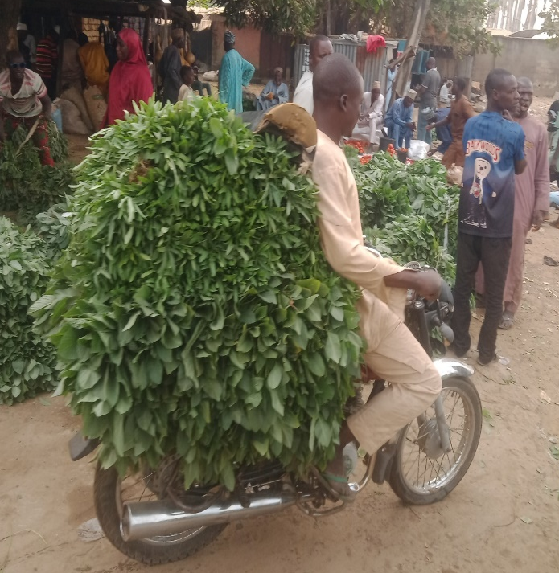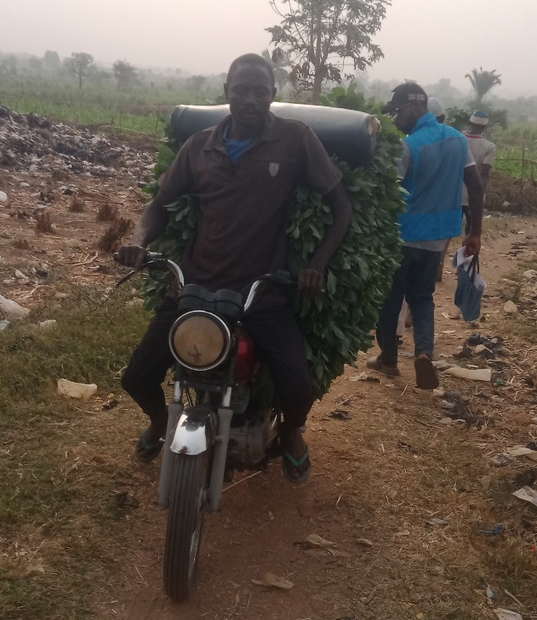
Plate 1: Motorcycle (Okada) Used as Mode of Transport for Green Leafy Vegetable
Source: Author’s Field Survey, 2026

Tricycles, or "Keke", are the second most common mode of transportation, used by 41% of vegetable farmers. Plate 2, indicates that tricycles are also a significant part of the transportation landscape for green leafy vegetables in Minna, possibly offering a more stable and potentially higher-capacity alternative to motorcycles. The reliance on motorcycles and tricycles suggests that farmers are using flexible and relatively affordable options to transport their produce. However, this might limit the quantity or distance they can effectively cover, potentially affecting market access and prices.
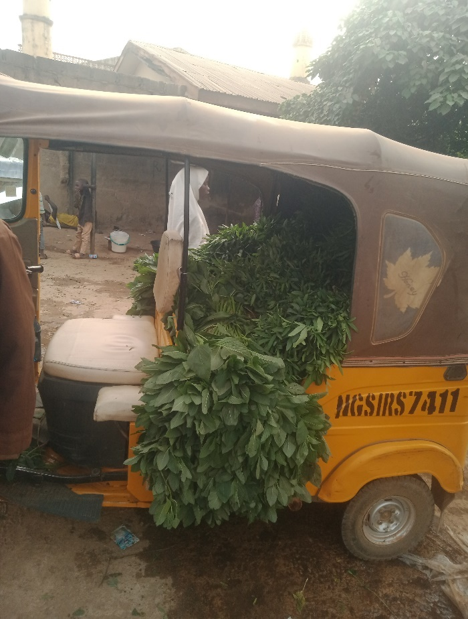
Plate 2: Tricycle (Keke) Used as Mode of Transport for Green Leafy Vegetable
Source: Author’s Field Survey, 2026
In contrast, manual carrying or head porterage accounts for only 8% of the transportation methods used (Plate 3). This minimal usage suggests that most farmers are transporting vegetables over distances or in quantities that make manual carrying impractical, or that they have access to more efficient alternatives. Though, these modes of transportation adapt well to the terrain of the study area given that there are inadequate motorable roads linking vegetable farms to market, they do not represent the most effective mode of transportation needed to boost the interest of farmers, prevent loss and increase farmers’ and distributors’ profits. This outcome corresponds with the result obtained by Tsado et al. (2020) that showed that motorcycles and tricycles are largely used in the transportation of vegetable products in Minna.
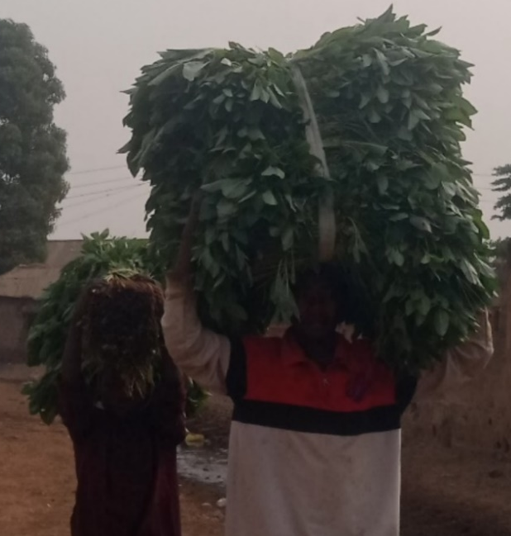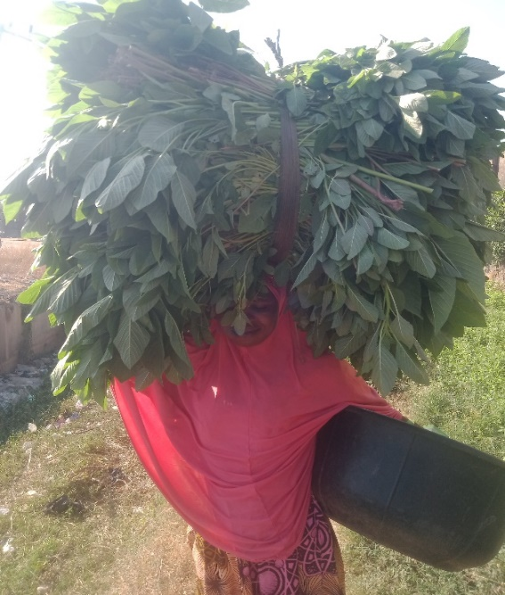
Plate 3: Head Porterage as Mode of Transport for Green Leafy Vegetable from Farm
Source: Author’s Field Survey, 2026

4.3 Reason for Preferred Mode of Transportation of Leafy Vegetables
The analysis presented in figure 1 shows the respondents’ reasons for the preferred mode of transportation in distributing leafy vegetable in Minna metropolis. The major reasons include accessibility, affordability, availability, load capacity and speed.

Figure 1: Reason for Preferred Mode of Transportation
Source: Author’s Field Survey, 2026

The reasons behind the preferred mode of transportation for green leafy vegetables in Minna reveal insightful trends. Figure 1 indicates that availability is the top reason, cited by 32% of respondents, suggesting that the chosen modes of transportation (motorcycles and tricycles) are readily accessible to farmers, making them a practical choice. Affordability is the second most important factor, mentioned by 18% of respondents, implying that cost considerations play a significant role in farmers' transportation decisions. This highlights the importance of managing transportation costs to keep vegetable prices competitive. Load capacity is another key consideration, cited by 22% of respondents, indicating that farmers value the ability to transport a reasonable quantity of vegetables at a time, balancing capacity with cost and accessibility.
Accessibility and speed are also factors, though less prominent, with 17% and 11% of respondents citing these reasons, respectively. This suggests that while these aspects are important, they are secondary to availability, affordability, and load capacity in influencing transportation choices. Overall, the preferences suggest that farmers prioritise practical and economic considerations when choosing transportation modes for green leafy vegetables. The emphasis on availability, affordability, and load capacity indicates that solutions addressing these aspects could significantly impact transportation efficiency and farmers' livelihoods.

4.4 Factors Influencing the Choice of Transport Mode
The analysis reveals significant factors influencing the choice of transportation modes of leafy vegetables within Minna metropolis as shown in Table 3.
Table 3: Factors Influencing the Choice of Transport Mode
Factors | Frequency | Percentage
Cost | 15 | 21
Distance to Market | 11 | 16
Load Size | 15 | 21
Road Conditions | 16 | 23
Speed of Delivery | 13 | 19
Total | 70 | 100
Source: Author’s Field Survey, 2026

The factors influencing the choice of transport mode by leafy vegetable farmers and distributors in Minna reveal a multifaceted decision-making process. As shown in Table 3, road conditions emerge as the most significant factor, cited by 23% of respondents, underscoring the pivotal role of infrastructure in shaping transportation choices. This highlights the need for improved road networks to enhance accessibility and efficiency in transporting perishable goods. Cost and load size are equally critical, each accounting for 21% of responses, indicating that farmers and distributors prioritize affordability and capacity when selecting transport modes. This balance suggests that solutions offering cost-effective options with sufficient load capacity could significantly impact transportation decisions.

Speed of delivery is another key consideration, mentioned by 19% of respondents, reflecting the importance of timely market arrival for maintaining the quality of leafy vegetables. Distance to market, while relevant, is cited by 16% of respondents, implying it's a factor but less influential than infrastructure, cost, load size, and speed. The analysis suggests that addressing road conditions, cost, and load capacity could substantially improve transportation efficiency for leafy vegetable farmers and distributors. The emphasis on these factors indicates that practical and economic considerations drive transportation choices in this sector.

4.5 Average Distance Between Vegetable Source and Markets
The result of analysis shows the average distance covered by the respondents from the source of vegetables to the points of distribution. The result is presented in Table 4.
Table 4: Average Distance Between Vegetable Source and Markets
Average Distance | Frequency | Percentage
2-5km | 17 | 24
6-10km | 14 | 20
Less than 2km | 39 | 56
Total | 70 | 100
Source: Author’s Field Survey, 2026

Table 4 shows the average distance between vegetable production sources and markets in Minna. The results indicate that the majority of the respondents (56%) transport their vegetables over a distance of less than 2 kilometres, suggesting that most vegetable farms are located relatively close to the markets. This proximity may help reduce transportation costs, minimize post-harvest losses, and ensure the freshness of leafy vegetables due to shorter travel time. In contrast, 24% of the respondents travel between 2–5 kilometres, while only 20% cover distances of 6–10 kilometres, indicating that fewer farmers transport vegetables over longer distances. The relatively short distances observed among most farmers may reflect the localized nature of vegetable production and marketing within the metropolis. However, farmers travelling longer distances may experience higher transportation costs, increased spoilage risks, and delays in distribution, which could negatively affect profitability and product quality. Overall, the findings suggest that distance plays an important role in the efficiency of vegetable transportation and distribution in the study area.
4.6 Challenges Faced While Transporting Vegetables
The transportation of leafy vegetables within Minna is faced with challenges, which, are presented in Table 5.
Table 5: Challenges Faced While Transporting Vegetables
Challenges | Frequency | Percentage
Poor / bad road conditions & inaccessible farm roads | 20 | 28
Produce damage / spoilage / loss during transport | 12 | 17
Transport delays & mobility constraints | 8 | 11
High transport & fuel cost | 7 | 10
Poor loading and unloading practices | 7 | 10
Packaging problems (rough sacks/materials) | 6 | 8
Transport union / road marshal interference | 6 | 8
Vehicle/transport means limitations | 6 | 8
Total | 70 | 100
Source: Author’s Field Survey, 2026
The challenges faced by farmers and distributors in transporting leafy vegetables in Minna paint a vivid picture of the hurdles in getting these perishable goods to market. As presented in Table 5, poor and inaccessible road conditions top the list, cited by 28% of respondents, highlighting the crippling impact of inadequate infrastructure on transportation. This suggests that improving farm roads and main routes could significantly ease the challenges faced by farmers and distributors. Produce damage, spoilage, and loss during transport are the next major concern, mentioned by 17% of respondents, underscoring the vulnerability of leafy vegetables and the need for better handling and transport practices.
Table 5 also shows that transport delays and mobility constraints, high transport and fuel costs, and poor loading and unloading practices are also significant challenges, cited by 11%, 10%, and 10% of respondents, respectively. These issues point to inefficiencies in the transportation process and opportunities for improvement in logistics and cost management. Packaging problems, transport union interference, and vehicle limitations are lesser but still notable challenges, each cited by 8% of respondents, indicating areas for targeted interventions.
Overall, the findings emphasize the need for infrastructure development, improved transport practices, and cost-effective solutions to mitigate these challenges and reduce losses. Addressing these issues could enhance the efficiency of leafy vegetable transportation and improve market outcomes for farmers and distributors.

5.0 CONCLUSION AND RECOMMENDATIONS
The study examined the transportation modes and their implications for the distribution efficiency of leafy vegetables in Minna Metropolis, Niger State, Nigeria. The findings revealed that motorcycles and tricycles are the dominant means of transporting leafy vegetables due to their accessibility and flexibility. However, the transportation and distribution system is constrained by poor road conditions, high transportation costs, inadequate storage facilities, unfavourable weather conditions, and reliance on traditional packaging methods, all of which reduce distribution efficiency and increase post-harvest losses. The study therefore concludes that although leafy vegetable distribution plays an important role in food supply and livelihoods within Minna, the existing transportation system requires significant improvement to enhance efficiency, product quality, and market accessibility.
Based on the findings, the study recommends that Government should prioritize the rehabilitation and construction of feeder roads linking vegetable farms to markets in order to address the problem of poor and inaccessible road conditions, which was identified as the major challenge affecting transportation efficiency. Farmers and distributors should be encouraged to adopt improved transport and handling practices, including better loading, unloading, and packaging methods, to reduce produce damage, spoilage, and losses during transportation. Since motorcycles (Okada) and tricycles (Keke) are the dominant means of transport due to their affordability, availability, and accessibility, support should be provided through soft loans or transport cooperatives to enable farmers and distributors acquire more efficient and higher-capacity transport facilities. Measures should be introduced to reduce transportation and fuel costs, such as transport subsidies or improved access to affordable fuel and maintenance services, in order to lower distribution expenses and improve farmers’ profitability. Stakeholders in the transportation and agricultural sectors should strengthen logistics coordination to minimize transport delays and mobility constraints, especially for farmers transporting vegetables over longer distances where spoilage risks are higher.
6.0 REFERENCES
Adebisi, A., Oyebisi, T., Ojo, M., and Oladele, S. (2018). Logistics practices of the vegetable supply chain. International Journal of Research in Social Sciences and Interdisciplinary Studies, 11(10), 204-222.
FAO. (2011). Global food losses and food waste — extent, causes and prevention. Food and Agriculture Organization of the United Nations. (FAOHome)
FAO. (2024). Assessment of the vegetable sector in Nigeria. Food and Agriculture Organization.
Idah, P. A., Ajisegiri, E. S. A., & Yisa, M. G. (2007). Fruits and vegetables handling and transportation in Nigeria. AU Journal of Technology, 10(3), 175–183. (FUNAAB, Academia)
Idah, P.A., Ajisegiri, E.S.A., & Yisa, M.G. (2010). Fruits and Vegetables Handling and Transportation in Nigeria. Nigerian Food Journal.
Ismail, M. R. (2020). Process evaluation of fruit and vegetables distribution interventions. International Journal of Behavioural Nutrition and Physical Activity.
Kazemi, S., Cassou, E., Victor, K., and Eleojo, J. (2024). Cold chain logistics distribution routing for safe tomato delivery in Nigeria. International Journal of Academic Research in Business and Social Sciences, 14(2).
Liverpool-Tasie, L. S. O., et al., (2023). Transformation of vegetable value chains in Nigeria (Working Paper). Michigan State University / Research for policy on vegetables. (msu-prod.dotcmscloud.com
Mecalux. (2023). Logistics history: Origin and development. https://www.mecalux.com/blog/logistics-history-origin
Mukaila, R., Falola, A., Akanbi, S.-U. O., Obetta, A., Egwue, L., & Onah, T. L. (2022). Effects of vegetable production on income and livelihood of rural households in Nigeria. Mustafa Kemal University Journal of Agricultural Sciences, 27(2), 213-223.
Oladosu Jubril. O, Kolawole Olusola. J & Mensah Frank. A (2018). The effect of rural transport infrastructure on agricultural productivity in some selected local governments of Oyo state. International Journal of Research in Humanities, Arts and Literature (IMPACT: IJRHAL), 6(11). 85-94.
Onuk, E. G., Shehu, N. D., & Anzaku, T. A. K. (2019). Factors affecting the marketing of perishables agricultural produce in Minna metropolis, Niger State, Nigeria. Journal of Agricultural Science and Practice, 3(4), 71-78.
Sheahan, M., & Barrett, C. B. (2017). A review of food loss and waste in Sub-Saharan Africa. Food Policy / World Development literature. (PMC)
Tsado, E. K., Jiya, M. J., Adesina, O. A., Saidu, A., & Jatto, A. A. (2020). Effect of transportation and distribution of Amaranthus (Amaranthus cruentus) in Minna, Niger State, Nigeria. Direct Research Journal of Agriculture and Food Science, 8(1), 32–38.
Vasold, K. L. (2024). Evaluation of a distribution model to increase access to fruits and vegetables. Public Health Nutrition.
Zego, S. I., & Husny Mohamad, Z. B. J. (2024). Nexus of cold chain logistics distribution routing and scheduling for safe fresh tomatoes distribution in Nigeria. International Journal of Academic Research in Business and Social Sciences, 14(2). https://doi.org/10.6007/IJARBSS/v14-i2/20844

