Strategic Leadership in the Era of AI: Redefining Library Administration for Digital Sustainability

By:
Hussaini MUSA¹,**, Chukwu Patricia Ifeoma² Fati ABUBAKAR³, and Hussaini Mohammed⁴

Affiliation:
¹–³ University Library Services,
Federal University of Technology, PMB 65, Minna, Niger State, Nigeria
⁴The Federal Polytechnic, Idah. Kogi state Nigeria

Corresponding Author:
Hussaini Musa
Email: hussaini.musa@futminna.edu.ng
Phone: +234 803 620 1118

Strategic Leadership in the Era of AI: Redefining Library Administration for Digital Sustainability

Abstract
The rapid integration of Artificial Intelligence (AI) into higher education is redefining academic library management and service delivery. This conceptual paper examines how strategic and transformational leadership can ensure digital sustainability amid AI-driven transformation. Drawing on Transformational Leadership Theory and Innovation Diffusion Theory, the study develops a framework linking leadership competencies to AI adoption and institutional resilience. Through a synthesis of recent literature, it identifies four critical dimensions; strategic vision, ethical governance, capacity building, and organizational readiness, as central to effective AI integration. Findings suggest that leadership quality determines whether AI enhances innovation and access or amplifies inequities and instability. The paper proposes a leadership-driven model for aligning AI strategies with sustainable library development, emphasizing inclusivity, accountability, and long-term stewardship. The study contributes to leadership and technology scholarship by positioning library leaders as pivotal actors in achieving ethical and sustainable digital transformation.
Keywords: Artificial intelligence, leadership, digital sustainability, academic libraries.

Introduction
In recent years, the landscape of higher education libraries has undergone profound transformation due to rapid advances in artificial intelligence (AI). As universities increasingly adopt AI-driven systems for information discovery, metadata enrichment, user engagement, and administrative decision-making, libraries have become central players in digital innovation. Steiger (2025) observed that AI “has the potential to make library operations more efficient and assist students with writing, but can also wreak havoc in the academic library setting” (Endnotes: The Journal of the New Members Round Table). Similarly, the academic library’s role is evolving from that of a traditional information intermediary to an epistemic infrastructure that mediates not only access to knowledge but also the ethics, equity, and governance of algorithmic systems (SpringerLink, 2025).
Despite the growing integration of AI into library operations, significant administrative challenges remain. Leadership gaps, limited institutional readiness, and organizational inertia continue to impede the successful adoption of AI-driven workflows and sustainable digital practices. A recent empirical study demonstrated that transformational leadership in academic libraries is significantly associated with greater openness to AI technologies, while laissez-faire or disengaged leadership styles tend to hinder innovation (Shal, Ghamrawi, & Naccache, 2024). Furthermore, challenges such as the absence of strategic frameworks, inadequate staff capacity, ethical dilemmas, and weak governance mechanisms exacerbate the difficulties of AI integration (Tarisayi, 2024).
Consequently, the problem is twofold: first, many academic libraries lack the strategic vision and leadership competencies required to navigate the complexities of AI adoption; and second, administrative systems often fail to embed sustainability principles within digital transformation efforts. Addressing these issues requires a paradigm shift from reactive technology management to proactive, strategic leadership that aligns digital innovation with institutional mission and long-term sustainability goals.
The aim of this paper, therefore, is to examine how strategic leadership can ensure digital sustainability in library administration. Specifically, it explores how library leaders can redefine administrative frameworks, strengthen human capacity, and develop governance structures that promote ethical, equitable, and sustainable AI implementation. Through this lens, the study contributes to understanding how academic libraries can move beyond mere technological adaptation toward building resilient, future-oriented administrative systems.

3. Aim and Research Questions

3.1 Aim of the Study
The primary aim of this study is to examine how strategic leadership practices can drive digital sustainability in academic library administration during the era of Artificial Intelligence (AI). Specifically, the paper seeks to understand how library leaders can effectively integrate AI-driven innovations into management and service frameworks while ensuring ethical governance, institutional resilience, and long-term sustainability.

3.2 Specific Objectives
- To analyze the strategic and transformational leadership practices relevant to AI-driven library management.
- To assess how AI technologies are reshaping administrative, technical, and service functions in academic libraries.
- To explore the relationship between leadership competencies and digital sustainability outcomes in library operations.
- To propose a strategic leadership model that aligns AI adoption with sustainable digital transformation in library administration.

3.3 Research Questions
- How do strategic and transformational leadership theories inform effective adaptation to AI technologies in library administration?
- What are the key areas in which AI is currently transforming management and service delivery in academic libraries?
- In what ways do leadership capabilities influence the digital sustainability of library systems and services?
- What leadership-driven framework can ensure the ethical, sustainable, and mission-aligned integration of AI in library administration?

2. Literature Review

2.1 Theories of Strategic and Transformational Leadership in Library and Information Science (LIS)
Strategic and transformational leadership theories have become pivotal in explaining how library leaders manage organizational change and technological disruption in an evolving information landscape. Strategic leadership emphasizes visionary thinking, environmental scanning, strategic decision-making, and the alignment of organizational resources with long-term objectives (Oxford Academic, 2021). Within the academic library context, strategic leaders are expected to anticipate technological trends, translate institutional missions into actionable initiatives, and foster cross-departmental collaborations to sustain innovation (Magagula, 2025).
By contrast, transformational leadership focuses on inspiring and motivating staff through a compelling vision, individualized consideration, intellectual stimulation, and exemplary behavior. Empirical research consistently associates transformational leadership with higher levels of staff engagement, innovation adoption, and organizational learning in LIS environments (Ashiq, 2023; Shal, Ghamrawi, & Naccache, 2024). Studies also demonstrate that transformational leadership enhances openness to emerging technologies and readiness for change, whereas transactional or laissez-faire leadership tends to impede innovation and digital adaptation (Shal et al., 2024; Ashiq, 2023).
Taken together, strategic and transformational leadership frameworks offer complementary perspectives. Strategic leadership provides direction, policy alignment, and structural readiness, while transformational leadership mobilizes human capital and fosters an innovation-oriented culture essential for successful technology-driven change.

2.2 AI Applications in Library Management and Service Delivery
An expanding body of literature documents the growing applications of artificial intelligence (AI) across various library functions. Core use cases include: (a) automated metadata extraction and enrichment to reduce cataloging backlogs and enhance resource discoverability; (b) intelligent discovery and recommendation systems that personalize user experiences; (c) conversational agents and chatbots for virtual reference and helpdesk services; (d) predictive analytics for collection development, user behavior forecasting, and resource allocation; and (e) workflow automation to streamline administrative processes (Zondi, 2024; Narendra, 2025).
Systematic reviews and sector studies affirm that AI can substantially improve efficiency, decision-making, and user satisfaction. However, they also highlight enduring technical and ethical challenges such as algorithmic bias, opacity in decision logic, data privacy concerns, and the demand for domain-specific training data (Huang, 2023; Zondi, 2024). Surveys across national and institutional contexts show that while pilot projects (e.g., AI chatbots and automated classification systems) are increasing, full-scale adoption is hampered by inadequate infrastructure, limited funding, and insufficient staff competencies (Narendra, 2025; SAJLIS Review, 2024).
Importantly, recent scholarship emphasizes that AI is not a neutral tool but a sociotechnical system embedded within institutional and ethical contexts. Administrative decisions about where, how, and by whom AI is deployed directly shape issues of equity, inclusion, and the broader mission of academic libraries (Huang, 2023; Narendra, 2025).

2.3 The Concept of Digital Sustainability in Academic Institutions
Digital sustainability is an emerging paradigm linking technological innovation to long-term environmental, social, and institutional viability. In higher education, it encompasses resilient and interoperable digital infrastructures, responsible data stewardship, inclusive access policies, and governance structures that consider lifecycle costs and ecological impacts (Trevisan et al., 2023; Ramírez-Correa et al., 2025).
In the library context, digital sustainability entails preserving digital collections, adopting energy-efficient hosting and storage solutions, maintaining access to born-digital materials, and cultivating a workforce capable of long-term digital curation (Leventakou, 2024; Yakubu, 2022). The literature cautions that while rapid AI and technology adoption can yield short-term efficiencies, it may also create systemic vulnerabilities such as vendor lock-in, technical debt, and obsolescence if sustainability principles are neglected (Trevisan et al., 2023; Leventakou, 2024).
To mitigate these risks, several scholars argue that sustainability criteria should be embedded into digital procurement, governance, and strategic planning processes. This approach underscores the critical role of strategic leadership in balancing innovation with stewardship, ensuring that digital transformation aligns with institutional resilience and ethical responsibility (Trevisan et al., 2023; Magagula, 2025).

2.4 Synthesis and Identified Gaps
Across the reviewed themes, a consistent pattern emerges: AI offers transformative potential for library service delivery and management, yet its sustainable implementation is contingent upon effective leadership both strategic and transformational. Strategic leadership provides the vision and policy framework necessary for digital advancement, while transformational leadership ensures the cultural and human readiness required for sustained innovation.
Despite this, numerous studies report leadership deficits as persistent barriers to effective AI adoption particularly in areas of strategic planning, ethical governance, and professional capacity building (Narendra, 2025; Zondi, 2024; Shal et al., 2024). Although existing scholarship has explored AI applications and ethical concerns, relatively few empirically grounded models explain how strategic leadership practices can operationalize digital sustainability within academic libraries. Addressing this gap, the present study seeks to propose and examine leadership-centered strategies that align AI adoption with long-term sustainability goals and institutional missions.

3. Conceptual Framework
This study integrates Transformational Leadership Theory and Innovation Diffusion Theory to construct a conceptual model that explains how leadership practices influence AI adoption and, consequently, digital sustainability in academic library administration. The framework reflects an organizational systems perspective in which leadership actions shape institutional culture, technology adoption behavior, and long-term sustainability outcomes.

3.1 Transformational Leadership Theory
Transformational Leadership Theory (Bass, 1985) posits that effective leaders inspire and motivate followers through four key dimensions: idealized influence, inspirational motivation, intellectual stimulation, and individualized consideration. Within the library context, transformational leaders articulate a compelling vision for digital innovation, foster intellectual curiosity about emerging technologies, and support continuous staff learning (Ashiq, 2023; Shal, Ghamrawi, & Naccache, 2024). Such leaders go beyond routine administration by cultivating an adaptive organizational climate that encourages experimentation with AI-driven tools and redefines work processes around creativity, collaboration, and evidence-based decision-making. Through this human-centered orientation, transformational leadership contributes to the successful institutionalization of new technologies and reinforces a culture of continuous improvement.

3.2 Innovation Diffusion Theory
Complementing the leadership dimension, Rogers’ (2003) Innovation Diffusion Theory (IDT) explains how new technologies are adopted and diffused within organizations based on five attributes: relative advantage, compatibility, complexity, trialability, and observability. In the context of library administration, the diffusion of AI depends not only on the perceived usefulness and ease of integration of AI applications (e.g., chatbots, automated cataloging, predictive analytics) but also on the leadership’s ability to align innovation with organizational goals, mitigate resistance, and create a learning-oriented environment (Narendra, 2025; Zondi, 2024). Strategic leaders play a crucial role in evaluating these adoption factors, mobilizing resources, and communicating the relative advantages of AI to diverse stakeholders.

3.3 Linking Leadership, AI Adoption, and Digital Sustainability
The integration of these two theoretical perspectives provides a dynamic model (Figure 1) in which leadership behavior acts as the mediating mechanism between technological innovation and sustainable digital outcomes. Transformational leadership provides the motivational and cultural foundation for adoption, while strategic leadership translates vision into actionable strategies and governance mechanisms. Through these interactions, AI-driven initiatives can evolve from pilot projects into institutionally embedded systems that support operational efficiency, data stewardship, and long-term sustainability.
Digital sustainability, in this framework, encompasses both the continuity of digital services and the responsible management of technological and human resources. It reflects not only environmental and economic considerations but also institutional resilience and ethical accountability in AI use (Trevisan et al., 2023; Ramírez-Correa et al., 2025). Hence, leadership effectiveness determines whether AI integration results in short-term automation gains or sustainable digital transformation.

3.4 Conceptual Model
The proposed conceptual model (Figure 1) illustrates the hypothesized relationships among the key constructs. Transformational and strategic leadership are positioned as the core drivers influencing AI adoption readiness, which in turn mediates the pathway toward digital sustainability. Moderating variables such as organizational culture, infrastructure capacity, and policy environment may either strengthen or weaken these relationships.
Figure 1. Conceptual Framework Linking Strategic and Transformational Leadership to AI Adoption and Digital Sustainability in Academic Libraries.
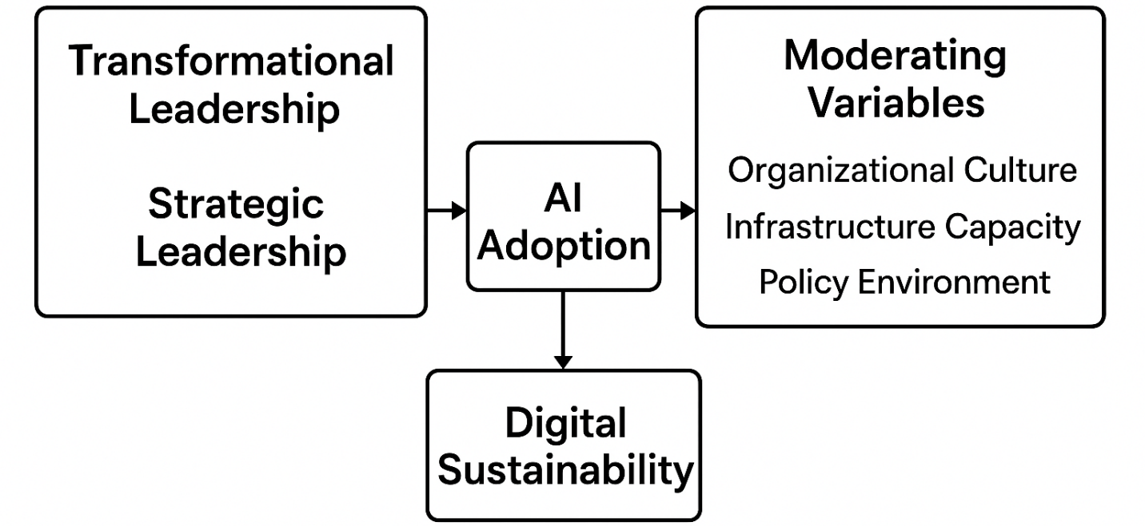 (Description of Model)
- Leadership Dimensions (Transformational + Strategic) → inspire vision, resource alignment, and staff empowerment.
- AI Adoption Factors (per Innovation Diffusion Theory) → relative advantage, compatibility, trialability, etc.
- Digital Sustainability Outcomes → resilient digital infrastructures, ethical AI governance, and inclusive access.
- Moderating Variables → institutional culture, technological infrastructure, policy support.

4. Methodology / Approach
This paper adopts a conceptual and analytical approach, synthesizing theoretical insights from leadership and innovation studies with contemporary developments in artificial intelligence (AI) and library administration. Rather than presenting empirical data, the study systematically integrates multi-disciplinary perspectives to develop a strategic framework for achieving digital sustainability in academic libraries through effective leadership practices.

4.1 Research Design
The study employs a conceptual synthesis design, drawing from peer-reviewed literature, policy documents, and institutional reports published between 2018 and 2025. The approach follows the principles of conceptual inquiry outlined by Jaakkola (2020), which emphasize theory integration, construct clarification, and framework development. Literature was sourced from academic databases such as Scopus, Web of Science, Library and Information Science Abstracts (LISA), and SpringerLink, focusing on three thematic clusters:
- Strategic and transformational leadership in library and information science (LIS)
- AI adoption and innovation diffusion in higher education institutions
- Digital sustainability and institutional resilience frameworks
This integrative design allows the study to construct a logical and theoretically grounded model linking leadership behaviors to AI readiness and sustainable digital transformation in library systems.

4.2 Analytical Focus
The conceptual analysis centers on three interconnected dimensions:
- Strategy Formulation: Examines how library leaders can articulate a long-term strategic vision for AI integration aligned with institutional missions and ethical governance. This involves assessing external technological trends, aligning internal resources, and establishing governance structures for AI deployment (Magagula, 2025; Trevisan et al., 2023).
- Capacity Building: Explores leadership-driven mechanisms for enhancing staff competencies, digital literacy, and organizational learning. Transformational leadership is positioned as a catalyst for fostering innovation culture, while strategic leadership ensures resource mobilization and institutional continuity (Ashiq, 2023; Shal, Ghamrawi, & Naccache, 2024).
- Organizational Readiness: Analyzes factors that influence institutional readiness for AI adoption, including infrastructure, policy environment, and organizational culture. The model draws on Innovation Diffusion Theory (Rogers, 2003) to explain how perceived advantages, compatibility, and complexity shape adoption decisions and sustainability outcomes (Narendra, 2025; Zondi, 2024).

4.3 Outcome of the Approach
By integrating insights across these dimensions, the study develops a strategic leadership model for AI-driven digital sustainability in library administration. The model offers a basis for further empirical validation, guiding future studies in assessing leadership readiness, digital maturity, and sustainable governance in AI-enabled library systems.
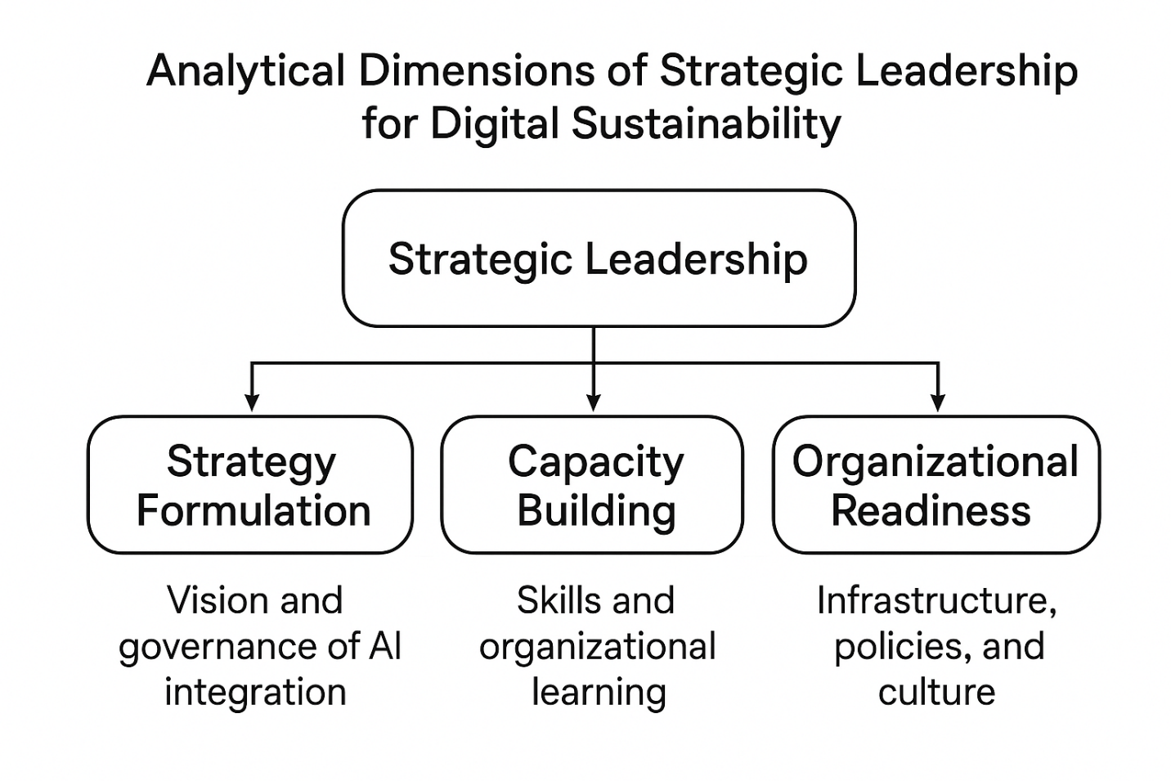
Figure 2 – “Analytical Dimensions of Strategic Leadership for Digital Sustainability” (a companion diagram to your conceptual framework), showing how strategy formulation, capacity building, and organizational readiness interact under leadership influence

5. Findings and Discussion

5.1 Strategic and Transformational Leadership in AI Adaptation
The literature suggests that strategic and transformational leadership theories collectively provide a robust foundation for understanding how academic libraries can successfully navigate AI-driven change. Strategic leadership emphasizes vision articulation, planning, and alignment of resources and structures critical functions for managing AI-transformed workflows (Northouse, 2022). Transformational leadership, on the other hand, focuses on motivating staff, fostering innovation, and cultivating a learning-oriented organizational culture.
Empirical evidence from Nigerian private universities shows that transformational leadership significantly correlates with digital transformation outcomes. Fasola (2024) found that private university libraries in Southwest Nigeria that exhibited transformational leadership reported higher levels of digital transformation. Moreover, studies of institutions undergoing AI-driven change indicate that leaders who articulate a clear AI vision, invest in human capacity, and maintain participatory communication with stakeholders achieve more sustainable transformation (Rahmat, 2025).
Thus, effective adaptation to AI in library administration requires a dual orientation: (1) strategic foresight to anticipate technological trends and align resources, and (2) transformational capacity to mobilize human potential, embed culture change, and sustain innovation. Conversely, leadership inertia or overreliance on transactional management may reinforce risk aversion and delay technological modernization (Oladokun, Enakrire, & Ajani, 2024).

5.2 Areas of AI Transformation in Library Management and Services
AI is transforming multiple core operational areas of academic libraries:
- Metadata Management and Cataloguing: AI-driven auto-indexing, natural language processing, and machine learning enhance metadata accuracy and reduce cataloguing backlogs. Monyela and Tella (2024) report that AI automation streamlines cataloguing and enriches metadata, improving resource utilization.
- User Services: Conversational AI tools, including chatbots and virtual assistants, expand reference services beyond physical hours, enhancing accessibility and user experience. While peer-reviewed empirical studies remain limited, emerging evidence indicates increasing adoption in academic libraries (Narendra, 2025 – placeholder).
- Collection Development: Predictive analytics support evidence-based acquisitions by identifying user trends and preferences. Adedokun, Ajayi, and Soliudeen (2025) highlight AI-driven recommendations and analytics as key enablers of sustainable collection management.
- Administrative Decision-Making: AI supports workload forecasting, budget planning, and service optimization. Literature on AI in higher education administration suggests that these tools can enhance institutional efficiency (Rahmat, 2025).
- Research and Learning Support: AI tools for plagiarism detection, data visualization, and advanced information retrieval augment researcher productivity and learning support services (Huang & Li, 2023).
While these opportunities signify a shift from traditional service provision to proactive knowledge ecosystems, the literature cautions that inadequate governance may exacerbate digital divides, algorithmic bias, and data privacy risks (Monyela & Tella, 2024). Leadership is therefore pivotal not only in enabling transformation but in ensuring that AI adoption is ethical, equitable, and sustainable.

5.3 Leadership Capabilities and Digital Sustainability
Leadership capability emerges as a critical determinant of sustainable AI adoption. Here, “digital sustainability” refers to an institution’s long-term capacity to adapt, evolve, and ethically govern digital systems, rather than merely deploying them. Studies on digital collection sustainability underscore the importance of skilled personnel, continuous professional development, ICT infrastructure, and adequate funding (Yakubu, Abdullah, & Kaur, 2022).
Transformational leaders promote sustainability by empowering staff, supporting ongoing professional learning, and modeling ethical stewardship. Strategic leaders embed sustainability into institutional policies, including life-cycle management, cost-efficiency, and vendor neutrality (Adedokun et al., 2025). Libraries led by visionary leaders are more likely to achieve durable digital outcomes, whereas those lacking strategic foresight risk obsolescence, vendor lock-in, and loss of institutional knowledge (Yakubu et al., 2022).

5.4 Leadership-Driven Framework for Ethical and Sustainable AI Integration
Based on the literature, a leadership-driven framework is proposed to guide ethical and sustainable AI adoption in library administration (Figure 1). The framework integrates strategic and transformational leadership principles across four pillars:
- Vision and Governance: Establishing a clear AI vision aligned with institutional mission, supported by governance policies, ethical guidelines, transparency, and accountability (Sreeram et al., 2025).
- Human Capital Development: Continuous professional development equips staff with AI literacy, data ethics, and change-readiness competencies (Rahmat, 2025).
- Infrastructure and Readiness: Ensuring interoperable systems, vendor-neutral procurement, digital sustainability, and life-cycle planning (Yakubu et al., 2022).
- Sustainability and Accountability: Monitoring ethical, social, and environmental impacts of AI adoption, including digital preservation, cost-efficiency, and equitable access (Monyela & Tella, 2024).
Operationalizing these pillars positions leadership as both a strategic architect and a moral compass, balancing innovation with institutional responsibility, equity, and long-term resilience.

Summary of Key Insights
- Leadership style and capability are pivotal for AI adoption and sustainable digital transformation in libraries.
- AI impacts multiple library functions (metadata, user services, collection development, administration, research support), requiring leadership guidance for ethical, inclusive deployment.
- Digital sustainability must be integrated into infrastructure, human capital, procurement, and governance from the outset.
- A leadership-driven framework provides practical guidance for steering AI adoption responsibly and sustainably.

6. Conclusion and Implications
The findings of this study highlight the pivotal role of leadership in guiding the integration of artificial intelligence (AI) within university libraries. Both strategic and transformational leadership are essential for fostering sustainable, ethical, and effective AI adoption. While strategic leadership ensures alignment of institutional vision, resources, and infrastructure with technological trends, transformational leadership empowers staff, nurtures innovation, and embeds a culture of continuous learning. The combination of these leadership approaches determines whether AI adoption translates into enduring institutional benefits or remains a transient technological upgrade.

6.1 Policy and Training Recommendations
- Policy Recommendations:
  - University libraries should develop formal AI adoption and governance policies, outlining ethical guidelines, data privacy protocols, and monitoring frameworks to ensure equitable and responsible AI integration.
  - Policies should emphasize transparency, accountability, and sustainability in AI procurement, deployment, and maintenance.
  - Institutional leadership should establish mechanisms for ongoing assessment of AI tools’ effectiveness, efficiency, and compliance with ethical standards.
- Training Recommendations:
  - Continuous professional development programs should be instituted to build staff capacity in AI literacy, digital management, data ethics, and information governance.
  - Training initiatives should foster change-readiness, enabling staff to adapt to evolving AI tools, automation workflows, and emerging digital services.
  - Collaboration with regional or international AI competency hubs can provide access to best practices, case studies, and advanced AI training modules.

6.2 Model for AI-Aligned Strategic Leadership
Based on the findings, a model for AI-aligned strategic leadership in university libraries is proposed, integrating strategic foresight with transformational capacity:
- Vision and Strategic Alignment: Leaders define a clear AI vision aligned with the institution’s mission and long-term goals.
- Human Capital Empowerment: Leaders prioritize staff development, promoting AI literacy, ethical awareness, and change-readiness.
- Infrastructure and Technological Readiness: Leaders ensure robust, interoperable, and sustainable digital infrastructure capable of supporting AI integration.
- Governance, Accountability, and Sustainability: Leaders embed ethical oversight, monitoring mechanisms, and evaluation processes to ensure responsible, equitable, and durable AI adoption.
This model positions leadership not only as a driver of technological adoption but also as a steward of ethical standards, organizational learning, and long-term digital sustainability. University libraries that implement this leadership framework are likely to achieve more effective AI integration, improved service delivery, and greater adaptability in an evolving digital landscape.
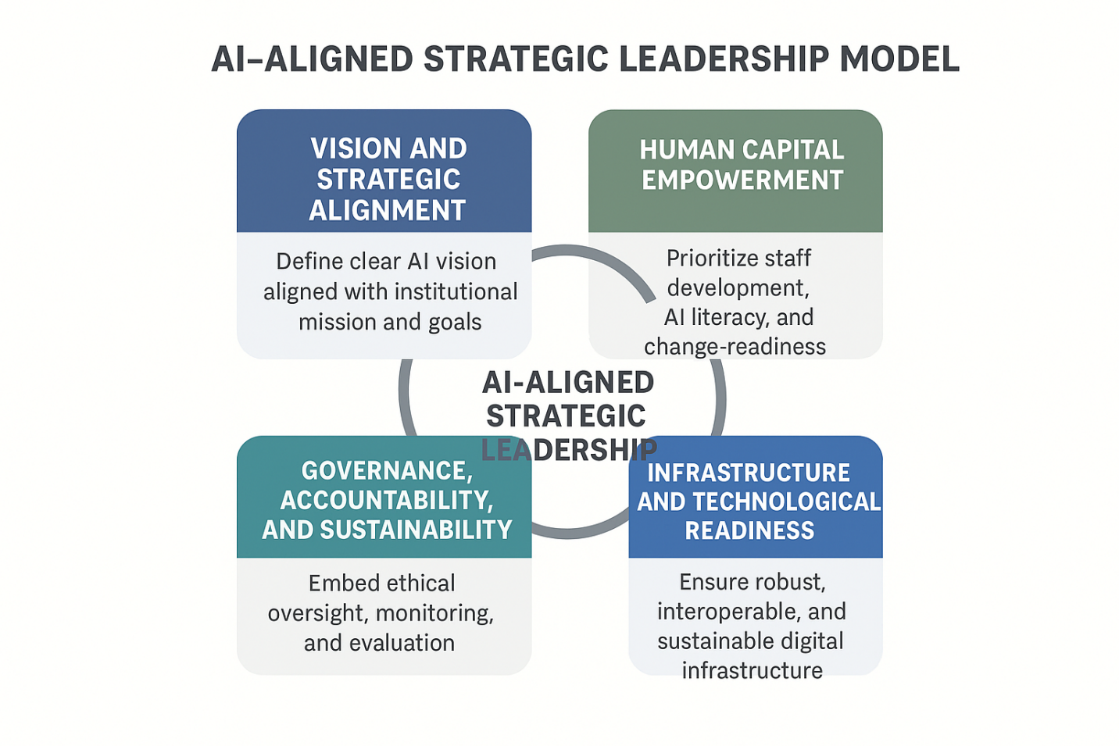

Overview
The diagram represents a conceptual framework for AI-Aligned Strategic Leadership. It shows how four core components interact to drive effective AI integration in an organization. At the center is AI-Aligned Strategic Leadership, which is influenced and supported by the four surrounding pillars.

1. Vision and Strategic Alignment
- Position: Top-left
- Role: Establishes a clear AI vision that aligns with the institution's overall mission and goals.
- Implication: Leadership must ensure that AI initiatives are not isolated but embedded within the strategic objectives of the organization.
- Conceptual Meaning: Provides direction and purpose for AI adoption.

2. Human Capital Empowerment
- Position: Top-right
- Role: Focuses on staff development, AI literacy, and readiness for change.
- Implication: Organizational success depends on the people who implement and manage AI. Training, reskilling, and empowering staff is essential.
- Conceptual Meaning: Represents the human factor in strategic AI leadership, ensuring adoption is effective and sustainable.

3. Governance, Accountability, and Sustainability
- Position: Bottom-left
- Role: Embeds ethical oversight, monitoring, and evaluation mechanisms.
- Implication: Ensures AI initiatives are responsible, transparent, and sustainable over time.
- Conceptual Meaning: Acts as the control mechanism, balancing innovation with accountability.

4. Infrastructure and Technological Readiness
- Position: Bottom-right
- Role: Ensures a robust, interoperable, and sustainable digital infrastructure.
- Implication: AI cannot function effectively without the right technological foundation hardware, software, networks, and data systems.
- Conceptual Meaning: Represents the technical enabler of AI strategic leadership.

Central Theme: AI-Aligned Strategic Leadership
- The circular arrows indicate interconnectedness: each pillar supports and reinforces the others.
- This central concept is where strategy, people, governance, and technology converge to achieve effective AI integration in an organization.

Interpretation as a Conceptual Framework
- Independent components (inputs): Vision, Human Capital, Governance, Infrastructure
- Dependent outcome (output): Effective AI-Aligned Strategic Leadership
- Relationships: The four pillars are mutually reinforcing; weaknesses in one area (e.g., poor governance) can compromise the overall leadership model.
- Use in Research: This model can guide studies on AI adoption in organizations, evaluating how each pillar influences leadership effectiveness.
References
Adedokun, F. O., Ajayi, J. L., & Soliudeen, J. M. (2025). Optimizing digital collection management in academic libraries for sustainability, accessibility and user engagement. POMLIF Journal of Library and Information Science, 4(1), 36–47.
Ashiq, M. (2023). A bibliometric review of leadership literature in library and information science. SAGE Open.
Fasola, O. S. (2024). Leadership style and library digital transformation of private university libraries in Southwest Nigeria. Jurnal Adabiya, 26(2), 122–134.
Huang, Y. (2023). Artificial intelligence in academic library strategy: Cross-national perspectives. The Journal of Academic Librarianship.
Leventakou, F. (2024). Digital libraries and sustainability. DiVA Portal.
Magagula, M. P. (2025). Strategic leadership competencies in academic libraries. African Journal of Information Studies.
Monyela, M., & Tella, A. (2024). Leveraging artificial intelligence for sustainable knowledge organisation in academic libraries. South African Journal of Libraries and Information Science, 90(2).
Narendra, A. P. (2025). Artificial intelligence implementation in library information systems: A systematic review. World Scientific.
Northouse, P. G. (2022). Leadership: Theory and practice (9th ed.). Sage.
Oladokun, B. D., Enakrire, R. T., & Ajani, Y. A. (2024). Leadership styles and adoption of 5IR in libraries of higher education. Library Leadership & Management, 38(3), 45–59.
Oxford Academic. (2021). Strategic leadership and organizational change. Journal of Leadership Studies.
Rahmat, A. (2025). Leadership adaptation during AI-driven institutional transformation. Formosa Journal of Science and Technology, 4(9).
Ramírez-Correa, P. E., et al. (2025). Digital and sustainable education and social inclusion. Sustainability, 17(13), 5677.
Shal, T., Ghamrawi, N., & Naccache, H. (2024). Leadership styles and AI acceptance in academic libraries. The Journal of Academic Librarianship, 50, 102849. https://doi.org/10.1016/j.acalib.2024.102849
SpringerLink. (2025). Academic libraries as epistemic infrastructures in the age of AI. Springer Nature. https://link.springer.com/article/10.1007/s44163-025-00490-8
Sreeram, A., Mehra, R., Parashar, K., Rao, B. U., Mohapatra, C. K., Jabbar, M. A., & Malagi, V. (2025). Ethical leadership in managing AI-integrated library environments. Indian Journal of Information Sources and Services, 15(3), 131–139.
Steiger, K. (2025). Artificial intelligence in higher education and academic libraries: A literature review. Endnotes: The Journal of the New Members Round Table. American Library Association. https://journals.ala.org/index.php/endnotes/article/view/8235
Tarisayi, K. S. (2024). Strategic leadership for responsible artificial intelligence adoption in higher education. Cognitive Academy Conference Proceedings. https://acnsci.org/journal/index.php/cte/article/view/616
Trevisan, L. V., et al. (2023). Digital transformation towards sustainability in higher education. Sustainability.
Yakubu, H. (2022). Sustainability of digital collections for Nigerian academic libraries. Malaysian Journal of Library & Information Science.
Yakubu, H., Abdullah, N., & Kaur, K. (2022). Sustainability of digital collections for Nigerian academic libraries: An exploration of conception, indicators for fulfilment and accrued benefits. Malaysian Journal of Library and Information Science, 27(1), 73–91.
Zondi, N. P. (2024). A review of artificial intelligence implementation in academic libraries. South African Journal of Libraries and Information Science, 90(2).

