NIGERIAN JOURNAL OF TECHNOLOGICAL RESEARCH
Federal University of Technology Minna

Vice Chancellor Editor-in-Chief
Prof. Faruk Adamu Kuta
B. Sc (UDUS) M. Tech (FUT Minna) PhD (ATBU) Prof. O. Morenikeji Ph. D

Registrar Email: jtr@futminna.edu.ng
Mallam Danladi Mallam

10th March 2026
Dear Isiaq Oludare ALABI¹, Stela Abiola ETUK², Yahaya Mohammed SANI³, Sulaiman AHMAD⁴ and Abdulazeez T. HASSAN⁵

Acceptance of Your Manuscript for Publication in NJTR Journal
I am pleased to inform you that your manuscript “Smart Attendance System Using Multi-Classifier Face Recognition” has been accepted for publication in the Nigerian Journal of Technological Research (NJTR).

After a rigorous peer-review process, we appreciate the quality of your work and its relevance. Your manuscript has been evaluated by expert reviewers, and based on their constructive feedback and your revisions, we are happy to accept it for publication.
Please sign and return the attached publication agreement form.
Your article will be published in an upcoming issue of NJTR Volume 20, No 1, 2025 December.
Thank you for contributing to NJTR. We look forward to publishing your work and sharing it with our readers.

Best regards,
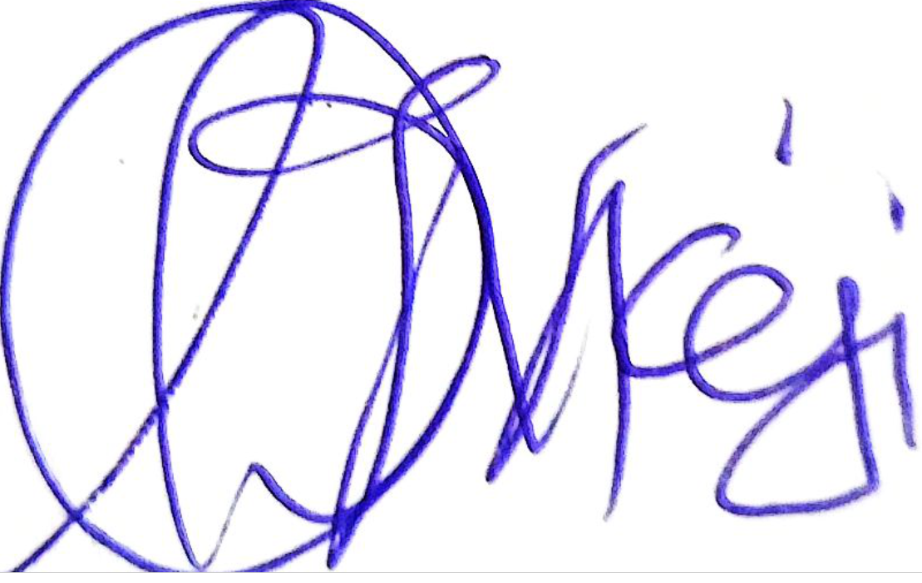
Prof. Morenikeji O. Oluwole
Editor-in-Chief

NJTR Journal Publication Agreement Form
Manuscript Title: ____________________________________________________
Author(s): ______________________________________________________

I/We, the undersigned, hereby declare that:

1. The manuscript is original, unpublished, and not under consideration elsewhere.
2. I/We grant the Nigerian Journal of Technological Research (NJTR) a non-exclusive license to publish the manuscript under the Creative Commons Attribution 4.0 International License (CC BY 4.0).
3. The manuscript will be published Open Access, free of charge, and available for anyone to read, download, and share.
4. I/We warrant that the manuscript does not infringe on any copyright or other proprietary right.
5. I/We affirm that no AI tool has been used to generate substantial portions of the manuscript's content, and that any AI-assisted editing has been clearly indicated.
6. I/We agree to comply with NJTR's publication policies and formatting guidelines.

Author Signature(s):
____________________________________________________
Date: ____________________________________________________

Co-Author(s) Signature(s) (if applicable):
____________________________________________________
Date: ____________________________________________________

Return to:
Editor-in-Chief, NJTR
njtr@futminna.edu.ng

