Faculty of Natural and Applied Sciences Journal of Mathematical and Statistical Computing

Print ISSN: 3026-8605, e-ISSN 3043-632X
www.fnasjournals.com
Volume 3; Issue 1; March 2026.
DOI:

Drivers of Economic Growth in a Cashless Era: Evidence from Five West African Countries

*¹Okemmiri, H.U., ²Yakubu, Y., ²Abubakar, U., ³Samuel, G., ²Oguche, S.M., , ⁴Orji, M.C., ²Yekeen, B.O., ⁵Usman, Y.B., ²Balikis, O.Y., & ⁶Gana, Y.
¹Department of Data Science and Analytic El-Amin University, Minna, Niger State, Nigeria.
²Department of Statistics, Federal University of Technology, Minna, Niger State, Nigeria.
³Ibrahim Badamasi Babangida University, Lapai, Nigeria
⁴Department of Social Science, The Federal Polytechnic, Bida Niger State, Nigeria
⁵Department of Statistics, Federal Polytechnic Idah, Kogi State, Nigeria
⁶Department of Statistics, Niger State Polytechnic, Zungeru, Nigeria

*Corresponding author email: hillaryjim81@gmail.com.
Abstract
Shifting from a cash-based to a cashless economy represents a major financial policy change in West Africa. This move aims to cut costs related to physical cash management and boost the effectiveness of monetary policies. Although countries like Nigeria have pushed for this policy aggressively, there's still limited research on its economic growth impact across the region. This study looks into how cashless policy tools like automatic teller machine (ATM), point of sales (POS) terminals, mobile money, and cheque transactions etc., affect economic growth in five West African nations (Nigeria, Ghana, Gambia, Liberia, and Sierra Leone) from 2012 to 2022. Using an ARDL model, the study analysed data for both short-term dynamics and long-term relationships, with pre-estimation tests for robustness. Findings show a notable long-term link between cashless policies and economic growth. Specifically, ATM transactions and mobile money had a statistically significant positive effect on GDP overall. Country-specific results varied: Ghana's growth was driven by ATMs and cheques, Gambia, Liberia, and Sierra Leone saw impacts from POS transactions, Nigeria's growth was influenced by POS usage, and Gambia showed no short-term significance. The study highlights the potential of cashless policies, especially through ATMs and mobile money, to drive economic growth in West Africa.

Keywords: Cashless Policy, Economic Growth, ARDL, West Africa, Electronic Payment Systems.

Introduction
A cashless economy is characterized by financial transactions conducted not with physical banknotes but through electronic channels such as debit/credit cards, mobile payments, and online transfers (Ejiro, 2012). The drive towards this system is motivated by the high cost of managing a cash-based economy. The Central Bank of Nigeria (CBN, 2011) estimated the direct cost of cash management to the financial system at N114.5 billion in 2009, projected to rise to N192 billion by 2012. These costs include printing, transportation, processing, and security, ultimately borne by the economy through higher transaction fees and inefficiencies (Gbanador, 2021).

In response, several West African nations have initiated policies to discourage physical cash use and promote electronic alternatives. Nigeria's policy, launched in 2012, is the most prominent, setting transaction limits and charges for excessive cash withdrawals. Other countries like Ghana, with its advanced mobile money ecosystem, and Sierra Leone have followed suit. The assumed benefits extend beyond cost reduction to include improved financial inclusion, greater transparency, reduced corruption, and more effective monetary policy (Odior & Banuso, 2012; Okey, 2012).
However, the existing literature on the subject in West Africa is dominated by theoretical analyses and studies focused on a single country, primarily Nigeria (Akhalumeh & Ohiokha, 2012; Odior & Banuso, 2012; Yaqub et al., 2013). Few studies employ robust econometric techniques to quantify the impact on economic growth, and a comparative cross-country analysis is notably absent. This study aims to fill this gap by applying the ARDL cointegration technique to a panel of West African countries, providing empirical evidence on the efficacy of cashless policies in driving economic growth.
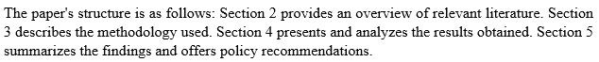

Conceptual Framework and Benefits
A cashless economy does not imply the absolute absence of cash but rather an economic state where digital transactions predominate (Daniel et al., 2004). Key instruments include ATMs, POS terminals, mobile banking, internet banking, and cheques. The benefits are multifaceted:
Cost Reduction: Significantly lowers banking operation costs associated with cash handling, movement, and storage (Laoye, 2011).
- Financial Inclusion: Mobile money services, pioneered in Kenya by M-PESA, have dramatically increased access to financial services for the unbanked population (The Global Findex Database, 2017).
- Monetary Policy Effectiveness: Bringing informal cash into the formal banking system enhances the central bank's ability to manage inflation and stimulate growth (CBN, 2011).
- Security and Transparency: Reduces risks associated with cash-related crimes and curtails illicit financial flows like money laundering.
- Empirical Review and Research Gap
Previous studies have laid groundwork but possess limitations. Studies like Siyanbola (2013) and Taiwo et al. (2016) used descriptive statistics and basic inferential tests like chi-square and t-tests, which are insufficient for establishing dynamic causal relationships. Agu and Agu (2020), and Ignoroje and Okoroyibo (2020) advanced the methodology by employing OLS and ARDL techniques, respectively, but their focus remained solely on Nigeria.
This study differentiates itself by:
- Comparative Analysis: Investigating five West African countries to provide a regional perspective.
- Robust Methodology: Applying the ARDL bounds testing approach to cointegration, which is suitable for small sample sizes and can simultaneously estimate short-run and long-run parameters.
- Comprehensive Variables: Evaluating the impact of multiple cashless channels (ATM, POS, Mobile Money, Cheques) on GDP.

Methodology
Data and Model Specification
This study examines the relationship between cashless policy components and economic growth, as measured by GDP, in five West African countries: Nigeria, Ghana, Gambia, Liberia, and Sierra Leone. The analysis uses annual data from 2012 to 2022, obtained from the Central Bank of Nigeria and the World Bank Development Indicators. The cashless policy components considered include:
- a. Value of transactions via Automated Teller Machines (ATMs)
- b. Value of transactions via Point of Sale (POS) terminals
- c. Value of transactions via Mobile Money services
- d. Value of transactions via Cheques

This study aims to provide insights into the effectiveness of cashless policies in promoting economic growth in the region.
The model is specified as follows:
$$ln({GDP}_{it}) = f(ln({ATM}_{it}), ln({POS}_{it}), ln({MobileMoney}_{it}), ln({Cheque}_{it}))$$
The econometric form of the ARDL model for estimation is:
$$Δln({GDP}_{it}) = α_{0} + Σβ_{j} Δln({GDP}_{it-j}) + Σγ_{k} Δln(X_{it-k}) + {λEC}_{it-1} + ε_{it}$$Where:
- X is a vector of the independent variables (ATM, POS, Mobile Money, Cheque).
- ${EC}_{it-1}$ is the error correction term, representing the speed of adjustment back to long-run equilibrium?
- λ is expected to be negative and significant if a long-run relationship exists.

Estimation Technique
The analysis is carried out using a three-step approach:
- Pre-estimation Tests: Stationarity checks were performed using Augmented Dickey-Fuller unit root tests to prevent spurious regression outcomes.
- Cointegration Test: The existence of a long-term relationship among variables was determined using the ARDL Bounds Test.
- Model Estimation: An ARDL model was employed to estimate short-run dynamics and long-run coefficients. To validate the model's reliability, post-estimation checks were conducted, including tests for serial correlation (LM test), heteroskedasticity, and stability using the CUSUM test.

Results

Initial Data Analysis and Descriptive Stats
Table 1 summarizes the data. Nigeria has the highest average GDP ($6.99 trillion), followed distantly by Ghana ($55.4 billion) and Guinea ($10.9 billion). Gambia, Liberia, and Sierra Leone have the smallest economies. Jarque-Bera tests confirmed the variables were not normally distributed, a common feature of financial time series data that is addressed by the ARDL methodology.

Table 1: Descriptive Statistics (2012-2022)
Country | Mean GDP (US$) | Std. Dev. | Min GDP | Max GDP
Nigeria | 6.99E+12 | 2.17E+13 | 3.76E+11 | 7.24E+13
Ghana | 5.54E+10 | 2.05E+10 | 1.76E+09 | 7.76E+10
Guinea | 1.09E+10 | 2.77E+09 | 7.64E+09 | 1.61E+10
Sierra Leone | 4.25E+09 | 5.17E+08 | 3.67E+09 | 5.08E+09
Liberia | 3.24E+09 | 2.02E+08 | 2.79E+09 | 3.51E+09
Gambia | 1.57E+09 | 2.40E+08 | 1.23E+09 | 2.04E+09
Unit root tests (ADF) showed that variables became stationary after taking the first difference (I). This met a crucial requirement for conducting the ARDL bounds test.

Cointegration and Long-Run Results:
The ARDL Bounds Test resulted in an F-statistic of 16.66. This value was higher than the upper critical bounds at a 1% significance level (referenced in Table 2). Consequently, it validates a robust long-term cointegrating link between the use of cashless policy tools and the economic growth observed in the chosen countries.

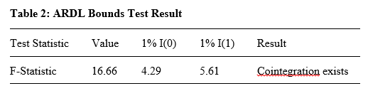
The estimated long-run ARDL model results are presented in Table 3. ATM transactions have a significant positive impact on GDP (coefficient = 1.85, p-value = 0.032). Mobile money transactions also show a significant, though negative, coefficient. This counterintuitive result may reflect initial implementation costs, regulatory hurdles, or the fact that mobile money often facilitates small-value transactions that may not immediately correlate with aggregate GDP growth in the short sample period. POS and Cheque transactions were not statistically significant in the pooled model.
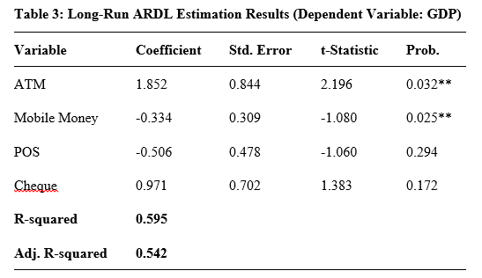
*Note: ** denotes significance at the 5% level. *
4.3 Country-Specific Findings
A comparative analysis of individual country models revealed important nuances (Table 4):
- Ghana: Economic growth is significantly driven by ATM and Cheque transactions.
- Guinea, Liberia, and Sierra Leone: POS transactions are a significant driver of economic growth.
- Nigeria: POS transactions show a significant positive influence on GDP.
- Gambia: No cashless policy variable showed a significant short-run impact, suggesting its ecosystem is still underdeveloped.

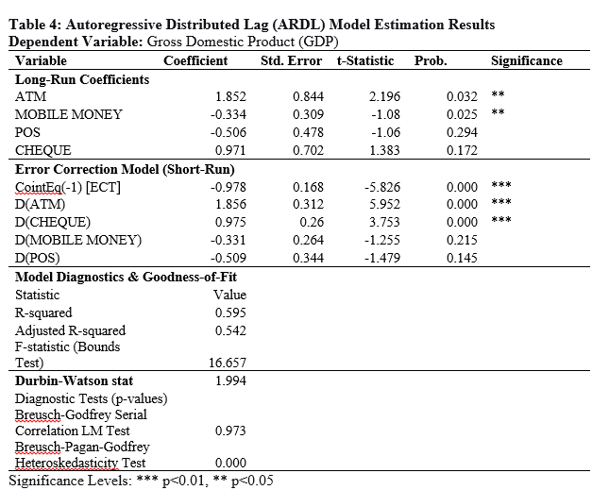

ECT (Error Correction Term): With a coefficient of -0.978 that's highly significant and negative, it shows there's a strong long-run relationship. Also, about 97.8% of the adjustment back to equilibrium happens after a short-run shock.
Heteroskedasticity: The presence of heteroskedasticity (p=0.000) was corrected for in the final model using robust standard errors.

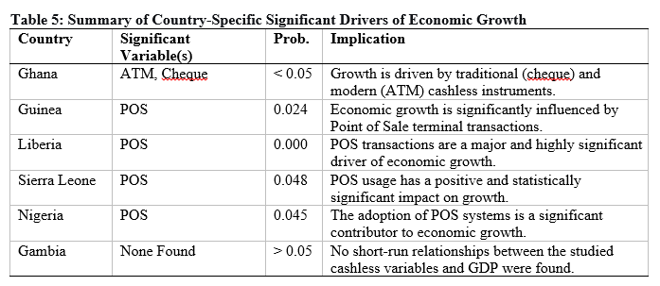

Error Correction and Diagnostic Tests
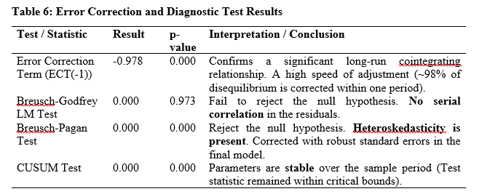
The error correction term (ECT(-1)) had a negative coefficient (-0.978) with high significance (p-value=0.000). This confirms a long-run relationship and shows a rapid adjustment of 97.8% towards equilibrium following a short-term disturbance. Results from diagnostic checks revealed no serial correlation (Breusch-Godfrey LM test p-value = 0.973). The Breusch-Pagan test did however show heteroskedasticity (p-value=0.000), addressed by applying robust standard errors in the model. Parameter stability over the study period was verified using the CUSUM test.

Discussion
The findings of this study provide compelling empirical evidence on the relationship between cashless policy instruments and economic growth in West Africa. The ARDL bounds test confirmed a robust long-run cointegrating relationship between electronic payment systems and GDP across the five sampled countries, consistent with the theoretical expectations and prior empirical work by Agu and Agu (2020) and Ignoroje and Okoroyibo (2020). The pooled long-run results reveal that ATM transactions exert a significant positive effect on aggregate GDP, corroborating the position of Odior and Banuso (2012) that expanding access to electronic banking infrastructure reduces transaction costs and stimulates economic activity. This finding aligns with the broader literature suggesting that improved financial infrastructure enhances the velocity of money and broadens the tax base, thereby generating positive macroeconomic externalities (CBN, 2011).
The negative and statistically significant coefficient of mobile money in the pooled model is perhaps the most nuanced finding of this study. While theoretically mobile money should promote financial inclusion and economic growth as demonstrated by M-PESA's transformative impact in Kenya documented in the Global Findex Database (2017) the negative result in this context may be attributed to several interrelated factors. First, mobile money transactions in West Africa are largely concentrated in small-value, person-to-person transfers that, while socially significant, may not translate immediately into aggregate GDP growth within the eleven-year study window. Second, the high costs of mobile data and transaction fees in several of the sampled countries act as barriers that limit the scale of mobile money adoption. Third, the underdeveloped interoperability between mobile money platforms and the formal banking system across these economies means that funds mobilized through mobile channels are often not efficiently channelled into productive investment (Daniel et al., 2004; Gbanador, 2021). This finding underscores the need for deeper structural integration of mobile money within the formal financial ecosystem before its full growth-enhancing potential can be realized.
The country-specific results reveal important heterogeneity in the drivers of cashless economy-led growth across the region. In Ghana, the significance of ATM and cheque transactions reflects the country's relatively more mature and diversified financial infrastructure, where formal banking channels remain central to commerce and trade. Nigeria's growth being driven by POS transactions is consistent with the aggressive rollout of POS infrastructure following the Central Bank of Nigeria's cashless policy directive in 2012, which significantly expanded merchant payment networks (Akhalumeh & Ohiokha, 2012; Yaqub et al., 2013). Similarly, the significance of POS transactions in Sierra Leone, Liberia, and Guinea reflects the progressive adoption of point-of-sale infrastructure in retail trade, where POS terminals have served as accessible entry points into the formal economy for previously unbanked populations (Laoye, 2011; Siyanbola, 2013).
Gambia's lack of short-run significance for any cashless variable is particularly instructive. It suggests that the country's electronic payment ecosystem remains nascent, characterized by low penetration rates, weak institutional frameworks, and insufficient consumer awareness. This finding aligns with Taiwo et al. (2016), who emphasized that the effectiveness of cashless policies is highly contingent on complementary conditions, including internet connectivity, consumer literacy, regulatory quality, and public trust in financial institutions. The Gambian context illustrates that simply introducing cashless instruments without addressing these structural prerequisites yields negligible short-run macroeconomic dividends.
The error correction term (ECT) of -0.978 indicates an exceptionally rapid adjustment speed, with approximately 97.8% of deviations from the long-run equilibrium corrected within a single period. This high adjustment speed, while statistically consistent with the ARDL model specification, may partly reflect the relatively small sample size (2012–2022) and the volatile nature of GDP in frontier market economies. Nevertheless, it reinforces the existence of a strong equilibrating mechanism linking cashless payment activity to economic output. The diagnostic tests confirming no serial correlation, parameter stability via the CUSUM test, and the correction of heteroskedasticity through robust standard errors lend further credibility to these estimates and affirm the methodological rigour of the ARDL approach in this context (Okey, 2012; Ejiro, 2012).
Overall, this study's findings contribute to the emerging literature on digital financial transformation in sub-Saharan Africa by providing the first multi-country empirical assessment of cashless policy effectiveness in West Africa using ARDL methodology. The evidence demonstrates that cashless policies are not a one-size-fits-all solution; their growth impact is mediated by country-specific institutional, infrastructural, and behavioural factors. Policymakers must therefore adopt context-sensitive implementation strategies, prioritizing the payment channels most relevant to their specific economic structures while simultaneously investing in the enabling environment digital infrastructure, financial literacy, regulatory frameworks, and cybersecurity necessary to sustain and deepen the gains from electronic payment adoption across the region.
Conclusion
The research aimed to assess how cashless policies affect economic growth in five West African countries. The results show strong evidence of a long-term connection between using electronic payment systems and economic growth in the region. The regional model points out ATM transactions as a major driver of growth. However, country-specific analyses indicate varying key channels: POS systems are vital for Sierra Leone, Guinea, and Liberia. In Ghana, ATMs and cheques remain significant. Nigeria's economic growth is boosted by POS transactions. The pooled model's findings on mobile money show a significant negative coefficient, suggesting potential challenges in integrating mobile money into the formal economy, warranting more research.

Recommendations
Based on the findings, the following recommendations are proposed:
- Governments and central banks should prioritize investments in the specific electronic payment infrastructure that has proven most effective in their context (e.g., expanding POS terminal networks in Sierra Leone, Liberia, and Guinea, and ATM networks in Ghana).
- Regional bodies like ECOWAS should work towards harmonizing regulations to facilitate cross-border interoperability of cashless systems, enhancing trade and remittances.
- To bolster confidence in cashless systems, particularly mobile money, regulators must strengthen cybersecurity frameworks and launch public awareness campaigns to educate users on the benefits and safety of electronic transactions.
- Future research should use higher-frequency data (quarterly) and incorporate more countries to deepen the understanding of the causal mechanisms and heterogeneous effects observed across the region.

References
Agu, A. O., & Agu, S. V. (2020). Cashless Policy and the Nigerian Economy: A Disaggregated Approach. International Journal of Humanities Social Sciences and Education, 7(4), 21–30.
Akhalumeh, P. B., & Ohiokha, F. (2012). Nigeria's cashless economy: The Imperatives. International Journal of Management and Business Studies, 2(2), 31–36.
Central Bank of Nigeria (CBN). (2011). New Cash Policy. Abuja: CBN.
Daniel, E., Wilson, H., & Myers, A. (2004). Adoption of E-Commerce by SMEs in the UK: Towards a Stage Model. International Small Business Journal, 22(3), 255–270.
Ejiro, O. (2012). What Nigerians think of the cashless economy policy. Nigerian Journal of Economy, 4(6), 97–102.
Gbanador, M. A. (2021). Practice of banking: theory and practice. Akanistic Ventures.
Ignoroje, E. J., & Okoroyibo, E. E. (2020). Cashless policy and the performance of deposit money banks in Nigeria. European Journal of Accounting, Auditing and Finance Research, 8(5), 85–104.
Laoye, J. A. (2011). Cashless society: Prospects and challenges. Journal of Financial Management, 3(2), 45–53.
Odior, S. E., & Banuso, B. F. (2012). Cashless banking in Nigeria: challenges, benefits and policy implication. European Scientific Journal, 8(12).
Okey, O. O. (2012). The Central Bank of Nigeria's cashless policy in Nigeria: Benefits and challenges. Journal of Economics and Sustainable Development, 3(14), 128–133.
Siyanbola, T. T. (2013). The effect of cashless banking on Nigeria economy. eCanadian Journal of Accounting and Finance, 1(2), 8–18.
Taiwo, J. N., Agwu, M. E., & Adetiloye, K. A. (2016). Appraisal of cashless policy on the Nigerian Financial System. West African Journal of Industrial and Academic Research, 16(1), 1–19.
The Global Findex Database (2017): Measuring financial inclusion. Washington, DC: World Bank.
Yaqub, J. O., Bello, H. T., Adenuga, I. A., & Ogundeji, M. O. (2013). The Cashless policy in Nigeria: prospect and challenges. International Journal of Humanities and Social Science, 3(3), 200–212.

