EFFECTS OF METHANOL SEED EXTRACT OF ACACIA NILOTICA ON INDOMETHACIN-INDUCED ULCER IN WISTAR RATS

Nwamaka Maureen Odu^{1,2}, Saudat Bisola Bello¹ and Mary Uchenna Ogunsanya¹

¹Federal University of Technology, Minna, Nigeria.
²Africa Centre for Excellence for Mycotoxin and Food Safety, Federal University of Technology, Minna, Nigeria

Ulcers are acid-induced lesions that develop on the mucous membrane and duodenum, often accompanied by inflammation, leading to abdominal pain, bleeding and perforation. Current treatments strategies for ulcers have limitations, including side effects, antibiotic resistance, and recurrence. Therefore, there is a need for alternative therapeutic agents with minimal side effects. Traditionally, medicinal plants which include Acacia nilotica, have been used for centuries to treat wide range of ailments including ulcer. The aim of this study was to authenticate this claim by investigating the effects of Acacia nilotica seed extract on indomethacin induced ulcer in Wistar rats. The phytochemical composition of Acacia nilotica, total acidity, pH, gastric volume and histopathological examinations were determined using standard methods. Six groups (three per group) of rats were induced with ulcer and treated with a standard drug and different concentrations of Acacia nilotica seed extract. Thereafter, the body weight of the animals were observed for a period of 21 days and then, sacrificed. The result showed the presence of bioactive compounds such as alkaloids, flavonoids, phenols, saponins and tannins with phenols having highest concentration (274.73±0.22 mg/100 g) while alkaloids had the lowest concentration (13.20±0.15 mg/100 g). The results also showed a significant (p < 0.05) increase in body weight in groups treated with Acacia nilotica seed extract when compared to the untreated group. Again, Acacia nilotica seed extract, particularly at the 400mg/kg body weight dose showed significant (p < 0.05) differences in the antiulcerative effects, with total acidity (64.07±1.08 meq/L)), pH (2.94±0.16), gastric volume (7.40±0.47 ml) and mild gastric mucosal damage as compared to the untreated group; indicating significant protection. The results demonstrate the potential of Acacia nilotica extract as the natural source of antiulcer and this suggests that the plant could have relevance in the management of ulcer disorders.
Keywords: Ulcer, Acacia nilotica, Phytochemicals.
Introduction
Gastric ulcers are a significant gastrointestinal disorder affecting millions of people worldwide, with a prevalence of approximately 4.5 million cases annually (Laine et al., 2018). Nonsteroidal anti-inflammatory drugs (NSAIDs), such as indomethacin, are commonly used to manage pain and inflammation but are known to induce gastrointestinal toxicity, leading to peptic ulcers (Wallace, 2018).
The pathophysiology of NSAID-induced ulcers involves the inhibition of cyclooxygenase (COX) enzymes, leading to a decrease in prostaglandin synthesis, which protects the gastric mucosa (Kumar et al., 2020). This results in increased gastric acid secretion, reduced mucus production, and impaired blood flow to the gastric mucosa, ultimately leading to ulcer formation (Bhaskar et al., 2018).
Treatments for ulcers include antacids, histamine-2 receptor antagonists, and proton pump inhibitors (PPIs) (Lopez-Garcia et al., 2020). However, these treatments have limitations, including side effects and the development of antibiotic resistance (Adebayo et al., 2022); and this necessitate need for alternative therapeutic agents with minimal side effects.
Traditional medicine has utilized various plant extracts for their medicinal properties, including wound healing and anti-inflammatory effects. Medicinal plants have been used for centuries to treat various ailments, including gastrointestinal disorders (Kumar et al., 2020). Acacia nilotica seeds are rich in bioactive compounds such as phenols, flavonoids, and saponins have been traditionally used in folk medicine for their anti-inflammatory and antioxidant properties (Oyedemi et al., 2020). Studies have demonstrated the potential of Acacia nilotica seed extract in mitigating oxidative stress and inflammation (Adebayo et al., 2022). Previous studies have investigated the effects of various plant extracts on indomethacin-induced ulcers in animal models (Kumar et al., 2020). However, there is limited research on the specific effects of Acacia nilotica seed extract on indomethacin-induced ulcers in Wistar rats. This study will pave the way for further research on the pharmacological effects of Acacia nilotica seed extract.
MATERIALS AND METHODS

All chemicals used in this study were acquired from Sigma Aldrich, Germany.
Plant collection and identification
The fresh pods of Acacia nilotica was collected from Gunu area in Minna, Shiroro Local Government of Niger state, Nigeria and identified in Department of Biological Sciences, Federal University of Technology, Minna, Niger state.
Experimental Animals
Thirty (30) Wistar rats of both sexes were obtained from Murine Top Farms, Minna, Niger State and kept at the Department of Biochemistry Animal House, Federal University of Technology, Minna. The animals were allowed to acclimatized to the environment two weeks prior to the commencement of the experiment under Institutional Standard Laboratory Conditions peculiar for the use of experimental animals with free access to water and feed.
Phytochemical analysis
Standard qualitative test (Trease and Evans, 2008) was carried out for the detection of alkaloids, phenols, flavonoids, tannins, and saponins.
Acute Toxicity Test of Methanol Extract of Acacia nilotica seeds
The acute toxicity test was carried according to the method of (Lorke, 1983). A total of twelve (12) rats were used for the test. The test was conducted in two phases. Nine experimental rats were distributed into three groups of three rats each and were administered 10mg/kgbw, 100mg/kgbw and 1000mg/kgbw doses of the methanol extract of Acacia nilotica seed in phase one and observed for mortality or any sign of toxicity for 24hours. In the phase two, three rats were distributed into three groups of one rat each and administered with 1600mg/kgbw, 2900mg/kgbw and 500mg/kgbw of extract. The animals were again observed for 24hours for mortality or any sign of toxicity.
Indomethacin-Induced Ulcer Model
The ulcer was induced with indomethacin at a dose of 18 mg/kg to evaluate the ulcer healing effect of the plant extract which was compared with the normal and positive (Omeprazole 10 mg/kg) treated groups. The treatment groups orally received the vehicle, Omeprazole (10 mg/kg), 100, 200 and 400 mg/kg (once daily) for 21 days. The first dose was given 6 hours after induction of ulcer with indomethacin (18 mg/kg) (Inas et al., 2011). The weight variations of the experimental animals were also determined on a weekly basis and were sacrificed on the 22nd day. The stomach was opened and gastric contents was collected into a centrifuge tube. The gastric juice was centrifuged to remove debris and sediment.
Determination of Total Acidity
An aliquot of 1 ml gastric juice diluted with 9 ml of distilled water was taken and two drops of phenolphthalein indicator were added. Then, it was titrated with 0.01 N NaOH until a permanent pink color was observed. Based on the volume of 0.01 N NaOH consumed, the total acidity was expressed as mEq/l by the following formula (Jalilzadeh-Amin et al., 2015):
Total Acidity = Vol:of NaOH × N × 100 mEq/l/0:1
Determination of pH and Gastric Volume
An aliquot of gastric juice was taken and the pH of the solution was measured using a pH meter based on the method of Jalilzadeh-Amin et al., (2015). The volume of gastric juice of each animal was measured after centrifugation at 1000 rpm for 10 minutes and analyzed.
Histology of the Gastric Tissue
For the histological analysis of the gastric tissues, a section of the tissue was fixed in neutral buffered formalin solution (10%) immediately after excision from the animals. The conventional paraffin embedding technique (dehydration by ascending grades of ethanol, using chloroform for clearing and embedding with paraffin wax at 60 ºC) was employed in processing of the fixed tissues. Sections of 3-4 μm thick were obtained and stained with haematoxylin and eosin from prepared paraffin blocks. Under light microscope (magnification X40), the histology observations were made.
Result
Table 1 Qualitative phytochemical compositions of methanol extract of Acacia nilotica seed
Phytochemical | Bioavailability
Alkaloids | +
Saponins | ++
Flavonoids | +
Phenols | +++
Tannins | ++
Key: (+) slightly present, (++) moderate present, (+++) highly present.

Table 2 Mortality recorded in the acute toxicity study of methanol extract of Acacia nilotica seeds in rats
Dose administered (mg/kgbw) | Number of rats used | Signs of toxicity | Mortality
10 | 3 | Nil | 0/3
100 | 3 | Nil | 0/3
1000 | 3 | Nil | 0/3
1600 | 1 | Nil | 0/1
2900 | 1 | Nil | 0/1
5000 | 1 | Licking of paw, salivating, restlessness for about 10 minutes | 0/1

Table 4 Effects of Acacia nilotica seed extracts on body weight of Wistar rats
Values are presented as mean ± standard error of mean (SEM) of three replicates. Values with different superscripts along column are significantly different at p < 0.05.

Sample | Week 0 | Week 1 | Week 2 | Week 3
Negative control | 140.42±2.28ª | 135.75±1.65^{ab} | 130.81±1.26ª | 128.42±0.86ª
Normal control | 137.14±5.17ª | 159.17±2.96^{c} | 175.71±3.03^{d} | 193.81±3.29e
Positive control | 129.46±4.10ª | 140.41±4.55^{b} | 158.62±3.91^{c} | 178.89±3.51^{d}
400mg/kg bw | 127.83±4.04ª | 136.24±2.27^{ab} | 146.65±2.99^{b} | 157.82±1.83^{c}
200mg/kg bw | 131.53±2.53ª | 133.19±3.46^{ab} | 139.32±4.49^{ab} | 144.81±5.83^{b}
100mg/kg bw | 131.20±3.83ª | 128.25±3.94ª | 130.06±3.80ª | 133.82±4.74^{ab}
Table 5 Effect of methanol extract of Acacia nilotica seed on gastric juice parameters in rats
Sample | pH | Gastric volume  (mL) | Total acidity (meq/L)
Negative control | 1.59±0.15ª | 8.88±0.38^{c} | 83.79±0.93^{f}
Normal control | 3.44±0.18^{d} | 5.65±0.13ª | 47.38±1.25ª
Positive control | 3.55±0.13^{d} | 6.90±0.18^{b} | 56.37±1.19b
400mg/kgbw | 2.94±0.16^{c} | 7.40±0.47^{b} | 64.07±1.08^{c}
200mg/kgbw | 2.01±0.07^{ab} | 7.78±0.32^{b} | 71.54±1.15^{d}
100mg/kgbw | 2.22±0.12^{b} | 8.82±0.23^{c} | 78.88±0.77e
Values are presented as mean ± standard error of mean (SEM) of three replicates. Values with different superscripts along column are significantly different at p < 0.05.
Histopathology of the stomach lining
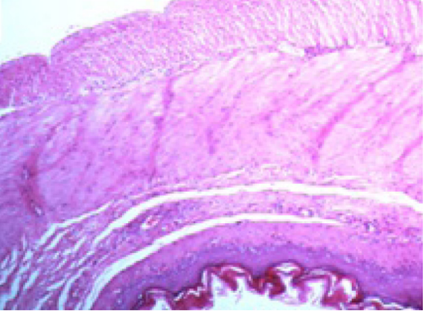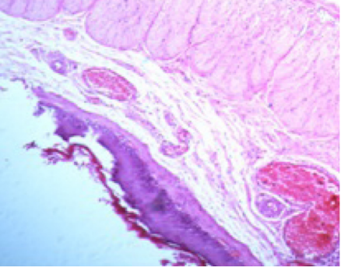
Positive control D. 400 mg/kg BW Acacia nilotica seed
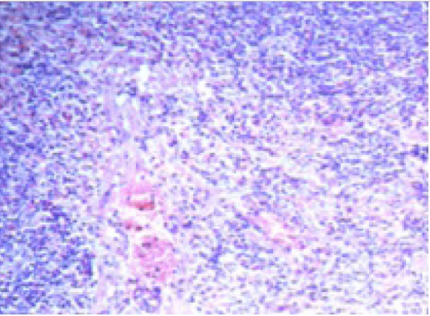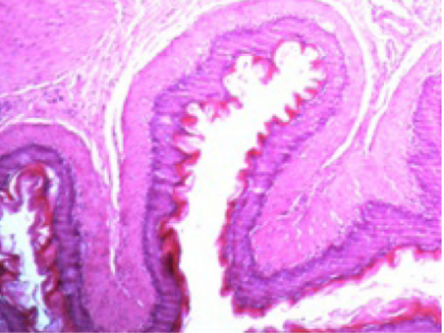
Negative control E. 200 mg/kg BW Acacia nilotica seed

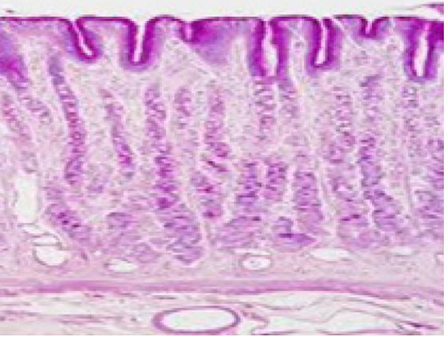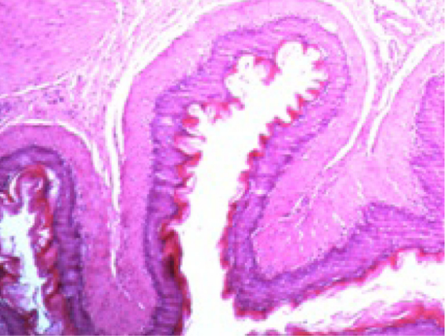
C. Omeprazole F. 100 mg/kg BW Acacia nilotica seed
A. Treated indomethacin induced-ulcer using the standard (arrows) B. Untreated indomethacin induced ulcer (arrows). C. A normal result expected if ulcer is treated using omeprazole. D. Treated indomethacin induced ulcer using 400mg/kg of Acacia nilotica seed (arrows). E. Treated indomethacin induced ulcer using 200mg/kg of Acacia nilotica seed (arrows). F. Treated indomethacin induced ulcer using 100mg/kg of Acacia nilotica seed (arrows).
Figure 1: Histopathology of the stomach lining of indomethacin induced gastric ulcers in Wistar rats
Discussion
The results of the phytochemical analysis of the plant extract revealed the presence of alkaloids, flavonoids, tannins, saponins and phenol. According to Singh et al., (2019) and Kumar et al., (2020) phenolic compounds such as phenolic acids, flavonoids and tannins among others possess antioxidant, anti-inflammatory and anti-ulcer effects. Saponins have wide range of pharmacological activities which include anticancer activity (Laine et al., 2018) and immunomodulatory effects (Bhat et al., 2019). Alkaloids on the other hand exhibit analgesic (Bhat et al., 2019), antimalarial and antimicrobial activities (Adebayo et al., 2022). The presence of these secondary metabolites is responsible for the biological activities exhibited by the seed of Acacia nilotica plant, hence their significant role in prevention and treatment of various diseases. The administration of 5000mg/kg bodyweight Acacia nilotica seed extract to Wistar rats resulted in transient behavioral changes, including licking of paws, salivating and restlessness, lasting approximately 10 minutes may indicate mild irritation or discomfort, possibly due to the bitter taste or gastrointestinal disturbance caused by the extract (Kumar et al., 2020). Salivating suggests stimulation of the salivary glands, potentially as a reflex response to the bitter taste or irritation (Mahapatra et al., 2023). The zero mortality rate suggests that the administered dose (5000mg/kg bodyweight) is below the lethal dose (LD50) of Acacia nilotica seed extract in Wistar rats. This finding aligns with the Organization for Economic Cooperation and Development (OECD) guidelines, categorizing substances with LD50 > 5000mg/kg bodyweight as Class 5, the lowest toxicity class (OECD, 2017).
Effects of methanol extract of Acacia nilotica seed on indomethacin-induced ulcer in Wistar rats on body weight changes shows significant differences in body weight among the treatment groups. This observation is in agreement with the research carried out by Adeyemi et al., (2022) and Mahapatra et al., (2023).The negative control group, which received no treatment, showed a consistent decrease in body weight throughout the three-week period. This weight loss may be attributed to the ulcerative effects of indomethacin, which can lead to reduced appetite and increased metabolic stress (Singh et al., 2020). In contrast, the normal control group, which received no indomethacin or treatment, showed a steady increase in body weight. This weight gain suggests normal growth and development in the absence of ulcerative stress. The Acacia nilotica seed extract treatment groups showed varying degrees of weight gain. The dose-dependent response of Acacia nilotica seed extract on body weight suggests that higher doses may be more effective in promoting weight gain and reducing ulcerative stress (Kumar et al., 2020).
Gastric pH, in the context of indomethacin-induced ulcers, plays a pivotal role, as increased acidity exacerbates mucosal damage. The negative control group showed a significantly lower gastric pH compared to the normal control group, indicating increased acidity in the stomach due to indomethacin-induced ulcer. The Acacia nilotica seed extract treatment groups showed a dose-dependent increase in gastric pH.
Gastric volume, measured in milliliters, indicates the total amount of gastric juice present in the stomach. Normal gastric volume ranges from 20 to 100 mL (Kumar et al., 2020). Alterations in gastric volume can signify gastrointestinal disorders, such as gastric ulcers. The negative control group showed a significantly higher gastric volume compared to the normal control group, indicating increased gastric secretion due to indomethacin-induced ulcer. The Acacia nilotica seed extract treatment groups showed varying effects on gastric volume.
Total acidity, expressed in milliequivalents per liter (mEq/L), reflects the concentration of hydrogen ions in gastric juice. Normal total acidity ranges from 20 to 100 mEq/L (Adeyemi et al., 2022). Elevated total acidity contributes to gastric ulcer development (Kumar et al., 2020). The negative control group showed a significantly higher total acidity compared to the normal control group indicating increased acid production due to indomethacin-induced ulcer. The omeprazole treatment group showed a moderate decrease in total acidity compared to the negative control group. The Acacia nilotica seed extract treatment groups showed a dose-dependent decrease in total acidity. The results demonstrated the potential benefits of Acacia nilotica seed extract, particularly at the 400mg/kg dose in mitigating indomethacin-induced ulcer in Wistar rats, as evidenced by improved gastric pH, reduced gastric volume, and decreased total acidity.
The stomach lining, also known as the gastric mucosa, plays a crucial role in protecting the stomach from the corrosive effects of gastric acid and enzymes (Kumar et al., 2020). The histopathological examination of the stomach lining reveals significant differences among the treatment groups. The negative control group showed severe gastric mucosal damage, ulceration, and erosion, indicative of indomethacin-induced ulcer, which align with the findings of American Gastroenterological Association (2020). The normal control group demonstrated normal gastric mucosal architecture, confirming the absence of ulcerative stress. The positive control group showed mild to moderate gastric mucosal damage, indicating partial protection against indomethacin-induced ulcers. The Acacia nilotica seed extract treatment groups demonstrated dose-dependent protection against gastric mucosal damage. The 400mg/kg bodyweight group showed mild gastric mucosal damage, indicating significant protection.The 200mg/kg bodyweight and 100mg/kg bodyweight groups showed moderate and moderate to severe gastric mucosal damage, respectively

Plate 6: Photomicrograph of gastric mucosa of induced rats treated with water.

Plate 5: Photomicrograph of gastric mucosa of induced rats treated with 10mg/kg of omeprazole.

References
Adebayo, O. A., Olaleye, O. O., & Oyedemi, S. O. (2022). Phytochemical analysis and antioxidant activity of Acacia seed extract. Journal of Food Science and Technology, 59(2), 531-539.
Bhaskar, S., Nandigam, R. K., & Thangaraj, P. (2018). Animal models for studying peptic ulcer disease. Journal of Clinical and Experimental Hepatology, 8(2), 153-162.
Bhat, R., Rai, V., & Karim, A. A. (2019). Acacia seeds as a potential source of nutrition and medicine. Journal of Food Science and Technology, 56(4), 2240-2248.
Inas, Z. M., Hala, G. E., and Samia, M. M. (2011). Gastroprotective effect of chamomile (Matricaria chamomilla) against indomethacin-induced gastric ulcer in rats. Journal of Applied Pharmaceutical Science, 1(10), 151-156.
Jalilzadeh-Amin, G., Maham, M., and Alavi, S. F. (2015). Evaluation of gastroprotective effects of aerial parts of Polygonum aviculare extract against ethanol-induced gastric ulcer in rats. Journal of Ethnopharmacology, 159, 284-290.
Kumar, V., Kumar, A., & Shah, A. (2020). Traditional medicine to modern drug discovery: A review on medicinal plants. Journal of Ayurveda and Integrative Medicine, 11(2), 53-63.
Laine, L., Goldstein, J. L., & Schnitzer, T. J. (2018). Gastrointestinal safety of NSAIDs: A review of the evidence. Journal of Clinical Gastroenterology, 52(8), 553-561.
Lopez-Garcia, A., Martinez-Moreno, J. M., & Rodriguez-Munoz, M. (2020). Indomethacin-induced gastric ulcers in rats: A model for evaluating anti-ulcerogenic agents. European Journal of Pharmacology, 866, 172831.
Lorke, D. (1983). A new approach to practical acute toxicity testing. Archives of Toxicology, 54(4), 275-287.
Mahapatra, S. K., Patra, J. K., & Das, K. (2023). Acacia nilotica seed extract: A potential natural remedy for ulcers. Journal of Food Science and Technology, 60(2), 533-542.
Organization for Economic Cooperation and Development (OECD). (2017). Test No. 423: Acute Oral Toxicity - Acute Toxic Class Method. OECD Guidelines for the Testing of Chemicals, Section 4.
Oyedemi, S. O., Adebayo, O. A., & Adeniyi, B. A. (2020). Antioxidant and anti-inflammatory activities of Acacia seed extract. Journal of Ethnopharmacology, 239, 112257.
Singh, A., Singh, R., & Maurya, R. (2019). Acacia seed extract attenuates oxidative stress and inflammation in lipopolysaccharide-induced RAW 264.7 macrophages. Journal of Ethnopharmacology, 231, 145-153.
Singh, A., Singh, R., & Maurya, R. (2020). Indomethacin-induced gastric ulcers in Wistar rats: A study on oxidative stress and inflammation. Journal of Pharmacology and Toxicology, 15(2), 143-153.
Wallace, J. L. (2018). Mechanisms of NSAID-induced gastrointestinal damage and prevention. American Journal of Physiology-Gastrointestinal and Liver Physiology, 315(3), G361-G369.

