EFFECT OF HIGH CONCENTRATION OF eTh AND eU WITHIN PART OF NORTH CENTRAL NIGERIA ON GEOTHERMAL PARAMETERS
Rafiu Abdulwaheed Adewuyi and Alkali Aisha
Federal University of Technology Minna, Nigeria
Corresponding Author: aisha.alkali@futminna.edu.ng
Tel:08035703809
ABSTRACT
The study deployed aeromagnetic data to estimate geothermal potential and radiometric concentration data to evaluate the radiogenic heat in parts of Kaduna state, central Nigeria. The study area which has been noted for relative high concentration of Potassium (K), Uranium (eU) and Thorium (eU) within Nigeria is bounded by latitude 10°00' to 10°30' and longitude 7°30' to 8°30', an area of 6,050 km². The modified Curie depth method was employed in evaluating the Curie depth, geothermal gradient and heat flow. The region is found to have its shallow Curie point depth of 8.43 km below Wugana. The heat flow of the study area has values ranging from 81.9 mW/m² to 171.9 mW/m² with an average value of 167.8 mW/m². The geothermal gradients range from 32.76 to 68.8 degrees Celsius per kilometre, with an average of 67.16 degrees Celsius per kilometre. Results of radionuclide concentrations revealed that the northern central regions extending down to the central part of the study area recorded medium to high values of radiogenic heat flow in the range of 3.85 to 4.5 μW/m³. Correlating the result of geothermal potential with radiogenic heat production reveals that regions of low Curie point depth correspond to regions of medium to high radiogenic heat production. Hence, the regions of significant geothermal potential are the mid-northern and mid-western areas such as Wugana, New Kwasan, and down to Ron village.The geology consist of rocks such as Pophyritic Granite Biotite granite, medium-to-coarse grained Younger Basalt, and granite gneiss, these in-situ basement rocks has undergone structural deformation and weathering which account for high concentration of radionuclide which exhibit radioactivity and consequently generate heat at the subsurface.
Keywords: Curie depth, Geothermal gradient, Heat Flow, Aero magnetic and radiometric data.
1. Introduction
Geothermal energy is the heat energy that is derived naturally from the earth's interior, mainly by the disintegration of radioactive elements like uranium, thorium, and potassium. Recently, more attention has been given to it due to its ample benefits like; inexhaustible power supply, environmental friendliness, low emission of greenhouse gases, and it is globally available. All these make geothermal energy a very vital contributor to global energy production in an environmentally friendly way (Abdel Zaher et al., 2012; mono et al., 2018; Sui et al., 2019). Geothermal energy, which aim to produce electricity or heat by exploiting the underground temperature, has the potential to be one of the answer to the world’s energy problem.
The essential geothermal parameters and indicators for assessing a viable potential geothermal energy source or reservoir are the Curie point depth, geothermal gradient and heat flow (Jessop et al., 1976; Cull and Conley, 1983; Okubo et al., 1985; Obande et al., 2014; Nwankwo and Shehu, 2015). In regions of the earth crust where decayed radio nuclide particles generate enough heat that converts the magnetic susceptibility of the rock to zero, this will lead to shallow curie depth, the heat within the region can be explored for generation of electricity and other industrial heating processes (Alistar et al., 2014; Kuforijimi and Christopher 2017; Abdel Zaher et al., 2018a; Akinnubi and Adetona, 2018; Salako et al, 2020). Two factors that could lead to such scenario are concentration and degree of decay of radio nuclei particle in the basement rock.
Gama-ray spectrometric survey have been identified as a means of accurately determining the crustal concentrations of the three radiogenic elements simultaneously (Brookins, 1982; Chiozzi et al., 2003). There has been a review of the radio nuclei concentrate on of Nigeria from the radiometric data of the country as compiled by Nigeria Geological Survey Agency in the year 2009 to 2011. The existence of relatively high concentration of both uranium and thorium within the young granite of Plateau and Kaduna States at certain areas like, Kajuru, Kachia, Naraguta and Maijuju was also reported in some ground truthing exploration by other researchers such as (Atipo and Olarinoye, 2020; Arisekola, 2020). This concentration is expected to affect the heat content within the lithology, this is what drew the attention of the researchers to the study area.
The primary aim of this research is to investigate the effect of high concentration of eTh and eU radio nuclide observed on sheets 145 (Kajuru) and 146 (Kachia) on the curie point depth, and subsequently, geothermal gradient and heat flow values within the study area. While spectral analysis of the airborne magnetic data will be used to assess the geothermal parameters (Curie point, thermal gradient and heat flow); a measure of concentration of radioelements will be used to determine the radiogenic heat production. A comparison of these analysis will show the effect and contribution of high concentration of radioelements to the geothermal nature of study area.
2.0 Objective of the research
The objectives of the research are to:
- Determine the sedimentary thickness, Centroid and Curie point depth of magnetic source using spectral depth analysis.
- Determine the geothermal Gradients and heat flow within the study area.
- Delineate the geothermal potential zones in the study area.
- Determine the Radiogenic Heat

2.1. Location and geology of the study area
The study area covers a part of the Kaduna Central Nigeria basement complex. It is bounded by latitude 10°00' to 10°30'N and longitude 7°30' to 8°30'E as shown in (Figure 1). Two high resolution aeromagnetic map sheets (145, 146) covering Geshere and Kajuru spann a total area of 6,050 km². The entire Kaduna state is underlain by a basement complex of igneous and metamorphic rocks. These rocks are essentially granite, gneisses, Migmatite, schist, and quartzite. The geology of Kaduna North is predominantly metamorphic rocks of the Nigerian basement complex, consisting of biotitic gneisses and other granites. Figure 2.
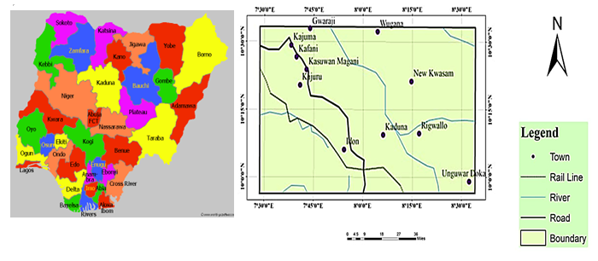
Figure 1: Location map of the study area (modified from the administrative map of Nigeria)

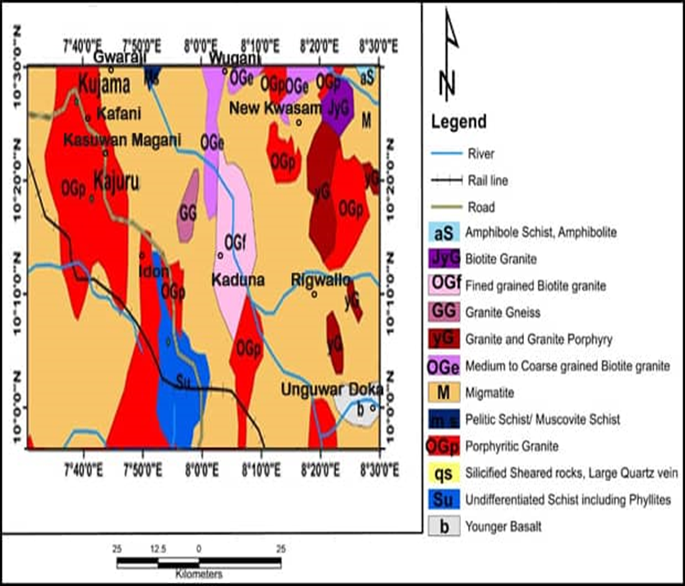
Figure 2: Geology map of the study area (Modified from NGSA, 2009).

3.0 Materials and Methodology
3.1 Data source and specifications
Aeromagnetic and radiometric data of high resolution covering the study area was obtained from the Nigeria Geological Survey Agency (NGSA). The various map sheets obtained are Geshere (145) and Kajuru (146), bounded by latitude 10°00' to 10°30'N and longitude 7°30' to 8°30'E. The airborne data sets was collected by Fugro Airborne Survey in 2009 using Cessna Caravan 208B ZS-FSA and Cessna Caravan 208 ZS-MSJ aircrafts, 3 x Scintrex CS3 Cesium Vapour magnetometer, for magnetic data, 512-channels gamma-ray spectrometer, a NaI(TI) crystals mounted on fixed-wing aircraft for the radiometric data. 5000- and 2000-meters Tie Line Spacing for the magnetic and radiometric data respectively, 500 meters Flight Line Spacing, 80 meters Sensor Mean Terrain Clearance and 0.1 seconds or less Recording Interval for both data sets. The flight line direction was NW–SE (135°), and the control line was in NE–SW direction (45°).

3.2 Methodology theory
3.3 Spectral Depth Analysis
The algorithm for the models of the centroid method employed the shape of an isolated magnetic anomaly, by Bhattacharyya and Leu (1975, 1977) and applied to the statistical properties of magnetic ensembles by Spector and Grant (1970). Blakely (1995) extended the same to power spectral density of magnetic field, $ϕ$Δ$T\left(k_{x},k_{y}\right)$as:
A relationship for an isolated magnetic anomaly by Bhattacharyya and Leu (1975, 1977) was substituted for the statistical properties of magnetic ensembles by Spector and Grant (1970), the resultant mathematical model was extended to for centroid depth method using spectral density of magnetic field $ϕ$Δ$T\left(k_{x},k_{y}\right)$ by Blakely (1995), expressed as:

$φ$Δ$β\left(C_{x},C_{y}\right) =φ_{M}\left(C_{x},C_{y}\right).4π^{2}{K_{M}}^{2}|σ_{M}|^{2}|σ_{f}|^{2}e^{-2|c|δ_{t}}{\left(1- e^{-2\left|c\right|{(δ}_{b}-δ_{t}}\right)}^{2}$ (1)
Where, $φ_{M}\left(C_{x},C_{y}\right)$ represents spectral of magnetization, $φ_{M}$ and $φ_{f}$are magnetization and field direction, $C_{x}$ and $C_{y}$ are wave numbers in cartesian coordinate $δ_{b}$ depths to magnetic basement and $δ_{t}$ of overburden layer
For a layer with random magnetization in $x, y,$ $φ_{M}\left(C_{x},C_{y}\right)$is a constant, and therefore the azimuthally averaged power spectrum, $φ\left(\left|C\right|\right)$would be given as
$φ\left(\left|C\right|\right)$ = $Ae^{-2|c|δ_{t}}{\left(1- e^{-2\left|C\right|{(δ}_{b}-δ_{t}}\right)}^{2}$ (2)

3.4 Depth to the Top ($δ$_{t}), Centroid ($δ$₀) and Bottom ($δ_{b})$ of Magnetic sources

Two approaches were involved here,
1. Depth of the overburden is obtained from the slope of the high-wave-number portion of the power spectrum as:
$ln⁡(P\left(({C)}^{\frac{1}{2}}\right)=A-|C|δ$_{t} (3)
where$P(C)$ is the azimuthally averaged power spectrum, $C$ is the wave number $\left(2π km^{-1}\right), A$ is a constant, and $δ_{t}$ is the depth to the top of magnetic sources.
2. The centroid depth, which comprise of both the overburden and the basement rocks is obtained from the low-wave-number portion as, (Tanaka et al., 1999)
$ln⁡(P\left({(C)}^{\frac{1}{2}}/C\right)=B-|C|δ$₀ (4)
if B is a constant then $δ$o is the centroid.
The depth the magnetic source ($δ_{b}$) that has a constant density and Thermal conductivity of 2.5W/m/°C for granite required for evaluating the Geothermal Gradient can is obtained from the relation (Okubo et al., 1985 Adetona et al.,2017)
$δ_{b}=2δ_{0}-δ$_{t} (5)
3.5 Geothermal Gradient and Heat Flow
Using the result of ($δ_{b}$), in equation 5 above the geothermal gradient $\left(\frac{dT}{dZ}\right)$can be estimated as $\left(\frac{dT}{dZ}\right)=\left(\frac{Ɵ_{c}}{Z_{δb}}\right),$ (6)
Where $Ɵ_{c}$ is the Curie temperature.
By employing, $δ_{b}$ and $\frac{dT}{ dZ}$, the heat flow ($q_{z}$) can be estimated as (Okubo et al., 1985)
$q_{z}= -σ\left(\frac{Ɵ_{c}}{δ_{b}}\right)= -σ\left(\frac{dT}{dZ}\right)$, 9+ (7)
Where $σ$ is thermal Conductivity a value of 2.5W/m/°C is the average for igneous rocks at a Curie temperature of 580 °C (Stacey, 1977; Trifonova et al., 2009) are used as standard.
3.6 Spectral Analysis Procedure and Result
- In order to estimate the Curie point depth, geothermal gradient and heat flow, the RMI map was divided into nine sub-sheets for spectral analysis.
- Each sub-sheet was further subjected to Fast Fourier Transform, a process which decomposes the magnetic values to its energy spectrum and wave number components.
- The data from spectral analysis was used to calculate depth to the top and centroid of magnetic sources. The depths were then used to calculate the Curie point depth (CPD) using equation (5). The CPD values were used to estimate the heat flow and geothermal gradient using equations (6) and (7), respectively.
BLOCKS | $δ$ o | $δ$ t | $δ$ b | dT/dZ | q
1 | 4.567552514 | 0.704646722 | 8.430458307 | 68.79815769 | 171.9953942
2 | 9.215467855 | 0.728859007 | 17.7020767 | 32.76451739 | 81.91129348
3 | 6.461569064 | 0.387356779 | 12.53578135 | 46.26755874 | 115.6688969
4 | 5.74355506 | 0.233513686 | 11.25359644 | 51.53907938 | 128.8476985
5 | 6.382320178 | 0.349578294 | 12.41506206 | 46.71744669 | 116.7936167
6 | 6.413908339 | 0.315499682 | 12.512317 | 46.35432432 | 115.8858108
7 | 7.69127944 | 0.411242839 | 14.97131604 | 38.7407492 | 96.85187301
8 | 4.471594526 | 0.252577976 | 8.690611076 | 66.73869017 | 166.8467254
9 | 6.670910248 | 0.230919796 | 13.1109007 | 44.23799808 | 110.5949952
AVERAGE VALUES |  |  | 12.40245774 | 49.12872463 | 122.8218116

3.7 Radiogenic Heat Production Procedure
Radiogenic heat production is apply to the study in order to properly estimate lithospheric temperature and understand the processes related to thermal evolution of the earth. The concentration of the three radio elements (K, eTh, and eU) was used to calculate the radiogenic heat production of rocks in the study area from an empirical equation given by Rybach (1976)
A(μW/m³) = ρ(0.0952 C_{U}+ 0.0256 C_{Th} + 0.0348 C_{K}) (8)
where: ρ is rock density (kg m⁻³), C_{K} is the concentration of potassium by percentage weight, Cu and C_{Th} are the concentrations of uranium and thorium in ppm. A numerical constant is multiplied by each radioelement concentration. The constants indicate the various contributions made by each radioelement to radiogenic heat generation. The constant for uranium (0.097) is more than twice the constants for potassium (0.035) or thorium (0.026), indicating that uranium dominates thorium and potassium in terms of heat production. (Bücker and Rybach, 1996; Alistair et al., 2014). Also the density values were a reflection of average densities of rocks types hosting the radioelements with in the area of study (Madu et al., 2015; Kuforijimi and Christopher, 2017; Telford et al., 1990)
4.0 Results and Interpretation of Magnetic Signatures within the Study Area
The residual magnetic intensity map Figure (3), comprises both positive and negative anomalies and ranges from -145.062 nT to 47.293 nT. The deep blue to pink colors on the map represents the range of magnetic intensity from low to high. It reveals various degrees of high magnetic susceptibility in the left-hand part of the study area, while low magnetic susceptibility occupies the south eastern part of the study area. The map was divided into nine sub-sheets for spectral analysis pre-processing.
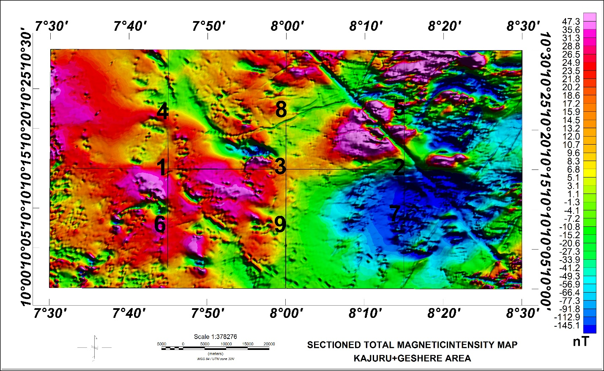
Figure 3: Sectioned Residual Magnetic Intensity map of study area
4.1 Result of Curie Point Depth Analysis
The Curie point depth map of the study area shown in Figure (5) depicts depth variation from 12 km to 56 km across the study area, with an average value of 30.46 km. The north-central regions surrounded by Wugana, Kajuru, Kasuwan, Magani, New Kwasam and the south-western portion of the study area portray the shallowest curie depths ranging from 12 to 22 km. High curie depth occurrence ranging from 42 to 56 km is observed around the north-western edge and south-eastern part of the study area corresponding to Kajuma and Unguwar Doka respectively. The regions delineated to host low Curie point depths also correspond to regions on the geology map, Figure (2.) dominated by fine grained Biotite granite, medium to coarse grained Biotite granite, granite gneiss and porphyritic granite.
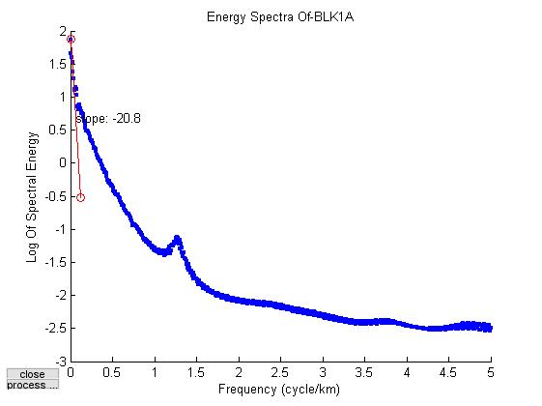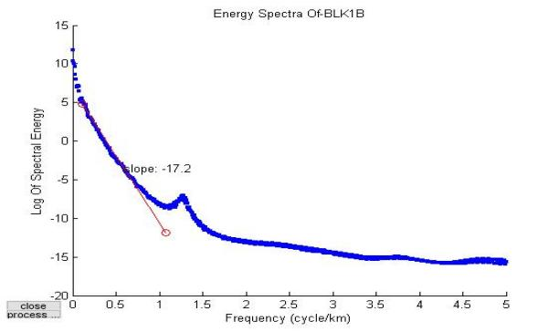
Figure 4: Graph of energy spectrum versus wave number for block 1 and 2
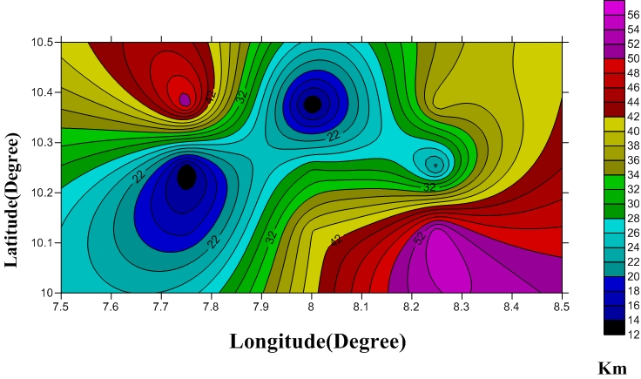
Figure 5: Curie point depth contour map of study area
4.2 Result of the Geothermal Gradients and Heat Flow Analysis
The geothermal gradient, Figure (6) was observed to have values distributed across the study area ranging from 8 to 50 °C/km with an average value of 25.19 ⁰C/km. The region surrounded by major towns like Wugana, Kajuru, and New Kwasam, as well as the South-Western portion of the study area, had the highest geothermal gradient values, ranging from 38 to 50 °C/km.The lowest geothermal gradients were observed at the south-eastern edge, corresponding to the Unguwar Doka area. Medium values ranging from 22 to 36 °C/km were recorded in the study area's north-west, south-west, and near New Kwasam. The heat flow map of the study area, Figure (7) reveals the value ranges from 30 to 160 mW/m² with an average value of 80.60 mW/m². The North-Central regions surrounded by Wugana, Kajuru, New Kwasam and the Western edge of the study area recorded high and anomalous values of heat flow, with a range of 105 to 160 mW/m². Relatively high values of 80 to 100 mW/m2 were observed in the Kaguru, North-East, and South-West regions of the study area.
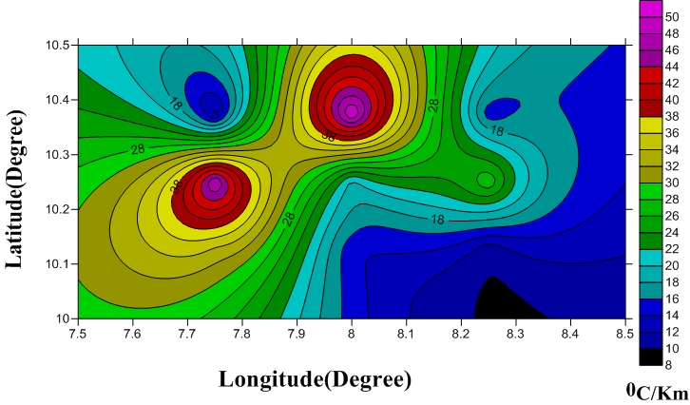
Figure 6: Geothermal gradient contour map of the study area
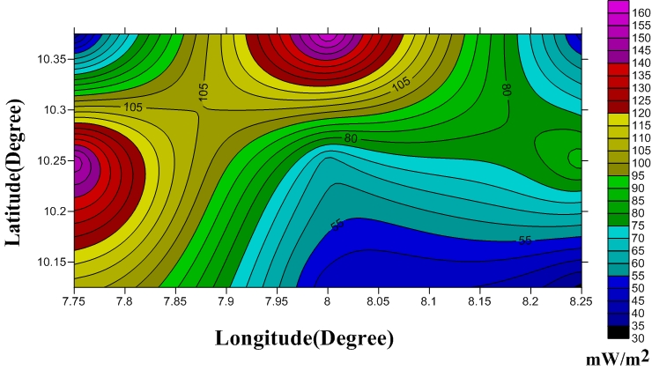
Figure 7: Heat flow contour map of the study area

Table 1: Estimated Curie point depth, geothermal gradient, and heat flow values are shown in Table 1.
Blk | Lon  ( ̊E) | Lat  ( ̊N) | Depth To  Centroid(km) | Depth To Top (km) | Curie point Depth (km) | Heat Flow  mW/m² | Geothermal Grad(°C/km)
1 | 7.75 | 10.25 | 14.6 | 17.2 | 12.00 | 154.6666667 | 48.33333333
2 | 8.25 | 10.25 | 18.9 | 16.8 | 21.00 | 88.38095238 | 27.61904762
3 | 8.0 | 10.25 | 19.6 | 9.44 | 29.76 | 62.3655914 | 19.48924731
4 | 7.75 | 10.375 | 29.2 | 6.72 | 51.68 | 35.91331269 | 11.22291022
5 | 8.25 | 10.375 | 23.6 | 8.04 | 39.16 | 47.39530133 | 14.81103166
6 | 7.75 | 10.125 | 12.9 | 8.46 | 17.34 | 107.0357555 | 33.44867359
7 | 8.25 | 10.125 | 32.1 | 8.8 | 55.40 | 33.50180505 | 10.46931408
8 | 8.0 | 10.375 | 8.44 | 5.35 | 11.53 | 160.971379 | 50.30355594
9 | 8.0 | 10.125 | 22.5 | 5.0 | 40.00 | 46.4000000 | 14.50000000
4.3 Result of the Radiometric Analysis
The Th and U channel concentrations in Figure (8) and (9) respectively shows high range of values for the radioelements within the study area which from the geological map Figure (2) is shown to be composed mainly of igneous granitic rocks. Concentration maps of the three radiogenic elements (K, Th and U) were fused together to create a ternary image (Figure 10). This helped to understand their effect on varying geothermal parameters of the study area. From the ternary map, the three elements are combined together in a color aggregate. The red, green, and blue colorations represent potassium, Thorium and uranium, respectively. The red areas in the composite map are an indication of strong content in potassium concentration, while the green indicates an area of strong content in uranium and the white region is an indication of strong content of the three elements concentration, which correspond to New Kwasam, Kaduna, Idon, and Kasuwan Magani. In this study, the regions of high content of the three radiogenic elements are related to the most viable regions for geothermal exploration where high geothermal and heat flow were observed.

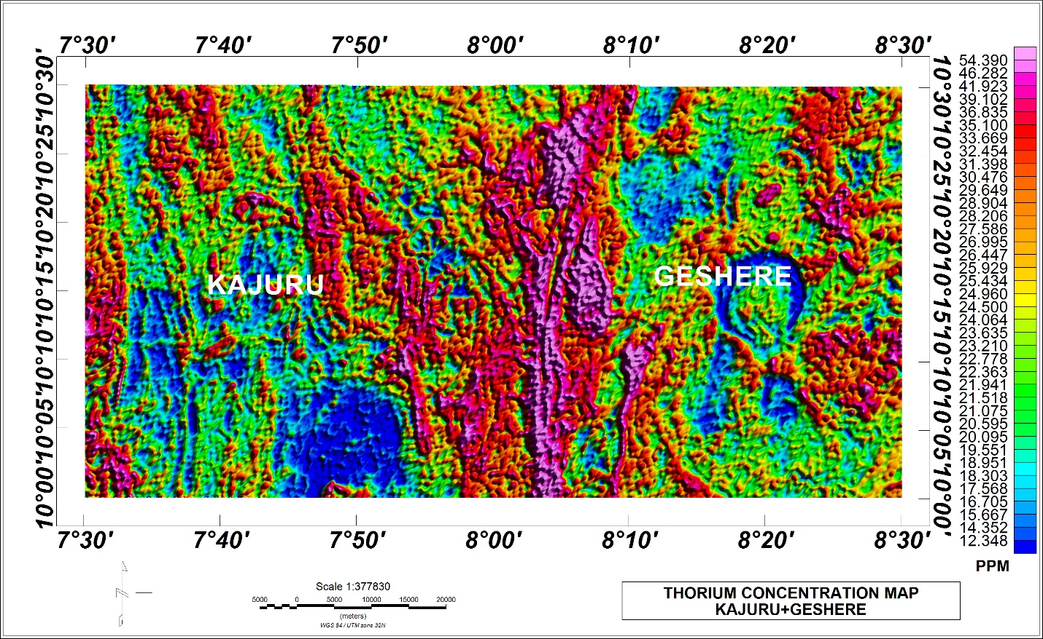
Figure 8: Concentration map of Thorium within study area
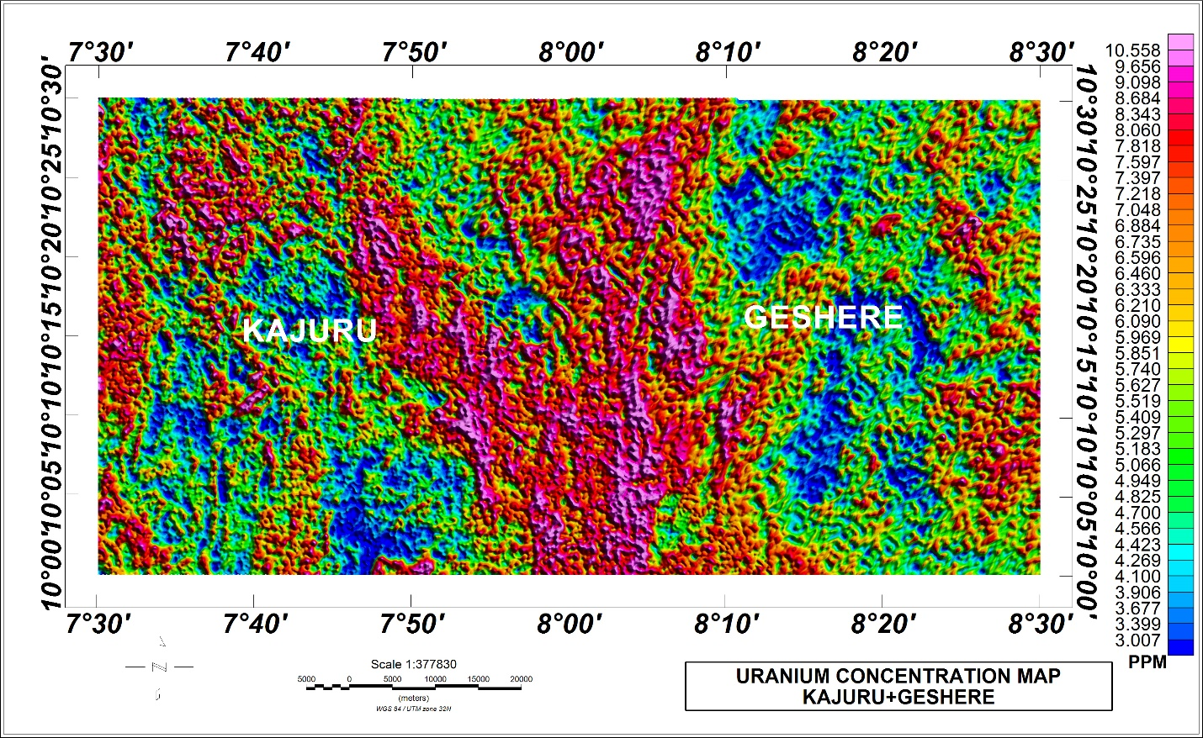
Figure 9: Concentration map of Uranium within study area
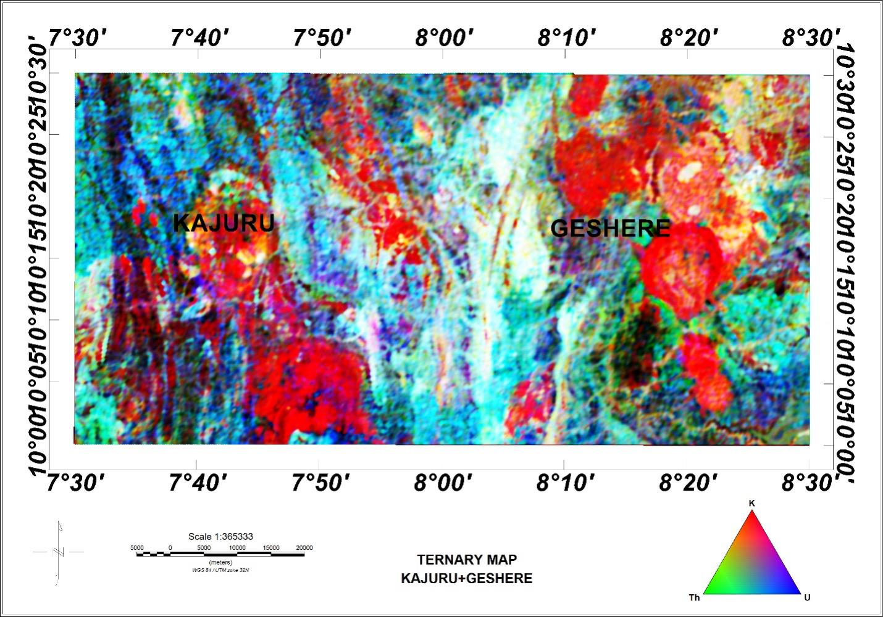
Figure 10: Ternary Map of the study area
4.4 Result of the Radioelement Concentration Profiles Analysis
Three main profiles were drawn on the concentration map of each radioelement (K, Th and U). The profiles cut across the central points of nine sub sheets used for spectral analysis (Figure 11). The concentration of each radioelement was recorded at the points labelled (P1 to P9) across the study area. The average density of the rock unit hosting the radioelements at each point was also noted and used to calculate the radiogenic heat production at the designated point using equation (7). A summary of estimated RHP values is in table 2.
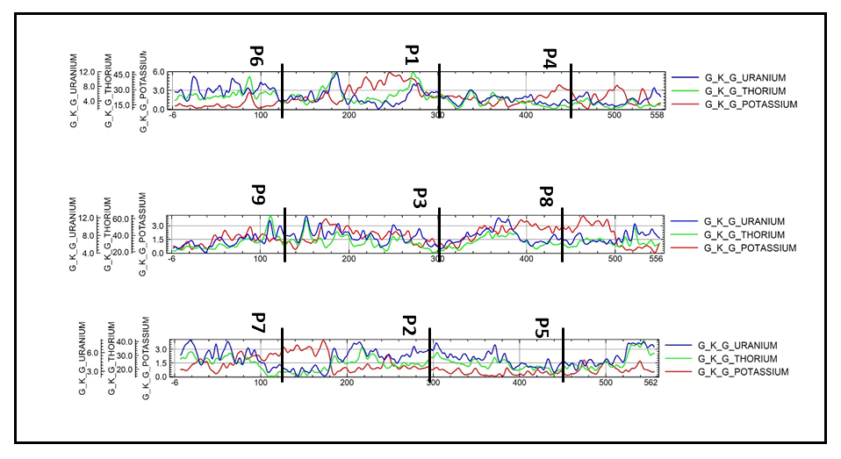
Figure 11 Profiles drawn to record the concentration of the three radioelements (K in red, Th in green and U in blue)
Table 2: Estimated Radiogenic Heat Production of study area
SEC | LON | LAT | K(%) | eTh(ppm) | eU(ppm) | ROCK UNITES | AV.DENSITY(g/cm³) |  | RHP(μW/m³)
1 | 7.75 | 10.25 | 2.0 | 20.0 | 8.0 | Pophyritic Granite |  | 2.65 |  | 3.55948
2 | 8.25 | 10.25 | 0.75 | 35.0 | 6.5 | Migmatite |  | 2.75 |  | 4.237475
3 | 8.00 | 10.25 | 1.25 | 24.0 | 6.0 | Granite Gnessis |  | 2.65 |  | 3.257115
4 | 7.75 | 10.375 | 1.5 | 22.5 | 6.0 | Porphyritic Granite |  | 2.65 |  | 3.17841
5 | 8.25 | 10.375 | 3.2 | 24.0 | 4.0 | Biotite Granite |  | 2.65 |  | 2.932384
6 | 7.75 | 10.125 | 3 | 17.0 | 6.0 | Migmatite |  | 2.75 |  | 3.0547
7 | 8.25 | 10.125 | 0.7 | 25.0 | 5.0 | Younger Basalt |  | 3.00 |  | 2.09236
8 | 8.00 | 10.375 | 1.3 | 28.0 | 10.0 | Coarse Grain Biotite Granite |  | 2.65 |  | 4.542206
9 | 8.00 | 10.125 | 3.0 | 30.0 | 8.0 | Undifferentiated Schist |  | 2.64 |  | 4.31376

4.5 Result of the Radiogenic Heat Production (RHP) Analysis
The radiogenic heat production reveals the activity of radioelements within their host rocks. The RHP values recorded across the study area range from 2.09 μW/m³ minimum to 4.54 μW/m³ maximum with an average value of 3.46 μW/m³. Peak values were observed in the north and south-central regions, within Wugana, New Kwasan and down to Ron, generally within the intrusive granitic regions. These regions of high RHP also corresponds to regions with high concentration of radio elements as can been Figure (8, 9 and 10).
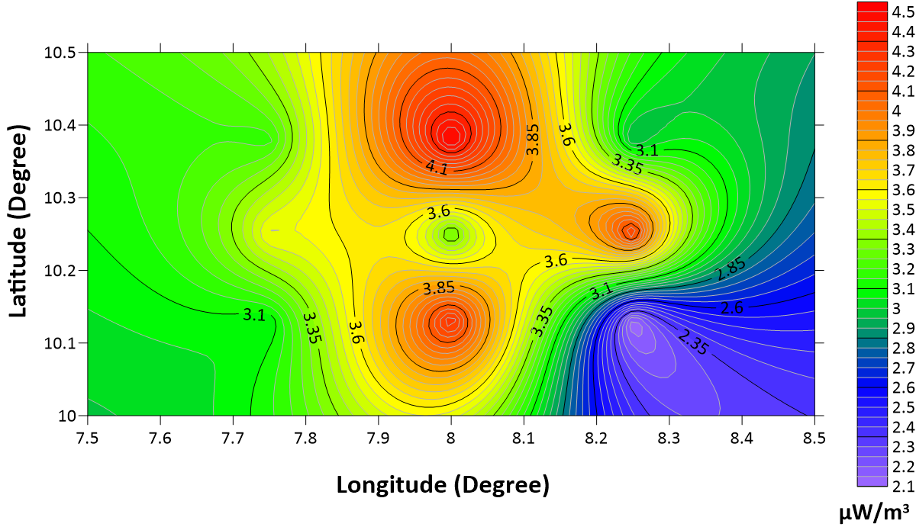
Figure 12: Production of radiogenic heat in the study area.
4.6 Discussion of Results.
The regions observed with the shallowest Curie point depth, high geothermal gradient, and peak values of heat flow are within the towns such as Wugana, Kajuru, and New Kwasam of the study area. The spotted regions shows favourable geothermal parameters and could be considered for good potential geothermal sources. Researches have shown that an estimate of the bottom of the magnetized crust represents a direct indicator of the Curie isotherm, and variations in the thickness of the magnetized crust can be explained as variations in temperature. (Manea and Manea, 2011; Abdel Zaher 2018a, 2018b; Mono et al., 2018). Hence, the shallow curie depth in a region makes it more viable for harnessing geothermal energy. A direct variation of Curie point depth with geothermal gradient and heat flow was observed. Regions with decreasing Curie point depth recorded increasing heat flow with geothermal gradient.
Generally, values between 80-100 mWm² are good geothermal sources, while values greater than 100 mWm² indicate anomalous conditions (Cull and Conley, 1983; Jessop et al., 1976). The result of this research recorded a peak heat flow value of 160 mWm² which is an indication of an anomalous condition. The range of Curie point and heat flow values obtained in this study also agrees with values earlier gotten from a more regional scale study of geothermal parameters by Odidi et al, 2020.
Studies have shown that the average content of Thorium and Uranium within granitic rocks is set at (5 ppm of U and 15 ppm of Th), compared to the Earth's crust (averagely 1.8 ppm for U and 7.2 ppm for Th) (Mason & Moore, 1982; Usoif et al., 2015). The maximum range of concentration values observed within the study area (54.39 ppm for Th and 10.56 ppm for U) are typically above the usual average and indicates an anomalous condition. The composite radioelement map indicated a high concentration of the three radioelements from the north toward the central regions, a trend that can be related to the observed high radiogenic heat production in the regions. A general convention in geothermal exploration is that values above 4 μW/m³ are considered high radiogenic heat production and thus a potentially economic heat resource (Alistair et al., 2014). RHP values of 4.5 μW/m³, which is in excess of the recommended threshold, were recorded in the north and central parts of the study area. The geology map in figure 2 indicates the rock types as fine-grained Biotite granite, medium-to-coarse grained Biotite granite, and granite gneiss, these in-situ basement rocks has undergone structural deformation and weathering which account forhigh concentration of radionuclide which exhibit radioactivity and consequently generate heat at the subsurface.
5.0 Conclusion
The high resolution aeromagnetic and radiometric data of sheets 145 and 146, covering Geshere and Kajuru within Kaduna State of North Central Nigeria, were analysed using relevant mathematical algorithms such as reduction to equator, Fast Furrier transform, Spectral analysis, and computing the ternary image to access the geothermal and radiogenic potentials within the region. Results obtained show that the curie depth has the shallowest depth of 12 km, which coincides with a geothermal gradient of 154.67 °C/km and a heat flow of 160.9 mW/m². Similarly, the radionuclide concentrations for potassium, thorium, and uranium coupled with the average density of the rock lithology gave a maximum estimated radiogenic heat content of 4.5 μW/m³ within the same vicinity. It can therefore be concluded that these regions, which falls within Wugana New Kwasan and Ron, can be associated with high geothermal potential. Finally, the high geothermal gradient and heat flow obtained shows a resultant effect of high radio nuclei concentrations within the in-situ basement granitic rocks.
5.1 Recommendation
The approach in this research work is recommended for other areas where high concentration of radio nuclei is observed for validation.

References
Abdel Zaher, M., Saibi, H., Nishijima, j., Fujimitsu, Y., Mesbah, H., Ehara, S., (2012) Exploration and assessment of the geothermal resources in the Hammam Faraun hot spring, Sinai Peninsula, Egypt Journal of Asian Earth Sciences Volume 45, 2 Pages 256-267. https://doi.org/10.1016/j.jseaes.2011.11.007.
Abdel Zaher, M., Elbarbary, S., Sultan, S.A., El-Qady, G., Ismail, A., Takla, E.M. (2018a). Crustal thermal structure of the Farafra oasis, Egypt, based on airborne potential field data. Geothermics 75, pages 220–234. https://doi.org/10.1016/j.geothermics.2018.05.006
Abdel Zaher, M., Saibi, H., Mansour, K., Khalil, A., Soliman, M., (2018b) Geothermal exploration using airborne gravity and magnetic data at Siwa Oasis, Western Desert, Egypt Renewable and Sustainable Energy Reviews Volume 82, Part 3, Pages 3824-3832. https://doi.org/10.1016/j.rser.2017.10.088
Abraham K. M., Lawal A. A (2011) Interpretation of aeromagnetic data for geothermal energy investigation of Ikogosi Warm Spring, Ekiti state, south western Nigeria. International Journal of Scientific research 1: 103-118.
Adetona, A.A., and Abu, M., (2013) Estimating the Thickness of Sedimentation within Lower Benue Basin and Upper Anambra Basin, Nigeria, Using Both Spectral Depth Determination and Source Parameter Imaging. Hindawi Publishing Corporation ISRN Geophysics Volume Article ID 124706, pp 1-10
Akinnubi T. D., Adetona A. A. (2018) Investigating the geothermal potential within Benue State, central Nigeria from radiometric and high resolution aeromagnetic data. Journal of Geology and Mining Research. pp.(9)10
Alistair, T.M., Thomas, L.H., Paul, L.Y., David, C.W., Alan, J.C. (2014). Gamma-ray Spectrometry in Geothermal Exploration: State of the Art Techniques. Energies 2014, 7, 4757-4780; doi:10.3390/en7084757
Aliyu, A; Salako, K.A Adewumi, T., and Mohammed A. (2018). Interpretation of high-resolution aeromagnetic data to estimate the Curie Point Depth Isotherm of parts of middle Benue Trough, North East, Nigeria. Physical Science International Journal, 17(3), 1-9.
Bhahacharryya, B.K, Leu, L.K. (1975). Spectral analysis of gravity and magnetic anomalies due to the dimensional structures, Geophysics 40: 993-1031
Bhattacharya, Bk, Leu, Lk (1977). Spectral analysis of gravity and magnetic anomalies due to rectangular prismatic bodies. Geophysics (42): 4-50.
Blackely, R.J, (1995). Potential theory in gravity and magnetic application. Cambridge University
Brookins, D.G. (1982). Potassium, uranium, thorium radiogenic heat contribution to heat flow in the precambrian and younger silicic rocks of the Zuni and Florida mountains, New Mexico (U.S.A.). Journal of Volcanology and Geothermal Research. Volume 13, Issues 3–4, Pages 189-197. https://doi.org/10.1016/0377-0273(82)90049-X
Bücker, C; Rybach, L (1996). A simple method to determine heat production from gamma-ray logs, Marine and Petroleum Geology 13, 373-375
Chiozzi, P., Pasquale, V., Verdoya, M., (2003). Heat from radioactive elements in young volcanics by γ-ray spectrometry. Journal of Volcanology and Geothermal Research
Volume 119, Issues 1–4, Pages 205-214. https://doi.org/10.1016/S0377-0273(02)00354-2
Cull, J.P, Conley D. (1983). Geothermal Gradients and Heat Flow in Australian sedimentary Basin. Journal of Australian Geology and Geophysics 8: 32-337.
Jessop, A.M., Habart, M.A., Sclater, J.G. (1976). The world heat data collection 1976. Geothermal Services of Canada. Geotherm-ser.50, 251-266
Kuforijimi O. and Christopher A. (2017). Correlation and mapping of geothermal and radioactive heat production from the Anambra Basin, Nigeria. African Journal of Environmental Science and Technology. Vol. 11(10), pp. 517-531. DOI: 10.5897/AJEST2017.2382
Madu, A., Chinenyeze, J., Aniebonam, A. I., Onuoha M. K. (2015) Density and Magnetic Susceptibility Characterization in the Basement Complex Terrain of NE Kogi State/NW Benue State of Nigeria. International Journal of Science and Research (IJSR) Volume 5 Issue 12.
Manea, M., and Manea, V.C. (2011). Curie Point depth estimates and correlation with subduction in Mexico. Pure and Applied Geophysics, 168, 1489. https://doi.org/10.1007/s00024-010
Mason, B., & Moore, C. B. (1982). Principles of geochemistry (4th ed.). New York: Wiley.
Mono, J.A., Théophile, N., Yara T., Ngoh, J.D., Olivier, U. I.O. A., (2018) Estimation of Curie-point depths, geothermal gradients and near-surface heat flow from spectral analysis of aeromagnetic data in the Loum – Minta area (Centre-East Cameroon) Egyptian Journal of Petroleum Volume 27, Issue 4, Pages 1291-1299. https://doi.org/10.1016/j.ejpe.2018.07.002
Nwankwo, L.I., Shehu, A.T. (2015) Evaluation of Curie-point depths, geothermal gradients and near-surface heat flow from high-resolution aeromagnetic (HRAM) data of the entire Sokoto Basin, Nigeria. J VolcanolGeotherm Res 305:45–55
Obande, G. E., Lawal, K. M., Ahmed, L. A., (2014). Spectral analysis of aeromagnetic data for geothermal investigation of Wikki Warm Spring, north-east Nigeria. Geothermics (50) 85–9. DOI of original article: http://dx.doi.org/10.1016/j.geothermics.2013.08.002.
Odidi, I. G., Abu, M., Nasir, N. (2020). Investigation of Geothermal Energy Potential of Parts of Central and North-Eastern Nigeria Using Spectral Analysis Technique. FUDMA Journal of Sciences (FJS) ISSN online: 2616-1370 ISSN print: 2645 - 2944
Vol. 4 No. 2, pp 627 – 638. DOI: https://d oi.org/10.33003/fjs-2020-0402-248
Okubo Y, Graf RJ, Hansent RO, Ogawa K, Tsu H (1985) Curie point depths of the island of Kyushu and surrounding areas Japan. Geophysics 53:481–494
Okubo Y, Matsushima J, Correia A (2003) Magnetic spectral analysis in Portugal and its adjacent seas. Phys Chem Earth 28:511–519
Salako, K. A., Adetona, A. A., Rafiu, A. A., Alahassan, U. D., Aliyu, A. & Adewumi, T. (2020) Assessment of Geothermal Potential of Parts of Middle Benue Trough, North-East Nigeria. Journal of the Earth and Space Physics, Vol. 45, No. 4. DOI: 10.22059/jesphys.2019.260257.1007017
Spector, A., Grant, F. S. (1970). Statistical models for interpreting aeromagnetic data, Geophysics 35: 293-302.
Stacey, F.O (1977). Physic of the earth John Willey and Sons, New York.
Tanaka, A Okubo, Y Matsubayashi, O (1999). Curie point depth based on spectrum analysis of the magnetic anomaly data in East and Southeast Asia, Tectonophysics, 306:461-470.
Telford, W. M., Geldart, L. P., Sherif, R. E. & Keys, D. A. (1990). Applied Geophysics. Cambridge: Cambridge University Press
Tselentis GA (1991) an attempt to define curie depths in Greece from aeromagnetic and heat flow data. PAGEOPH 136:87–101
Trifonova, P., Zheler, Z., Petova, T. and Bojadgievak. (2009) Curie point depths of the Bulgarian territoty inferred from geomagnetic observations and its correction with regional thernal structure and seismicity. Tectono Physics. 2009; 473: 362-374.
Uosif, M.A.M., Shams A.M., Issaa, L.M., Abd El-Salam (2015). Measurement of natural radioactivity in granites and its quartz-bearing gold at El-Fawakhir area (Central Eastern Desert), Egypt. Journal of Radiation Research and Applied Sciences. Volume 8, Issue 3, Pages 393-398. https://doi.org/10.1016/j.jrras.2015.02.005
Whitmarsh, R. B., Manatschal, G., and Minshull, T. A. (2001). Evolution of magma-poor continental margins from rifting to seafloor spreading. Nature, 413(6852), 150

