Crustal Structure and Modeling of Parts of Anambra Basin, Nigeria, using Bouguer Gravity Data

Lawrence Jane Osita¹, Udensi Emmanuel Emeka¹, Salako Kazeem Adeyinka¹, Alkali Aisha¹, Abdullahi Muhammad² and Adewumi Taiwo³
¹ Department of Geophysics, Federal University of Technology Minna, Nigeria
² Department of Physics, Ibrahim Badamasi Babangida University Lapai, Nigeria
³ Department of Physics, Federal University of Lafia, Nigeria

Corresponding Author: Lawrence Jane Osita
Corresponding Author’s email address: jane.osita@futminna.edu.ng

Authors’ Contributions
This work was carried out in collaboration between all authors. Author LJO wrote the manuscript, analyzed the data. Author UEE checked the protocol of the study, the grammar and language and appraised data quality. Author SKA and AA designed the study. Author AM and AT managed the literature searches. All authors read and approved the final manuscript.

ABSTRACT
The bouguer gravity map covering the study area were digitized, merged, contoured and subjected to Spectral depth analysis and Two-dimensional (2-D) gravity Modeling to determine the crustal structure and Mohorovicic Discontinuity beneath parts of Anambra Basin, Nigeria. Nine Spectral sections and four two-dimensional (2-D) gravity Models were constructed for the study area bounded by Longitudes 5° 00' to 6°00' E and Latitudes 6° 00' to 7° 00' N as with gravity data, relationship between crustal structure and crustal density can be established. With the Bouguer gravity anomalies and the available geological and geophysical information for the study area. The obtained results indicates that: 1) the migmatitic crust is underlain by upper mantle. 2) The highest sedimentary thickness for the study area is about 14.5 km- a good sign for mineral exploration. 3) the crustal thickness ranges from 31.0 km to 41.5 km. 4) The average densities for the different rock layers are: 2.623 g/cm³ for sediments, 2.65g/cm³ for the crustal layer, and 3.2 g/cm³ for the upper mantle.

Keywords: Bouguer Gravity data, Crustal Structure, Mohorovicic Discontinuity, Spectral depth analysis, 2-D Modeling

.
- Introduction

The Planet Earth, the planet which supports man existence from time immemorial has been of concern to Geoscientists who attempt to explore it using different techniques, some for educational research while Others for exploration of economic resources like minerals and hydrocarbons. To achieve this, Geoscientists use the properties associated with the earths subsurface.

The gravity method, like the magnetic method, is a non-destructive geophysical technique for surveying the earth’s subsurface and it depends on measuring differences in the earth’s gravitational field within area of interest (Ofoha et al, 2018). The crustal structure can be imaged precisely through costly profound seismic profiling, but economic contemplations make gravity method a more applied approach for crustal mapping over regional scale (Jamal and Mahmoud, 2015). Recent acquisition of high-resolution gravity data by the Nigerian Geological Survey Agency (NGSA) has made scientists to begin venturing into subsurface study using this approach. Gomez –Ortiz et al (2005), Lefort and Agarwel (2002), Rivero et al (2002), Udensi (2000) and many more had used gravity data in the analysis of the earths subsurface. When compared to other methods, the gravity method penetrates greater depth, has fewer crews and also covers inaccessible areas (Nabighian et al (2001) & Ofoha et al (2018)). In view of this, Nabighian et al (2001) & Ofoha et al (2018) stated that the gravity method can be used where target area underlies high velocity zones like salt provinces, overthrust and foothills belts and underexplored basins. The gravity method can be used to delineate structural trends as well as estimating depth to basement rocks in a particular study area.

Nigeria dependence on crude oil cannot be overemphasized. Tokunbo (2021) says the sales of crude oil made up one-third of the government’s budget revenue. This crude oil is usually found in regions called Basins.
The study area bounded by Longitudes 5° 00' to 6°00' E and Latitudes 6° 00' to 7° 00' N forms part of the Anambra Basin - one of the Basins where crude oil is found in commercial quantity in Nigeria. Report from Department of Petroleum Resources (DPR) in 2019 has it that crude oil of about 10,000 barrels is mined per day from this Basin. Due to the amazingly well-endowed ecology of this Basin, there is need to study its crustal structure as it relates to the geologic development of key tectonic features (Akpan et al., 2015).
For the purpose of this research, crustal structure investigation was carried out to obtain the Basement depth (sedimentary thickness), Conrad depth and Mohorovicic discontinuity (Moho depth) of the study area by integrating spectral analysis method and 2-D Modeling technique in the interpretation of the residual bouguer gravity data.

- Theoretical Background of the Gravity Method

The universal law of gravitation and the 2nd law of motion by Newton are the two laws on which the gravity method depends. The universal law of gravitation states that the force of attraction between two bodies of known mass is directly proportional to the product of the two masses and inversely proportional to the square of the distance between their centers of mass (Rivas, 2009). While Newton’s second law of motion states that the rate of change of momentum of a body, is directly proportional to the force applied and this change in momentum takes place in the direction of the applied force. In other words, Newton’s second law can be stated as: In an inertial reference frame, the vector sum of the forces F, on an object is equal to the mass m of that object multiplied by the acceleration, a, of the object (Rivas, 2009):
Newton’s second law can be expressed mathematically as:

$F=Mg$ (1)

where;
F is the force of attraction between bodies
M is the mass of the body
g is the acceleration due to gravity
In differential form, Newton’s second law can be stated as

$F=\frac{∆Mv}{∆t}$ (2)
Therefore
where;
F = the applied force,
$∆Mv$ = change in momentum
∆t = change in time
The universal gravitational law, according to Newton, can be expressed as

$F= \frac{GMm}{R^{2}}$ (3)

where;
F = the force of attraction between two of the masses
G = Universal gravitation constant
M and m = masses of particle 1 and 2 respectively
R = distance between the two masses

Nevertheless, the essential characteristics of the gravity method can be explained in terms of mass and acceleration as illustrated in Newton’s second law. The mass distribution and shape of an object are linked by the objects center of mass (Dentith & Mudge, 2014). The gravitational potential (Figure 1) at a point in a given field is defined as the work done by the attractive force of M on m as it moves from 0 to infinity. The concept of the potential helps in simplifying and analyzing certain kinds of force fields like gravity, magnetic and electric fields.

- Location and Extent of Study Area
The study area which cuts across two (2) States in Nigeria which are Ondo and Edo lies between Longitudes 5° 00' & 6°00' E and Latitudes 6° 00' & 7° 00' N (Figure l) and covers a surface area of about 12100 km². Four bouguer anomaly maps were used for the study. The entire area is covered by tertiary-recent sediments except at the north western region where the Precambrian basement of western Nigeria intrudes.

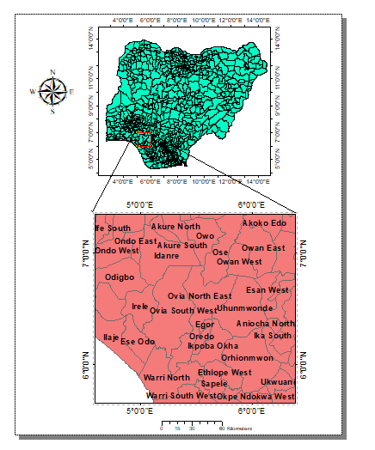

Figure 1: Map of Nigeria showing Location of the study area

- Geology Of Anambra Basin

The study area is a part of Anambra Basin. the Anambra Basin was formed when the Mid- Santonian deformation in the Benue Trough displaced the major depositional axis westwards. Post-deformational sedimentation in the Lower Benue Trough, therefore, constitutes the Anambra Basin. Sedimentation in the Anambra Basin thus commenced with the Campanian-Maastrichtian marine and paralic shales of the Enugu and Nkporo Formations, overlaid by the coal measures of the Mamu Formation. The fluvio-deltaic sandstones of the Ajali and Owelli Formations lie on the Mamu Formation and constitute its lateral equivalents in most places. In the Paleocene, the marine shales of the Imo and Nsukka Formations were deposited, overlain by the tidal Nanka Sandstone of Eocene age. Downdip, towards the Niger Delta, the Akata Shale and the Agbada Formation constitute the Paleogene equivalents of the Anambra Basin (Figure 2). The Basin Formation and the Imo Shale mark the onset of another transgression in the Anambra during the Paleocene. The shales contain significant amount of organic matter and may be potential source for the hydrocarbons in the northern part of the Niger Delta (Rivas, 2009). In the Anambra Basin, they are only locally expected to reach maturity levels for hydrocarbon exploration.

The Anambra Basin is a NE-SW-trending syncline that is part of the Cretaceous-Paleogene rift evolution of the West African Rift Systems (WARS) (Binks and Fairhead, 1992). Gravity interpretations deduced that the combined thickness of the Cretaceous-Paleogene sediments on the southern limit of the Anambra Basin could rise to more than 12 km into the Niger Delta Basin

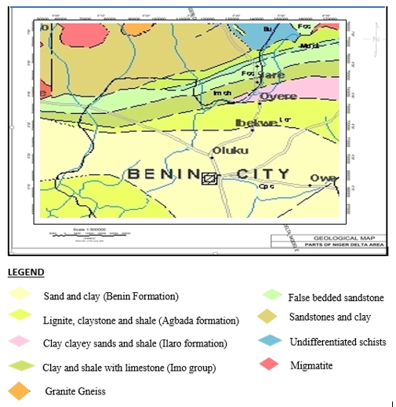
Figure 2: The Geological Map of the Study area (Extracted from Nigerian Geological map Obtained from Nigeria Geological Survey Agency NGSA)

- Materials and Methods
Four onshore bouguer gravity maps in half degree sheet on a scale of 1:100,000 were acquired from Shell Nigeria Exploration and Production Company (SNEPCO). The maps were digitized manually at 1.0 km intervals and data points obtained were merged and contoured using Oasis Montaj Geophysical software to obtain the colored merged Bouguer anomaly map of the study area (Figure 3) to be used for further processing. The procedures employed in this research include the following.
- Production of Bouguer anomaly map of the study area.
- Spectral depth determination to distinct rock types and rock boundaries within the earth crust.
- 2D modeling of the subsurface

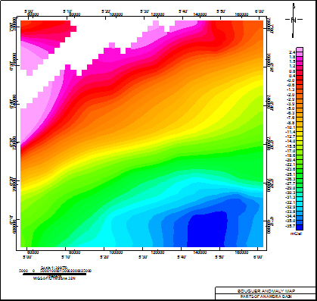

Figure 3: Bouguer Anomaly Map for the Study area

- Data enhancement techniques
A lengthy period of observation and rigorous reductions is usually carried out in the measurement of an absolute value of gravity. This is difficult and requires complex apparatus. Such reductions include Drift Corrections, latitude corrections, elevation correction, bouguer correction, tidal correction, Eotvos correction. The main end-product of gravity data reduction is the Bouguer anomaly, which should correlate only with lateral variations in density of the upper crust or near-surface environment and which are of most interest to applied geophysicists and geologists.

- Spectral Depth Analysis (SDA)
Determination of depths to discontinuities is one of the principal applications of gravity data. This statistical approach has been found to yield good estimates of mean depth to basement underlying a sedimentary basin (Udensi, 2001). Spectral analysis of gravity data uses the 2-D Fast Fourier Transform and first transforms gravity data from the space domain to the wavenumber domain and then analyzing their frequency characteristics
The total gravity anomaly values are used to obtain the two-dimensional Fourier Transform from which the spectrum is to be extracted consisting of M rows and N columns in X-Y. The depths to causative mass distributions are obtained by analyzing a plot of the logarithm of the power spectrum as a function of the wavenumber or frequency.

$LogE={LogA(k)}_{z=0}-2πkh$ (4)

where:
k = the wavenumber
h= the depth to boundary surfaces;
A(k) = the amplitude spectrum.

One can plot the wavenumber k against Log E to obtain the average depth to the Moho interface and the Conrad discontinuity. The interpretation of LogE against the wavenumber k requires the best-fit line through the lowest wavenumber of spectrum
$h =-\frac{∆LogE}{2π∆k}$ (5)

$h = -\frac{m}{2π}$ (6)

where:
h=The average depth to boundary surfaces;
ΔLogE= Variations of Energy log
Δk= Variations of wavenumber.

- 2-D geological modeling of the subsurface

Of primary concern to geophysicists is the analysis of data to generate reasonable models and predictions about the properties and structures of the subsurface. Depths to discontinuities may be estimated using 2-D Modeling with the aid of the computer installed Geosoft software - Oasis montaj Version 8.3. The software allows the digitizing of a profile from maps in Geosoft. In general, the extent (x-coordinate) and depth (z-coordinate) of the profile to be modeled are defined. In the environment, the user interactively adjusts the model parameters in order to improve the fit between the calculated and the observed depths.

In modeling operation, Profiles are spaced out and drawn through relatively less disturbed area (Udensi and Osazuwa, 2002) perpendicular to the striking length across the Bouguer gravity anomaly map in order to estimate the depths. The method used for calculating the signal response is based on the methods of Talwani using the algorithms described in Wen and Bevis

- Results and Discussions

9.1 Analysis of Bouguer Anomaly Map:
The present study is based on the gravity data within the area. The reproduced bouguer gravity anomaly map obtained from contouring of the available data for the study area is shown in Figure 3. Inspection of the reproduced map reveals that the gravity field trends in NE-SW direction. The Bouguer anomaly values follows a regular trend across the map as the values takes a regular reduction pattern with movement from north towards south. The gravity values range from -36 mGal at the south eastern parts to 2 mGal at the north western part of the study area. The negative Bouguer anomaly value which covers almost all part of the study area is as a result of the presence of Tertiary-recent sediments deposited from the Atlantic Ocean offshore This negative gravity anomaly with amplitude -35.7 mGal, is attributed to the huge sedimentary cover over the area. At the north western edge of the study area, the positive gravity anomaly is observed. The dense materials of the Idanre hill in Ondo State, which is 24.8 km south west of the state capital Akure intrudes into the soft and less dense sediments of the Anambra Basin at this region as high frequency (short wavelength) signatures are generally attributed to basement areas. The qualitative and quantitative interpretations of this map are extremely useful for determining the depths and relief of the Basement surface, Conrad and Moho discontinuities of the area.

9.2 Spectral Analysis
To analytically estimate the Conrad and Mohorovicic discontinuities beneath the study area, cross sections were constructed from the gravity anomaly map and Fast Fourier Transform (FFT) applied using the MAGMAP facility in Oasis Montaj software,
Gridding and Sectioning of the Bouguer anomaly map into nine spectra sections (SPT1-SPT9) was carried out using Oasis Montaj Geosoft and the radial spectral energies were plotted within it. The Sample Graphical Results of logarithm of spectra energy with respect to the frequency in cycles per kilometer which gives the spectra energy section generated from the MATLAB program is shown in Figure 4. The results of the depth estimate for the nine spectra sections (SPT1-SPT9) are given in Table 1.
From the earth’s surface downwards, the slope (m1) is attributed to average depth of shallow sources from the crystalline rocks (basement and/or intrusions). Meanwhile, the slope m2 is associated with the average depth to Conrad discontinuity which reflects a change in the rock type within the crust from dense silicon-aluminum (SIAL) rock type at the upper crust to denser silicon-magnesium rock type at the lower crust. However, slope m3 is connected with the average depth of the Moho discontinuity which comes about as a result of density contrast between the overlying crust and the underlying mantle.
To evaluate the corresponding depths from the slopes, Equation 6 was used as it gives relationship between the obtained slopes and the various depths to be calculated. The spectral results shows that the Basement depth ranges from 1.61 km to 9.36 km, the depths to Conrad discontinuity and the Moho discontinuity ranges from 8.24 km to 20.85 km and 24.82 to 31.83 km respectively.

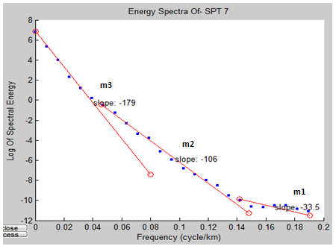
Figure 4: A graph of Log of Spectral energy against Frequency Spectral Section 7 (SPT 7)

Table 1: Basement Depth, Conrad depth and Moho depth obtained from Spectral analysis and its location

SPECTRAL SECTIONS | LONGITUDE  (⁰E) | LATITUDE  (⁰N) |  | m1 | m2 | m3 | BASEMENT DEPTH  h1 (km) | CONRAD  DEPTH  h2 (km) | MOHO  DEPTH  h3 (km)
SPT 1 | 5.00 – 5.50 | 6.00 – 6.50 |  | -45.8 | -86.0 | -171 | 7.29 | 13.69 | 27.21
SPT 2 | 5.50 – 6.00 | 6.00 – 6.50 |  | -38.2 | -76.6 | -177 | 6.09 | 12.19 | 28.17
SPT 3 | 5.00 – 5.50 | 6.50 – 7.00 |  | -10.1 | -76.8 | -158 | 1.61 | 12.22 | 25.14
SPT 4 | 5.50 – 6.00 | 6.50 – 7.00 |  | -18.0 | -51.8 | -156 | 2.86 | 8.24 | 24.82
SPT 5 | 5.00 – 6.00 | 6.00 – 6.50 |  | -54.2 | -131.0 | -199 | 8.63 | 20.85 | 31.67
SPT 6 | 5.00 – 6.00 | 6.50 – 7.00 |  | -45.5 | -75.0 | -200 | 7.24 | 11.94 | 31.83
SPT 7 | 5.00 – 5.50 | 6.00 – 7.00 |  | -33.5 | -106.0 | -179 | 5.33 | 16.87 | 28.49
SPT 8 | 5.50 – 6.00 | 6.00 – 7.00 |  | -32.2 | -90.1 | -167 | 5.12 | 14.34 | 26.58
SPT 9 | 5.00 – 6.00 | 6.00 – 7.00 |  | -58.8 | -113.0 | -195 | 9.36 | 17.98 | 31.03

9.2.1 Depth to Basement Map (Sedimentary Thickness)
The basement depth map (Figure 5) produced from results shown in Table 1 shows that the depth to the basement surface (sedimentary thickness) within the area ranges approximately from 1.6 km to 9.3 km. This corresponds to the stated maximum sedimentary thickness of the Anambra Basin 9 km (Iheanacho, 2010). The map exhibits common thickening of sedimentary cover towards the central region of the study area. At all regions in the study area except at the NW region where the Idanre hill intrude into the study area, it is observed that the depth to basement is above 3 km. This reflects a large thick sedimentary basin which indicates that the area is of great interest in hydrocarbon exploration. Maximum depth values to basement surface are encountered in the central portion (9.3 km), this depth is seen to decrease with movement away from the center indicating that the area is indeed a “Basin”

9.2.2 Conrad Discontinuity Map
The Conrad Depth map (Figure 6) shows the depth of the Conrad discontinuity as obtained from the Spectral approach. At this depth, the continental crust (SIAL) becomes close in physical properties to the oceanic crust (SIMA) and this is due to the change in velocity seismic wave at this sub horizontal boundary. This depth ranges from 8 km to 21 km within the study area. The low Conrad depth of 8 km shows that in this Basin, the basement rock underlying the sediments is
Longitude (Degree)
Latitude (Degree)
km
Figure 5: The Contour map of Basement depth obtained from spectral analysis for the Study area

N

Figure 6: The Contour map of Conrad Discontinuity obtained from spectral analysis for the Study area

N
Longitude (Degree)
Latitude (Degree)
km
interpreted to be oceanic crust unlike some Sedimentary basins in Nigeria like the Bida Basin that are underlain by continental crust. This explains why the Conrad depth looks like the Depth to Basement as the range of the Conrad depth is interwoven with the range of the Sedimentary thickness. The Conrad depth with highest thickness is seen at Longitude 5.5⁰E and Latitude 6.5⁰N within the study area.

9.2.3 Moho Discontinuity Map
The Moho discontinuity map (Figure 7) reveals that the depth to the Moho attains its maximum value of about 32 km along longitude 5.5⁰E. This depth decreases gradually eastward and westward reaching its minimum value of 24.5 km at the NW and NE corner of the study area. Depth to Moho from this map can be said to approach its maximum thickness at the central region of the study area.

N
Longitude (Degree)
Latitude (Degree)
km
Figure 7: The Contour map of the Moho depth obtained from Spectral analysis for the study area

9.3 2-D Modeling
In this research work, four profiles A-A', B-B', C-C' and D-D’ were investigated with the 2-D modeling approach followed by a modification of the model parameters to obtain the improved models and good fitness between the observed and calculated curves as illustrated in the modeling results. The positions of these profiles are also shown on the geological map of the study area (Figure 8a). Three profiles (A-A', B-B' and C-C') were taken along the NW-SE direction to include the negative and positive Bouguer anomalies values across the region and one profile (D-D’) was taken along the SW-SE direction.

9.3.1 Modeling along Profile A-A|

The A-A' profile Figure 8(b) cut across the only pronounced anomaly within the study area marked “Z” at the southern region of the study area and runs through towns like Ulegu, Oluku and Benin moat all in Edo State The profile A-A' cuts across the study area in NW-SE direction into the pronounced anomaly marked “Z” and extends to about 99 km long. Oluku, Benin Moat and Ulegu - towns through which profile A-A| cuts in Edo state Nigeria, are 14.6 km, 5.0 km, 15.6 km away from Edo state capital, Benin City respectively. The Bouguer anomaly values of different amplitudes and gradients ranges from – 36 mGal at its southern end to 1.2 mGal at its northern end.

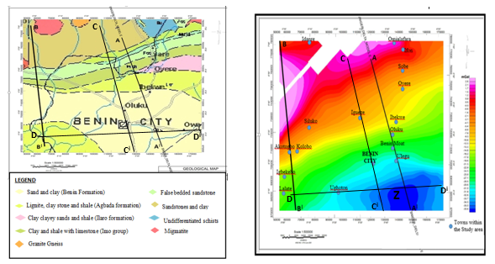
(b)
(a)
Figure 8: (a) Geology map of study area with locations of 2-D Modeling profiles (b) Bouguer gravity map with towns within the study area and locations of 2-D Modeling profiles (A-A|, B-B|, C-C| and D-D|)

The crustal model for profile A-A' (Figure 9) shows two major layers above the Moho discontinuity (sediments and the crust) which differ in thickness and density. Apparent density of overlying sediments indicating the Benin formation, Agbada formation and Imo Shale on average is 2.59g/cm³, 2.62 g/cm³ and 2.63 g/cm³ respectively. The positive anomalies came about as a result of basement rock (migmatite) from the Idanre hill, southwestern Nigeria that intrude into the sedimentary region of the study area and hence the resulted model supports a basement of high density migmatitic crust with a uniform density of 2.65g/cm³.

The Depth to Basement (Sedimentary thickness) is seen to show large variation with a maximum depth of 15 km which indicates that the region is adequate for Crude oil exploration. The model approximates the Moho depth below this region to range between 32 km and 41 km and the rock density below Moho discontinuity (Mantle) is calculated to be 3.2 g/cm³.

9.3.2 Modeling along Profile B-B'
Figure 10 gives the modeling result along profile B-B'. The selection of a second profile for 2-D Modeling was motivated by the results of the prior Model which indicated reasons for the positive anomaly values observed in the northwestern region of the study area. The B-B' profile shown in Figure 8a and 8b cut across the study area in NW – SE direction from a basement terrain towards a relatively undisturbed region in the area with a horizontal distance of about 109 km. Profile B-B' shown in Figure 5 runs across the Flank of Idanre hill (a basement complex) at the north through Akotogbo town in Irele, Ondo State. Nigeria located at Longitude 5.03⁰E and Latitude 6.39⁰N. Left of B-B' profile are towns like Igbekelo and Lalate towns in Ondo state and right of the profile is seen Siluko and Kolobo towns in Edo state Nigeria.

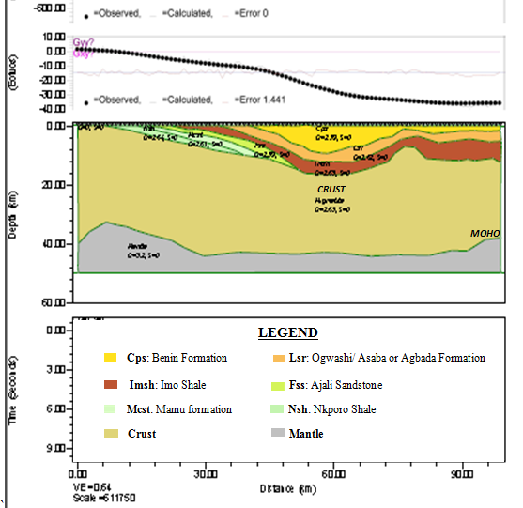
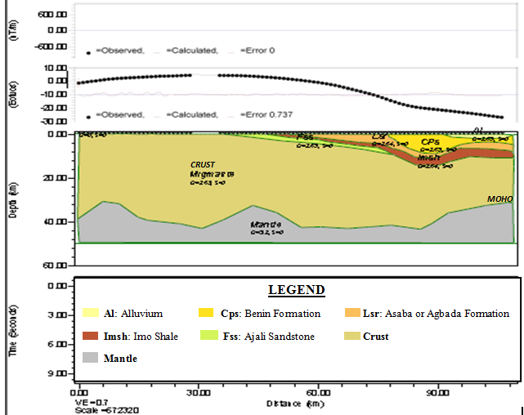

Figure 9: Crustal Modeling along Profile A-A|

Figure 10: Crustal Modeling along Profile B-B|

The gravity field along this profile shows a maximum value of about 2 mGal near the northern part where the Idanre hill in Ondo state intrude into the sediments of the Anambra Basin. A major minimum of approximately –30 mGal is observed at its southern end. A portion of the observed gravity appears empty as a result of absence of gravity data for that region as river Owena (in Ondo state) flows across the region.

The depth scale on this profile shown in the Modeling shows sediments of average density 2.634 g/cm³ and a crustal migmatitic layer of average density 2.65 g/cm³. The basement relief described as high corrugated surface at depth has a maximum value of 14 km along this trend. This increase in basement depth along the profile southwards is as a result of movement from mountainous areas surrounding the study area to the sedimentary regions within the study area. The positive anomalies shown in Figure 4 have been attributed to basement rock (migmatite) that intrudes into the sedimentary region of the study area. Mohorovicic discontinuity shows depth variation of 30 km to 41 km along this profile. It is characterized by a significant density variation from 2.65 g/cm³ of the crust to 3.2 g/cm³ for upper mantle.

9.3.3 Modeling along Profile C-C'
Profile C-C' which extends to about 100 km runs NW-SE direction and cuts across Igueze and Benin city- Edo state capital running into the pronounced anomaly marked ‘Z’ as is the case in Profile A-A'. The Bouguer anomaly values of different amplitudes and gradients ranges from – 33 mGal at its southern end to -8 mGal at its northern end.
The crustal model for profile C-C' (Figure 11) shows two major layers above the Moho discontinuity (Upper Crust and the Lower Crust) which differ in thickness and density. The Apparent density of the upper crust is made up of sediments has an apparent density of 2.7 g/cm³. the Lower crust and the Migmatitic mantle possess apparent densities of 2.9 g/cm³ and 3.2 g/cm³ respectively. The upper crust is made of sediments.

9.3.4 Modeling along Profile D-D'
Profile D-D' intersects all other three profiles (A-A', B-B' and C-C') and runs SW-SE direction cutting through Ughoton Town in Edo State. This profile which cuts through Ughoton town (Longitude 5.3632⁰E and Latitude 6.1662⁰N) runs into the anomaly ‘Z’ at the South-Eastern part of the study area as Profile A-A' and C-C'. A horizontal distance of about 105 km is covered by this profile. At the lower half of this model (Figure 12) is seen a highly dense mantle (3.2 g/cm³) underlying a 2.9 g/cm³ dense lower crust.

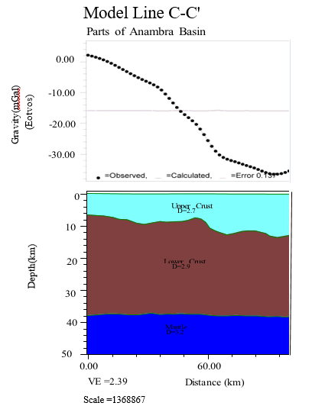
Figure 11: Crustal Modeling along Profile C-C|

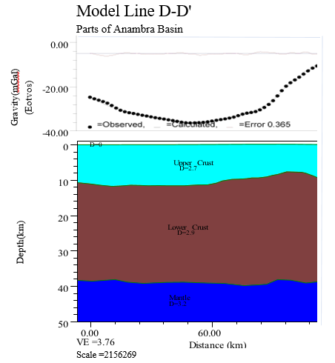
Figure 12: Crustal Modeling along Profile D-D|

- Surface Plot
The Moho depths from corresponding positions from Spectral analysis and 2D Modeling was added and averaged and a 3-D Surface plot of Moho Depth against location plotted (Figure 13). The plot shows an almost uniform Moho depth across the region except at the northwestern and southwestern edges of the area where volcanic intrusions (migmatite) are obvious. This agrees with the geological map (Figure 2) of the study area as these volcanic intrusions which are migmatite from the mantle are seen to intrude at the surface at these regions.

Figure 13: 3-D Surface plot of the Moho depth obtained from Spectral and 2D Modeling for the Study area.

CONCLUSION
The bouguer anomaly map of the study area highlights negative bouguer anomaly values which are as a result of presence of lights sediments and which covers almost all the part of the study area and the positive gravity anomaly observed at the north western region of the study area highlights the dense materials of the Idanre hill which intrudes into the soft and less dense sediments of the Anambra Basin.

Application of the spectral analysis technique to the gravity field provided average depth estimates to three major depths attributed to the Basement, Conrad and Moho discontinuities at the ranges of 1.6 – 9.35 km, 8.24 - 20.24 km and 24.82 – 34.82 km respectively. The calculated depths show good correlation with the depth results previously deduced on the basis of the gravity and seismic refraction survey.

The 2D Modeling carried out along Four gravity profiles explain the shape and variations of the Moho discontinuity along these profiles. The modeled profiles show a good fit between the observed and computed curves, confirming the likely occurrence of the proposed subsurface structures in the lower part of the profiles. The result of the 2-Dimensional Modeling along the four profiles shows three (3) distinct layers distinguished by its different densities The density model used indicate that the average densities of the different rock layers in the study area are: 2.62 g/cm³for the Sedimentary cover, 2.65 g/cm³for the Crustal layer and 3.2 g/cm³for the upper Mantle. It is possible to conclude that the gravity field in the study area is made up of highly dense and thick sediments which gives an indication that the area will be viable for hydrocarbon exploration,

The surface plot of the Mohorovicic discontinuity beneath the study area obtained from the average of the spectral and Modeling approach is seen to occur at a depth range between 30.5 km and 41.5 km. This is a considerable Moho depth for a tectonically stable zone.

COMPETING INTERESTS
Authors have declared that no competing interests exist.

REFERENCES

- Akpan, O., Nyblade, A., Okereke, C., Oden, M., Emry, E., & Jordi, J., (2015). Crustal structure of Nigeria and Southern Ghana, West Africa from P-wave receiver functions. Tectonophysics Journal, 2, 1-10.
- Binks, R.M. & Fairhead, J.D. (1992). A plate tectonic setting for the Mesozoic rifts of the Westand Central Africa. Tectonophysics, 213: 41-151.
- Dentith, M. & Mudge, S. (2014). Geophysics for the mineral exploration Geoscientist (1st Edition), Cambridge University Press, New York.; 87-88.
- Gomez –Ortiz, D., Tejero-Lopez, R., Babin- Vich, R., & Rivas-ponce, A. (2005). Crustal Density Structure in the Spanish central system derived from gravity data analysis (Central Spain). Tectonophysics 327, 37-59.
- Iheanacho, P. U. (2010). Subsurface evaluation of source rock and hydrocarbon potential of the Anambra basin, southeastern Nigeria (PDF). Dissertation.com boca raton, Florida, USA www.bookpump.com. ISBN 978-1-59942-339-5. Retrieved June 22, 2016
- Jamal, A., & Mahmoud, M. U., (2015). Estimate the Crust thickness using Gravity data for the Kopehtdagh region. Indian Journal of Science and Technology, 8(S9), 513-517.
- Lefort, J. P., & Agarwal, B. N. P. (2002). Topography of the Moho Undulations in France from Gravity data: their age and origin. Tectonophysics 350, 193-213.
- Nabighian, M. N., Ander, M. E., Grauch, V. J. S., Hansen, R. O., LaFehr, T. R., Li, Y., Pearson, W. C., Peirce, J. W., Phillips J. D. & Ruder, M. E. (2001). Historical development of gravity method in exploration. Geophysics.;23(17): 11- 31
- Ofoha, C. C., Emujakporue, G. & Ekine, A. S. (2018) Structural evaluation of bouguer gravity data covering parts of southern Niger delta, Nigeria. Archives of Current Research International, 13(3), 1-18.
- Rivas, J. (2009) Gravity and magnetic method. Geothermal training programme, presented at short course on surface presented at short course on surface organized by UNU- GTP and LaGeo in Ahuachapan and Santa Tecla, El Salvador.;1-13.
- Rivero, L., Pinto, V., & Casas, A. (2002). Moho depth Structure of the Eastern part of the Pyrenean Belt derived from Gravity data. Journal of Geodynamics, 33, 315-332.
- Telford, W. M., Geldert, L. P., Sheriff, R. E., & Kets, D. A. (1980). Applied Geophysics. First Edition, (pp.860). London, Cambridge University Press.
- Tokunbo A., (2021). Nigerian Financial Publication Stears Business.
- Udensi, E. E. (2000). Estimation of the Moho depth of the Minna Area using Bouguer Gravity Anomaly data. Journal of Science, Technology and Mathematics Education (JOSMED), 3(1), 10-18.
- Udensi, E. E. (2001). Basement Depth Estimates of Sokoto Sedimentary basin, Northwestern Nigeria, using Spectral Depth Analysis. International Journal of Engineering and Science, 3(6), 10-14.
- Udensi, E. E. & Osazuwa, I. B. (2002). Two & Half dimensional Modeling of the Major structures underlying the Nupe Basin, Nigeria using Aeromagnetic data. Nigeria Journal of Physics, 14(1), 55-61.

