Delineating the Regional Gold Mineral Veins within Wawa (Sheet 128) and Kubil (Sheet 159) Niger State, Nigeria, North Central Nigeria
U.D Alhassan., Lawrence Jane O. and Aisha Alkali.
Department of Geophysics, Federal University of Technology, Minna, Niger State, Nigeria
Corresponding Author:Aisha Alkali aisha.alkali@futminna.edu.ng Ph. No.0803570309
ABSTRACT
Aeromagnetic data subjected to various filtering method: Analytical Signal, First Vertical Derivatives(FVD) and Center for Exploration Targeting (CET). was used to delineate the geological structures that could serve as host to gold within Wawa (Sheet 128) and Kubil (Sheet 159) Niger State, Nigeria. The area is bounded by Latitude 4º00' and 4º30E' to Longitude 9º30' and 10º30'N. The total magnetic intensity map comprises of both positive and negative anomalies with magnetic values within the study area ranges from -66.589 nT to 129.237 nT. The result of the FVD and CET revealed magnetic lineaments in SW-NE direction that could serve as gold veins around latitude 9º50' to 10º10'N within Yangari, Lasun Sarabe, Wawa Malete town down to Doro across river Yakumosin. The major lineament are mapped as F1 to F7 on the first vertical derivatives.
Key words: Aeromagnetic data, Wawa sheet, Kubil sheet, Analytical signal. First Vertical Derivative, Center for Exploration Targeting, Geological Structures, Gold veins.
1.0 Background to the Study
Geophysics is a very potent and vital tool for exploration and is consistently used in detailed surveys. There are a lot of geophysical survey methods which include gravity, magnetic, radiometric, seismic, electrical resistivity etc. Each of this survey method have unique operative physical property like density, magnetic susceptibility, radioactivity, propagation or velocity of seismic waves, electrical conductivity etc. of the Earth (Kearey et al., 2002). These methods are useful in the investigation of the subsurface geology of an area of interest.
Magnetic method seeks to probe the geology of the particular area due to difference in the susceptibility of the field. These differences are as a result of the magnetic features of the rocks subsurface (Kearey et al., 2002) which can be taken on air (aeromagnetic), land or at sea.
The study focuses on the exploration of gold and gemstone deposits in the study area using aeromagnetic data interpretation. Gold vein deposits are of significant interest due to their economic value and potential for mining operations. The geological formation of an area of study is crucial role in the hosting of minerals, as certain rock types and structures are more favorable for the accumulation of minerals such as gold. Identifying potential host structures for gold veins is essential for efficient and effective mining operations, as it allows for targeted exploration and reduces the need for random and destructive mining activities. The study aims to utilize aeromagnetic data analysis in revealing subsurface structures, to accurately locate potential mineral deposits such as gold veins in the study area.
The Nigeria Geological Survey Agency is recent times have played an invaluable role in the exploration for mineral deposits. Presently, there is a great interest in the development of solid mineral resources whose production in the last three decades has been depreciating in every case. The privatisation, commercialisation and general reform exercises currently being undertaken by the Federal Republic of Nigeria are expected to lead to a positive change in the exploration, growth and development of Nigeria’s solid mineral resources (Rowland & Ahmed, 2018).

2.0 Objectives of the research
The objectives of the research are:
(a) to generate a Total Magnetic Intensity (TMI) map of the study area from gridded data.
(b) to apply aeromagnetic data analysis to accurately locate potential minerals, such as gold and gemstones, in the study area.
(c) to delineate geological structures that could potentially host solid minerals, including gold and gemstones, in the study area.
(d) to enhance mining operations by providing accurate information on the location of potential mineral deposits, improving productivity in the study area.
(e) to correlate the identified geological structures with other data, such as First Vertical Derivatives (FVD), Central Exploration Targeting (CET), and the geology map, to gain a comprehensive understanding of the subsurface structures and potential mineral resources in the study area.
3.0 Location and Geology of the Study Area
The study area Kubil (Sheet 128) and Wawa (Sheet 159) under Borgu local Government Area of Niger State is located between Longitude 4º00'E – 4°30'E and Latitude 9°30'N – 10°30'N. It occupy the portion of the basement complex in Niger state. The Kubil and Wawa area comprises of meta sedimentary and meta-igneous rocks which have undergone polyphase deformation and metamorphism. These rocks have been intruded by granitic rocks of Pan-African age (Obaje et al., 2004). Ten lithostratigraphic units have been recognized in Kubil and Wawa area (Figure 2). The schist which occur as a flat laying narrow southwest-northeast belt at the central part of Borgu with small quartzite ridge parallel to it, the gneiss occur as a small suites at the northern and southern part of the area forming a contact with the granite. Feldspathic rich pegmatite is bounded to the east, the pegmatite host tourmaline. Granitic rocks dominate the rock types in the area and vary in texture and composition (Obaje et al., 2004)/
The area under investigation is Kubil (sheet 128) and Wawa (sheet 159) in Borgu local government area of Niger State, North Central Nigeria, it is bounded by Longitude 4°00”E – 4°300”E and Latitude 9°30’0”N - 10°30’0’’N (Figure 3). The study area is located at the western part of Niger state which falls within basement complex and cretaceous sediment area is about 9 Km away from New Bussa. The region has an undulating topography and the elevation varies between 279 m above sea level. This area of study is accessible through a network of major and minor roads in addition to several foot paths.

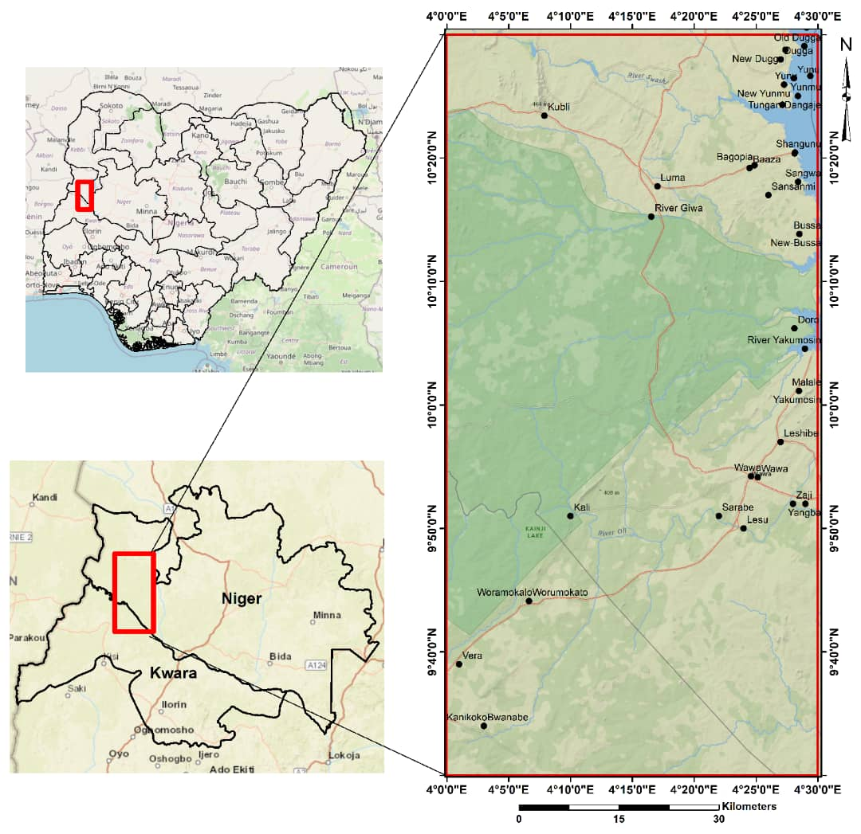
Figure 2 (a),(b) and (c): Location Map of the Study Area

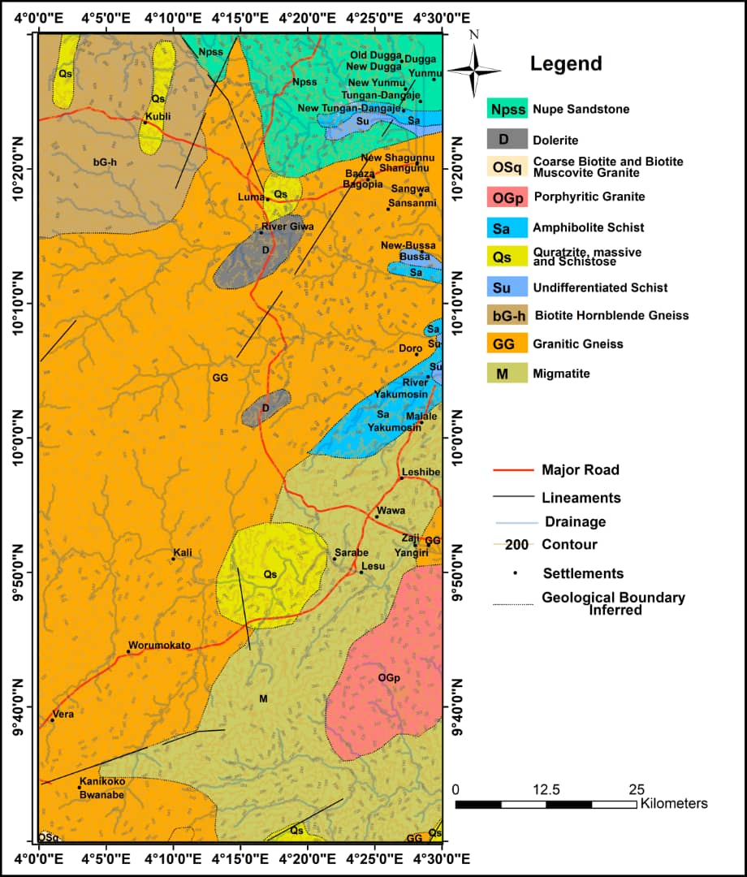
Figure 3: Geology Map of the study area (Modified from NGSA, 2009)

4. METHOD
Methods used in the study are
- The total magnetic intensity (TMI) map (Composite aeromagnetic map) was generated from the gridded data and reduction to equator and pole was applied to remove dependence on the angle of inclination and declination
- Horizontal derivative analysis was performed to enhance near-surface structures and provide input data for further analysis .
- Analytical signal evaluation was used to identify regions of outcrop near-surface intrusive bodies and to place anomalies directly above the causative body .
- Correlation of structures was done using First Vertical Derivatives (FVD), Central Exploration Targeting (CET), and the geology map to delineate structures that could potentially host gold mineralization and associated minerals .

5.0 RESULTS AND DISCUSSION

5.1 The Total Magnetic Intensity Map (TMI) production of the Study Area
The gridded aeromagnetic data (Figure 4) exhibits the various magnetic susceptibility that constitutes the lithology within the study area. Being an area that is close to the equator the effect of Earth’s field plays a significant role in variation of susceptibility. Regions of high positive magnetic susceptibility shows magnetic values ranging from 85.776 nT to 129.237 nT while regions with low magnetic susceptibility shows magnetic values ranging from -66.589 nT to 53.871 nT. This range in magnetic susceptibility from -66.589 nT to 129.237 nT, indicates lateral variations in rock composition

5.2 Total Magnetic Intensity Reduce to Equator Map (TMI-RTE)
The TMI map was reduced to Equator (Figure 5) for the purpose of removing the dependency of the magnetic field on the angle of inclination and as a result, the position and shape of the anomaly was altered. The anomalies were observed to have been mixed with low and high anomalies. The areas with high magnetic susceptibility shows high magnetic value ranging from 85.776 nT to 129.237 nT while region with low magnetic susceptibility shows magnetic values ranges from -66.589 nT to 53.871 nT.

5.3 Total magnetic Intensity Reduce to Pole (TMI-RTP) Map
In the (TMI-RTP), relatively high magnetic intensity anomaly dominate the entire central portion of the study area, which may be due to the effect of granite gneiss susceptibility compare to other lithologies within the study area. Regional trend of major anomalies within the area is NE-SW except for E-W trending with low susceptibility at the Northern end, within the Biotite gneiss. The areas with high magnetic susceptibility shows high magnetic values ranging from 85.776 nT to 129.237 nT while region with low magnetic susceptibility shows magnetic values ranging from -66.589 nT to 53.871 nT. (Figure 6)

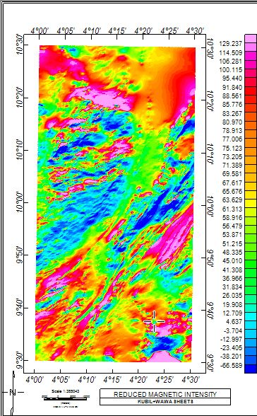
Figure (4) Total Magnetic Intensity Map (TMI) of the Study Area

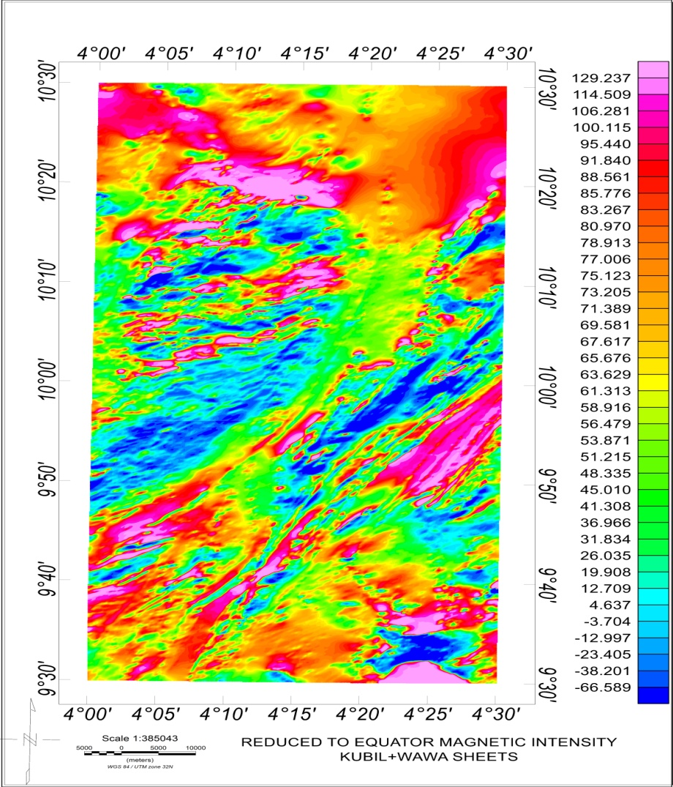
Figure 5: Total Magnetic Intensity Reduce to Equator Map of the Study Area

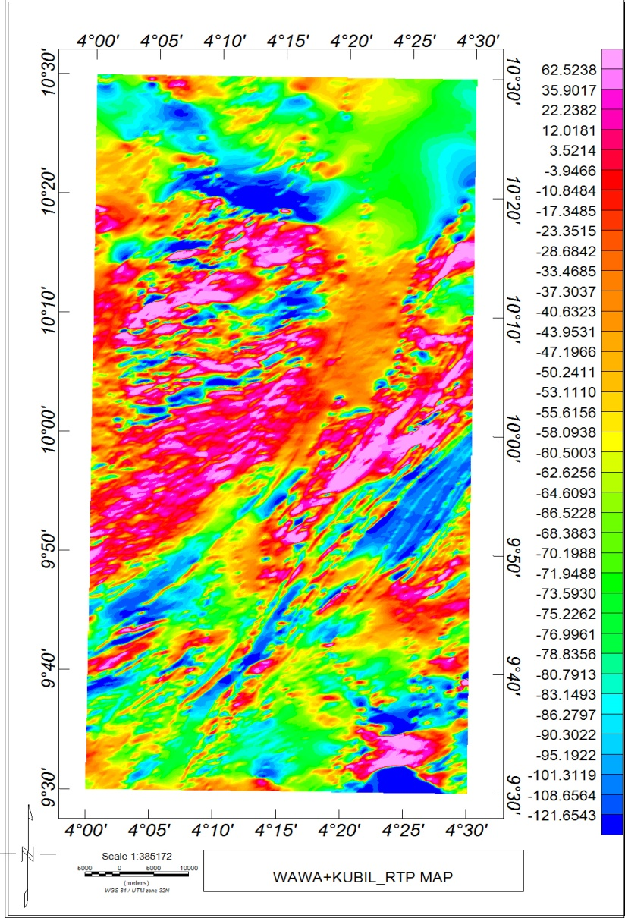
Figure 6: Total Magnetic Intensity Map (TMI) Reduced to Pole Map of the Study Area

5.4 Derivative
The Nupe sand stone that constitute part of the sedimentary formation within the study area is situated at North-eastern corner and is intruded by Amphibolite shirts strata (Figure 2.1 Geology Map) this is very evident on the derivative maps. The contact between this sedimentary formation and the basement which forms more than 80% of the entire areas is define by a set of fold and a fracture line that is evident as a horizontal line around latitude 10º20' on the First Vertical Derivative (FVD).

5.4.1 Horizontal derivatives map (Dx, Dy and Dz)
Three derivatives were computed as in xyz directions and mapped; they signify the turning points to the magnetic data at a shallow depth. These directional derivatives illustrates sharp changes in regular pattern to the magnetic values that can be interpreted as lineament and their relative directions. Generally the structures deduced from these derivatives trends in NS-EW direction agree with the regional structural trend within the field. These structures are shown vividly on the (Figure 7, 8 and 9) Dx and Dz derivatives.

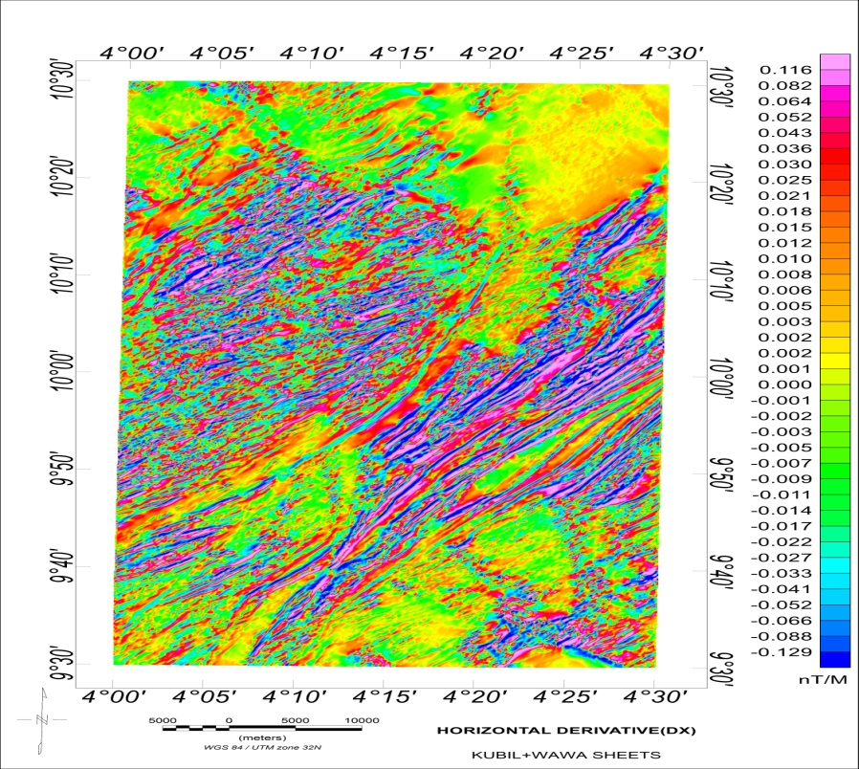

Figure 7: Horizontal Derivatives Map (Dx) of the Study Area

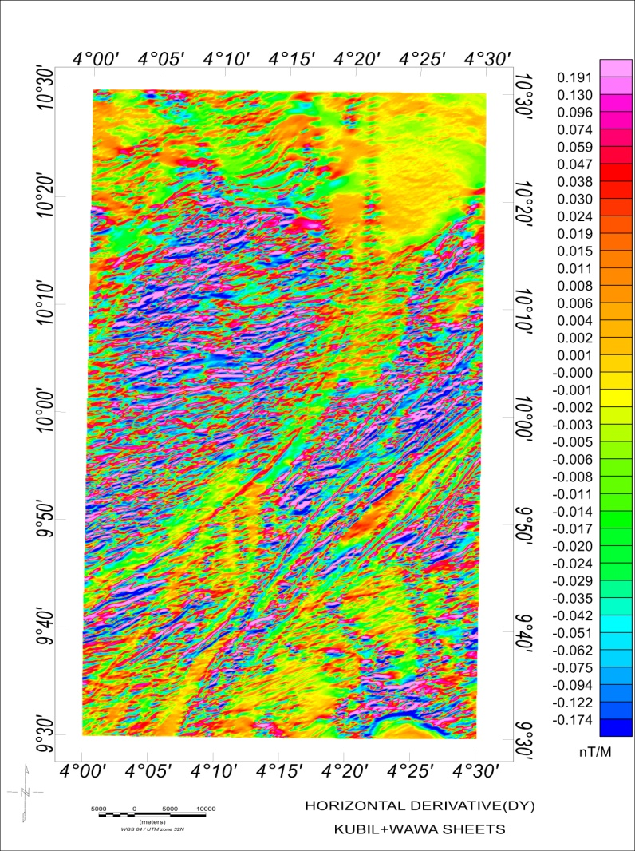

Figure 8: Horizontal Derivatives Map (Dy) of the Study Area

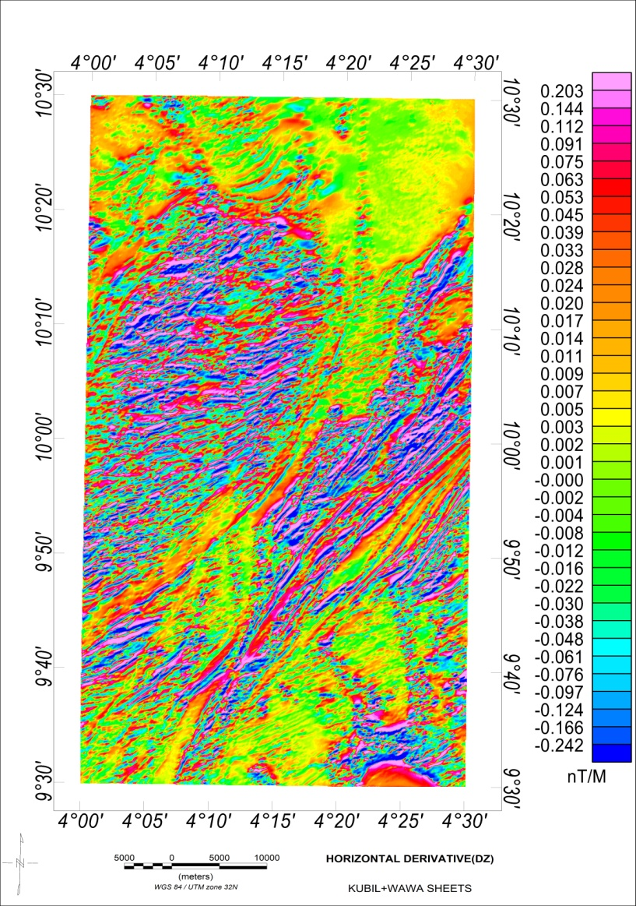
Figure 9: Horizontal Derivatives Map (Dz) of the Study Area

5.5 Analytical Signal Map
The analytical signal map depicts the amplitude responses of the magnetic susceptibility ranges from 0.232 m to 0.355 m represent region of magnetic rocks. Specific major anomalies were clearly observed and delineated above the causative bodies. While the amplitude response of the magnetic susceptibility which ranges from 0.010 m to 0.218 m represent high sedimentation. It is observed that regions with very low amplitude are regions of maximum depth to magnetic rocks while regions with high amplitude have minimum depth to magnetic rocks (Figure 10).

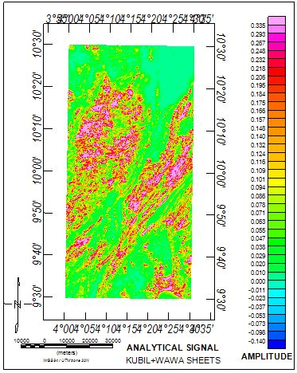
Figure 10: Analytical Signal Map of the Study Area

5.6 First Vertical Derivative Map (FVD)
The relatively high overburden regions are in yellowish green colouration in the FVD map (Figure 11). The area of low overburden in blue to pink colour. Regions of lineaments are marked with deep blue and deep red colour depending on the susceptibility of the anomaly. These lineaments are mapped on the grey scale of first vertical derivative map (Figure 12). In the mineralized zone are observed lineaments starting from the North East and trending in South Western direction, around latitude 9º50'N to 10º10'N within Yangari Village to Lasun, Sarabe, Wawa, Malete down to Doro across rivers Yakumosin.

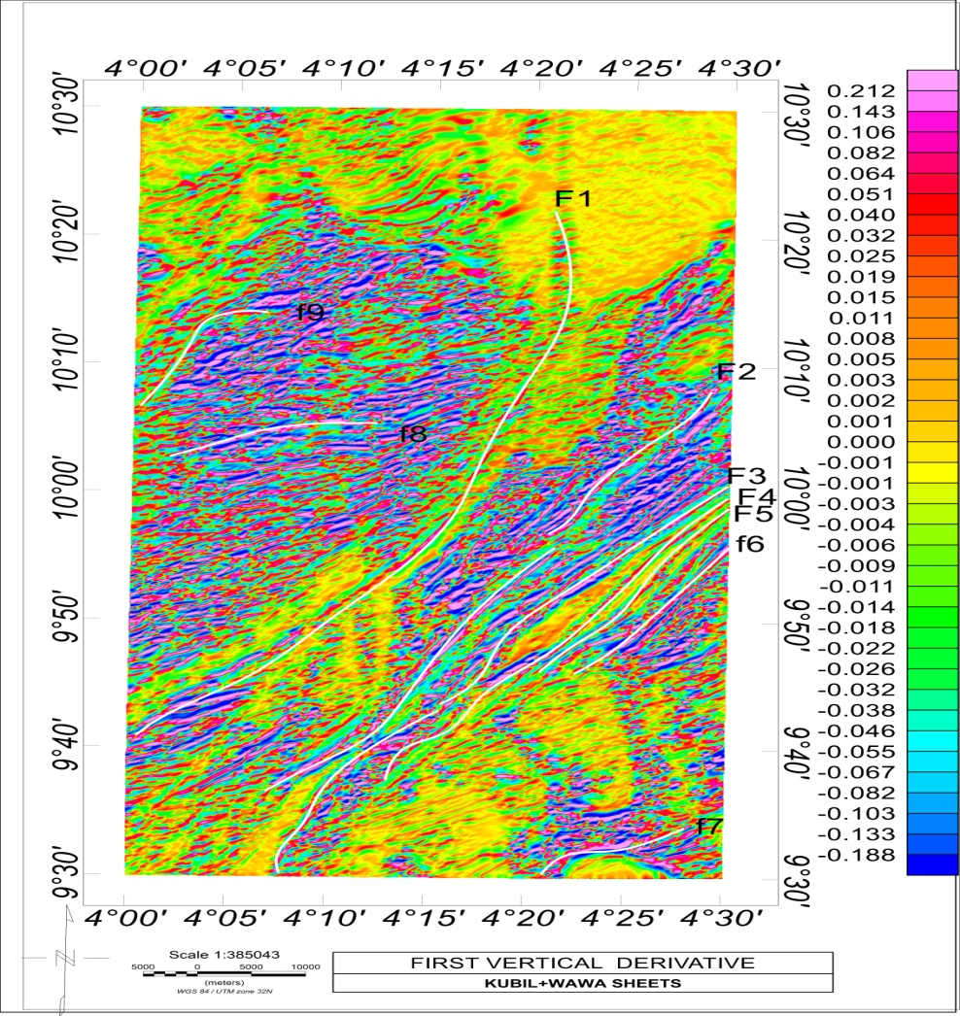
Figure 11: First Vertical Derivatives Map (FVD) of the Study Area

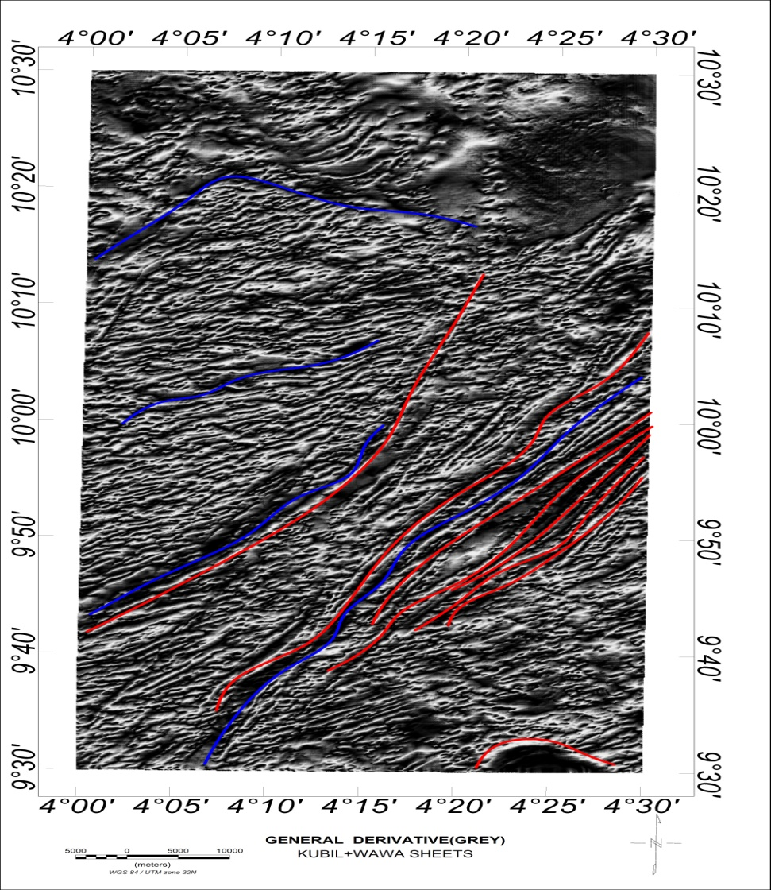

Figure 12: First Vertical Derivatives Map (Grey Scale) of the Study Area

5.7 Centre for Exploration Targeting (CET) Map
Centre for exploration targeting delineate and map lineaments automatically extracting the coordinates where lineaments were observed.. The results from CET map (Figure 13) interestingly correlate with the lineaments mapped on the first vertical derivative. Between Latitude 9º50' to 10º10' are observed major structures and lineament with varying degree of mineralization..

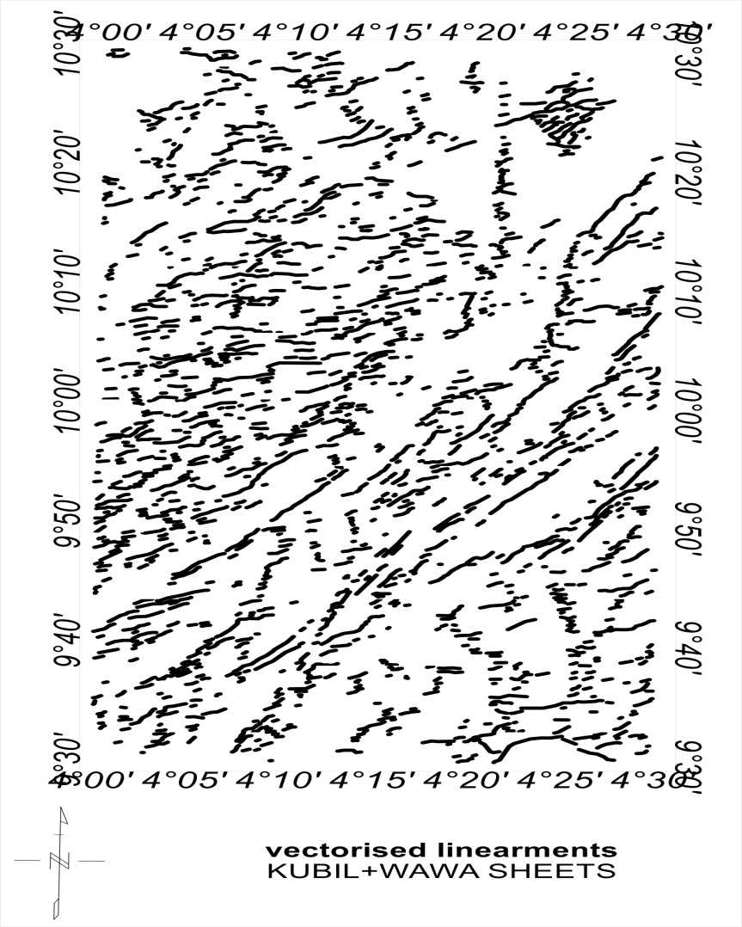

Figure 13: Center for Exploration Targeting Map (CET) of the study area

6.0 CONCLUSION
The Aeromagnetic data of Kubil and Wawa areas were interpreted to delineate the structure that can serve as host for gold mineralization and other associated minerals. An area of 55 X 110 km square was subjected to filtering method such as vertical derivatives, horizontal derivative, analytical signal and Centre for exploration targeting (CET). The following results were obtained:

The total magnetic intensity map comprises of both positive and negative anomalies of which the negative anomalies are observed at the mid portion of the study area with some isolated anomalies showing high magnetic susceptibility. The magnetic susceptibility of the study area ranges from 66.589 nT to 129.237 nT. The variations in susceptibility occur as a result of lateral variation in rock.
The first vertical derivative (FVD) delineated regions of high overburden with yellowish green colouration and area of basement of low overburden with blue and pink colour. Lineaments were observed in the FVD and CET majorly around the western region and trending in SW-NE direction around latitude 9º50'N to 10º00'N to Lasun Sarabe, Wawa malete down to Divo across rivers Yakumosin. These regions are regions where gold are likely to be found.

REFERENCES
Adetona A. Abbass and Abu Mallam (2013). Estimating the Thickness of Sedimentation within lower Benue Basin and Upper Anambra Basin, Nigeria, using both spectral depth determination and source parameter imaging. International Scholarly Research. Volume 2019, https://doi.org/10.1155/2019/8202879

Adewumi T., and Salako K.A, (2017). Delineation of mineral zone using high resolution aeromagnetic data over part of Nasarawa State, North Central Nigeria. Egypt. J.petrol. (2017), https://doi.org/10.1016/j.ejpe.2017.11.002

Amigun J. O, Afolabi O and Ako B. D (2012). Application of airborne magnetic data to mineral exploration in the Okene Iron Ore Province of Nigeria. International Research Journal of Geology and Mining (IRJGM) (2276-6618) Vol. 2(6) pp. 132-140, August 2012Available online http://www.interesjournals.org/IRJGM

Bala G.A, Wante H.P and Ngaram S.M (2016). Interpretation of High Resolution Aeromagnetic Data of Chibok and Damboa in North Eastern Nigeria Using Spectral Analysis Method for Hydrocarbon Potential. International Digital Organization For Scientific Research Issn: 2550-794x Idosr Journal Of Scientific Research 1(1): 1-27, 2016.

Bashar, M. G.,Y. A. Sanusi, and Udensi, E. E. (2016). Interpretation of Aeromagnetic Data Over Birnin-Kebbi And Its Adjoining Areas Using First Vertical Derivative And Local Wave number Methods. IOSR Journal of Applied Geology and Geophysics (IOSR-JAGG) e-ISSN: 2321–0990, p-ISSN: 2321–0982.Volume 5, Issue 5 Ver. I (Sep. – Oct. 2017), PP 44-53 www.iosrjournals.org.

Clark, D. A. (1997). Magnetic properties of rocks and minerals. AGSO Journal of Australian Geology and Geophysics, 17(2).

Clark, D. A. and Emerson, D. W. (1991). Notes on rock magnetic characteristics in applied Geophysical studies. Exploration Geophysics, pp. 22:547–555.
Dahuwa, D., Umar .W, Sani .M, and Abba .L. (2018). Aeromagnetic data analysis of Tafawa Balewa area using second vertical derivative and analytic signal techniques. IOSR Journal of Applied Geology and Geophysics (IOSR-JAGG) e-ISSN: 2321–0990, p-ISSN: 2321–0982.Volume 6, Issue 1 Ver. I (Jan. – Feb. 2018), PP 25-32 www.iosrjournals.org

Dalan, R.A. (2006). A geophysical approach to buried site detection using down-hole susceptibility and soil magnetic techniques. Archaeological Prospection 13, pp. 182–206

Dearing J.A, (1994). Environmental magnetic susceptibility, using the Bartington MS2 system.

Fraser G. and Jack D., (2002). An introduction to geophysical Exploration third Edition. TJ international. pp. 2-160

Inglis D.R. (1955). Theories of the Earth's Magnetism Rev. Mod. Physics. 27, pp. 212–248

Ishalu Godwin and Tsepav .M.T. (2018). Interpretation of Ground Magnetic Data, Over Suspected Gold Deposit in Gwam, Paikoro LGA Niger State. International Journal of Advances in Scientific Research and Engineering (ijasre) E-ISSN : 2454-8006 DOI: http://dx.doi.org/10.7324/IJASRE.2018.32686 Volume 4, Issue 4 April – 2018.

Kearey .P, Brooks .M, and Hill .L. (2002). An introduction to geophysical Exploration third Edition. TJ international. pp. 2-160

Kono, M. and Schubert, G. (2007). Geomagnetism (Treatise on Geophysics) Volume 5.

Kovise, (1991). An introduction to geophysical Exploration second Edition. TJ international. pp. 10-150

Lam A., Jack .P, and Doka A. (1992). Application of airborne magnetic data to mineral exploration in the Okene Iron Ore Province of Nigeria. International Research Journal of Geology and Mining (IRJGM) (2276-6618) Vol. 2(6) pp. 132-140, August 2012 Available online http://www.interesjournals.org/IRJGM.

Modified from NGSA, (2009). Nigeria Geological Survey Agency.

Murphy, B. S. R. (2007). Airborne geophysics and the indian scenario. J. Ind. Geophysics Union, 11(1): pp. 1–28.

Obaje N.G., Wehner H., Abubakar M.B., and Isah M.T. (2004). Well, Gongola Basin (Upper Benue Trough, Nigeria): source-rock evaluation Namibia using high resolution aeromagnetic, radiometric, Landsat data and aerial photographs

Ofoha C.C. (2015). Geological Interpretations Inferred From A High Resolution Aeromagnetic (Hram) Data Overs Parts Of Mmaku And Environs, South Eastern, Nigeria. International Journal of Applied Science and Mathematical Theory ISSN 2489-009X Vol. 1 No.8 2015 www.iiardonline.org

Okonkwo C. C, Onwuemesi A. G., Anakwuba E. K, Chinwuko A. I, Ikumbur B. E, and Usman A. O., (2012 ).Aeromagnetic Interpretation over Maiduguri and Environs of Southern Chad Basin, Nigeria. Journal of Earth Sciences and Geotechnical Engineering, vol.2, no. 3, 2012, 77-93 ISSN: 1792-9040(print), 1792-9660 (online) Scienpress Ltd, 2012

Onuba, L. N, Anudu G.K., Chiaghanam O.I. and Anakwuba E.K., (2011). Evaluation of Aeromagnetic Anomalies Over Okigwe Area, Southeastern Nigeria. Research Journal of Environmental and Earth Sciences 3(5): 498-507, 2011 ISSN: 2041-0492.

Petersen, N. (1990). Curie temperature. In James, D. E. (ed.), The Encyclopedia of solid Earth Geophysics, pp. 166–173. New York: Van Nostrand Reinhold

Reeve W. D. (2010). Geomagnetism Tutorial. Reeve Observatory Anchorage, Alaska-USA

Reeves, C. V. (2005). Aeromagnetic interpretation and rock magnetism. First Break, 7: pp. 275-286.

Remke L. Van .D, Jan M.H. Hendrickx A, Bruce H., Brian .B, David I., Norman S. N., Chris J., Patrick N., Robert N., David V., Lucas C., and Janet E. S. (2004). Spatial variability of magnetic soil properties. The International Society for Optical Engineering. 2004;5415 (PART 1): pp.665-675.

Report (2018). Nigeria geological survey agency.

Reynolds J. M. (1997). An introduction to Applied and Environmental Geophysics, John Wiley & Ltd. Bans Lane, Chichester. pp. 124-132

Rivas J. (2009). Gravity and Magnetic Methods.jarivas@lageo.com.sv

Rowland, A. A. and Ahmed, N. (2018). Analysis of high Aeromagnetic Data and Satellite Imagery for Mineral potential over Parts of Nasarawa and Environs, North-Central Nigeria. International Journal of Scientific & Technology Research Volume 7, ISSUE 06, 2018.

Telford, W. M., Geldart, L. P., and Sheriff, R. E. (1990). Applied Geophysics. Cambridge University Press, second edition.

Wemegah, D. D., Menyeh, A., and Danuor, S. K. (2009). Magnetic Susceptibility Characterization of mineralized and non mineralized rocks of the Subenso Concession of Newmont Ghana Gold Limited. In Ghana Science Association Biennial Conference, UCC.

Whitham, K. (1960). Measurement of the geomagnetic elements. In Methods and techniques in Geophysics 1, S. K. Runcorn. pp. 134–48.

