INTEGRATED AEROMAGNETIC AND SEISMOLOGICAL ANALYSIS OF INTRAPLATE EARTH TREMORS (2016-2018) IN NORTH –CENTRAL NIGERIA

ABSTRACT
The primary aim of this study is to use High-resolution aeromagnetic and seismological data from parts of North Central Nigeria to pinpoint the causes of the earth tremors that occurred in 2016 and 2018 in the region. Techniques such as upward continuation, First Vertical Derivative (FVD), and Center for Exploration Targeting (CET) grid analyses were employed to interpret the aeromagnetic data, while the earthquake parameters derived from the seismological data were analyzed to investigate the earthquake magnitude and location of earthquake epicentre using SEISAN. Upward continuation at 5 km depth revealed the presence of deep-seated faults. Similarly, a prominent discontinuity was identified using the First Vertical Derivative (FVD) method which traverses the study area, is suspected to represent the same paleostructure (Romanche ). The Center for Exploration Targeting (CET) analysis identified four major structural trends: NE-SW, NW-SE, E-W, and NNE-SSW. The epicentres of the earth tremors at Jema’a (2016) and Municipal area council (2018) were observed to coincide with the emerging fault lines labelled (F4 and F8) in the study area. The findings indicate that the paleostructures coincide with the earthquake epicentres, suggesting a tectonic origin.

Keywords: Epicentre, magnitude, vertical derivative, upward continuation, tectonic origin.
- Introduction
Earthquake are experienced in many regions of the world. It is one of the most devastating natural disasters that poses a threat and has the capability to impact negatively on human lives, economy, and the built environment, especially; if the buildings are not designed to be earthquake-resistant. The impact of an earthquake in a nation can lead to a major setback in the development and economic status and this can even linger for years after the event has occurred (Akpan and Yakubu, 2010). The earth tremors of 2016 to 2018 in north-central Nigeria were also intraplate earthquakes in Nigeria as instrumentally recorded generating controversies over their causes, which were attributed to many factors that, in some cases were not scientific. Though Nigeria does not lie on or near any plate tectonic boundary, there have been reports of seismic activities within the last 90 years, especially in the south-western part of Nigeria (Akpan and Yakubu, 2010). It was difficult to determine the epicentres of these historical earthquakes due to a lack of instrumentally recorded data. However, the installation of seismic equipment in some parts of Nigeria and the availability of data has brought to the fore the need to carry out more research in earthquake seismology in the country.

- Location and Geology of the study area
The study area is located in the North-central part of Nigeria. It is bounded by latitude 9. 00º to 10. 00º N and longitude 7.00º to 9.00 º E. The study area falls within parts of the Federal Capital Territory, Kaduna, Nasarawa, Plateau, and Niger States (Figure 1). The study area (Figure 1) lies in the tropical climatic belt of Nigeria with distinct wet and dry seasons and lies entirely within the Basement complex Terrain of Nigeria (Figure 2). Migmatites are the most predominant rock types, which almost cover the entire area, mainly around Jema’a, part of Kachia and Karu areas, with undifferentiated Schists-phyllites occurring around NE-SW of the study area within Paikoro and Kaura areas. The Basaltic rock intruded into the porphyritic granite, coarse porphyritic-biotite and biotite-homblende granite rock around the NE portion of Jos south and Part of Barkin Ladi areas. Younger Basalt are found at the NE part of the map with isolated occurrences of other types of rocks, which are undifferentiated older granite, Dolerite, Granite Gnesis, and medium to coarse grained biotite granite. The structural elements in Figure 2 are characterized by faults and lineaments. Some of the fault lines in the area are deep-seated in origin, resulted from thermo-tectonic deformational events of the Ebumean and Pan-African Orogenies. The domain structural trend in the basement is essentially NE- SW and follows the tectonic grain of the schist belt (Olasehinde et al. 1990). The rocks of the study area have various episodes of deformational ages ranging from Precambrian to Pan African; the Basaltic rocks are the intruded rocks that have very high magnetic susceptibility (Obaje, 2009).

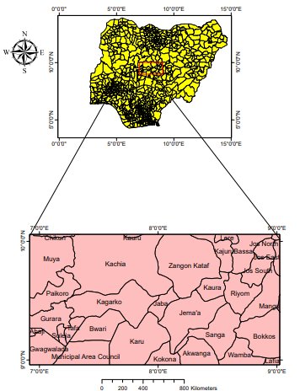
Figure 1: Location map of the study area
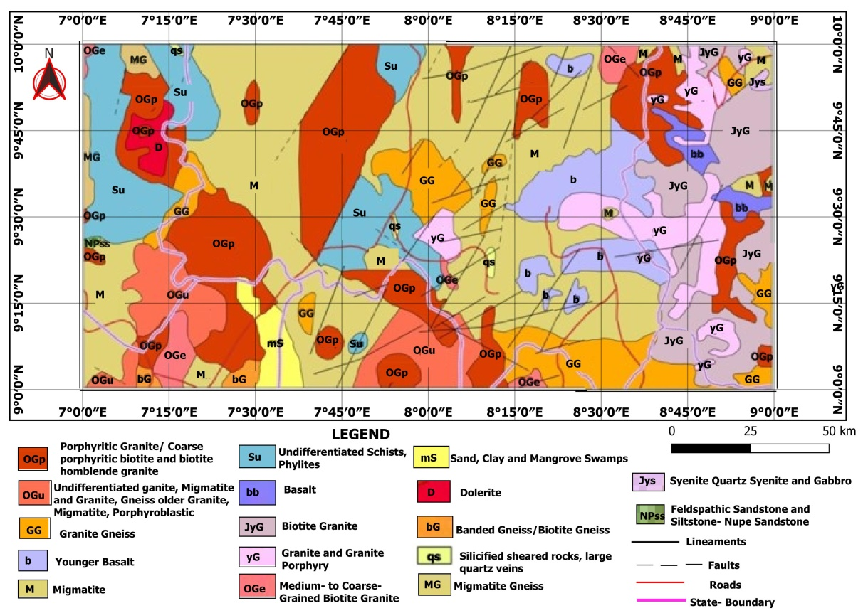
Figure 2: Geological Map of the Study Area (Adopted from Nigeria Geological Survey Agency, 2006)

  - Data Acquisition
The aeromagnetic data set used for the research was obtained from the Nigeria Geological Survey Agency, comprised of eight (8) aeromagnetic sheets covering parts of North Central Nigeria. The seismological data used were seismograms recorded by the five seismological stations in Nigeria. The stations are located in Ile-Ife (IFE), Kaduna (KAD), Abakaliki (BKL), Nsukka (NSU), and Minna (MNA). These stations are managed by an agency of the Federal Government of Nigeria, the Centre for Geodesy and Geodynamics, Toro Bauchi State. Each of the stations is equipped with the Eentec DR-4000 data acquisition system, three-component seismometers (Eentec SP-400) and Global Positioning System (GPS) timing signals. Each of them is powered by solar panels connected to a 200 Ah battery to ensure a stable power supply. The data were recorded continuously in the MiniSEED format at a sampling rate of 40 samples per second (sps).

  - Theory of Methods
The airborne geophysical data (magnetic data) and seismological data were subjected to various filtering methods to enhance the data sets for clearer interpretation. The filters used are upward continuation, First vertical derivative, CET, earthquake magnitude, and Epicenter of the tremor.

3.2.1 Upward Continuation
This filter smooths out near - surface effects and was used to locate deep - seated anomalies within the study area. The upward continuation (where z is positive upward) is given in equation (1)

(1)

where F (x, y,-h ) = Total field at the point P(x, y, -h) above the surface on which F(x,y,0) is known, h = elevation above the surface (Telford et al., 1990).

3.2.2 Vertical Derivatives
This filter suppresses long-wavelength magnetic anomalies and enhances the short- wavelength (Dobrin and Savit, 1988: Telford et al., 2002). It was used in this study to determine prominent structural trends locate the position of magnetic lineaments (faults or fractures) and, delineate the paleo-fractures in the area.
The FVD of the magnetic field is often computed by using the relation in equation (2)

$FVD \frac{∂T\left(x,y,z\right)}{∂z}$ (2)

where, T$1 VD=\frac{dA\left(x,y,z\right)}{dt} (3.2)$ is the total magnetic field at (x, y, z)

3.2.3 The Centre for Exploration Targeting (CET) grid analysis plug-in for structures
The Centre for Exploration Targeting (CET) was used to delineate lineament within the area. It consists of several tools that provide automated lineament detection of gridded data, which can be used for first-pass data processing. The procedures involved in this method include the following Statistical steps:
(1) Texture Analysis
(2) Lineation Detection
(3) Lineation Vectorisation
Texture analysis involves two steps, which are entropy and Standard deviation.
Entropy provides a measure of the textural information within localized windows in a dataset using Oasis Montaj software, and standard deviation provides an estimate of the local variation in the data. Lineation detection involves phase symmetry and phase congruency in CET analysis.Phase symmetry is used to detect line-like features through identifying axes of symmetry, and phase congruency is gradient-based edge detection. The lineation vectorisation menu includes three plugins for generating skeletal estimates of grid features. These are: Amplitude Thresholding, which applies non-maximal suppression to data, skeletonisation reduces feature regions to thin lines, and skeleton to vectors is for vectorising the skeletonised structures from the skeletonisation plugin via a line fitting method.
3.2.4 Earthquake magnitude
Two types of magnitude were computed in this study: the local magnitude and the moment magnitude. The local magnitude (ML) is an important parameter in earthquake hazard assessments both in terms of quantifying the rate and amount of seismicity and in understanding the attenuation of ground motion with distance. ML scales are typically based on amplitude measurements of high-frequency S waves (Brazier et al., 2008). Due to the absence of a local magnitude scale for Nigeria, the scale obtained by Langston et al. (1998) for the Tanzania region was used for this study. The expression is given in equation (3)
(3)
where Ml is local magnitude, A is the maximum ground displacement (nm) measured in the frequency band 1.25-20 Hz, a is the geometric spreading (0.776), r is the hypocentral distance, b is the attenuation (0.000902), and c is the base level (- 1.66).
The moment magnitude, Mw, of the earthquake was computed using the expression of Kanamori (1983) given in equation (4)
(4)

3.2.5 Location of earthquake epicentre
The seismic database has been produced using SEISAN earthquake analysis software, version 11.0 (Havskov and Ottemoller, 2000). Data from the 5 stations were used for the location of the earthquake. The first arrivals of the P- and S- S-waves were picked on each of the vertical components of the 5 stations. Although the velocity structure beneath the Nigerian crust has not yet been determined, to locate the epicenter of this earthquake, a flat six-layered earth model was adopted (Table 1). The thickness of the crust was assumed to be 40 km, which is the average value for Proterozoic crust (Mooney et al., 1998). The upper and lower crusts were 23 km and 17 km thick, respectively. The program HYPO- CENTER 3.2 (Lienert and Havskov, 1995) was used to locate the epicenters of the events
Table 1: Earth model used for the location of the epicentre of the earthquake
Earth layer | P-wave velocity (km/s) | Layer thickness (km)
Upper crust | 6.2  6.6 | 12  11
Lower crust | 7.0 | 17
Upper mantle | 8.0  8.15  8.5 | 10  30

4.0 Results and Discussion
4.1 Total Magnetic Intensity (TMI) Map
The total magnetic intensity (TMI) anomaly map of the study area (Figure 3) reveals variation in magnetic anomaly within the study area. The total magnetic intensity map shows both positive and negative anomalies with susceptibility values ranging from 33490.1 nT to 33801.8 nT. The high magnetic susceptibilities obtained were found around the North-eastern and North-western parts of the study area, which corresponds to Lere, Kajuru, Toro, Bassa, Jema’a, Riyom, Barkin-Ladi, and Zangon-Kataf areas. These anomalies could be due to the presence of basalt in the area as mapped by the geologists. The low magnetic susceptibilities were found around the south-western corner of the area, corresponding to Gwagwalada, Abaji, Suleja, Gurara, Tafa, Bwari, Paikoro, Kagarko, and Abuja Municipal Area Council, due to the level of weathering of the basement rock and thick overburden. The low magnetic susceptibility values ranging between 33490.1 nT and 33660.1 nT indicate alluvium deposit around Muya, Kokona, and Akwanga areas.

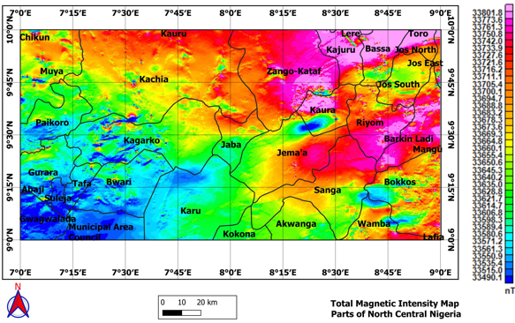
Figure 3: Total Magnetic Intensity map of the study area

4.2 TMI Reduced to Equator (RTE)
RTE filter positions the magnetic anomalies over their corresponding causative source bodies. The RTE map (Figure 4) has magnetic intensity values ranging from -89.525 nT to 79.677 nT. It has high magnetic signatures trending NE-SW direction and extends to the central part of the map around the Jema’a area. This could be due to basaltic rock found within the area (Figure 2). The northeastern part of the study area is characterized by low magnetic anomalies around Jos North, Jos East, and Jos South, and towards the central part of the Kaura and Jaba area. Figure 5 is the 2-D and 3-D maps of RTE, which show a major fault cutting across the study area.

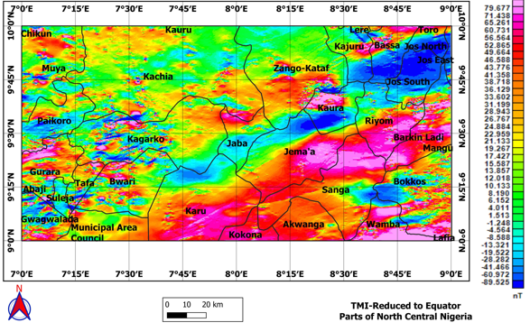

Figure 4: TMI– Reduced to Equator

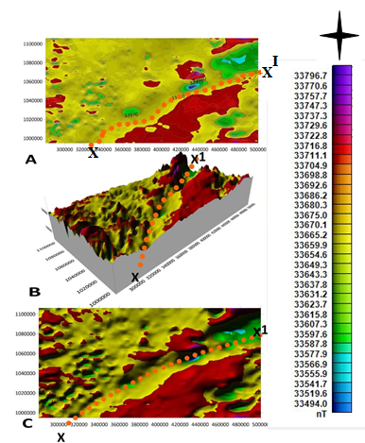

Figure 5: 2D (A and C) and 3D (B) fault line passing across the study area

4.3 Upward Continuation
The total magnetic field data of the study area reduced to the magnetic equator were upward continued at a height of 5 km (Figure 6) to locate the deep-seated anomalies. The upward continuation at the height of 5 km shows the existence of a prominent fault trending NE-SW. The appearance of this fault at 5 km depth shows that the fault is deep-seated. The fault delineated in Figure 6 agreed with the fault delineated in Figures 3, 4, and 5. The fault is shown at 5 km depth (Figure 6), which is believed to be one of the continental paleostructure. This fault line was delineated by Megwara and Udensi (2013) and Tawey et al. (2020), as Romanche, and is a historical fault system because there has been significant relative movement which passes through the study area Figure 7. Some lineaments are also observed in the geological map (Figure 2).

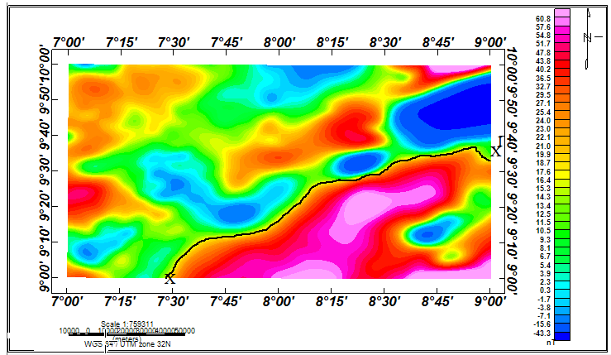
Figure 6: Upward continuation at 5 km showing fault line XX’

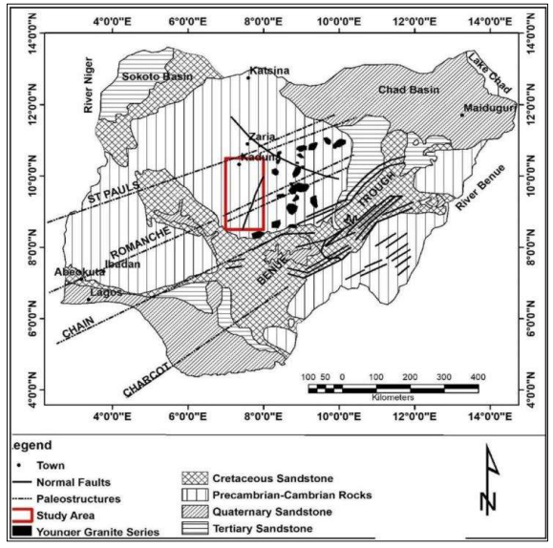

Figure 7: Paleostructure zone’s map

4.4 First Vertical Derivatives
The First vertical derivative (Figure 8) delineated several lineaments that are primarily fault lines within the study area; these lineaments are marked as F1 to F8. The map revealed high frequency (short wavelength) anomalies along the north-western part of the area; these short wavelengths are also observed at the northeastern part. Four major trends were observed: NE-SW, NW-SE, E-W, and NNE-SSW. The dominant trend is NE-SW and NNE-SSW. The N-S trend defines the geological trend within this area. These trend directions correlate well with the mineral density map of Nigeria (NGSA 2006). There is a prominent fault line, F4 in Figure 7, which cuts across the study area labeled AA’, which is believed to be one of the continental paleostructures. This fault line was delineated by Megwara and Udensi (2013) and Tawey et al. (2020), as Romanche. These lineaments agreed with the fault lines delineated by Figures 5 and 6. Faults F1, F2, F3, F5, F6, F7, and F8 are emerging near surface fault lines, since they could not be captured by upward continuation at 5 km depth. Therefore, those fault lines there are indications that the paleostructure (Romanche) is still active since those emerging fault lines are traceable to it. The rose diagram, as shown in Figure 8, revealed that the dominant structural trend is in the NE-SW which corresponds to the major lineament trend, while NW-SE and N-S reflect the younger and deeper tectonic trends. However, the NE-SW trend reflects the older tectonic events, because the older events are more pronounced and tend to obliterate the younger events.
4.5 Center for Exploration Targeting (CET) Grid Analysis
Figure 9 shows the application of the center for exploration targeting (CET) to the aeromagnetic data of the study area. The trends of the linear structure delineated trends in the NE-SW, NW-SE, and E-W directions which are in agreement with Figure 8. Center for exploration targeting (CET) also expresses major structures in the NE-SW direction both in the map and in the rose diagram, as shown in Figure 9. Most of the fault lines identified in the two maps (Figures 8 and 9) are in conformity with the trend that occurred during the pan-African orogeny. The fault provides insight into the tectonic history of the region.

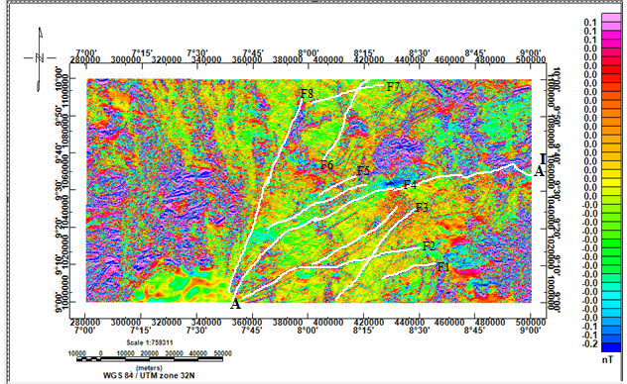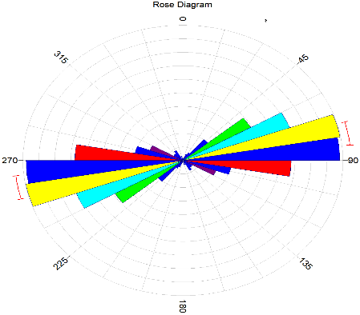

Figure 8: First Vertical Derivative of the study area

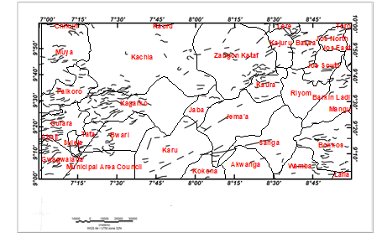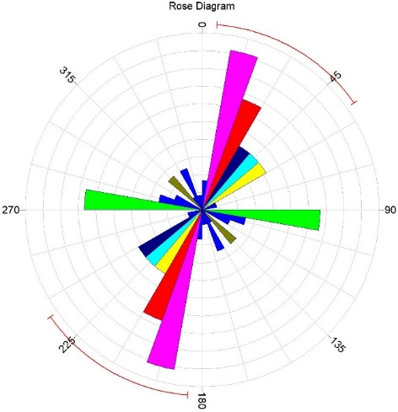

Figure 9: Center for Exploration Targeting (CET) map of the Study Area

4.5.1 Lineament Map superimposed on First vertical derivative map
Figure 10 is the lineament map of the study area culled from the lineament map of Nigeria (NGSA, 2006). Figure 11 is the superimposed lineament map of the study area on the first vertical derivative map (FVD). The FVD map (Figure 8) and lineament map (Figure 10) were superimposed to ascertain significant similarities between both maps. Fault lines obtained from FVD analysis are depicted with red coloration, while those of lineament are depicted with black coloration (Figure 11). Figures 10 and 11 show fault lines trending in NE-SW and NNE-SSW directions. Vertical Derivative map did not detect the structures trending in NW-SE directions, but agrees with structures trending in NE-SW and NNE-SSW. Some differ in location (coordinate). The difference is due to the fact that the data used for the present analysis has higher and better resolution compared to that used in mapping the Lineament map of the area.
A major fault (F8) trending NE-SW situated at the middle of the study area enters through Karu village on Longitude 7.30 ºE and exits at Kachia on Longitude 8.00 ºE. Another set of lineaments labeled F2, F3, F4, and F5 trending NNE-SSW were mapped between latitude 9 00 °N to 940' °N and longitude 8 00 to 8 45' ºE striking through Sanga, Jemma’a, Karu, and part of Jaba areas. The faults labeled F7 and F8 correlate in location and direction with some faults in the Structural geological map of the area. The trend NNE-SSW conforms to the NNE-SSW Ifewara fault in southwestern Nigeria, which disappears beneath Bida Basin but reappears at Zungeru (Anifowose et al., 2010; Awoyemi et al., 2017, and Okonkwo et al., 2020). The minor subsidiary fractures were visible at the northern and south-eastern regions of the study area, where intrusions of basalt and Younger Granite were observed.

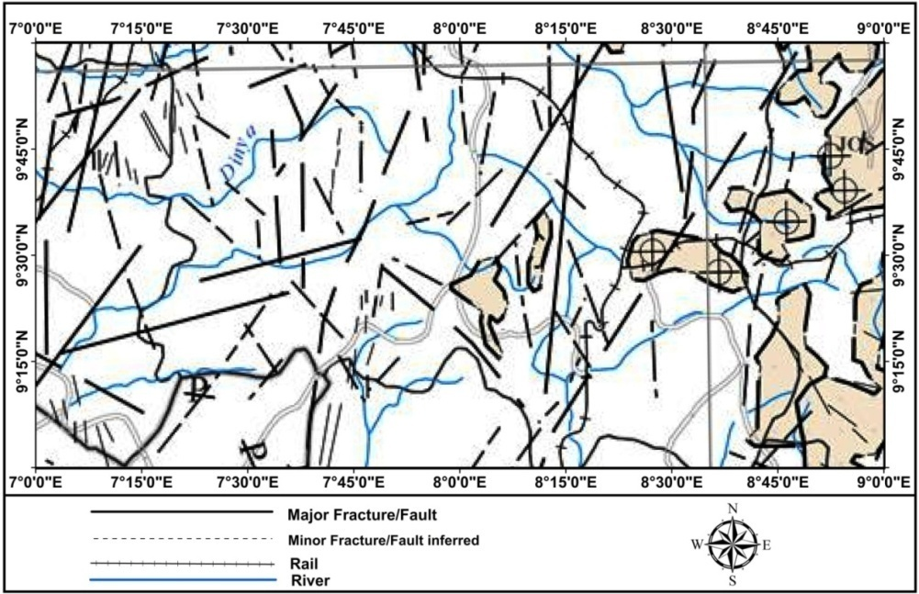
Figure 10: Structural Geological map of the study area (NGSA, 2006)

Figure 11: Lineament map superimposed on First Vertical Derivative Map

4.6 Source parameters of 2016 Kwoi earthquakes
The earthquake magnitude and epicentre were determined. The local magnitude of the first event was 2.8, and the moment magnitude was 3.1; the local and moment magnitudes of the second event were 2.7 and 3.0, respectively. The third event recorded a local magnitude of 3.1 and a moment magnitude of 3.1. The focal depth of the Kwoi earthquakes was estimated to be 10 km. The epicenters of the Kwoi earthquakes were latitude 9.570 ºN and longitude 8.070 °E for the first event, latitude 9.640 ºN and longitude 8.180 °E for the second earthquake, and latitude 9.590 °N and longitude 8.130 °E for the third event. These parameters are presented in Table 2 as shown below.
Table 2: Source parameters of 2016 Kwoi earthquakes
Date | Origin Time (GMT) | Lat (°N) | Lon (°E) | Depth (km) | Local mag. | Moment mag.
11/09/2016 | 12:28:16.5 | 9.570 | 8.070 | 10 | 2.8 | 3.1
12/09/2016 | 03:10:48.8 | 9.640 | 8.180 | 10 | 2.7 | 3.0
12/09/2016 | 03:11:20.0 | 9.590 | 8.130 | 10 | 3.1 | 3.1

4.6.1 Source parameters of 2018 Abuja Earthquake
The Abuja earthquakes occurred in 2018. The magnitude of the first, second aftershock, and the main shock were determined as follows: the first aftershock had a moment magnitude of 2.5 and local magnitude of 2.6, the second aftershock had a moment magnitude of 2.2 and local magnitude of 2.5, while the main shock had a local magnitude of 3.0 and a moment magnitude of 2.6. The epicentre of the first aftershock was at latitude 9.0339 °N and longitude 7.5008 °E, the second aftershock was located at latitude 9.1620 °N and longitude 7.4014 °E, while the main shock was located at latitude 9.139 °N and longitude 7.594°E. The parameters of the Abuja tremor are presented in Table 3
Table 3: Source parmeters of 2018 Abuja earthquakes
Date | Event | Origin Time (GMT) | Lat (°N) | Lon (°E) | Depth (km) | Local mag. | Moment mag.
06/09/2018 | Mainshock | 5:11:32.60 | 9.14 | 7.59 | 15 | 3.0 | 2.6
7/09/2018 | Aftershock | 6:16:17.80 | 9.03 | 7.50 | 12 | 2.6 | 2.5
7/09/2018 | Aftershock | 7:12:18.40 | 9.16 | 7.40 | 10 | 2.5 | 2.2

4.6.2 Superimposing of Lineament Map on Geology Map Showing the Epicentres and Fractures zones
Figure 12 is the geological map showing the epicenters of the study area (Earthquake plot). Figure 13 is the superimposed epicentre map (Figure 12) on the Lineament map (Figure 11) to identify faults that coincided with the related epicenters. Faults that are depicted by black colour are faults obtained from the Lineament map, while those depicted by white colour are faults obtained from the First vertical derivative map. Epicenters are depicted by a red circle and are seen at the central part and towards the southern part of the map. The epicenters are strongly related to the emerging faults delineated in this study. The superimposition between the two maps agreed in terms of the trend direction in NE-SW and NNE-SSW directions. The major NNE-SSW trend conforms to the NNE-SSW Ifewara–Zungeru fault because it is linked with the Atlantic Fracture System in which the Romanche fracture zone cuts across the study area (Anifowose et al., 2010, Awoyemi et al., 2017). From the map, fault lines F5, F6, and F8 coincide with some of the epicenters corresponding to areas around Jaba, Zangon-Kataf, and parts of the Abuja Municipal Area Council. These Faults (F5, F6, and F8) seem to be tectonically active due to the closeness of the epicentre within that region. The earth tremor activities are therefore a result of the emergence of these near-surface faults. Stress has been built up around those identified faults, and this may also cause faults (F1, F2, F3, and F4) to be active and, as a result, could cause earthquakes within the study area. Fault lines F5 and F8 coincide with the epicenter at Jaba and the Abuja Municipal Area Council. These are areas affected by earthquakes in 2016 and 2018. Oyibo et al., talked about the theory of stress transform from plate boundaries who argues that stresses that builds up around plate boundaries could travels towards the center of the plate triggering intraplate tremors espially in preexisting faults. The zone of weakness model proposed by Sykes (1978) states that intrplate seismicity occurs where the crust has been weakned by previous activity.
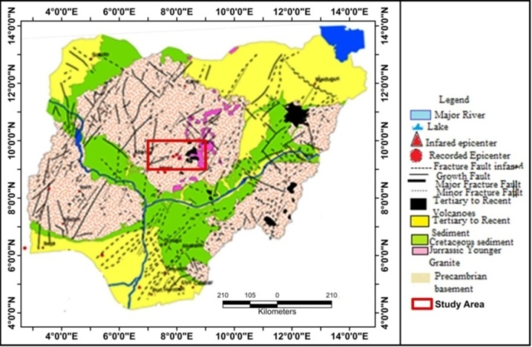

Figure 12: Geological map of Nigeria showing epicentres and fracture zones (Modified from Akpan and Yakubu 2010

Figure 13: Superimposing of Magnetic Lineament Map on Epicentre Map

5.0 Conclusion
The aeromagnetic data over parts of North Central Nigeria were used in mapping geological structures and faults that are associated with earthquakes in the study area. The origin time, magnitudes, and epicentres of earthquakes were determined from the seismological data. The upward continuation techniques have been used successfully in this study to locate a deep-seated anomaly at 5 km altitude. Four major trends were observed: NE-SW, NW-SE, E-W, and NNE-SSW. The dominant trends are NW-SE and NNE-SSW within the area. The magnitude of the Kwoi earthquake tremor was determined for three events. The first has a local magnitude of 2.8 and moment magnitude of 3.1, the Second event has a local magnitude of 2.7 and moment magnitude of 3.0, and the third event has a local magnitude of 3.1 and moment magnitude of 3.1. The epicentre was estimated for the three events to have occurred at latitude 9.570 °N and longitude 8.070 °E, latitude 9.640 °N and longitude 8.180 °E, and latitude 9.590 °N and longitude 8.130 °E, respectively. The magnitude of the Abuja earthquake was estimated to have a main shock of local magnitude 3.0 and moment magnitude of 2.6. The main shock was located at latitude of 9.139 °N and a longitude of 7.594 °E. The lineament map superimposed on the epicenter map identified the fault that coincided with the epicenter. Faults F5, F6, and F8 coincide with some of the epicenters corresponding to areas around Jaba, Zangon-Kataf, and part of the Abuja Municipal Area Council. Faults F5 and F8 coincide with the epicentres at Jaba and Abuja Municipal Area Council; these are areas affected by earthquakes in 2016 and 2018. Therefore, the earth tremor activities within the study area are a result of the effect of the emergence of these near-surface faults.
COMPETING INTEREST
Authors have declared that no competing interests exist
Disclaimer (Artificial intelligence)
Author(s) hereby declare that NO generative AI technologies such as Large Language Models (ChatGPT, COPILOT, etc.) and text- to-image generators have been used during the writing or editing of this manuscript.

REFERENCES
Akpan, O.U., & Yakubu, T. A. (2010). A Review of Earthquake Occurrences and Observations in Nigeria. Earthquake Sciences, 23, 289-294
Anifowose, A.Y. B., Oladapo, M.I., Akpan, O.U., Ologun, C.O., Adeoye-Oladapo, O. O., Tsebeje, S.Y and Yakubu T. A (2010). Systematic multi-technique mapping of the southern flank of Iwaraja fault, Nigeria. Journal of Applied Science and Technology 15(1-2): 70-76.
Awoyemi, MO., Hammed, O.S., Falade, S.C., Arogundade, A.B., Ajama, O.D. &Iwalehin P.O (2017).Geophysical investigation of the possible extension of Ifewara fault zone beyond IIesa area, southwestern Nigeria. Arab Journal of Geosciences. 2017; 10 (27): 1-14
Brazier, R. A., Miao, Q., Nyblade, A. A., Ayele, A., & Langston, C. A. (2008). Local Magnitude Scale for the Ethiopian Plateau. Bulletin Seismological Society of America, 98, 2341-2348. http://dx.doi.org/10.1785/0120070266.
Dobrin, M.B Savit, C.H. (1988). Introduction to Geophysical prospecting fourth ed. McGraw- Hill, New York Pp 867.
Havskov, J., & Ottemoller, L. (2000). SEISAN Earthquake Analysis Software. Seismological Research Letters, 70, 532-534. http://dx.doi.org/10.1785/gssrl.70.5.532
Incorporated Research Institution for Seismology, 2013
Kanamori, H. (1983). Magnitude Scale and Quantification of Earthquakes, Tectonophysics, 93, 185-199.
Kovesi, P. (1997). Symmetry and Asymmetry from local phase. A¹ 97, Tenth Australian Joint Conference on Artificial Intelligence 2-4 December 1997
Langston, C. A., Brazier, R., Nyblade, A. A., & Owens, T. J. (1998). Local Magnitude Scale and Seismicity Rate for Tanzania, East Africa. Bulletin of the Seismological Society of America, 88, 712-721
Lienart,B.R.E. and Havskov, J. (1995). A computer program for Locating Earthquakes Both Locally and Globally. Seismological Research Letters, 66, 26-36. http://dx.doi.org/10.1785/gssrl.66.5.26
Megwara, J.U. & Udensi E.E (2013). Lineaments study using aeromagnetic data over parts of southern Bida basin, Nigeria and the surrounding basement rocks. International Journal of Basic and Applied Sciences 2(1)

Meltzner, A.J., & Wald, D. J. (2002). Felt reports and intensity assignments for aftershocks and triggered events of the great 1906 California earthquake (No. 2002-37). US Geological Survey
Milligan, P.R.& Gunn R.J. (1997). Enhancement and presentation of airborne geophysical data, Australian Geology Survey organization Journal of Australian Geology and Geophysics. 17(2), (63-75)

Miller, H.G. Singh, V.J., (1994), Potential Field Tilt –A new concept for location of potential field sources. Applied Geophysics, 32: 213-217
Mooney, W.D., Laske, G. & Masters, T.G., (1998), CRUST 5.1: a global crustal model at 5º* 5 º. J. Geophys.Res. 103 (B1). 727-747.
Nigerian Geological Survey Agency, (2006). Geology and Structural Lineament Map of Nigeria. Abuja: NGSA.
Obaje, N.G. (2009). Geology and mineral resources of Nigeria. Berlin: Springer-Verlag, Heidelberg, pp. 221.Hazards in Africa. Nigeria Mining and Geosciences society Publication Jos, 10-14.
Olasehinde, P. I., Pal, P. C., &Annor, A. E. (1990). Aeromagnetic Anomalies and Structural Lineaments in the Nigerian Basement Complex. Journal of African Earth Science,11, (3/4), 351 – 355
Oyibo. D., Omali. A.O., & Abdullahi A.A. (2025) Review of seismic activities in Northern Nigeria and the Gulf of Guinea, FUDMA Journal of Sciences (FJS) 9(4) pp 6-11

Stein, S., &Wysession, M. (2003). An introduction to Seismology, Earthquakes and Earth structure Blackwell Publishing. Pp1- 52

Tawey, M. D., Alhassan, D. U.,Adetona, A. A.,Salako ,K. A., RafiuA. A. &Udensi, E. E (2020). Application of Aeromagnetic Data to Assess the Structures and Solid Mineral Potentials in Part of North Central Nigeria Journal of Geography, Environment and Earth Science International 24(5): 11-29, 2020; Article no.JGEESI.58030 ISSN: 2454-7352

Telford, W.M., Geldart, L.P., Sheriff, R.E. & Keys, D.A. (2002). Applied Geophysics. Cambridge University Press, Cambridge
Verduzco, B., Fairhead, J.D., Green, C.M & Mackenzie C., (2004). New insights into magnetic derivatives for structural mapping, The Leading Edge, (116-119).

APPENDICES
APPENDIX A
SEISMOGRAMS OF EARTHQUAKES RECORDED AT SEISMOLOGICAL STATIONS USED IN THIS STUDY
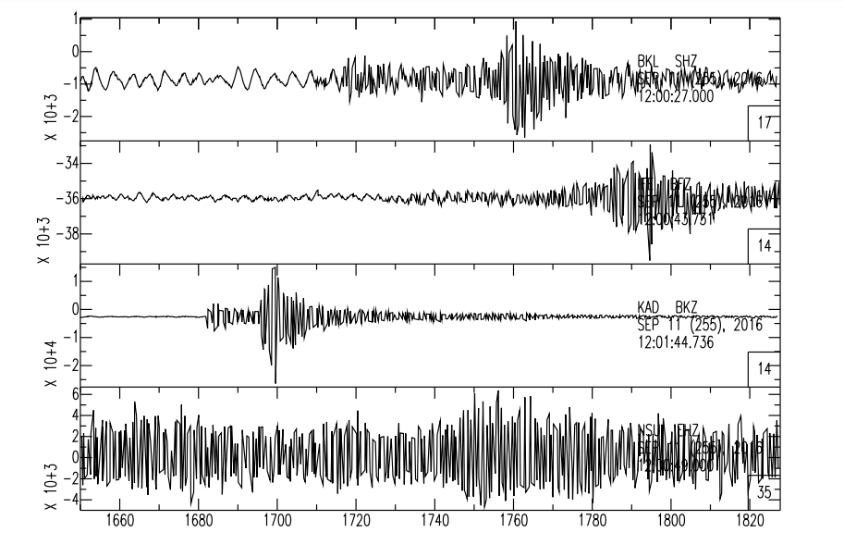
APPENDIX A1: Seismograms of first Kwoi earthquakes

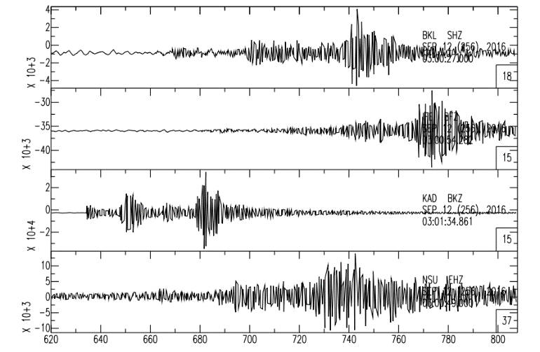

APPENDIX A2: Seismograms of the second and third Kwoi earthquakes

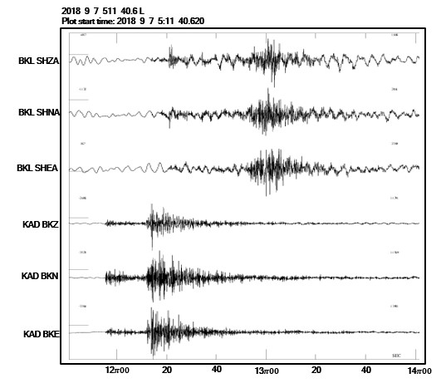
APPENDIX A3: Seismogram of the magnitude 3.0 Abuja earthquake of September 7, 2018

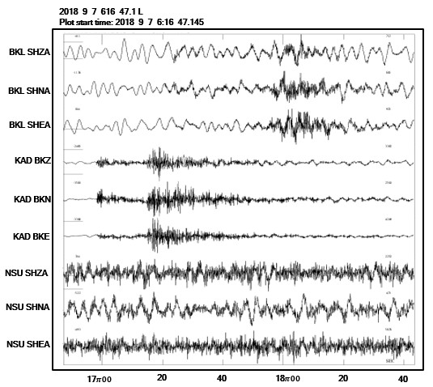
APPENDIX A4: Seismogram of first aftershock of the Abuja earthquake of 7th September, 2018

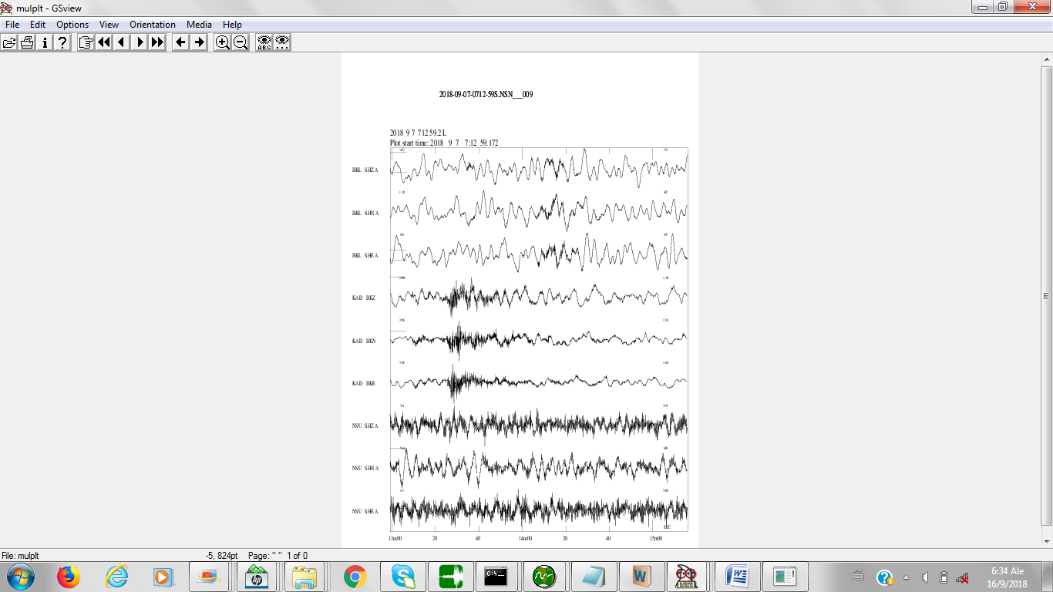
APPENDIX A5: Seismogram of the second aftershock of the Abuja earthquake of 7th September, 2018

