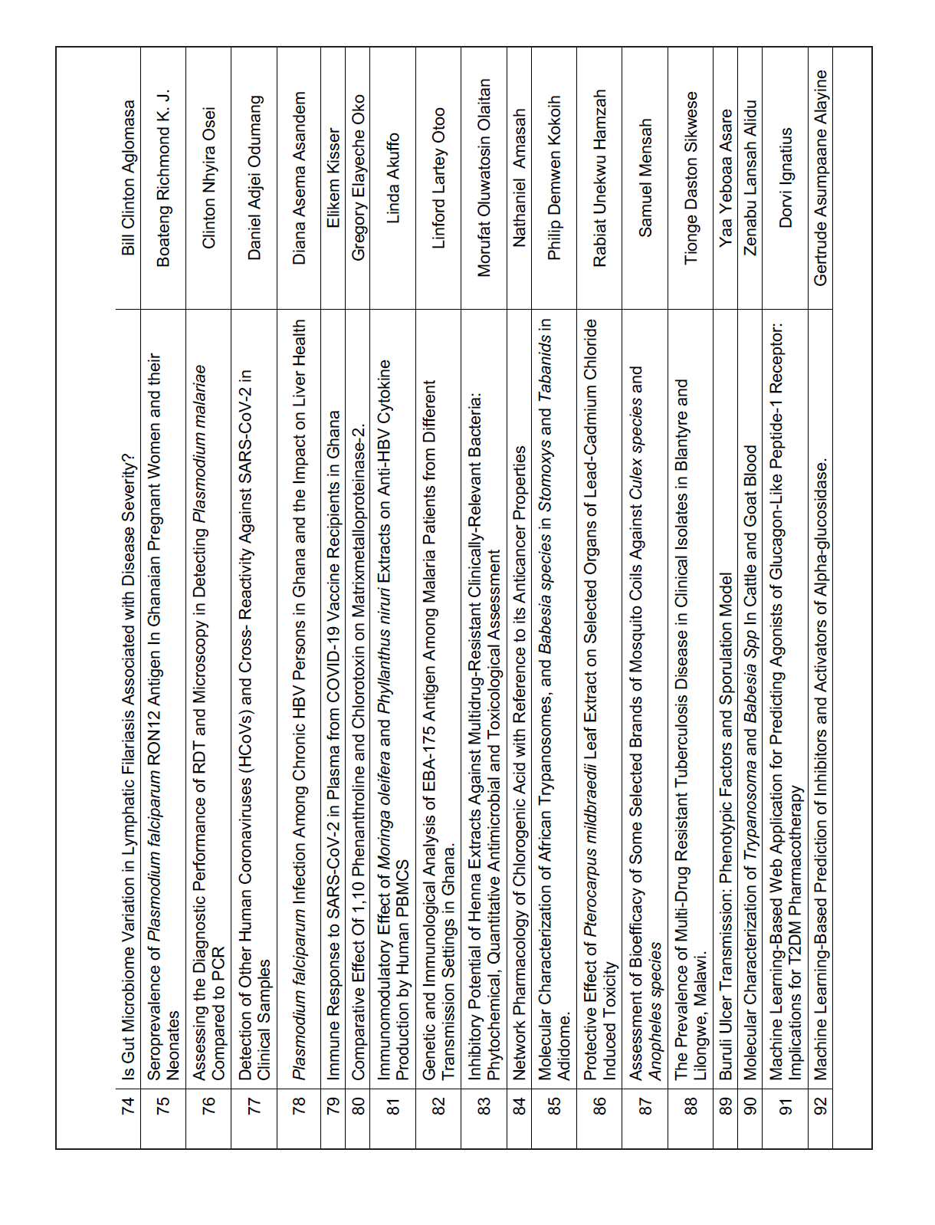

PROTECTIVE EFFECT OF PTEROCARPUS MILDBRAEDII LEAF EXTRACT ON SELECTED ORGANS OF LEAD-CADMIUM CHLORIDE INDUCED TOXICITY
Rabiat Unekwu Hamzah, Busari, M. B., Garba, R. and Atabo, S.
Background:
Lead and Cadmium are environmental toxicants which pose many health risks for both humans and Animals. Chelating agents used for lead and cadmium toxicity are not readily available, toxic, expensive and unable to clean up most of the toxic metals accumulated in various organs. The need to source from safe natural plants become necessary, therefore this study evaluated the effect of crude and fractions of Pterocarpus mildbraedii leaf extracts (PMLE) on the lipid profile and antioxidant indices of the heart, lungs in lead-cadmium chloride-induced toxicity in rats.
Methodology:
The crude extract (CE) of the leaf was obtained with methanol through cold maceration after 72 hours which was further subjected to solvent partitioning via vacuum liquid chromatographic (VLC) techniques using, acetone, ethyl acetate and 70% methanol. Thirty-two wistar rats were divided into eight groups of four rats each comprising of the normal, negative control, treatments and standard group. Exactly 10 mg/kg body weight (bw) and 50 mg/kg bw of cadmium and lead chloride was used to induced toxicity in rats. Lipid profile and antioxidant parameters were determined using standard methods.
Results/Findings:
Administration of lead/cadmium chloride significantly decreased superoxide dismutase activity and glutathione concentration with an increase in the level of malonaldehyde in the heart and lung of negative control animals when compared with normal control. Likewise, administration of Pb/CdCl2 significantly increased the level of cholesterol, low density lipoprotein-cholesterol and triglycerides with concomitant decrease in high density lipoprotein-cholesterol. Treatment with crude Pterocarpus mildbraedii leaf extract and its fractions reverted the antioxidants and lipid profile alteration induced by cadmium/lead chloride in rats with best activity in 400 mg/kg bw of acetone fraction and crude extracts.
Significance:
Pterocarpus mildbaedii leaf extract and fractions can be used in the management of high lipids and oxidative stress associated lead and cadmium induced toxicity in rats, thus it has protective properties. Further study is ongoing to study the active principle and mechanism of action involved.

