Evaluation of Logistics of Sweet Potatoes Transportation in Offa and Oyun LGAs of Kwara State

Ajiboye, Araoye Olarinkoye / Dere, Ismail Gbolahan / Aliyu, Muktar Tosin / Akorede, Ibrahim Ayinla / Yisa, Mutiat Shittu

ABSTRACT
The distribution of agricultural products between zones, regions, and nations is easy and smooth because of a via- ble transportation system. This study evaluates the logistics of sweet potato transportation in Offa and Oyun local government areas (LGAs) of Kwara State, Nigeria. to identify the types of sweet potatoes produced and the trans- port-logistics facilities available in the study area as well as to determine the factors affecting the choice of trans- portation used by sweet potato farmers/marketer in the study area. The study used descriptive statistics method and analysed the primary data gathered via a well-structured questionnaire. The study results show a significant relationship between efficient logistics and sweet potato transportation in the study area. Improving the trans- portation system can encourage farmers to work hard toward increasing sweet potato production. The research recommends that government should support sweet potato farming through the construction and maintenance of rural roads and make easy accessibility of loans from banks and cooperative societies to farmers and transport operators to acquire necessary/modern equipment and new vehicles needed as well as to reduce the price of petro- leum for effective and efficient production process.
Keywords: farmers, marketers, sweet potato, transport operators, vehicles

INTRODUCTION
ransportation helps in moving goods and people from one geographical location to an- other. Transportation, therefore, helps bring raw materials to the factory for processing, and finished products are delivered to the final consumers through various channels
T
such as wholesalers and retailers (Ajiboye, 2011, Ade, 2004). Effective distribution of agro-com- modity and business activities occur with the aid of transportation system. The distribution of agricultural products between zones, regions, and nations is made easy and smooth because of the transportation system (Ajiboye & Afolayan, 2009). The transportation system therefore enables long distances to be reached quickly and encourages inter-regional and international trade. Kareem (2010) opined that logistics strategically manage the movement and storage of raw materials, parts, and finished goods throughout a production process from the suppliers to final delivery to customers. Logistics, therefore, plays an essential role in getting the right product to the right customer at the right time, in the suitable condition and place, in the cor- rect quantity, and at the right cost.
Generally, in Nigeria and Kwara state in particular, agricultural commodities like potatoes, yams, vegetables, fruits, grains, cereals, and tubers, to mention only a few, constitute a sig- nificant percentage of commodities of inter-regional trade transported by road (Musa, 2011). Thus, agro-commodities transportation could be a liberating force, setting free natural, hu- man-made, and human resources from the situation where they yield little or no satisfaction

and transferring them to places where their full utility can be realized; this is because no urban area could exist without a reliable freight transport system (Michael, 2008).
Ayinde, Adewumi, Olatinwo, and Olowogbayi (2014) noted that sweet potato-like other agri- cultural produce has a significant role in the economy of a developing nation like Nigeria. Its production, transportation, and marketing offer farmers, transporters, and marketers job op- portunities and raising their income. Agricultural products provide food for people, raw mate- rials for the agro-allied industries, and earn foreign exchange for any nation’s economy. Also,
51.7 % of Nigerians live in the rural sector and are primarily engaged in agriculture either di- rectly or indirectly, which is very popular in Offa and Oyun LGAs (Ayinde, Adewumi, Olat- inwo & Olowogbayi, 2014).
Agriculture is vital to the economy of every growing country, and Nigeria is no exception. This is due to the fact that it accounts for 43.64 percent of Nigeria’s overall gross domestic output. The majority of the farmers are small-scale subsistence farmers who produce over 70% of the food available for human consumption in Nigeria (Falola & Heaton, 2008). There are two major types of sweet potatoes generally in Nigeria and particularly in Offa and Oyun LGAs (See Fig- ure 1a &b). These are cream skin, orange-fleshed and purple-red skin, and white-fleshed types. The cream skin, orange-fleshed type: - This is the most widely grown sweet potato in Nigeria. It has cream skin and an off-white interior, and the flesh takes on a yellow cast with a lightly sweet flavor. The purple-red skin, white-fleshed type: this has speckled purple skin and white flesh with a moist, heavy, pumpkin-like quality. It also has a firm, lightly sweet flesh and a slightly pleasant tautness.
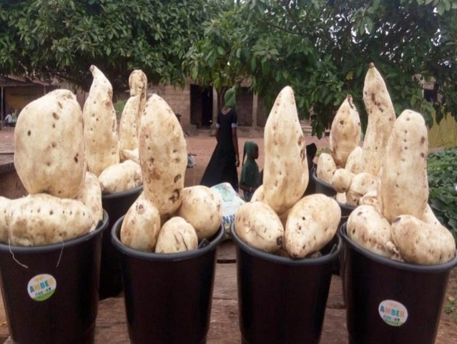
Fig. 1a: Cream skin and orange-fleshed potato type. Source: Authors’ field survey

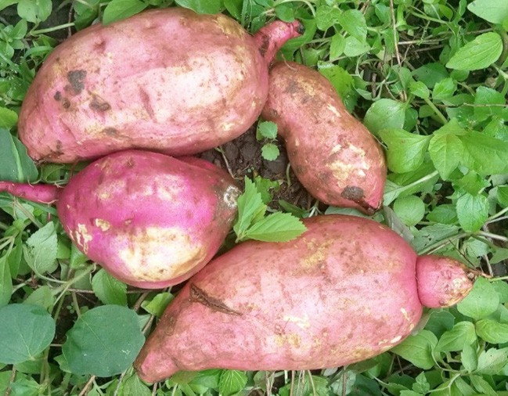
Fig. 1b: Purple-red skin and white-fleshed sweet potato type. Source: Authors’ field survey

Offa and Oyun LGAs in Kwara have a high potential for sweet potato production. The high cultivation of sweet potatoes is due to the favourable climatic condition and fertile soil. The area is a hub that generates about 50% of sweet potato production in Kwara state on a periodic and timely basis. However, this product is scarce in most markets within the local government areas due to an inadequate logistics mix (Ayinde, et al., 2013).
Otitolaiye (2009) observed that agricultural product distribution is necessary since there is a gap between the producer and the majority of customers. These gaps might be caused by dif- ference in space or time. A physical separation between regions or areas of production and consumption is referred to as spatial separation. For instance, Lagos and Warri’s fish and sea- food, Benin, Nsukka and Ondo’s palmoil, Fiditi, Ogota and Ondo‘s fruits and Sagamu, Ondo and Ile-Ife’s kolanut as well as Ijebu’s Gari and Egba’s lafun for examples are collected from the southern part of Nigeria and sold throughout the country (Ajboye, 1995). In addition, crops like Sokoto’s onion, Funtua’s tomatoes, and pepper, as well as animal products, are collected from Sokoto, Kano, Katsina, and Adamawa, among other areas and marketed in Southern Ni- geria (Ajboye, 1995). In terms of time separation, consuming is a continuous activity, while production, particularly of perishables, is discrete, therefore time adjustment and some com- ponents of storage are eventually required to accommodate supply and demand gaps.
Sweet potato is naturally a perishable product that requires a quick and efficient transportation system with minimum delays. It also demands that the proper logistics mix of acquiring the

proper transportation, packaging, material handling, and storage must be carefully planned and executed. Hence this research work was carried out to reveal the logistics of sweet potato transportation in Offa and Oyun LGAs. In light of the above, this research identified the types of sweet potatoes and the transportation facilities available, determine the factors affecting the choice of transportation used by sweet potato farmers/marketers, and identified the problem that affects the location and growth of sweet potato farms in the study area.
Otitolaiye (2009) observed that agricultural product distribution is necessary since there is a gap between the producer and the majority of customers. These gaps might be caused by dif- ference in space or time. A physical separation between regions or areas of production and consumption is referred to as spatial separation. For instance, Lagos and Warri’s fish and sea- food, Benin, Nsukka and Ondo’s palmoil, Fiditi, Ogota and Ondo‘s fruits and Sagamu, Ondo and Ile-Ife’s kolanut as well as Ijebu’s Gari and Egba’s lafun for examples are collected from the southern part of Nigeria and sold throughout the country (Ajboye, 1995). In addition, crops like Sokoto’s onion, Funtua’s tomatoes, and pepper, as well as animal products, are collected from Sokoto, Kano, Katsina, and Adamawa, among other areas and marketed in Southern Ni- geria (Ajboye, 1995). In terms of time separation, consuming is a continuous activity, while production, particularly of perishables, is discrete, therefore time adjustment and some com- ponents of storage are eventually required to accommodate supply and demand gaps.

LITERATURE REVIEW
According to Tunde (2007), transportation is an essential factor in agricultural production and development worldwide while Ajiboye and Afolayan (2009) observed that road transportation is the most common network that is highly flexible, physically convenient, and usually the most operationally suitable and available means of freight movement and people over short, medium, and long distances as well as covering a wide range in Nigeria. Similarly, Aderamo & Magaji (2010) also see transportation as the linkage bidding different parts of society. In this light, Ademiluyi (2016) observes that transport is essential and requires daily human activities worldwide.
In the contemporary world, technology has brought much improvement to transportation cur- rently enjoyed. For instance, transportation has made goods move from one geographical lo- cation to another easily and quickly. Thus, consumers spread in different parts of the coun- try and world benefit from consumer goods produced in distant places. Transport provides employment opportunities directly to the individual as drivers, bus conductors, captains of ships, pilots, cabin crew, etc., while several others are indirectly employed through the trans- port industry.
On the other hand, Rodrigue (2020) and Food Agricultural Organization (FAO) (2017) see ag- ricultural logistics system as connecting producers who grow and raise food products to con- sumers. The agricultural logistics system is an extensive network of individuals and organi- zations coordinating the harvesting, collection, transportation, inspection, and distribution of food products. Although distribution methods vary, in the traditional food system, the vast majority of agricultural products are produced and sold, and how they are distributed through a logistics system while Martinez (2002) and Burt et al., (2003) reported that for an agricultur-

al logistics system to be efficient, it needs to be vertically coordinated. When a logistics sys- tem is vertically coordinated, each stage of the supply chain (production, processing, inspec- tion, transportation, and marketing) is streamlined and efficiently managed (Gebresenbet & Bosona, 2012). Products pass from one stage to the next in a seamless, synchronized manner.
One way to achieve vertical coordination in food markets according to Martinez (2002) is for a single firm to control all production, distribution, and marketing processes for specific prod- ucts. Certain producers and retailers have become vertically integrated, often bypassing whole- sale markets entirely. Although such forms of so-called direct distribution from producers to retailers grow in size and importance, they still account for a relatively small percentage of the agricultural goods purchased (Zhang, Luo & Li, 2021).
Yahaya (2009) indicated that transportation, poor credit accessibility, insecurity, and the high cost of human labor represent the most severe challenges facing Nigeria’s agricultural devel- opment. With the ever-growing population, food scarcity was not far-fetched.
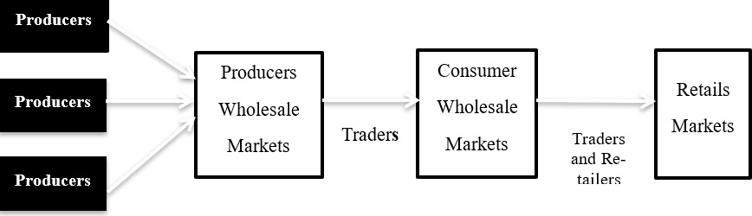

Fig. 2: A typical distribution chain of agro-commodity. Source: RAND Corporation and Development Research Center of the People’s Republic of China (2016).

METHODOLOGY

Study area
Oyun and Offa are two different LGAs sharing boundaries as shown in Figure 3. It will be dif- ficult for visitors to distinguish between the two. Though they were previously one LGA called Oyun in Kwara State, Nigeria, with about 218,083 inhabitants, and coordinates of Latitude 80 9’ 52.776N, Longitude 40 41’12.44E 436 meters elevation above sea level (See Figure 1). The flo- ra in Offa and Oyun LGAs is savanna vegetation. The town is noted for its weaving and dye- ing trade, using vegetable dyes made from locally grown indigo and other plants (Kadiri & Alabi, 2014).
Offa and Oyun LGAs are well known for the cultivation of arable crops. Such as yams, maize, millets, sweet potatoes, vegetables, melon, and animal rearing, such as cattle, goats, and sheep. However, sweet potatoes also formed part of the favorite staple foods of the indigenes in the town. Offa and Oyun are addressed as the home of sweet potatoes in one of her tributes.

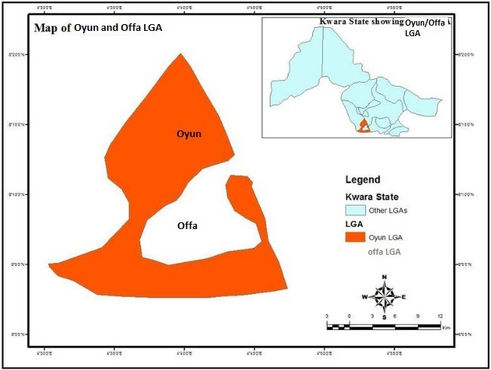
Fig. 3: Map of Kwara State showing Oyun and Offa LGAs.

Method of data analysis
The data analysis was carried out using a computer-aided Statistical Package for Social Science (IBM SPSS) version 2.0, which was used to generate a descriptive and inferential deduction. Descriptive statistics are statistics of numerical data (i.e., tables, charts, percentages) and infer- ential statistics that use deductive reasoning. A Likert scale of 1 to 5 was used and arranged us- ing ranking factors so that the questionnaire results would be revealed.

Sample size
The sample size for this study was drawn from the total population of Offa and Oyun LGAs, using Yamane’s formula:

Equation 1.1:
Where n = Sample size;
N = population size (218,083) e = level of precision (0.6) Therefore: n = 277.7 n ~ 278 Sources of data collection
n  N
1 + N [e]²

The source of data for this study was primary sources. The primary data was collected through
questionnaires to solicit a response from sweet potato farmers, traders, and transport opera- tors in the two LGAs, Kwara State, Nigeria.

DATA ANALYSIS AND INTERPRETATION OF RESULT

Statistics of questionnaire administered and returned
Two hundred and seventy-eight (278) respondents were selected from the study area. A total of one hundred and eighty (180) questionnaires were administered to the sweet potato farmers, Sixty (60) questionnaires were administered to the sweet potato traders, while a total number of thirty eighty (38) questionnaires were administered to the transport operators in the study area while two hundred forty-three questionnaires were returned.
Table 1: No. of questionnaires administered

Respondents | No questionnaire administered | No of the questionnaire returned
Farmers | 180 | 157
Traders | 60 | 52
Transporter | 38 | 34
Total | 278 | 243
Source: Authors’ field survey

The breakdown of the returned filled questionnaires are 157 from the farmers, fifty-two (52) from traders and thirty-four (34) from the transporters (See Table 1). It shows that farmers have the highest population in the study area compared to traders and transporters, who constitute the lowest number of respondents in the study area. The analysis of the data was carried out with the use of descriptive statistical analysis and factor analysis. The analysis results were dis- cussed, and the significant findings were summarized accordingly.
Table 2 shows that 125 farmers with 79.6% grow cream-skin and orange-fleshed, 23 farmers with 14.6% grow purple-red skin and white-fleshed, and nine farmers with 5.7% grow both. The implication for the high growth (79.6%) of cream skin potatoes is due to the high demand of the product in the local market. Many believe it is sweet and goes with many varieties of food cooking it with, like beans and yam (for pounding).

Type of sweet potato production in the study area
Table 2: Types of sweet potatoes produced

Type | Percent
Cream-skin, orange-fleshed. | 79.6
Purple-red skin, white-fleshed | 14.6
Both | 5.7
Total | 100.0
Source: Authors’ field survey

Kilometer distance from respondent’s house to farm
Table 3 shows that 35.7% of the respondents covered a distance between 1-2km from their houses to farms, 33.3% covers 2 to 4km, 22.3% covers above 4km, and the remaining 8.3% of the respondents covers less than 1km. However it can be induced that most farmers live close to their farms which make it for the people to easily access their farmland and work till late.
Table 3: Distance in km from house to farm

Distance | Frequency | Percent
<1km | 20 | 8.3
1-2km | 87 | 35.7

2-4km | 82 | 33.8
>4km | 54 | 22.3
Total | 243 | 100.0
Source: Authors’ field survey

Means of transportation farmers uses to transport sweet potato to farms
Table 4: Means of transportation

Means | Frequency | Percent
Head carriage | 70 | 28.7
Bicycle | 11 | 4.5
Motorcycle/Bike Pickup van | 116  37 | 47.8  15.3
Tricycle | 9 | 3.8
Total | 243 | 100.0
Source: Authors’ field survey

On the means of transportation used by the respondents to get to their farms, Table .4 shows that 41.7% of the respondents use a motorcycle/bike, 28.7% of them walked and use their heads to carry their goods, 15.3% of the respondents use the pickup van, while 4.5% and 3.8% are for bicycles and tricycles (Keke NAPEP) means of transport respectively. The proximity of the farm to home, high-income earner farmers, and farm size influence the use or means of trans- portation commonly used in the study area. A farmer with a big farm and his house far from the farm constitutes 15.3% of pickup vans. The rests are low-income earners and other factors who cannot afford vehicles but trek and use the bicycle as means of movement.

Cost of transportation to farm daily
The cost of transporting the respondents were also considered, Table 5 shows the cost range the respondent incurs daily to get to a sweet potato farm and back home daily; about 40.2% spent less than #500 and 31.8% spent between #500 to #1000 while 28% spent above #1000 to get to and from their farms. As expressed by the respondents (farmers, traders and transporters), the high cost of transportation is responsible for the high cost of agricultural products includ- ing potatoes in the study area as well as the inflation.
Table 5: The cost to get to the farm daily

Cost (N) | Frequency | Percent
<500 | 98 | 40.2
501-1000 | 77 | 31.8
>1000 | 68 | 28
Total | 243 | 100.0
Source: Authors’ field survey

Nature of road
Table 6 shows the nature of the road available for the sweet potato farmers and traders from their various houses to the farm and market. 13.4% of the respondents indicated that the nature

of their road was very bad; 77.7% believed it was bad and only 9.6% of the respondents agreed that the nature of the road was fairly good. The bad condition of the road in the local area is part of the major factors responsible for the high cost of transportation and high price of potatoes in the study area. A motorable or good road will enhance the smooth flow of transportation and eliminate excessive inflation in potato prices in the study area.
Table 6: Depiction of road condition

Nature | Frequency | Percent
Very bad | 33 | 13.4
Bad | 187 | 77.1
Fairly Good | 23 | 9.6
Good | _ | _
Total | 243 | 100.0
Source: Authors’ field survey

Factors responsible for the cost of transportation
Table 7 shows the various factors responsible for the high cost of transportation in the study area, 49.7% of respondents indicated that distance from their homes to the farms and markets and 48.4% claimed it was the bad road condition in comparison, only 1.9% said it was fuel price. Bad roads, distance, and fuel prices are very determinant factors responsible for the high cost of transporting potatoes in Offa and Oyun LGAs. The need for swift government intervention will help to mitigate the factors mentioned above, and the negligence will continue to have an adverse effect on the farmers, transporters, and consumers of potatoes in the study area.
Table 7: Factors responsible for transport cost

Factors | Frequency | Percent
Bad road | 118 | 48.4
Distance | 120 | 49.7
Fuel price | 5 | 1.9
Total | 243 | 100.0
Source: Authors’ field survey.

FARM PRODUCTS PRODUCED IN THE STUDY AREA.
The land in Offa and Oyun LGAs is a very productive land that can produced so many agro- food products. Table 8 shows the other farm products that are planted and harvested by the farmers in the study area; 52% of the respondents plant potatoes only, 16.5% engage in yam planting, 10.2%, 2.6% and 17.8% do plant maize, vegetables and cassava respectively. There is a famous saying that potato is the food of the Offa people. Therefore, this is familiar to see potatoes topping the most significant percentage of farm produce in the study area.
Table 8: Farm products produced in the study area

Products | Frequency | Percent
Potato | 128 | 52.8

Products | Frequency | Percent
Yam | 40 | 16.5
Maize | 25 | 10.2
Vegetable | 6 | 2.6
Cassava | 44 | 17.8
Total | 243 | 100.0
Source: Authors’ computation

Distance of farm to nearest motorable road
The level of motorable distance covered by the respondents from their farms to a motorable road was also analysed. From the Table 4.9 the distance of farms to the nearest motorable road, 37.6% indicated that their farms are less than 1 km to the motorable road, 31.8%, 24.8%, and 5.7% are between 1 and 2km, 2 and 3km, and less than 500m respectively. This factor is significant in evaluating the logistics of sweet potatoes in the Offa and Oyun LGAs. The nearness of the farm to the motorable road will determine how the transporter will charge (fare) the farmers and the traders and this also affects the cost of the products as well as post- harvest lost due to spoilage when the products cannot be transported home/markets. This will effectually lead to high of potatoes in the markets.
Table 9: Motorable distance in the study area

Distance | Frequency | Percent
<500m | 14 | 5.7
<1km | 91 | 37.6
1-2km | 78 | 31.8
2-3km | 60 | 24.8
Total | 243 | 100.0
Source: Authors’ computation

Table .9 shows the distance of farms to the nearest motorable road; 37.6% indicate that their far is <1km to the motorable road, 31.8%, 24.8%, and 5.7% are for 1-2km, 2-3km, and <500m respectively. This factor is significant in evaluating the logistics of sweet potatoes in the Offa/ Oyun local government. The nearness of the farm to the motorable road will determine how the transporter will charge (fare) the farmers, and this tells on the farm harvest, i.e., the cost of potatoes in the market.

Quantity of sweet potato produced per year
The quantity of sweet potatoes produced by the respondents were also analysed, For instance, Table 10 shows the quantity of sweet potatoes produces yearly by the respondents. 50.3% of the respondent produce >500kg, 31.8% signifies that they produce 100-200kg, 12.1% indicated that they produce 300-400kg, while the remaining 5.7% produce <100kg. From the results, potato farming is a serious business of the people and residents of Oyun and Offa LGAs.

Table 10: Quantity of sweet potato produce

Quantity | Frequency | Percent
<100kg | 14 | 5.7
100-200kg | 77 | 31.8
300-400kg | 4 | 12.1
>500kg | 122 | 50.3
Total | 243 | 100.0
Source: Authors field survey.

Effect of transportation cost on production capacity
According to the survey conducted with representation in Table 11 above, this study signifies how transportation cost impacts the production capacity of the farmers in the study area. 87.3% of the respondent agreed that transportation cost has a slight effect on production capacity. 7.6% and 5.1% thought of many effects and not at all, respectively. The transportation cost plays a huge role in potatoes’ production and sales/market in the Offa and Oyun LGAs. The higher the cost of transport, the higher the cost of potatoes in the market. This system is vice- versal. The need to maintain or cut the transportation cost to sustain an affordable potato or farm produce must be balanced.
Table 11: Effect of transportation cost on production capacity

Factors | Frequency | Percent
Not at all | 12 | 5.1
Slightly | 212 | 87.3
Much | 19 | 7.6
Very much | _ | _
Total | 243 | 100.0
Source: Authors’ field survey

Effect of transport facilities on the production of sweet potato
According to the survey conducted with representation in Table 12 above, this signifies how transportation facilities significantly impact the production capacity of sweet potatoes in the study area. 57.3% of respondents agreed that transportation cost has many effects on production capacity: 39.7% and 3.2% thought of a slight effect and very much, respectively.
Table 12: Effects of transport facilities on the production of sweet potatoes

Factors | Frequency | Percent
Not at all | _ | _
Slightly | 96 | 39.5
Much | 139 | 57.3
Very much | 8 | 3.2
Total | 243 | 100.0
.

Source: Authors’ field survey

THE PROBLEM THAT AFFECTS THE LOCATION AND GROWTH OF
SWEET POTATO FARMS
According to the analysis of the questionnaire distributed to the farmers in the study area on the factors affecting the location and growth of sweet potatoes in Offa and Oyun LGAs in Kwara State. It was observed that poor storage facilities and high level of spoilage ranked first with the Likert scale mean factor of 3.61, inadequate and lack of fund for farming as well as inadequate transport facilities was ranked second and third with a mean of 3.1 and
2.52 respectively. Inadequate infrastructural facilities was ranked fourth with a mean of 2.27; scarce land for farming was ranked fifth with a mean of 1.85. Scarcity and high cost of labour was ranked sixth with a mean of 1.54; high cost of modern farming equipment was ranked seventh with a mean of 1.52; high cost of transporting farming equipment was ranked eighth with a mean of 1.16. Pest infection was ranked last among the factors affecting the location and growth of sweet potatoes, with a mean of 1.11. Based on Table 13 which implies that the significant factor affecting the location and growth of sweet potatoes in Offa and Oyun LGAs is inadequate storage facilities. At the same time, pest infection has little or no effect on sweet potatoes. The respondents also gave suggestions for improving the problems listed above, which will benefit them in sweet potato farming. These ways include the provision of good roads, provision of modern equipment, loan, provision of storage facilities, and provision of an efficient transport system.
Table 13: Problem that affects the location and growth of sweet potato farms

Factors | NP | P | FP | SP | VSP | WS | Mean | Rank
High cost of modern farming equipment | 110 (70.1) | 12 (7.6) | 35 (22.3) | 0 (0) | 0 (0) | 239 | 1.52 | 7th
Scarcity and high cost of labor | 74 (47.1) | 81 (51.6) | 2 (1.3) | 0 (0) | 0 (0) | 242 | 1.54 | 6th
Inadequate/ lack of funds for farming | 0 (0) | 65 (41.4) | 40 (25.5) | 28 (17.8) | 24 (15.3) | 482 | 3.1 | 2nd
Inadequate/ lack of transport facilities | 4 (2.5) | 67 (42.7) | 86 (54.8) | 0 (0) | 0 (0) | 396 | 2.52 | 3rd
High cost of transport of farm inputs | 144 (91.7) | 0 (0) | 13 (8.3) | 0 (0) | 0 (0) | 183 | 1.16 | 8th
Poor storage facilities/ high spoilage rate | 0 (0) | 14 (8.9) | 45 (28.7) | 87 (55.4) | 11 (7.0) | 566 | 3.61 | 1st
Inadequate/lack of land for farming | 37 (23.6) | 106 (67.5) | 14 (8.9) | 0 (0) | 0 (0) | 291 | 1.85 | 5th
Pests infection | 140 (89.2) | 17 (10.8) | 0 (0) | 0 (0) | 0 (0) | 174 | 1.11 | 9th
Inadequate infrastructural facilities | 1 (0.6) | 115 (73.2) | 36 (22.9) | 5 (3.2) | 0 (0) | 359 | 2.27 | 4th
Any weighted mean score ≥ 3.0 was considered a serious problem, and any weighted mean of <3.0 was considered a fair problem affecting the location and growth of the sweet potato.
Source: Authors’ computation

TEST OF HYPOTHESIS
A 2-tailed Pearson correlation test was carried out using SPSS 23 to determine whether there is a statistically significant relationship between the means of transportation (Logistics) and sweet potatoes in the study area. Table 14 indicates a strong statistically significant relationship between the logistics (means of transportation) and sweet potato in the Offa and/Oyun LGAs.

The correlation Table14 shows that the calculated value (sig = 0.876) is greater than the table value α (0.05). Therefore, H0 is rejected, and H1 is accepted, as there is a significant relationship between the sweet potato and logistics (means of transportation) in the study area. The means of transportation in the study area plays a vital role in the availability of sweet potatoes from farm to market. It also helps to boost the economic viability of sweet potatoes in the study area. It can be said that the absence of logistics in Offa and Oyun LGAs will enhance the wastage of agricultural products including sweet potatoes.
Table 14: The correlation between logistics (means of transportation) and sweet potato in the study
area.

Correlations
 |  | Sweet potato in Kg | Means of transport
Sweet potato in kg | Pearson correlation | 1 | .010
Sweet potato in kg | Sig. (2-tailed) |  | .876
Sweet potato in kg | N | 243 | 243
Means of transport | Pearson correlation | .010 | 1
Means of transport | Sig. (2-tailed) | .876
Means of transport | N | 243 | 243
Source: Authors’ computation.

CONCLUSION
This research aims to examine the impact and challenges of logistics in the transportation of sweet potatoes. The research has shown a significant relationship between efficient logistics and sweet potato transportation in the study area. The research was deemed necessary because transportation plays a vital role in the marketing and distribution of sweet potatoes. However, it needs to be addressed due to the nation’s socio-economic problems. It further confirmed the challenges associated with the transportation of sweet potatoes within the study area, and it is essential to focus on those challenges to improve the efficient and effective transportation of sweet potatoes. Finally, improving the transportation system can encourage farmers to work hard toward increasing sweet potato production. The research also recommends that govern- ment should support sweet potato farmers through access to loans from banks and coopera- tive societies in other to acquire necessary/modern equipment needed for the effective and ef- ficient production process and to transport operators in other to purchase new vehicles and reduce the price of petroleum which in the long run minimize the transportation cost.

R E F E R E N C E S
Ade, T. (2004). Divine Commerce. Ibadan: Divine Press Nigeria Ltd.
Aderamo, A. J. & Magaji, S. A. (2010). Rural transportation and the distribution of public facilities in Nigeria: A case of Edu Local Government Area of Kwara State. Journal of Human Ecology 29: 171-179. https://doi.or g/10.1080/09709274.2010.11906260
Ajiboye, A.O. (2011). The effects of transportation systems on food marketing and security in Nigeria. Journal of Logistics and Transport, 4 (1):57-72.
Ajiboye, A.O. & Afolayan, O. (2009). The impact of transportation on agricultural production in developing country: a case of kolanut production in Nigeria. International Journal of Agricultural Economics and Rural Development: 14 (5),3-24.
Ajboye, A.O. (1995). Transportation and distribution of Agricultural products: A case study of kolanut production in Remoland, Ogun State, Nigeria. Unpublished M.Sc Transport Studies Dissertation, Centre for Transport Studies, Department of Geography, University of Ilorin, Nigeria.
Aworemi, J. R., Salami, A. O., Adewoye, J. O. & Ilori, M. O. (2008). Impact of socio-economic characteristics on formal and informal public transport demands in Kwara state, Nigeria. African Journal of Business Management, 2 (4): 072-076.
Ayinde, O. E; Adewumi, M.O., Olatinwo K. B. & Olowogbayi, M. A., (2013). Impacts of transportation on the profitability of sweet potato production in selected local government areas of Kwara state, Nigeria. International Journal of Development and Management Review (INJODEMAR) 9 (1).
Burt, D. N., Dobler, D. W. & Starling, S. L. (2003). World class supply management: the key to supply chain management, 7th edition. McGraw-Hill Irwin, New York.
Falola, T. & Heaton, M. M. (2003). A history of Nigeria in NISEREEL, The Magazine of the Nigerian Institute of Social and Economic Research, 4&5, December, 2003, Ibadan Nigeria, Cambridge: University press.
Food Agriculture Organization of the United Nations (FAO) (2017). The future of food and agriculture – Trends and challenges. Rome:FAO.
Gebresenbet G., Bosona T.G., Ljungberg D., Aradom S. (2012a). Optimisation analysis of large and small- scale abattoirs in relation to animal transport and meat distribution. Australian Journal of Agricultural Engineering, 2 (2): 31-39.
Kadiri ,K.O. & Alabi, O.A. (2014). Household energy consumption pattern in Offa City, Kwara State,Nigeria.
Journal of Scientific Research and Reports, 3 (11): 1499-1506. https://doi.org/109734/JSRR/2014/8077 Kareem, T. S (2010). Distribution and logistics management. Ibadan: Titles Publishers.
Musa, I.J. (2011). Physical distribution management. Unpublished M.Sc. lecture note series, Department of Geography, Ahmadu Bello University Zaria.
Michael, G. U. (2008). Freight flow pattern of agricultural commodities in Zaria Urban Area. A case study of Giwa and Maigana Markets. An unpublished final year project Ahmadu Bello University, Zaria.
Otitolaiye, J. O (2009). Commercial distribution of agricultural produce in Nigeria: problems and prospects.
Continental Agricultural Science, 4 (1); 38-42.
Rodrigue, Jean-Paul (2020). The logistics of global food systems in The Geography of Transport Systems, 5th Ed.
New York: Routledge, 456 pages. ISBN 978-0-367-36463 doi.org/10.4324/9780429346323
Tunde, M. A. (2007). Gender differences in agricultural production in Oke Ero L.G.A. Kwara State. M.Sc diss., Department of Geography, University of Ilorin, Nigeria.
Yahaya A. Y. (2009). Rural women participation in agriculture and food production in Asa L.G.A. Kwara State.
M.Sc diss., Department of Geography, University of Ilorin, Ilorin.
Zhang J, Luo J, & Li J (2021). Agricultural co-operatives participating in supply chain integration in China: A qualitative comparative analysis. PLoS ONE 16 (4): e0250018. https://doi.org/10.1371/journal.pone.0250018

