ASSESSMENT OF THE LOGISTICS OF SCHOOL FEEDING PROGRAMME IN CHANCHAGA LOCAL GOVERNMENT AREA, NIGER STATE, NIGERIA.

*Anozie, R.N., Ajiboye, A.O., Owoeye, A. S., Adebayo T.M., & Yisa, M.S
Department of Logistics and Transport Technology, Federal University of Technology, Minna
Corresponding author: regina.anozie@futminna.edu.ng
Mobile contact: +2348035888282

Abstract
The importance of logistics to the successful implementation of school feeding programme (SFP) cannot be overemphasised. It is on this premise that the study assessed the logistics involved in providing meals to students within the public primary schools in Chanchaga Local Government Area (LGA) of Niger State. The study covered activities such as sourcing of food, transportation, storage and distribution. Questionnaire and direct observation were used for data collection. Descriptive analytical method were used to analyse derived data. Findings revealed that crop grown by the network of local farmers within the State were the sources of food for the SFP. The food are locally sourced from all the 25 LGA in Niger State. Out of the 25 LGA in the State, rice is being sourced from 8 LGA which represents 32% while soya beans is being sourced from 5 LGA which represents 20% of the location where food is being sourced. Trucks were used by Local Farmers to transport raw food to Chanchaga LG Secretariat (distribution centre). Maikunkele being the proximate settlement to distribution centre, covers an estimated distance of 10km while Edati LGA being the farthest distance covers an average distance of 121km to the food distribution centre. The women (540) recruited as cooks (vendors) for the SFP were recruited from various communities where the benefiting public primary schools are located. Raw food are collected at the distribution centre by the cooks, transformed into cooked food in their individual homes and packaged in coolers for the feeding of the pupils based on the State Government approved feeding menu. The cooks live near the schools, hence, do not need to cover long distances in order to convey the food to the schools. Among the nine major constraints identified, corruption (M=4.39) and poor remuneration of cooks (M=4.25) were ranked highest while the least of the challenges to effective implementation of SFP in the State is political interference (M=3.21).The study recommends amongst others, that the State Government should provide better storage facilities to prevent spoilage and wastages of farm produces supplied by farmers within the locality.

Keywords: Logistics, Food, School-feeding, Public Primary School, Chanchaga
Introduction
Examining the logistics of school feeding initiatives within Chanchaga Local Government Area of Niger State is a critical undertaking aimed at gauging the efficacy and efficiency of these programs in addressing nutritional requirements and educational outcomes. Such feeding schemes have emerged as pivotal interventions in the fight against malnutrition and the enhancement of school attendance and academic performance, particularly in economically disadvantaged regions like Chanchaga. However, the triumph of these initiatives heavily hinges on the seamless execution of logistical tasks encompassing procurement, transportation, storage, and distribution of food commodities to educational institutions (Adebisi et al., 2020). Given the intricate nature of logistics management within the sphere of school feeding programs, a thorough evaluation becomes imperative to pinpoint challenges, identify lacunae, and unearth avenues for enhancement, thereby ensuring the uninterrupted provision of nourishing meals to schoolchildren.

In the specific context of Chanchaga Local Government Area, grasping the intricacies of school feeding logistics holds utmost significance due to the socio-economic dynamics prevailing in the region and the alarming prevalence of malnutrition among school-aged youths. Efficient management of logistics stands as a linchpin in guaranteeing the prompt dispatch of food provisions to schools, upholding standards of food quality and safety, and curtailing wastage (Makinde et al., 2019). Moreover, logistical impediments such as subpar road networks, inadequate storage facilities, and a dearth of transportation resources pose substantial hurdles to the seamless execution of school feeding endeavours. Hence, conducting a comprehensive assessment of logistics within Chanchaga becomes indispensable for policymakers, stakeholders, and implementing bodies to craft strategies that optimize resource allocation, streamline operations, and ultimately amplify the efficacy of school feeding initiatives in bolstering child well-being and educational attainment.
2. Literature Review
The School Feeding Program (SFP) stands as a pivotal mechanism worldwide, facilitating children's access to education while providing notable benefits to underprivileged youths in terms of physical growth and cognitive development (Mastewal et al., 2018). Recognized as a well-established developmental aid endeavour, SFPs aim to combat hunger, malnutrition, and educational deficiencies by offering daily meals to students (Andreas et al., 2014). The logistical dimension of school feeding encompasses overseeing the supply chain to ensure the efficient distribution of food to educational institutions (Andreas et al., 2014). This involves various tasks such as locally sourcing food, procuring from nearby producers, and coordinating delivery to schools (Mahadevan et al., 2013). The ultimate goal is to provide meals to attending students, either consumed on-site or taken home as provisions (João et al., 2019).
Strategies such as grouping schools, assigning suitable distribution vehicles, and optimizing vehicle routes within clusters aim to enhance efficiency, as suggested by Constance et al. (2020). The overarching aim is to ensure timely food delivery to schools, thereby maximizing the effectiveness of school feeding programs. Through adept management of the supply chain, these programs can contribute significantly to improving educational outcomes, food security, and developmental goals. In the theoretical realm, various concepts and practices come into play, shaping the management and efficacy of local food supply chains within school feeding programs. Supply Chain Management Theory underscores the importance of coordinating and integrating activities to ensure resource and product flow efficiency. Within local food supply chains, factors such as infrastructure development and the adoption of blockchain technology are deemed critical for mitigating food losses and enhancing transparency (Claudia et al., 2022; Tim et al., 2019).
Additionally, leveraging dynamic capabilities like supply chain orientation and innovation practices can foster sustainable management practices (Nida et al., 2022). Lean Management Theory, on the other hand, focuses on optimizing efficiency and minimizing waste through principles such as low inventories and streamlined operations, particularly advantageous within the food commodity supply chain (Eliseo et al., 2018; Chutchai et al., 2011). Just in Time Theory and Risk Management Theory emphasize strategies for efficient procurement and risk mitigation, respectively, while Sustainability Theory highlights the importance of environmentally conscious solutions and community engagement (Per et al., 2016; Andreas et al., 2014; Elena and Pagliarino, 2015). These theoretical frameworks provide valuable insights into enhancing the logistics of food supply within school feeding programs, ultimately promoting healthy eating habits and nutrition among students while ensuring sustainability and efficiency in operations.
3.0 Study Area and Methodology
3.1 Study Area
Minna, the Capital of Niger State, is located at 9.62 latitude and 6.55 longitudes with 243m elevation above the sea level (World Atlas, 2019). Minna shares boundary with Shiroro Northwards, Paikoro Eastwards, Katcha Southwards and Wushishi in a Westerly direction. Minna is divided into two Local Government Areas namely Bosso LGA and Chanchaga LGA. Figure 1 shows Map of Nigeria indicating the location of Niger State while Figure 2 shows the map of Niger State indicating the precise location of Chanchaga LGA. Whereas Figure 3 is showing Map of Chanchaga LGA which is the study area where the school feeding programme is implemented. The estimated projected population of Chanchaga LGA in Niger State as at mid-year 2022 was 346,700 (NPC, 2006). Chanchaga LGA has a total of 36 pubic primary schools benefitting from the National school feeding programme. The thirty six (36) schools are distributed across eleven (11) geo-political wards in the Local Government Area.
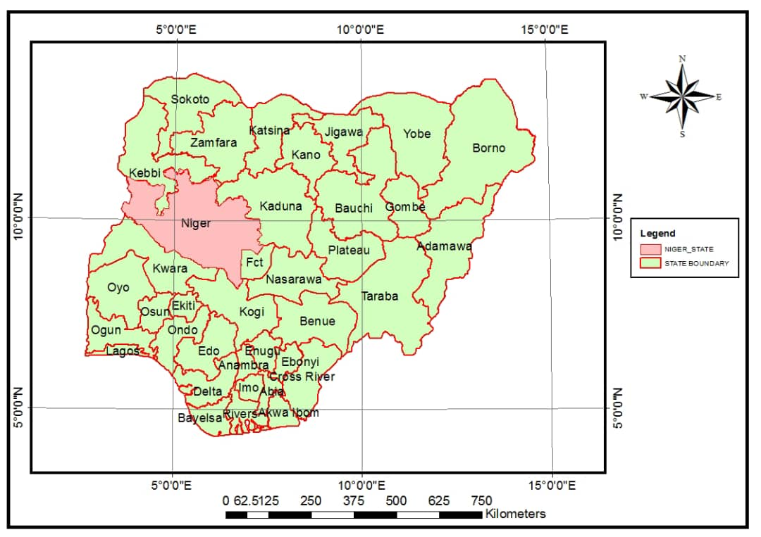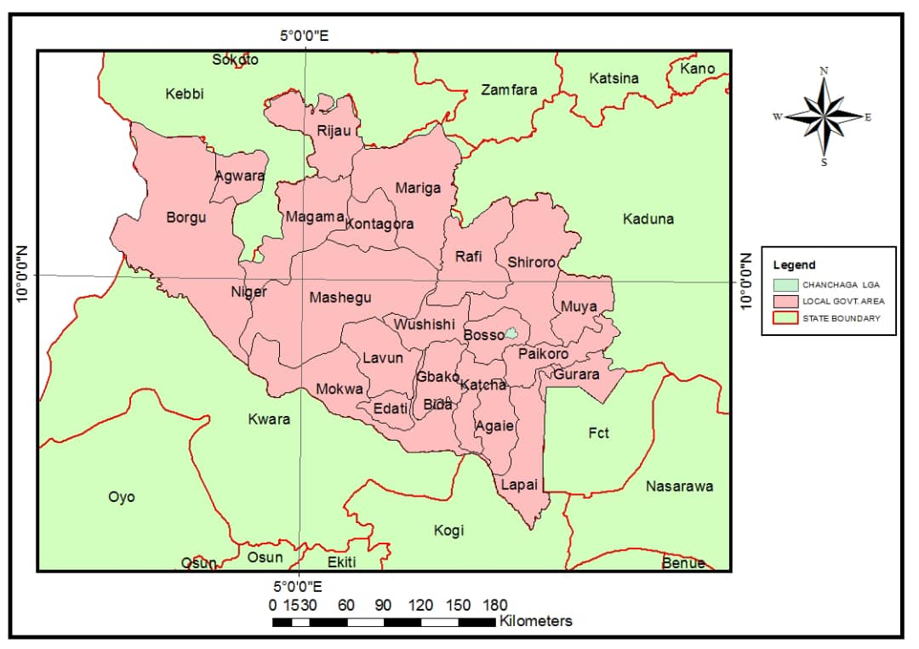

Figure 1: Nigeria Map indicating Niger State Figure 2: Niger State Map showing Chanchaga LGA
Source: Grid3 Nigeria, 2023 Source: Grid3 Nigeria, 2023

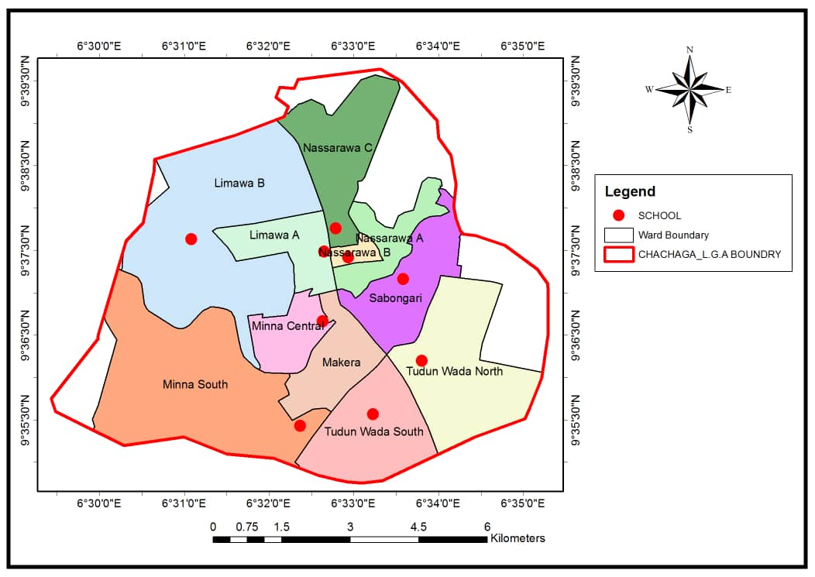
Figure 3: Ward map indicating geographical location of selected schools
Source: Author’s Digitized Work from Grid3 Nigeria, 2023

3.2 Methodology
A descriptive survey research design was adopted to examine the logistics of school feeding programme in Chanchaga LGA. Data types adopted for this study were derived from primary and secondary sources. The primary data were acquired through the use of questionnaires, global positioning system (GPS), camera and direct observations while secondary data were acquired from Grid3 Nigeria and National Population Commission (NPC, 2006 census). The questionnaires were administered to staff at Chanchaga Local Government Secretariat and National Social Investment Programme, Niger State to collect first-hand information pertaining to food sourcing, transportation, storage and distribution to the public primary schools. The GPS was used to acquire the geographical coordinates of the selected schools in the LGA, in order to aid in the spatial description of the benefitting schools across the LGA. On-site photographs were taken from the schools during meal distribution and pictures of the farm produce taken to the LG Secretariat (distribution centre) were also captured using digital camera.

4.0 Results and Discussion

4.1 Food Sourcing for School Feeding Programme
Figure 4. Shows the locations where rice, one of the major food in the menu for school feeding programme is procured. According to the State Programme Manager of the National Home Grown School Feeding Programme, Niger State, rice is locally sourced from Wushishi, Agaie, Edati, Gbako, Katcha, Lapai, Lavun and Gurara Local Government Areas. From Figure 4, rice for SFP is sourced from eight (8) LGA which represents 32% of the entire Local Government Areas where food for SFP are being sourced.
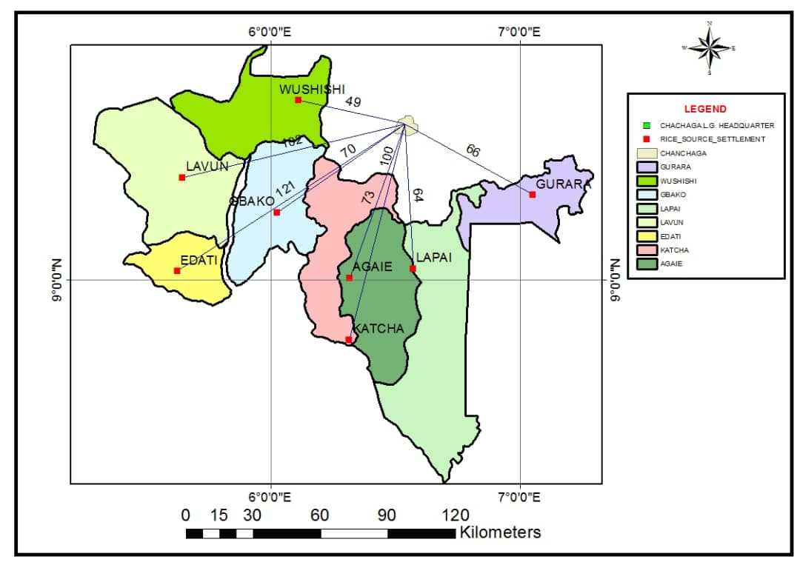
Figure 4: A contexture map of locations where rice grains are sourced
Source: Author’s Digitized Work, 2023.
In relation to the distance covered from the study area, Figure 4 also shows that the estimated shortest average distance covered while transporting rice from the various locations is 49km (Wushishi LGA) while the estimated longest average distance covered is 121km (Edati LGA). Rice suppliers from Lapai (64km) and Gurara (66km) travel nearly the same estimated distance to the study area to supply rice while those from Gbako and Agaie travel 70km and 73km to supply their rice. Likewise, suppliers from Katcha and Lavun cover an estimated average distance of 100km and 102km to the study area. The foregoing analysis shows that the socioeconomic effects of the SFP goes beyond the immediate location of the schools, but also contribute to the inter-community interaction of the communities.
In the same vein, as shown in Figure 5, yam tubers distributed for the feeding programme are locally sourced from Sarkin Pawa, Kuta, Gwada, Fuka, Dandaudu, Beni, KafinKoro, Lambata, Paiko, Maikunkele and Garatu areas in Niger East Senatorial District of the State. All these aforementioned settlements create 6 LGA which represents 24% of the entire 25 LGA in the State.

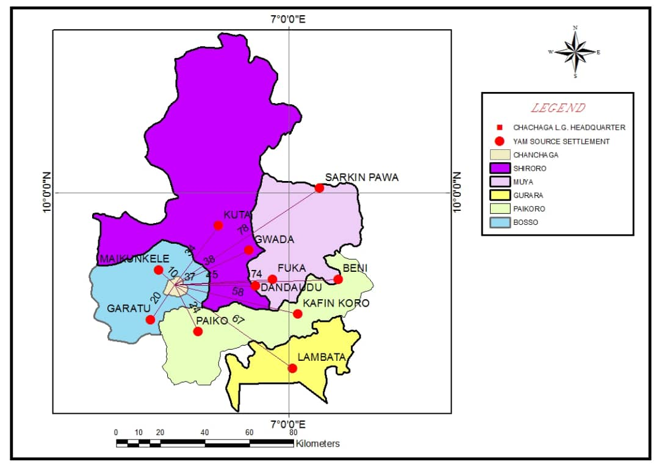
Figure 5: A contexture map of locations where yam tubers are sourced
Source: Author’s Digitized Work, 2023.

Again, Figure 5 shows the distance covered from the distribution centre to the various locations where these yam tubers are sourced for the school feeding programme. From the map, Maikunkele is the nearest settlement with estimated distance of 10km from the study area while Sarkin Pawa settlement in Munya Local Government Area is an average of 78km from the study area, making it the farthest estimated distance covered. Garartu and Paiko settlements cover almost the same distance (20km and 24km) from the study area while the estimated distance covered transporting yam tubers from Kuta, Dandaudu and Gwada is 34km, 37km and 38km respectively. Also, Fuka, KafinKoro and Lambata settlements are settlements where yam tubers are sourced in large quantity for the purpose of school feeding programme and these settlements cover estimated distance of 45km, 58km and 67km respectively from the distribution centre.

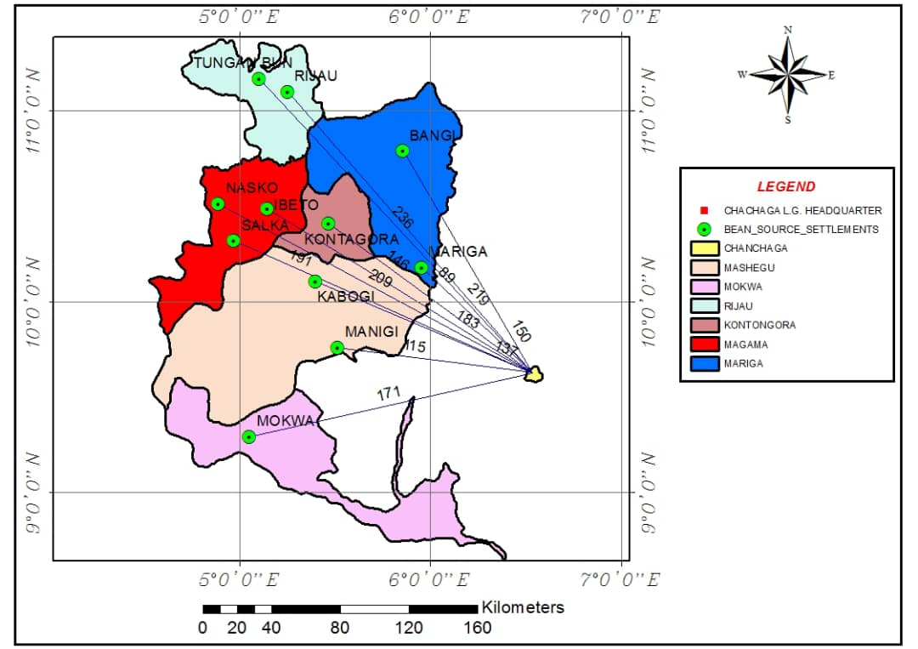
Figure 6: A contexture map of locations where beans are sourced
Source: Author’s Digitized Work, 2023.

Like other staple food, beans supplied to cooks for the feeding programme are produced in large quantity by beans farmers association in Mokwa, Kontagora, Magama, Mariga, Mashegu and Rijau Local Government Areas of Niger State as shown in Figure 6. These six (6) Local Government Areas represents 24% of the entire LGAs where food for SFP are being sourced. In Figure 6, it’s obvious that farmers in beans sourced locations travel a longer distance to supply their produce as compared with those supplying rice and yam tubers. Tungan Bun is the farthest location with an average distance of 236km to the distribution centre while Mariga, which is 89km to the Local Government Secretariat is the closest location where beans is sourced for SFP.
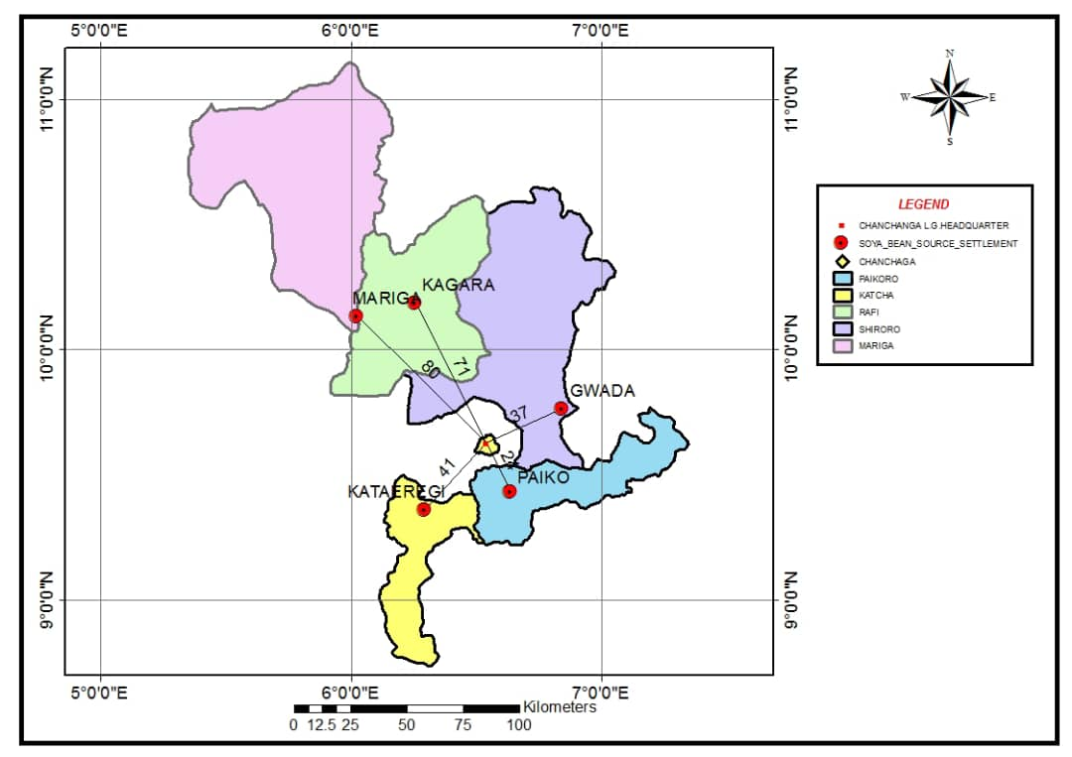
Figure 7: A contexture map of locations where soya beans are sourced
Source: Author’s Digitized Work, 2023.

Like other farm produce, Figure 7 shows the locations of where soya beans are sourced for SFP in the State. Network of smallholder farmers in Kagara, Mariga, Gwada, Paiko and Kataeregi settlements produce and supply soya beans used for the production of cheese in the school feeding menu. The abovementioned settlements are located within 5 LGAs which constitutes 20% of the entire LGAs in the State where food for school feeding programme are sourced.
From Figure 7, Mariga which is the farthest location covers an average estimated distance of 89km from the study area while Paiko covers an average estimated distance of 24km making it the shortest distance covered in transporting soya beans to Chanchaga LG Secretariat (distribution centre).

4.2 Transportation of Food for School Feeding Programme
From the study, it was discovered that the network of smallholder farmers in the 25 Local Government Areas of the State transport their farm produce from various locations to the distribution centre using trucks as a major mode of conveyance. The farmers put their farm produce (rice, beans and soya beans) in stitched bags to avoid pouring while the yam tubers are stacked on the truck for conveyance to the LG Secretariat for further distribution to the benefiting schools. Plate I shows a truck loaded with bags of beans ready to be offloaded at Chanchaga LG Secretariat (distribution centre). Cost of transportation of food from sourced locations to the distribution centre varies depending on the distance of the locations to the distribution centre.
As for the conveyance of cooked food to pupils, cooks live within the community where the SFP benefitting schools are located therefore live near the schools, hence, do not need to cover long distances in order to convey the food to the schools.

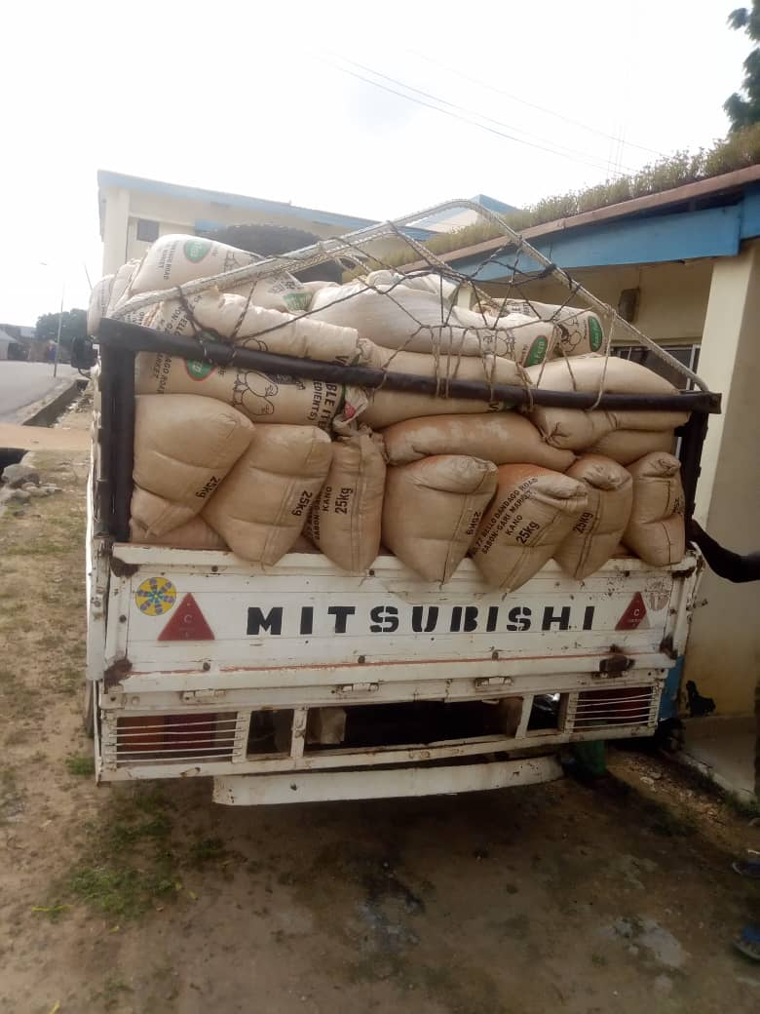

Plate I. Mode of Transportation

4.3 Storage of Food for School Feeding Programme

The study revealed that both the protein and the carbohydrate contents supplied for school feeding programme in Chanchaga LG Secretariat are usually stored in enclosed environment. According to the Programme Manager, every week, over eighteen thousand (18,000) crates of fresh eggs are supplied from the poultry by a network of registered poultry farmers within the community and stored in designated warehouse for onward distribution to the schools benefiting from the feeding programme in Chanchaga LG.
In the same vein, bread supplied to make up the carbohydrate content in the menu is handled by master bakers association of Niger State. Delivery of bread baked by these registered bakers is taken once weekly and shelved in a store for onward distribution among benefitting schools. Like the aforementioned foods, bags of rice, beans and yam tubers are kept in warehouses until they are needed and also to facilitate distribution to various locations of the benefiting schools. Plate II shows pictures of raw food items received in warehouses ready for distribution to the SFP benefitting schools in Chanchaga LG.
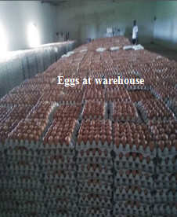
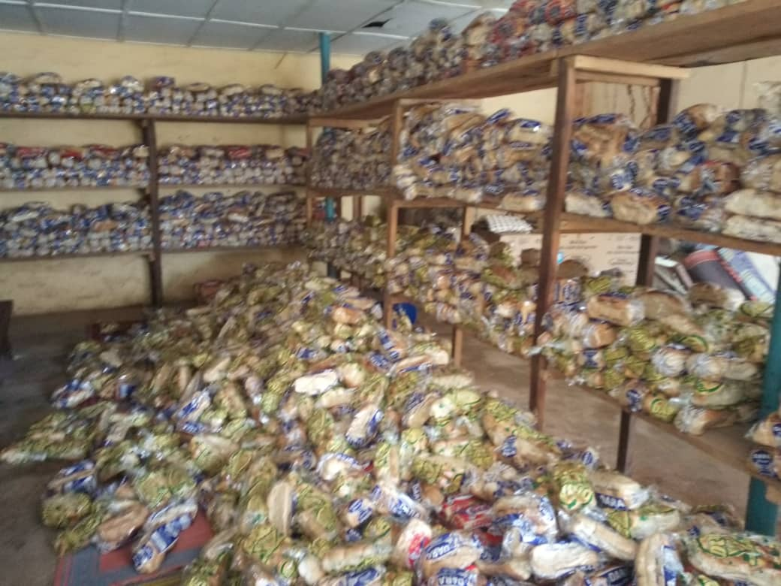
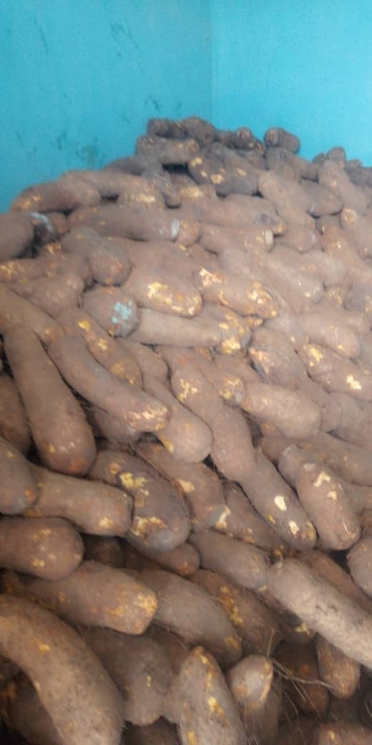
Yam tubers at warehouse
Loafs of bread at warehouse
Plate II: Storage of Food for School Feeding Programme
Source: Author’s Field Work (2023)

4.4 Distribution of Food for School Feeding Programme
This aspect of the study revealed how the raw foods are being distributed to the cooks from the distribution centre and how the cooks in turn convert the food into cooked food and distribute same to the eligible students in various SFP benefitting schools. In accordance with the approved national feeding guideline, the feeding menu contains both protein and carbohydrate contents. Addressing the protein contents, beef, which makes up protein content in the menu, is processed by Butchers Association of Niger State. From Plate III, the cooks have an allotment of 70-100 pupils whereby the pieces of meat are counted and tied in nylon bags and number of pupils written on each nylon bag. In the same vein, eggs are distributed to the cooks considering the number of the eligible pupils and allotted number to serve in each of the schools. Also, soya beans is processed and packaged into fried cheese (wara) by cheese makers for onward distribution to the cooks employed for the feeding programme. Plate III shows the process of packaging beef, eggs and fried cheese to be distributed to cooks for the purpose of school feeding in Chanchaga LGA.

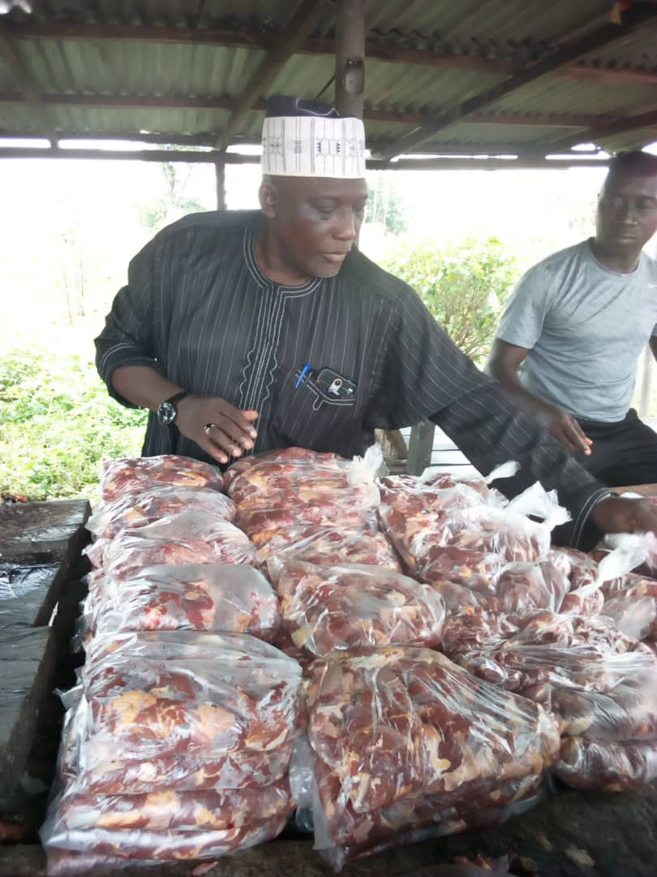
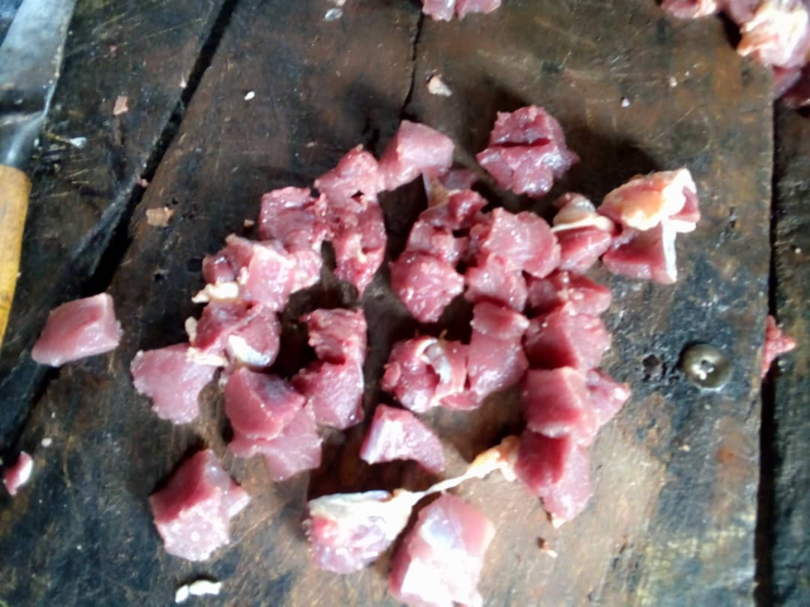
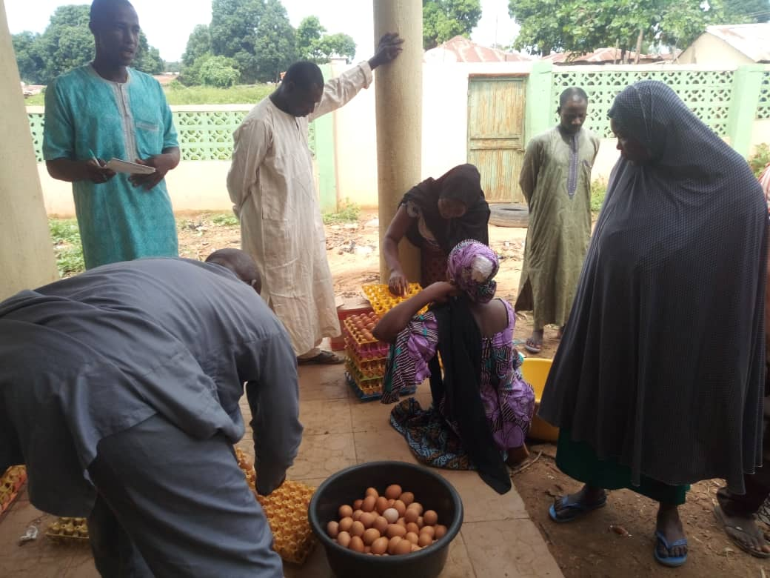
Beef Production Process by Butchers Association of Niger State
Distribution of eggs to Cooks
Fried Cheese (wara)

Fried Cheese
Cheese Making Process
Plate III: Protein Contents distributed to Cooks in Chanchaga LGA
Source: Author’s Field Work (2023)

In furtherance of the food distribution, Plate IV addresses the distribution of carbohydrate contents in the food menu. From Plate IV, Loafs of bread, yam tubers and measures (mudu) of rice can be seen to be distributed to cooks in the various wards in Chanchaga Local Government. Loafs of bread are distributed at the distribution centre once weekly to the cooks and each loaf of bread, shared among eight (8) pupils. Recognisable from Plate IV, are the tubers of yam supplied by network of smallholder yam farmers in the State. The yam tubers are sourced and transported from different farm locations to Chanchaga Local Government Secretariat where they are distributed to the cooks engaged in the SFP.
In the same vein, network of smallholder rice farmers and millers in the State produce, mill and supply all the bags of rice needed for the school feeding programme in the State as shown in Plate IV. The bags of rice are de-stoned however unpolished so as to retain nutrient benefits before supplying them to Chanchaga Local Government for onward distribution to the cooks that are saddled with the responsibility of preparing the food for the SFP benefitting schools.
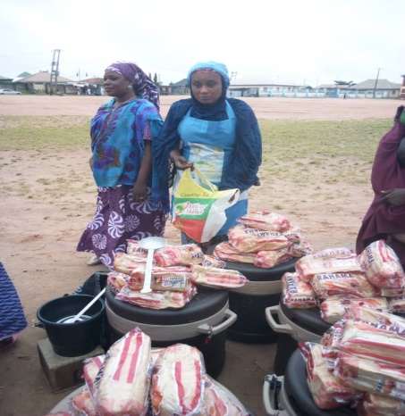
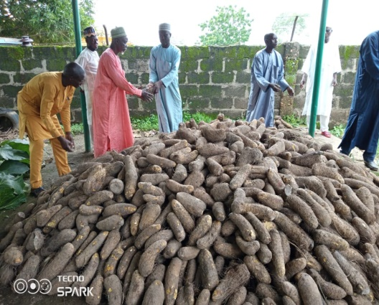
Distribution of Yam Tubers to Cooks
Distribution of Bread to Cooks
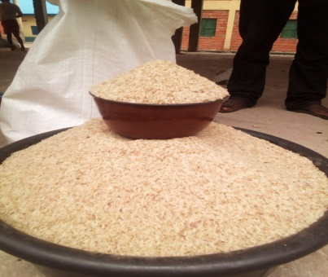
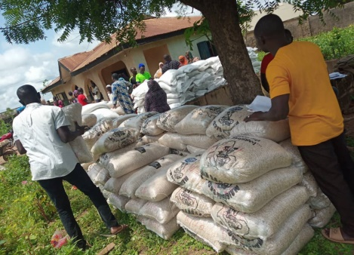
Distribution of Rice to Cooks

Plate IV: Carbohydrate Contents distributed to Cooks in Chanchaga LGA
Source: Author’s Field Work (2023)

Following the distribution of raw food, Plate V shows the pictures of some of the cooks recruited for the school feeding programme in Chanchaga LGA. It is obvious in Plate V that foods cooked are packaged in plastic coolers for onward delivery service to the eligible pupils in the respective SFP schools. The characteristics of food served to pupils under the SFP programme was observed across the selected schools and the result is presented in Table 1. The result shows that four classes of food are prepared and administered to the students from Monday to Friday. Jollof rice and beef is served twice (Monday and Wednesday). Yam porridge and egg, beans porridge and bread, and bread and Soya Sauce are served once on Tuesday, Thursday, and Friday respectively. The study shows that the food served on daily basis had elements of four classes of food which include carbohydrate, protein, vitamin, fat and oil. Hence, the food served can be adjudged to be rich for child development. A typical example of food served on Friday is depicted in Plate V.
Table 1: Types and Quantity of Food Served with Service Frequency
Food type | Class of food | Frequency per week | Qty. of food served
Jollof rice & beef | Carbohydrate/protein/vitamin/fat & oil | Twice | Two serving spoons
Yam porridge & egg | Carbohydrate/protein/vitamin/fat & oil | Once | One serving spoon
Beans porridge & egg | Carbohydrate/protein/vitamin/fat & oil | Once | One scoop
Bread and soya cheese sauce | Carbohydrate/protein/vitamin/fat & oil | Once | One soya cheese with sauce
Source: Author’s Field Work (2023)

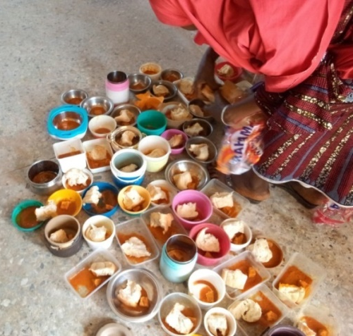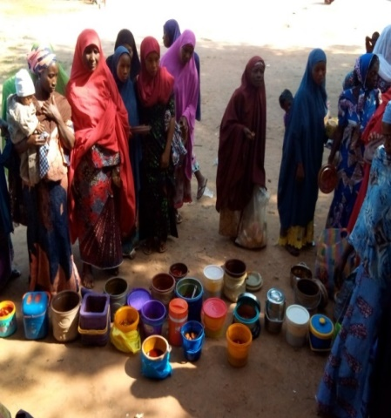
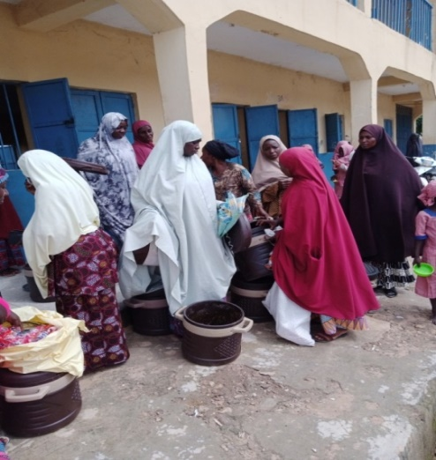
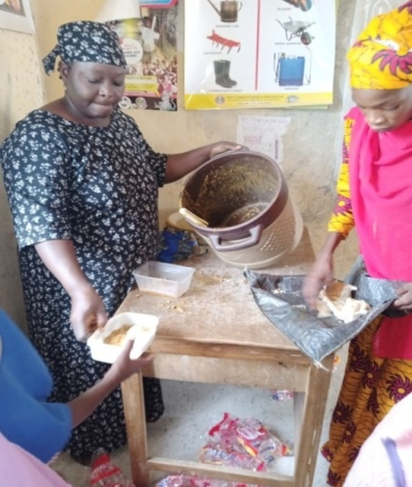

Plate V: Cooks serving cooked food to pupils in Kwasau and Barkin Sale Primary Schools
Source: Author’s Field Work (2023)

5.0 Constraints to School Feeding Programme in Chanchaga Local Government Area
The study examined the constraints to effective implementation and success of the school feeding programme in Chanchaga LGA. The study identified nine constraints from extant review of literature and these challenges were presented to the head teachers and the cooks in each of the school for consideration using a five item Likert. Table 2 shows that corruption is the most challenging constraint to school feeding programme having recorded an index of 4.39 to rank 1st position. Poor remuneration of cooks ranked 2nd with an index of 4.25, while inadequate funding and high inflation ranked 3rd and 4th with an index of 4.10 and 4.05 respectively. These four factors were identified as major constraints to the successful implementation of the school feeding programme. In relation to high inflation and poor remuneration, the Cooks complained about the money for condiments not being enough to purchase the needed condiments hence making them spend out of their monthly stipend to augment. Going forward, corruption, funding, poor remuneration and inflation must be addressed to improve the success of the National school feeding programme.
However, political influence was the least ranked constraint with an index of 3.21 (9th); poor budgetary allocation (3.53) and inconsistency in food supply (3.65) were among the least ranked constraints to the National school feeding programme in Chanchaga LGA. Poor supervision ranked 6th with an index of 3.71 and poor storage facilities ranked 5th with an index of 3.87. The implication of having poor storage facilities is that food supplied by smallholder farmers will not be properly stored and preserved hence leading to spoilage and wastage of food for the school feeding programme. This invariably can lead to food not being enough for school feeding of the eligible pupils in the Local Government.
Table 2: Constraints to School Feeding Programme
Item | Weighted Sum | Mean | Rank
Corruption | 79 | 4.39 | 1
Poor Remuneration of Cooks | 77 | 4.25 | 2
Inadequate Funding | 74 | 4.10 | 3
High Inflation | 73 | 4.05 | 4
Poor Storage Facilities | 70 | 3.87 | 5
Poor Supervision | 67 | 3.71 | 6
Inconsistence in Food Supply | 66 | 3.65 | 7
Poor Budgetary Allocation | 64 | 3.53 | 8
Political Interference | 58 | 3.21 | 9
Source: Author’s Computation (2023)

6.0 Conclusion
The study underscores the pivotal role of logistics in the successful execution of the School Feeding Programme (SFP) in Chanchaga Local Government Area (LGA) of Niger State, emphasizing its heavy reliance on locally sourced food from farmers across the state, particularly rice and soya beans sourced from multiple LGAs. Transportation of raw food to the distribution center is predominantly facilitated by trucks, covering varying distances. The recruited predominantly female cooks gather raw materials at the distribution center, preparing cooked meals in their homes for delivery to schools. Identified challenges include corruption and inadequate remuneration for cooks. To mitigate these issues, the study recommends the State Government improve storage facilities to maintain food quality, ensuring fresh supplies for the students and overall success of the SFP.

7.0 Recommendations
The study recommends the following:
- improve storage facilities to prevent spoilage and ensure fresh, high-quality raw materials for the school feeding program.
- enhance cooks' remuneration to adequately motivate and incentivize them to continue providing their services for the successful implementation of the school feeding program.
- strengthen logistics and distribution infrastructure, such as expanding distribution centers and transportation capabilities, to ensure timely and efficient delivery of food to the schools.
- implement robust anti-corruption measures, including increased transparency, accountability, and monitoring mechanisms, to ensure effective and efficient utilization of the school feeding program's resources.
- enhance community engagement, particularly with local farmers and cooks, to better understand their needs and challenges, and develop more targeted and effective strategies to support the long-term sustainability of the school feeding program.

REFERENCES
Adebisi, Y. A., Oke, G. A., Oladimeji, L. M., Ndwiga, C., Oyetunji, A., Lucero-Prisno, D. E., & Ekpenyong, A. (2020). The public health implications of COVID-19 in Africa: An overview. Pan African Medical Journal, 38(230).
Adekunle, Solomon, Kpada, Rakiya, Yusuf. (2022). Impact of school home grown feeding programme on pupils’ enrolment and performance in FCT Abuja, primary schools. International Journal of Development and Management Review, 17(1):30-45. doi: 10.4314/ijdmr.v17i1.3
Andreas, Kretschmer, Stefan, Spinler., Luk, N., Van, Wassenhove. (2014). A School Feeding Supply Chain Framework: Critical Factors for Sustainable Program Design. Production and Operations Management, doi: 10.1111/POMS.12109
Constance, Sitali, Oswell, C., Chakulimba, Sophie, Kasonde, Ng’andu. (2020). The benefits of school feeding programme in western zambia. International Journal of Research, 8(9):176-182. doi: 10.29121/GRANTHAALAYAH.V8.I9.2020.1412
Claudia, Paciarotti, Giovanni, Mazzuto., Francesco, Torregiani., Christian, Fikar. (2022). Locally produced food for restaurants: a theoretical approach for the supply chain network design. 50(13):164-183. doi: 10.1108/ijrdm-10-2021-0477
Chutchai, Suksa-ard., Morrakot, Raweewan. (2011). Sustainability of Local Food Supply Chain in the New Theory Agriculture.
Eliseo, Luis, Vilalta-perdomo., Martin, Hingley. (2018). Beyond links and chains in food supply: a Community OR perspective. Journal of the Operational Research Society, 69(4):580-588. doi: 10.1057/S41274-017-0252-1
Elena, P., Potapkina, T, V, Mazhaeva., I., A., Nosova., Valentina, I., Kozubskaya., S., V., Sinitsyna., S., E., Dubenko. (2022). Risk Management System in Municipal School Catering. Zdorovʹe naseleniâ isreda obitaniâ, 59-66. doi: 10.35627/2219-5238/2022-30-9-59-66
Elena, Pagliarino. (2015). Innovative logistics and supply chain management for sustainable food public procurement.
Fahed, Algassem, Qingping, Yang., Joe, Au. (2014). Application of Lean Six Sigma Principles to Food Distribution SMEs. American academic & scholarly research journal, 6(4):251-.
Mahadevan.B., S., Sivakumar., D., Dinesh, Kumar., K., Ganeshram. (2013). Redesigning Midday Meal Logistics for the Akshaya Patra Foundation: OR at Work in Feeding Hungry School Children. Interfaces, doi: 10.1287/INTE.2013.0714
Makinde, O. F., & Pemede, O. (2019). Exploiting the dividends of Nigeria's cultural and ethnic divisiveness in national development. University of Eswatini Kwaluseni Journal of Education. 2(1). ISSN: 2616-3012
Mastewal, Zenebe., Samson, Gebremedhin., Carol, J., Henry., Nigatu, Regassa. (2018). School feeding program has resulted in improved dietary diversity, nutritional status and class attendance of school children. Italian Journal of Pediatrics, doi: 10.1186/S13052-018-0449-1
Igor, L., Vorotnikov., Irina, Sukhanova., Larisa, Tretyak., Sergey, Baskakov. (2017). A logistics model of sustainable food supply of the region. 164:94-98. doi: 10.21003/EA.V164-21

João, Roberto, Maiellaro, João, Gilberto, Mendes, dos, Reis, Fernando, Juabre, Muçouçah, Daniel, Nery, dos, Santos. (2019). Developing a system to improve food distribution in public schools: a case in Mogi das Cruzes. 12(43):111-120. doi: 10.30612/AGRARIAN.V12I43.9207
Joshua, Kyalo, Mutua., Meshack, Misoi., Rose, Boit. (2021). Effects of just-in-time procurement strategy on organization performance of food and beverage manufacturing firms in Nairobi county, kenya. 5(2):21-32. doi: 10.47941/IJSCL.666
Laura, Palacios-Argüello., João, Gilberto, Mendes, dos, Reis., João, Roberto, Maiellaro. (2022). Supplying School Canteens with Organic and Local Products: Comparative Analysis. 92-98. doi: 10.1007/978-3-031-16411-8_12
Manpreet, Singh. (2017). Optimization of Food Commodity Supply Chain in Logistics Service Provider Business by Implementing Lean Management. Social Science Research Network, doi: 10.2139/SSRN.3071632
Nida, Islam, Wahab, Nazir, Nauman, Khalid. (2022). Conceptual Study of Problems and Challenges Associated With the Food Supply Chain in Developing Countries. Arab Gulf Journal of Scientific Research, 100-117. doi: 10.51758/agjsr-02-2021-0013
Pernilla, Sjögren. (2014). Usefulness of lean as a sustainable strategy in food supply chains.
Per, Engelseth., Heidi, Hogset. (2016). Adapting Supply Chain Management for Local Foods Logistics. 143-160. doi: 10.18461/PFSD.2016.1619.
Tim, Gruchmann, Stefan, Seuring, Kristina, Petljak. (2019). Assessing the role of dynamic capabilities in local food distribution: a theory-elaboration study. Supply Chain Management, 24(6):767-783. doi: 10.1108/SCM-02-2019-0073

