GEOLOGY AND GEOCHEMICAL EVALUATION OF GOLD POTENTIAL IN KORO, PART OF PATIGI SHEET 204SE, NIGERIA

OMOKORE, David Temitope¹
^{1,} Federal University of Technology, School of Physical Sciences, Department of Geology, Minna, Niger State, Nigeria
Corresponding Author’s Email: ¹davidomokore@gmail.com, +2348034869206

ALABI Adekola Amos²
² Federal University of Technology, School of Physical Sciences, Department of Geology, Minna, Niger State, Nigeria
²alabiadekola@futminna.edu.ng , +2347064326403

Abstract

This study evaluates the gold mineralization potential of the Koro area (Patigi Sheet 204SE), Kwara State, Nigeria, using an integrated approach involving airborne geophysical interpretation, geological mapping, petrographic analysis, and geochemical investigation. The study area lies within the northern extension of the Egbe-Isanlu Schist Belt of the Nigerian Basement Complex, a region recognized for structurally controlled mesothermal gold systems but relatively underexplored in this segment. Airborne magnetic and radiometric datasets were processed using first vertical derivative, tilt derivative, analytic signal, and horizontal gradient techniques to delineate lithological boundaries, structural fabrics, and hydrothermal alteration zones. Results from the geophysical analysis reveal dominant NE-SW to NNE-SSW structural trends, intersected by NW-SE cross-cutting faults that define potential pathways for mineralizing fluids. Geological mapping at a scale of 1:12,500 identified migmatitic gneiss, granites, amphibolites, and quartz veins, with evidence of deformation including shearing, fracturing, and veining. Petrographic analysis confirms mineral assemblages dominated by quartz, feldspars, biotite, and amphibole, alongside microstructural features indicative of tectono-metamorphic evolution. A systematic soil geochemical survey conducted on a 200m X 200m grid, with samples analyzed using ICP-MS, indicates generally low background gold concentrations but highlights discrete anomalous zones. Gold and associated pathfinder elements, such as arsenic, copper, lead, and antimony, show positive correlations and spatial clustering at NW-SE structural intersections, suggesting structurally controlled mineralization. The integration of geophysical, geological, and geochemical datasets confirms the presence of a structurally controlled hydrothermal gold system within the study area. The delineated anomalies and structural targets provide a strong basis for further exploration, including detailed infill geochemical sampling, trenching, ground geophysics, and drilling to evaluate subsurface continuity and economic potential.
Keywords: Gold mineralization, Geophysics, Geochemistry, Structural geology, Koro, Egbe-Isanlu Schist Belt

- Introduction
Gold (Au) has long held a unique position among the elements, valued not only for its aesthetic appeal and role as a financial hedge but increasingly for its critical applications in modern technology and medicine. As a siderophile element with high electrical conductivity and resistance to corrosion, it is indispensable in the electronics industry. However, its primary global driver remains its status as a "safe-haven" asset, which continues to spur intensive exploration efforts worldwide (Frimmel, 2008).
Nigeria is endowed with significant gold mineralization, primarily hosted within the Proterozoic schist belts of the western half of the country. Historically, gold mining in Nigeria dates back to 1913, with peak production occurring in the 1930s. The mineralization is generally associated with the Schist Belts (such as the Ilesha, Egbe-Isanlu, and Kushaka belts) and is often controlled by structural features like shear zones and faults within the Pan-African Basement Complex (Woakes and Bafor, 1984; Garba, 2003). Despite this potential, much of the country’s gold remains underexplored, with current activities dominated by artisanal and small-scale miners.

Gold Exploration and the Egbe-Isanlu Schist Belt
Modern gold exploration relies on a multi-disciplinary approach, integrating geological mapping, aerogeophysical data interpretation, and detailed geochemical surveys to identify "blind" deposits. The Egbe-Isanlu Schist Belt, located in North-Central Nigeria, is a critical focal point for such studies. This belt is characterized by a suite of metasedimentary and metavolcanic rocks, including phyllites, schists, and amphibolites, often intruded by Granitoids (Olobaniyi, 2003).
Previous studies in the Egbe-Isanlu area have highlighted the presence of gold-bearing quartz veins and associated hydrothermal alterations. Research has shown that mineralization in this region is typically orogenic, linked to the late-stage tectonic events of the Pan-African Orogeny (Danbatta, 2008). In the Koro area of the Pategi Sheet 204SE, the geological setting suggests a continuation of these favourable mineralized structures. Evaluating the geochemical signature of the soil and rocks in this specific sector is essential to unlocking its economic potential and providing a blueprint for sustainable mineral development in Kwara State.

- Study Area
The study area falls within Patigi Sheet 204SE, and it is bounded by latitude 8°32’45” to 8°35’15” and longitude 5°54’15” to 5°57’15”, it spans an area of approximately 25.88km² and it is located within the environs of Patigi Local Government Area of Kwara State, Nigeria (Figure 1). The region is located in West Africa's Guinea Savannah belt, which is known for its moderate grasslands and sparse shrubbery. In the region, tall grass grows to its fullest extent from September to December. The vegetation cover is tropical and is characterized by alternating rainy and dry seasons. During the dry season, there are intermittent showers. The North-East trade winds (harmattan)" keep the humidity low from December through January. The average yearly rainfall ranges from 700 to 1300 millimeters. The area is underlain by the Basement Complex of Nigeria, which consists of the Migmatite-Gneiss Complex; the Upper Proterozoic supracrustal rocks known as the Schist belts, and the Syn to late tectonic granitic rocks, which intruded the Migmatite-Gneiss Complex and the Schist belts that are pan-African in age (Obaje, 2009).

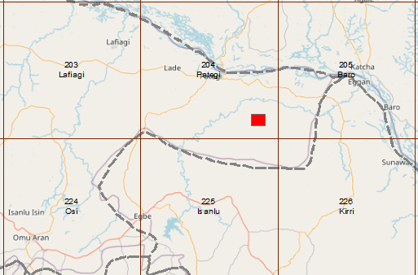
Figure 1: Topographical Index Map showing the spatial location of the study area within Sheet 204SE (Pategi)

- Materials and Methods
The evaluation of the gold potential in the Koro area followed a systematic, multi-disciplinary exploration workflow. This integrated approach ensured that surface geochemical signatures were interpreted within a robust litho-structural framework.

Pre-Field Litho-structural Analysis
The study commenced with the acquisition of high-resolution aero-geophysical data from the Nigerian Geological Survey Agency (NGSA). Using Oasis Montaj and ArcGIS software, these data were processed to generate enhanced magnetic and radiometric maps. This phase focused on identifying deep-seated structural controls, such as shear zones, faults, and hydrothermal alteration zones, which often serve as conduits for mineralizing fluids in the Nigerian Basement Complex.

Geological Mapping and Field Operations
Building on the geophysical interpretations, a detailed field mapping exercise was conducted on a scale of 1:12,500 across the study area located within Patigi Sheet 204SE. The primary objective was to ground-truth the interpreted structures and confirm the local lithology. During this phase, 30 representative rock samples were systematically collected from outcrops for subsequent laboratory study. Special attention was paid to quartz vein orientations and evidence of hydrothermal activity. Structures like joints, faults, foliations and field relations of one lithology with other lithologies were observed.

Petrographic Studies
To understand the mineralogical composition and paragenetic sequences of the host rocks, 10 thin sections were selected and prepared. Petrographic analysis was performed using a polarizing microscope to identify key rock-forming minerals, textures, and microstructures that assist in naming rocks and in assessing microstructures indicative of gold mineralization.

Geochemical Soil Sampling
Residual soil samples were collected across a predetermined 200 X 200 regional soils grid prepared over the high prospect areas where cross-sectional features occur. Sampling was focused on the B-horizon to minimize the influence of organic matter and surface contamination. Approximately 500g of soil was collected at each station and securely bagged. The sampling density was designed to provide adequate coverage for identifying geochemical anomalies across the Koro study site.

Laboratory Analysis
The prepared soil samples were submitted for high-precision laboratory analysis. Inductively Coupled Plasma Mass Spectrometry (ICP-MS) was utilized to determine the concentrations of gold (Au) and a suite of associated pathfinder elements. The use of ICP-MS ensured low detection limits and high sensitivity, which are critical for detecting subtle geochemical signatures in a primary exploration target. Analysis was carried out at ALS Laboratory South Africa.

Data Integration and Statistical Analysis
The final stage involved the integration of the geophysical, geological, and geochemical datasets. Statistical analysis was performed on the assay results to determine the background and threshold values for gold and its pathfinder elements. Multivariate techniques, including the calculation of Pearson correlation coefficients (r), were applied to evaluate the relationship between gold and other elements, the relationship between one pathfinder element and the other, helping to distinguish between lithogenic signatures and true mineralization anomalies.
- Findings and Discussions

- Geology and Structures
Litho-structural Interpretation
The integrated analysis of aeromagnetic and radiometric data revealed a complex structural framework dominated by NE-SW and NNE-SSW regional trending lineaments and localized NW-SE cross faults. These regional structures are consistent with the regional deformation patterns of the Pan-African Orogeny. Magnetic highs and lows coincide with Amphibolites and felsic rocks, respectively, also indicative of zones of suspected alterations. The structural complexity is indicative of multiple episodes of deformation (Figure 2). Radiometric ternary maps highlighted distinct potassium (K) and thorium (Th) anomalies, often coinciding with hydrothermally altered zones within the amphibolite units. A combination of processing, interpretation, and integration of aero-magnetic and aero-radiometric data was used to produce a preliminary litho-structural map, which serves as a pre-field source of information to guide the ground-truthing exercise.

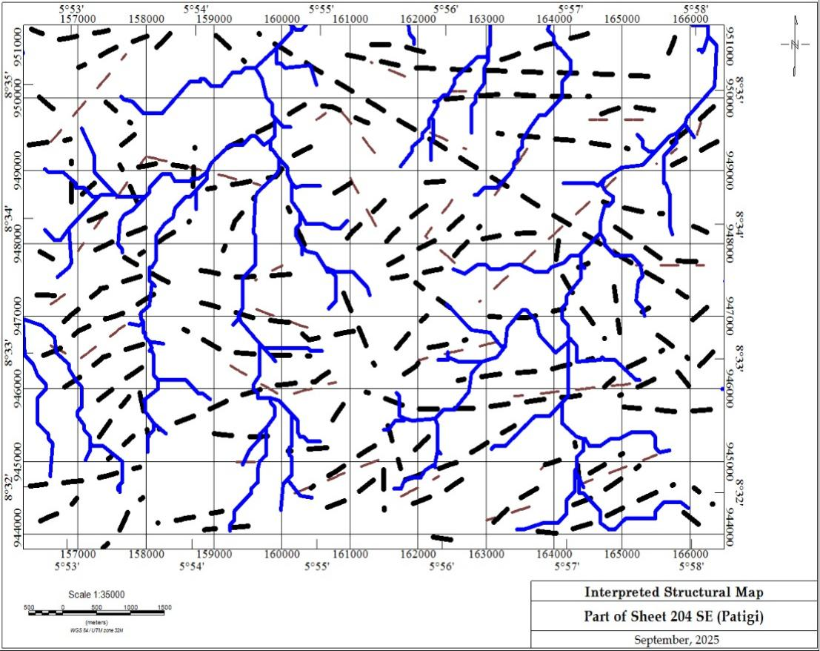
Figure 2: Aero-magnetic Structural Interpretation Map

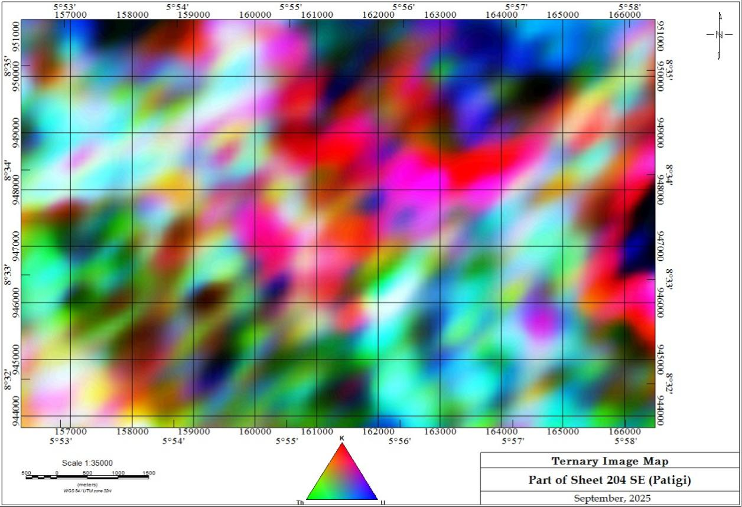

Figure 3: Ternary Image map
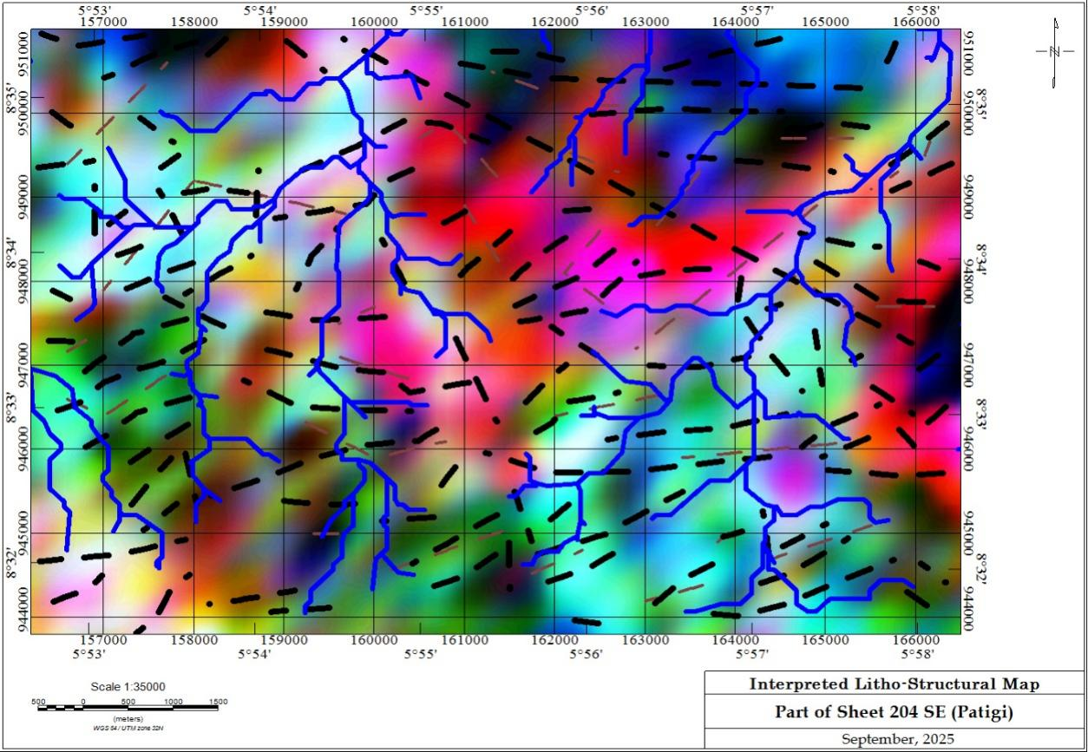

Figure 4: Structural Interpretation Map in relation to Ternary Image Map: A combination of Aeromagnetic and Aero-radiometric Data Interpretations

Ground Truthing and Field Observations
The study area, located 22.5km southeast of Pategi, is situated within the Nigerian Basement Complex, comprising a suite of Migmatite-gneisses, Schist Belt units (Amphibolite schist), and Older Granite intrusions. Field mapping and reconnaissance identified five primary lithological units from a total of 30 outcrops that were studied on the field:
- Granitic Suites: Both fine-medium and medium-coarse grained granites were observed. These units frequently outcrop as bouldery or dome-shaped bodies and appear to have intruded the surrounding schists and gneisses, predominantly following a NE-SW orientation.
- Amphibolite and Amphibole Gneiss: These mafic-rich units are characterized by their dark grey to greenish-grey coloration, aphanitic textures. Structural measurements of foliation indicate a NW-SE strike, reflecting the intense tectonic history of the region.
- Migmatitic Gneiss: Exposed along river channels, these rocks display classic neosome (pegmatitic) and paleosome (gneissic) components with a general NNE-SSW trend. Some outcrops show a distinct migmatite flow structure (Figure x), while others show a weak foliation of platy minerals.
- Metasedimentary Units: Quartzite and quartz-schists form subtle topographic highs. Though weathered, these units exhibit a preferred NW-SE orientation, dipping toward the SW.
- Altered Quartz (The Exploration Pointer): The central regions of the tenement contain quartz rubbles and highly fractures and disjointed quartz outcrops showing sulphide oxidation and hematization. These alterations are direct evidence of hydrothermal fluid activity, marking them as high-priority targets for gold mineralization.
The migmatitic gneises, granites, and granitic gneisses occupy over 80% of the study area and are spread all across the area. Field observations show that the granites intruded the migmatite/grainitic gneisses as contacts were established and relics of the older rocks (gneisses) were seen in some of the outcrops, which actually shows an incomplete assimilation of the granitic melt (Figure x).
A total of ten (10) samples out of the thirty (30) rock samples collected during the field mapping exercise were sent as representative samples for the study area for preliminary petrographic analysis through the production of thin section slides for observation under a plane and cross polarized light of a petrographic microscope
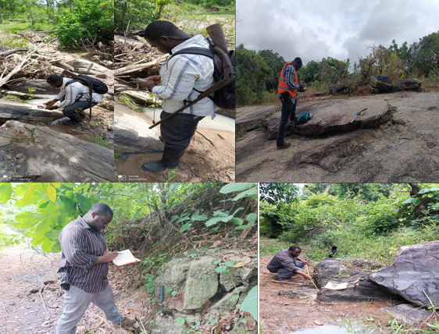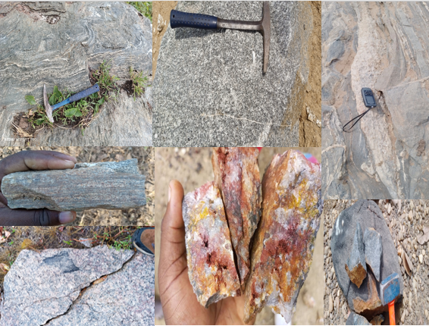
G
F
E
D
C
B
A
Figure 5: Field Mapping exercise and Hand Specimen Samples of Rock: A: Migmatite-gneiss, B: Gneiss, C: Coarse Grained Granite, D: Granite, E: Altered Quartz, F: Migmatite, G: Amphibolite

Petrographic Characteristics
Ten (10) representative rock samples were taken from the number of outcrops located within the study area for thin section production and analysis. Thin-section analysis of representative samples, including granites, gneisses, amphibolites, and quartz veins, revealed a diverse mineralogical assemblage characteristic of the Nigerian Basement Complex.
- Granites and Gneisses: These units are primarily composed of quartz, plagioclase, microcline, and micas (biotite and muscovite). Quartz grains in both units are predominantly anhedral and non-equidimensional, displaying internal fractures and distinct undulatory extinction, which indicates post-crystallization tectonic stress. Plagioclase is identified by its characteristic albite twinning, while microcline exhibits diagnostic cross-hatch (tartan) twinning. Biotite and muscovite appear as subhedral, elongated crystals with a preferred orientation, with biotite showing strong pleochroism from light to dark brown.

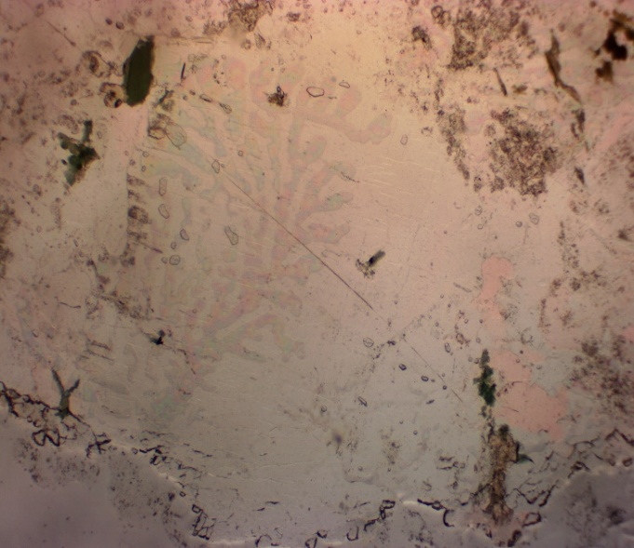
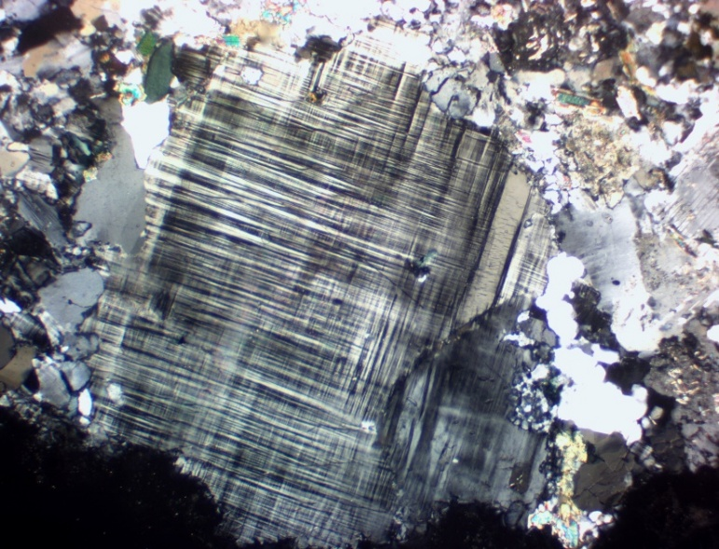
Q
Mi
B
A
Q
B
Q
Figure 6. Photomicrograph of granites composed of Microcline (Mi), Biotite (B) and quartz (Q) under (A) crossed- polarized light, (B) plain-polarized light (Mag. 20x).

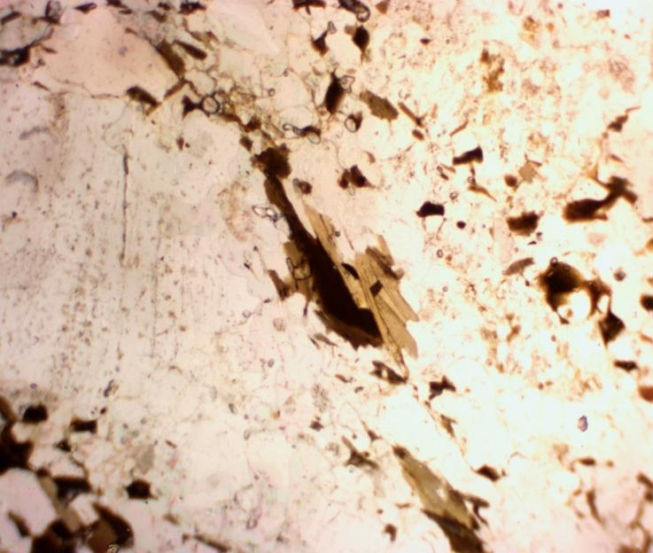
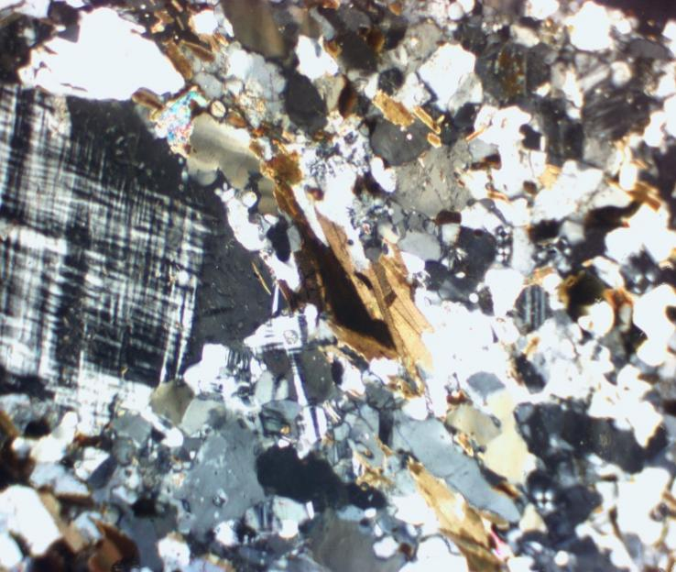
B
B
B
Q
Q
Q
B
Q
Q
B
Q
Mi
B
A
Figure 7. Photomicrograph of gneisses composed of microcline (Mi), biotite (B) and quartz (Q) under (A) crossed-polarized light, (B) plain-polarized light (Mag. 20x).

- Amphibolites: The amphibolite suite consists of amphibole (hornblende), plagioclase, quartz, and orthoclase. Hornblende is distinguished by its strong pleochroism (pale yellow to dark green) and characteristic cleavage. Notably, the presence of opaque minerals which remain extinct under both plane and cross-polarized light suggests the presence of metallic ores or sulfides, potentially pointing to the site's economic mineral potential.

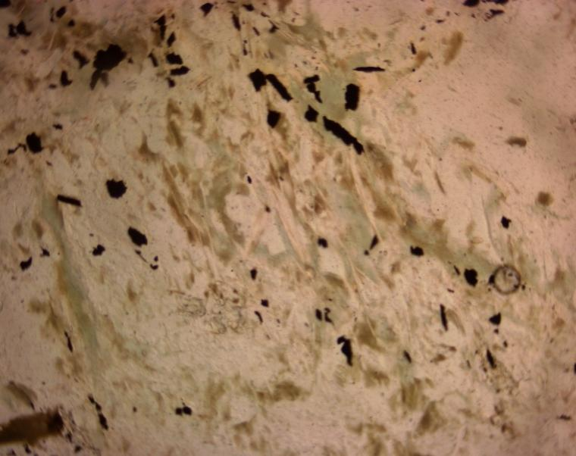
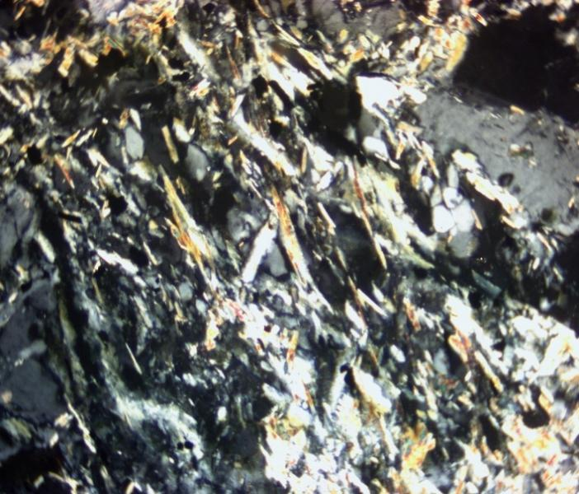
Q
Q
Q
Op
Op
Am
Am
B
Q
B
A
Figure 8. Photomicrograph of amphibolite composed of amphibole (Am), Plagioclase (PL), Orthoclase (OT), Opaque (Op), and quartz (Q) under (A) crossed-polarized light, (B) plain-polarized light (Mag. 20x).
- Quartz Veins: Dominated by large, anhedral quartz crystals, these samples exhibit interlocking boundaries and conchoidal fractures. The prevalence of undulose ("wavy") extinction across these veins suggests they have been subjected to significant hydrothermal and structural deformation, consistent with the localized shear zones identified in the aeromagnetic data.
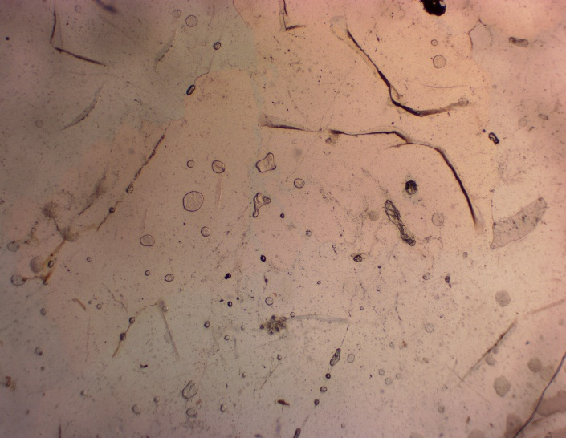
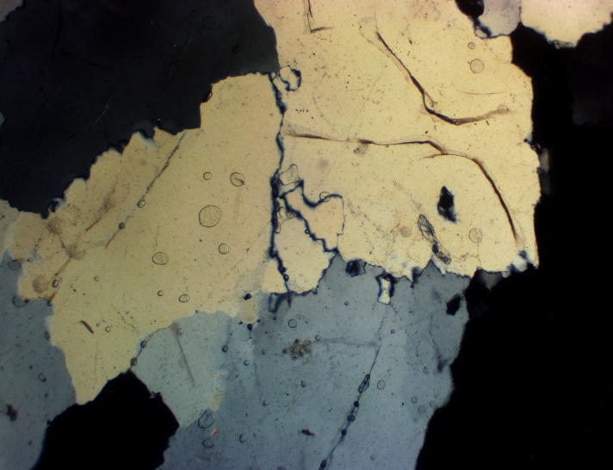
A
B
Q
Q
Q
Q
Figure 9. Photomicrograph of quartz vein composed of quartz (Q) and biotite (B) under (A) crossed-polarized light, (B) plane-polarized light (Mag. 20x).

- Geochemical Dispersion and Statistical Analysis
The geochemical evaluation of 95 residual soil samples (N-95) provides a clear picture of the distribution of elements across the Koro study area. Statistical analysis (Table 1) was bench marked against Average Crustal Abundance to determine the relative enrichment of gold and its pathfinders.
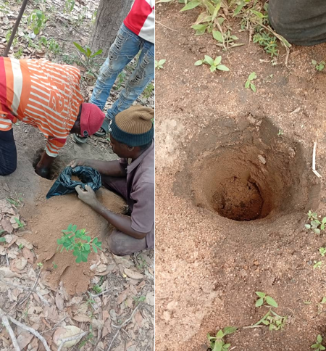
Figure 10: Residual Soil Sampling at Shallow depth of 20-50cm, dependent on soil profile
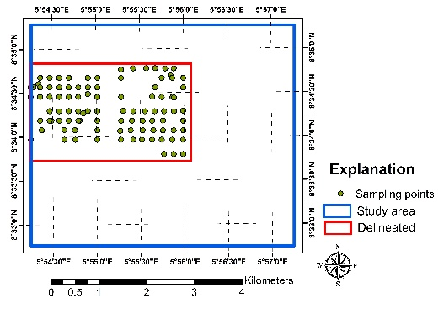
Figure 11: Gridded Soil Sample Plan for regional (200m X 200m) across high prospect zone

Table 1: Background Average Crustal Abundance Statistics for Gold and its Pathfinder Elements
Elements | Au | Ag | As | Cu | Pb | Sb | Zn
N | 95 | 95 | 95 | 95 | 95 | 95 | 95
Background | 0.001 | 0.01 | 0.7 | 17.9 | 11.9 | 0.1 | 29
Average Crustal Abundance | 0.004 | 0.075 | 1.8 | 60 | 14 | 0.2 | 70
Mean | 0.003737 | 0.018947 | 1.026316 | 24.61053 | 17.67474 | 0.118263 | 34.6
Std.Deviation | 0.027716 | 0.015691 | 0.897184 | 21.76811 | 19.16993 | 0.047157 | 26.74601
Min | 0.0005 | 0.005 | 0.1 | 1.6 | 4 | 0.025 | 1
Max | 0.271 | 0.09 | 6.4 | 124 | 146 | 0.33 | 146

Gold (Au) and Silver (Ag) Distribution
Gold concentrations in the study area range from 0.0005 ppm to 0.271 ppm, with a mean value of 0.0037 ppm. While the local background (0.001 ppm) is lower than the global crustal average (0.004 ppm), a significant anomalous peak of 0.271 ppm was identified in the central-western sector. This anomaly follows a distinct NW-SE trend, suggesting a primary structural control. Silver (Ag) mirrors this trend in the south eastern portion, with concentrations ranging from 0.005 to 0.09 ppm.
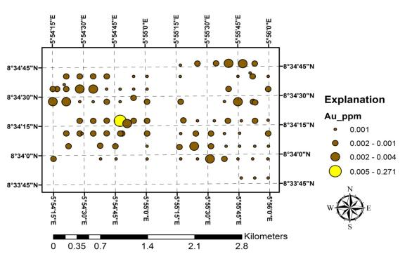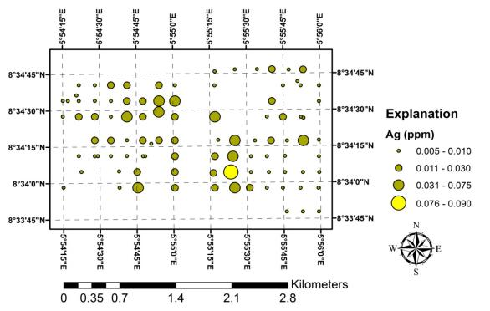
Figures 12: Concentration Point Map of Gold and Silver In the Residual Soil of the Study Area

Pathfinder Element Behavior (As, Pb, Cu, Sb)
The distribution of pathfinder elements further substantiates the gold potential:
- Arsenic (As): Ranges from 0.1 to 6.4 ppm. Despite a low mean (1.026 ppm), isolated values in the eastern axis exceed crustal abundance, maintaining the characteristic NW-SE orientation.
- Lead (Pb) and Copper (Cu): Lead reached a maximum of 146 ppm, and Copper peaked at 124 ppm. Both elements exhibit spatial patterns and directional trends identical to Arsenic and Gold, suggesting a common hydrothermal source.
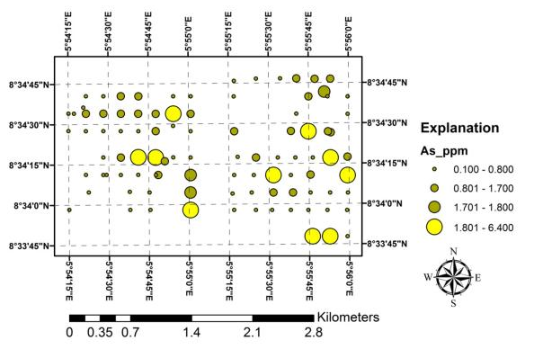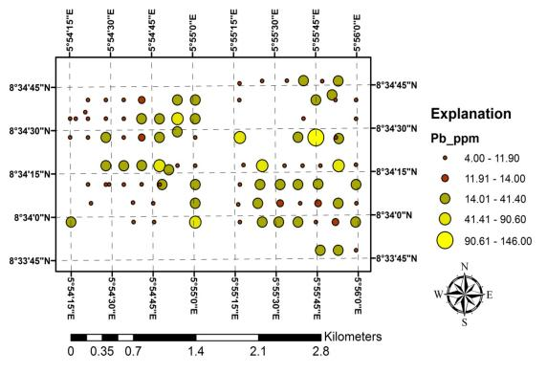
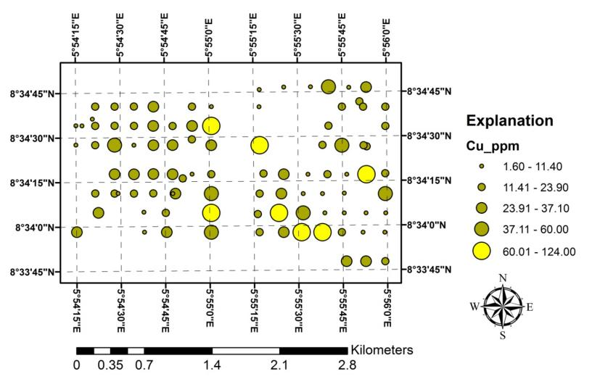
Figure 13: Concentration point map of Arsenic (As), Copper (Cu), Lead (Pb) in residual soil of the study area
- Correlation Coefficient and Inter-Elemental Relationships
The computation of the Pearson correlation coefficient for all pairs of elements is one of the initial steps in conducting multivariate analysis. Certain elements tend more or less to be associated with another element or group of elements (Goldschmidt, 1954), so that different types of bedrock or mineralization are determined by specific elemental associations. It is also performed to uncover inter-element relationships or associations inherent in the geochemical data that could be interpreted as characteristic of the geological or geochemical processes operating in the study area. Pearson’s correlation coefficient method is used in order to delineate the inter-elemental relationships. The coefficient measures the strength of the linear relationship between any two variables. Correlation coefficients were also determined to identify the relationship between different geochemical factors that often influence the concentrations and associations of elements using SPSS 16.0 (Statistical Program for the Social Sciences). This computer software package is used to calculate the correlation coefficient and determine the inter-elemental relationship.
Certain groups of elements respond more or less similarly to a given set of environmental conditions. Consequently, mutual correlations between different elements serve to identify variations in the geochemical landscape more clearly (Levinson, 1974). The correlation matrix for the data obtained in this study (Table 5) was generated using the Statistical Package for the Social Sciences (SPSS), and it shows both negative and positive correlations.
Some of the elements exhibit fairly strong to strong positive correlations with each other and weak negative to positive correlations with certain other elements. Moreover, the strong positive correlation between some of the elements, notably, Ag/Cu, Ag/Zn, As/Ce, As/Pb, As/Sb, Co/Cr, Co/Cu, La/Sc, La/Y, Sc/Y, Sc/Sn just to mention a few, may be indicative of a common source of mineralization or concentration
Table 2: Pearson correlation matrix of soil geochemical data from the study area showing significance at 0.5 and above.
0 | Au | Ag | As | Ce | Co | Cr | Cu | La | Li | Nb | Pb | Sb | Sc | Sn | Y
Au | 1
Ag | 0.0091 | 1
As | 0.1028 | 0.084 | 1
Ce | 0.1811 | 0.21 | 0.7594 | 1
Co | 0.3059 | 0.3657 | 0.6819 | 0.6439 | 1
Cr | 0.021 | 0.136 | 0.4787 | 0.2925 | 0.5962 | 1
Cu | 0.0568 | 0.6443 | 0.3728 | 0.4025 | 0.6941 | 0.4573 | 1
La | 0.0168 | 0.317 | 0.1462 | 0.2263 | 0.2878 | 0.1935 | 0.4784 | 1
Li | -0.037 | 0.2698 | 0.0157 | 0.008 | 0.2861 | 0.0391 | 0.38664 | 0.2175 | 1
Nb | 0.0279 | 0.2492 | -0.135 | -0.0644 | -0.081 | -0.154 | 0.009 | -0.13 | 0.1237 | 1
Pb | 0.2245 | 0.383 | 0.7049 | 0.8773 | 0.6966 | 0.2982 | 0.442 | 0.0982 | 0.2054 | 0.00811 | 1
Sb | 0.2017 | -0.1096 | 0.7914 | 0.5314 | 0.4521 | 0.3063 | 0.15751 | 0.0446 | -0.1075 | -0.1857 | 0.5013 | 1
Sc | -0.006 | 0.4918 | 0.2383 | 0.2927 | 0.5807 | 0.4456 | 0.75887 | 0.6295 | 0.3994 | -0.081 | 0.2491 | -0.0146 | 1
Sn | -0.069 | 0.3781 | 0.0554 | 0.0729 | 0.2993 | 0.2377 | 0.40992 | 0.4125 | 0.4387 | -0.0077 | 0.0904 | -0.1111 | 0.7291 | 1
Y | -0.046 | 0.3858 | 0.0897 | 0.0937 | 0.2906 | 0.1665 | 0.49607 | 0.7436 | 0.1984 | -0.1233 | -9E-04 | -0.1119 | 0.7755 | 0.5877 | 1
Zn | -0.019 | 0.7528 | -0.009 | 0.1444 | 0.3292 | 0.093 | 0.71143 | 0.4792 | 0.5664 | 0.31337 | 0.2499 | -0.2133 | 0.6446 | 0.4707 | 0.5

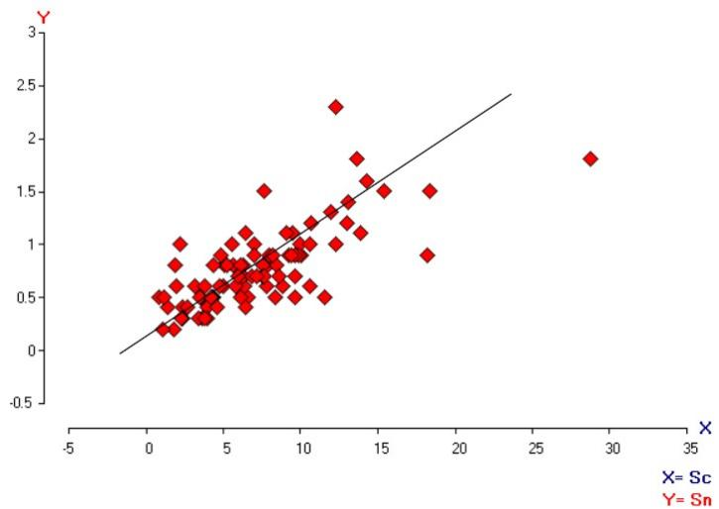
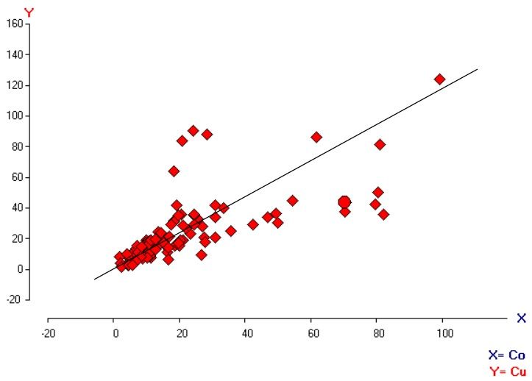
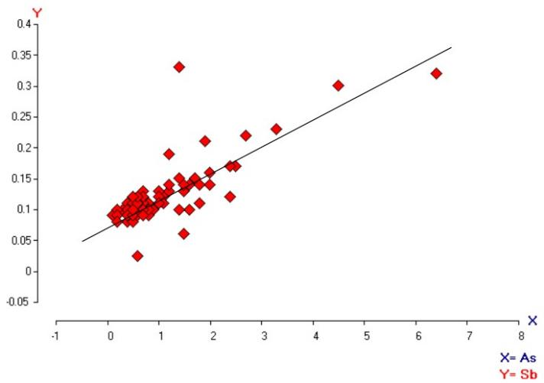

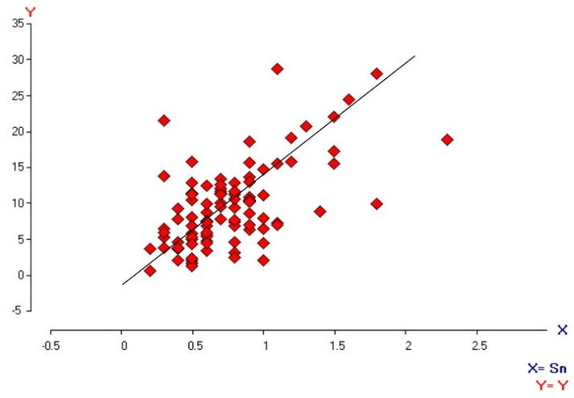
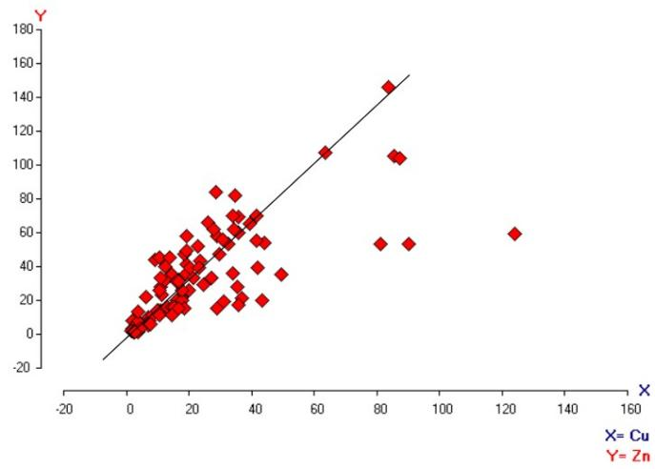

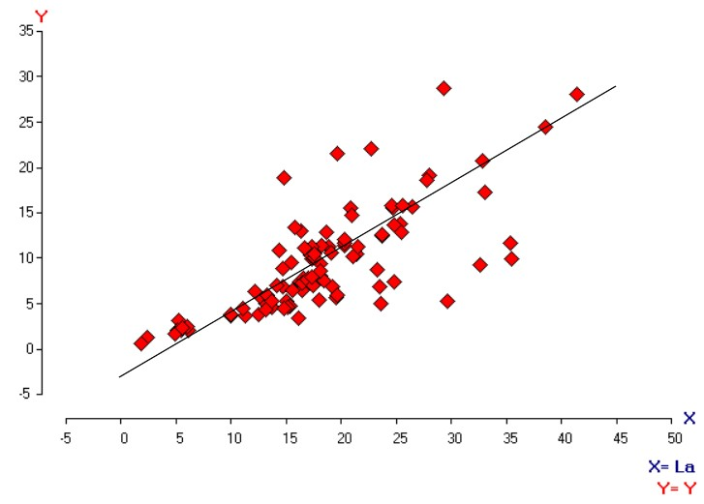

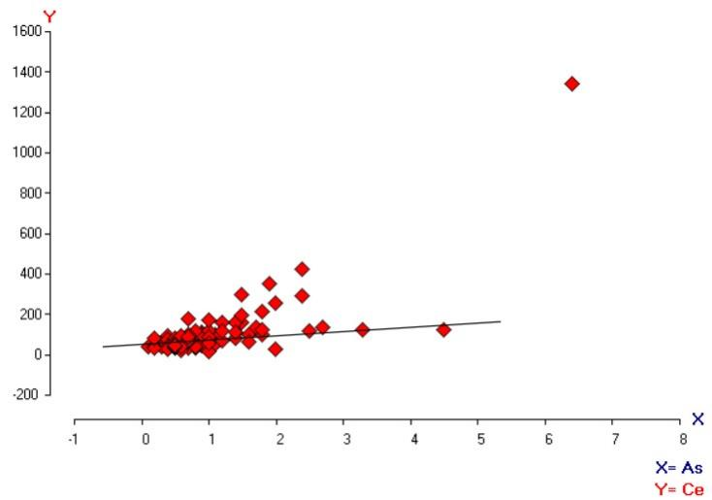
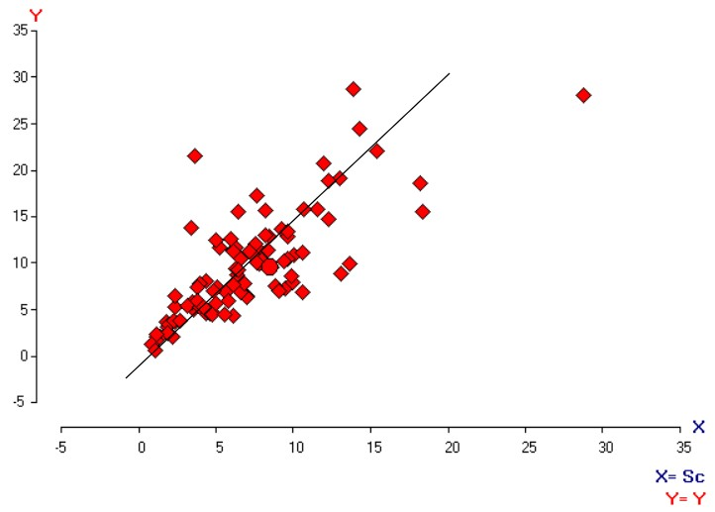

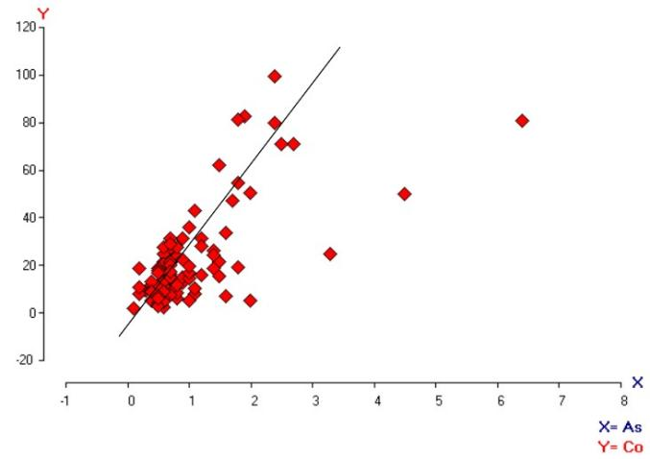

From the correlation table and binary plots above using the Pearson linear correlation of elements which measures the linear relationship/association between pairs of elements, the correlation matrix for the data shows that a strong association exist between certain elements; Trace elements (As, Sb, Ce & Sn), Base metals (Cu, Co, Zn & Cr) and Rare Earth Elements (La, Sc & Y). Within the correlated elements, the plots show positive correlation between each other as shown in the correlation plots and correlation table with a significant value of 0.5 and above, which interprets a strong association and a possible common source of mineralization.
- The Gold-Pathfinder Association: The geochemical maps for Au, Ag, As, Cu, and Sb show striking similarities in high-concentration zones. This co-precipitation signature is indicative of a unified mineralizing event.
- Elemental Groupings: Multivariate analysis identified three primary associations:
  - Trace Elements: As, Sb, Ce, and Sn.
  - Base Metals: Cu, Co, Zn, and Cr.
  - Rare Earth Elements (REE): La, Sc, and Y.
These strong positive correlations confirm that the mineralization in Koro is likely tied to a single, litho-structurally controlled system rather than isolated occurrences.

Conclusion and Recommendations
The geochemical and petrographic study of the Koro area confirms a promising environment for gold mineralization. Although average concentrations appear low relative to global crustal averages, the presence of a 0.271 ppm Au anomaly, spatially coincident with pathfinder elements (Cu, Pb, As) and following a consistent NW-SE structural trend, points to significant underlying mineral potential.
To further delineate the ore body and transition from preliminary to a detailed phase, the following is recommended:
- High-Density Sampling: Conduct systematic soil sampling at a 50m x 50m grid within the delineated anomaly zones to increase spatial resolution.
- Subsurface Investigation: Execute selective pitting (5-10m depth) to evaluate soil horizons and determine the continuity of mineralization at depth.
- Ground Geophysics: Integrate the current geochemical findings with Induced Polarization (IP) or Ground Magnetics to pinpoint subsurface sulfide concentrations and structural conduits.
- Targeted Trenching: Focus follow-up activities on the central-western and eastern axes where the NW-SE geochemical trends are most pronounced.
References
Ajayi, T. R. (1981). On the Geochemistry of the Ilesha Schist Belt (Southwestern Nigeria) and its Relation to Gold Mineralization. Journal of Geochemical Exploration, 15(1-3), p.213-227.
Carranza, E. J. M. (2009). Geochemical Anomaly and Mineral Prospectivity Mapping in GIS. Handbook of Exploration and Environmental Geochemistry, 11, p.1-568. Elsevier.
Chandrajith, R., et al. (2001). The use of ICP-MS in mineral exploration: A review of applications and challenges. Journal of Geochemical Exploration, 72(2), p.1-14.
Danbatta, U. A. (2008). A Review of the Evolution and Tectonic Setting of the Schist Belts of Western Nigeria. Journal of Mining and Geology, 44(2), p.147-158.
Frimmel, H. E. (2008). Earth's Continental Crustal Gold Endowment. Earth and Planetary Science Letters, 267(1-2), p.45-55.
Garba, I. (2000). Structural Controls on Gold Mineralization at Bin Yauri, Nigeria. Journal of Mining and Geology, 36(2), p.127-135.
Garba, I. (2003). Geochemical Characteristics of Mesothermal Gold Mineralization in the Pan-African (600 Ma) Precambrian Basement of Nigeria. Applied Earth Science (Trans. Inst. Min. Metall. B), 112(3), p.319-325.
Gleeson, S. A. (2010). Geochemical exploration for gold: Lessons from the past and challenges for the future. Geochemistry: Exploration, Environment, Analysis, 10(4), p.315-322.
Levinson, A. A. (1980). Introduction to Exploration Geochemistry. Applied Publishing Ltd., p.1-924.
McLean, J., et al. (2013). Integrating aeromagnetic and radiometric data for mineral exploration in covered terrains. Exploration Geophysics, 44(3), p.160-172.
Olobaniyi, S. B. (2003). Petrology and Geochemistry of the Egbe-Isanlu Schist Belt, SW Nigeria. Unpublished PhD Thesis, University of Ilorin, Nigeria.
Reimann, C. & Filzmoser, P. (2000). Normal and lognormal data distribution in geochemistry: death of a myth. Environmental Geology, 39(9), p.1001-1014.
Woakes, M. & Bafor, B. E. (1984). Primary Gold Mineralization in Nigeria. Gold '82: The Geology, Geochemistry and Genesis of Gold Deposits, p.661-681. A.A. Balkema, Rotterdam.

