DESIGN AND ANALYSIS OF A SINGLE PHASE 650VA TRANSFORMER-LESS INVERTER FOR SOLAR PV POWER APPLICATION

Yisa Mutiat Shittu, Dr. J.C Onuegbu, and Micheal Ephraim
Department of Electrical Engineering, Nnamdi Azikiwe University, Awka
Email: shittuadenike2003@yahoo.co.uk
Email: onuegbujo@yahoo.com
Email: electmike84@gmail.com
Abstract: This paper presents a single phase boost Photovoltaic (PV) inverter system and its control implementation. In order to achieve low cost, easy control, high efficiency and high reliability. The inverter employs push pull switch mode converter, an H bridge inverter, an automatic changeover dual battery bank and an RF remote control circuit unit. The switching technique of the proposed inverter consists of a combination of sinusoidal pulse width modulation (SPWM) and square wave oscillator along with grid synchronization condition. As the suggested method is entirely transformer less, it ridiculously reduces total harmonic distortion (THD) which is less than 0.1%, minimizes size and swells with inverter efficiency up to 98% which can be used in our homes, offices and schools for lightening and charging. Most of the PV systems are designed with transformer for safety purpose with galvanic isolation. However, the transformer is big, heavy and expensive. Also, it reduces the overall frequency of the conversion stage. Generally PV inverter with transformer is having efficiency around 92%–94% only. To overcome these problems, transformer less PV system is introduced. It is smaller, lighter, cheaper and higher in efficiency.
A capacitance conversion circuit provides a nearly constant output current which stabilize system rapidly and reduces harmonics generated by inverter. Overall performance of the proposed inverter is simulated through the proteus. The simulation results are analyzed through PROTEUS and MATLAB software which produced a pure sinusoidal waveform as the output voltage.
A 650VA prototype was designed and construction, tested, simulated and Experimental results are provided to verify the validity and performance of the circuit operations and current control.

Keywords: DC–AC power conversion, photovoltaic system, transformer-less inverter, PIC microcontroller, Mosfet switches, Solar energy.

- Introduction
With the worsening situation of the world’s energy shortage and environmental pollution problems, protecting the energy and the environment becomes the major problems for engineers. Thus the development and application of clean renewable energy such as solar, wind, fuel cell, tidal and geothermal heat are getting more and more attention. Among them, solar power will be dominant because of its availability and reliability, the cost of utilizing the renewable energy is at ever decreasing rate. The sun offers unlimited energy for harnessing and for this very reason, Photo Voltaic (PV) system consisting of PV modules, for generating environmental friendly, power are gaining more and more recognition with each passing day. (Chandra T.S, 2015)
The PV modules comprise of several solar cells, which convert the energy of the sunlight directly into electricity and are connected as required to provide desired levels of DC current and voltage. They produce electricity due to a quantum mechanical process known as the “Photovoltaic effect”. The major drawback with these PV systems is that their cost is much high compared to the convectional sources such as fossil fuel and their efficiency are also quite low.
Power semi-conductor devices represent the heart of the modern power electronics and are being extensively used in power electronic converters in the form of ON or OFF switches, and helps to convert power from one form to another. There are four basic conversion functions that can be implemented such as:
- AC – AC converter (AC voltage controller)
- AC – DC converter (controlled rectifier)
- DC – DC converter (DC chopper)
- DC – AC converter (inverters)
Inverter is one of the converter families which are called DC to AC converter. It converts DC power to AC power to a symmetric AC output voltage at desired magnitude and frequency. (Rashid.M.H, 2007)
Inverter is widely used in industrial application such as variable speed, AC motor drives, induction heating, standby power supplies and uninterruptible power supply. The DC power input of inverter is obtained from the existing power supply network. It can be a battery, photovoltaic, wind energy, fuel cell or other DC sources. (GuptaJ.B, 2013)
A sinusoidal pulse width modulation (SPWM) is widely used in power electronics to digitize the power so that a sequence of voltage pulses can be generated by the ON and OFF of the power switches. (Jagannathan.V, 2011)The pulse width modulation inverter has been the main choice in power electronics for decades, because of its circuit simplicity and rugged control scheme. SPWM techniques are characterized by constant amplitude pulse with different duty cycle for each period. The width of the pulse is modulated in order to obtain inverter output voltage control and to reduce its harmonic content. (KjaerS.B, 2005)
In this paper, new models of inverter will operate without a transformer by using an effective single phase DC-AC boost choppers. The PV configuration consists of five (5) main components namely:
(a) Solar panel / DC Voltage Source
(b) Charge change-over
(c) Battery change-over
(d) DC – AC Inverter
(e) Load

- Proposed inverter system

All existing models of transformer-less inverters use either single phase or multiple phases of power converters. They also use more components like a high frequency transformer (choppers), filters, diode rectifiers and a bridge inverter. A new single switch inverter is developed which is capable of generating a pure sinusoidal waveform from a fixed dc input voltage. The new switch inverter is a full bridge voltage source inverter, a double bank battery with a remote control is proposed.
The H-bridge topology is formed by 4 MOSFET and a capacitive divider connected to the PV array. The connection of the grid neutral wire to the capacitive divider midpoint ensures an almost constant common mode voltage, thus preventing leakage current through the parasitic capacitance of the PV module.
It consists of two arms with a two semiconductor switches on both arms with antiparallel freewheeling diodes for discharging the reverse current. In case of resistive-inductive load, the reverse load current flows through these diodes. These diodes provide an alternate path to inductive current which continue to flow during the Turn OFF condition. In switching process, four switches are grouped into two groups, Q1 and Q2 are in one group and Q3 and Q4 are in another group. When Q1 and Q2 are switched, Q3 and Q4 are forced turned off. Similarly, when Q3 and Q4 are switched, Q1 and Q2 are forced off because a short circuit across the dc link voltage source V₁ would be produced.
The capacitor is energy storage device which is optimally designed to ensure small size and low cost.
However, a double bank battery will have two auxiliary batteries whereby when one battery is down, the other will be working meanwhile the used battery (discharged) will continue charging.

Figure 1: proposed H- Bridge inverter.

- System description

The principle of the circuit below is that when the sine wave oscillator (SG2524) pin 11 is high and pin 14 is low this will control the pin 7 of the upper IR2110 to be high and pin 1 will be low. On the second IR2110, the reverse is the case. Pin 7 is low and pin 5 high. This will cause current to flow through Q7 and Q6 only. If there is an alternation in the output of the oscillator, all the logic stated earlier is inverted causing Q5 and Q8 to conduct. This action converts the 310V DC to AC. The reduction of the voltage to 230 is as a result of the resistance across the source and drain of each MOSFET.
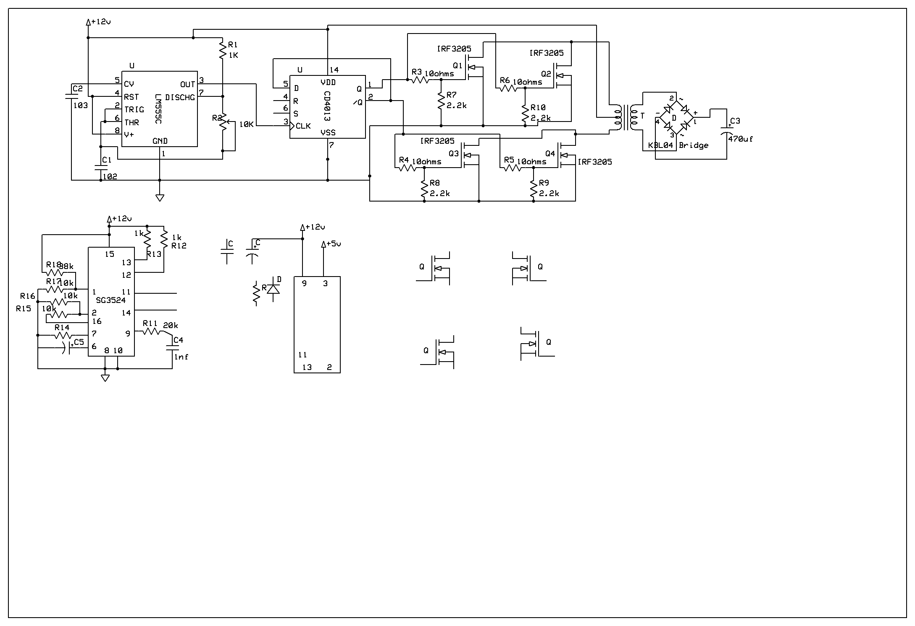
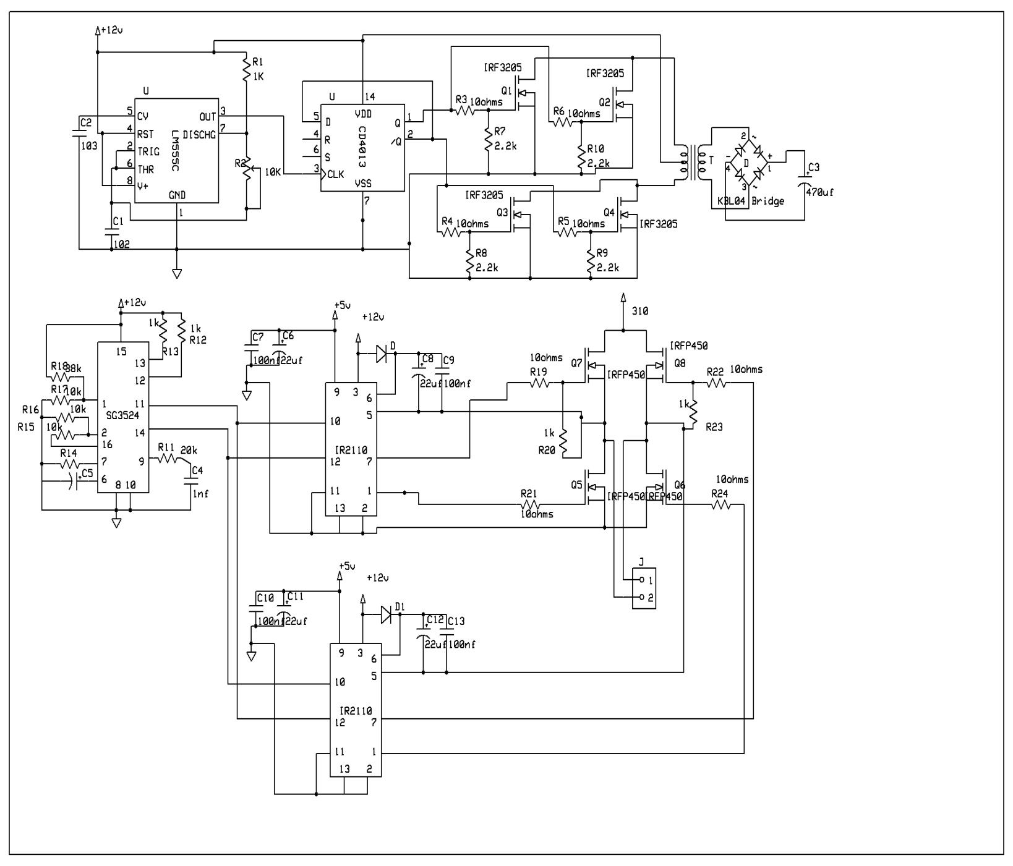
Figure 2: circuit diagram system

- Inverter design requirement

The requirement for inverter is as follows:
• Output Voltage = 220V
• Fixed Output frequency = 50Hz
• Power rating S= 625VA
• Input DC Voltage = 12V
•Efficiency at full load current greater than 98%.
•Maximum Load Current at input =51A.

- Experimental result
Figure3: Simulink model of the system

The simulations were done in MATLAB Simulink. The Switching frequency was set to 60 kHz. In order to simplify the simulation, the PV array was simulated with a DC voltage source of 12V. The Duty cycle of the first boost converter is 0.5 and that of the second converter is 0.68. The output filter Cf=100 μF filter capacitor; the grid was modelled at F=50Hz grid with Vg=75Vrms. The simulation period was 50us. The switching frequency = 60 KHz.
$$F=\frac{1}{T}=\frac{1.44}{\left(\left(R_{1}+2R_{2}\right)×C\right)}$$
$$Duty cycle\left(D\right)=\frac{R_{1}+R_{2}}{R_{1}+2R_{2}}$$
$$R_{1}=\frac{1.44\left(2D-1\right)}{f×C}$$
$$R_{2}=\frac{1.44\left(1-D\right)}{f×C}$$
$$T_{on}=0.693\left(R_{1}+R_{2}\right)×C$$
$$T_{off}=0.693×R_{2}×C$$
$$f=\frac{1.44}{\left(R_{1}+2R_{2}\right)×C}$$
$let C= C_{1}=1nf$
$$frequency intended for use (f)=120kHz$$
$let R_{1}=1kΩ$
$$120000=\frac{1.44}{\left(1000+2R_{2}\right)×0.0000001}$$
$$1000+2R_{2}=\frac{1.44}{120000×0.000000001}$$
$$1000+2R_{2}=\frac{1.44}{0.00012}$$
$$1000+2R_{2}=12000$$
$$2R_{2}=11000$$
$$R_{2}=5500Ω$$
$$Usually because of the tolerance of the$$
$$resistor and capacitor,$$
$$we may not get 120kHz to combat$$
$$this ill, avariable resistor of 10kΩ is$$
$used.$
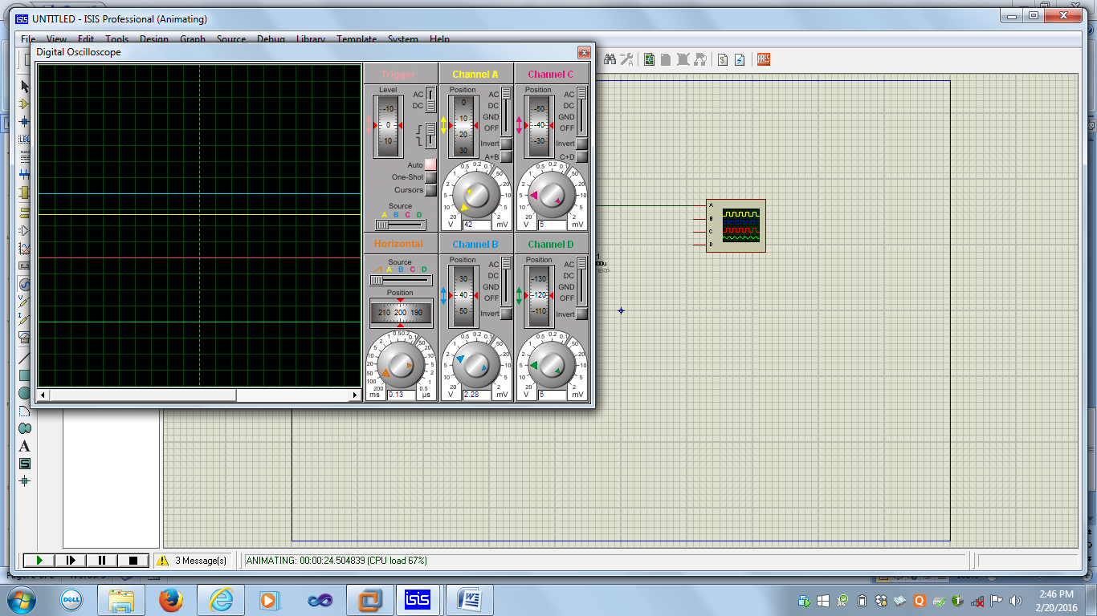

Figure 4: Rectification and filtration of AC- DC converter

Figure 5: output waveform of DC-DC converter

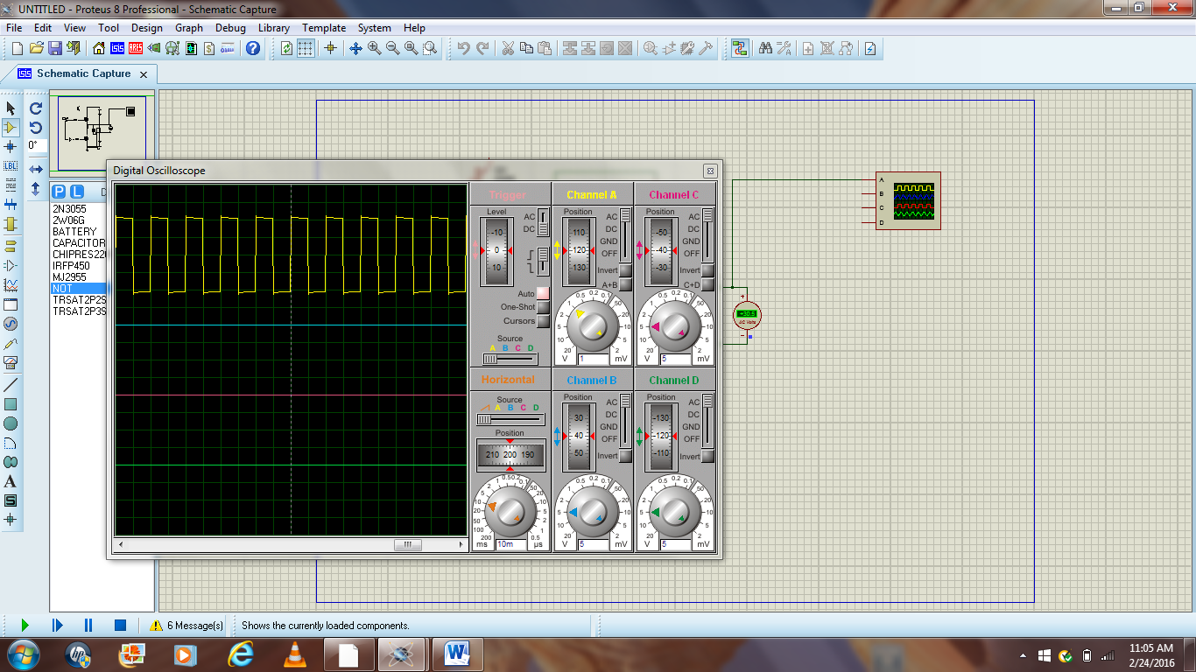

Figure 6: Inverter waveform unit

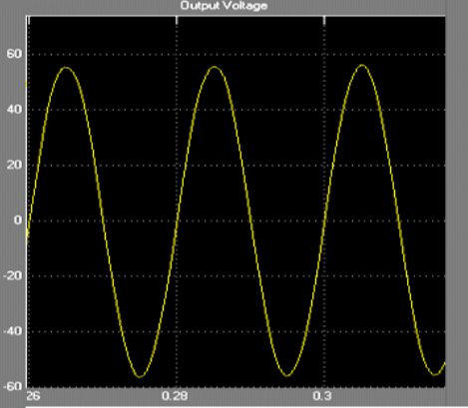

Figure 7: Output voltage

- Discussion of Result

MOSFET IRF 3205 was used because of its ability to handle high current and fast switching rate. It also has low drain source resistance which is about0.08 ohms, this is to ensure minimum waste of power; a push pull topology was used due to high power handling capability. Figure 4 shows the rectification of a rectified voltage of a pure DC circuit with a capacitor filter. After rectification, a step up DC voltage of 12V to 310V high frequency transformer also known as chopper was used to boost to boost the voltage. Figure 5 shows a 310V output from DC-AC converter. The converter was fed to H-bridge and this H-bridge is used to generate a positive and negative cycles of AC voltage with PIC16F628A microcontroller to generate a SPWM. Figure 6 shows the pulsating output obtained from H-bridge. Figure 7 shows the output voltage of proposed transformer less inverter. From the figure the output voltage is pure neat and clean sinusoidal shape with the use of capacitor filter element. As the voltage is in sinusoidal in nature the THD is very low.
The switches are T1, T2, T3 and T4. The switches in each branch is operated alternatively so that they are not in same mode (ON /OFF) simultaneously .In practice they are both OFF for short period of time called blanking time, to avoid short circuiting. The switches T1 and T2 or T3 and T4 should operate in a pair to get the output. These bridges legs are switched such that the output voltage is shifted from one to another and hence the change in polarity occurs in voltage waveform. If the shift angle is zero, the output voltage is also zero and maximal when shift angle is π. In case of resistive load, the current waveform follows the voltage waveform but not in case of reactive load. The feedback diode operates for the reactive load when the voltage and current are of opposite polarities.
Table 1: Switching state of inverter system

T1 | T2 | T3 | T4 | Va | Vb | Vab
ON | OFF | OFF | ON | $$\frac{Vs}{2}$$ | $$_\frac{Vs}{2}$$ | V_{S}
OFF | ON | ON | OFF | $$+\frac{Vs}{2}$$ | $$+\frac{Vs}{2}$$ | -V_{S}
ON | OFF | ON | OF | $$\frac{Vs}{2}$$ | $$-\frac{Vs}{2}$$ | 0
OFF | ON | OFF | ON | $$-\frac{Vs}{2}$$ | $$+\frac{Vs}{2}$$ | 0

A decoder (HT12D) and Encoder (HT12E) is also used to control the switching state of the inverter system at a distance of 25m. This remote control sensor makes it easier and convenient to switch ON/OFF the system when compared to other solar systems.
Furthermore, as the load rating increases, the voltage decreases ,from the table shown below, load rating stops at 500W because going beyond that will cause overloading of the system.

Table 2: Load rating

Load rating (W) | Voltage (V)
100 | 220
200 | 218
300 | 199
400 | 190
500 | 180

- Conclusion

In this paper, the implementation of a microcontroller based stand-alone PV power system is presented. The PIC16F628A microcontrollers have been employed to implement the control scheme for the complete standalone PV power-system with a dual battery changeover system. The inverter system can be remote controlled at a distance of 25m. One of the advantages of this system is reducing THD of output voltage to less than 1%. Transformer less inverters offers a better efficiency, compared to those inverters that have a galvanic isolation.
On the other hand, in case the transformer is omitted, the generated common-mode behavior of the inverter topology greatly influences the ground leakage current through the parasitic capacitance of the PV. As a conclusion, the proposed topology can be an advantageous power-conversion stage for transformer less, grid connected PV systems.

References
[1] J.B Gupta , A Course in Electrical power, 15th Ed New Delhi:.S.K Kataria & Sons.2013 pp129-170

[2] Chandra T.S, Deva Kumar M.L.S & Viyaja Kumar. “Design of transformer less single phase inverter for Renewable Energy based Distribution Generation system.” International Journal of Science Research, vol.4,Issue 7, 2015
[3] M. H. Rashid, Power Electronics, Circuits, Devices, and Applications, 3rd Ed.
New Delhi: Prentice-Hall of India Private Limited, 2007 pp.253-256.
[4] S. B. Kjaer, J. K. Pedersen, and F.Blaabjerg, “A review of single-phase Grid-Connected Inverters for Photovoltaic Modules,” IEEE Transactions on Industry Applications, vol. 41, pp. 1292-1306, September/October 2005.
[5] Jagannathan.V, Power Electronics: Devices and Circuits. 4th Ed. New Delhi: Asoke K. Ghosh. 2011pp.90-112

