SOLAR RESOURCE AVAILABILITY AND PHOTOVOLTAIC POWER SYSTEM DESIGN MONTH IN MINNA, NIGER STATE NIGERIA

EZENWORA J. A.1, IGWE K. C.1, MUHAMMAD S.2 and IBEKWE E. C.3  
1 Department of Physics, Federal University of Technology, Minna, Niger State, Nigeria.

2 Physics with Electronics Department, Federal University, Birnin Kebbi, 862104, Kebbi State, Nigeria.

3 Department of Atmospheric Sciences, Texas A&M University, Texas, USA.

joelezen@futminna.edu.ng

**Abstract** **- Many installers of Photovoltaic (PV) power system do not consider the period or month in a year that has the worst-case combination of solar resource availability and load demand to size or design PV power system, which often results in defective systems. In this study, the Design Month of Minna was determined based on solar resource availability.** **Campbell Scientific CR1000 software-based data logging system incorporated with ambient weather sensors and with computer interface was employed as Data Acquisition System (DAS) to measure and log weather variables; solar irradiance, relative humidity, temperature and wind speed for six years. Solar irradiance was measured by Li-200SA M200 Pyranometer sensor, temperature and relative humidity were measured with HC2S3-L Rotronic HygroClip2 Temperature and Relative Humidity sensor and wind speed was measured with 03002-L RM Young Wind Sentry Set. The logger was programmed to measure and log these ambient weather parameters at every 5 minutes intervals and daytime data from the year 2008, 2009, 2015, 2016, 2017 and 2018 were obtained and analysed. The weather pattern, quantity available and the month with the lowest solar resource was determined by computing the hourly, daily and monthly averages of these ambient weather parameters, using Excel’s Macro Developer programme. The result shows that August is the design month in Minna. Statistical analysis was equally carried out on the solar irradiance and ambient temperature data set and a model was deduced to predict hourly averages of solar irradiance from ambient temperature in Minna and environs.**

**Keywords:** measurement, ambient parameters, solar irradiance, photovoltaics, sizing

1. **Introduction**

The majority of the energy on Earth comes from the sun, our closest star. It powers plants, causes the atmosphere and water to flow, and provides the warmth necessary for life. It is a massive mass of incandescent gas and a massive nuclear furnace with a massive mass change caused by a net thermonuclear reaction of protons. The net mass shift that emerges from this reaction is the energy that the sun emits as electromagnetic radiation. Einstein's relation, E = mC2, provides the energy resulting from a net mass change, ∆m. With a hydrogen mass conversion rate of 7.0 x 1011 kg/sec, the sun is thought to radiate energy into space at a rate of about 3.8 x 1023 kW. The earth, which is situated about 150 x 106 km from the sun, only intercepts about 1.2 x 1014 kW of this energy, meaning that in less than an hour, the earth receives enough energy to meet all of the human population's energy needs for the entire year. Within this amount of solar radiation, 6% is reflected back into space by the earth’s atmosphere, 20% is reflected and/or scattered by clouds and 4% is reflected by the earth’s surface, implying that a total of 30% is reflected and scattered back into space, 47% is absorbed by the earth’s surface and oceans and is converted to energy and 23% is absorbed within the earth’s atmosphere and used for transpiration, precipitation and evaporation [1]. The availability of solar resources differs depending on the location and season of a certain geographic area on the earth's surface [2]. Proper planning and sizing of a solar PV power system in a specific area requires knowledge of the quantity of solar resource obtainable every given time. The performance of a PV power system in a given area is equally impacted by other ambient variables as wind speed, surrounding temperature, and relative humidity. Generally, adequate knowledge and application of the weather parameters pattern of a location plays a pivotal role in solar PV power system planning and sizing [3]. Installing solar photovoltaic or thermal energy equipment is only beneficial in locations where a sufficient supply of solar radiation can be fairly guaranteed. Minna is situated at a latitude of 09o37'N and a longitude of 06o32'E, with an elevation of 249 metres above sea level (see Figure 1). It is part of the Northern states of Nigeria and lies partially within the quasi-arid Sahelian region of West Africa. This region's climate is defined by two distinct seasons: the wet (or rainy) season and the dry season, which is commonly referred to as Hammattan. These seasons align with the summer and winter periods of the northern hemisphere, respectively. The beginning and conclusion of the dry and wet seasons each year are influenced by the semi-periodic movements of the inter-tropical convergence zone

(ITCZ) as it moves north and south. The ITCZ divides the north-east trade wind, which is accompanied by dry dust, from the south-west trade wind, which is accompanied by moisture. In the Sahel region of Nigeria, the dry season begins in October and continues until May of the next year. The ITCZ is shifted to the southern portion of the zone during this time of year, and the predominant north-east trade wind carries with it a lot of dust, aerosols, and smoke from burning biomass, which fills the atmosphere across the whole region [4].

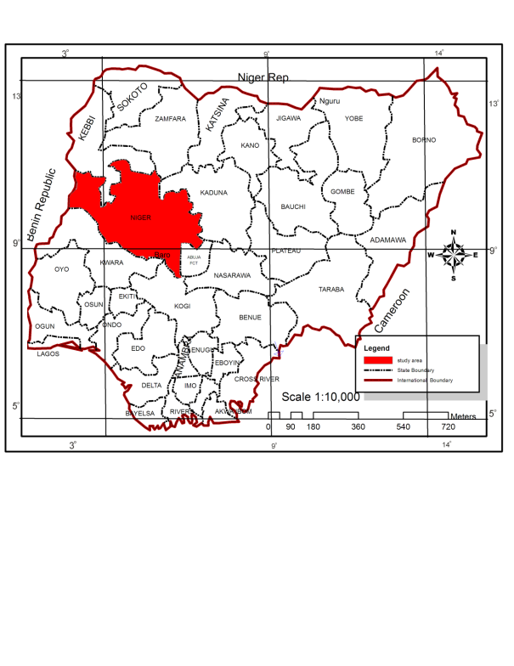

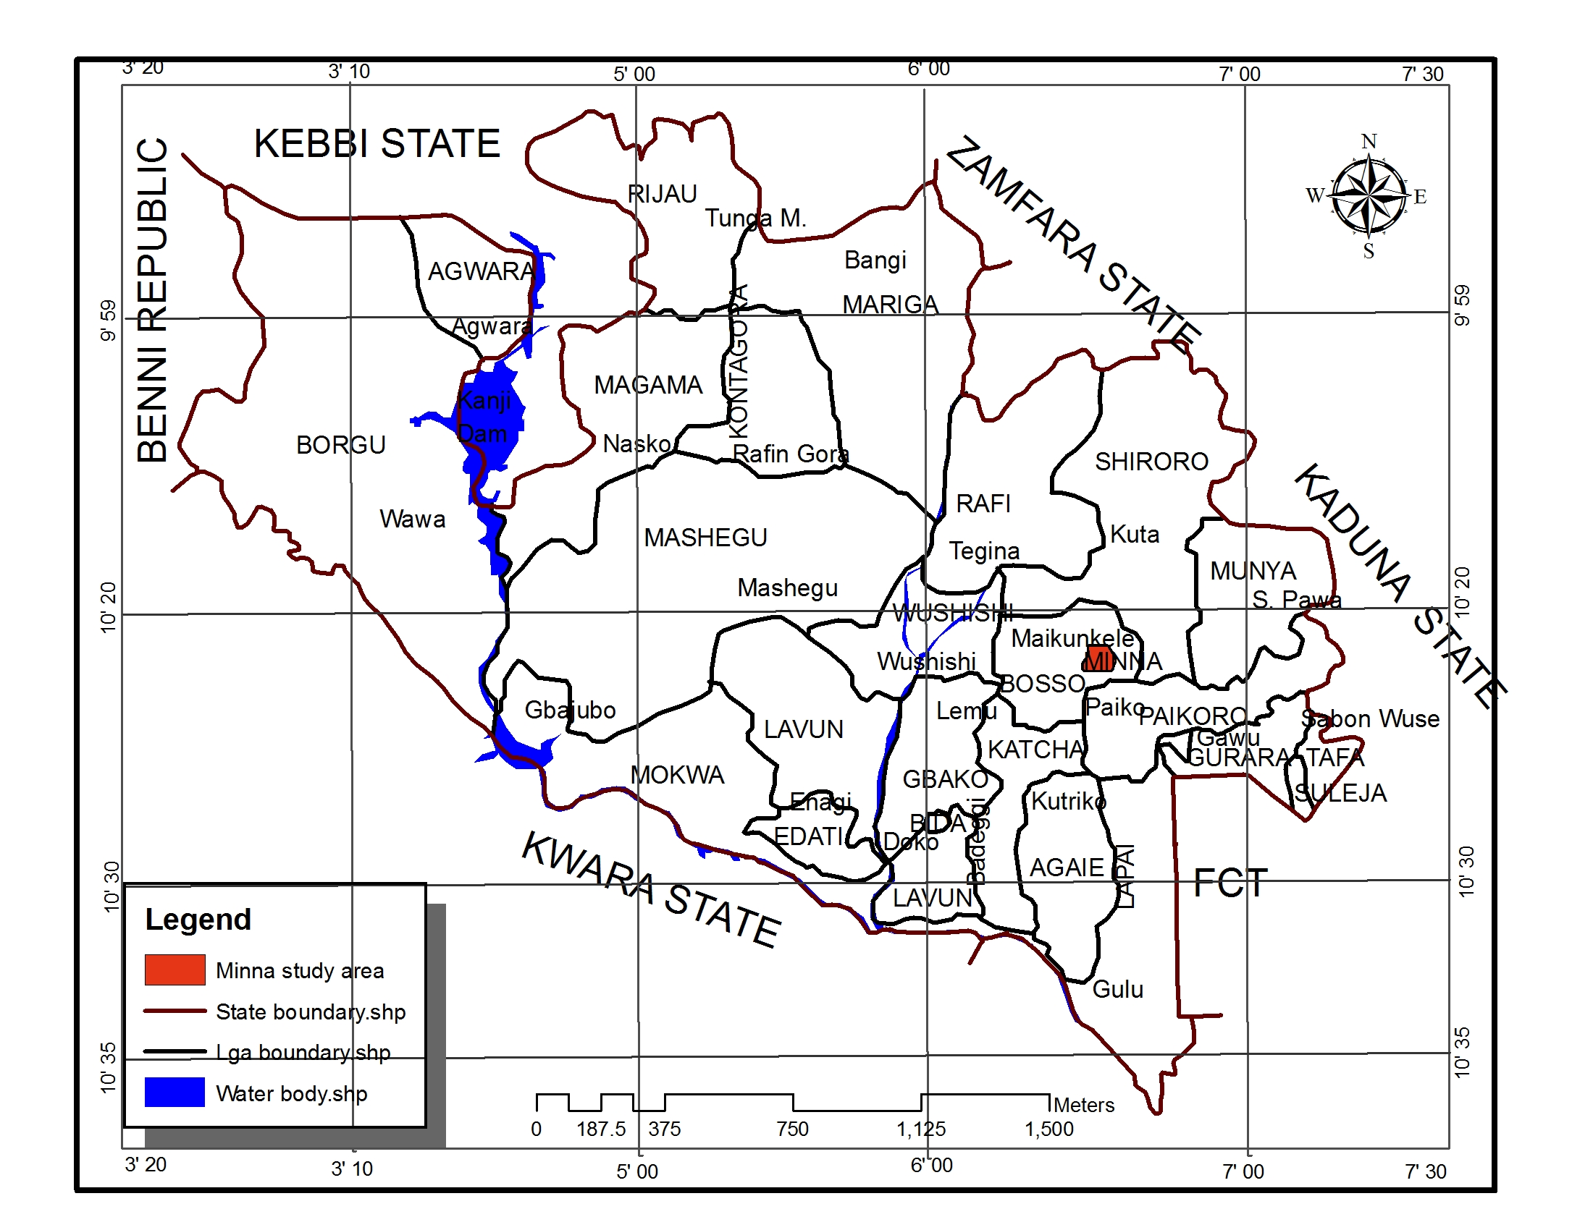

Figure 1: Study area (Minna)

Source: Niger State Ministry of Land and Housing, 2016

Aerosols of smoke and dust have a variety of effects on the climate system at the local, regional, and global levels. The vertical temperature distribution in the troposphere is altered by dust aerosol's direct radiative influence on atmospheric temperature, which results in variations in the rates of heating and cooling at various elevations. As a result, atmospheric stability is impacted. According to certain research, the atmosphere's dust and smoke aerosols may also have an impact on the sun's photo-synthetically active radiation (PAR) [5][6].

According, to previous study in the zone, average rainy as well as the dry season temperature in Minna is 28.0°C and 30.7°C, the relative humidity is 70.8°C and 39.9°C, and the wind speed is 1.68 m/s during the rainy season and 1.82 m/s during the dry season. The city of Minna is also fortunate to receive an average of 9.00 hours of sunlight each year, which translates into an average of 7.00 kWh/m2/day of solar energy [7]. Minna can therefore accommodate solar power plant.

However, it is essential to study a typical year hourly, daily and seasonal variation for a number of years in order to satisfactorily understand solar resource availability profile, including days of autonomy - the number of days without sunshine consecutively and the month that has lowest monthly average of solar intensity. This month with the lowest sun irradiation average per month, also, considering monthly load demand variation, is the suitable design month for the location. Failure or anomalies in the solar PV power system sizing and planning in any location can have enormous cost and serious damage [8][9].

Given the fact that Minna is in tropical climatic zone and the load demand variation is minimal, this research is carried out to determine the solar resource availability and the month with the lowest solar resource for an effective solar energy planning system of the environment.

**2.0 Research Method**

2.1 Data Acquisition

Solar resource availability and other ambient weather parameters of relative humidity, temperature and wind speed was observed in a Minna setting utilizing a data logging system based on the CR1000 software, incorporating meteorological sensors and with computer interface. The data logger with the installed meteorological sensors, which are part of larger Data Acquisition System (DAS) for Photovoltaic research (see plate I), were mounted on support structure at roughly three meters above the ground, in order to provide sufficient exposure to sunlight and sufficient wind speed, as wind speed is directly related to altitude. The height also guarantees that the system is not shaded by bushes and is shielded from outside influence or damage. Additionally, the entire experimental setup was contained within a four-meter-diameter region. In order to capture the two different and clearly established climate seasons of the region, the data was continually monitored from 8 a.m. to 6 p.m. local time, every day for four years, from December 2014 to November 2018. Additionally, two years data, spanning from February to December, 2008 and from January to December, 2009 from Nigeria Environmental and Climatic Observation Programme (NECOP) weather station facility, which embodies same type of DAS and adjacent to each other, was equally obtained and used. The experiment was conducted 249 meters above sea level, close to the Physics Department of the Federal University of Technology, Minna (latitude 09o37' N, longitude 06o32' E). The Li-200SA M200 Pyranometer, produced by LI-COR Inc. in the USA, was used to measure the global solar radiation, or solar irradiance, with a calibration of 94.62 microamperes per 1000 W/m2. The Swiss-made HC2S3-L Rotronic HygroClip2 Temperature/Relative Humidity probe was used to measure the ambient temperature and relative humidity. The 03002-L RM Young Wind Sentry Set was used to measure wind speed. As instructed by the manufacturer, the sensors were connected to the Campbell Scientific CR1000 data recorder. The average values of solar irradiance, relative humidity, ambient temperature, and wind speed were determined by programming the logger to measure and record the ambient (meteorological) parameters every five minutes, and averages of wind speed, air temperature, relative humidity, and solar irradiance were measured and recorded. To guarantee efficient and careful DAS monitoring, data downloads were carried out at the data gathering site every seven days. Plate I below displays the experimental setup [3].

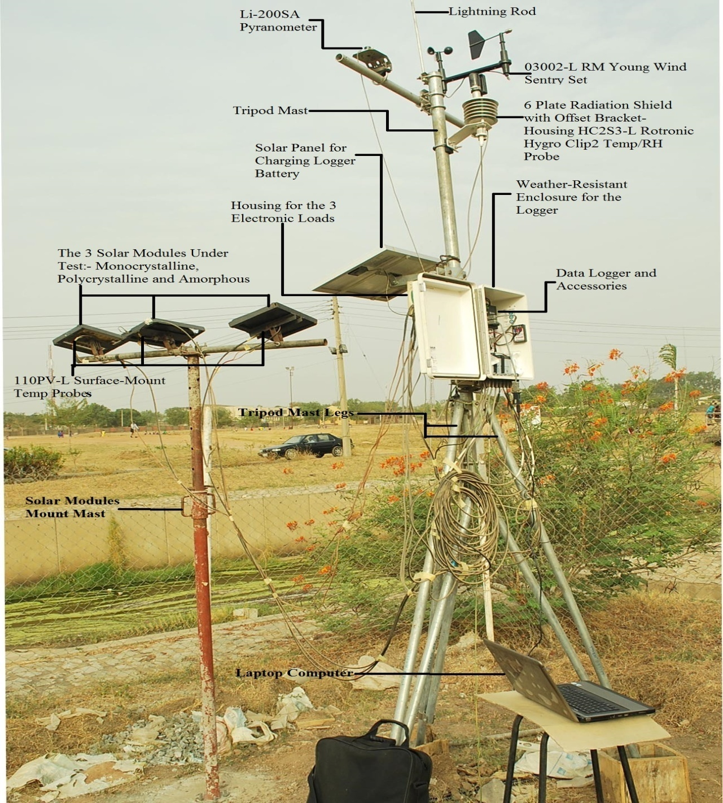

Pate I: Experimental set up (Joel Ezenwora’s Lab, Dept. of Physics, Fed. Univ. of Tech, Minna)

2.2 Data Analysis

Collected data was filtered to remove night hours data, utilizing only daytime data from 8.00 am to 6.00pm local time. Hourly, daily hourly and monthly hourly averages of solar (global) irradiance for the six years (2008, 2009, 2015, 2016, 2017 and 2018) was computed with Excel’s Macro Developer Programme and monthly averages were plotted and presented in Figures 2 to 7. A typical year’s distribution pattern of relative humidity, air temperature and wind speed were equally computed, from January to December to ensure proper coverage of the two distinct seasons in Minna local environment. These computed averages of the meteorological parameters are plotted and presented in Figures 8 to 10 and Tables 1 to 3. Statistical analysis was equally carried out with the aid of Python software and models for prediction of hourly averages of solar irradiance for each month of the year are produced as shown in equations 1 to 12.

**3.0 Result and discussion**

Figures 2, 3, 4, 5, 6 and 7 show the monthly hourly average values and variations in solar irradiance from January to December each year for 2008, 2009 and from December 2014 to November 2018 respectively. The result shows that solar irradiance picks between March and May, both months and April in-between are within the Harmattan period of the study area. The month of March recorded the maximum amount of sun intensity in 2008 with an average value of 513 w/m2, but it was May in the following year, 2009 that recorded the maximum value of solar irradiance with an average monthly hourly value of 472 w/m2 and 2015 has April leading with an average monthly hourly value of 569 w/m2, while it was April in 2016 with 569 w/m2 and March in 2017 and 2018 with 599 w/m2 and 557 w/m2 respectively. In comparison, August usually records the lowest monthly hourly average of solar irradiance, as can be seen in Figures 2, 4, 5, 6 and 7. This is within the wet period of the area of study when there is much moisture content in the atmosphere, Figure 8 shows that the month of August has the highest value of relative humidity. High level of water molecules in the atmosphere leads to high level of absorption and scattering of sun rays thereby resulting to reduced solar irradiance. The least average monthly hourly value of solar irradiance observed in January 2009 may have been caused by the high aerosol concentration in the atmosphere, which is typical of the Harmattan period, as a result of light being scattered and absorbed by airborne particles, nevertheless, this is not the usual trend as validated by the plot of 2015 to 2018, data was not available in January 2008. However, it was observed that there was generally low solar intensity in 2009 which recorded the least monthly hourly value, and as such least annual hourly averages during the six-year research period. Year 2017 recorded the highest value of monthly and annual hourly average of solar irradiance, followed by 2016, in fact, there was steady rise in solar irradiance from year 2015 to 2017 for the period under study.

Figure 2: Monthly hourly average distribution of solar irradiance for 2008

Figure 3: Monthly hourly average distribution of solar irradiance for 2009

Figure 4: Monthly hourly average distribution of sola irradiance from December 2014 to November 2015

Figure 5: Monthly hourly average distribution of sola irradiance from December 2015 to November 2016

Figure 6: Monthly hourly average distribution of sola irradiance from December 2016 to November 2017

Figure 7: Monthly hourly average distribution of sola irradiance from December 2017 to November 2018

Results of other environmental factors such as temperature, wind speed, and relative humidity for year 2015, which serve to show a typical year’s trend and pattern of meteorological parameter in the study area, are also presented in Figures 8 to 10 respectively. Also, all the four ambient parameters are computed in each of the two separate seasons and presented in Tables 1 and 2. Table 1 shows hourly mean values of solar irradiance and relative humidity according to dry and wet seasons, while Table 2 shows the hourly average values of wind speed and the air temperature also according to the two seasonal variations. It is observed that all the ambient parameters, with the exception of relative humidity, recorded higher values in the dry season, which is similar to the result obtained earlier in the area by Bala, *et al*., in 2000 [7]. The results follow seasonal variations of the two seasons of dry and wet seasons of a typical year of the zone. Dust and smoke particles in the dry (Harmattan) season and wet clouds in the rainy season are the main causes of cloud attenuation of solar irradiance, and these ambient variable spreads clearly show the separation in the two different and clearly established weather-related cycles of the study area. While August, which occurs during the rainy season, is the most humid and thus records the lowest amount of solar radiation, with an average of two days of no sunlight per year occurring within this period. March and April, which fall within the dry season, are found to be the hottest months and the ones with the highest value of solar irradiance. This implies that the reduction of the sunlight caused by moist clouds is more powerful than that caused by smoke as well as dust particulates in the research area.

There is a clear association between solar irradiance and the surrounding temperature, as the former is often higher during the dry season than during the wet season. The Inter-tropical Convergence Zone (ITCZ) shifts to the southern portion of the zone during the dry season months, and in January, when wind speed peaks the predominant North-East trade wind transports massive quantities of smoke as well as dust particulates from biomass burning into the sky within the region. This confirms the result of previous researchers in the zone that the primary wind in the Sahelian belt is the North-East trade wind which occurs throughout the dry season. March and May both withness high winds, and May is the transitional month when the ITCZ shifts to the north and the predominant South-West wind brings moisture-rich air over the area, signaling the start of the wet season. The result is an agreement with the work of other researchers in the climatic zone [4]. Monthly hourly mean values of relative humidity spread have very low values during the dry period and very high values during the period when it rains, it is evident that these two climate periods can be distinguished from one another.

Figure 8: Monthly hourly average distribution of relative humidity

Figure 9: Monthly hourly average distribution of ambient temperature

Figure 10: Monthly hourly average distribution of wind speed

|  |  |  |  |  |  |  |
| --- | --- | --- | --- | --- | --- | --- |
| **Table 1: Hourly averages for solar irradiance and relative humidity** | | | | | | |
|  |  | Solar irradiance(w/m2) | | Relative humidity (%) | |  |
|  | T (Hours) | Dry | Wet | Dry | Wet |  |
|  | 9:00 AM | 279.5 | 237.4 | 42.0 | 83.3 |  |
|  | 10:00 AM | 483.5 | 370.7 | 39.5 | 79.3 |  |
|  | 11:00 AM | 657.5 | 479.9 | 33.1 | 75.9 |  |
|  | 12:00 PM | 775.2 | 557.3 | 33.6 | 72.7 |  |
|  | 1:00 PM | 815.3 | 601.1 | 33.1 | 69.8 |  |
|  | 2:00 PM | 783.6 | 608.8 | 30.3 | 67.2 |  |
|  | 3:00 PM | 676.6 | 539.7 | 28.8 | 65.9 |  |
|  | 4:00 PM | 511.5 | 452.7 | 26.6 | 64.8 |  |
|  | 5:00 PM | 311.3 | 306.6 | 25.4 | 64.5 |  |
|  | 6:00 PM | 131.8 | 146.5 | 25.0 | 67.4 |  |

|  |  |  |  |  |  |  |
| --- | --- | --- | --- | --- | --- | --- |
| **Table 2: Hourly averages for Ambient temperature and wind speed** | | | | | | |
|  |  | Ambient temp (oC) | | Wind speed (m/s) | |  |
|  | T(Hours) | Dry | Wet | Dry | Wet |  |
|  | 9:00 AM | 27.2 | 25.9 | 2.3 | 1.7 |  |
|  | 10:00 AM | 29.1 | 26.8 | 2.5 | 1.9 |  |
|  | 11:00 AM | 30.9 | 27.6 | 2.5 | 2.0 |  |
|  | 12:00 PM | 32.5 | 28.5 | 2.3 | 1.9 |  |
|  | 1:00 PM | 33.9 | 29.2 | 2.1 | 1.9 |  |
|  | 2:00 PM | 34.9 | 29.9 | 2.0 | 1.9 |  |
|  | 3:00 PM | 35.6 | 30.2 | 1.9 | 1.8 |  |
|  | 4:00 PM | 36.0 | 30.5 | 1.8 | 1.8 |  |
|  | 5:00 PM | 36.0 | 30.4 | 1.6 | 1.8 |  |
|  | 6:00 PM | 34.6 | 29.6 | 1.5 | 1.6 |  |

Annual hourly average values of ambient parameters for the year, starting from December 2014 to November 2015 are shown in Table 1. On average, as much as 258 w/m2 of solar irradiance is recorded within the first hour from sunrise, 8.00 am to 9.00 am local time. The value increases significantly during the course of the day and peaks within solar noon hour, 12.00 o’clock to 1.00 pm, with annual hourly mean value of 708 w/m2. This peak value starts decreasing gradually as the day winds down towards sunset, and at the last hour before sunset, 5.00 pm to 6.00 pm local time, the lowest annual hourly average value of 139 w/m2 is recorded. This result shows that the study area, Minna has an average 10 hours of sunshine with daily average of 4.862 kw/m2 of solar irradiance, making it a suitable location for the deployment of solar equipment. The relative humidity (RH) peaks between 8.00 am and 9:00 am with annual hourly average value of 65.3 %, ambient temperature (Ta) peak hour is between 3.00 pm to 4:00 pm with annual hourly average value of 33 oC, and wind speed (WS) is from 9.00 am to 10:00 am with annual hourly average value of 2.18 m/s local time.

|  |  |  |  |  |  |  |
| --- | --- | --- | --- | --- | --- | --- |
| **Table 3: Annual hourly average values of ambient parameters** | | | | | | |
|  | T (Hours) | Hg (W/m2) | RH (%) | Ta (oC) | WS (m/s) |  |
|  | 9:00 AM | 258 | 65.3 | 26.5 | 1.99 |  |
|  | 10:00 AM | 427 | 61.8 | 27.8 | 2.18 |  |
|  | 11:00 AM | 569 | 54.5 | 29.1 | 2.17 |  |
|  | 12:00 PM | 666 | 53.2 | 30.3 | 2.08 |  |
|  | 1:00 PM | 708 | 51.5 | 31.3 | 2.02 |  |
|  | 2:00 PM | 696 | 48.8 | 32.2 | 1.93 |  |
|  | 3:00 PM | 608 | 47.3 | 32.7 | 1.87 |  |
|  | 4:00 PM | 482 | 45.7 | 33 | 1.82 |  |
|  | 5:00 PM | 309 | 44.9 | 32.9 | 1.71 |  |
|  | 6:00 PM | 139 | 46.2 | 31.9 | 1.59 |  |

**4.0 Statistical Result and Models**

Computed hourly averages for each month of the year for the six-year period of this study were used to train the Raw Feature Random Forest model, which produced the best result in the Python software given the statistical indicators. The regression equations for predicting hourly averages of solar irradiance at a given air temperature for each month of the year are presented in equations 1 to 12 respectively.

January: $Hg=-5281.1+1037.75*Hour+\left(-37.5\right)*{Hour}^{2}+-34.67*Ta$ (1)

February: $Hg=-4945.8+944.59*Hour+\left(-34.44\right)*{Hour}^{2}+-21.58*Ta$ (2)

March: $Hg=-4602.2+839.44*Hour+\left(-31.24\right)*Hour^{2}+-6.37*Ta$ (3)

April: $Hg=-3957.9+797.33*Hour+\left(-29.53\right)*{Hour}^{2}+-18.7*Ta$ (4)

May: $Hg=-3401.6+584.46*Hour+\left(-22.23\right)*{Hour}^{2}+7.63*Ta$ (5)

June: $Hg=-3018.2+446.09*Hour+\left(-17.16\right)*{Hour}^{2}+23.63*Ta$ (6)

July: $Hg=-3642.5+235.79*Hour+\left(-10.17\right)*{Hour}^{2}+98.28*Ta$ (7)

August: $Hg=-3597.4+201.23*Hour+\left(-8.78\right)*{Hour}^{2}+105.6*Ta$ (8)

September: $Hg=-3161.5+629.78*Hour+\left(-23.43\right)*{Hour}^{2}+-15.46*Ta$ (9)

October: $Hg=-3489.0+707.45*Hour+\left(-26.99\right)*{Hour}^{2}+-13.46*Ta$ (10)

November: $Hg=-4960.3+1105.65*Hour+\left(-40.79\right)*{Hour}^{2}+-49.38*Ta$ (11)

December: $Hg=-5844.6+1308.35*Hour+\left(-46.91\right)*{Hour}^{2}+-74.87*Ta$ (12)

where; Hg is solar irradiance (global solar irradiance,

Hour is time of the day in 24 hours format,

Ta is the corresponding air temperature at the time of the day.

Comparison between measured and predicted data was carried out to ascertain the goodness of the fit, and the data for the month of June is presented as an example, in Table 4.

|  |  |  |  |  |
| --- | --- | --- | --- | --- |
| **Table 4: Comparison between measured and predicted Hg (June)** | | | | |
| T (Hours) | Hg (w/m2) Measured | Hg(w/m2) Predicted | Ta (oC) | Residual |
| 9:00 AM | 233.3 | 230.5 | 26.4 | 2.8 |
| 10:00 AM | 368.9 | 374.1 | 27.4 | -5.2 |
| 11:00 AM | 480.7 | 481.1 | 28.3 | -0.4 |
| 12:00 PM | 551.0 | 553.7 | 29.2 | -2.7 |
| 1:00 PM | 601.6 | 592.0 | 30.1 | 9.6 |
| 2:00 PM | 590.4 | 588.9 | 30.7 | 1.5 |
| 3:00 PM | 538.8 | 544.4 | 31.0 | -5.6 |
| 4:00 PM | 468.0 | 463.2 | 31.2 | 4.8 |
| 5:00 PM | 324.3 | 335.8 | 30.9 | -11.5 |
| 6:00 PM | 173.8 | 167.1 | 30.3 | 6.7 |
| R2 score: 0.998 | | | | |

It can be seen from Tabe 4 that the model is a good fit, given residual and R2 values, which are similar for other months of the year.

**5.0 Conclusion**

Solar resource availability in Minna, Niger state of Nigeria is presented. The result follows seasonal variations of the two distinct weather conditions of the zone – dry and rainy periods. The amount of solar resource available at any point in time depends on the prevailing weather condition at the time. On the basis of annual hourly average, (Table 3) the upper limit of solar irradiance in Minna is 708 w/m2 recoded within solar noon hour of the location, while the lower limit of 139 w/m2 is recorded within the last hour before sunset at 6.00 pm local time. Accordingly, Minna has an average 10 hours of sunshine with daily average of 4.862 kw/m2 of solar irradiance. The dry season period generally produces higher solar irradiance than the wet season period, with the maximum monthly hourly average values of 513 w/m2 in March, 2008, 472 w/m2 in May, 2009 and 569 w/m2 in April, 2015, while it was April in 2016 with 569 w/m2 and March in 2017 and 2018 with 599 w/m2 and 557 w/m2 respectively, which are all dry season months in the study area. On the other hand, August usually records the lowest monthly hourly average of solar irradiance.

Consequently, Minna is a very good location for the deployment of photovoltaic power system, and based on solar resource availability, the month of August produces the least amount of solar resource in the study area, with an average of two (2) days of autonomy, and as such August is the design month for the location.

The statistical models for predicting the hourly averages of solar irradiance at a given air temperature, arising from the six years of this study are all good fits, and can be used to predict solar irradiance in Minna and its environs.

**Acknowledgement**

The authors would like to thank all the personnel in Joel Ezenwora’s lab, Federal University of technology, Minna, Nigeria for their assistant in making available the facilities and data needed to complete this study.

**REFERENCES**

[1] Ezenwora, J.A., (2015). Development Prototype Photovoltaic Power System Based on Characterisation and Performance Evaluation of Photovoltaic Modules in Minna, Nigeria. *PhD Thesis, Department of Physics, Federal University of Technology, Minna, 2-6.*

[2] Pelletier, J. D., Brad Murray, A., Pierce, J.L., Bierman, P.R., Breshears, D. D., Crosby, B. T. & Yager, E.M. (2015). Forecasting the response of Earth’s surface to future climate and land use changes: A review of methods and research needs. *Earth’s Future,* 3(7). 220-251.

[3] Ezenwora, J.A., Oyedum, O.D. and Ugwuoke, P.E. (2018); Comparative Study on Different Types of Photovoltaic Modules Under Outdoor Operating Conditions in Minna, Nigeria. *International Journal of Physical Research, Vol. 6 (1), pp 35-48.*

[4] Anuforom, A.C., Akeh, L.E., Okeke, P.N. & Opara, F.E., (2007). Inter-Annual Variability and Long-term Trend of UV-Absorbing Aerosols during Harmattan Season in Sub-Saharan West Africa. *Atmospheric Environment* 41, 1550-1559.

[5] Carlson T. N. and Benjamin S. G. (1980); Radiative Heating Rates for Saharan Dust. Journal of Atmospheric Science 37, 193-213.

[6] Quijano A. L. (2000); Radiative Heating and Direct Forcing by Mineral Dust in Cloudy Atmospheric Conditions. *Journal of Geophysical Research 105 (D10), 12,207-12,219.*

[7] Bala E. J., Ojosu J. O. and Umar I. H. (2000); Government Policies and Programmes on the Development of Solar PV Sub-sector in Nigeria. *Nigerian Journal of Renewable Energy 8 (1&2), 1-6.*

[8] Solar Energy Research Institute, Colorado 80401-3393 (1988). *Photovoltaic Technical Information Guide (second edition),*22-30.

[9] Uruakpa F. U., Ezenwora J. A. and Ibrahim A. G. (2022); Comparative Study on Solar Energy on Inclined and Horizontal Surfaces in Minna, Niger State, Nigeria. *Journal of Sustainable Energy, vol 13 (1), pp 6-11.*