**Interference Management Techniques for D2D Communication in 5G Networks: A Survey.**

Usman Abraham Usman, Ameh Innocent Ameh, Abubakar Saddiq Mohammed, Bala Alhaji Salihu

**Abstract**

The astronomical escalation in wireless data traffic has attracted serious attention recently. With an estimated over fifty billion devices on the cellular network by the end of 2020, the current infrastructural status will be insufficient to service the anticipated demands. As a result, talks on the 5th generation (5G) are in progress at both the academic and industrial levels. Apart from improved capacity; energy efficiency, decreased latency (near zero), and heightened reliability have been foreseen as defining characteristics of 5G. This would, however, be accompanied by a lot of issues and pressure on the cellular network. Device-to-Device (D2D) communication is one of the proposed solutions to the anticipated problems. With D2D communication, proximal devices can form links directly to each other, thereby reducing the pressure on the Base Stations (BS) significantly, and improving reuse of spectrum, throughput, coverage, energy efficiency, and reduction of end-to-end latency. Furthermore, it will create a medium for more peer-to-peer as well as location-based services. Interference management between D2D and Cellular User Equipment (DUEs and CUEs) is seen as a critical success factor in the deployment of D2D communication, since both sets of UEs share same licensed spectrum. In this paper, a survey of some existing approaches to interference management in a D2D-enabled (two-tiered) 5G network. Further analysis of the surveyed interference management schemes reveals the inadequacies of the techniques to address on their own, the inherent incidences of cross-tier and co-tier interfering signals in two-tiered 5G networks, and hence give room for further research.

**Introduction**

In mobile communication, four technological generations have been experienced, with approximately ten-year period between generations. The first generation was mainly analogue systems developed in the early 1980s, and was basically voice centric. The 2nd generation (2G), which started in the early 1990s, ushered in the digital transmission. Though a voice centric service, the 2G digital transmission introduced the first support for mobile data. The 3rd generation (3G), was deployed in 2001 and created the platform for mobile broadband and especially, the proliferation of the mobile internet service through the High Speed Packet Access (HSPA). The 4th generation (4G), which introduced the first Long-Term Evolution (LTE) systems, was deployed in 2009. LTE is a platform for a higher quality mobile broadband relative to the HSPA. Although LTE is fairly new and still being deployed, the academic environment as well as the communications industry are already reaching for the next generation of mobile communication, the 5G. Table 1 provides a breakdown of the network generations.

**Table 1: Comparison of the Mobile Communication Generations**

| **Technology** | **1G** | **2G** | **3G** | **4G** | **5G** |
| --- | --- | --- | --- | --- | --- |
| **Start/Deployment** | 1970-80 | 1990-2004 | 2004-10 | Now | 2020 |
| **Data Bandwidth Rates** | 2 Kbps | 64 Kbps | 2 Mbps | 1 Gbps | > 1 Gbps |
| **Technology** | Analog | Digital | WCDMA 2000, UMTS, EDGE | Wi-Max, Wi-Fi, LTE | WWWW |
| **Core Network** | PSTN | PSTN | Packet Networks | Internet | Internet |
| **Multiplexing** | FDMA | TDMA/  CDMA | CDMA | CDMA | CDMA |
| **Switching** | Circuit | Circuit, Packet | Packet | All Packet | All Packet |
| **Primary Service** | Analog Phone Calls | Digital Phone Calls and Messaging | Phone calls, Messaging, Data | All-IP Services (including Voice Messages) | High speed, High Capacity, and provides large broadcasting of data in Gbps |
| **Key Differentiator** | Mobility | Secure, Mass adoption | Better quality internet | Faster Internet Broadband, Reduced Latency | Expected increased coverage, no call dropping, minimized latency, higher performance |
| **Weakness** | Poor in spectral efficiency, severe security concerns | Data rates are limited, emails and internet demands are difficult to support | Performance and technology do not match, WAP failure. | Consumes more energy, Expensive and complicated hardware required. | ??? |

The gigantic scope and its anticipated advantages has made the 5G place demands on new technologies, methodologies, and architectures. They include cloud based communication, Machine to Machine (M2M) communication, energy efficient heterogeneous frameworks, and Device to Device (D2D) communication, which incidentally is our focus in this survey.

**D2D Communication Technology**

According to Boccardi *et al.,* (2014), the device centric attribute of the envisioned 5G would permit smart devices in spatial proximity to form communication links directly and bypassing the BS. Network performance would be driven up if closely located user pairs are allowed direct transmission with each other, rather than through the traditional Up-link and Down-link communication channels of the BS. This, of course, comes with its challenges, chief among which is interference between the User Equipment (UEs). With enabled Device to Device communication between devices in proximity, there would be an introduction of interference between D2D User Equipment (DUEs) and other D2D Users, known as Co-Tier Interference, and then interference between D2D users and traditional Cellular User Equipment (CUEs)-the Cross-Tier Interference.

The architecture of a cellular network transforms into a two-tier upon the introduction of D2D communication. If properly designed, this architecture has considerable end-to-end latency, coverage, and throughput improvements (Noura and Nordin, 2016). The conventional macrocell layer, which encompasses the CUE and BS links, is the first tier, while the formation of direct links between DUEs occurs in the second (device tier) tier. Since both CUEs and DUEs share the same licensed spectrum in such architecture, interference management challenges ensue between both tiers. This would degrade the potential advantages of D2D communication if not properly managed.

**Categorization of D2DCommunication**

D2D communication may be inband or outband as shown in Figure 1. Inband D2D operates within the licensed spectrum, while Outband D2D operates in the unlicensed spectrum band. Inband D2D is further subcategorized as overlay and underlay. For overlay D2D, the spectrum is apportioned into two parts, with one part reserved for direct links formation, while the rest is available for the conventional communication through the macrocell. Conversely, Underlay D2D enables the interplay between CUEs and DUEs within the same spectrum.

On the other hand, Outband D2D, which operates outside the licensed spectrum, is further subcategorized as Controlled and Autonomous. In controlled mode, the D2D radio interfaces are managed centrally from the BS, while they are managed in a distributed manner by the User Equipment (UEs) in the autonomous mode. In outband D2D, interference between DUEs and CUEs does not pose a threat to communication, although an additional radio interface, e.g. a Mobile Ad-hoc Network (MANET) would be required for the establishment of links.

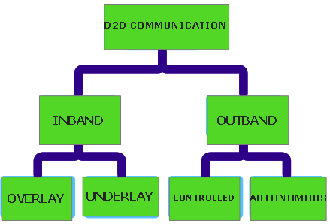

Figure 1: Types of D2D Communication

For efficient utilization of spectrum resources, the choice of D2D category must be carefully made.

As UEs in the device tier permit the formation of direct links, the BS may have a limited or total control over their communication. Therefore, based on control, device tier communication is further subcategorized into four in the following sub sections.

**Base Station Controlled Device Relaying**

Devices in poor link quality areas can ride on other devices serving as relays, and talk to the BS as depicted in Figure 2. In this mode, the BS handles all link formation tasks, and has the advantage of device power consumption efficiency.

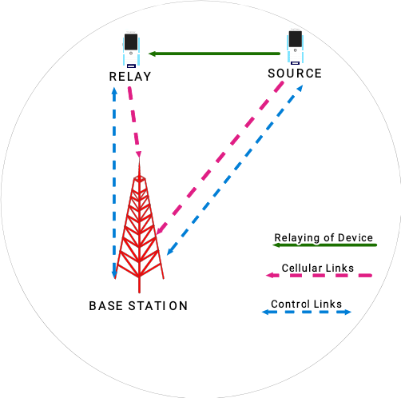

Figure 2: BS Controlled Device Relaying

**Base Station Controlled Direct D2D**

In this mode, DUEs establish direct links, but the BS provides control links that manage the direct communication between the DUEs. Its architecture is as shown in Figure 3:

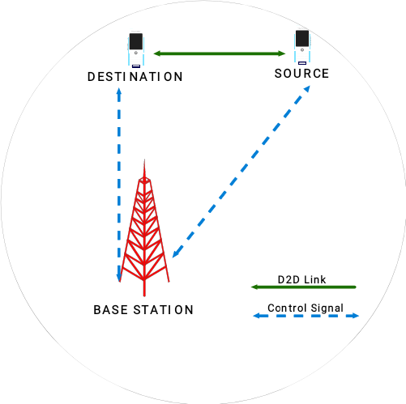

Figure 3: BS Controlled Direct D2D

**Device Controlled Device Relaying**

DUEs form links through relays in this mode. The DUEs also manage the spectrum resources by themselves in a distributed manner, and there’s a total absence of BS control as shown in the architecture depicted in Figure 4 below.

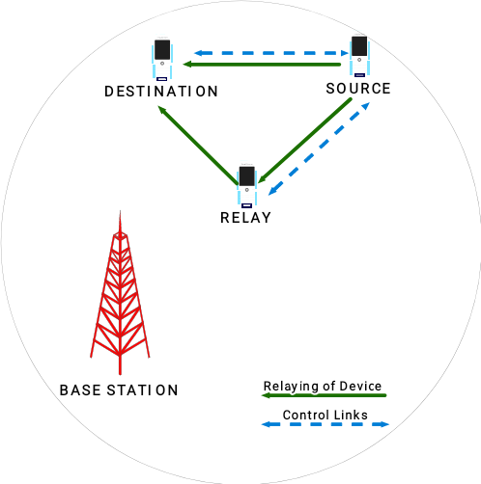

Figure 4: Device Controlled Device Relaying

**Device Controlled Direct D2D**

DUEs form communication links directly without having to talk to the BS, as it is with the Device Controlled Device Relaying discussed in section 2.1.3, the difference being the absence of relays as shown in Figure 5 below.

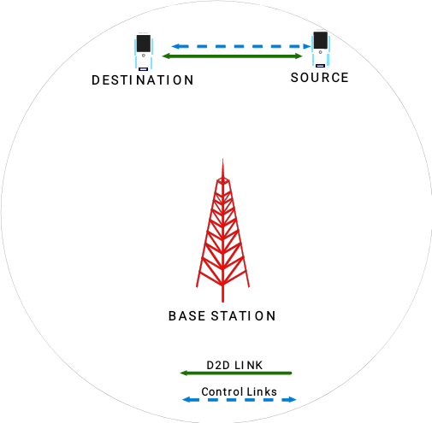

Figure 5: Device Controlled Direct D2D.

**D2D Communication Challenges**

Despite several advantages of D2D communication, interference issues along with other such issues as power control, mode selection, peer discovery, security, and radio resource allocation need to be addressed. This paper focuses on interference management, while also making brief mention of the other challenges in the following sections.

**Device (Peer) Discovery**

Proximal devices must be mutually aware of each other’s presence before D2D communication can be established between them. The devices search for each other’s presence in proximity in order to establish D2D links (Fodor *et al.,* 2012). This is made possible by exchanging the identity of devices between user pairs in proximity through the transmission of discovery signal to sense the possible availability of proximal devices. When two UEs sense each other, they become D2D candidates. Lastly, a number of signals concerning the quality of the links are exchanged between the BS and the devices. This signal information is further fed into the mode selection stage as its basic input. However, until all mode selection criteria (as discussed in section 2.2.2 and 4.3) are satisfied, direct links cannot be formed between D2D candidates.

**Mode Selection**

Mode selection refers to the communication mode employed, i.e. either cellular or D2D mode. It occurs after two D2D peers discover one another for possible communication. Although the pair are in proximity with each other for direct communication, it may not be beneficial for them to communicate directly, for performance considerations. Mode selection implies that either the D2D candidates or the network or both decide on how the D2D pairs communicate, either directly or conventionally through the BS.

**Security**

D2D communication networks are exposed a host of security concerns due to the existing possibility of compromise or corruption of user information while routing it through the devices of other users. This information becomes vulnerable and could be tampered with, leading to a breach of privacy and confidentiality. Because of the vulnerability of D2D communication to all sorts of malicious attacks, sophisticated authentication along with critical agreement mechanisms are necessary to secure formulated D2D communication links. This is a cardinal requirement and must be adequately addressed in D2D communication.

**Interference Management**

The DUE and CUE interplay in the spectrum generates interference across the network, which if not properly controlled, could degrade the potential benefits of D2D communication. The presence of Interfering signals can be mitigated by the use of several techniques like radio resource control, power control, mode selection and spectrum splitting. Figure 6 depicts a typical interference scenario in a D2D enabled cellular network.

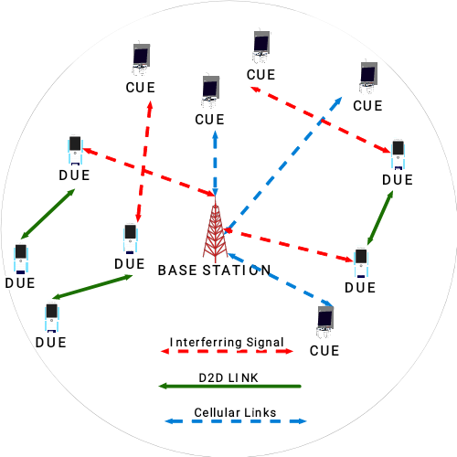

Figure 6: A Typical D2D interference scenario

Interference mitigation schemes can be broadly categorized into three, namely interference cancellation, interference avoidance, and interference coordination schemes. A very important aspect of interference avoidance is mode selection. Typically, the distance separating DUEs from CUEs as well as that between the CUEs and the BS are a very key criterion for communication mode selection for the avoidance of interference (Wen, *et al.,* 2012). Jänis, *et al*. (2009) introduced MIMO transmission techniques for the avoidance of interference, which resulted in a significant improvement of D2D SINR. As a result of the presence of interference, the received signal comprises:

$S_{r}= S_{d}+S_{oi}+S_{di}$

*Where;*

$S_{r}$*= Received Signal*

$S_{d}$*= Desired signal*

$S_{oi}=$*Outside interference signal, and,*

$S_{di}$*= D2D interference signal*

The interference at the receiver end must be reduced to the barest minimum to attain the highest possible SINR. Modulation and Coding Schemes (MCS) have been used to achieve this since they support error-free reception of information (Jänis, *et al*., 2009). It is only possible however, to reduce the interfering D2D signals, but difficult to avoid interfering signals from external sources.

The work of Wang, *et al* (2012) proposed an interference coordination scheme for the improvement of efficient resource utilization and improved system throughput in a D2D multicast network. Simulation results revealed that the power control scheme proposed had better performance in all instances than fractional power control schemes. Additionally, UEs displayed better frequency efficiencies with the proposed schemes than with the conventional scheme. In a related development, Zhou, *et al* (2015) considered a D2D underlayed network for the cancellation of interference, along with the transmission powers for network utility maximization. The result suggested considerable gains in the aspect of spectral efficiency. Likewise, Guo, *et al* (2015) concentrated on mitigating interfering signals between DUEs and CUEs by looking at the Interference Suppression Area (ISA) range, which is a measure of the intensity of the interfering signals between the CUEs and the DUEs, and hence determines the performance of the system. According to Gandotra & Jha, (2016), optimal system performance can be achieved by sufficiently tuning the ISA range. Similarly, Soret, *et al* (2015) proposed co-tier interference coordination by either applying time domain (proactive) or carrier domain (reactive) algorithms with different optimization goals in dense wireless networks. The algorithms dynamically estimated the partitioning’s potential so as to have a proper frequency or time (resource) division. Between 25 and 40% performance gains in terms of throughput was realized, with another 25% gains in terms of capacity. Likewise, Wang, *et al.,* (2012) evaluated interference scenarios when CUEs share spectrum with D2D multicast links. Radio resource allocations as well as Power control are resourceful in such scenarios. Bouras *et al* (2012) focused on mitigating interfering signals in LTE networks integrating femtocell overlay. Their work was based on the technique of reducing SINR and achieving greater throughput results, by reusing frequency. The mechanism applies Fractional Frequency Reuse (FFR) to optimum values selected based on the maximization of user satisfaction. The technique was much more effective concerning fairness than it was for total cell throughput.

In a two-tiered network, there are two possible interference scenarios; the co-tier and cross-tier interference.

**Co-tier (Intra-tier) Interference**

Co-tier, or intra-tier interference arises between UEs that are members of the same network tier. In a D2D enabled network, co-tier interference occurs between DUEs in the device tier. The DUEs that generate the interfering signals are neighbouring DUEs in proximity.

In Orthogonal Frequency-Division Multiple Access (OFDMA) systems, the co-tier interference ensues when many DUEs are allocated the same set of resources. When this happens, the transmitting DUE geenerates the interfering signal to the receiving DUE, irrespective of the direction of resource reuse (Up-link/Down-link). Consequently, the co-tier interfering signals encountered at the receiving DUE from the transmitting DUE can be reduced by the appropriate pairing of users and proper usage of frequency assignment techniques (Tehrani *et al,* 2014).

**Cross-tier (Inter-tier) Interference**

Cross-tier**,** otherwise called inter-tier interference arises between UEs belonging to different tiers, i.e., the type occuring between CUEs and DUEs. Cross-tier interfering signals could occur either between a CUE and a DUE, or a numer of DUEs and a CUE. Cross-tier interference occurs when DUEs reuse resources allocated to a CUE. The aggressor (interfering signal generator) and the victim do not belong to the same tier, depending on the direction in which the resource is being reused (Up-link/Down-link) (Liu *et al.,* 2014).

**Interference Management Techniques in Two-tiered Networks**

Many useful techniques exist for managing the two interference scenarios that ensue during D2D communications, though with varying underlying principle and technologies. This section reviews these schemes from the available literature.

**Spectrum Splitting**

Spectrum splitting suggests the division of the spectrum band in two parts, with each part dedicated to a network communication tier as shown in Figure 7. Cho *et al.* (2013) suggested the division of the available spectrum into two parts, dedicating one part each to CUEs and DUEs respectively. This resolves the incidences of cross-tier interference as each is restricted to its own part of the spectrum. However, this technique may lead to the inefficient use of available resources in cases where there are a proportionately low number of DUEs with respect to the available spectrum allocated. Since this strategy only addresses cross-tier interference, an additional co-tier interference mitigation technique must be employed as a complementary mechanism.

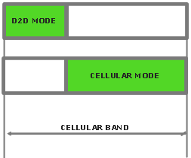

Figure 7: Spectrum Splitting

**Power Control**

Determining the optimum transmit power for spectrum reuse attracts research attention. It is very critical in the case of uplink transmissions due to the near-far effect and co-channel interference. For the maximization of system throughput, a power level limit is set for the DUE and its CUE reuse partner (Gandotra & Jha, 2016). The power control (PC) technique is an approach for mitigating cross-tier interfering signals generated by the DUEs to the networks Uplink and Downlink channels, and co-tier interference between DUEs in the device tier of a D2D enabled cellular network.

There exist two modes for the implementation of Power settings, the dynamic or the fixed mode. While the fixed settings entail static SNR target scheme, the dynamic settings are better and entails either Open or Closed Loop Fraction Power Control Schemes (OLPS, or CLPS) (Xing & Hakola, 2010). In OLPS, the transmission powers of DUEs are adjusted based on their measurements or system parameters. On the other hand, in CLPS, the DUEs regulate their transmission powers in accordance with their coordination with the BS. It was concluded, from the findings, that a good power control scheme for DUEs is the CLPS (Xing & Hakola, 2010).

Yu *et al*., (2009) proposed a centralized PC scheme in a single cell scenario, with a D2D pair and one CUE for the restriction of intra cell interference from DUEs to the network. The work concluded that for every D2D pair, there is a threshold value for determining the appropriate time for reusing uplink or downlink resources for D2D link formation. This, however, has a major limitation of inefficient resource reuse, being a worst case scenario design. Such scenarios are not ideal and may never occur in reality.

Two fractional PC schemes were considered by Yu *et al*., (2009) for the sharing mode. A greedy sum rate maximization was applied by the BS in the first case, without discriminating between D2D and cellular mode communication. However, priority was given to CUEs in the second scheme, which considered a rate constrained PC scheme. This scheme, however, assumed the availability of all the Channel State Information (CSI) with the BS, for transmit power control. This is a hardly realistic condition. In another work, Gu *et al*., (2011) focused on a centralized dynamic PC mechanism for one D2D link in a multi cell scenario. The scheme targeted the mitigation of the D2D link interference on the CUEs by having the BS regulate the DUE transmit power. This work has a major limitation of centralized BS controlled PC.

In a major departure from the works proposed so far, PC was considered for a case of multiple DUEs sharing the resources of a particular CUE by Shalmashi *et al*., (2013) for interference control. The scheme was studied using heuristic algorithm, under the availability of any of average or instantaneous CSI. Their results demonstrate that spectrum resources can be shared by multiple DUEs and one CUE without degrading the performance of the DUEs.

Summarily, PC is not a sufficient co-tier interference mitigation method when standing alone, but should be considered along with other techniques like resource scheduling, mode selection, and link adaptation**Mode Selection**

Mode Selection (MS) algorithms can be deployed to avoid the incidences of cross-tier interfering signals between DUEs and CUEs, as well as co-tier interfering signals between DUEs. Even when D2D peers are in proximity for link formation directly, it may not necessarily be most efficient for them to interact in D2D mode, due to the generation of cross-tier interference. For this reason, the MS scheme determines the most efficient mode of communication for maximized network throughput and satisfied QoS requirements. Each of the communication modes has an effect on the level of cross-tier and co-tier interference.

MS could be designed based on several parameters, like the distance seperating the UEs, the path loss, and the strength of the received D2D signal.

Pekka *et al.,* (2009) performed MS based on channel quality. The work considered the sum rate of both the D2D and cellular connections as the MS criterion. Four resource sharing modes (Uplink, Downlink, Cellular, and separate resource sharing modes) are defined, and the one with the maximum sum rate is selected.

In another approach, Doppler *et al.,* (2010) proposed an MS scheme for a multi cell scenario, which considers the link quality of both DUEs and CUEs, the load situation of the cell, and the cross-tier interference for each possible mode. First, the DUEs probe each other, then estimate the power of the received signals. Secondly, the DUEs would would estimate the interference plus power in both UL/DL. Afterwards, the obtained information is fed to the BS, which then makes a decision about the quantity of resources it would allocate the DUE in uplink/downlink based on the predefined parameters (maximum DUE transmit power, cellular load). After resource allocation has been completed, the BS estimates expected SINR value for each of the communication modes (D2D, and conventional cellular mode), and the anticipated throughput based on SINR and amount of resources available for each mode of communication. Lastly, the mode of communication with the highest throughput is selected. A 50% improvement in sum rate with minimal interference to the network was realized. However, this scheme assumed that the BS has all the Channel State Information (CSI) available to select the most optimal resource sharing mode, which is not realistic.

From an entirely different approach, the work of Lei *et al.* (2014) considered a dynamic MS scheme for limiting cross-tier interfering signals. Three modes of routing were proposed in their work namely; Cellular, D2D, and hybrid, for D2D communications underlaying cellular networks. They combined the routing modes with different resource allocation restrictions to form seven communication modes to model both the semi-static and dynamic mode selection using Discrete Time Markov Chain (DTMC). **Radio Resource Allocation**

Radio resource allocation (RRA) is concerned with the optimal assignment of frequency resources to D2D pairsin order to optimize certain performance metrics.

Resource allocation schemes in D2D communication can either be distributed or centralized. Centralized schemes lead to system complexities in large networks (Zhou *et al*., 2008), while distributed schemes decrease device complexity (Feng *et al*, 2014). The distributed techniques improve the scalability of the D2D links. For obtaining maximum throughput, D2D communication can function in a several modes:

Silent Mode: Here, the DUEs remain silent and cannot transmit because of lack of resources. Spectrum reuse is therefore, not possible.

Dedicated Mode: Here, some of the available resources are dedicated for D2D links formation only.

Reuse Mode: In reuse mode, the CUEs’ uplink and downlink resources are reused by DUEs.

Cellular Mode: In this mode, conventional links formation occurs through the BS and D2D data is transmitted.

Improved spectral efficiency can be achieved by the use of reuse mode, while interference management can better be achieved with the cellular and dedicated modes. The BS controls resource sharing. The reusage of the same resources by cellular and D2D links is called non-orthogonal resource sharing, while orthogonal resource sharing occurs when they do not share the same resources. Table 2 is a meta-analysis table of some reviewed interference mitigation works, Table 3 is a summary of some interference mitigation techniques highlighting the interference types they mitigate based on the given network complexities, while Table 4 briefly captures salient advantages and disadvantages of some intereference management techniques.

**Table 2: Meta Analysis Table of some Works**

| **Article** | **Methodology** | **Network Scenario** | **Strengths** | **Weaknesses** |
| --- | --- | --- | --- | --- |
| *Xing and Hakola (2010).* | The authors used the joint consideration of mode selection, resource scheduling, link adaption and power control to tackle co channel interference | LTE | * Presentation of detailed description of system parameters. * Availability of detailed simulation results. | * Too many techniques involved. * Too many parameters to handle. * Did not provide any solution for cross-tier interference |
| *Doppler et al., 2010* | This work considered the link quality of both D2D and cellular users, the  interference situation (cross-tier interference from DUE to cellular network) for each possible mode and the load situation of the  cell into account for a multi-cell scenario. | LTE A | The result of this study provides an improvement of 50% in sum-rate with limited interference to  the cellular network. | * Power control was not considered in this scheme. * It was assumed that the BS has all the CSI available to choose the best resource sharing mode. |
| *Lei et al., 2014.* | Authors considered a dynamic MS procedure to limit the cross-tier  interference between cellular and D2D users. They proposed three routing modes - D2D, cellular and hybrid, for D2D  communications underlaying cellular networks. | LTE A |  | * Too many communication modes resulted (seven) * Overlaying scenarios were not considered. * Method did not address co-tier interference challenges. * There were too many parameteres to handle. * Cumbersome mathematical equations and models. |
| *Yu, et al., 2011.* | The system aims to optimize the throughput over the shared resources while fulfilling prioritized cellular service constraints, like interference. | LTE-A | The obtained numerical results show substantial gain from D2D communication handling local traffic. | * Authors made too many assumptions, * There was no consideration for Overlaying networks. |
| *Zhou et al., 2015* | consider D2D communication underlying cellular  uplink communication when single stage interference cancellation  receivers are available to improve local service. The  interference cancelation configurations and transmission powers  are jointly optimized in the network to maximize a network  utility | LTE A | From simulation results, where sum rate  or proportionally fair network utility was maximized, significant gains in the spectral efficiency enjoyed by users was observed. | * There was no consideration for overlaying networks. |
| *Mumtaz, et al., 2014.* | Authors proposed a novel Resource Allocation scheme (cell level), which mitigates the interference between D2D and CUEs. | LTE A | * The RA schemes increased the throughput and reduced the overall energy cost per bit of the system. * when compared with the conventional methods, the simulation results show that the proposed schemes obtained higher throughput and saved significant amount of energy per bit. | * The method did not take into account the signaling overhead of D2D system. * Too many parameters to deal with. * Method was mathematically cumbersome. * Overlaying networks were not considered. |
| *Gu et al., 2011.* | Authors proposed a dynamic power control mechanism to reduce interference and improve performance of cellular systems. | LTE | Simulations results show that the proposed dynamic power control mechanism could improve performance of the entire communication systems. | * The proposed mechanism excludes cellular communication UE with same resource, base station, and areas of adjacent cells from the coverage area of D2D communication UE. * Proposed mechanism appeared too complex, with too many parameters. |

**Table 3: Reviewed Interference Mitigation Techniques and Network Complexities**

| **Article** | **Interference Mitigation Technique** | **Interference Type** | **Network complexity** |
| --- | --- | --- | --- |
| *Yu et al., (2009)* | Power Control | Cross-tier | Single Cell |
| *Gu et al., (2011)* | Power Control | Cross-tier | Multi Cell |
| *Shalmashi et al., (2013)* | Power Control | Cross-tier | Single cell |
| *Pekka et al., (2009)* | Mode selection | Co-tier, Cross-tier | Single cell |
| *Doppler et al., (2010)* | Mode selection, Resource allocation, and Power Control | Co-tier, Cross-tier | Multi cell |
| *Lei et al. (2014)* | Mode Selection, Resource allocation | Cross-tier | Single cell |
| *Cho et al. (2013)* | Spectrum splitting | Cross-tier | Single cell |

**Table 4: Pros and Cons of some Interference Mitigation Techniques**

| **Scheme** | **Advantages** | **Disadvantages** |
| --- | --- | --- |
| RA | * RA schemes are flexible, and so can be easily optimized to avoid interference. * Channel quality is improved when DUEs and CUEs use different resources in Fractional frequency reuse mode. | * Licensed spectrum may be inefficiently utilized. * Accurate UE location is required, as well as CSI, all at extra signaling overhead to the BS. * The large signaling overhead leads to a longer scheduling time. * Computational intensity when multiple D2D pairs and a CUE share same resources. |
| PC | * Interference can be mitigated by adaptively optimizing Transmission power. * Simplicity of implementation. * Computationally simple | * Low chance of D2D communication due to limited transmit power. * Poor in CUE to DUE interference mitigation. * Poor D2D communication performance. * Channel variations cannot be dynamically reflected, especially with fixed PC. |
| Joint PC and RA | * Enjoys the advantages of both schemes (PC and RA) | * Computational intensity. * Requires that RA and PC schemes be implemented and integrated. * Difficulty of coordination. * Increased signaling overhead * Suffers the disadvantages of both schemes. |
| Spectrum Splitting | * Eliminates the incidences of cross-tier interference. * Simplicity of implementation. * Low computational cost. | * Leads to the inefficient use of available resources in cases where there are a proportionately low number of DUEs with respect to the available spectrum allocated. * Addresses cross-tier interference strictly. * Requires a complementary interference mitigation technique. |
| MS | * Mitigates both cross-tier and co-tier interference. | * Discourages D2D communication in some cases. * Computationally expensive. * Complexity of implementation. |

**Conclusion**

D2D communication is potentially laden with myriads of benefits to cellular networks such as the reuse gain, hop gain and proximity gain. However, these gains risk being eroded while still further degrading the overall network performance if the generated interference (co-tier and cross-tier) are not properly managed. Since D2D communication is undoubtedly viewed as a beneficial paradigm for the next generation of cellular communication, this paper surveys the existing interference management techniques employed in two-tiered networks. These inherent interference scenarios were first classified in this review as either co-tier or cross-tier interferences. Existing research attempts have not holistically tackled these interference scenarios at minimal computational cost and system complexity levels. Mode selection is jointly proposed with spectrum splitting techniques in future works, to mitigate co-tier and cross-tier interferences respectively, in order to beneficially incorporate D2D communication into future 5G networks.

**References**

Boccardi F, Heath R.W, Lozano A, Marzetta T.L, and Popovski P, (2014) Five disruptive technology directions for 5G, *IEEE Communications Magazine*, vol. 52, no. 2, pp. 74–80.

Bouras C, Kavourgias G, Kokkinos V, and Papazois A (2012). Interference Management in LTE Femtocell Systems Using an Adaptive Frequency Reuse Scheme. *IEEE Wireless Telecommunications Symposium*, London, pp. 1-7. doi: 10.1109/WTS.2012.6266120.

Cho B, Koufos K, and Jantti J, (2013) Interference control in cognitive wireless networks by tuning the carrier sensing threshold, *IEEE International Conference on Cognitive Radio Oriented Networks*, pp. 282-287.

Doppler K, Yu C.H, Ribeiro C.B, and Jänis P, (2010) Mode selection for device-to-device communication underlaying an LTE-Advanced network,” *IEEE Wirel. Commun. Netw. Conf. WCNC*.

Feng, Daquan, *et al*., (2014) Device-to-device communications in cellular networks. *IEEE Communications Magazine,* 52.4: 49-55.

Fodor G, Dahlman E, Mildh G, Parkvall S, Reider N, Miklós G, and Turányi Z (2012) Design aspects of network assisted device-to-device communications, *IEEE Communications Magazine*, vol. 50, pp. 170–177.

Gandotra, P and Jha, R.K, (2016) Device-to-device communication in cellular networks: A survey. *Journal of Network and Computer Applications,* <http://dx.doi.org/10.1016/j.jnca.2016.06.004>.

Gu J, Bae S.J, Choi B.G, and Chung M.Y, (2011) Dynamic power control mechanism for interference coordination of device-to-device communication in cellular networks, *Third International Conference on Ubiquitous Future Networks*, pp. 71–75.

Guo B, Sun S, Gao Q (2015) Interference Management for D2D Communications Underlaying Cellular Networks at Cell Edge, ICWMC.

Jänis, Pekka, *et al*. (2009) Interference-avoiding MIMO schemes for device-to-device radio underlaying cellular networks. *IEEE 20th International Symposium on Personal, Indoor and Mobile Radio Communications*.

Lei L, Shen X.S, Dohler M, Lin C, Member S, and Zhong Z (2014) Queuing Models with Applications to Mode Selection in Device-to-Device Communications Underlaying Cellular Networks, *IEEE Transactions on Wireless Communication*, vol. 13, no. 12, pp. 6697–6715, 2014.

Liu J, Kato N, Ma J, and Kadowaki N, (2014) Device-to-Device Communication in LTE-Advanced Networks: A Survey, *IEEE Commun. Surv. Tutorials*.

Mumtaz, Sami, et al. (2014) Direct mobile-to-mobile communication: Paradigm for 5G. *Wireless Communications, IEEE* 21.5: 14-23.

Noura M and Nordin R (2016) A Survey on Interference Management for Device-to-Device (D2D) Communication and its Challenges in 5G Networks, *Journal of Network and Computer Applications,* <http://dx.doi.org/10.1016/j.jnca.2016.04.021>

Pekka J, Chia-Hao Y, Cassio R, Carl W, Klaus H, Olav T, and Visa K, (2009) Device-to-Device Communication Underlaying Cellular Communications Systems. *International Journal on Communications, Networks, System and Science. pp. 169–178.*

Shalmashi S, Miao G, and Ben S (2013) Interference management for Multiple Device-to-Device Communications Underlaying Cellular Networks*, 24th IEEE International Symposium on Pers. Indoor Mobile. Radio Communication. pp. 223–227.*

Soret, B., Pedersen, K. I., Jørgensen, N. T. K., and Lopez, V. F. (2015). Interference Coordination for Dense Wireless Networks. *IEEE Communications Magazine*, 53(1), 102-109. DOI: 10.1109/MCOM.2015.7010522

Tehrani M, Uysal M, and Yanikomeroglu H, (2014). Device-to-device communication in 5G cellular networks: Challenges, solutions, and future directions, *IEEE Communications Magazine*, vol. 52, no 5. pp. 86–92.

Wang, Dongyu, Wang X, and Zhao Y. (2012) An interference coordination scheme for device-to-device multicast in cellular networks. *IEEE Vehicular Technology Conference (VTC).*

Wen S, Zhu X, Lin Z, Zhang X, and Yang D, (2012) Optimization of interference coordination schemes in device -to- device (d2d) communication. *7th International ICST Conference on* *Communications and Networking in China* (CHINACOM), pp. 542–547.

Xing H and Hakola S (2010) The investigation of power control schemes for a device - To-device communication integrated into OFDMA cellular system, *IEEE International Symposium on Personal, Indoor, and Mobile Radio Communication*, pp. 1775–1780.

Yu, Chia-Hao, *et al*. (2009) On the performance of device-to-device underlay communication with simple power control. *IEEE 69th Vehicular Technology Conference, (VTC) Spring 2009.*

Zhou L, Ruttik K, and Tirkkonen O. (2015) Interference Canceling Power Optimization for Device to Device Communication. *IEEE 81st Vehicular Technology Conference (VTC).*

Zhou, Yun, Fang Y, and Zhang Y. (2008) Securing wireless sensor networks: A survey. *Communications Surveys & Tutorials, IEEE* 10.3: 6-28.