**A groundwater-based irrigation modeling system that optimizing water use efficiency and ensuring long-term sustainability of groundwater resources.**

1*Y.Y. Alheri, 2 N. Nyor, 3K. J. Audu

1,2,3Department of Mathematics, School of Physical Science, Federal University of Technology, Minna, Niger State, Nigeria.

[**yakubu4real4life@gmail.com**](mailto:yakubu4real4life@gmail.com)**,** [**ngutor.nyor@futminna.edu.ng, jameskhadeejah@yahoo.com**](mailto:ngutor.nyor@futminna.edu.ng,%20%20%20%20jameskhadeejah@yahoo.com)

**Abstract:** *Maximizing crop yield while ensuring sustainable water use is a critical challenge in agriculture, particularly in areas that are dependent on groundwater for irrigation. This study aims to develop and implement a groundwater-based irrigation modelling system that maximizes crop yields, optimizes water use efficiency, and ensures the long-term sustainability of groundwater resources. The research introduces new parameters into the Mass Balance Equation to investigate the relationship between Evapotranspiration (ET) and Specific Yield (SY) during the dry season, from November to April. Groundwater recharge, usage, and levels are assessed to provide a comprehensive understanding of the resource dynamics.*

**1.0 Introduction**

The urgent need for sustainable food production in the face of a burgeoning population and a changing climate has propelled irrigated agriculture to the forefront of global sustainability agendas. Yet, reliance on surface water for irrigation, traditionally the mainstay of this sector, is becoming increasingly untenable due to dwindling freshwater resources and intensifying competition for these limited supplies (Hejazi et al., 2023). In this context, groundwater-based irrigation modelling emerges as a transformative technology, offering a pathway towards maximizing crop yields while ensuring responsible and sustainable water management.

This thesis delves into the immense potential of groundwater-based irrigation modelling for revolutionizing agricultural practices. We begin by highlighting the current limitations of conventional irrigation methods, characterized by inefficiencies and unsustainable water use patterns (FAO, 2020). This section will also showcase the escalating pressures on freshwater resources, exacerbated by climate change and anthropogenic activities (UN-Water, 2023).

Against this backdrop, we introduce the concept of groundwater-based irrigation modelling, outlining its various components and showcasing its advantages over traditional approaches. This includes a discussion of hydrogeological modelling, which simulates groundwater flow and storage dynamics, incorporating crucial factors like aquifer characteristics and recharge patterns (Huntington et al., 2022). We will also delve into crop growth models, which predict yield responses to specific irrigation regimes and environmental conditions, accounting for plant physiology and soil-water interactions (Martre*et al.,* 2020). Harnessing the Power of Groundwater for Sustainable Crop Yield Optimization. In this context, maximizing crop yields has become a critical imperative for ensuring food availability and affordability for all. While traditional agricultural practices have played a vital role in this endeavor, the limitations of rain-fed agriculture, particularly in arid and semi-arid regions, necessitate exploring alternative irrigation strategies. Groundwater-based irrigation, with its inherent reliability and independence from erratic rainfall patterns, emerges as a promising solution (Foster & Gard, 2014). However, the unfettered exploitation of groundwater resources poses significant environmental and economic challenges. Unsustainable pumping rates lead to aquifer depletion, salinization, and land subsidence (Shah *et al.,* 2003). This, in turn, jeopardizes long-term water availability and the economic viability of agricultural systems. Therefore, maximizing crop yields through groundwater-based irrigation demands a delicate balance between achieving optimal production and ensuring the sustainable management of this precious resource. North-central Nigeria is characterized by a semi-arid climate with erratic rainfall, making irrigation crucial for sustainable agriculture. While surface water sources are limited, vast groundwater reserves offer significant potential. However, unregulated groundwater abstraction for irrigation can lead to aquifer depletion, land subsidence, and salinization, jeopardizing both water security and food production. Therefore, optimizing groundwater use for irrigation is essential for ensuring agricultural productivity and long-term sustainability in the region.

Mathematical models present powerful tools for analyzing and optimizing complex water resource systems. These models allow researchers and policymakers to simulate various irrigation scenarios, evaluate their impact on crop yields and groundwater resources, and identify optimal water allocation strategies. Several studies have demonstrated the effectiveness of mathematical models in optimizing groundwater use for irrigation in different climatic and geographic contexts (Saito *et al.,* 2022; Alfarsi *et al.,* 2021; Torres-Sanchez et al 2020). The model will incorporate key factors such as climate data, soil characteristics, crop water requirements, groundwater recharge rates, and economic considerations. By integrating these elements, the model will identify irrigation strategies that maximize crop yields while minimizing groundwater depletion and environmental impacts.

**2.0 Overview of Irrigation Practices**

Andrea *et’al* (2023) compares four different methods for estimating groundwater withdrawals for irrigation. The findings help practitioners evaluate the strengths and weaknesses of different approaches. Accurate estimation of groundwater withdrawals for agricultural irrigation is crucial for effective groundwater management. Different approaches can be used to estimate groundwater withdrawals, including the hydrologically-based Water Table Fluctuation method (WTFM), the demand-based SALUS crop model, satellite-derived evapotranspiration (ET) data from Open ET, and a landscape hydrology model that integrates hydrologic- and demand-based approaches. The choice of approach depends on factors such as data availability, spatial and temporal resolution, and accuracy of predictions. The WTFM method requires accurate groundwater levels, specific yield, and recharge data, while the SALUS crop model requires information about crop type, land use, and weather. All approaches reasonably estimate groundwater withdrawals, but the type and amount of data required and computational requirements vary. Practitioners can use these findings to evaluate the strengths and weaknesses of different approaches and select the most appropriate

One for their application. They made their equation known to be:

 (2.1)

Where,

= Specific yield

A= area of land considered

= change in ground water

R= recharge

Accurate estimation of groundwater quality is important for effective irrigation management in agricultural areas .Data-based models using physical groundwater parameters as inputs can be used to estimate irrigation water quality indexes .Support vector machine (SVM), random forests (RF), artificial neural networks (ANN), and extreme learning machine (ELM) models can be used for groundwater quality estimation .The Monte Carlo approach can be used to assess the uncertainty of physical groundwater parameters and the sensitivity of AI models .

Groundwater pollution is a significant water crisis in various regions, including the Sichuan Basin Groundwater quality in the Sichuan Basin is suitable for irrigation purposes, with some local areas having poor water quality.Groundwater organizations play a vital role in promoting groundwater resource stewardship and addressing groundwater overdraft and quality concerns. Fuzzy comprehensive evaluation can be used to classify groundwater for irrigation purposes, taking into account uncertainties near class boundaries. Different methods, such as the Water Table Fluctuation method, SALUS crop model, satellite-derived evapotranspiration data, and landscape hydrology model, can be used to estimate groundwater withdrawals for agricultural irrigation

**2.2 Groundwater Resources and Management**

Oluseyi *et al.* (2015) developed estimation of groundwater recharge using empirical formula in Odeda local government area of Ogun state, Nigeria. They determined groundwater and groundwater recharge coefficient through a case study using empirical methods applicable to the tropical zone. They collected the related climatological data between January 1983 and December 2014 in Ogun Osun River Basin Development Authority (OORBDA) Ogun State Nigeria.

The model for estimation of groundwater recharge of the study area was conducted using a modified version for tropical regions based on water level fluctuation and rainfall depth, thus the equation is given as

 (2.2)

Where R = net recharge due to precipitation in inches

P represents precipitation in inches

The recharge coefficients equation is given as the ratio of recharge to effective rainfall and is expressed in percentage as

 (2.3)

R represents recharge

 represents effective rainfall

The estimated runoff for water budget equation is given as



where,

 represents directed runoff

P represents precipitation

They used co-integration analysis which involves a unit root test performed on levels the first difference and the second difference to determine whether the individual input series and stationary and exhibit and similar statistical properties.

The augmented Dickey – fuller (ADF) test was used to test for the stationary of the data, the test consists the following regression.

 (2.4)

where;

 (2.5)

The co-integration model is given as

 (2.6)

They used Pearson correlation coefficient to evaluate the strength of the relationship between meteorological factors. The impact of the independent variables i.e, humidity, temperature, rainfall, wind speed and duration of daily solar radiation on estimate recharge was evaluated using linear regression. The result shows that groundwater recharge was 194.7mm per year, evapotranspiration was 1296.2mm per year and the recharge coefficient was 20.2% for the study area. The result shows that about 11% of rainfall infiltrated the aquifer, 73% was loss to evapotranspiration and 36% ended up as runoff. Correlation between recharge and rainfall, temperature, humidity, solar radiation and evapotranspiration were at the 0.01 significance level and the results of linear regression prove that precipitation has a significant effect (with R2 = 0.983) on estimated recharge.

**3.0 Materials and Methods**

**3.1 The Model Assumptions for Weather conditions**

We consider the following model assumption for the weather condition

1. Temperature: Higher temperatures can increase evaporation rates, leading to greater water loss from fields. Cooler temperatures can help conserve water.
2. Humidity: Higher humidity levels can reduce evapotranspiration rates, which can be beneficial for water conservation

**3.2 The mass balance equation:**

The mass balance equation is given as:

 (3.1)

where,

aquifer specific yield

 change in groundwater

 net irrigation requirement

gross irrigation requirement

aquifer discharge

A= area of land

**3.3 Decay flow equation**

The decay flow equation is formulated as;

 (3.2)

c = constant

Substitute equation 3.2 into equation 3.1 we have:

 (3.3)

Divide all through by  we have :

 (3.4)

 (3.5)

From equation (3.1)

 (3.6)

 (3.7)

Where,



area of irrigation

evapotranspiration

recharge due to irrigation practice

water store in the soil

leaching requirement

groundwater contribution from water table

 (3.8)

where,

Electrical conductivity of irrigation water (dS/m)

Electrical conductivity of the soil saturation extract for a given crop appropriate to the tolerable degree of yield reduction

Leaching efficiency  
For localized irrigation and high frequency (near daily) sprinkler:

 (3.9)

Maximum tolerable electrical conductivity of the soil saturation extract for a given crop (dS/m)

 (3.10)

If assuming that  and  are both zero, then Equation (3.7) becomes:

 (3.11)

Substitute equation (3.11) into equation (3.10) we have:

 (3.12)

Re arrange equation (3.12) we have:

 (3.13)

 (3.14)

From equation (3.10) we have

 (3.15)

From equation (3.10)

 (3.16)

Combine Equation (3.16) and (3.15) we have:

 (3.17)

 (3.18)

Let

 (3.21)

be Area (A) of the irrigation Land

Substituting equation (3.11),(3.19) and (3.21) into equation (3.1) we have :

 (3.22) the optimization model for the groundwater is formulated as:

**3.3 Groundwater Model formulation**

Converting (3.18) to Optimization model we have (3.23).

 (3.23)

Subject to:

 (3.24)

 (3.25)

 (3.26)

 (3.27)

**RESULTS AND DISCUSSION**

**4.1Experiment and Results**

In this chapter, we presented the data used for a mathematical model for the optimal inventory management of four products considered in our project. Our results in chapter three are analyzed here. Computational results are performed using Intel® Pentium® Dual [T3200@4.00GH](mailto:T3200@4.00GH) 500MBMemory Python.

**4.2 Groundwater Availability and Quality**

Table 4.1 Shows Evapotranspiration, Aquifer Discharge, Specific Yield, Net Irrigation Requirement and Change in Groundwater from November to April

|  |  |  |  |  |  |  |
| --- | --- | --- | --- | --- | --- | --- |
| z | Evapotranspiration  (ETC) | Aquifer Discharge  (RD) | Net Irrigation Requirement (D) | Gross Irrigation Requirement (Gr) | Aquifer Specific Yield (sy) | Change in Groundwater |
| November | 50 | 15 | 100 | 125 | 0.15 | 7225 |
| December | 40 | 12 | 100 | 125 | 0.15 | 7361.67 |
| January | 30 | 10 | 100 | 125 | 0.15 | 7483.33 |
| February | 40 | 12 | 100 | 125 | 0.15 | 7561.67 |
| March | 50 | 15 | 100 | 125 | 0.15 | 7683.33 |
| April | 70 | 20 | 100 | 125 | 0.15 | 7741.67 |

**Table 4.1**The results from November to April show how the interplay of evapotranspiration (ETC), aquifer discharge (RD), and irrigation requirements affect the change in groundwater. In November and December, evapotranspiration is moderate (50 mm and 40 mm, respectively), leading to lower water demand by crops, while aquifer discharge is also relatively low (15 mm and 12 mm). As a result, the change in groundwater is lower in November at 7225 units and slightly increases in December to 7361.67 units. This period reflects cooler months when crop water needs are not as high, leading to more stable groundwater levels. As we move into January through April, evapotranspiration begins to increase steadily, reaching its peak of 70 mm in April. Aquifer discharge also rises from 10 mm in January to 20 mm in April. This increase in both water demand (due to higher evapotranspiration) and aquifer discharge leads to a gradual increase in the change in groundwater, from 7483.33 units in January to 7741.67 units in April.

**4.3 Irrigation Model Output**

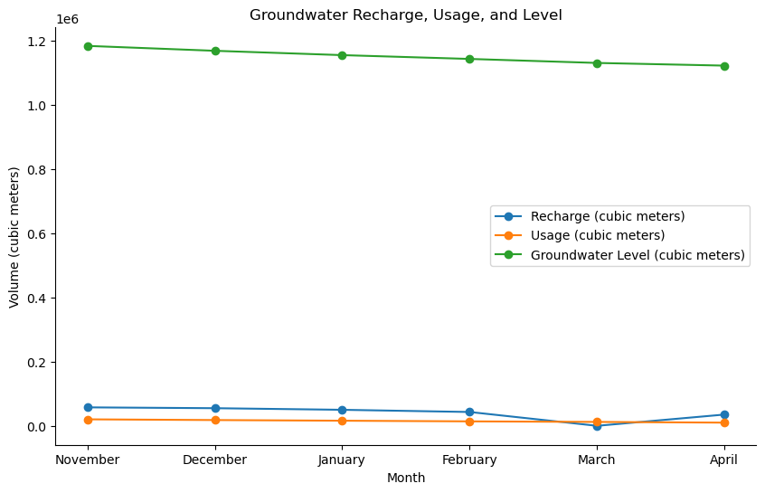

Figure 4.1 shows that the recharge (inflow) of groundwater is generally higher than the usage (outflow) for most months. This suggests that there is a net positive change in groundwater storage during these months, which is important for maintaining sustainable groundwater levels.

There is a noticeable pattern of seasonal variability in both recharge and usage. Recharge tends to be higher in the months of November and December, while usage is relatively lower during these months. On the other hand, recharge decreases and usage increases from January to April, indicating a shift in the balance between inflow and outflow.

The graph also shows the groundwater level, which is influenced by both recharge and usage. The level generally follows a pattern similar to recharge, with higher levels in November and December and lower levels in April. However, the groundwater level lags behind the recharge and usage changes, reflecting the time it takes for these changes to affect the overall groundwater system. Overall Trend: Despite the seasonal variability, there seems to be a gradual decline in groundwater level from November to April. This could indicate that the recharge during the wetter months is not sufficient to offset the usage and natural discharge, highlighting the importance of sustainable water management practices.

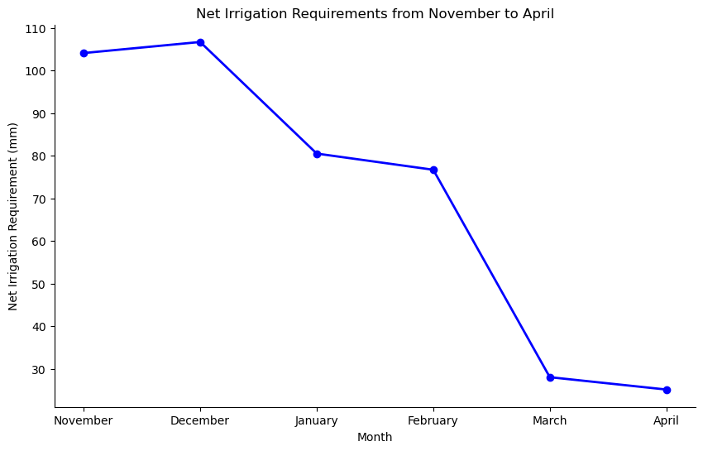

Figure 4.3 Shows Net irrigation requirement from November to April. Starting Point (November) shows that the graph start at a higher point with 104.1 mm for November, indicating the beginning of the irrigation season when water demand is higher due to planting or early growth stages of crops. Slight Increase (December), Moving to December, the graph. Shows a slight increase to 106.7 mm, suggesting that the water requirements remain high, possibly due to growing crop water needs. Decrease (January to February): As the graph progresses to January and February, there is a noticeable decline to 80.5 mm and 76.7 mm respectively. This trend is due to the onset of cooler weather, which generally reduces crop water demand, or possibly the crops are past their peak water requirement phase. Significant Drop (March to April): The most significant change would be observed from March to April, where the graph steeply drops to 28.0 mm and 25.1 mm. This sharp decline indicates that the crops are nearing the end of their growing season and require much less irrigation. The overall trend of the graph shows a decrease in irrigation requirements as the season progresses, which is typical for crop cycles that have higher water needs during the initial growth stages and lower needs as they mature.

Total Net Irrigation Requirement: The cumulative total of 421.1 mm from November to April would be represented as the area under the curve in the graph. This total is crucial for planning the water resource allocation for the entire irrigation season.

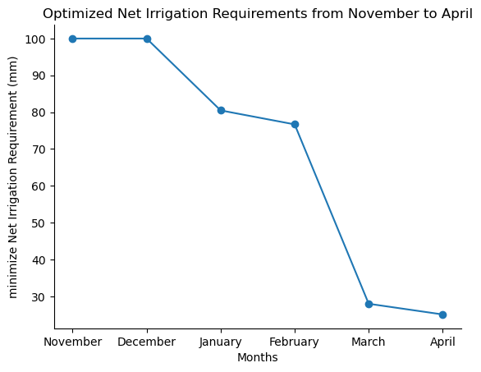

Figure 4.4:Shows net irrigation requirement from November to April

The graph which is for equation 3.1.8 starts with the highest irrigation requirements in November and December, both at 100.00 mm. This suggests that the crop’s water needs are greatest during these months, possibly due to lower rainfall or higher evapotranspiration rates. As the graph progresses from January to April, there is a noticeable decrease in the net irrigation requirements. January and February show a modest reduction, while March and April exhibit a significant decline, indicating a seasonal adjustment in water needs.

* 1. **Conclusion**

The comprehensive analysis of evapotranspiration, specific yield, groundwater levels, and irrigation requirements over a six-month period from November to April reveals several key insights into water resource management in agricultural settings. The study underscores the intricate relationship between various hydrogeological parameters and their impact on sustainable agriculture practices. The findings indicate that while there is a net positive change in groundwater storage, particularly in the early months, there is an overall gradual decline in groundwater levels. This trend suggests that current recharge rates during the wetter months may not be sufficient to offset the usage and natural discharge, emphasizing the need for enhanced water conservation and management strategies. Seasonal variability in recharge and usage rates points to the necessity of adjusting irrigation practices to align with these patterns. The optimization of irrigation requirements, as demonstrated by the minimized total net irrigation requirement of 410.26 mm for the dry season, shows that it is possible to meet crop needs efficiently without overexploiting water resources.

**References**

V. Vázquez-Báez, A. Rubio-Arellano, D. García-Toral, I. Rodríguez Mora, "Modeling an Aquifer: Numerical Solution to the Groundwater Flow Equation", *Mathematical Problems in Engineering*, vol. 2019, Article ID 1613726, 9

Joseph I. A., Elizabeth I. Okoyeh S. O. (2016) The Use of Mathematical Models in the Analysis of Flow in a Regional Water Table Aquifer in Nsukka Area, Southeast Nigeria. *Journal of Natural Sciences Research* [www.iiste.org](http://www.iiste.org) ISSN 2224-3186 (Paper) ISSN 2225-0921 (Online)

Saito, K., Watanabe, T., Tanaka, H., Nakano, M., & Yamamoto, Y. (2022). "Optimal irrigation water allocation considering water scarcity and salt buildup in an agricultural watershed." *Journal of Hydrology*, 610, 127688.

Alfarsi, A., Al-Zu'bi, Y., Al-Muhtaseb, A., & Al-Mashaqbeh, O. (2021). "Hydroeconomic optimization of a conjunctive water use system for sustainable irrigation in Jordan." *Journal of Cleaner Production*, 290, 125555.

Torres-Sanchez, R., Navarro-Hellin, H., Guillamon-Frutos, A., San-Segundo, R., Ruiz-Abellón, M. C., & Domingo-Miguel, R. (2020). "A Decision Support System for Irrigation Management: Analysis and Implementation of Different Learning Techniques." *Journal of WaterResources,* 12(2), 548. <https://doi.org/10.3390/w12020548>.

Foster, S. A., & Gard, C. A. (2014). Modeling irrigation Behavior in groundwater systems. *Water Resources Research*, 50(9), 7228-7251.

Shah, T., Bruinsma, J., & Makombe, I. (2003). Irrigation and drainage in Africa: Its challenges and opportunities *for the future*. IWMI.

Kang, G., Zhang, X., Zhu, T., & Liu, J. (2015). A coupled model for simulating water flow and crop growth in drip-irrigated maize field. *Agricultural Water Management*, 156, 120-132.

Gong, L., Wang, W., Li, T., Liu, M., & Li, X. (2022). Optimization of irrigation water allocation based on coupled simulation-optimization model in arid region. *Journal of Hydrology*, 611, 127626.

Giuliani, G., Castelletti, A., & Mason, R. (2015). Assessing the potential of groundwater modeling to support sustainable water management in agriculture: Lessons from the Campania region, Italy. *Journal of Environmental Management*, 153, 48-58. Open access•JournalArticle•DOI

Andrea E. B, Samuel C. Z, Anthony D. K, Hoori A, Jillian M. Deines (2023) Estimating groundwater pumping for irrigation - A method comparison. *Journal of Groundwater.*V(2)3, 234-456

22 Jun 2023-Ground Water

Rajandrea S., Antonio D., M., (2019) Technical Approach to Hydrogeology, Contaminant Transport and Groundwater Remediation: Springer Tracts in Civil Engineering ISBN 978-3-030-20514-0 <https://doi.org/10.1007/978-3-030-20516-4>