**TREATMENT OF FISHPOND WASTEWATER USING HYBRID CONSTRUCTED WETLANDS IN MINNA, NORTH CENTRAL NIGERIA.**

Adeoye Peter Aderemi

Department of Agricultural and Bioresources Engineering, Federal University of Technology, Minna, Nigeria

*Email:* [*peter.adeoye@futminna.edu.ng*](mailto:peter.adeoye@futminna.edu.ng)*;* Phone: +2348035868053.

Paramdi Solomon Abari

Department of Agricultural and Bioresources Engineering, Federal University of Technology, Minna, Nigeria.

*Email:abarist@futminna.edu.ng;* Phone: +2348066100080

**ABSTRACT**

Musgola fish farm is an integrated farm located in Bosso Local Government of Niger State, North Central Nigeria. The farm uses large volume of freshwater for the purpose of fish husbandry. Wastewater generated from the fishpond leads to environmental pollution as it contains uningested food, fish dregs, faeces of different classes and chemical constituents. There is therefore the need for a study on environmental impact of these wastewaters and how it can be treated for safe disposal. This study was carried out to characterise the wastewater and thereafter evaluate the effectiveness of constructed wetlands (CWs) to treat it before discharging it into adjacent river. The results of fish pond effluent characterisation showed that the pH of the effluent ranges between 5.7 and 6.84, temperature was between 26 and 27 0C, electric conductivity ranges between 250 and 334 µs/cm, TDS ranges between 232 and 265 mg/L, BOD5 was between 102 and 123 mg/L, NH3 ranges between 1.23 and 1.92 mg/L, and Turbidity was between 9.9 and 11.2 NTU). These data were predetermined to use as baseline information for the wastewater entering the constructed wetlands. The developed hybrid CWs of two planted horizontal and vertical CWs with a corresponding two unplanted horizontal and verticals to act as control. The flow was continuous with calculated hydraulic flow rate of 20 L/day, hydraulic loading rate 15 L/day while hydraulic retention time for horizontal and vertical flow CWs were 5 and 4 days respectively. One way analysis of variance (ANOVA) at 95% significance level was used to examine the performance of the treatment. The treatment efficiency of the systems was calculated as the percentage of contaminant removal as measured from planted horizontal and vertical CWs compared with unplanted horizontal and vertical CWs. The comparison of hybrid CWs displayed removal efficiencies of 90.1 and 89.0 % for BOD5, 44.9 and 58.2% for TDS, 60.7 and 77.7% for TSS, 48.9 and 57.4% for EC, 35.2 and 45.5% for Turbidity. *Sacciolepis africana*-planted hybrid CWs proved to be more efficient than unplanted wetlands in the treatment of fishpond wastewater. Planted hybrid CWs had final effluent concentrations that comply very well to the discharge limits of WHO and Nigerian FEPA standards. Hence, constructed wetlands is a viable alternative to address many of the water-management problems faced by the fish industry.

Keywords:*Sacciolepis africana*, constructed wetland, fishpond wastewater and environmental management.

**INTRODUCTION**

Agriculture has been backbone of Nigerian economy, contributing up to 85% of gross domestic product (GDP) before crude oil was discovered in commercial quantity in present day Bayelsa state (Samuel and Oje, 2012). Economic development of any nation depends on looking inwards to identify sectors of the economy where it has comparative advantage over other nations and seek to develop the identified sector. Jibrin (2016) carried out report on fish farming being the most practiced type of farming in Nigeria and has become an enterprise by Nigerians of various walks of life possibly due to its general acceptance by Nigerians with no restriction to ethnicity. Fish farming is the rearing of fish in an enclosed water bodies such as ponds, dams, cages, raceways, tanks, reservoirs under human management and has the same objective as agriculture to increase the production of food above the level that would be produced naturally (Olaoye, 2010). Fish farming remains the fastest growing agricultural industries globally, with an estimated total production of 66.6 million metric tonnes in 2012 (FAO, 2016). Intensification of fishponds production will require the use of more inputs, especially feed per unit area of land (Henriksson *et al.,* 2018), leading to an increase in wastewater generation from the production systems. Fish ponds wastewater contain a large number of physical, chemical and biological constituents from varying concentrations and levels (Jian-feng *et al*., 2005). It contains waste feeds and dregs which affect the receiving water bodies when discharged without proper treatment. The quantity of wastes generated from fishponds practices depends on the culture system, characteristics, choice of species, feed quality and management practices. Effective treatment is needed before these wastewaters are discharged into the environment or reused for irrigation (Badejo *et al.*, 2012).

The use of constructed wetlands (CWs) as natural and bases for economically low-cost effluent treatment cannot be over emphasised. Constructed wetlands (CWs) are treatment systems that have been designed and constructed to utilize the natural process of physical, chemical, and biological synergistic action among substrates, plants and microorganisms, but do so within a more controlled environment (Jian-feng *et al*., 2005). They provide a less disturbance than the harsh conventional methods like incineration, thermal vaporization, solvent washing, or other soil washing techniques, which can destroy the biological component of the soil or change the chemical and physical characteristics of the receiving soil and water (Lin and Mendelssohn, 2009).

Hybrid constructed wetland is the combination of two flow systems, horizontal subsurface flow (HSSF) system and vertical subsurface flow (VSSF) system in stage manner to complement each other (Vymazal, 2002). This type of constructed wetland is well approved to remove BOD5 and TSS from wastewater Zhang *et al*. (2012) experimented improve treatment of ammonium-N, TN, and TP from 4.37 to 0.94mg/l, 2.98 to 1.77mg/l and 3.14 to 1.95mg/l respectively. They concluded a significant decrease in organic nutrients using combination four stages CWs. Dong *et al*. (2016) demonstrated a high treatment of wastewater with hybrid CWs and recorded a significant decrease in 83% NH4, 90% TSS, 76% BOD5, 89% TP and 80% TN. Due to these reasons, there has been a growing interest in combined (hybrid) wetlands. Constructed wetlands are made up of four main components: plants, substrate media, microbial biomass and the aqueous phase (Vymazal, 2002). The sediment and gravel provide physical and chemical support in the root zone and. The root zone is the active reaction zone

of CWs, where physicochemical and biological processes are induced by the interaction of the pollutants with the plants, microorganisms, and soil particles (Lee and Scholz, 2007). However, the ability of CWs to purify wastewater depends on naturally occurring physical, chemical and biological processes that take place within the system (Dhulap *et al.,* 2014). Constructed wetlands use natural geochemical, physical, and biological processes in a wetland ecosystem to treat contaminants of concern. Jian-feng *et al*., (2005) reported bioremediation of contaminants takes place during the passage of raw or pre-treated wastewater through the gravel layer and root zone of the constructed wetlands. The constituents of concern are removed by various mechanisms such as filtration and sedimentation of suspended particles, adsorption to suspended matter, photolysis, volatilization, plant uptake and precipitation by biogeochemical processes (Jian-feng *et al*., 2005). Savita, (2007) described the mechanisms for nitrogen removal in CWs are denitrification, plant uptake, volatilization, and adsorption.

The discharge of fishpond wastewater from Musgola fish farm Lapai Gwari into River Chanchaga tributary leads to; aquatic pollution and unhealthy environment, the need for proper disposal of the effluents is paramount to reduce the level of hazardous constituents into water bodies as well as soil. Fish farming sites are fast growing and need to be addressed by naturally, simple, and effective technology such as constructed wetlands especially in a developing country like Nigeria. The proper disposal of fishpond wastewater is of essence and to develop a hybrid constructed wetland that is simple ecologically friendly to treat fishpond wastewater before discharge will be an environmentally friendly and economically feasible option. The objectives of this study are therefore to characterise effluent from Musgola fish farms Lapai-Gwari, at the point of discharged into the river Chanchaga tributary. design and develop a hybrid constructed wetlands to treat fish pond effluent, and estimate the quantity of waste treated by hybrid CWs.

**MATERIALS AND METHODS**

The study area is Musgola fish farm Lapai-Gwari, located in Minna, Niger State, Nigeria. Niger state is situated in the Northern guinea savannah ecological zone of Nigeria. It lies between latitude 9o31’21.23” N and longitude 6o30’4.66” E of the prime meridian. The climatic condition is categorized by long dry and wet seasons. The rainy season begins in April and ends in October with an average rainfall of 1200 – 1300 mm annually, and the dry season starts in November and ends in March. The average temperature ranges from 22.5oC to 33.6oC annually with an average relative humidity of 50.2% (NIMET, 2006). Effluent generated from the Musgola fish farm flows through series of fishponds within the farm through a pipe whereafter it is discharged into River Chanchaga tributary. The physical and chemical parameters of this discharged effluent from the farm was examined to provide a base line information on the contaminants present in the discharged effluent. The aim is to have the baseline information of parameters of concern. The approaches were collection of fishpond effluent from the fish farm and analyse it for parameters of concern using APHA (2005) standard methods.

**Experimental setup**

The HSSF and VSSF CWs were constructed for the purpose of this research. It comprises of 8 cells, 4 horizontal cells and 4 vertical cells with HSSF CWs rectangular in shape with dimensions 100 x 75 x 37 cm, respectively for length, width and depth and the VSSF CWS was circular in shape 47 cm diameter, 57 cm height) made of plastics. Each horizontal cell had a volume of 278 L and vertical cells had a volume of 99 L, hydraulic retention time (HRT) of 6 and 3 days with hydraulic loading rate of 15 and 4 L/day. Two HSSF and two VSSF CWs were planted with *Sacciolepis africana* Two HSSF and Two VSSF CWs without plant to serve as the control. Figure 1.

**Figure 1: Set up of a Planted and unplanted hybrid constructed wetland.**

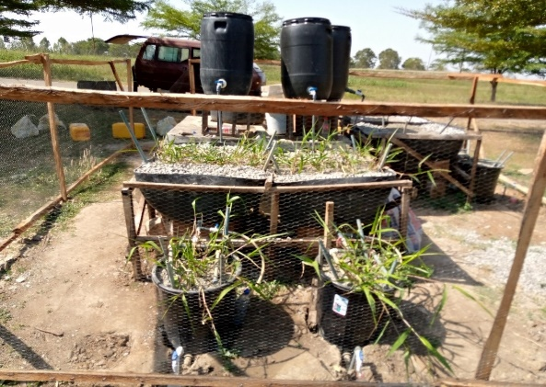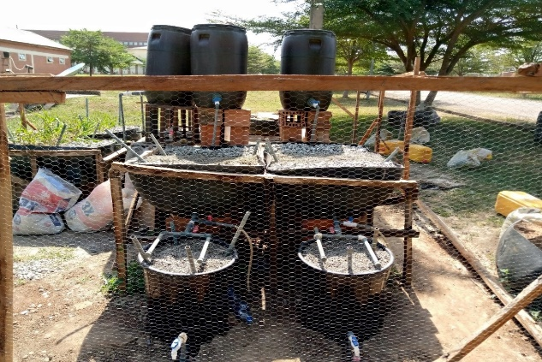

Fishpond wastewater was collected into 120 litres tank and allowed to flow into HSSF and VSSF CWs by gravity continuously through 50mm polyvinylchloride (PVC) pipe installed with control valves of porosity of 0.40. The control valves were inserted at the outlets of the dosing tank. The perforated pipes installed at the inlet and out of the cells were used to enable equal distribution of wastewater in and out of the wetlands. The influent tank 120 l was refilled every 6 days with fishpond wastewater.

After the completion of the construction and set up, the study seeks to investigate the suitability and effectiveness of *Sacciolepis africana* for the treatment of fish pond effluent. This was done by collecting

*Sacciolepis africana* from the natural wetland within Musgola fish farm and to transplanting them to the wetland cells. The macrophytes was transplanted to the wetland cells at an initial density of four plants per hole and allowed for the period of 3 weeks to be stabilized. The physicochemical and biological interactions were allowed take place in the root zone, with interaction of plants, microorganisms, the soil and pollutants. At the start of the planting, plant aboveground and belowground biomass was taken at wet and dry bases (biomass at day T0= 0), the 14th day (at T1=14), 28th days (at T2=28), 42nd days (at T3=42), to day173 (at X=173). Harvested biomass in replicates were taken to the laboratory, these plants were washed and sorted out into above ground (stems and leaves) and below ground (rhizomes and roots) parts. These harvested parts were washed dried and digested for analysis using Lin and Mendelssohn (2009) method.

After the establishment of the substrates, the wastewater was fed to the wetland from November 2019 to January 2020. The influent and effluent samples was taken every 6 days to analyse their treatment performance. On site analysis of physical - chemical parameters such as, pH, DO, temperature, conductivity was carried out on the field using a portable multi – parameter tester. After which the collected samples were carried to the laboratory to determine their parameters according to the methods described by Mustapha, (2018).

**Results and Discussions**

The results of the initial physico-chemical analysis of the fishpond effluent are presented in the table 1. The fishpond wastewater was composed of organic and inorganic compounds including salts, suspended solids and metals. The composition varied depending on feeds in the production chain.

**Table 1: Average physico - chemical quality of the fishpond wastewater between October 2019 and March 2022**

|  |  |  |  |  |
| --- | --- | --- | --- | --- |
| Parameters | Minimum | Maximum | Average | WHO Limits |
| Ec (µs/cm) | 250 | 264.17 | 334 | 1000 |
| DO (mg/L) | 1.3 | 1.7791 | 1.99 | <0.2 |
| Turbidity (NTU) | 9.9 | 10.709 | 11.2 | 5 |
| TDS (mg/L) | 232 | 251.21 | 265 | 500 - 2000 |
| TSS (mg/L) | 122 | 142.91 | 162 | 30 - 50 |
| TS (mg/L) | 155 | 377.69 | 420 |  |
| BOD5 (mg/L) | 102 | 115.65 | 123 | 25 - 10 |
| NO3--N (mg/L) | 0.03 | 0.0437 | 0.05 | 20 - 50 |
| NH3+- N (mg/L) | 1.23 | 1.6852 | 1.92 | 0.1 -1.0 |
| SO4 (mg/L) | 114 | 122.34 | 138 |  |

The fishpond wastewater revealed that pH, temperature, TDS and nitrates were within the permissible limits. The nature of the fishpond wastewaters was such that it ranged between weakly acidic and weakly basic (6.5 ± 0.0 and 9.5 ± 0.1). A similar occurrence was reported for fishpond effluents by Naylor, (2003) Dissolved Oxygen, Turbidity, total soluble solids (TSS), biological oxygen demand (BOD5), were above the permissible limits. High turbid water is often associated with the possibility of microbiological contamination (Igbinosa and Okoh, 2009). Also, if such effluent is discharged into water bodies, it will affect fish and other aquatic life. Discharge of effluents into the environment with high levels of BOD5 imply that less oxygen is available for living organisms (Kaur *et al.,* 2010). In addition, this may indicate toxic conditions and the presence of biologically resistant organic substances in the effluent (Yusuff and Sonibare, 2004). Nutrients are required by plants for growth; however, high concentrations of nutrients are largely responsible for eutrophication, depletion of dissolved oxygen and pollution of water bodies (Chang *et al.,* 2010). This study showed that it is paramount to treat and brings these contaminants to non-hazardous levels to protect the aquatic ecosystem and people in the downstream end of the river who use the river as source of water for domestic and agricultural purposes.

**Treatment efficiencies of the hybrid wetlands (BOD5, DO)**

Mean values of the various pollutants’ concentration and water quality parameters in the influent wastewater and effluent discharge of all the respective wetlands configurations were taken and compiled for comparison. The sample space comprised of 23 sample points. Planted wetlands had higher efficiency compared to unplanted in improving the BOD5 and DO of the wastewater figure 4.2 and figure 4.3. For BOD5, average efficiency of 90% and 89% was recorded for planted horizontal and planted vertical wetlands, compared to lower efficiencies of 70.3% and 79.1% from unplanted horizontal wetland and unplanted vertical wetlands respectively. DO average efficiencies 70.3 % and 68.7% compared to unplanted were also recorded 30.0% and 24.6%. Table 2 Mustapha (2011) also reported on performance of constructed wetland compared to unplanted wetland in Morocco also noticed similar performance.

**Table 2: Removal efficiency of various wetlands configurations in treatment for BOD5, and DO**

|  |  |  |  |  |  |  |
| --- | --- | --- | --- | --- | --- | --- |
|  | **BOD5** | | | **DO** | | |
| **Wetland Configuration** | **Influent Average** | **Effluent Average** | **Efficiency**  **(%)** | **Influent Average** | **Effluent Average** | **Efficiency**  **(%)** |
| **Planted Horizontal** | 115.7±0.5a | 11.5±0.8a | 90.1±0.4c | 11.8±0.3a | 3.5±0.3a | 70.3 ±0.2b |
| **Planted Vertical** | 115.7±0.5a | 12.7±0.4a | 89.0±0.0c | 11.8±0.1a | 3.7 ±0.3a | 68.7±0.3b |
| **Unplanted Horizontal** | 115.7±0.3a | 34.4±0.8d | 70.3±1a | 11.8±0.0a | 8.5 ±0.3a | 30.0 ±0.6a |
| **Unplanted Vertical** | 115.7±0.6a | 24.2±0.6c | 79.1±0.7b | 11.8±0.1a | 8.9 ±0.1a | 24.6 ±0.9a |

*Values are Means of two replicates (n=2), value followed by same superscript alphabet are not significantly different at (P<0.05) along the column, as assessed by LSD, Tukey (HSD).*

**Figure 2: BOD5 Treatment Efficiency of various wetlands configurations**

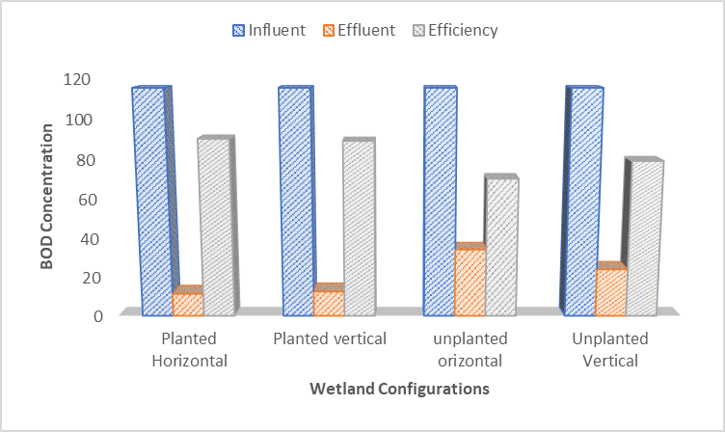

**Figure 3: DO Treatment Efficiency of various wetlands configurations.**

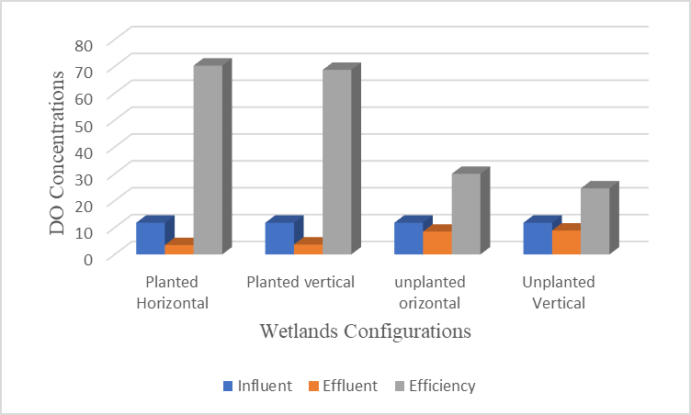

**Treatment efficiencies of the hybrid wetlands (TDS and TSS)**

As shown in table 3, for planted wetlands (horizontal and vertical), treatment efficiencies for TSS were 60.7% and 77.7%, while for unplanted wetlands (horizontal and vertical) efficiencies of 60.2% and 76.9% were gotten, significant differences of the constructed wetlands were reviled. For TDS, planted wetland performed better than unplanted wetlands with treatment efficiencies of 44.9% and 58.2% for planted Horizontal and Planted Vertical, compared to lesser efficiency values of 32.2% and 37.5% for unplanted horizontal. Similar high performance of planted wetlands over unplanted for TS was also found. Planted Horizontal and vertical wetlands had TS removal efficiencies of 49.7% and 63.1%, compared to lower efficiencies for unplanted horizontal and vertical wetland of 41.5% and 50.9%. Figures 4 and 5. Hybrid constructed wetlands has been seen to be able to treat the effluent from fishpond to a level that will allow it to be disposable into water courses without any nuisance.

**Table 3: Removal efficiency of various wetlands configurations in treatment for TSS and TDS**

|  |  |  |  |  |  |  |
| --- | --- | --- | --- | --- | --- | --- |
|  | **TSS** | | | **TDS** | | |
| **Wetland Configuration** | **Influent Average** | **Effluent Average** | **Efficiency**  **(%)** | **Influent Average** | **Effluent Average** | **Efficiency**  **(%)** |
| **Planted Horizontal** | 142.9±0.1a | 56.2±0.2c | 60.7±0.2a | 251.2±0.7a | 138.4±0.2b | 44.9±0.3b |
| **Planted Vertical** | 142.9±0.4a | 31.8±0.2a | 77.7±0.3b | 251.2±0.5a | 105.1±0.1a | 58.2±0.3c |
| **Unplanted Horizontal** | 142.9±0.3a | 56.8±0.4c | 60.2±0.2a | 251.2±0.6a | 170.3±0.4d | 32.2±0.4a |
| **Unplanted Vertical** | 142.9±0.4a | 33.0±0.3b | 76.9±0.2b | 251.2±0.5a | 156.9±0.5c | 37.5±0.3a |

*Values are Means of two replicates (n=2), value followed by same superscript alphabet are not significantly different at (P<0.05) along the column, as assessed by LSD, Tukey (HSD).*

**Figure 4.: TSS Treatment Efficiency of various wetlands configurations**

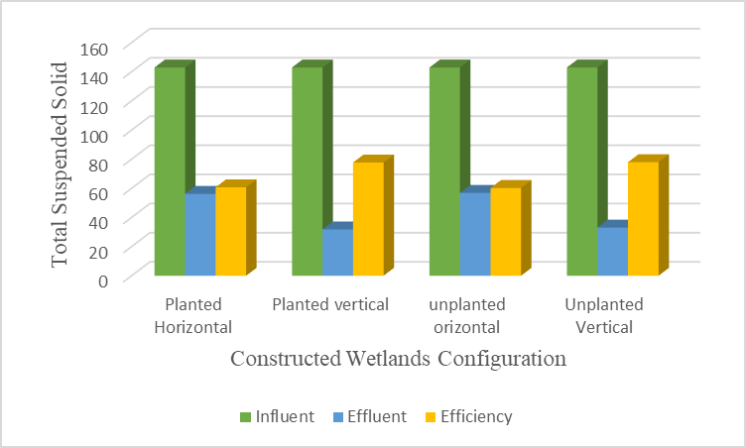

**Figure 5: TDS Treatment Efficiency of various wetlands configurations**

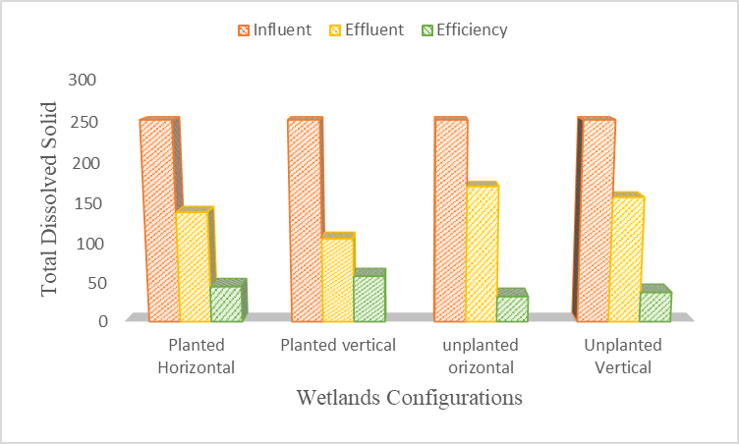

**CONCLUSION AND RECOMMENDATION**

The *Sacciolepis africana-*planted hybrid CW are more efficient than unplanted wetlands in the treatment of fishpond wastewater. Planted hybrid CWs had final effluent concentrations that comply very well to the discharge limits of WHO and FEPA (Nigeria), such values of 5 NTU for turbidity, 30 mg/L for TSS, 10 mg/L for BOD5, 40 mg/L for COD and 5 mg/L Plants are important components of wetland and their roles can be seen when you compare the performance of planted vs unplanted wetlands. Sediments of planted wetlands trapped more elements from the wastewater compared to sediments of unplanted wetlands. This is because of the presence of plant (*Sacciolepis africana*) in the wetlands. The elements taken up by the plants are deposited in the sediment after they die, these lead to accumulation of these elements overtime. With little availability of locally materials, both horizontal and vertical hybrid/planted wetlands should be run alongside each other to combine the benefits and efficiencies of both configurations put together.

**REFERNCES**

Badejo, A. A., Coker, A. O., and Sridhar, M. K. (2012). Performance and short-term durability of kernel shell as a substrate material in a pilot-scale horizontal subsurface flow constructed wetland treating slaughterhouse wastewater. *Research Journal of water security.* 14(3): 123 -134

Chang, N.-B., Xuan, Z., Daranpob, A., Wanielista, M. (2010). A Subsurface up flow wetland system for removal of nutrients and pathogens in on-site sewage treatment and disposal systems. *Environmental Engineering Science, 65.*  1-14.

Dhulap, V. P., Ghorade, I. B., and Patil, S. S. (2014). Seasonal study and its impact on sewage treatment in the angular horizontal subsurface flow constructed wetlands using aquatic macrophytes. *International Journal of Research in Engineering &Technology, 2*(5), 213-224.

Dong, J. L., Se, W. K. and Dong, C. S 2016. The Enhancement of nutrient removal in a hybrid constructed wetland utilizing an electric fan air blower with renewable Energy of Solar and Wind Power. *Journal of Chemitry* 6(8), 123 – 322.

Food and Agriculture Organisation (FAO) (2009). National aquaculture sector overview:Ghana. FAO fisheries and aquaculture Department. Rome. Italy. Pp18–21, http:// www.fao.org

Henriksson, P. J. G., Belton, B., Murshed-e-Jahan, K., and Rico, A. (2018). Measuring the potential for sustainable intensification of aquaculture in Bangladesh using life cycle assessment. Proceedings of the National Academy of Sciences. [www.pnas.org/cgi/doi/](http://www.pnas.org/cgi/doi/) 10.1073/pnas.1716530115.

Jian-Feng, P., Bao-zhen, W., and Lin, W. (2003). Multi-stage ponds-wetlands ecosystem for effective wastewater treatment. *Journal of Zhejiang University Science*, *6B*(5), 346–352.

Kaur, A., Vats, S., Rekhi, S., Bhardwaj, A., Goel, J., Tanwar, R. S., Gaur, K. K. (2010). Physico-chemical analysis of the industrial effluents and their impact on the soil microflora. Procedia Environmental Science 2: 595-599.

Lee, B., and Scholz. M, (2007). What is the role of *Phragmites australis* in experimental constructed wetland filters treating urban runoff*? Ecological Engineering* 29:87-95.

Lin, Q., and Mendelssohn, I. A. (2009). Potential of restoration and phytoremediation with *Juncus roemerianus* for diesel-contaminated coastal wetlands. *Ecological Engineering*, 35(1), 85-91.

Mustapha, H. I., Rousseau, D., van Bruggen, J. J. A., Lens, P. N. L. (2011). Treatment performance of horizontal subsurface flow constructed wetlands treating inorganic pollutants in simulated refinery effluent. *2nd Biennial Engineering Conference.* Minna: School of Engineering and Engineering Technology, Federal University of Technology, Minna.

Mustapha, H. I., Van Bruggen, J. J., and Lens, P. N. (2018). Fate of heavy metals in vertical subsurface flow constructed wetlands treating secondary treated petroleum refinery wastewater in Kaduna, Nigeria. *International Journal of Phytoremediation*, 20(1), 44- 53.

Nigerian Meteorological Agency. (2006). Seasonal rainfall prediction Available at nitmet,gov.ng/ seasonal-rainfall-prediction pp1-20

Olaoye, O. J. (2010). Dynamics of adoption process of improved fisheries technologies in Lagos and Ogun states, Nigeria. Unpublished PhD Thesis, University of Agriculture, Abeokuta. p. 337.

Sativa, D. (2007). Role of Macrophytes in improving water quality of aquatic eco system. *Journal of Applied Science and Environmental Management*. 11(4)133–135.

Vymazal, J. (2002). The use of subsurface flow constructed wetlands for wastewater treatment in the Czech Republic: 10 years of experience. *Journal of ecological engineering* 18: 633-646.

Zhang J-E, Liu J-L, Liu Ounyang Y, Liao B-W, Zhao B-L (2012) Removal of nutrients and heavy metals from wastewater with mangrove Sonneratia apetala Buch-Ham. *Ecological Engineering*, 36(10): 807-812.

Yusuff, R. O., Sonibare, J. A. (2004). Characterization of textile industries' effluents in Kaduna, Nigeria, and pollution implications. *Global Nest International Journal* 22, 212- 221.