Implementation of Malaria Parasite Detection and Species Classification Using Dilated Convolutional Neural Network

Suleiman Garba
Computer Science.Federal University of Tehnology)
Minna, Nigeria
sulgarba@gmail.com
Muhammad Bashir Abdullahi
Computer Science.Federal University of Tehnology)
Minna, Nigeria
el.bashir02@futminna.edu.ng
Sulaimon Adebayo Bashir
Computer Science.Federal University of Tehnology)
Minna, Nigeria
bashirsulaimon@futminna.edu.ng
Opeyemi Adenike Abisoye
Computer Science.Federal University of Tehnology)
Minna, Nigeria
o.abisoye@futminna.edu.ng

Abstract— Malaria is an infectious disease caused by a bite of the Anopheles Mosquito which has caused a lot of death. Treating malaria infected patient involves diagnosis using microscopy to ascertain its presence in the blood. This microscopy process takes time, need for a laboratory expert to read the results obtained and changes involved in the morphology of the parasites life cycle stages. To get reliable and accurate diagnosis, machine learning has been used to automate this process; still there is issue of enough datasets and high computational time. This paper presents an implemented Dilated Convolution Neural Network for malaria parasites detection and species classification using blood smear images. A direct classification was carried out to detect infected and uninfected malaria parasites and subsequently species classification was carried out whereby 3 convolutional layers was deployed, Convolution2D was for used for convolution operation and dilation rate of 2 was fixed. The model was trained with public available dataset for comparison with other existing models. This model shows overall performance accuracy as criteria of 99.9% for parasite detection and 88.9% for the species classification. We were able to achieve better results in comparison with other experiment and most importantly we deployed it to classify four species of malaria parasites; falciparum, ovale, malarie and vivax.
Keywords— Classification, Convolution Neural Network, Dilated, Malaria, Parasite, Species.

Introduction
Malaria is a dangerous parasite and very infectious disease caused by the plasmodium parasite which is transmitted by a bite of a female anopheles mosquito. Malaria disease is found all over the world but the species of each region or tropical area varies as a result of environmental conditions. Diagnosis of malaria is mostly done manually by a laboratory technician or expert by observing stained blood already on a glass slide and then counting the infected blood cells to determine its infections [1], although there are other techniques such as clinical symptoms observation and Rapid Diagnostics Test. However all the techniques take a lot of time, skilled technicians/laboratory scientist is needed to analyse the morphological variations features, and region of interest of the parasites which will enable and enhance the identification of infection and species of the malaria

There are over 20 species of plasmodium but only plasmodium malaria (p.malarie), plasmodium ovale (p.ovale), plasmodium falciparum (p.falciparum), plasmodium vivax (p.vivax) are the most common [2]. According to WHO, 2020 report, Plasmodium falciparum and Plasmodium Vivax have a high rate of infections and as such posed a great high risk to human survival. Despite the development of a vaccine for the treatment of only Plasmodium Falciparum which is still undergoing deployment and on trial stage there is a need for continuous scientific research due to plasmodium diversity, adaptability, co-infections with other diseases such as Dengue, Chikuganya, Zika, Tuberculosis and HIV/AIDS to avoid re-occurrence [3] [4].

In determining the malaria treatment; the species of the parasite need to be known to choose which type of treatment to be administered either by using drugs or vaccine to any infected patient and due to challenges faced in detecting and classifying malaria parasites, there is a need to have a model that can detect and identify the species in blood image to determine the type of prescription that will assist in reducing the spread and their infections in human. Given this, there is a need to deploy Deep Learning (DL) which has been described as a subset of machine learning which requires large amounts of data for processing such that the layers of a neural network provide a different meaning to the data supplied [5]. Due to DL advantages in image processing, Convolution Neural Network (CNN) is one of the types of DL because of its ability to learn two-dimensional data like images and its hierarchical nature of learning layers which ensures a robust manner during the training. Although, there is various CNN architecture their basic components are similar. Despite its computing resources by improving the training efficiency, the CNN lacks classification efficiency, data pre-processing, and a dataset which affects its performance

The advantage of CNN for classification is that ability to automatically identify and differentiate features of any given images or objects[6], hence the need for its further improvement and these improvements as stated by [7] include convolution layers which include tiled convolution, transposed convolution, and dilated convolution, which is the core concept of this paper

Dilated Convolutional Neural Network (DCNN) introduces one or more hyper-parameters to a convolution layer by inserting zeros between filter elements [8]. The use of dilated CNN is to achieve accuracy whereby the convolution kernels are replaced with dilated convolution. Dilated convolution is also to make up an element to adjust to a learning process. Dilated convolution is also able to recover the spatial resolution by the introduction of dilating filter computation before the basic empty position which must be filled with zero and getting the height and width of the kernel convolution which replaces the original convolution [9]

In addition, dilated convolution has a dilation factor increased through layers which shows that the receptive field can be expanded by still maintaining the spatial resolution whereby the sparsely dilated kernels do not change the performance of the objects [10]. Therefore, to get a reliable performance of a network, the depth of CNN in normal CNN is increased by introducing a dilated convolution kernel. This is done by expanding the kernel receptive field without adding to the parameters but by adding zeros values weight to the filters [11]

The scope of this work is limited to detecting malaria parasites and as well as classifying the most prevalent species (p ovale, p, malarie, p.vivax, and p.falciparum) from an infected blood image to improve and enhance research for total elimination or eradication of this deadly malaria parasite in the society. The paper was structured as the introduction in section 1, section 2 is the literature review, section 3 described the methods employed and section 4 presented the results and discussions and lastly, conclusion was then made thereafter.

LITERATURE REVIEW
A lot of research work has been done on malaria parasite detection and species classification to have an accurate and efficient output to aid treatment, elimination, or reduction in malaria infections. [12] used extraction based on histogram-based surface to extract the highlighted parasite cell of plasmodium falciparum. They went further to use Multilayer perceptron back propagation to classify the plasmodium stages of malaria parasites which accomplishes accuracy of 87.8%, sensitivity of 81.7%, and specificity of 90.8%. However, the algorithm only detects if the image is infected or not and only one species was used for evaluation, hence it cannot be used for multi-classification of species

[13]presented an algorithm to determine the presence of plasmodium falciparum trophozoites and white blood cells from a Giemsa-stain thick blood smears image. The authors used 314 images feature extracted images and SVM as a classifier. The evaluation of the detection shows 80.5% sensitivity and 93.8% specificity. The algorithm used Falciparum parasites for the analysis. On the other hand, [14] applied leverage on the image spatial relations validation to limit the parameters. Using the CNN model of 16 layers was applied to learn the two-dimensional data of the images. MATLAB was used to read the images, where the images were resized. Normalization was also carried out to improve the image with a width and height of 44 x 44 pixels. Ten-fold cross-validation was done during the training with 90:10 images for training and testing. A dataset of 27578 was used with overall accuracies of 97.37%, however, this system used single parameters which reduces the model flexibility whereby the model could not extract the whole features of the image for training.

[15]proposed a model which consists of pre-processing for sample level global white balance method, multiple focal planes based on novel adaptive non-linear grayscale intensity. It also consists of features extraction and CNN which was incorporated to introduce a new gamma-transform colour augmentation while a classification module was used to compute patient's level diagnosis and quantification. However, insufficient data of 1452 images were used and only falciparum parasites were identified. [16] on the other hand developed a system to detect malaria parasites and species by using morphological transformations for pre-processing to give better contrast of the region of the images between the parasitized and non-parasitized ones. The image segmentation was also carried out by rescaling the image to 299x299 pixels and data augmentation was also performed to reduce imbalance as a result of classifiers relying on minimization of some loss function. Finally, classification was carried out to detect infected and non-infected with an accuracy of 92.4% while species classification was 87.9% overall. In contrast, only 363 images of P. vivax and P. falciparum were considered.

In [17] a model was made for the detection of the plasmodium falciparum parasite where CNN was used to perform a focus stack using a thin blood smear images which were acquired from a custom-built slide camera. The system used hand-engineered features for processing the image patches. The model achieves a sensitivity of 97.06% and specificity of 98.50%. While dried blood spots (DBS) were attenuated by [18] using a total reflection –Fourier transform (ATR-FTIR) spectrometer to obtain high resolution, a supervised machine learning (MIR-ML) was used to screen the parasites from the blood spot which helped in screening plasmodium infections. The model achieved overall accuracies of 92% for predicting P. Falciparum, a sample collected using PCR while 85% for predicting mixed infections of P. falciparum and P. Ovale for the sample collected from the field. Meanwhile, 296 people's samples were collected and used for the model

[19] deployed dilated CNN in malaria diagnosis to classify infected and uninfected. A 5- layer CNN model was used but a 4-dilated convolution element having with each kernel element having a receptive field of 15x15. The system achieved 96.5% and a comparison with other approaches shows higher results than others. [20] method consists of intensity-based iterative global minimum screening (IGMS) for screening of image and then a customized CNN to classify the parasite either as infected or uninfected. A dataset of 1819 images was used for the training. The system achieves 93.4% accuracy, but the method was only applied to only falciparum species of malaria parasites.

[21] worked on Attentive Dense Circular Net (ADCN) which is related to residual and dense networks. The system used 27558 images which is a public dataset from NIH public dataset. The system compared its results with other state-of-the-art method and the performance shows high results in comparison. Their accuracy was 97.68% which is higher than those compared with. [22] on the hand modified YOLOV3 and YOLOV4 to identify small objects by increasing the features scale and by extension adding more layers such that the model can have a better capability for the small objects detection than the original model. The system was only demonstrated for P.falciparum parasite while other species were not considered.
In summary, these related works showed a high level of performance but some images used are patches where some affected areas were not captured because they were far away from the region which might not be easy for their model to detect. In addition, their work does not have a complete system that detects infected, uninfected, and classification of species of the malaria parasites in a single model. Therefore, to overcome some downsides of the related works we focused on using fewer layers of networks, images, and training. In addition, we are optimizing some of the hyper-parameters such as learning rate, epochs, and dropout which will help in fine-tuning the designed model and as well as extract very important features from the image.

METHODS

The workflow diagram of this work is shown in figure 1. Stage one is the acquisition of images which involves image pre-processing and normalization. The second stage is the classification of images into infected and uninfected. The next stage is the classification of species into different types (P.Ovale, P.falciparum, P.Vivax, and P.malarie), while the last stage is to evaluate the performance of the model. To improve the performance, the network needs to be enhanced because there might be the presence of plasmodium in some infected images or not because of the key features of the infected images which greatly affect the accuracy expected from the evaluation.

As shown in figure 2, normal CNN architecture was used without any dilation rate but the inner architecture was based on the dilation rate of the layer which was fixed at 2 for the model performance. The addition of dilation rate as a hyperparameter is by introducing zeroes between the elements which makes the network cover more information that is relevant by increasing the receptive field. The input images used for the model were fixed at 150x150 which is a feature indicator. The hidden layers of the model consist of 3 convolution layers with neurons and have a connection link with input and output which is made up of Convolution2D object as used in this work which performs convolution operation on the image. In the architecture, it shows Layer 1 has 146 feature maps, layer 2 with 71, and last layer 3 with 33 feature maps respectively

No
Uninfected
Ovale
Malarie
Falciparum
Vivax
Knowlesis
Model evaluation

Species Classification
Infected
Classification
Y
Image input

Fig 1: Flow diagram of the methodology

The pooling type used was max-pooling which the Maxpool2D object is. We used a pool size of 2x2 for the whole layers. The pooling operation gives an overview of the features gotten from the convolution operation by sliding a filter over the feature of an input image and as well select the highest or maximum value from the region, which is purposely meant to reduce computational time and reduction of feature map used for the convolution layer.

Rectified Linear Unit (ReLU) was used as an activation function for all the layers which helped in preventing gradient problems that do occur during training. The final layer has a flattened and 3 dense layers which the model needs for the training after the feature maps have been generated. The Dense layer which is a fully connected neural network is connected to the last layer. In addition to the model, the batch size was set at 64, and the epoch was set at 10, while, the Adam optimizer was used for the binary cross-entropy of the loss function and sigmoid were used for species classification which has more than one category. Finally, categorical cross-entropy for loss function and softmax for activation function was used.

Image
Input image
Classification
Feature Learning
Layer 1
(64x 146x146)
Activation (RELU)
Kernel (3x3)
150x150
Pooling (2x2)
64x73x73
Layer 2
(64x 71x71)
Activation (RELU)
Kernel (3x3)
Pooling (2x2)
64x35x35
Layer 3
(64x 33x33)
Activation (RELU)
Kernel (3x3)
Pooling (2x2)
64x16x16
Flatten
Dense (64)
Dense (2)
Dense (64)

Fig 2: System architecture Connection

Data description
Malaria images were sourced from a publicly available dataset available from the USA National Institutes of Health (NIH), which is good in terms of comparative analysis of other related work to arrive at a standard, however, a Microbiologist was involved to ascertain the data samples due to observation found in the labeling of the data as some were wrongly labelled as infected and uninfected. A total of 27699 data images (Table 1) were used with 14394 as infected and 13305 as uninfected while that of species (Table 2) was 134 for p.ovale, 65 for p.malarie, 1316 for p.falciparum, and 80 for p.vivax. The normalization was also carried out to prepare the data for training and testing. The images were then split into training and testing with the width and height normalized as 150 by 150 pixels. All the images have three color channels.

Table 1: Datasize for Infected and uninfected Parasites
Infected | 14394
Uninfected | 13305
Total | 27699

Table 2: Data size for species
P.Falciparum | P. Malarie | P. Ovale | P. Vivax
1316 | 65 | 134 | 80

B. Image pre-processing
Images are acquired through a high resolution digital camera connected to a microscope and most of this data has different resolution, in view of this, Python 3.7 functions were used to convert the image from coloured to grayscale to improve and enhance the quality of the input image for processing activities, such that any noise present in the image is removed or reduced. Figure 3 shows the original image used for the pre-processing. Figure 4 is the final image after the pre-processing has been carried out.

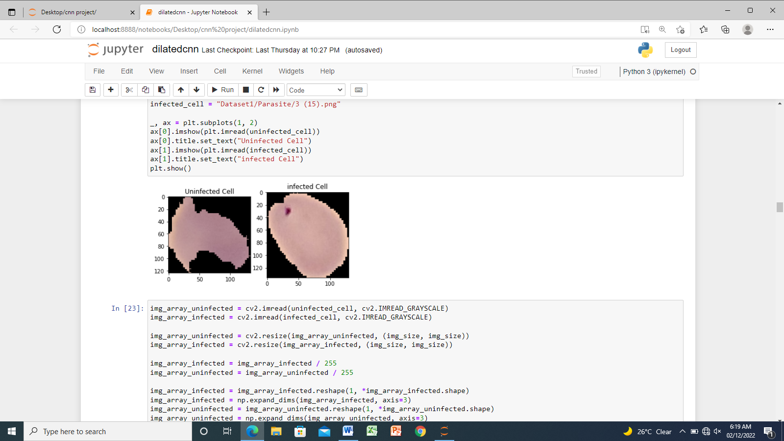

(a) (b)
Fig 3: Original Image for uninfected (a) and infected (b)

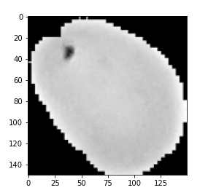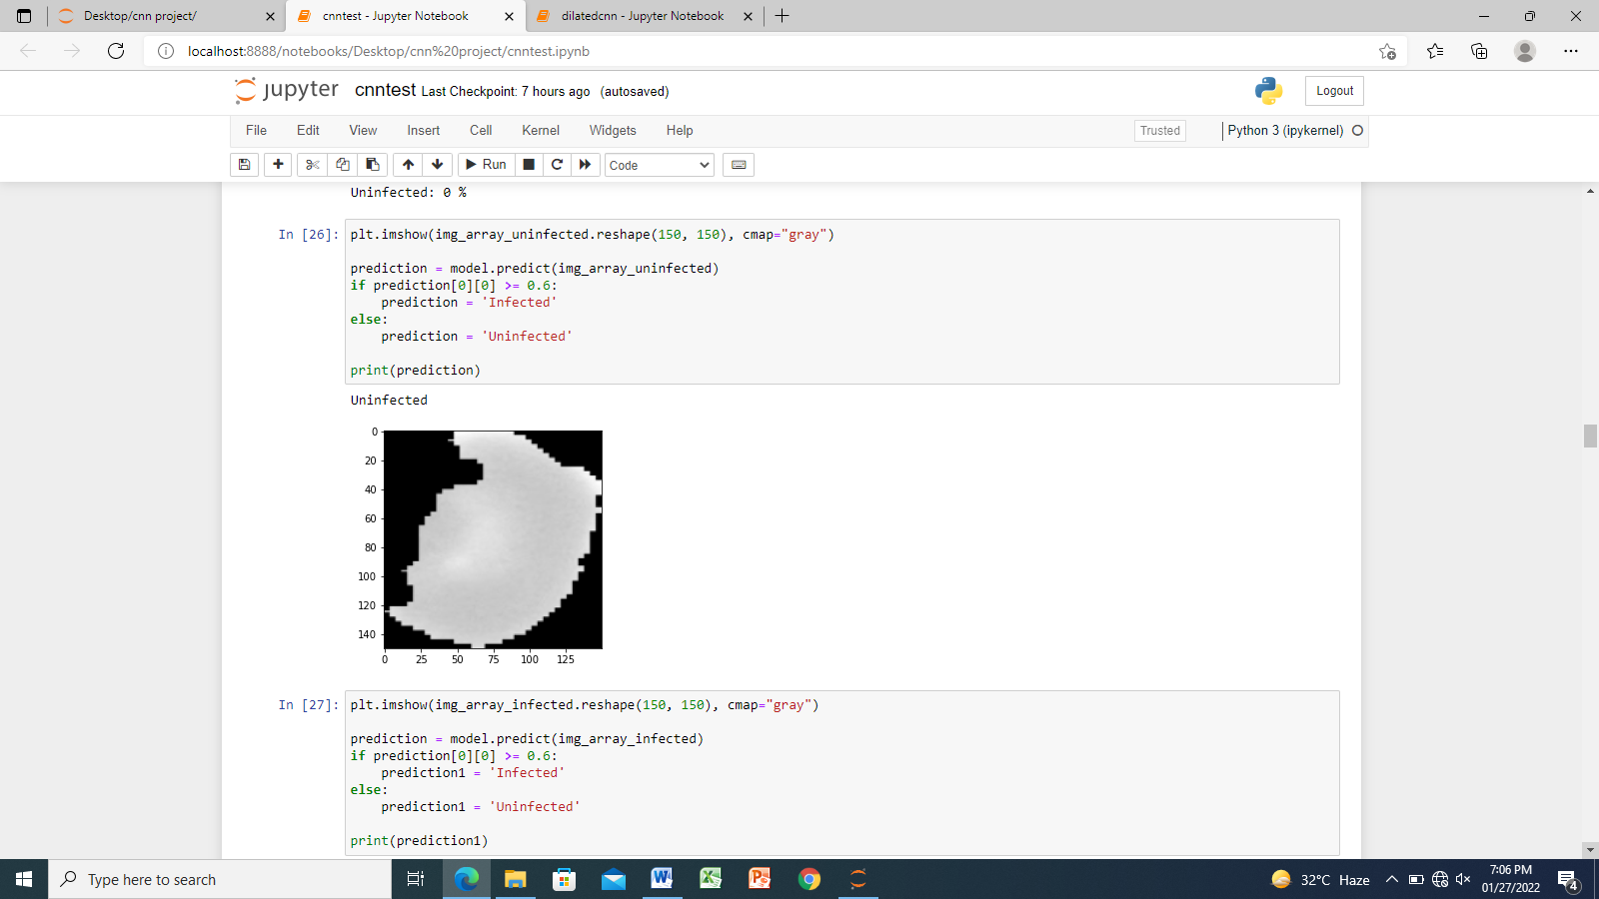
- (b)
Fig 4: Images after pre-processing (a- Infected, b- Uninfected)

results
A. Malaria Parasites Classification
The work was carried out using a simple and less costly PC for deployment. Figure 5a shows that the training started to achieve accuracy at 0.61 and a loss of 0.65 at the first epoch and it steadily progressed with a sharp increase in the accuracy and decrease in loss. However at epoch 6, the model experienced overfitting, thereafter it increased again with less loss result until the last epoch. Figure 5b shows the training loss and validation loss for 10 epochs as performed by the model. The training loss started at 0.56 and decreases steadily to the last 10 epochs while validation loss decreases from 0.47 to 0.1.
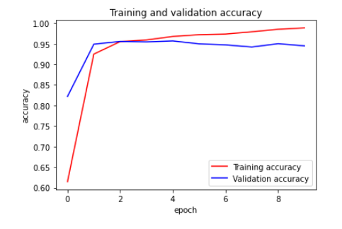
Fig 5: (a) Training and validation Accuracy

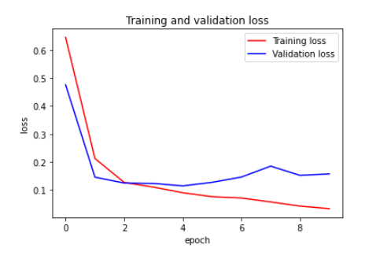
Fig 5: (b) Training and Validation loss

B. Species classification
Figure 6a shows that of the species classification, the model started to achieve training accuracy from 0.83 and steadily increased at epoch 2 to epoch 8 and finally to 0.89 at epoch 10, however, validation accuracy started from 0.89 and maintain that till 0.89 at epoch 8 but later increased at epoch 9 and 10 to stop at 0.90. Meanwhile, figure 6b shows the training loss and validation loss where Training loss started at 0.79 and reduces sporadically to 0.24 at epoch 10, while validation loss started from 0.55 and also dropped steadily to 0.22. The training loss started from 0.79 at epoch 1 and reduced steadily to 0.24 at epoch 10. Validation loss started from 0.55 from epoch 1 while it dropped to 0.22 at epoch 10

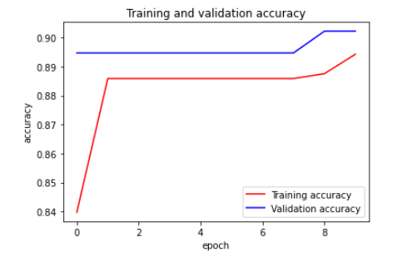
Fig 6: (a) Training and validation Accuracy

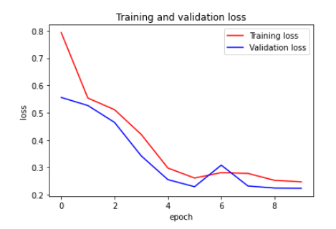
Fig 6: (b) Training and Validation loss

In summary, the model performed effectively, this clearly shows that it is not necessary to accomplish or attained all the epochs for a model to get a better result. In addition, the state of the dataset used also determine the performance of the model, this was experienced in the species classification due to the number of the dataset which is very low compared to parasites classification.
The overall performance of this system accuracy was 99.9% for the classification of malaria parasites while 88.9% was achieved overall for species classification. However, as shown in figure 7, it was observed that Plasmodium falciparum achieved a higher rate of 99.9%, plasmodium malarie 64.6.3%, Plasmodium ovale 39.1%, and plasmodium Vivax 37.3%.
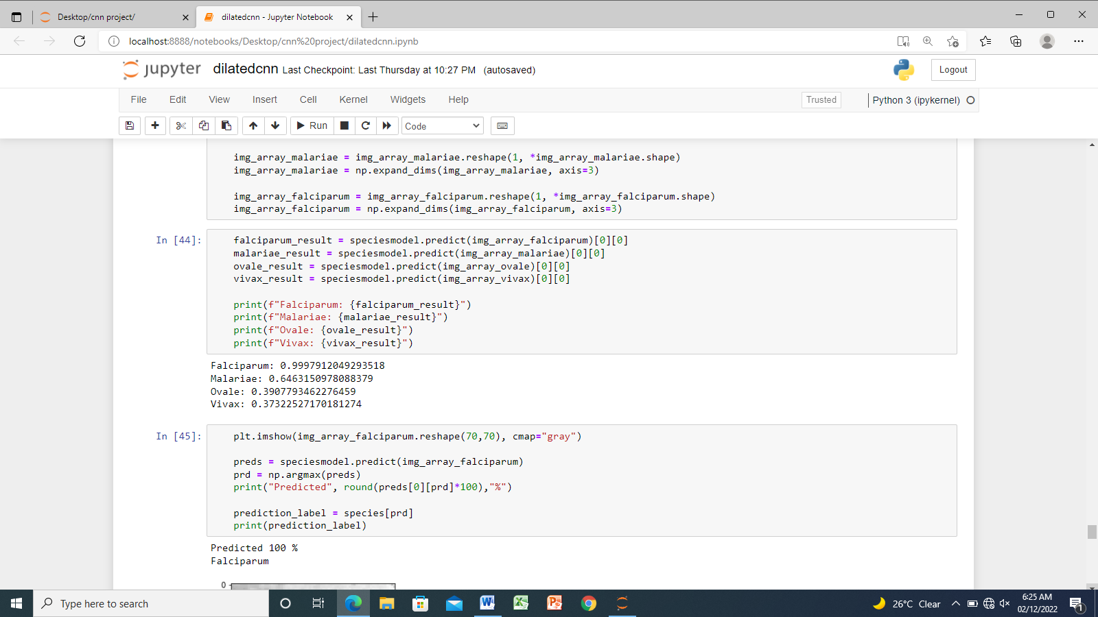
Fig 7: Results of Species classification

Table 3: Relationship of the proposed method with existing methods of Classifications
Author | Parasite Classification | Species Classification |  |  |  | Dataset | Results
 |  | M | O | F | V
Nugroho et al. [12] |  |  |  |  |  | 60 | 87.8%
Rosado et al. [13] |  |  |  |  |  | 314 | 80.59% Parasite classification
Liang et al. [14] |  |  |  |  |  | 27578 | 97.37% Parasite classification
Mehanian et al. [15] |  |  |  |  |  | 1452 | Not Stated
Penas et al. [16] |  |  |  |  |  | 363 | 92.4% parasite classification
Qayyum et al. [19] |  |  |  |  |  | 27558 | 96.5% classification
Yang et al. [20] |  |  |  |  |  | 1819 | 93.4% species classification
Quan et al. [21] |  |  |  |  |  | 27558 | 97.68% classification
Proposed model |  |  |  |  |  | 27699 | 99.9% classification

Key: : Represent activity carried out : Represent activity not carried out
M: P. Malarie O: P.Ovale F: P.Falciparium V: P.Vivax

Table 3 gives a comparison of the performance metrics of the model and other state-of-the-art approaches. This model shows an improvement over others for accuracy and classification in terms of coverage of infected and uninfected and as well as species classification which clearly shows that with little size of the model, less number of parameters, few layers and epochs used for training we have achieved a better result.

In addition of using a less costly and simple PC, the CPU environment for training; the model still used an average training time of 1921 seconds, although the time is much higher but still better for areas where there is no network infrastructure and also it makes it easier, accessible and useage for rural areas.

CONCLUSION
Diagnosis of malaria involves knowing if the blood sampled is infected or not and subsequently knowing the species is very important before administering drugs or vaccine to the infected person. This study has shown that malaria parasites can be effectively detected and species classified on an infected blood images by using a Dilated Convolutional Neural Network which reduces laboratory technicians’ errors and as well computational time. The model was built using 3 convolution layers, ReLU for activation function and addition of dilation rate of 2 as hyper-parameters. The Database consists of infected and uninfected parasites and that of species which consist of P. falciparum, P. Vivax, P. Ovale and P. Malarie. The system achieved performance accuracy of 99.9% for parasite detection and 88.9% for species classification. Because of its high result and simplicity in implementation, it has reduced the errors observed of using manual methods in diagnosis and this can also assist in the ongoing trial vaccine development for all the species. However, the limitation of the work is the issue of getting enough species dataset which would have improved the overall performance of the species classification.

References

[1] H. A. Mohammed and I. A. M. Abdelrahman, “Detection and classification of Malaria in thin blood slide images,” Proc. - 2017 Int. Conf. Commun. Control. Comput. Electron. Eng. ICCCCEE 2017, pp. 1–5, 2017.
[2] Y. M. Kassim, F. Yang, H. Yu, R. J. Maude, and S. Jaeger, “Diagnosing malaria patients with plasmodium falciparum and vivax using deep learning for thick smear images,” Diagnostics, vol. 11, no. 11, pp. 1–19, 2021.
[3] M. Peter Asaga, A. Hussaini Fatima, G. Amuga, T. Prerna, and A. Philomena, “Prevalence of Plasmodium Falciparum among Nigerians in Abuja and Central States: A Comparative Analysis of Sensitivity and Specificity Using Rapid Diagnostic Test and Microscopy as Tools in Management of Malaria,” Int. J. Trop. Dis., vol. 2, no. 1, pp. 2–7, 2019.
[4] W. Kudisthalert, K. Pasupa, and S. Tongsima, “Counting and classification of malarial parasite from giemsa-stained thin film images,” IEEE Access, vol. 8, pp. 78663–78682, 2020.
[5] M. Papakostas, T. Giannakopoulos, F. Makedon, and V. Karkaletsis, “Short-Term Recognition of Human Activities Using Convolutional Neural Networks,” Proc. - 12th Int. Conf. Signal Image Technol. Internet-Based Syst. SITIS 2016, pp. 302–307, 2017.
[6] A. Kumar, S. Sarkar, and C. Pradhan, “Malaria Disease Detection Using CNN Technique with SGD, RMSprop and ADAM Optimizers,” Stud. Big Data, vol. 68, pp. 211–230, 2020.
[7] Q. Zhang, M. Zhang, T. Chen, Z. Sun, Y. Ma, and B. Yu, “Recent advances in convolutional neural network acceleration,” Neurocomputing, vol. 323, pp. 37–51, 2019.
[8] F. Yu and V. Koltun, “Multi-scale context aggregation by dilated convolutions,” 4th Int. Conf. Learn. Represent. ICLR 2016 - Conf. Track Proc., 2016.
[9] S. Zhang, S. Zhang, C. Zhang, X. Wang, and Y. Shi, “Cucumber leaf disease identification with global pooling dilated convolutional neural network,” Comput. Electron. Agric., vol. 162, no. February, pp. 422–430, 2019.
[10] R. Hamaguchi, A. Fujita, K. Nemoto, T. Imaizumi, and S. Hikosaka, “Effective Use of Dilated Convolutions for Segmenting Small Object Instances in Remote Sensing Imagery,” Proc. - 2018 IEEE Winter Conf. Appl. Comput. Vision, WACV 2018, vol. 2018-Janua, pp. 1442–1450, 2018.
[11] D. P, “Remote Sensing Image Scene Classification using Dilated Convolutional Neural Networks,” Int. J. Emerg. Trends Eng. Res., vol. 8, no. 7, pp. 3622–3630, 2020.
[12] H. A. Nugroho, S. A. Akbar, and E. E. H. Murhandarwati, “Feature extraction and classification for detection malaria parasites in thin blood smear,” ICITACEE 2015 - 2nd Int. Conf. Inf. Technol. Comput. Electr. Eng. Green Technol. Strength. Inf. Technol. Electr. Comput. Eng. Implementation, Proc., vol. 1, no. c, pp. 197–201, 2016.
[13] L. Rosado, J. M. C. Da Costa, D. Elias, and J. S. Cardoso, “Automated Detection of Malaria Parasites on Thick Blood Smears via Mobile Devices,” Procedia Comput. Sci., vol. 90, no. July, pp. 138–144, 2016.
[14] Z. Liang et al., “CNN-based image analysis for malaria diagnosis,” Proc. - 2016 IEEE Int. Conf. Bioinforma. Biomed. BIBM 2016, pp. 493–496, 2017.
[15] C. Mehanian et al., “Computer-Automated Malaria Diagnosis and Quantitation Using Convolutional Neural Networks,” Proc. - 2017 IEEE Int. Conf. Comput. Vis. Work. ICCVW 2017, vol. 2018-Janua, pp. 116–125, 2017.
[16] K. E. D. Penas, P. T. Rivera, and P. C. Naval, “Malaria Parasite Detection and Species Identification on Thin Blood Smears Using a Convolutional Neural Network,” Proc. - 2017 IEEE 2nd Int. Conf. Connect. Heal. Appl. Syst. Eng. Technol. CHASE 2017, pp. 1–6, 2017.
[17] G. P. Gopakumar, M. Swetha, G. Sai Siva, and G. R. K. Sai Subrahmanyam, “Convolutional neural network-based malaria diagnosis from focus stack of blood smear images acquired using custom-built slide scanner,” J. Biophotonics, vol. 11, no. 3, 2018.
[18] E. P. Mwanga et al., “Eave ribbons treated with transfluthrin can protect both users and non-users against malaria vectors,” Malar. J., vol. 18, no. 1, pp. 1–14, 2019.
[19] A. Bin Abdul Qayyum, T. Islam, and M. A. Haque, “Malaria Diagnosis with Dilated Convolutional Neural Network Based Image Analysis,” BECITHCON 2019 - 2019 IEEE Int. Conf. Biomed. Eng. Comput. Inf. Technol. Heal., pp. 68–72, 2019.
[20] F. Yang et al., “Deep Learning for Smartphone-Based Malaria Parasite Detection in Thick Blood Smears,” IEEE J. Biomed. Heal. Informatics, vol. 24, no. 5, pp. 1427–1438, 2020.
[21] Q. Quan, J. Wang, and L. Liu, “An Effective Convolutional Neural Network for Classifying Red Blood Cells in Malaria Diseases,” Interdiscip. Sci. – Comput. Life Sci., vol. 12, no. 2, pp. 217–225, 2020.
[22] F. Abdurahman, K. A. Fante, and M. Aliy, “Malaria parasite detection in thick blood smear microscopic images using modified YOLOV3 and YOLOV4 models,” BMC Bioinformatics, vol. 22, no. 1, pp. 1–17, 2021.

