Efficiency and Food Security Status: Evidence from fluted pumpkin (Telfairia occidentalis) farmers in Nigeria
By
Ayodeji Alexander Ajibola Coker, Abigail John Jirgi and Halima Anave Omolori
Department of Agricultural Economics & Farm Management, School of Agriculture & Agricultural Technology, Federal University of Technology, Minna, P.M.B. 65, Minna, Gidan-Kwanu, Niger State, Nigeria
Paper presented at the West Africa Centre for Crop Improvement (WACCI) International Conference on Food and Nutrition Security in Africa, held from October 3-4, 2018 at the University of Ghana, Legon, Accra, Ghana
ABSTRACT
Study unearths relationship between technical efficiency and food security status among fluted pumpkin farmers in Nigeria. A total of 157 respondents were sampled at 95% confidence limit. Respondents were fairly technically efficient with mean efficiency index of 84%, Estimated 58% of respondents were food insecure, Farmers technical efficiencies were positively related to their food security status. - Study recommended enhanced technical efficiency through extension support and optimum input combination.

Aim and Objectives of Study
Aim of Study: To determine the effect of technical efficiency of fluted pumpkin farmers on their food security status in Niger State, Nigeria.
Objectives of the Study:
  - describe the socio-economic characteristics of fluted pumpkin farmers;
  - determine the technical efficiency and food security status of respondents; and
  - ascertain the effect of respondents’ technical efficiency on their food security status.
INTRODUCTION
- Recent global statistics suggest an increase in the population of chronically undernourished persons from 777 million in 2015 to 821 million currently (FAO, 2017 and 2018).
- The recent outcome represents a reversal of trends, more so that the situation is particularly worrisome in sub-Saharan Africa.
- USAID (2018) noted the high incidence of malnutrition in Nigeria, with 32% national average stunting rate for children under five, while FAO (2016) revealed that food insecurity situation was prevalent in the North.
- Orewa et al. (2009) and Obayelu, (2010) attributed causes of food insecurity attributed to factors like low productivity and output, wide spread poverty and technical inefficiency.
- Fluted pumpkin (Telfairia occidentalis) is one of the key vegetables grown in Nigeria, particularly in the Southern and Middle belt regions, including Niger State
- The edible parts of the plant are leaves, shoot and petioles. However, it is mainly grown for its leaves and also for medicinal purpose
- It serves as rich source of antioxidant, antimicrobial properties, minerals (mainly iron), vitamins (A and C) and protein (Akoroda, 1990; Kayode and Kayode, (2011))

METHODOLOGY
Study Area
  - The study was undertaken in selected Local Government Areas of Niger State, Nigeria
  - Niger is the largest state in Nigeria by land mass
  - The state is located in the Guinea Savannah Vegetation agro-ecological Zone of Nigeria
  - Niger State lies within Latitude 8^{O} 20´ and 11^{O} 30´ of the equator and Longitudes 3^{O} 30´ and 8^{O} 20´, with a projected population of 5,337,148 (Omolori, 2017)
  - Niger State is largely agrarian, with major crops grown being rice, yam, maize, vegetables, groundnut and cowpea.
Sampling Technique and Sampling Size
Multi-stage random sampling procedure was employed to select 157 fluted pumpkin farmers from a frame of 258 farmers using Yamane (1967) formula, as adopted by Eboh (2009) at 95% confidence level and 5% precision level.
Method of Data Collection
Primary data were utilised for this study using structured questionnaires. Data collected covers demographic characteristics of the farmers, household monthly expenditures on food and non-food items, input and output data, including prices.
Data Analytical Techniques
The analytical techniques comprise descriptive statistics, food security index, stochastic frontier function and Logit model.
Source: Aisha (2017)
RESULT AND DISCUSSIONS
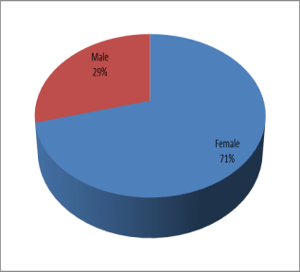
- Most (56.1%) respondents owned less than 0.3 hectares of land (Figure 3)
- Only 41% had extension contact (Fihure 4)
Socio-economic Characteristics of Respondents

Gender of Respondents
Estimated 70% of fluted pumpkin farmers are women (Figure 1)
FAO (2011); UNIDO (2011) and AfDB (2014) noted that 70 percent of Africa’s smallholder farmers are women, and are responsible for more than 90 percent of Africa’s agricultural production.
Age of Respondents:
- Most (57.2%) respondents fall within the age bracket of 37-48 years (Figure 2).
- Most fluted pumpkin farmers are in their active and productive stage
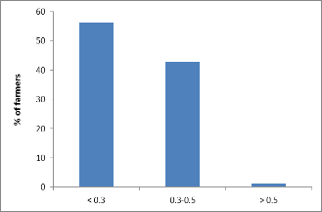
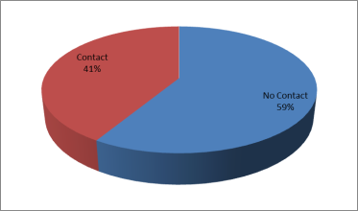
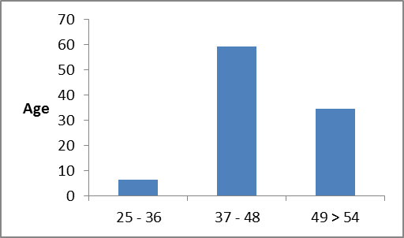
Figure 1: Gender of respondents
Figure 3: Farm size of respondents
Figure 4: Extension contact by respondents
Figure 6: Food security status of respondents
Determinants of food security status
Food security status
Technical efficiency of respondents
Figure 2: Age of respondents
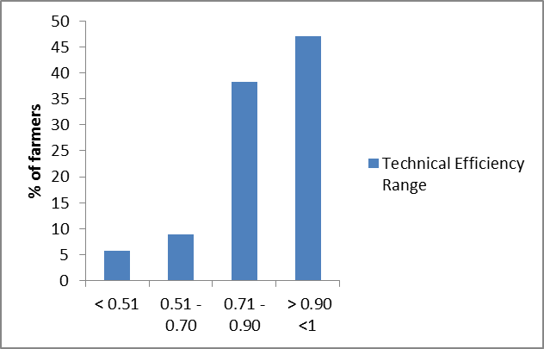
- Technical efficiency, labour, household size, agrochemicals and extension contacts had positive relationship with food security status of respondents (Table 7)
- Capital items, age, education and incomes had negative relationships with food security status of respondents (Table 8)
Food Security Status of Respondents
- About 60% of respondents are food insecure (Figure 6)

- Food security line ₦41,733.72 ($116.85), food security gap - 13.6% and severity of food security - 8.2%

- Amaza et al. (2009) reported food security index of 58.0%, while Akinyele (2009) reported food security gap and severity of 15.0% and 11.0% respectively
TECHNICAL EFFICIENCY OF RESPONDENTS
- Most (47.1%) of the fluted pumpkin farmers were close to efficiency frontier (0.90 <1) (Figure 5)
- Mean technical efficiency stands at 84%, implying that fluted pumpkin farmers were fairly efficient and close to the frontier.
- Ayanwale and Abiola (2016) obtained a mean technical efficiency of 0.75 for fluted pumpkin in Edo State, Nigeria
- Norton et al. (2015) affirmed that small holder farmers are efficient but not productive.
- Determinants of technical efficiency/inefficiency were Capital input, hired labour, agro-inputs, education, extension contact.

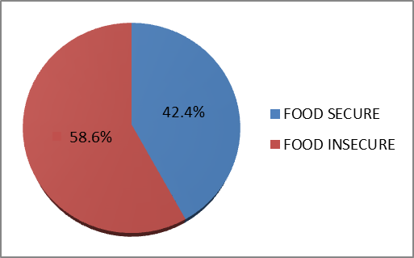
Figure 5: Technical Efficiency range of respondents
Figure 6: Food security status of respondents
Table 7: Logit regression on effect of technical efficiency on food security

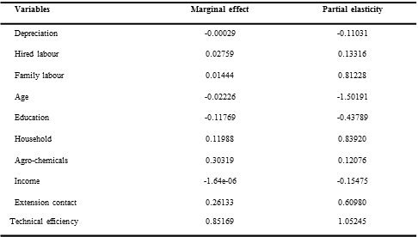
CONCLUSION AND RECOMMENDATIONS
Conclusion:
- Majority of fluted pumpkin farmers were women in their active ages, owned less than 0.3 hectares, with weak extension contact.
- Most of the fluted pumpkin farmers were food insecure, but close to being technically efficient
- Respondents’ probability of being food secured will increase with their technical efficiencies.
Recommendations:
- There is need to improve food security of farmers through enhanced technical efficiency
- Enhance extension support towards ensuring optimum input usage and combinations
- Incentivize youths to take up fluted pumpkin production.
Table 8: Estimates of marginal effect and partial elasticity

