AN INTERFERENCE MITIGATION TECHNIQUE FOR DEVICE-TO-DEVICE COMMUNICATION NETWORKS BASED ON USER DISTRIBUTION

BY

OLUWAMOTEMI, Taiwo Favour
MEng/SEET/2018/8177

DEPARTMENT OF TELECOMMUNICATION
ENGINEERING
FEDERAL UNIVERSITY OF TECHNOLOGY
MINNA

NOVEMBER, 2021

i
AN INTERFERENCE MITIGATION TECHNIQUE FOR DEVICE-TO-DEVICE COMMUNICATION NETWORKS BASED ON USER DISTRIBUTION

BY

OLUWAMOTEMI, Taiwo Favour
MEng/SEET/2018/8177

A THESIS SUBMITTED TO THE POSTGRADUATE SCHOOL, FEDERAL UNIVERSITY OF TECHNOLOGY MINNA, NIGERIA IN PARTIAL FULFILLMENT OF THE REQUIREMENTS FOR THE AWARD OF THE DEGREE OF MASTER OF ENGINEERING IN COMMUNICATION ENGINEERING

NOVEMBER, 2021

i
DECLARATION

I hereby declare that this thesis titled: “An Interference Mitigation Technique for

Device-To-Device Communication Networks Based on User Distribution” is a

collection of my original research work and it has not been presented for any other

qualification anywhere. Information from other sources (published or unpublished) has

been duly acknowledged.

OLUWAMOTEMI, Taiwo Favour | …………………………
MENG/SEET/2018/8177 | SIGNATURE/DATE
FEDERAL UNIVERSITY OF TECHNOLOGY,
MINNA, NIGERIA

ii
CERTIFICATION

The thesis titled: “An Interference Mitigation Technique for Device-To-Device

Communication Networks Based on User Distribution” by: OLUWAMOTEMI,

Taiwo Favour (MENG/SEET/2018/8177) meets the regulations governing the award of

the degree of Master of Engineering of the Federal University of Technology, Minna and

it is approved for its contribution to scientific knowledge and literary presentation.

Engr. Dr. A. O Adejo

MAJOR SUPERVISOR

------------------------------------

Signature & Date

Engr. Dr. Bala A. Salihu

CO-SUPERVISOR

-----------------------------------

Signature & Date

Engr. Dr. A. U. Usman

HEAD OF DEPARTMENT

-----------------------------------

Signature & Date

Engr. Prof. E. N. Onwuka

DEAN OF SCHOOL OF ELECTRICAL

ENGINEERING AND TECHNOLOGY

------------------------------------

Signature & Date

Engr. Prof. O. K. Abubakre

DEAN OF POSTGRADUATE SCHOOL

------------------------------------

Signature & Date

iii

ACKNOWLEDGEMENTS

I am deeply grateful to God Almighty, the helper to the helpless and the maker of all things for the privileged to be counted worthy among the living. Thank you Lord.

I sincerely appreciate Engr. Dr. Achonu Adejo, for his selfless and unquantifiable effort in ensuring the success of this research work and Engr. Dr. Bala A. Salihu, my co-supervisor whose support and guidance cannot be measurable. The high level of professionalism and moral supports they exhibited brought about the successful end of this work. My special gratitude also goes to Engr. Dr. Segun Adebayo, Engr. Dr. Mohammed Abubakar Saddiq, Engr. Dr. Adeiza J. Onumanyi, Engr. Dr. Caroline O. Alenoghena, Engr. Dr. Salawu Nathaniel, Engr. Dr. David Micheal, Engr. Dr. Henry Ohize, Surv. James Nwakpuda, Mrs. Funke Rapheal and all my friends I could not mention, for their impactful supports and motivation towards the success of this work.

I want to use this medium to say a big thank you to the Dean, School of Electrical Engineering and Technology, Prof. E. N Onwuka, Head of Department Engr. Dr. A. U Usman, lecturers and the Departmental Laboratory Staff of the Department of Telecommunication Engineering of the Federal University of Technology, Minna for all their contribution towards the completion of this work.

My gratitude goes to my loving husband Pst Ayomipo Olatunji and my children, David and Daniel for their maximum support to embark on this study with rest of mind. I want to appreciate my loving, heavenly ordained parent Pst. & Dcns F.O Adeyemi, Pst. Kola Bamisaye, Rev. P. Oluwamotemi, Feyisayo and Gbenga for their support. I want to say thank you to my Minna parent, Pst. & Mrs. Gbenga Olaleye, family for their support and care and especially to Engr. Emmanuel Ohihoin and Katfun & to my entire colleague, I greatly celebrate you all for your supports and prayers. Thanks and God bless you all.

iv
ABSTRACT

Device-to-Device (D2D) communication is one of the enabled technologies in Fifth Generation of cellular networks that allows two devices in close range to communicate without traversing the Base Station (BS). Device-to-Device Communication comes with numerous benefits which include data traffic offloading, location awareness service, social networking and smart city. However, this D2D Communication Network comes with several challenges such as Interference Management which causes great impairment to communication. Therefore, to improve the D2D Communication performances and maximize its potentials, interference must be reduced to reduce this issue of interference, several researchers’ proposed different approaches to mitigate it and soft frequency reuse (SFR) through fair bandwidth allocation has been greatly explored. SFR scheme, the users in the cellular network are divided into two; the Center Users and Edge Users. In this research work, three different algorithms for bandwidth allocation namely; separate bandwidth allocation; overlapping bandwidth allocation and hybrid bandwidth allocation were developed for three categories of users in order to mitigate the interference between the Cellular Network and Device-to-Device Communication Network. The bandwidth allocation is done in fairness among the center users, edge users and the Device-to-Device users based on Users demand in each network in order to reduce interference. The users in the network are randomly selected. The proposed algorithms were evaluated by simulation using MATLAB in terms of Signal-to-interference plus noise ratio (SINR) and system capacity. The results of this research work are presented by comparing the performance for different number of D2D users in the network. Hence, evaluation of how the size of D2D networks can affect the cellular network performance was done as the first unique contribution. For the two proposed algorithms (Separate bandwidth allocation and Overlapping bandwidth allocation), comparison was made with fixed bandwidth allocation. When the number of D2D users is within 10% , the Hybrid bandwidth allocation and Separate bandwidth allocation for three cases (the high, average and low edge users) outperforms others for D2D Users SINR with the improvement up to 34% but when the number D2D users increases to over 30% in the network the performance reduces to 27%. Therefore, as the number of D2D user increases in the network, the performance of the system reduces. For future research, the algorithm can be improved upon to accommodate more D2D users.

v
 | TABLE OF CONTENTS
Content |  | Page
TITLE |  | i
DECLARATION |  | ii
CERTIFICATION |  | iii
ACKNOWLEDGEMENTS |  | iv
ABSTRACT |  | v
TABLE OF CONTENTS |  | vi
LIST OF TABLES |  | viii
LIST OF FIGURES |  | ix
LIST OF ABBREVIATIONS |  | xi
CHAPTER ONE |  | 1
1.0 | INTRODUCTION | 1
1.1 | Background to the Study | 1
1.2 | Statement of the Research Problem | 2
1.3 | Aim and Objectives of the Study | 3
1.4 | Scope of the Study | 3
1.5 | Justification for the Study | 4
CHAPTER TWO |  | 5
2.0 | LITERATURE REVIEW | 5
2.1 D2D Communication Network |  | 5
2.2 Forms of D2D Communication |  | 6
2.3 | Area of Benefits of D2D Communication | 12
2.3 | Technical Challenges in Carrying out D2D Communication | 12
2.4 | Review of related works on Interference in D2D Communication Network | 14
2.5 | System Capacity | 19
CHAPTER THREE |  | 24
 | vi

3.0 | RESEARCH METHODOLOGY | 24
3.1 | Network Model | 24
3.2 | Simulation Parameters | 25
3.3 | Soft Frequency Reuse Based on User Distribution for D2D Cellular Networks | 27
3.4 | Overlapping Bandwidth Allocation Algorithm | 29
3.5 | Separate Bandwidth Allocation Algorithm | 34
3.6 | Hybrid Bandwidth Allocation Algorithm | 36
CHAPTER FOUR |  | 38
4.0 | RESULTS AND DISCUSSION | 38
4.1 | Presentation of Results and Discussion | 38
4.2 | Result Comparison of Bandwidth Allocation Algorithms | 38
4.6 | Evaluation of Hybrid Bandwidth Allocation Algorithm | 43
CHAPTER FIVE |  | 47
5.0 | CONCLUSION AND RECOMMENDATIONS | 47
5.1 | Conclusion | 47
5.2 | Recommendations | 47
5.3 | Contributions to Knowledge | 48
REFERENCES |  | 49
APPENDIX A |  | 53

vii
 | LIST OF TABLES
Table |  | Page
2.1 | Representation of forms of D2D communication with their | 11
 | advantages and disadvantages
2.2 | Reviewed past related works on interference mitigation in D2D | 22
 | Communication Network
4.1 | Summary of Base Station Parameters | 25
4.2 | Best Performing Algorithms for the three cases of edge user’s
 | deployment | 42

viii
 | LIST OF FIGURES
Figure | Page
1.1 | Cellular and D2D Network | 2
2.1 | Stand-alone and Network Assisted D2D Communication | 6
2.2 | Classification of D2D Communications | 7
2.3 | Device relaying with operator-controlled link establishment (DR-OC) | 8
2.4 | Direct D2D communication with operator-controlled link
 | establishment (DC-OC) | 9
2.5 | Device relaying with device-controlled link establishment (DR-DC) | 9
2.6 | Direct D2D communication with device-controlled link establishment
 | (DCDC) | 10
2.7 | Areas of Benefit of D2D communication in cellular network | 12
2.8 | Standard SFR and SFR technique that capture User Distribution | 18
2.9 | An interference in CN with cellular user and D2D user interfering
 | to one another | 20
3.1 | Cellular Network with D2D Users | 24
3.2 | Flow chart of user distribution algorithms for D2D networks in cellular
 | networks | 29
3.3 | Typical bandwidth allocation in a base station | 30
3.4 | Three approaches for bandwidth allocation | 31
3.5 | Bandwidth allocation for algorithm 1 (Overlapping Bandwidth
 | Allocation) | 32
3.6 | Bandwidth allocation for algorithm 2 (Separate Bandwidth Allocation) | 35

ix
3.7 | Flow chart of hybrid allocation algorithm for D2D network | 36
4.1 | Average edge user capacity when the % of edge user is high in the
 | network | 38
4.2 | Average center user capacity when the % of edge user is high in the
 | network | 39
4.3 | Average D2D user capacity when the % of the edge user is high in the
 | network | 40
4.4 | Average user capacity for all users when the % of edge user is high
 | in the network | 41
4.5 | Performance of hybrid allocation algorithm for case1 (High no of
 | edge users) | 43
4.6 | Performance of hybrid allocation algorithm for case2 (Avg. no of edge
 | users) | 44
4.7 | Performance of hybrid allocation algorithm for case3 (Low numb. of edge
 | users) | 44

x
LIST OF ABBREVIATIONS

Abbreviation

Meaning

BS

B2D

CUs

D2D

D2DUs

DR-OC

DC-OC

Base Station

BS-to-Device

Cellular Users

Device-to-Device

Device-to-Device Users

Device relaying with Operator-Controlled

Device relaying with Device Controlled Link

Establishment

DC-DC

DR-DC

Direct D2D Comm. with Device Controlled Link

Establishment

Direct relaying with Device Controlled Link

Establishment

EE

FFR

HSPA

ICIC

ISM

IoT

LTE-A

Energy Efficiency

Fractional Frequency Reuse

High Speed Packet Access

Inter-cell Interference

Industrial Scientific and Medical

Internet of Thing

Long Term Evolution- Advanced

xi

MATLAB

MU-MIMO

M2M

QoS

SINR

SFR

SE

UE

UL

5G

4G
Matrix Laboratory

Multi-User Multiple-Input Multiple Output

Machine-to-Machine

Quality of service

Signal-to-Interference plus Noise Ratio

Soft Frequency Reuse

Spectral Efficiency

User Equipment

Uplink

Fifth Generations

Fourth Generation

xii

CHAPTER ONE

1.0 INTRODUCTION

1.1 Background to the Study

Advancement in mobile communication services has brought a tremendous expansion of request for higher information rate and Quality of Service (QoS) provisioning which will continue as long as there is a continuous advancement in cellular technology. Notwithstanding, the need to further develop mobile network infrastructure is a long way from fulfilling the expanding interest for communication services (Melki, 2017, Militano et al., 2015 and Jameel et al., 2018). In order to meet up with this advancement and high demand, the evolution of Fifth Generation (5G) of cellular network came with a broad advantages and flexibilities. This aimed at developing high capacity networks with very high data rate and low latency to meet the demands of future applications and services

.(Olaobaju and Mohammed, 2018, Gupta and Jha, 2015 and Adnan and Zuriati , 2020). This generation of wireless network will convey new degrees of execution and proficiency that will engage new user encounter and bring together new industries. It has remarkable benefits over the previous ones which include; a superfast mobile internet (100 times faster than Fourth Generation (4G)), Low latency to settle the interest of future performances in terms of applications and services. Device-to-Device (D2D) communication is one of the empowered technologies in 5G which is relied upon to deal with a vital function in 5G networks (Jameel et al., 2018). D2D communication permits two devices in closeness to convey information between them without passing through the base station as represented in Figure 1.1. The utilization of D2D communication did not acquire a lot of significance in the past generation of cellular network, however, it's an imperative piece of 5G (Gandotra and Jha, 2016).

1
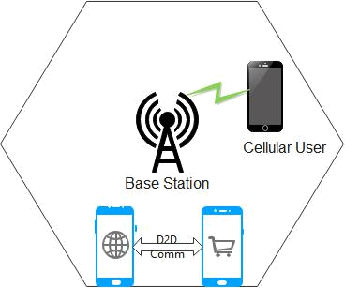

Figure 1.1: Cellular and D2D Network

D2D communication network is a mobile heterogeneous Network that has been utilized as of late to improve closeness services and information traffic offloading. It is a promising solution that helps to improve spectrum utilization (Jameel et al., 2018).

More so, D2D can be applied in so many ways in 5G Networks include; Energy harvesting, Vehicular ad-hoc networks, Massive MIMO, IoT, hyper-dense networks and Leveraging other network. However, D2D communication offers different challenges such as Device recovery, security, power control, mobility, interference, privacy and economic (Militano et al., 2015) .

1.2 Statement of the Research Problem

To maximize the full potentials that D2D communication has to offer, interference management which remain one of the critical one among several challenges of D2D communication needs to be studied and carefully regulated (Li, 2019, Hassan et al., 2018 and Safdar et al., 2016). Several researchers have proposed different approaches to mitigate this issues (Asaka et al., 2021, Adejo et al., 2020 and Adejo, 2018). Frequency reuse has been widely explored as a technique to mitigate interference in cellular network (Onu, 2018).

2
This research developed an algorithm for bandwidth allocation based on a modified Soft Frequency Reuse (SFR) scheme adopting user distribution analysis to mitigate interference in D2D communication network by adequately allocating bandwidth to different categories of users in the network and the system performance will be evaluated by simulation using MATLAB Software in terms of SINR

1.3 Aim and Objectives of the Study

The aim of this research work is to develop an algorithm that will mitigate interference in D2D communication Network. This aim will be achieved through the following objectives.

- To identify an existing network model and develop algorithms that will allocate bandwidth to users.

- To simulate the algorithm developed using MATLAB Software

- To evaluate the performance of the system using the SINR

1.4 Scope of the Study

The problem of interference of D2D communication in 5G cellular network is addressed in this research work. This research work focuses on reusing the cellular resources by allocating bandwidth to the users in the network utilizing the SFR strategies. The users within the interfering base station is separated into two, the center and edge users. The D2D users utilize the resources apportioned to the center users and it is randomly deployed. Therefore, this research work helps to reduce interference in D2D communication network.

3
1.5 Justification for the Study

Among all the challenges of D2D communication network, interference management remains one of the critical one. Interference causes impairment to communication which in returns gives a poor signal or feedback.

This challenge of communication needs to be attended to and the reduction in communication will greatly help in the improvement of system performance and give better feedback which is the important aspect of communication.

Therefore, proper bandwidth allocation using soft frequency reuse scheme is an important techniques that help in the mitigation of this issue of interference in cellular network (Adejo et al., 2018). Furthermore, to maximize the benefits of D2D communication networks there are need for proper bandwidth allocation among users in the network. Therefore, User distribution analysis through fair bandwidth allocation will greatly help to mitigate this issue of interference which in returns improve system performances and efficiency which is a justifiable area of interest.

4
CHAPTER TWO

2.0 LITERATURE REVIEW

2.1 D2D Communication Network

D2D communication network is one of the enabled technologies in 5G networks, is a communication network that allows User Equipment (UE) in a close range to communicate information to one to going through the base station (Alquhali et al., 2020, Ansari et al., 2018 and Melki, 2017). One of the main benefits of D2D communication network is the short signal traversal path which result in an ultra-low latency in communication (Kar and Sanyal, 2018). It allows local data services (information sharing, data and computation offloading), coverage extension and IoT another directly as opposed. D2D helped greatly in fulfilling the requirement of 4G and 5Gtechnologies. 4G cannot meet up with the high data rate. The D2D is accepted to give a significant improvement in the utilization of communication resources, energy productivity and in general, throughput, which are the significant interest of 5G networks (Alquhali et al., 2020).

The D2D communication network can be grouped into two main structures namely stand-alone D2D communication (where the device makes no use of the infrastructure) and Network Assisted D2D communication (Here, the infrastructure organizes the communication and resource utilization in the network) (Henebry et al., 1998). Figure 2.1 depicts the two main structures of D2D communication.

5
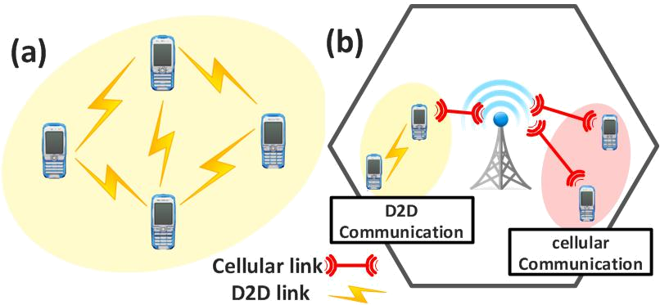

Figure 2.1: Stand-alone and Network assisted D2D communication (Henebry et al.,

1998)

There are some issues associated with this scenario such as energy efficiency, spectral efficiency, data interference and transmission delay because of data rate requirement (Alquhali et al., 2020). When mobile devices communicate with each other directly it increases spectral efficiency and reduces transmission delay (Ikram, 2019, Kim et al., 2017 and Alquhali et al., 2020).

D2D communication is a cellular technology that has been in presence for some time. The most common low level D2D communication technology that provide a short range includes; Bluetooth, ZigBee, IrDA and Wi-Fi Direct. They work over the unlicensed Industrial, Scientific and Medical (ISM) band but the disadvantage is that, interference here cannot be controlled (Olaobaju and Mohammed, 2018).

2.2 Forms of D2D Communication

The cellular networks can be grouped into two-tiers with the integration of D2D communication in 5G networks; specifically macro-cell level and device level. The macro-cell level addresses the conventional cellular network with BS-to-Device (B2D) communication for example the device interface with the cellular network through the

base station, while the Device level address the D2D communication for example the 6
device discuss straightforwardly with another device (Olaobaju and Mohammed, 2018). Due to spectrum utilization for direct communication between devices, Ikram, (2019) characterized D2D communication into the following as shown in Figure 2.2
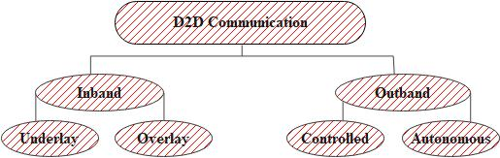

Figure 2.2: Classifications of D2D Communications

The D2D communication is classified into In-band (Underlay and Overlay) and Out-band (Controlled and Autonomous) communication.

In-band Communication: The D2D users utilize the cellular spectrum for their own communication. The communication links is managed by the BS and it ensures communication performance. The spectrum used by the D2D users is owned by the operator (Ikram, 2019) . The Device-to-Device and the Cellular network make use of the same frequency band in underlay in-band D2D. Resource management scheme is required to reduce interference, while in Overlay in-band D2D, a dedicated frequency band is used by the D2D and the cellular network, (Ikram, 2019).

Out-band communication: Here, D2D communication makes use of the unlicensed spectrum that is allowed by other wireless technologies such Wi-Fi or Bluetooth and other related application. (Ningombam and Shin, 2018) D2D communication is more prone to interference due to un-ending opportunity to the unlicensed spectrum by those that make use of it i.e. the users. There is little or no communication with cellular network. More

7
so, as expressed by (Olaobaju and Mohammed, 2018), classify D2D communication into

four categories namely.

2.2.1 Device relaying with operator-controlled link establishment (DR-OC)

This is the relaying of data to be transmitted by a device in a poor network coverage location through other devices. A control interface is made for the base station to have full or partial authority over the allocation of resources as illustrated in Figure 2.3. (Olaobaju and Mohammed, 2018).
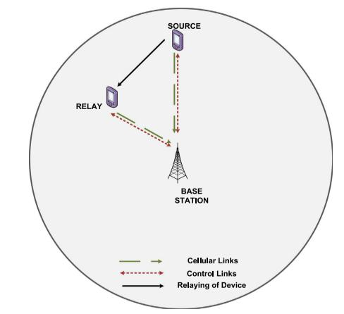

Figure 2.3: DR-OC (Gandotra & Jha, 2016)

2.2.2 Direct D2D communication with operator-controlled link establishment (DC-

OC)

Here, the source and destination devices impart and share information directly without going through the Base Station (BS) as shown in Figure 2.4. However, the BS actually makes control interface for overseeing radio resources

8
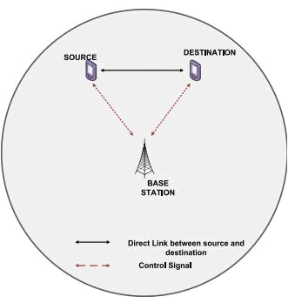

Figure 2.4: DC-OC (Gandotra & Jha, 2016)

2.2.3 Device relaying with device-controlled link establishment (DR-DC)

In this form of D2D communication, the source and destination device communicate directly just like the DR-OC but they do not need the BS to manage and create control link instead they made use of relaying devices to actualize the transmission of data between devices. This is illustrated in Figure 2.5 (Olaobaju and Mohammed, 2018).
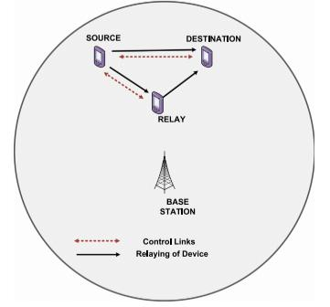

Figure 2.5: DR-DC (Gandotra & Jha, 2016)

9
2.2.4 Direct D2D communication with device-controlled link establishment

(DCDC)

Here, the destination and source devices exchange information directly without the help of BS to establish control link and manage the available radio resources to reduce interference as illustrated in Figure 2.6.
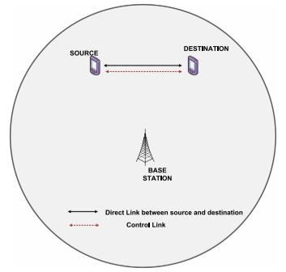

Figure 2.6: DC-DC (Gandotra & Jha, 2016)

Table 2.1 contains the different forms of D2D Communication and their advantages and disadvantages.

10
Table 2.1: Representation of forms of D2D communication with their advantages and disadvantages

 | Form | Description | Advantages | Disadvantages
 | Inband | It uses the cellular licensed | Interference can be | Interference
 |  | spectrum for cellular and | controlled and no inter- | between the
 |  | D2D links. | platform is needed. It | Cellular Users
 |  |  | does not need more than | (CUs) and D2D
 |  |  | one interface for devices | users is very
 |  |  |  | difficult in
 |  |  |  | underlay comm.
 |  |  |  | compared with
 |  |  |  | overlay comm.
 | Outband | The users make use of the | It is free of charge D2D | Interference cannot
 |  | unlicensed spectrum. It is | and cellular users can | be controlled due
 |  | used to reduce the | transmit data | to unlimited access
 |  | interference between D2D | simultaneously | to the unlicensed
 |  | and cellular link |  | spectrum by users
 |  |  |  | Increased power
 |  |  |  | consumption
 | Centralized/ | The BS uses the channel | Low interference | The entire system
 | Controlled | quality indicator of all the | between the devices | can fail due to
 | B2D and D2D link to allocate |  | Efficient handling of the | single point failure
 |  | spectrum to B2D and D2D | dynamic system works | Poor availability
 |  | connection using the | on the unwavering | Lack of failure
 |  | centralized technique. | quality and execution | tolerance
 |  | BS perform all the computer
 |  | tasks
 | Distributed/ | Individual UE perform | Fast adaptation of the | UE can make self-
 | Autonomou | allocation of bandwidth for | dynamic system can be | decision and when
 | s | D2D comm. The UE acquire | used when there is no | there is diverse
 |  | the Computer Sensitive | coverage | decisions, this can
 | Language (CSL) of the entire |  |  | bring about
 |  | network by exchanging their |  | divergence of the
 |  | local information with other |  | overall joint
 |  | UE |  | decision.
 |  | Source: (Gandotra and Jha, 2016)
 | D2D Communication can be applied in diverse areas which include; Traffic Offloading,
 | Multicasting, | Video dissemination, Machine-to-Machine (M2M) |  | communication,

Emergency communication, IoT- it is the interconnection of wireless network such as

Vehicle-to-Vehicle (V2V) , Internet of Vehicle. (Gandotra and Jha, 2016, Olaobaju and

Mohammed, 2018).

11
2.3 Area of Benefits of D2D Communication

Location awareness services, data traffic offloading, Cooperative relaying, Virtual MIMO, Social networking, E-health services, Smart city as shown in Figure 2.7 (Gandotra and Jha, 2016)
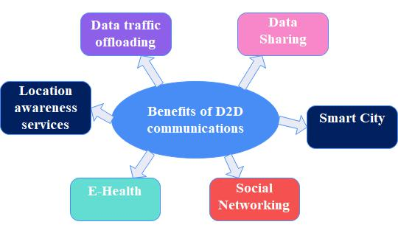

Figure 2.7: Area of benefits of D2D communication in cellular network

2.3 Technical Challenges in Carrying out D2D Communication

D2D communication networks come with some challenges to be addressed in order to enjoy the full potentials of it (Olaobaju and Mohammed, 2018). The challenges include;

2.3.1 Device discovery

Device discovery is one of the challenges of D2D communication network. Device needs to know the availability and distinguish the presence of different devices, get information about the device and fulfill the closeness condition before establishing the communication between the two (Safdar et al., 2016) i.e. Device must be able to detect other devices close to them for D2D communication to be established (Olaobaju and Mohammed, 2018). Dissemination of device information can be done periodically where other devices choose whether to react to discovery request and starts D2D communication (Peer discovery). Considering D2D, peer discovery is done by exchanging signaling messages also known

12
as Beacon signals between users that need to convey in D2D mode and the base station for control purposes.

2.3.2 Mode selection

Selecting transmission mode (Cellular mode or D2D mode) is one of the difficult task in communication for potential D2D users after discovery even though they are in close proximity to each other but it might not be optimal for them to operate efficiently and

effectively (Alquhali et al., 2020 and Ansari et al., 2018). Therefore, mode selection enables the BS and the D2D users to choose which mode to work from whether D2D communication mode or Cellular mode based on some selection metrics which includes; interference among D2D pairs, distance between D2D and Cellular users. The quality of the channel condition and Signal-to-interference plus noise ratio (SINR) is one of the most common selection metrics. Predefined SINR threshold is often considered as the mode selection criteria for D2D communication. Therefore, proper mode selection determines the performance of D2D communication (Safdar et al., 2016).

2.3.3 Interference Management

Introducing D2D links within a cellular network can bring about a big danger of interference to the cellular links in the network. D2D links can cause an increase in intra-cell interference between D2D Users (Gandotra and Jha, 2016). In order to prevent interference, the distance between the D2D users and cellular users is crucial and the way bandwidth are allocated in the network is also important (Gandotra and Jha, 2016). Multiple-Input-Multiple-Output (MIMO) transmission scheme are introduced for interference avoidance which result in a great enhancement of D2D SINR. The received signal contains three components as namely; Desired Signal, Outside Interference Signal and D2D Interference Signal.

13
Therefore, researcher has adopted different approaches to mitigate interference in D2D and cellular links which include Interference Avoidance, Interference Cancellation and Interference Coordination (Gandotra and Jha, 2016).

2.4 Review of related works on Interference in D2D Communication Network

The introduction of enhanced technologies introduced by 3GPP standardization made interference restricted environment to become a significant scenery in wireless network deployment especially in Long Term Evolution-Advanced (LTE-A) systems (Salihu et al., 2014). Therefore, as demand for higher data rate and quality of services continue to increase which brought about the release of 5G, interference between cellular users is on increase.

The most common and major impairment of D2D communication network is the interference caused by the D2D users to the conventional cellular users vice versa (Ansari et al., 2018). Interference mitigation remains a major challenge in the implementation of multiple access technologies to realize 5G mobile networks (Hassan et al., 2018).

The D2D users will suffer from either intracellular or intercellular interference depending on the network operational mode such uplink or downlink at which the D2D is operating from (Adnan and Zuriati, 2020). Therefore, great number of researchers have identified this issue and proposed different solutions to help reduce it. Song et al. (2019) adopted an interference limited area control method; this constraint is used to reduce interference between D2D communication and cellular network. Gupta et al. (2016) proposed a resource allocation for D2D link in Fractional Frequency and Soft Frequency Reuse network. The authors proposed three frequency allocation schemes namely: Fractional Frequency Allocation (FFA1 and FFA2) when macro base station uses FFR and Soft

14
Frequency Allocation (SFA) when macro base station uses SFR to reduce interference of the D2D link at same time ensure that the quality of service of the cellular network is highly secured.

Similarly, Ningombam and Shin (2019) proposed a resource sharing optimization where a multicast D2D shares resources with cellular network in a non-orthogonal manner in other to mitigate interference. Chae et al. (2011) proposed a scheme whereby the D2D and Cellular Users utilizes diverse frequency band picked as user’s location.

To mitigate interference, Bao et al. (2013) proposed a location based channel reusing scheme by introducing two novel ideas, opened and reusable region. Where-by the D2D users in the opened region can use the cellular resources in the reusable region vice versa. Boundary is dictated by predetermined SINR threshold and outage probability requirement. Hao et al. (2015) proposed a D2D pair forming and game theory to reduce interference and enhance the overall system capacity. Lindner et al. (2019) proposed a novel joint radio resource scheduling and allocation for D2D communication that utilizes two strategies from field of game hypothesis to diminish interference.

Ningombam et al. (2017) proposed a distance based throughput enhancement strategies for D2D communication in a sectored multicellular framework utilizing FFR technique in order to improve system performance by mitigating interference. The issue of interference was tackle in Choudhury et al. (2017) by using two phase resource allocation algorithm (Fair and restricted), in the fair the D2D users has the flexibility to share the base station resources of one of the cellular network. In the restricted, D2D are blocked from sharing any cellular resources in other to reduce interference in the system.

However, from the reviewed works, it is clear that resource management take an important role in minimizing interference and when resources are adequately allocated in

15
the system, interference is reduced. More so, the way users are distributed in the network is also critical in the reduction of interference in the system.

Yang (2015) proposed a non-uniform user distribution model for both uplink and downlink resource management. Li et al. (2016) a non-uniform user model that depends on the distance to the serving base station was carried-out in the research work. The users in the macro and small cells may have different density distribution models.

Soft frequency reuse has been identified as an effective frequency planning scheme that has been greatly employed to help reduce interference in cellular network (Li et al., 2016, Adejo et al., 2017ª and Li, 2019). SFR also improve spectral efficiency (Nuraini, 2016 and Adejo, et al., 2017^{b}), it increases system capacity (Qian et al., 2012) and it improve system throughput and fairness performance (Attia et al., 2017).

Adejo et al. (2020) employed SFR to adequately model an interference frame considering the overlapping bandwidth allocation. The result obtained allowed BS to be tuned to achieve desired network performance which may be other disadvantage. In order to alleviate interference, Li (2019) proposed SFR for both the licensed and unlicensed band. Using unlicensed band that consider resource allocation based on SFR give an outstanding design.

2.4.1 Soft Frequency Reuse based on user distribution for Cellular networks

The SFR scheme is a special frequency reuse method that works to reduce the problem of interference and enhance bandwidth utilization in the network. In this research, SFR technique was applied to cellular networks that are also having D2D networks within 16
them. However, in this section, discussion is first made of an SFR scheme that improves user performance in typical cellular networks when the user distribution was considered, as presented in Asaka et al. (2021).

The coverage area of the cell is sub-divided into two major areas; the central and edge area as was shown for three base stations in Figure. 3.1. The spectrum is then allocated efficiently to the cellular regions such that part of the bandwidth dedicated for cell edge of one sector can also be used in the central region if it is not fully utilized by the cell edge. Limitation in available power is also considered; therefore, analysis was carried out by considering a power budget at the base station which specifies how energy will be shared among the Centre and Edge regions. A higher power is transmitted to the edge region and a smaller Power to the Centre region.

SFR algorithms are guided by the rule that frequency allocation must be considered carefully for base stations in close proximity to each other. Therefore, the bandwidth allocation within a base station is carried out alongside that of its neighboring base stations. By preventing parts of the network with very high-power transmissions from transmitting with the same frequency bands, it is possible to reduce the effect of interference which affects the user performance. Figure 3.2 shows the resource (bandwidth/power) allocation for a cellular only network for both the basic

SFR scheme and in a modified SFR scheme that considers the random deployment of users (Asaka et al., 2021).

17
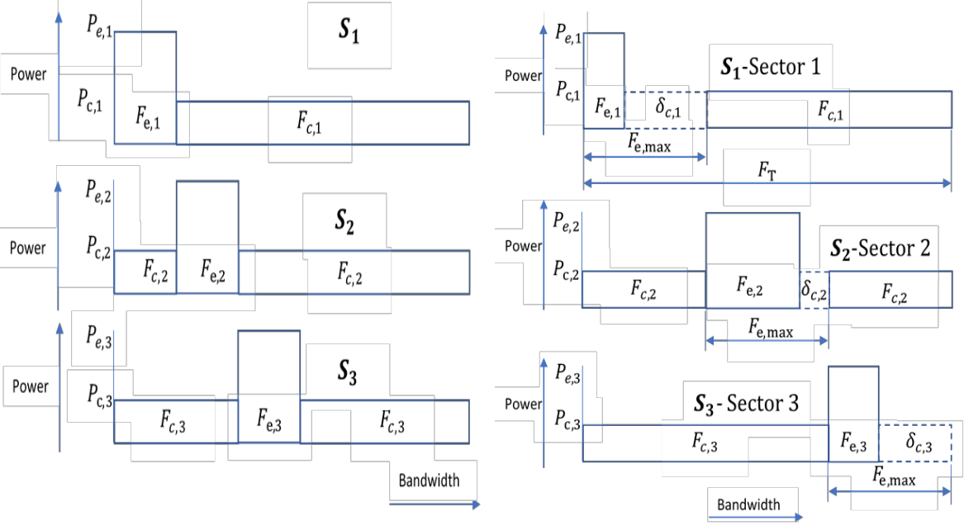

Figure 3.2: Standard SFR and SFR technique that captures user distribution ( Asaka et

al., 2021).

In Figure 3.2, it can be seen that improvement of the modified SFR technique over the standard SFR is achieved using the fact of _{,1}, _{,2} and _{,3} which helped to achieve

flexible allocation of edge bandwidth as opposed to fixed allocation.
The equations for the bandwidth and power for a reference sector ₁ are given by:
= ,1 ⁺ ,1 ⁼ ,2 ⁺ ,2 ⁼ ,3 ⁺ ,3 | (2.1)

where is the total system bandwidth _{,1} is the total bandwidth for edge users in sector 1 of the reference base station 1 and _{,1} is the total bandwidth for center users.
= ,1 ,1 ⁺ ,1 ,1 ⁼ ,2 ,2 ⁺ ,2 ,2 ⁼ ,3 ,3 ⁺ ,3 ,3 | (2.2).

where _{,1} = total number of edge users in sector 1 of the reference base station, while _{,1} = total number of center users, = total power budget, _{,1} is the transmitted power to each edge user in sector 1 of and _{,1} is the transmitted power to each center user.

18
_{,1} and _{,1} are related by the power ratio constant β:
,1 ^{= β} ,1 | (2.3)

The equations for user performance respectively for SINR of center users, SINR of edge users and Capacity are given below (Adejo et al., 2020)
,
 |  |  |  |  |  |  | _{ℎ} −
= |  |  |  |  |  | ,1 | , |  |  |  |  |  |  |  |  |  | (2.4)
= |  | ,2 ⁻ ⁽ ,1 | + _{,2}) |  | ,2 ,2 |  |  | ,3 ⁻ ⁽ ,1 ⁺ ,3⁾ |  |  |  |  | ,3 ,3 |  |  |  | (2.4)
 | [ | ,2 ⁻ ⁽ ,1 | + _{,2}) | + | ,2 ,2 | ]ℎ ⁻ | + [ |  |  |  | + |  |  |  | ]ℎ ⁻
 | ,2 | ,1 |  |  | ,1 | 2, | ,3 |  | ,1 |  |  |  | ,1 |  | 3,
Where ℎ is the fading component, , = distance between the user and the reference base
station , _{2,} = distance between the user and the base station that interferes with the
reference base station and _{3,} = distance between the user and the interfering base
station ₁, ∝= the path loss component.
_{,1}ℎ ⁻

, = _{ℎ − +} , _{ℎ −} (2.5) ,2 2, ,3 3,

2.5 System Capacity

System capacity is defined as the maximum rate at which information can be transmitted through a channel.
= log₂ (1 + |  | ) | (2.6)

Where C represent capacity of the channel which is measured in bits/sec., W is the bandwidth of the channel which is a fixed quantity and it is measured Hz and S/N is the signal to noise ratio, usually express in decibel (dB). Therefore, to mitigate interference to a reasonable extent, the way or pattern in which the users are distributed should be greatly considered. User distribution analysis is considered as one of the most critical

19
issue in cellular network (Yang, 2015). In most studies, users are not always uniformly distributed.

D2D communication underlying cellular network is envisaged to function within the same coverage area and use the same cellular bandwidth (Jameel et al., 2018). The reuse of radio resources of the Cellular Users by the D2D Users introduces a harmful interference from the CUs to the D2DUs (Cross-tier interference) and from the D2DUs to the CUs. When reusing the DL resources, the transmit power of the base station which causes the D2D user to suffer a harmful interference which cause a decrease in SINR, reducing quality of service of D2D systems. Reusing the UL resources, less interference is experienced because the overload and control signaling of UL are much lower than that of DL (Safdar et al., 2016).

Figure 2.8 shows a hexagonal representation of cellular network, with a reference base station (Br) at the center surrounded by six other interfering base stations (B1, B2, B3, B4, B5, B6). The Br is expanded further to show the D2DUs and CUs, the outer cell region, inner cell region, desired and undesired signal is shown.
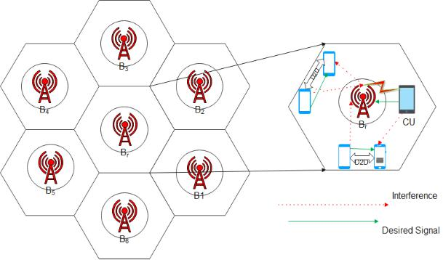

Figure 2.8: An Interference scenario in cellular network with cellular user and D2D

users’ interfering to with another

20
As illuistrated in figure 2.8, the desired signal occurs between the two mobile devices and between the CUs and the Cellular Network (CN). There is interference between the D2D and the CUs, Cellular Network and the D2DUs and also between the D2DUs and the CN.

Ningombam et al. (2019) proposed a multicast D2D group that uses the same resources with the CUs in non-orthogonal way (Overlap) and their scheme performed a comprehensive numerical analysis using monte-carlo simulation varying SINR and distance between users in the network in order to improve system data rate and for better transmission. Ningombam and Shin (2018) allow two pair of D2D to use cellular resources (Overlap) at a time and provided a technique that allow more D2D pair and the interference within the network was controlled.

Kamal et al. (2017) proposed a resource scheduling to utilize the available bandwidth and efficiently maximize the throughput considering user distribution. Hidayat et al. (2017) performed an analysis of SFR performance considering different traffic loads therefore giving greater throughput for CEUs reduces the intercell interference. Adejo et al. (2017)ª proposed an interference model that consider the probabilic nature of Inter-Cell Interference (ICI) in SFR to mitigate interference in HetNets and Nuraini (2016) adequately evaluated SFR as a method to reduce ICI. Table 2.2 shows the detailed summary of the past and related reviewed work with the strength and weakness of the paper.

21
Table 2.2: Summary of the reviewed past work on interference mitigation

 | S/N | Author/Title | Frequency | Strength | Weakness
 |  |  | Reuse Method
 | 1 | (Adejo et al., 2020) New framework | SFR | Ability to adjust a BS to achieve desired | Other user suffers the
 |  | for interference and energy analysis |  | network performance | consequences when BS is
 |  | of soft frequency reuse in 5G |  |  | tuned to favours a
 |  | networks |  |  | particular performance
 | 2 | (Li, 2019) Soft Frequency Reuse- | SFR | The work considered Soft Frequency Reuse for | Less result to back up the
 |  | Based Resource Allocation |  | both licensed and unlicensed band that allows | work
 |  | for D2D Communications Using |  | D2D communication which significantly
 |  | Both Licensed and Unlicensed |  | improve system performance
 | 3 | (Ningombam and Shin, 2019) | SFR | The work considered a Multicast D2D group | Each multicast D2D can
 |  | Interference Mitigation For Multicast |  | and interference was minimized to a | reuse only one uplink
 |  | D2D communication Underlay |  | reasonable level | cellular link per time
 |  | Cellular networks
 | 4 | (Ningombam & Shin, 2018) Outage | FFR | The paper allowed more than one D2D pair to | Inter-cell interference
 |  | probability analysis of device-to- |  | simultaneously reuse single cellular resource | was not considered.
 |  | device communications with |  | and it consider the outage probability of D2D
 |  | frequency reuse-2 in fractional |  | comm. caused by the intra-cell interference
 |  | frequency reuse method
 | 5 | (Kamal et al., 2017) Influence of | - | Considered two scheduling scheme (Max-rate | More result is needed
 |  | Non-Uniform User Distribution on |  | and Equal allocation) to measure the
 |  | Throughput Performance in Outdoor |  | throughput performance The Maximum
 |  | Macro-Cellular Environment |  | Rate(MR) produced a better throughput which
 |  |  |  | will help the network planner to decide

22

 | 6 | (Hidayat et al., 2017) Cell Capacity | SFR | Good frequency planning and power allocation | Only inter-cell
 |  | Prediction with Traffic Load Effect |  | and critical analysis of SFR. It provided a | interference is considered
 |  | for Soft Frequency Reuse (SFR) |  | higher throughput to cell-edge user to reduce
 |  | Technique in LTE – A Network |  | interference
 | 7 | (Melki, 2017) Radio Resource | SFR | The approach used reduces interference to a | -
 |  | Management for Device-to-Device |  | reasonable extent through resource allocation
 |  | Communications Underlaying
 |  | Network
 | 8 | (A. Adejo, Boussakta, et al., | SFR | Provided an interference model considered the | Intra-Cell interference
 |  | 2017)Interference Modeling for Soft |  | probabilistic nature of ICI in SFR to mitigate | needs also to be
 |  | Frequency Reuse in Irregular |  | interference in HetNets | considered
 |  | Heterogeneous Cellular Networks
 | 9 | (Nuraini, 2016) Inter-Cell Interference | SFR | The result supported the fact that SFR is the | It should have also verify
 |  | Coordination with Soft Frequency |  | most effective scheme for inter-cell | for intra-cell interference
 |  | Reuse Method for LTE Network |  | interference mitigation and it generated better
 |  |  |  | throughput as compare to FR1and FR3
 | 10 | (Safdar et al., 2016)Interference | - | A comprehensive research was done on | More mathematical
 |  | Mitigation in D2D Communication |  | different interference mitigation scheme for | backup is needed
 |  | Underlaying LTE-A Network |  | D2D Comm. Network
 |  | Ghazanfar
 | 11 | (Yang, 2015) Effect of User | FFR | In-depth study of the effect of user distribution | It should have considered
 |  | Distribution on the Capacity of |  | on the system capacity | both the SFR and FFR
 |  | Cellular Network
 | 12 | (Chae et al., 2011) Radio resource | FFR | To avoid interference D2D operate at the inner | D2D might be limited in
 |  | allocation scheme for device-to- |  | region and if it operate at the outer region, | operation due to the
 |  | device communication in cellular |  | there is a tolerable interference | restrictions
 |  | networks using fractional frequency
 |  | reuse,

23
CHAPTER THREE

3.0 RESEARCH METHODOLOGY

This chapter contains the methodology for this research project which includes technical details of the network model, user distribution model, SFR technique for all bandwidth allocation approaches and the equations for user performance assessment.

3.1 Network Model

A basic cellular network with D2D users is hereby described in Figure 3.1. The extracted portion only shows three closely located macro base stations that provide strong interference to each other. The cellular base stations are represented as , ₁ and ₂, where is the reference base station whose coverage is to be investigated, ₁ and ₂ are the main interfering base stations to .
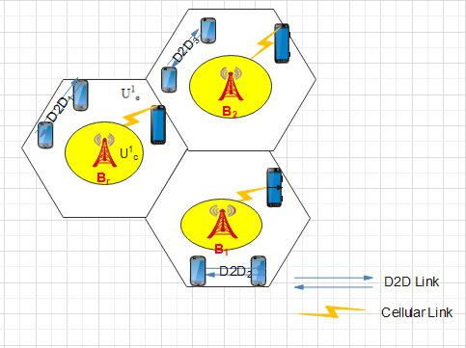

Figure 3.1: Cellular Network with D2D Users

24
Two Cellular Users are also depicted, connected in the region of . They are ¹ (which is located close to ) and ¹ (which is located close to the edge of ).

The D2D networks are formed when two D2D users communicate between themselves. One is identified as a transmitter and the other a receiver both are called D2D users. the D2D communication network allow User Equipment in close proximity to transmit data over a direct link using the cellular network resources without transversing the base station. This technology reduces traffic to base station but it is prone to both intra-cell and inter-cell interference.

From Figure 3.1, the base station coverage arrangement shows a hexagonal network pattern. In addition, the users are deployed randomly within the network to simulate a real network scenario where the position of the users is not stable, it changes over time.

3.2 Simulation Parameters

3.2.1 Simulation tool

The software used for simulation of the network scenario is Matrix Laboratory (MATLAB), it is the programming and numeric computing platform used to develop the proposed algorithms. The MATLAB was used to define the network environment including the layout of the base stations, CUs and D2DUs. It is also used in performing the bandwidth allocation algorithm.

3.2.2 Base station configuration

The BS is configured in such a way that the reference base station is assumed to be placed at the origin (0, 0), surrounded by other six interfering base stations arranged in hexagonal way. The coordinate locations for the interfering base stations are randomly generated to

be [(0.433, 0.750), (0.866,0), (0.433,-0.750), (-0.433,--0.750), (-0.866,0), (-0.433,0.750)], 25
assuming coverage radius of 0.5km since the interfering base station considered are in

close proximity to the reference base station. Table 4.1 shows other parameters used in

the configuration. Some of the parameters used are fixed while some are based on

assumption.

Table 4.1: Summary of Base station parameters

 | Parameter | Value
 | Base station type used | Macro base station
 | Base station radius | 0.5km
 | Number of sectors | 3
 | Number of users per sector | 49 (full user deployment)
 | Number of bandwidth slots per base station | 48
 | Power threshold | 1.2W
 | Edge User bandwidth for fixed SFR | [7,10,13,16]
 | Power budget | 43dBm
 | Power ratio | 2.5

3.2.3 Network user categories

The users in the network are categories into Cellular Users and D2D Users. The CUs are

further grouped into Edge and Center users.

3.2.4 Cellular user parameters

The CUs in the network are classified into center and edge users which are randomly

selected depending on the base station coverage radius.

3.2.5 Network assumptions

The simulation of the algorithm is achieved based on the following assumptions

- The closest base station neighbors to the reference BS under consideration are considered.

26
- The scheduling assumption is fair scheduling, i.e. the channel conditions are not considered when allocating bandwidth to users which guarantee a baseline testing
of the algorithm performance without any external influence.

- Dense user deployment with center and edge users available in all cases of simulation

3.3 Soft Frequency Reuse Based on User Distribution for D2D Cellular Networks

This section contains the contribution of this work, which is the methodology for implementing soft frequency reuse in D2D networks when considering the user distribution of cellular networks. It is an extension of the work in (Asaka et al., 2021) to the case of D2D networks.

When D2D networks are to share bandwidth resources with cellular networks, the major challenge with tackling interference is the rules on which part of the bandwidth the D2D user is permitted to utilize. Some of the major rules are as follows:

- Edge user bandwidth is not shared with either center user bandwidth or D2D user bandwidth

- D2D users may be allowed to use the same bandwidth with center users. This can

be called overlapping bandwidth allocation algorithm which is considered as Algorithm 1 in this research.

- D2D users may not be allowed to use the same bandwidth with center users. This can be called separate bandwidth allocation algorithm which will be considered as Algorithm 2 in this work.

Based on the principle of using user distribution to control bandwidth allocation, the following important steps are required in each algorithm:

27
Stage 1: Initial allocation of bandwidth to the edge region of the cellular network based on the ratio of edge users to other user classes. This is done for each base station and any bandwidth allocated but unused in the edge regions are noted

Stage 2: Assignment of unused bandwidths if any to edge regions with high bandwidth

demand

Stage 3: Allocation of bandwidth to center regions based on edge region allocation of same base station. This is based on whether Algorithm 1 or Algorithm 2 is being applied. Stage 4: Allocation of bandwidth to D2D users.

28
These four stages are shown in Figure 3.3
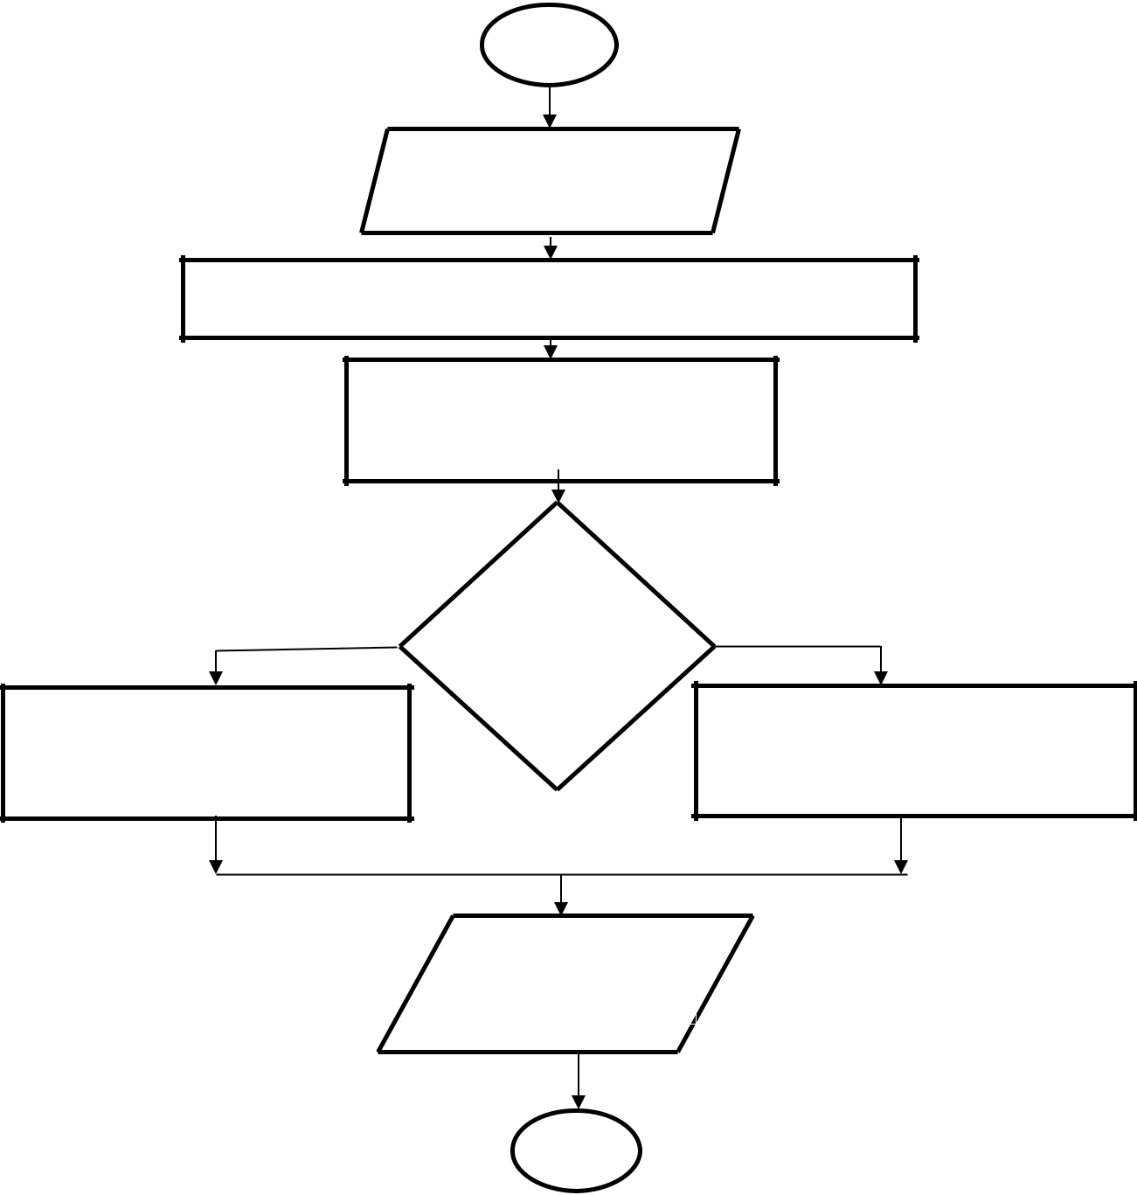

Start

Input user distribution
information

Stage 1: Initial bandwidth allocation to edge users based on
algorithm in use and the user distribution

Stage 2: Assign unused
bandwidth among edge users if
required

Yes

Stage 3: run overlapping
bandwidth algorithm for center
users

If
algorithm
- is
selected

No

Stage 3: run separate bandwidth
algorithm for center users

Allocate remaining
bandwidth to D2D

users

Stop

Figure 3.2: Flow chart of user distribution algorithms for D2D networks in cellular networks

3.4 Overlapping Bandwidth Allocation Algorithm

For each base station in the network, the total bandwidth at every point is allocated

according to the pattern in Figure 3.4.

29

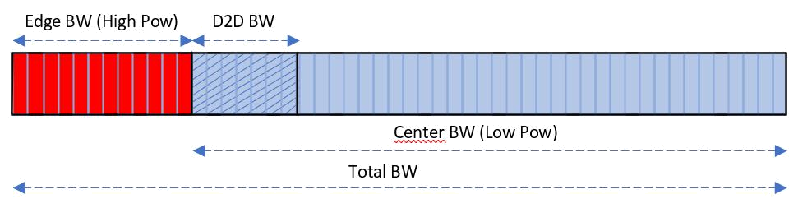

Figure 3.3: Typical bandwidth allocation in a base station

The blue vertical lines divide the entire bandwidth into smaller segments or slots of equal sizes. A group of slots are assigned to each group of users:

- Edge users are allocated the portion of bandwidth shaded red, transmitted at high power

- Center users are allocated the portion shaded blue, transmitted at a lower power than the edge region

- D2D users are given part of the center bandwidth allocation indicated by the diagonal lines also shaded blue

The major task is to compute the size of each bandwidth group such that resources are fairly allocated and interference is reduced as much as possible. Regions should be assigned bandwidth sizes based on the demand of users within them. Bandwidth assignment is usually done by considering interference from neighboring base stations such that the edge regions use different bandwidth slots. Based on the hexagonal coverage pattern of the base stations, three base stations are grouped for proper utilization of their bandwidth assignment. Three approaches are used in this research work for bandwidth allocation between users namely Overlapping Bandwidth Allocation, Separate Bandwidth Allocation and Hybrid Bandwidth Allocation as illustrated in Figure 3.4.

30
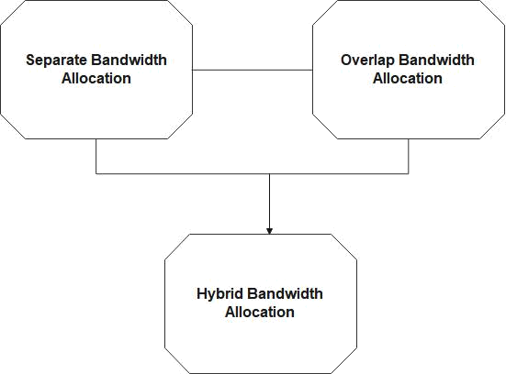

Figure 3.4: Three approaches for Bandwidth Allocation

Figure 3.6 shows the bandwidth allocation for a group of three close base stations. As seen, the edge allocations are unique for each base station, while the center allocations are allowed to overlap. D2D allocations are contained within the center allocations. In the proposed method as depicted in Figure 3.6, one third of the bandwidth is reserved first for the edge region of each base station. However, the actual allocation of bandwidth to the edge region depends on the current demand. If the current demand is not up to one third of the total, then the remaining bandwidth, called the Edge reserve is made available for the center region and D2D users. In this way, a fair allocation procedure is made in the network, while ensuring that the problem of inter-cell interference is also tackled. The algorithm to achieve is further discussed in the work.

31
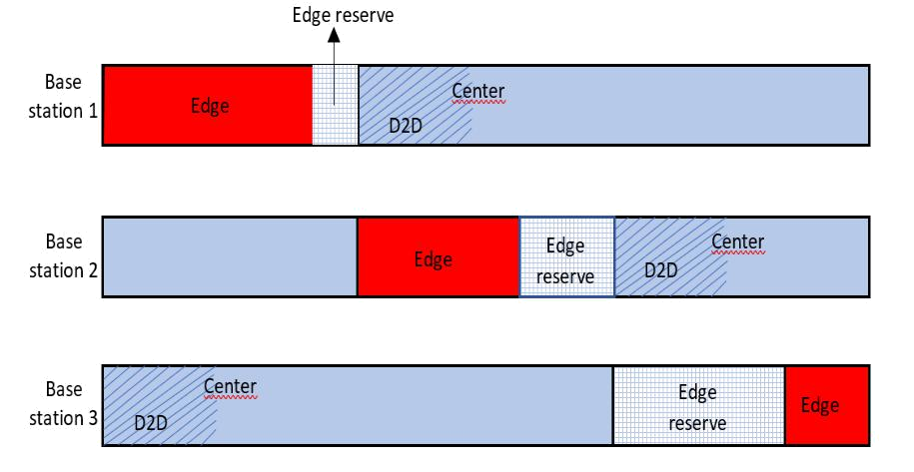

Figure 3.5: Bandwidth allocation for Algorithm 1 (Overlapping bandwidth allocation)

User performance: This depend on SINR and System Capacity

Center User SINR
, = | , | (3.1)
, = | ∑ , ^{+∑} , ^{+ ∑} , | (3.1)
where , is the SINR of a center user, , = received signal from the center region
of the reference macro base station, , , , = received interfering signal from the center
and edge regions of a neighbouring base station respectively and , = received

interfering signal from a D2D transmitter

Edge User SINR
, = | , | (3.2)
, = | ∑ , ^{+∑} , | (3.2)
where , is the SINR of an edge user, , is the received signal from the edge region
of the reference macro base station, , is the received interfering signal from the center

32
region of a neighbouring base station and , is the received interfering signal from a
,

D2D transmitter within a neighbouring base station’s coverage

D2D User SINR
, = | , | (3.3)
, = | ∑ , ^{+∑} , ^{+ ∑} , | (3.3)
where , is the SINR of a D2D user within the coverage location of the reference

macro base station, , is the received signal at a D2D user from its transmitter, , , , are the received interfering signal from the center and edge regions of a neighboring base station respectively and , is the received interfering signal from a D2D transmitter

within a neighboring base station’s coverage.

System Capacity: This is given by:
= log₂ (1 + |  | ) | (3.4)

Where C = Capacity (bits/sec), S/N = Signal to noise (and interference) ratio W = BW (Hz)

The summary of the Overlapping Bandwidth allocation algorithm is given below:

Details of this algorithm are presented below:

Algorithm 1
INPUT System Bandwidth ( ), Maximum allowable edge bandwidth ( , ),
Number of edge and center users per sector ( = [ _{,1}, _{,2}, _{,3}], =
[ _{,1}, _{,2}, _{,3}]), Number of D2D networks ( ₂ )
OUTPUT User bandwidths to edge, center and D2D ( _{,1}, _{,2}, _{,3}, _{,1}, _{,2}, _{,3}, ₂ )

Stage 1: First allocation of Edge bandwidth to macro network

01 Compute the ratio of edge users in each sector, i.e = _{, + ,} , = 1,2,3, Bi= is the bandwidth assign to user identified by i

33
02 = × , = min( , , ), = − ,

03 Use as the size of bandwidth initially allocated from to the edge region of
04 Note the remainder of any unused edge bandwidth , = ( , − )

Stage 2: Final allocation of Edge bandwidth based on user distribution

05 Based on , , allocate more bandwidth to any edge region with high user distribution
06 If more than one sector is under allocated, use |  |  | to share ,
 | ₁+ ₂+ ₃
07 Final edge bandwidth allocation is , , . _{,1}, _{,2} |  | and _{,3}
08 Remaining bandwidth for other user groups (center and D2D) is _{,1} = − ,

Stage 3: Allocation of Center bandwidth
09 Allocate bandwidth to center region based on and _{,1}
11 Final center bandwidth allocation is , , . _{,1}, _{,2} and _{,3}

Stage 4: Allocation of D2D bandwidth
12 Allocate bandwidth to D2D region based on _{,1}
13 Final D2D bandwidth allocation is ₂

3.5 Separate Bandwidth Allocation Algorithm

In this algorithm, the bandwidth allocation to D2D users is carried out such that overlapping assignment with center users is not allowed. Whilst this means efficiency of bandwidth utilization is reduced, the advantage is that inter-cell interference is also reduced.

The bandwidth allocation of neighboring base stations is depicted as a modification of

Figure 3.6, with the overlaps completely replaced as shown in Figure 3.7:

34
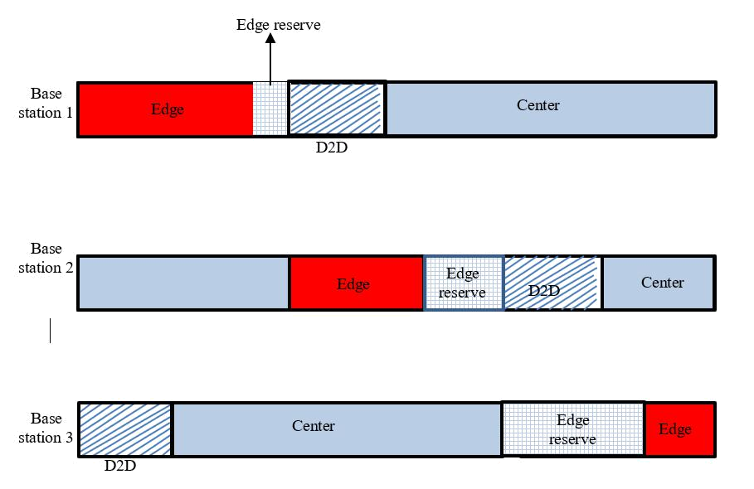

Figure 3.6: Bandwidth allocation for Algorithm 2 (Separate bandwidth allocation)

Likewise, the modified algorithm is presented in Algorithm 2. This was simulated using

MATLAB software.

Algorithm 2

INPUT System Bandwidth ( ), Maximum allowable edge bandwidth ( , ), Number of edge and center users per sector ( = [ _{,1}, _{,2}, _{,3}], = [ _{,1}, _{,2}, _{,3}]), Number of D2D networks ( ₂ )

OUTPUT User bandwidths

to

edge,

center

and

D2D

( ,1, ,2, ,3, ,1, ,2, ,3, 2 )

Stage 1: First allocation of Edge bandwidth for macro network
01 Compute the ratio of edge users in each sector, i.e = | , | , = 1,2,3
01 Compute the ratio of edge users in each sector, i.e = | , ⁺ , ⁺ 2 | , = 1,2,3
35

02 = × , = min( , , ), = − ,
= − ,
2
,

03 Use as the size of bandwidth initially allocated from to the edge region of
04 Note the remainder of any unused edge bandwidth , = ( , − )

Stage 2: Final allocation of Edge bandwidth based on user distribution

05 Based on , , allocate more bandwidth to any edge region with high user distribution
06 If more than one sector is under allocated, use |  |  | to share ,
 | ₁+ ₂+ ₃
07 Final edge bandwidth allocation is , , . _{,1}, _{,2} |  | and _{,3}
08 Remaining bandwidth for other user groups (center and D2D) is _{,1} = − ,

Stage 3: Allocation of Center bandwidth

09 Compute ratio of center users to D2D users, i.e ⁼ _{, + 2}

10 Allocate bandwidth to center region based on and _{,1}
11 Final center bandwidth allocation is , , . _{,1}, _{,2} and _{,3}
12 Remaining bandwidth for D2D is _{,2} − ,

Stage 4: Allocation of D2D bandwidth

13 Compute ratio of D2D users, i.e ⁼ _{, + 2}

14 Allocate bandwidth to D2D region based on and _{,2}
- Final D2D bandwidth allocation is ₂

3.6 Hybrid Bandwidth Allocation Algorithm

The final SFR algorithm is a hybrid of the first two. A rule is programmed to determine which of the two algorithms (separate bandwidth and overlapping bandwidth) is executed. The sum of center users and D2D users is used to set the condition for this rule. When the sum is high, it means there are several users competing for bandwidth and the overlapping bandwidth algorithm is preferred based on Algorithm 2 to ensure that the resource need

36
is met. However, when the sum is low, the separate bandwidth algorithm is selected based

on Algorithm 1.The flowchart for the Hybrid algorithm is shown in Figure 3.8.
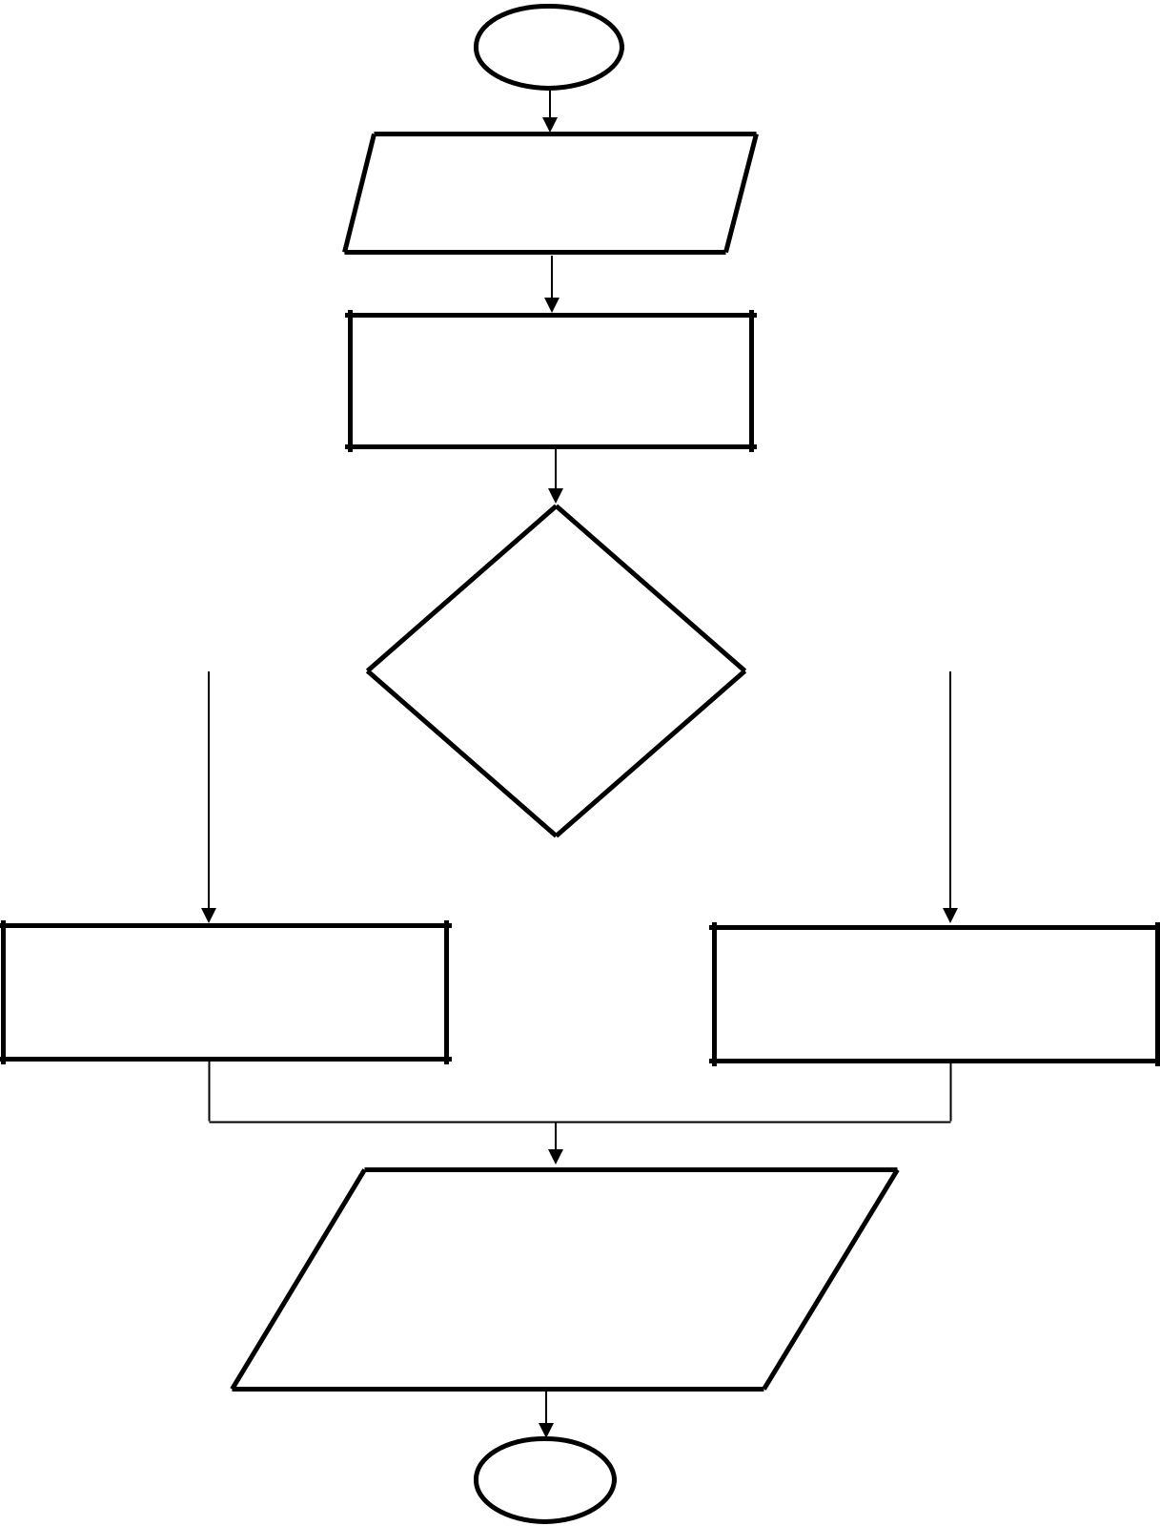

Start

Input user distribution
information

Compute the ratio of center
and D2D users in relation to
edge users

 |  |  | High
 |  |  |  |  | No
 | Yes |  |  |  | No
 | Yes |  | number of |  | No
center +
D2D users?

Run stages 1 – 4 using separate bandwidth allocation algorithm

Run stages 1 – 4 using

overlapping allocation algorithm

Selection is made based on

the number of center and

D2D user

Stop

Figure 3.7: Flow chart of Hybrid allocation algorithm for D2D networks

37

CHAPTER FOUR

4.0 RESULTS AND DISCUSSION

4.1 Presentation of Results and Discussion

In this Chapter, the outcome of the results are presented and discussed showing the functionality of the proposed SFR algorithm in three different categories of users, the Edge Users, the Center Users and D2D Users respectively. First of all, the simulation parameters are defined including base station configuration, user configuration and network assumptions. The plots for SINR and capacity using MATLAB are presented as results of the simulation process and detailed description is made on them.

4.2 Result Comparison of Bandwidth Allocation Algorithms

Three algorithms were implemented and compared in the results for the three categories of users:

- Algorithm 1 – Overlapping of bandwidth between center users and D2D users was permitted, with only edge users having a unique bandwidth allocation group. Bandwidth allocation is also done according to user distribution.

- Algorithm 2 – Separate bandwidth allocation was done, i.e. edge users, center users and D2D users in a base station all use different bandwidth groups. Bandwidth allocation is done according to user distribution.

- Algorithm 3 – A fixed bandwidth allocation is assigned to edge and center users in all cases of user arrangement in the network. Therefore, bandwidth allocation does not consider user distribution.

The results of this research work are presented by comparing the average capacity performance for different number of D2D user groups in the network. Hence, the evaluation of how the size of D2D networks can affect the cellular network performance 38
was done which served as the first unique contribution of this research work. For the two proposed algorithms (Separate bandwidth allocation and Overlapping bandwidth allocation), comparison is made with the fixed bandwidth allocation.

Figure 4.1 shows the capacity for edge users for a case of user distribution such that the percentage of edge users is high in the network. It can be observed that the separate bandwidth allocation technique gives the best performance while the fixed bandwidth allocation technique has the worst performance. The performances remain relatively stable even when the D2D users increase in the network, because bandwidth allocation for edge users is separate from other groups of users.
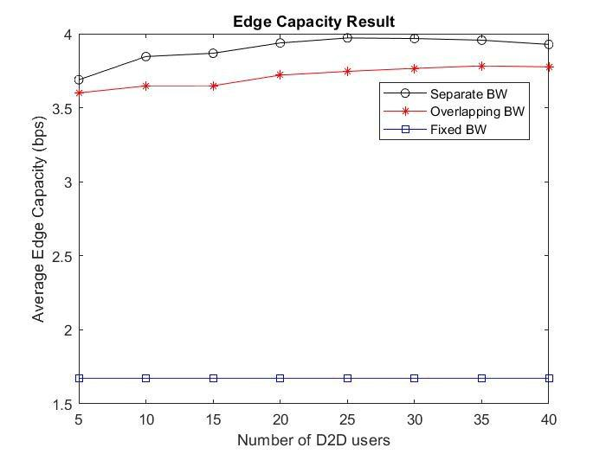

Figure 4.1: Average edge user capacity when the % of edge user is high in the network In Figure 4.1, the result for average edge user capacity when the number of edge users is high in the network. Considering the average edge capacity rate from 1.5 to 4.0bps, the fixed bandwidth allocation technique in blue colour became stable and unchanged at 1.6bps even with increase in the number of D2D users, the overlapping (red) bandwidth allocation approach performs better at the rate of 3.6bps and the rate increases as the

39
number of D2D increases. The separate (black) bandwidth allocation approach outperforms the others up to the rate of 4.0bps up to 8.5% above others.

Similarly, the results for center user average capacity are presented in Figure 4.2 for the same network case. Unlike the edge user results, it can be observed the fixed bandwidth algorithm maintains a constant result and has the best performance in all cases of D2D deployment. The overlapping algorithm also remains stable as the D2D users increase, but the separate algorithm shows a drastic change.
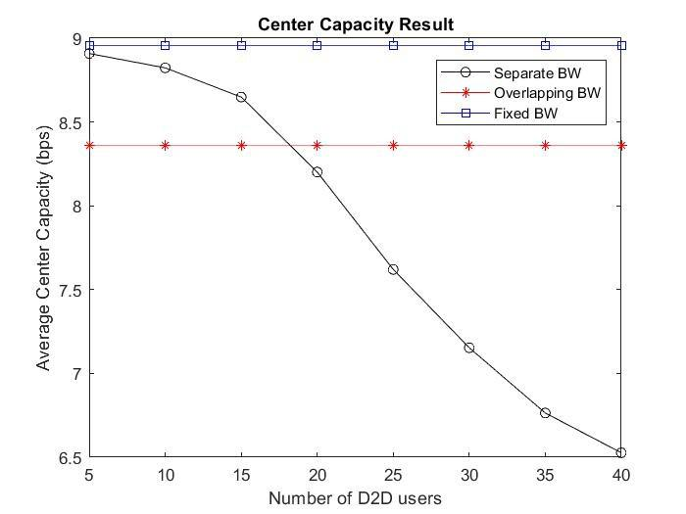

Figure 4.2: Average center user capacity when the % of edge user is high in the network The separate bandwidth allocation gives a good performance when the D2D users are low up to the rate of 9.0bps and reduces when more D2D users are added to the network. This is because both center users and D2D users are assigned the different portion of the bandwidth and the more the users, the higher the amount of interference.

The final group of users whose performance was analyzed is the actual D2D user group, which is presented in Figure 4.3. It can be observed that the separate bandwidth allocation

40
technique gives the best performance for all cases even though it drops as the number of D2D users increase.
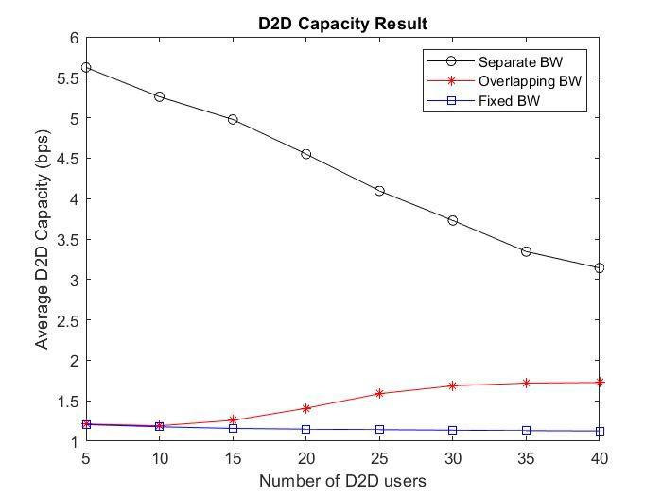

Figure 4.3: Average D2D user capacity when the % of edge user is high in the network A summary of the individual results comparing the three algorithms shows that different algorithms are preferred for the three classes of users (edge, center and D2D) depending on the number of D2D users. This is an important and useful observation that will aid the design and deployment of algorithms for efficient D2D networks. Figure 4.4 shows the combined average capacity for all users in the network.
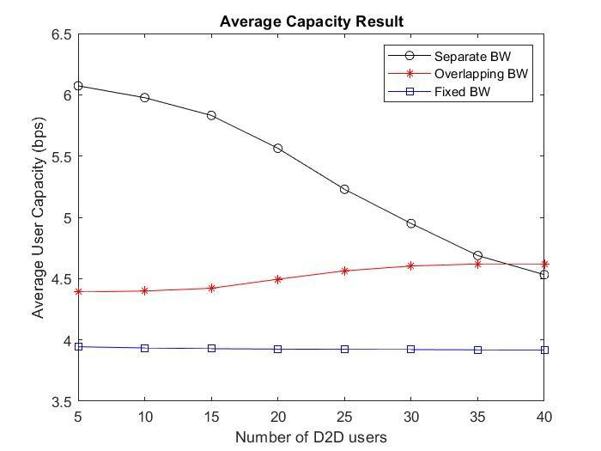

41
Figure 4.4: Average user capacity for all users when the % of edge user is high in the network

The result in Figure 4.4, shows that the fixed bandwidth allocation remain unchanged even as the number of D2D users increases, overlapping BW performed better up to the rate of 4.4bps and became stable as the number of D2D increases but as the number of D2D users increases to 25 and above, the rate increase a bit and remain stable. The separate BW allocation is the best performing algorithm when comparing the average capacity for all users. It increases to over 6.05bps but the rate decreases when the number of D2D users increases.

Other cases were also considered in the simulation and the best performing algorithm was noted as presented in Table 4.2.

42
Table 4.2: Best Performing Algorithm for three cases of edge user deployment
 | Low percentage of | Average | High percentage
 | edge users | percentage of edge | of edge users
Edge user capacity | Overlapping | Overlapping | Separate
Center user | Fixed | Fixed | Fixed
capacity
D2D user capacity | Separate | Separate | Separate
All user capacity | Separate/Overlapping | Separate | Separate

4.6 Evaluation of Hybrid Bandwidth Allocation Algorithm

The final presentation of results shows the performance of the hybrid bandwidth allocation algorithm which is evaluated over the three cases of edge user deployment. The results show that the hybrid algorithm equals the best performance of the other three algorithms in all implementations of the network but the separate BW approach has a very close performance to that of hybrid.

Figure 4.5, shows the performance of hybrid allocation algorithm for high number of edge users.

when the number of D2D users is within 10 users, the separate BW give a capacity rate of 5.7bps, overlapping BW gives a value of 4.85bps, fixed BW gives a value of 4.8bps and the Hybrid give a capacity rate of 5.75bps but when the number of D2D users is above 30 users, the performance rate decreases which may increase the chance of interference in the system.

43
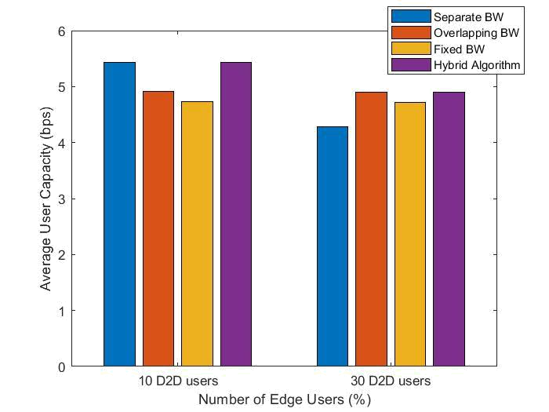

Figure 4.5: Performance of hybrid allocation algorithm for Case 1 (high number of edge

users)

The separate BW give a capacity rate of 4.4bps, overlapping BW gives a value of 4.9bps, Fixed BW gives a value of 4.91bps and the Hybrid give a capacity rate of 5.5bps.

Figure 4.6 shows the performance of hybrid allocation algorithm for average number of edge users when the number of D2D users is within 10 users for average number of edge users in the network, the separate BW give a capacity rate of 5.9bps, overlapping BW gives a value of 4.7bps, fixed BW gives a value of 3.8bps and the Hybrid give a capacity rate of 5.91bps but when the number of D2D users is above 30 users, the performance rate decreases which may increase the chance of interference in the system.

44
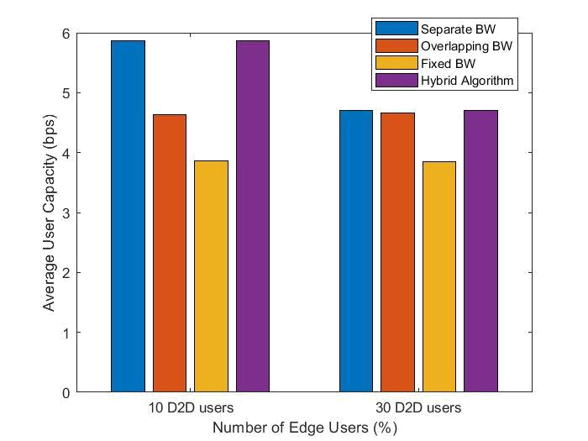

Figure 4.6: Performance of hybrid allocation algorithm for Case 2 (Average number of

edge users)

The separate BW give a capacity rate of 4.8bps, overlapping BW gives a rate of 4.75bps ,Fixed BW gives a rate of 3.69bps and the Hybrid give a capacity rate of 4.82bps having over 34% increase others and 27% when the number of D2D users is up to 30 users .

Figure 4.7 shows the performance of hybrid allocation algorithm when considering a low number of edge users in the network.
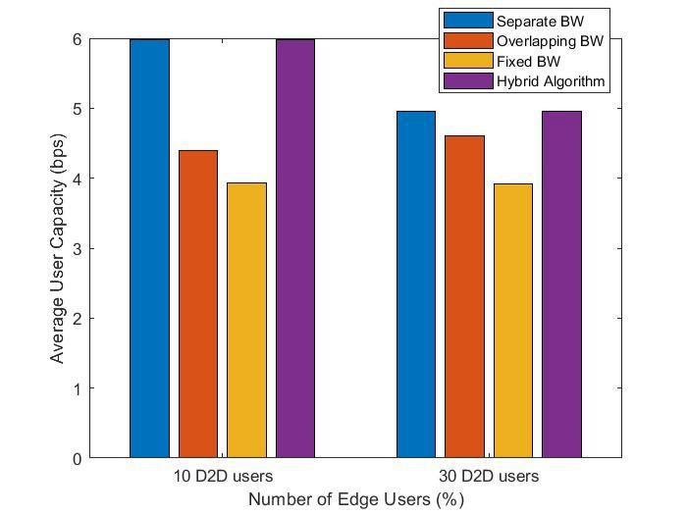

Figure 4.7: Performance of hybrid allocation algorithm for Case 3 (low number of edge

users)

45
Figure 4.7, considering a low number of edges users in the network, when the number of D2D users is within 10 users, the separate BW give a capacity rate of 5.95bps, overlapping BW gives a value of 4.20bps, fixed BW gives a value of 3.85bps and the Hybrid give a capacity rate of 6bps but when the number of D2D users is above 30 users, the performance rate decreases which may increase the chance of interference in the system. The separate BW give a capacity rate of 5.0bps, overlapping BW gives a value of 4.9bps ,Fixed BW gives a value of 3.82bps and the Hybrid give a capacity rate of 5.2bps. The separate bandwidth allocation has a capacity rate close to that of hybrid in all the cases.

46
CHAPTER FIVE

5.0 CONCLUSION AND RECOMMENDATIONS

5.1 Conclusion

In order to reduce interference within a cellular network with D2D communication network, allocation of bandwidths among the users in the network is very crucial. This research work developed three different algorithms based on user distribution for bandwidth allocation for the three categories of users in the network (edge users, center users and D2D users) in order to mitigate interference. The first algorithm; Overlapping of bandwidth between center users and D2D users was allowed, with only edge users having a unique bandwidth allocation. Second algorithm separate bandwidth allocation where all users in the network make use of different bandwidth and the third algorithm; A fixed bandwidth allocation is assigned to edge and center users in all cases of user arrangement in the network but bandwidth allocation does not consider user distribution.

The simulation of the three algorithms, evaluation and comparison of the performance of the algorithms was done using MATLAB R2016b computational software. Considering different case scenario for the algorithms, it was observed that the hybrid/separate bandwidth allocation technique gives the best performance over the remaining algorithms but drops when number of D2DUs increases. With the hybrid bandwidth allocation technique, interference can be reduced to a reasonable extent.

5.2 Recommendations

For future studies, to minimize interference in the network through bandwidth allocation, the algorithms should be improved upon in order to accommodate more D2D users in the

47
network. The increase in the size of D2D users affects the cellular network performance.

Also, the network model should be upgraded to consider more D2DUs in the network.

5.3 Contributions to Knowledge

- The major contribution of this work is the methodology for implementation of bandwidth allocation for interference mitigation in D2D networks using two major approaches. The first approach is allocation of separate bandwidth between the center region and D2D region of the cellular network. In the second approach,

the bandwidth allocation to center and D2D are allowed to overlap. A hybrid approach which involves the combination of strengths of both approaches is also proposed.

- Development of the three algorithms to implement bandwidth allocation in D2D networks based on user distribution (Separate bandwidth allocation, overlapping bandwidth allocation and hybrid bandwidth allocation). The algorithms have been

tested over different network cases where the numbers of edge users were varied and tested over several D2D deployment cases. The results show that the algorithms give better performance than the standard fixed bandwidth allocation algorithm. The hybrid algorithm equals the best performance in all cases.

- Evaluation of how the size of D2D network affects the cellular network performances.

48
REFERENCES

Adejo, A., Asaka, O., Bello-Salau, H., & Alenoghena, C. (2020). New framework for interference and energy analysis of soft frequency reuse in 5g networks. Bulletin of

Electrical Engineering and Informatics, 9(5), 1941–1949. https://doi.org/10.11591/eei.v9i5.2536

Adejo, A., Boussakta, S., & Neasham, J. (2017). Interference Modelling for Soft Frequency Reuse in Irregular Heterogeneous Cellular Networks. 381–386. https://doi.org/https://doi.org/10.1109/ICUFN.2017.7993813

Adejo, A., Hussein, J., & Boussakta, S. (2017). Optimal Transmit Power Configuration for Soft Frequency Reuse in Irregular Cellular Networks. 711–713. https://doi.org/https://doi.org/10.1109/ICUFN.2017.7993883

Adejo, A. O. (2018). Geometric Frequency Reuse for Irregular Cellular Networks. July. Alquhali, A. H., Roslee, M., Alias, M. Y., & Mohamed, K. S. (2020). D2D communication for spectral efficiency improvement and interference reduction: A survey. Bulletin of Electrical Engineering and Informatics, 9(3), 1085–1094.

https://doi.org/10.11591/eei.v9i3.2171

Adnan, Mohd Hirzi, and Zuriati Ahmad Zukarnain. "Device-to-device communication in

5G environment: Issues, solutions, and challenges." Symmetry 12, no. 11 (2020):
1762.

Ansari, R. I., Chrysostomou, C., Hassan, S. A., Guizani, M., & Mumtaz, S. (2018). 5G D2D Networks : Techniques , Challenges and Future Prospects. December. https://doi.org/10.1109/JSYST.2017.2773633

Asaka, O. T., Adejo, A., Salawu, N., & Onumanyi, A. J. (2021). Load-Driven Resource Allocation for enhanced Interference mitigation in Cellular Networks. 3–8.

Attia, E. S., El-Dolil, S. A., & Abd-Elnaby, M. (2017). Performance enhancement based resource allocation scheme using soft frequency reuse for LTE femtocell networks. National Radio Science Conference, NRSC, Proceedings, Nrsc, 246–255. https://doi.org/10.1109/NRSC.2017.7893483

Bao, P., Yu, G., & Yin, R. (2013). Novel frequency reusing scheme for interference mitigation in D2D uplink underlaying networks. 2013 9th International Wireless Communications and Mobile Computing Conference, IWCMC 2013, 491–496. https://doi.org/10.1109/IWCMC.2013.6583607

Chae, H. S., Gu, J., Choi, B. G., & Chung, M. Y. (2011). Radio resource allocation scheme for device-to-device communication in cellular networks using fractional frequency reuse. 17th Asia-Pacific Conference on Communications, APCC 2011, 1(October), 58–62. https://doi.org/10.1109/APCC.2011.6152760

Choudhury, S., Alam, M., Automata, C., Assignment, I. H., & Offline, U. (2017). Interference minimization in D2D Communication Underlaying Cellular Networks. October. https://doi.org/10.1109/ACCESS.2017.2763424

49
Gandotra, P., & Jha, R. K. (2016). Device-to-Device Communication in Cellular Networks: A Survey. Journal of Network and Computer Applications, 71, 99–117. https://doi.org/10.1016/j.jnca.2016.06.004

Gupta, A., & Jha, R. K. (2015). A Survey of 5G Network: Architecture and Emerging

Technologies. IEEE Access, 3(c), 1206–1232. https://doi.org/10.1109/ACCESS.2015.2461602

Gupta, S., Kumar, S., Zhang, R., Kalyani, S., Giridhar, K., & Hanzo, L. (2016). Resource Allocation for D2D Links in the FFR and SFR Aided Cellular Downlink. IEEE

Transactions on Communications, 64(10), 4434–4448. https://doi.org/10.1109/TCOMM.2016.2602866

Hao, J., Zhang, H., Song, L., & Han, Z. (2015). Graph-based resource allocation for device-to-device communications aided cellular network. 2014 IEEE/CIC International Conference on Communications in China, ICCC 2014, 256–260. https://doi.org/10.1109/ICCChina.2014.7008282

Hassan, N. M., Bello-salau, H., Alenoghena, C. O., & Salihu, B. A. (2018). Non Orthogonal Multiple Access Based Interference Mitigation Schemes in the Emerging

5G Cellular Mobile Networks. 2(October), 17–21. https://doi.org/http://repository.futminna.edu.ng:8080/jspui/handle/123456789/746 1

Henebry, K. L., Motro, A., & Smets, P. (1998). Uncertainty Management in Information Systems: From Needs to Solutions. The Journal of Risk and Insurance, 65(4), 759. https://doi.org/10.2307/253812

Hidayat, H., Permana, A. K., & Ridwany, I. (2017). Cell Capacity Prediction with Traffic Load Effect for Soft Frequency Reuse ( SFR ) Technique in LTE – A Network. October, 26–27. https://doi.org/10.1109/TSSA.2017.8272938

Ikram, M. (2019). Radio resource management in device-to-device and vehicle-to-vehicle communication in 5G networks and beyond.

Jameel, F., Hamid, Z., Jabeen, F., Zeadally, S., & Javed, M. A. (2018). A survey of device-to-device communications: Research issues and challenges. IEEE

Communications Surveys and Tutorials, 20(3), 2133–2168. https://doi.org/10.1109/COMST.2018.2828120

Kamal, N. L. M., Sowerby, K. W., & Neve, M. J. (2017). Influence of Non-Uniform User Distribution on Throughput Performance in Outdoor Macro-Cellular Environment. IEEE Region 10 Annual International Conference, Proceedings/TENCON, 2017-Decem, 624–629. https://doi.org/10.1109/TENCON.2017.8227937

Kar, U. N., & Sanyal, D. K. (2018). An overview of device-to-device communication in

cellular networks. ICT Express, 4(4), 203–208. https://doi.org/10.1016/j.icte.2017.08.002

Kim, J., Karim, N. A., & Cho, S. (2017). An interference mitigation scheme of device-to-device communications for sensor networks underlying LTE-A. Sensors

50
(Switzerland), 17(5), 1–18. https://doi.org/10.3390/s17051088

Li, C., Yongacoglu, A., & Amours, C. D. (2016). Heterogeneous Cellular Network User Distribution Model.

Li, M. (2019). Soft Frequency Reuse-Based Resource Allocation for D2D Communications Using Both Licensed and Unlicensed Bands. International Conference on Ubiquitous and Future Networks, ICUFN, 2019-July, 384–386. https://doi.org/10.1109/ICUFN.2019.8806044

Lindner, S., Elsner, R., Tran, P. N., & Timm-Giel, A. (2019). A two-game algorithm for device-to-device resource allocation with frequency reuse. IEEE Vehicular

Technology Conference, 2019-Septe, 1–5. https://doi.org/10.1109/VTCFall.2019.8891493

MELKI, L. (2017). Radio Resource Management for Device-to-Device Communications Underlaying Network (Doctoral dissertation, Telecom SudParis, France).

Militano, L., Araniti, G., Condoluci, M., Farris, I., & Iera, A. (2015). Device-to-Device Communications for 5G Internet of Things. EAI Endorsed Transactions on Internet of Things, 1(1), 150598. https://doi.org/10.4108/eai.26-10-2015.150598

Ningombam, D. D., Lee, C. G., & Shin, S. (2019). Interference Mitigation for Multicast D2D Communications Underlay Cellular Networks. 1st International Conference on Artificial Intelligence in Information and Communication, ICAIIC 2019, 459– 462. https://doi.org/10.1109/ICAIIC.2019.8668982

Ningombam, D. D., Pyun, J., Hwang, S., & Shin, S. (2017). Fractional Frequency Reuse Scheme for Interference Mitigation in Device-to-Device Communication Underlying LTE-A Networks. 1402–1406.

Ningombam, D. D., & Shin, S. (2018). Non-orthogonal resource sharing optimization for D2D communication in LTE-A cellular networks: A fractional frequency reuse-

based approach. Electronics (Switzerland), 7(10), 1–20. https://doi.org/10.3390/electronics7100238

Ningombam, D. D., & Shin, S. (2019). Resource-sharing optimization for multicast D2D communications underlaying LTE-a uplink cellular networks. Proceedings of the ACM Symposium on Applied Computing, Part F1477, 2001–2007. https://doi.org/10.1145/3297280.3297476

Nuraini, H. (2016). Inter-Cell Interference Coordination with Soft Frequency Reuse Method for LTE Network. 57–61.

Olaobaju A. M & Elmusrati, T. R. (2018). Device-to Device commnunication in 5G network (Vol. 10, Issue 2).

Qian, M., Hardjawana, W., Li, Y., Vucetic, B., Shi, J., & Yang, X. (2012). Inter-cell Interference Coordination Through Adaptive Soft Frequency Reuse in LTE Networks. April. https://doi.org/10.1109/WCNC.2012.6214041

51
Safdar, G. A., Ur-Rehman, M., Muhammad, M., Imran, M. A., & Tafazolli, R. (2016). Interference Mitigation in D2D Communication Underlaying LTE-A Network. IEEE Access, 4(c), 7967–7987. https://doi.org/10.1109/ACCESS.2016.2621115

Salihu, B. A., Yang, D., Zhang, X., Zubair, S., & Olawoyin, L. (2014). Scheduling in Interference-Limited Environment for LTE-A Systems. International Journal of Future Generation Communication and Networking, 7(5), 179–190. https://doi.org/10.14257/ijfgcn.2014.7.5.15

Song, X., Han, X., Ni, Y., Dong, L., & Qin, L. (2019). Joint uplink and downlink resource allocation for D2D communications system. Future Internet, 11(1), 1–6. https://doi.org/10.3390/fi11010012

Yang, H. (2015). Effect of User Distribution on the Capacity of Cellular Networks. May. https://doi.org/10.2991/citcs.2012.146

52
APPENDIX A (Publication)

Oluwamotemi T.F., Achonu A.O., Salihu B.A., & Osbert T. A. (2021). A Proposal On

The Improvement Of Mobile Device-To-Device (D2D) Communication In Practical Cellular Network Through Fair Bandwidth Allocation. In Proceeding of 2021 APWEN National Conference On Women Engineers Driving Digital Transformation In Nigeria, 48-60

53

