**PHY 215: GEOMETRICAL OPTICS**

**COURSE GUIDE**

**Introduction**

The course matter of Geometrical Optics, known as PHY 215, is a one-semester three-credit course. This course is a component of the core module of the BTech Physics programme. The course comprises twelve study units grouped into three modules, each of four units; all of the basic ideas of Geometrical Optics have been captured in these modules. The material has been developed in such a way that students with at least a credit in physics at the ordinary level would follow quite easily.

This course guide tells you briefly what the course is about, what course materials you will be using and how to work your way through these materials. It suggests some general guidelines for the *time* to complete it successfully. It also gives you some guidance on your tutor-marked assignments.

There are regular tutorial classes that are linked to the course. You are advised to attend these sessions regularly. Details of time and locations of tutorials would be given to you at the point of registration for the course.

**What You Will Learn in this Course**

The overall aim of PHY215 is to introduce the basic principles and applications of Geometrical Optics. During the course you will learn that the basic element in geometrical optics is the light ray, a hypothetical construct that indicates the direction of the propagation of light at any point in space. You would see that geometrical optics consists of a set of rules that determine the paths followed by light rays. In any uniform medium the rays travel in straight lines. The light emitted by a small localized source is represented by a collection of rays pointing radially outward from an idealized “point source.” A collection of parallel rays is used to represent light flowing with uniform intensity through space; examples include the light from a distant star and the light from a [laser](ebcid:com.britannica.oec2.identifier.ArticleIdentifier?articleId=47248&library=EB&query=null&title=laser#9047248.toc). The formation of a sharp shadow when an object is illuminated by a parallel beam of light is easily explained by tracing the paths of the rays that are not blocked by the object.

Toward the end of the course you would be introduced to the idea that an optical system consists of a succession of elements, which may include lenses, mirrors, light sources, detectors, etc.

**Course Aims and Objectives**

The course set overall objectives is to achieve the aims set out above. In addition, each unit also has specific objectives. The unit objectives are always included at the beginning of a unit; you should read then before you start working through the unit. You may want to refer to them during your study of the unit to check your progress. You should always look at the unit objectives after completing a unit. In this way you can be sure that you have done what was required of you for the unit.

Set out below are the objectives of the course as a whole. By meeting these objectives you should have achieved the aims of the course as a whole. On successful completion of the course, you should be able to:

1. Describe the idea of a ray of light.

2. Explain the concepts of reflection and refraction.

3. Compute refractive index.

4. Illustrate the principle of operation of a magnifying glass.

5. Demonstrate dispersion of light by a prism in a laboratory situation.

6. Describe the principles of operation a microscope and a telescope.

7. Identifying convex and concave surfaces.

8. Describe chromatic aberration.

9. Distinguish between spherical aberration and chromatic aberration.

10. Describe the correction for chromatic aberration.

11. Distinguish between a mirror and a lens.

12. Describe the procedure for the measurement of the speed of light.

**Working through This Course**

To complete this course you are required to read the study units, read textbooks and other relevant materials. You will also need to do some practical exercise which will be arranged by your Course Tutor. Each unit contains self assessment exercises, and at points in the course you are required to submit assignments for assessment purposes.

At the end of the course, there is a final examination. Below you will find listed all the components of the course, what you have to do and how you should allocate your time to each unit in order to complete the course successfully and on time.

**Course Materials**

1. Course guide
2. Study units
3. Assignment file
4. Presentation schedule

**Study Units**

There are ten study unitsgrouped into three modules, the first two modules comprising of four units each and the third module of two units, viz:

**Module 1**

Unit 1: Reflection on Plane and Curved Surfaces

Unit 2: Mirror Formulae

Unit 3: Refraction through Plane and Curved Surfaces

Unit 4: Prisms and Minimum Deviation

**Module 2**

Unit 5: Lenses

Unit 6: Lens Formulae

Unit 7: Combination of Lenses

Unit 8: Spherical and Chromatic Aberrations

**Module 3**

Unit 9: Optical Instruments

Unit 10: Measurement of the Speed of Light

Each study unit consists of two to three weeks' work, and includes specific objectives. Each unit contains a number of self-tests. In general, these self-tests question you on the material you have just covered or require you to apply it in some way and thereby help you to gauge your progress and reinforce your understanding of the material. Together with tutor-marked assignments, these exercises will assist you in achieving the stated learning objectives of the individual units and of the course.

**Set Textbooks**

**Duncan, T. 1982.** *Physics: A Textbook for Advanced Level Students*, John Murray Publishers, London.

**Encyclopaedia Britannica, 2012.** *Encyclopaedia Britannica Ultimate Reference Suite*, Chicago: Encyclopædia Britannica.

**Halliday, D., Resnick, R., and Walker, J. 2001.** *Fundamentals of Physics (6 ed.),*John Wiley and Sons, New York.

**Nelkon, M. and Parker, P. 1995.** *Advanced Level Physics (7 ed.)*, CBS Publishers, New Delhi.

**Serway, R.A. and Faughn, J.S. 1992.** *College Physics (3ed.)*, Harcourt Brace Jovanovic Publishers, Florida.

**Assignment File**

The assignment file will be supplied by CODeL. In this file you will find all the details of the work you must submit to your tutor for marking. The marks you obtain for these assignments will count towards the final mark you obtain for this course. Further information on assignments will be found in the assignment file itself and later in this course guide in the section on assessment.

**Presentation Schedule**

The presentation schedule included in your course materials may show the important dates for the completion of tutor-marked assignments. Remember, you are required to submit all your assignments by the due date as dictated by your facilitator. You should guide against falling behind in your work.

**Assessment**

There are two aspects to the assessment of the course. First are the tutor-marked assignments; second, there is a written examination. In doing the assignment, you are expected to apply information, knowledge and techniques gathered during the course. The assignments must be submitted to your tutor for formal assessment in accordance with the deadlines stated in the presentation schedule and the assignment file. The work you submit to your tutor for assessment will count for 40% of your total course work. At the end of the course you will need to sit for a final written examination of three hours duration. This examination will also count for 60% of your course mark.

**Tutor-Marked Assignments (TMA)**

The TMAs are listed as item 6.0 in each unit. Generally, you will be able to complete your assignment from the information and materials contained in the study units, textbooks, and other reading materials. However, it is desirable in all degree level education to demonstrate that you have read and researched more widely than the required minimum. Using other references will give you a broader viewpoint and may provide a deeper understanding of the subject.

When you have completed each assignment, send it together with a TMA form to your tutor. Make sure that each assignment reaches your tutor on or before the deadline given in the presentation schedule and assignment file. If, for any reason, you cannot complete your work on time contact your tutor before the assignment is due to discuss the possibility of an extension. Extensions will not be granted after the due date unless there are exceptional circumstances.

**Final Examination and Grading**

The final examination for PHY 215 will be of three hours duration and have a value of 60% of the total course grade. The examination will consist of quantities which reflect the types of self-testing practice exercises and tutor-marked problems you have previously encountered: All areas of the course will be assessed. You are advised to use the time between finishing the last unit and sitting the examination to revise the entire course. You might find it useful to review your self-tests, tutor-marked assignments and comments on them before the examination.

**UNIT 1**

**REFLECTION ON PLANE AND CURVED SURFACES**

**Contents**

1. Introduction
2. Objectives
3. Reflection

3.1 Introduction of Concept

3.2 Reflection at Plane Surface

3.3 Reflection by Curved Surfaces

3.4 Law of Reflection

4.0 Conclusion

5.0 Summary

6.0 Tutor-Marked Assignments (TMAs)

7.0 References

1. **Introduction**

According to the Longman Dictionary of Contemporary English, the verb “reflect” denotes the “throwing back” of light, heat, or sound that hits or strikes a surface. We are concerned with the “throwing back” of rays of light by flat (i.e. plane) and curved (i.e. spherical) surfaces in this course. What should come to our mind now is that it would be impossible to put the common household mirror to good use if the rays of light that are initially parallel in their travel toward the surface of the plane mirror are not reflected upon making contact. The reflected rays converges at the retina of our eyes and the brain helps us to process the information being converged. The physical form of curved mirrors influences the way they reflect rays of light and this state of affair determines how each of that mirror may be put to use. Indeed, reflection of light plays a pivotal role in our day-to-day interactions with our immediate environment.

**2.0 Objectives**

Upon completion of Unit 1, you should be able to recall the basic concepts associated with the idea of reflection of rays of light at surfaces that are flat and curved and their corresponding applications. You should also be able to locate the type of image formed by any one of these surfaces.

**3.0 Reflection**

**3.1 Introduction of Concept:** Although a light wave spreads as it moves away from its source, we can often approximate its travel as being in a straight line. The study of the properties of light waves under the approximation of a straight-line travel is called *geometrical optics*. Fig. 1.1 shows an example of light waves travelling in approximately straight lines. A narrow beam of light (the *incident* beam), angled downward from the left and travelling through air, encounters a *plane* (flat) glass surface. In reality, part of the light is *reflected* by the surface, forming a beam directed upward toward the right, travelling as if the original beam had balanced from the surface.

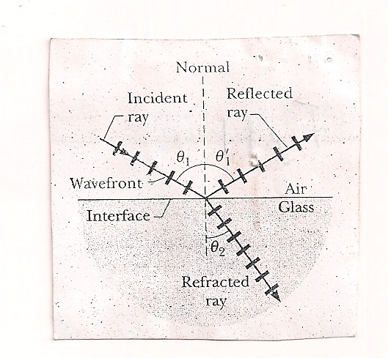

**Fig. 1.1** Representation of light travel using rays. The angles of incidence (θ1) and of reflection (θ11) are marked.

**3.2 Reflection at Plane Surface:** When we see an object, rays of light enter the eye and produce the sensation of vision. In Fig. 1.2, rays from a small (point) object O are reflected by a plane mirror so that the angle of incidence i = the angle of reflection r (law of reflection). The rays enter the eye of an observer at D. We always see images in the direction *in which the rays enter the eye*. So the image O appears to be at I, behind the mirror. Light rays never change their light path. So the ray of light CD can be reversed in direction to travel along DC: this is known as the *principle of reversibility of light*.

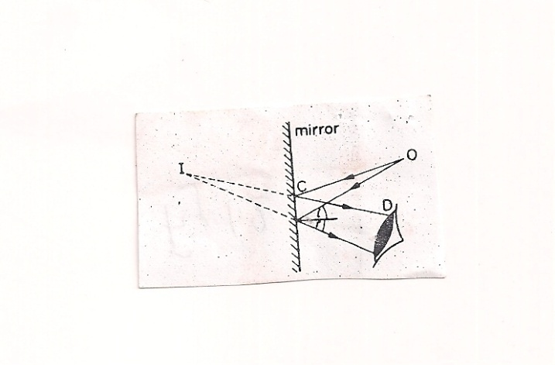

**Fig. 1.2** Reflection image

Generally, reflection may be viewed as an abrupt change in the direction of propagation of a wave that strikes the boundary between different media. At least part of the oncoming wave disturbance remains in the same medium. Regular reflection, which follows a simple law, occurs at plane boundaries. The angle between the direction of motion of the oncoming wave and a perpendicular to the reflecting surface ([angle of incidence](ebcid:com.britannica.oec2.identifier.IndexEntryContentIdentifier?idxStructId=24799&library=EB)) is equal to the angle between the direction of motion of the reflected wave and a perpendicular ([angle of reflection](ebcid:com.britannica.oec2.identifier.IndexEntryContentIdentifier?idxStructId=24811&library=EB)). Reflection at rough, or irregular, boundaries is diffuse. The reflectivity of a surface material is the fraction of energy of the oncoming wave that is reflected by it, see Figs 1.3, 1.4, and 1.5.



**Fig. 1.3** When light strikes rough surfaces, it reflects at many angles: This diffuse reflection enables illuminated objects to be seen from almost any line-of-sight location



**Fig. 1.4** Reflection of light in a mirror: According to the law of reflection, images are reflected from a smooth surface, such as a mirror, at the same angle (θ2) as the incidence angle (θ1). When the eye “sees” an object in three-dimensional space in a mirror, it is actually viewing an image along sight lines created by the reflection of light from the surface of the mirror.



**Fig. 1.5** For a smooth surface the angle of incidence (θ1) equals the angle of reflection (θ2), as measured with reference to the normal (line perpendicular) to the surface.

**Virtual and Real Images in Plane Mirror**

As was shown in Fig 1.2, an object O in front of a mirror has an image I behind the mirror. The rays reflected from the mirror do not actually pass through I, but only *appear* to do so. The image cannot be received on a screen because the image is behind the mirror, Fig. 1.6 (i). This type of image is therefore called a *virtual* image. You can see that the light beam from O is a diverging beam which appears to come from I.

Not only virtual images are obtained with a plane mirror. If a *convergent* beam is incident on a plane mirror M, the reflected rays pass through a point I *in front of* M, Fig. 1.6 (ii). If the incident beam converges to the point O, then O is called a ‘virtual’ object. I is called a real image because it can be received on a screen. Fig. 1.6 (i) and (ii) should now be compared. In the former, a real object (divergent beam) gives rise to a virtual image; in the latter, a virtual object (convergent beam) gives rise to a real image. In each case the image and object are at equal distances from the mirror. A plane mirror produces an image which is the same size as the object.

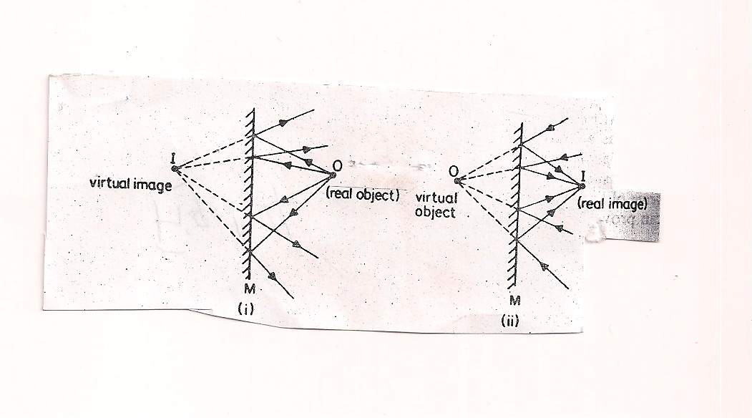

**Fig. 1.6** Virtual and real image in plane mirror

**Self-Assessment Exercise**

Imagine yourself in a barber’s shop looking into a system of two vertical parallel mirrors; these mirrors are A and B separated by distance d. You are seated at point O, a distance 0.2d from mirror A. Each mirror produces a *first* (least deep) image of the customer. Then each mirror produces a *second* image with the object being the first image in the opposite mirror. Then each mirror produces a *third* image with the object being the second image in the opposite mirror, and so on (you might see hundreds of customer images). How deep behind mirror A are the first, second, and third images in mirror A?

**3.3 Reflection by Curved Surfaces:** Curved, or spherical mirrors are simply mirrors in the shape of a small section of the surface of a sphere. Thus, it could be concluded that a plane mirror is in fact a spherical mirror with an infinitely large *radius of curvature*. Curved mirrors are widely used as driving mirrors in cars. Make-up and dentists’ mirrors are curved mirrors. The largest telescope in the world uses an enormous curved mirror to collect light from distant stars.

**Making a Spherical Mirror**

We start with the plane mirror of Fig. 1.7 (a), which faces leftward toward an object O that is shown and an observer that is not shown. We make a *concave mirror* by curving the mirror’s surface so it is *concave* (“caved in”) as in Fig. 1.7 (b). Curving the surface in this way changes several characteristics of the mirror and the image it produces of the object:

1. The *center of curvature C* (the center of the sphere of which the mirror’s surface is part) was infinitely far from the plane mirror; it is now closer but still in front of the concave mirror.
2. The *field of view* (i.e. the extent of the scene that is reflected to the observer) was wide; it is now smaller.
3. The image of the object was as far behind the plane mirror as the object was in front; the image is farther behind the concave mirror; that is /i/ is greater.
4. The height of the image was equal to the height of the object; the height of the image is now greater. This feature is why many makeup mirrors and shaving mirrors are concave – they produce a larger image of a face.

We can make a *convex mirror* by curving a plane mirror so its surface is *convex* (“flexed out”) as in Fig. 1.7 (c). Curving the surface in this way (i) moves the center of curvature C to *behind* the mirror and (ii) *increases* the field of view. It also (iii) moves the image of the object *closer* to the mirror and (4) *shrinks* it. Store surveillance mirrors are usually convex to take advantage of the increase in the field of view – more of the store can then be monitored with a single mirror.

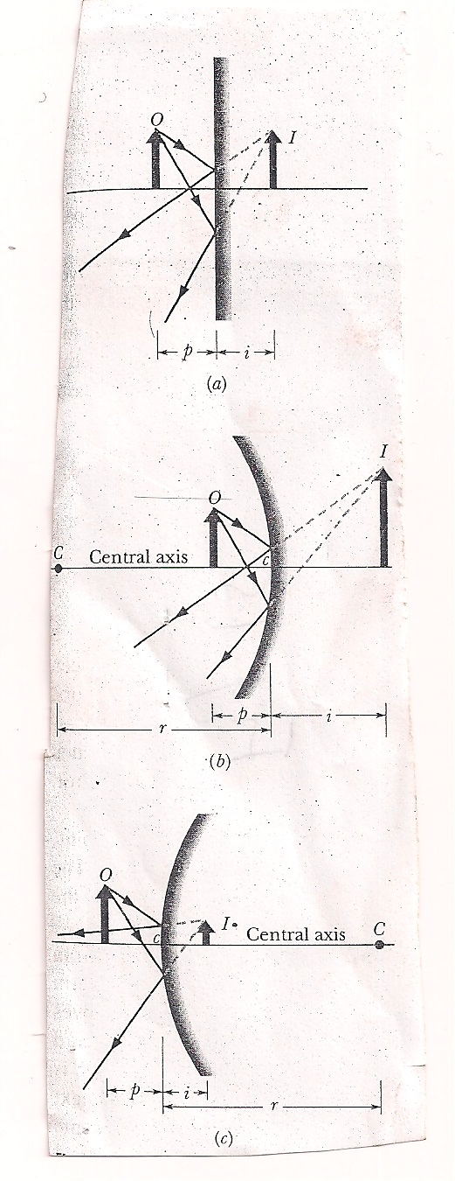

**Fig. 1.7** (a) An object O forms a virtual image I in a plane mirror. (b) If the mirror is bent so that it becomes *concave*, the image moves farther away and becomes larger. (c) If the plane mirror is bent so that it becomes *convex,* the image moves closer and becomes smaller.

British Telecom uses aerials in the shape of a paraboloid dish to send and receive radio signals. A communications satellite high above the earth sends a parallel beam of radio signals to all parts of the dish. This is reflected to a receiver at the focus, like light waves. Fig. 1.8 (i) shows a *concave mirror* P. Its surface is part of a sphere of centre C. When a *narrow* parallel beam of rays from a distant object such as the sun is incident on the middle of P, all the rays are reflected to one point or *focus* F. 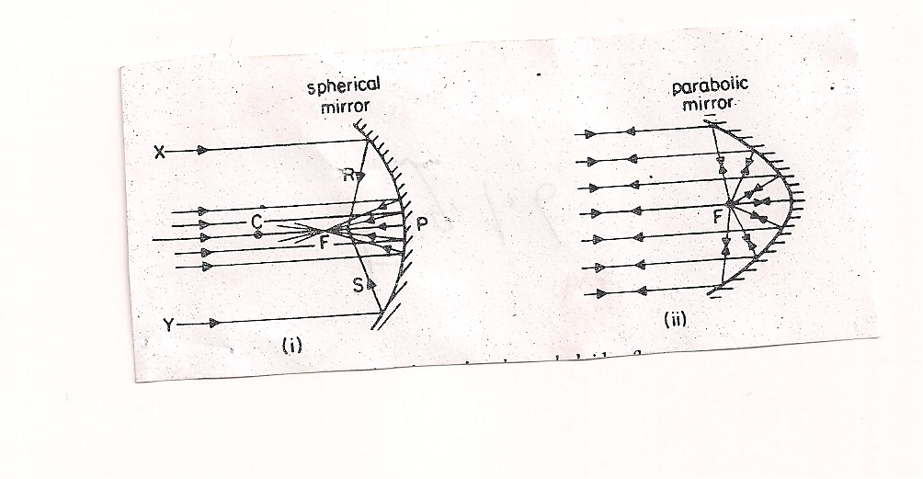

**Fig. 1.8** Spherical and paraboloid reflectors

When a *wide* beam of light XY, parallel to the principal axis, is incident on a concave spherical mirror, reflected rays such as R and S do not pass through a single point, as was the case with a narrow beam. In the same way, if a small lamp is placed at the focus F of a concave spherical mirror, those rays form the lamp which strike the mirror at points well away from the pole P will be reflected in different directions and not as a parallel beam. In this case the reflected beam diminishes in intensity as its distance from the mirror increases. So a concave spherical mirror is useless as a searchlight mirror. For this reason, a mirror whose section is the shape of a parabola (the path of a ball thrown forward into the air) is used in searchlights. A paraboloid mirror has the property of reflecting the wide beam of light from a lamp at its focus F as a perfectly parallel beam. The intensity of the reflected beam is practically undiminished as the distance from the mirror increases. For the same reason, motor headlamp reflectors and those used in torches are paraboloid in shape.

**3.4 Law of Reflection:** A reflected ray lies in the plane of incidence and has an angle of reflection equal to the angle of incidence. In Fig. 1.1, this means that

$θ_{1}^{1}= θ_{1}$ (reflection) 1.1

**4.0 Conclusion**

The idea of a ray of light “bouncing back” from plane and spherical mirrors should be familiar to you now, especially the type of image formed by each kind of mirror. Interestingly, also, is how a concave and a convex mirror are formed from a plane mirror. Do not forget that a plane mirror is actually a spherical mirror with an infinitely large *radius of curvature.*

**5.0 Summary**

**5.1 Real and Virtual Images:** An *image* is a reproduction of an object via light. If the image can form on a surface, it is a *real image* and can exist even if no observer is present. If the image requires the visual system of an observer, it is a *virtual image*.

**5.2 Image Formation:** *Spherical mirrors* can form images of a source of light (i.e. the object by redirecting rays emerging from the source. The image occurs where the redirected rays cross (forming a real image) or where backward extensions of those rays cross (forming a virtual image).

**6.0 Tutor-Marked Assignments**

i. A butterfly at about eye level is 10 cm in front of a plane mirror; you are behind the butterfly, 30 cm from the mirror. What is the distance between your eyes and the apparent position of the butterfly’s image in the mirror?

ii. You look through a camera toward an image of a bird in a plane mirror. The camera is 4.30 m in front of the mirror. The bird is at camera level, 5.00 m to your right and 3.30 m from the mirror. What is the distance between the camera and the apparent position of the bird’s image in the mirror?

**7.0 References**

**Anyakoha, M. W. 2010.** *New School Physics for Senior Secondary Schools (3ed.)*, Africana First Publishers Plc., Onitsha, Nigeria.

**Duncan, T. 1982.** *Physics: A Textbook for Advanced Level Students*, John Murray Publishers, London.

**Encyclopaedia Britannica, 2012.** *Encyclopaedia Britannica Ultimate Reference Suite*, Chicago: Encyclopædia Britannica.

**Halliday, D., Resnick, R., and Walker, J. 2001.** *Fundamentals of Physics (6 ed.),*John Wiley and Sons, New York.

**Nelkon, M. and Parker, P. 1995.** *Advanced Level Physics (7 ed.)*, CBS Publishers, New Delhi.

**Serway, R.A. and Faughn, J.S. 1992.** *College Physics (3ed.)*, Harcourt Brace Jovanovic Publishers, Florida.

**UNIT 2**

**MIRROR FORMULAE**

**Contents**

1.0 Introduction

2.0 Objectives

3.0 Plane and Curved Mirrors’ Formulae

3.1 Plane Mirror Relation

3.2 Focal Points of Spherical Mirrors

3.3 Images from Spherical Mirrors

4.0 Conclusion

5.0 Summary

6.0 Tutor-Marked Assignments (TMAs)

7.0 References

**1.0 Introduction**

Naturally, for an image to form there must be an object. The object must exist in space in relation to the particular mirror that is required to form its image. Normally, it is not necessary for the object in space to make direct contact with the mirror; thus the object has a particular clearance from the surface of the mirror that is called an *object distance*. The corresponding image is also formed at a particular distance from the surface of the mirror called an *image distance*. For a plane mirror, the relationship between the object distance and image distance is germane to understanding how the image is formed in the first place. For a curved mirror, additional variables come into play in describing the relationship between object distance and image distance: these include the focal length of the mirror as well as the ratio of the vertical orientation of the image with respect to that of the object. All these relations, expressed in compact formulae, are the objects of Unit 2.

**2.0 Objective**

At the completion of this unit, you should be able to recall with ease the operational formulae for the relationships between the image and object characteristics as well as their separations with respect to a specified mirror type.

**3.0 Plane and Curved Mirror’s Formulae**

**3.1 Plane Mirror Relation:** For a plane mirror, the magnitude of the image distance i is always equal to the object distance p. Note that this basic statement of fact refers to the “magnitude” of the object distance and image distance only; particular convention would specify “directional sense” to both the object and image locations (whether objects on the left side of the mirror should be positive- or negative-designated or whether images formed on the right side of a mirror should be likewise designated). Thus, in terms of “magnitude” only,

i = p 2.1

If a convention is adopted such that object distances are assigned as positive and image distances are assigned as negative, then

i = -p 2.2

**Self-Assessment Exercises**

1. How could a proof of Eq. 2.1 be obtained?
2. How may the operational form of Eq. 2.2, as it were, be defended?

**3.2 Focal Points of Spherical Mirrors:** Before we can determine how the object and image distances are related for a spherical mirror, we must consider the reflection of light from an object O located an effectively infinite distance in front of a spherical mirror, on the mirror’s *central axis*. That axis extends through the centre of curvature C and the centre c of the mirror. Because of the great distance between the object and the mirror, the light waves spreading from the object are plane waves when they reach the mirror along the central axis. This means that the rays representing the light waves are all parallel to the central axis when they reach the mirror.

When these parallel rays reach a concave mirror like that of Fig. 2.1 (a), those near the central axis are reflected through a common point *F*; two of these reflected rays are shown in the figure. If we placed a (small) card at *F*, a point image of the infinitely distant object *O* would appear on the card. (This would occur for any infinitely distant object.) Point *F* is called *focal point* (or*focus*) of the mirror, and its distance from the center of the mirror is the *focal length f* of the mirror.

If we now substitute a convex mirror for the concave mirror, we find that the parallel rays are no longer reflected through a common point. Instead, they diverge as shown in Fig. 2.1 (b). However, if your eye intercepts some of the reflected light, you perceive the light as originating from a point source behind the mirror. This perceived source is located where extensions of the reflected rays pass through a common point [*F* in Fig. 2.1 (b)]. That point is the focal point (or focus) *F* of the convex mirror, and its distance from the mirror surface is the focal length f of the mirror. If we placed a card at this focal point is not like that of a concave mirror.

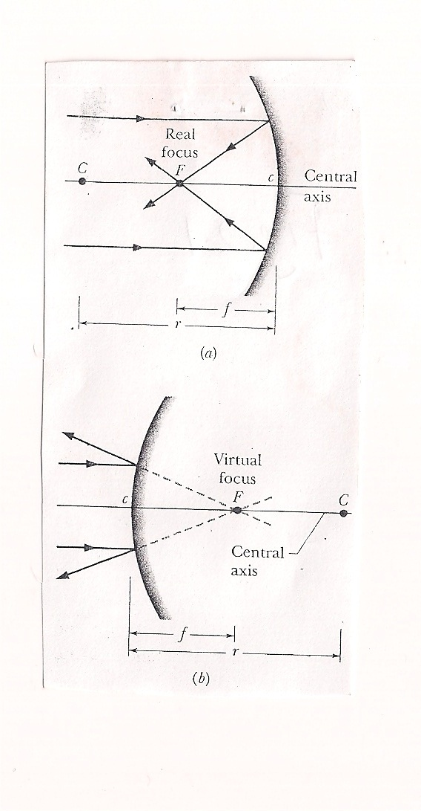

**Fig. 2.1** (a) In a concave mirror, incident parallel light rays are brought to a real focus at *F*, on the same side of the mirror as the light rays. (b) In a convex mirror, incident parallel light rays seem to diverge from a virtual focus at *F*, on the side of the mirror opposite the light rays.

To distinguish the actual point of a concave mirror from the perceived focal point of a convex mirror, the former is said to be a *real focal point* and the later is taken to be a *virtual focal point*. Moreover, the focal length *f* of a concave mirror is taken to be a positive quantity, and that of a convex mirror a negative quantity. For mirrors of both types, the focal length *f* is related to the radius of curvature r of the mirror by

*f* = ½ r (spherical mirror) 2.3

where, consistent with the signs for the focal length, r is a positive quantity for a concave mirror and a negative quantity for a convex mirror.

**Self-Assessment Exercises**

1. How may it be argued that the radius of curvature of a plane mirror is actually at infinity?
2. Examine a proof for the following relation for a spherical mirror:

f = ½ r

where f is the focal length and r is the radius of curvature.

**3.3 Images from Spherical Mirrors:** With the focal point of a spherical mirror defined, we can find the relation between image distance i and object distance p for concave and convex spherical mirrors. We begin by placing the object *O* *inside the focal point* of the concave mirror (that is, between the mirror and its focal point), Fig. 2.2 (a). An observer can then see a virtual image of *O* in the mirror. The image appears to be behind the mirror, and it has the same orientation as the object.

If we now move the object away from the mirror until it is at the focal point, the image moves farther back from the mirror until it is at infinity [Fig. 2.2 (b)]. The image is then ambiguous and imperceptible because neither the rays reflected by the mirror nor the ray extensions behind the mirror cross to form an image of *O*.

If we next move the object *outside the focal point* (that is, father away from the mirror than the focal point) the rays reflected by the mirror converge to form an *inverted* image of object *O* [Fig 2.2 (c)] in front of the mirror. That image moves in from infinity as we move the object farther outside F. if you were to hold a card at the position of the image, the image would show up on the card – the image is said to be *focused on the card by the mirror. (*The verb “focus,” which in this context means to produce an image, differs from the noun “focus,” which is another name for the focal point.) Because this image can actually appear on a surface, it is a real image – the rays actually intersect to create the image, regardless of whether an observer is present. The image distance i of a real image is a positive quantity, in contrast to that for a virtual image. Generally, *“Real images form on the side of a mirror where the object is, and virtual images form on the opposite side.”*

Furthermore, when light rays from an object make only small angles with the central axis of a spherical mirror, a simple equation relates the object distance *p*, the image *i*, and the focal length *f*:

$\frac{1}{p}+\frac{1}{i}=\frac{1}{f}$ (spherical mirror) 2.4

We assume such small angles in figures such as Fig. 2.2, but for clarity the rays are drawn with exaggerated angles. With that assumption, Eq. 2.4 applies to any concave, convex, or plane mirror. For a convex or plane mirror, only a virtual image can be formed, regardless of the object’s location on the central axis. Note that for a convex mirror, the image is always on the opposite side of the mirror from the object and has the same orientation as the object.

The size of an object or image, as measured *perpendicular* to the mirror’s central axis, is called the object or image *height*. Let *h* represent the height of the object, and *h’* the height of the image. Then the radio h’/h is called the **lateral magnification** *m* produced by the mirror. However, by convention, the lateral magnification always includes a plus sign when the image orientation is that of the object and a minus sign when the image orientation is opposite that of the object. For this reason, we write the formula for *m* as

$/m/= \frac{h^{`}}{h}$ (lateral magnification) 2.5

Note also that the lateral magnification can also be written as

$m=-\frac{i}{p}$ (lateral magnification) 2.6

For a plane mirror, for which i = -p, we have m = +1. The magnification of 1 means that the image is the same size as the object. The plus sign means that the image and the object have the same orientation. For the concave mirror of Fig. 2.2 (c), m = -1.5.

Eqs 2.3 through 2.6 hold for all plane mirrors, concave spherical mirrors, and convex spherical mirrors. In addition to those equations, you have been asked to absorb a lot of information about these mirrors, and you should organize it for yourself by filling in Table 1. Under Image Location, note whether the image is on the *same* side of the mirror as the object or on *opposite* side. Under Image Type, note whether the image is *real or virtual*. Under Image Orientation, note whether the image has the *same* orientation as the object or is *inverted*. Under Sign, give the sign of the quantity or fill in ± if the sign is ambiguous. You will need this organization to tackle homework or a test.

Table 1 Your Organising Table for Mirrors

|  |  |  |  |  |  |  |  |
| --- | --- | --- | --- | --- | --- | --- | --- |
| Mirror Type | Object Location | Image | Image | Image | Sign | Sign | Sign |
|  |  | Location | Type | Orientation | of  *f* | of *r* | of *m* |
| Plane | Anywhere |  |  |  |  |  |  |
| Concave | Inside *F*  Outside *F* |  |  |  |  |  |  |
| Convex | Anywhere |  |  |  |  |  |  |

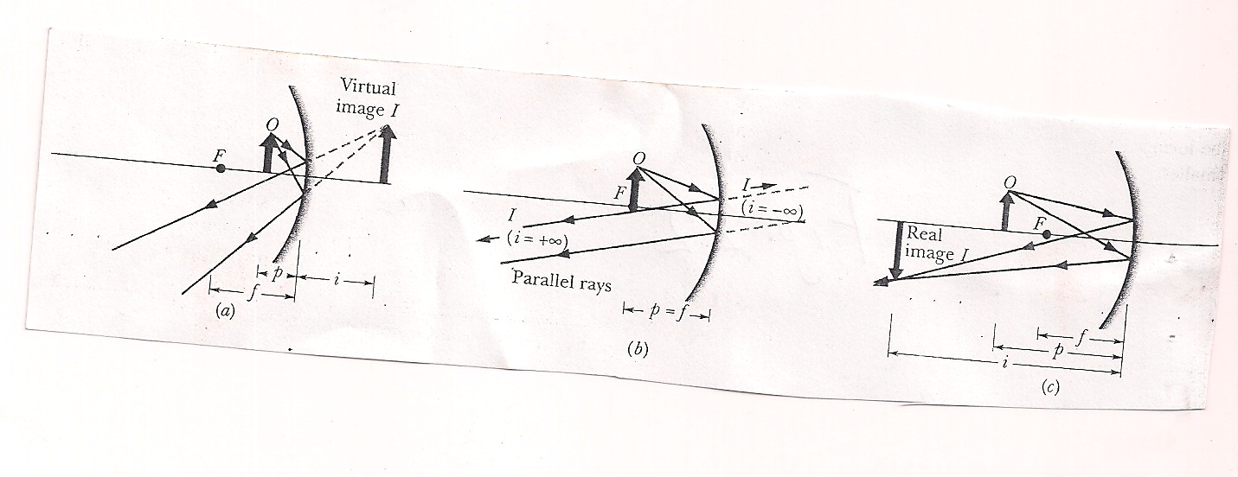

**Fig. 2.2** (a) An object O inside the focal point of a concave mirror, and its virtual image I. (b) The object at the focal point F. (c) The object outside the focal point, and its real image I.

**Locating Images by Drawing Rays**

Figs 2.3 (a) and 2.3 (b) show an object *O* in front of a concave mirror. We can graphically locate the image of any of the off-axis point of the object by drawing a *ray diagram* with any two of four special rays through the point:

1. A ray that is initially parallel to the central axis reflects through the focal point *F* [ray 1 in Fig. 2.3 (a)].
2. A ray that reflects from the mirror after passing through the focal point emerges parallel to the central axis [ray 2 in Fig. 2.3 (a)].
3. A ray that reflects from the mirror after passing through the center of curvature *C* returns along itself [ray 3 in Fig. 2.3 (b)].
4. A ray that reflects from the mirror at its intersection c with the central axis is reflected symmetrically about that axis [ray 4 in Fig. 2.3 (b)].

The image of the point is at the intersection of the two special rays you choose. The image of the object can then be found by locating the images of two or more of its off-axis points. You need to modify the descriptions of the rays slightly to apply them to convex mirrors, as in Figs 2.3 (c) and (d).

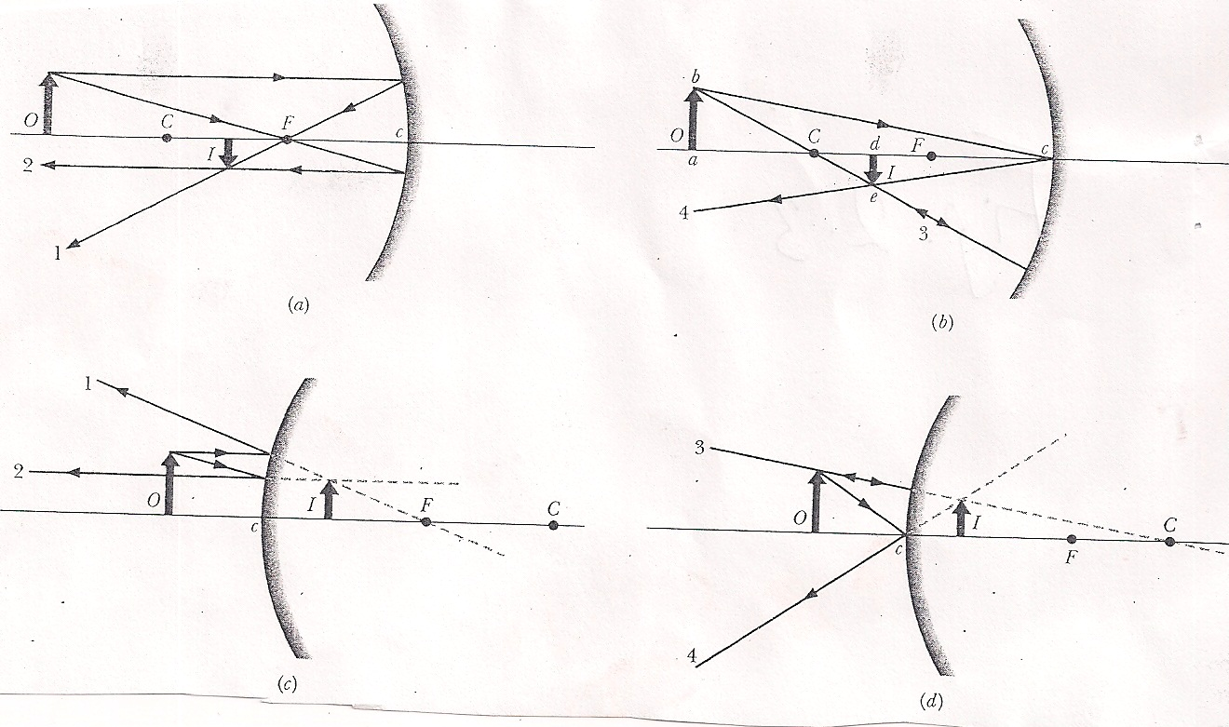

**Fig. 2.3** (a,b) Four rays that may be drawn to find the image of an object in a concave mirror. For the object position shown, the image is real, inverted, and smaller than the object. (c,d) Four similar rays for the case of a convex mirror. For a convex mirror, the image is always virtual, oriented like the object, and smaller than the object. [In (c), ray 2 is initially directed toward focal point *F*. In (d), ray 3 is initially directed toward centre of curvature *C*.].

**Self-Assessment Exercises**

1. How may it be shown that, for a spherical mirror, $\frac{1}{p}+\frac{1}{i}=\frac{1}{f}$?

where p is the object distance, i is the image distance, and f is the focal length.

1. How it be shown that the lateral magnification is also expressed as m = -i/p?
2. A tarantula spider species of height h sits cautiously before a spherical mirror whose focal length has absolute value /f/ = 40 cm. the image of the tarantula produced by the mirror has the same orientation as the tarantula and has height h1 = 0.20h. (a) Is the image real or virtual, and is it on the same side of the mirror as the tarantula or the opposite side? (b) Is the mirror concave or convex, and what is its focal length f, sign included?
3. A Central American vampire bat, dozing on the central axis of a spherical mirror, is magnified by m = -4. Is its image (a) real or virtual, (b) inverted or of the same orientation as the bat, and (c) on the same side of the mirror as the bat or on the opposite side?

**Proof of Eq. 2.6**

We are now in a position to derive Eq. 2.6 (m = -i/p), the equation for the lateral magnification of an object reflected in a mirror. Consider ray 4 in Fig. 2.3 (b). It is reflected at point c so that the incident and reflected rays make equal angles with the axis of the mirror at that point. The two right triangles *abc* and *dec* in the figure are similar (have the same set of angles), so we can write

$\frac{de}{ab}=\frac{cd}{ca}$ 2.7

The quantity on the left (apart from the question of sign) is the lateral magnification *m* produced by the mirror. Since we indicate an inverted image as a *negative* magnification, we symbolize this as –m. However, *cd =i* and *ca = p*, so we have

$m=-\frac{i}{p}$ (magnification)

**4.0 Conclusion**

Image formation,, image-object relations, image-object-focal length relationship, and suchlike concepts have been covered in Unit 2. Upon diligent study of this unit, you should be able to correctly determine the context in which any of the formulae may be appropriately applied.

**5.0 Summary**

i. An image is a representation of an object via light. If the image can form on a surface, it is a *real image* and can exist even if no observer is present. If the image requires the visual system of an observer, it is a *virtual image*.

ii. Spherical mirrors can form images of a source of light (i.e. the object) by redirecting rays emerging from the source. The image occurs where the redirected rays cross (forming a real image) or where backward extensions of those rays cross (forming a virtual image). If the rays are sufficiently close to the *central axis* through the spherical mirror, we have the following relation between the *object distance p* (which is positive) and the *image distance i* which is positive for real images and negative for virtual images):

$$\frac{1}{p}+\frac{1}{i}=\frac{1}{f}=\frac{2}{r}$$

where f is the mirror’s focal length and r is the mirror’s radius of curvature. A *plane mirror* is a special case for which r→ $∞$, so that p = -i. Real images form on the side of a mirror where the object is located, and virtual images form on the opposite side.

**6.0 Tutor-Marked Assignments**

i. Prove that if a plane mirror is rotated through an angle α, the reflected beam is rotated through an angle 2α. Show that this result is reasonable for = 450.

ii. A concave shaving mirror has a radius of curvature of 35.0 cm. It is positioned so that the (upright) image of a man’s face is 2.50 times the size of the face. How far is the mirror from the face?

iii. Fill in Table 2, each row of which refers to a different combination of an object and either a plane mirror, a spherical convex mirror, or a spherical concave mirror. Distances are in centimeters. If a number lacks a sign, find the sign. Sketch each combination and draw in enough rays to locate the object and its image.

Table 2

|  |  |  |  |  |  |  |  |  |
| --- | --- | --- | --- | --- | --- | --- | --- | --- |
|  | Type | f | r | i | p | m | Real image? | Inverted image? |
| a | Concave | 20 |  |  | +10 |  |  |  |
| b |  |  |  |  | +10 | +1.0 | No |  |
| c |  | +20 |  |  | +30 |  |  |  |
| d |  |  |  |  | +60 | -0.50 |  |  |
| e |  |  | -40 | -10 |  |  |  |  |
| f |  | 20 |  |  |  | +0.10 |  |  |
| g | Convex |  | 40 | 4.0 |  |  |  |  |
| h |  |  |  |  | +24 | 0.50 |  | Yes |

**7.0 References**

**Anyakoha, M. W. 2010.** *New School Physics for Senior Secondary Schools (3ed.)*, Africana First Publishers Plc., Onitsha, Nigeria.

**Duncan, T. 1982.** *Physics: A Textbook for Advanced Level Students*, John Murray Publishers, London.

**Encyclopaedia Britannica, 2012.** *Encyclopaedia Britannica Ultimate Reference Suite*, Chicago: Encyclopædia Britannica.

**Halliday, D., Resnick, R., and Walker, J. 2001.** *Fundamentals of Physics (6 ed.),*John Wiley and Sons, New York.

**Nelkon, M. and Parker, P. 1995.** *Advanced Level Physics (7 ed.)*, CBS Publishers, New Delhi.

**Serway, R.A. and Faughn, J.S. 1992.** *College Physics (3ed.)*, Harcourt Brace Jovanovic Publishers, Florida.

**UNIT 3**

**REFRACTION THROUGH PLANE AND CURVED SURFACES**

**Contents**

1. Introduction
2. Objectives
3. Refraction at Plane and Curved Surfaces
   1. Laws of Refraction
   2. Refractive Index
   3. Relations between Refractive Indices
   4. General Relation between n and sin i
   5. Total Internal Reflection
   6. Critical Angle Values
   7. Dispersion
   8. Real and Apparent Depth
   9. Spherical Refracting Surfaces
4. Conclusion
5. Summary
6. Tutor-Marked Assignments (TMAs)
7. References
8. **Introduction**

Your knowledge of Unit 1 should prepare you for Unit 3. By now, you are comfortable with the word “reflection.” But “refraction” is not a part of your everyday vocabulary so you would wonder, naturally, how this word relates to reflection especially as it deals with rays of light travelling through a material medium. Since, for a refraction to occur, a ray of light must travel through a material medium, it is instructive to conceptualize of refraction as a “bending” of that ray of light when it enters the second material medium as it emerges from air (usually taken as the first material medium for simplicity). Thus, while reflection involves a “sending back” of rays of light, refraction involves a “bending” of these rays of light.

Generally, in physics, refraction is the change in direction of a wave passing from one medium to another caused by its change in speed. For example, waves in deep water travel faster than in shallow; if an ocean wave approaches a beach obliquely, the part of the wave farther from the beach will move faster than that closer in, and so the wave will swing around until it moves in a direction perpendicular to the shoreline. The speed of sound waves is greater in warm air than in cold; at night, air is cooled at the surface of a lake, and any sound that travels upward is refracted down by the higher layers of air that still remain warm. Thus, sounds, such as voices and music, can be heard much farther across water at night than in the daytime.

The electromagnetic waves constituting light are refracted when crossing the boundary from one transparent medium to another because of their change in speed. A straight stick appears bent when partly immersed in water and viewed at an angle to the surface other than 90°. A ray of light of one wavelength, or colour (different wavelengths appear as different colours to the human eye), in passing from air to glass is refracted, or bent, by an amount that depends on its speed in air and glass, the two speeds depending on the wavelength. A ray of sunlight is composed of many wavelengths that in combination appear to be colourless; upon entering a glass prism, the different refractions of the various wavelengths spread them apart as in a rainbow.

1. **Objectives**

At the end of this unit, you would be able to distinguish between the geometrical-ray representation of the situations of reflection and refraction. You would also be able to calculate the refractive indices of different materials.

1. **Refraction at Plane and Curved Surfaces**
   1. **Laws of Refraction:** When a ray of light AO is incident at O on the plane surface of a glass medium, some of the light is reflected from the surface along OC in accordance with the laws of reflection. The rest of the light travels along a new direction, OB, in the glass, Fig. 3.1.

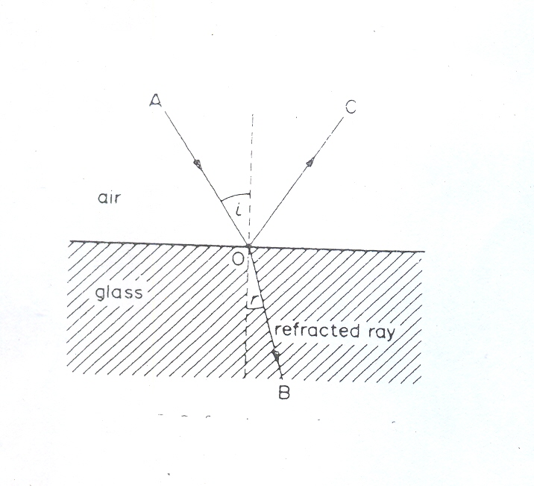

**Fig. 3.1** Refraction at plane surface

The light is said to be “refracted” on entering the glass. The *angle of refraction*, r, is the angle made by the refracted ray OB with the normal at O. Snell discovered in 1620 that the sines of the angles of incidence and refraction have a constant ratio to each other. The *laws of refraction* are:

1. The incident and refracted rays, and the normal at the point of incidence, all lie in the same plane.
2. For two given media, $\frac{\sin{i}}{\sin{r}}$ is a constant, where i is the angle of incidence and r is the angle of refraction (Snell’s law).

**Self-Assessment Exercises**

1. How would contrast the law of reflection with the laws of refraction?
2. Do you think that the angle of incidence should be equal to the angle of refraction? Give explanation for your position.
3. How would you explain refraction to a friend who is in secondary school?
   1. **Refractive Index**

The constant ratio sini/sinr is known as the *refractive index*, symbol n, for two given media. As the value of n depends on the colour of the light used, it is usually given as the value for a particular yellow wavelength emitted from sodium vapour. If the medium containing the incident ray is denoted by 1, and that containing the refracted ray by 2, the refractive index can be denoted by 1n2.

Scientists have drawn up tables of refractive indices when the incident ray is travelling in a vacuum and is then refracted into the medium, for example, glass or water. The values obtained are known as the *absolute* refractive indices of the media; and as a vacuum is always the first medium, the subscripts for the absolute refractive index, n, can be dropped. An average value for the magnitude of n for glass is about 1.5, n for water is about 1.33, n for air at normal pressure is about 1.00028. In fact the refractive index of a medium is only very slightly altered when the incident light is in air instead of a vacuum. So experiments to determine the absolute refractive index n are usually performed with the light incident from air into the medium. We can take airnglass as equal to vacuumnglass for most practical purposes.

Light is refracted because it has different speeds in different media. The wave theory of light shows that the refractive index 1n2 for two given media 1 and 2 is given by

1n2= 3.1

This is the *definition* of refractive index which can be used instead of the ratio sini/sinr. An alternative definition of the *absolute* refractive index, n, of a medium 1 is then

n= $\frac{speed of light in a vacuum, c}{speed of light in medium 1, c_{1},}$ 3.2

In practice the velocity of light in air can replace the velocity in a vacuum in this definition.

**Self-Assessment Exercises**

1. Would you agree that, in physics, the words “colour” and “wavelength” are one and the same thing?
2. Define the absolute refractive index of a medium.
3. Why is light refracted upon entering another medium from an initial medium?
4. Comparing Eqs 3.1 and 3.2, would you agree that Eq. 3.1 should be called a “*relative* refractive index?”
   1. **Relations between Refractive Indices**

1. Consider a ray of light, AO, refracted from glass to air along the direction OB. The refracted ray, OB, is bent away from the normal, Fig. 3.2. The refractive index from glass to air, gna, is given by sinx/siny where x is the angle of incidence in the glass and y is the angle of refraction in the air.

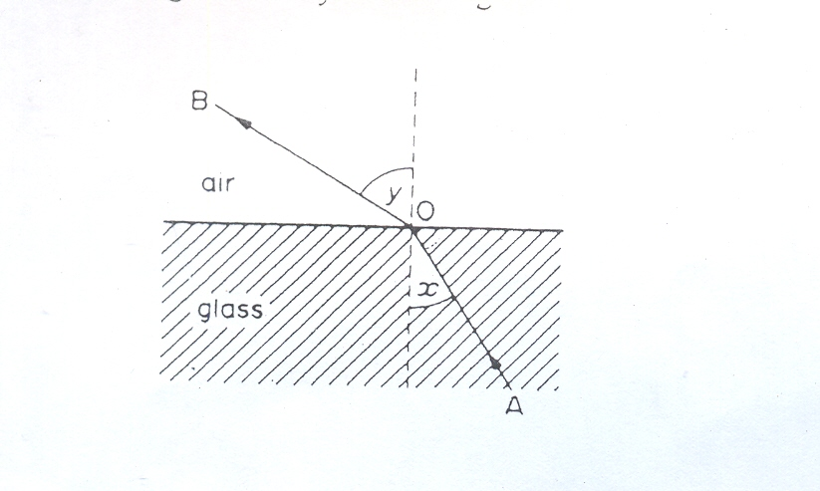

**Fig. 3.2** Refraction from glass to air

From the principle of the reversibility of light, it follows that a ray travelling along BO in air is refracted along OA is the glass. The refractive index from air to glass, ang, is given by sin y/sin x. But gna = sin x/sin y.

gna = 3.3

If ang in 1.5, then gna = 1/1.5 = 0.67. Similarly, ifthe refractive index from air to water is 4/3, the refractive index from water to air is 3/4.

1. Consider a ray AO incident in air on a plane glass boundary, then refracted from the glass into a water medium, and finally emerging a long direction CD into air. *If the boundaries of the media are parallel, the emergent ray CD is parallel to the incident ray AO*, although there is relative displacement, Fig. 3.3. So the angles made with the normals by AO, CD are equal, and let us denote them by ia.

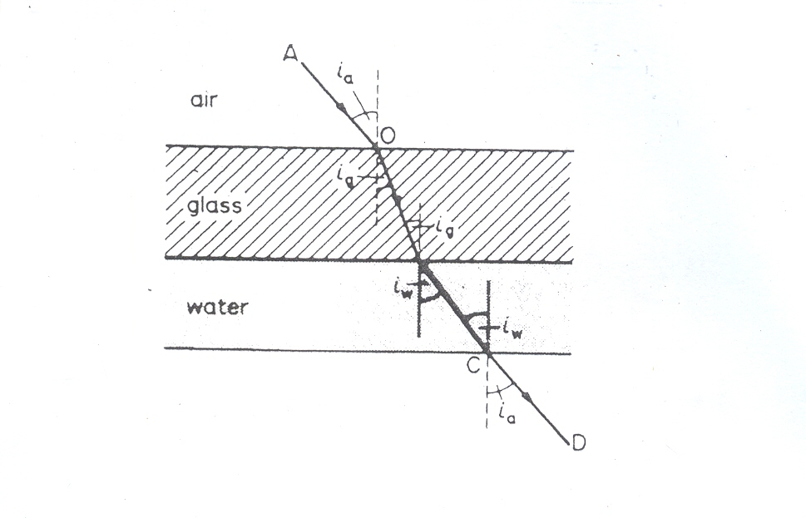

**Fig. 3.3** Refraction at parallel plane surfaces

We can find the fricative index gnw from glass to water from the ratio of the light speed in glass, cg, to that in water, cw. Assuming the speed of light in air, c, is practically the same in a vacuum,

then gcw = = x = gna x ang

= anw / ang 3.4

Using anw = 1.33 and ang = 1.5, it follows that gnw = = 0.89

We see from the equation above that, for different media 1, 2, and 3,

1n3 = 1n2 x 2n3 3.5

Note that the order of the suffices enables this formula to be easily memorized.

**Self-Assessment Exercises**

1. If a ray of light travels from a less dense medium to a mere dense medium, which of the following would be grater: angle of incidence or angle of refraction?
2. If a ray of light travels from a denser medium to a less dense medium, which of the following would be grater: angle of incidence or angle of refraction?
3. On what basis is it allowed that a ray of light should travel from glass to air?
4. Prove that for three media 1, 2 and, 3 the following relation holds true: 1n3 = 1n2 x 2n3.

**3.4 General Relation between n and sin i**

From Fig. 3.3, sinia/sinig = ang

sinia = ang sinig 3.6

Also, siniw/sinia = wna = 1/anw

sinia = anw siniw  3.7

From Eqs 3.6 and 3.7,

sinia = ang sinig = anw siniw

If the equations are re-written in terms of the absolute refractive indices of air (na), glass (ng) and water (nw), we have

na sinia = ng sinig = nw siniw

since na=1. This refraction shows that when a ray is refracted from one medium to another, the boundaries being parallel,

n sini = constant

when n is the absolute refractive index of a medium and i is the angle made by the ray with the normal in the medium. This relation also applies to the case of light passing directly from one medium to another. Suppose a ray in incident on a water-glass boundary at an angle of 600, Fig. 3.4. Then, applying “n sini is a constant”, we have

1.33 sin 600 (water) = 1.5 sin r (glass)

where r is the angle of refraction in the glass, and 1.33, 1.5 are the respective values of nw and ng. So sin r = 1.33 sin 600/1.5 = 0.7679, from which r = 50.10.

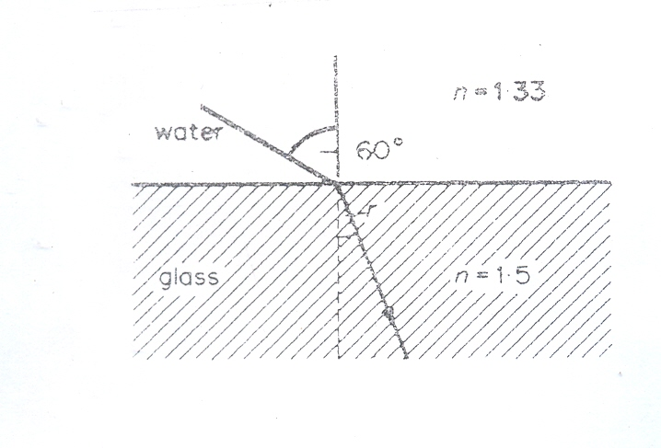

**Fig.3.4** Refraction from water to glass

**Self-Assessment Exercises**

1. How would you explain the meaning of the following expression to a secondary school girl: n sini = constant?
2. In the last example of Section 3.4, how would we be justified if we write 1.33 sin 600 (water) = 1.5 sin i (glass) instead of 1.33 sin 600 (water) = 1.5 sin r (glass)?

**3.5 Total Internal Reflection**

If a ray AO in glass is incident at a small angle α on a glass-air plane boundary, part of the incident light is reflected along OE in the glass, while the rest of the light is refracted away from the normal at an angle β into the air. The reflected ray OE is weak, but the refracted ray OL is bright, Fig. 3.5 (i). This means that most of the incident light energy is transmitted and only a little is reflected.

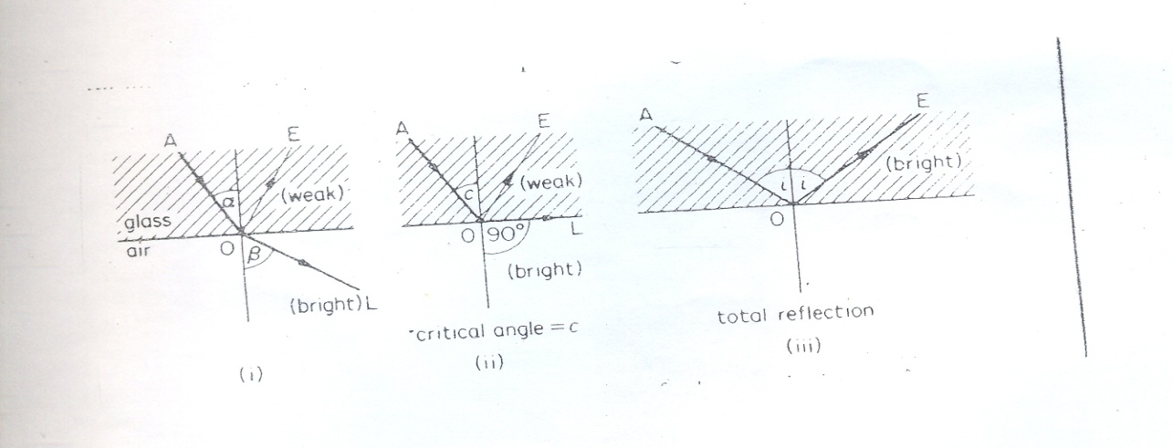

**Fig. 3.5** Total internal reflection at a perfectly smooth glass surface

When the angle of incidence, α, in the glass is increased, the angle of emergence, β, is increased at the same time. At some angle of incidence C in the glass, the refracted ray OL travels along the *glass-air boundary*, making the angle of refraction 900, Fig. 3.5 (ii). The reflected ray OE is still weak in intensity, but as the angle of incidence in the glass is increased slightly the reflected ray suddenly becomes bright, and no refracted ray is seen. Fig. 3.5 (iii) shows what happens. Since the entire incident light energy is now reflected, *total internal reflection* is said to take place in the glass at O.

**Self-Assessment Exercise**

1. List two conditions necessary for total internal reflection to occur.

**3.6 Critical Angle Values**

When the angle of refraction in air is 900**,** a critical stage is reached at the point of incidence O. the angle of incidence in the glass is known as the critical angle for glass and air, Fig. 3.5(ii). Since “n sin i is a constant”, we have

n sin C (glass) = 1 x sin 900(air)

where n is the refractive index of the glass. As sin 900= 1, then

n sin C = 1

or sin C = $\frac{1}{n}$ 3.8

Crown glass has a refractive index of about 1.51 for yellow light, and thus the critical angle for glass to air is given by sin C = 1/1.5 = 0.667. Consequently, C = 41.50. So if the incident angle in the glass is greater than C, for example 450, total internal reflection occurs, Fig. 3.5 (iii). The refractive index of glass for blue light is greater than for red light.

Total reflection may also occur when light in glass (ng = 1.51, say) is incident on a boundary with water (nw = 1.33). Applying “n sin i is a constant” to the critical case, Fig. 3.6, we have

ngsin C = nwsin 900

where C is the critical angle. As sin 900 = 1

ng sin C = nw

sin C = = = 0.889

C = 630 (approximately)

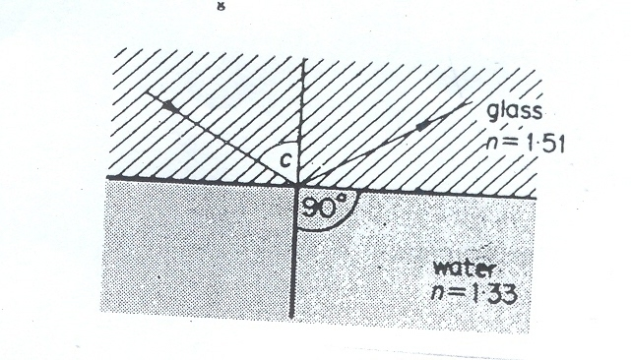

**Fig. 3.6** Critical angle for water and glass

So if the angle of incidence in the glass exceeds 630, total internal reflection occurs.

Note that total internal reflection can occur only when light travels from one medium to another which has a smaller refractive index, i.e. which is optically less dense. It cannot occur when light travels from one medium to another optically denser, for example from air to glass or from water to glass. In this case a refracted ray is always obtained.

**Self-Assessment Exercises**

1. Upon examining Figs 3.5 and 3.6, can you devise an explanation why total internal reflection cannot occur when light travels from an optically less medium to a denser medium?
2. What is the critical angle for light travelling from water to air? Refractive index of water = 4/3.
3. How would you explain the concept of “critical angle” to a friend in the secondary school?

**3.7 Dispersion**

While light has a band of wavelengths of different colours. This is called the *spectrum* of white light. The longest wavelength is red light, which has a wavelength in air of about 700 x 10-9 m (usually called “700 nanometre” or 700nm). The shortest wavelength is violet, which has a wavelength of about 450 x 10-9 m or 450nm.

In a vacuum (and particularly in air), all the colours travel at the same speed. In a medium such as glass, however, the colours travel at different speeds (red has faster speed and violet is the slowest). According to wave theory, refraction is due to the change in speed of light when it enters a different medium. So when a ray AO of white light is incident at O on a glass prism, the colours are refracted in different directions such as OBR and OCS, Fig. 3.7

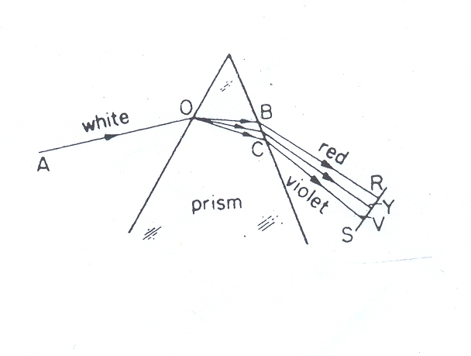

**Fig. 3.7** Dispersion in a glass prism

The glass prism has therefore separated or *dispersed* the white light into its various colours or wavelengths, as Newton first discovered in 1666. After leaving the glass, a band or spread of impure colours is formed on a white screen S. The spectrum of white light consists of (bands of) red, orange, yellow, green, blue, indigo, and violet. The separation of the colours by the prism is known as *dispersion*. The sun and the hot tungsten filament of a lamp have a continuous spectrum of visible wavelengths. Hot gases such as hydrogen and krypton have visible wavelengths which form a *line spectrum*.

**Self-assessment Exercise**

Examine Fig. 3.7 once again. Why is the ray-path of “red” higher than that of “violet” in the illustration?

**3.8 Real and Apparent Depth**

The depth of a river or a swimming pool always appears shallower than it actually is. When a glass block is placed on top of an object, e.g. a pin or a mark on a piece of paper, the object when viewed from directly above, appears nearer at the top. This apparent depth is caused by refraction. The real depth, the apparent depth, and the refractive index are related by the formula written below:

n = $\frac{real depth}{apparent depth}$ 3.9

Thus if the real depth of a river bed is 10m but its apparent depth is 7.5m then the refractive index of the river water is given by

n = $\frac{10}{7.5}$ = 1.33

**Self-Assessment Exercise**

Describe an everyday situation involving apparent depth observation.

**3.9 Spherical Refractive Surfaces**

Consider when light is emitted by a point object O in a medium with index of refraction n1; it will refract through a spherical surface into a medium of index of refraction n2. Six possible results are shown through Figs 3.8 to 3.12.

p

i

r

O

n1

n2

C

I

Real

n2 > n1

**Fig. 3.8** Refraction by a convex surface for the formation of real image. n2>n1

r

p

i

O

n1

n2

C

I

Real

n1 > n2

b.

**Fig. 3.9** Refraction by a concave surface for the formation of real image. n1>n2

O

n1

n2

C

I

Virtual

n2 > n1

**Fig. 3.10** Refraction by a convex surface for the formation of virtual image. n2>n1

n1 > n2

Virtual

I

C

O

n2

n1

**Fig. 3.11** Refraction by a concave surface for the formation of virtual image. n1>n2

n2 > n1

n1

n2

C

I

O

Virtual

**Fig. 3.12** Refraction by a concave surface for the formation of virtual image. n2>n1

**4.0 Conclusion**

Unit 3 dealt with a corresponding analogue of *reflection* through plane and curved surfaces (see Unit 1). It is instructive to compare the basic ideas of the two units and indentify correlations. Upon due completion of Unit 5, you would appreciate that the idea of a “refraction” allows for rays of light to travel through a medium unimpeded by the boundary separating the two media.

Also, in Unit 3, you examined the role that the ubiquitous glass prism of typical O’ Level and A’ Level physics experiment plays in helping us to understand the nature of white light.

Lastly, the aspect of refraction associated with concave and convex surfaces was also reviewed.

**5.0 Summary**

1. n (refractive index) = sin i/sin r (i in air )
2. n = c/cm (c = speed of light in vacuum or air, cm = speed in medium)
3. gna (glass to air) = 1/ang
4. 1n2 = 1na x an2 = an2/an1
5. Critical angle
6. Total internal reflection only occurs if light travels from a dense to a *less* dense medium.
7. Sin C = 1/n, from medium to air.
8. Sin C = n2/n1, from medium 1 to *less* dense medium 2.
9. Dispersion = separation of colour by glass (or other material like raindrop) due to their speed differences. All colours travel with the same speed in a vacuum.

**6.0 Tutor-Marked Assignments (TMAs)**

i. A ray of light is incident at 600 at an air-glass plane surface. Find the angle of refraction in the glass (n for glass = 1.5).

ii. A ray of light is incident in water at an angle of 300 on a water-air plane surface. Find the angle of refraction in the air (n for water = 4/3).

iii. A ray of light is incident in water at an angle of (i) 300; (ii) 700 on a water-glass plane surface. Calculate the angle of refraction in each case (ang = 1.5, anw = 1.33).

iv. calculate the critical angle for (i) on air-glass surface, (ii) an air-water surface, (iii) a water-glass surface; draw diagrams In each case illustrating the total reflection of a ray incident on the surface (ang=1.5, anw=1.33).

**7.0 References**

**Anyakoha, M. W. 2010.** *New School Physics for Senior Secondary Schools (3ed.)*, Africana First Publishers Plc., Onitsha, Nigeria.

**Duncan, T. 1982.** *Physics: A Textbook for Advanced Level Students*, John Murray Publishers, London.

**Encyclopaedia Britannica, 2012.** *Encyclopaedia Britannica Ultimate Reference Suite*, Chicago: Encyclopædia Britannica.

**Halliday, D., Resnick, R., and Walker, J. 2001.** *Fundamentals of Physics (6 ed.),*John Wiley and Sons, New York.

**Nelkon, M. and Parker, P. 1995.** *Advanced Level Physics (7 ed.)*, CBS Publishers, New Delhi.

**Serway, R.A. and Faughn, J.S. 1992.** *College Physics (3ed.)*, Harcourt Brace Jovanovic Publishers, Florida.

**UNIT 4**

**PRISMS AND MINIMUM DEVIATION**

**Contents**

1. Introduction
2. Objectives
3. Prisms and Minimum Deviation
   1. Refraction of Light through Triangular Prisms
   2. Minimum Deviation
4. Conclusion
5. Summary
6. Tutor-Marked Assignments (TMAs)
7. References
8. **Introduction**

By now you should be able to form mental images of what plane and curved surfaces are and what situations of reflection associated with them really mean. Recall also that for the situation of reflection to hold, one face of the plane or curved surface is usually coated by a material impermeable to light. Where this kind of coating must be avoided and where it is required to study the situation of light in its totality through a material medium, a glass block is usually adopted as that material medium. When this glass block assumes the shape of a triangle, then we are dealing with a “prism.”

1. **Objective**

At the end of this unit, you should be able to make clear distinctions between plane and curved reflection surfaces, and a prism. Henceforth, when the word “prism” is mentioned, it should not be difficult for you to form an accurate mental picture of what this really is.

1. **Prisms and Minimum Deviation**
   1. **Refraction of Light through Triangular Prisms**

When light rays travel through a rectangular glass block, the incident and the emergent rays are parallel to each other but the emergent ray is displaced to one side. There is no deviation or change in the direction of the emergent ray when compared with the incident rays. The prism deviates the incident ray through an angle known as *angle of deviation*. This is the angle between the incident ray and the emergent ray of light passing through a prism.

**Self-Assessment Exercises**

1. How is a glass prism differentiated from an ordinary glass block?
2. Explain the concept of the angle of deviation.
   1. **Minimum Deviation**

The amount of the angle of deviation is determined by (a) the angle of incidence, (b) the refracting angle of the prism, and (c) the refractive index of the material of the prism. Experiment shows that the angle of deviation (d) varies with the angle of incidence (i). There is thus a minimum angle of deviation (D) and this occurs when the incident and emergent rays are equally inclined to their respective surface. The ray passes symmetrically through the prism and the angle of incidence equals angle of emergence (i = e). It can be shown that, at minimum deviation, the refractive index (n) of the glass, the refracting angle (A) of the prism, and the angle of minimum deviation (D) are related by the following equation:

N = $\frac{sin\frac{1}{2}(A+D)}{sin\frac{1}{2}A}$

Thus by measuring the angle of minimum deviation and the refracting angle of the prism, the refractive index of the material of the prism can be calculated.

**Self-Assessment Exercise**

A ray of light experiences a minimum deviation when passing symmetrically through an equilateral triangular prism. Calculate the angle of incidence of the ray. (Refractive index of glass = 1.5.)

1. **Conclusion**

The nature of the travel of rays of light through a prism should be clear to the student. Also, note what a deviation is about, especially when such deviation is “minimum.”

1. **Summary**

The angle of deviation, D, of a light ray is the angle between the incident and emergent rays.

**6.0** **Tutor-Marked Assignment**

A ray of light is incident at an angle 300 on a glass prism of refractive index 1.5. Calculate the angle through which the ray is minimally deviated in the prism.

**7.0 References**

**Anyakoha, M. W. 2010.** *New School Physics for Senior Secondary Schools (3ed.)*, Africana First Publishers Plc., Onitsha, Nigeria.

**Duncan, T. 1982.** *Physics: A Textbook for Advanced Level Students*, John Murray Publishers, London.

**Encyclopaedia Britannica, 2012.** *Encyclopaedia Britannica Ultimate Reference Suite*, Chicago: Encyclopædia Britannica.

**Halliday, D., Resnick, R., and Walker, J. 2001.** *Fundamentals of Physics (6 ed.),*John Wiley and Sons, New York.

**Nelkon, M. and Parker, P. 1995.** *Advanced Level Physics (7 ed.)*, CBS Publishers, New Delhi.

**Serway, R.A. and Faughn, J.S. 1992.** *College Physics (3ed.)*, Harcourt Brace Jovanovic Publishers, Florida.

**UNIT 5**

**LENSES**

**Contents**

1. Introduction
2. Objectives
3. Lenses

3.1 Introduction of Lenses and Thin Lenses

3.2 Images from Thin Lenses

3.3 Locating Images of Extended Objects by Drawing Rays

1. Conclusion
2. Summary
3. Tutor-Marked Assignments (TMAs)
4. References

**1.0 Introduction**

Recall from your secondary school physics classes on “optics” that, soon after treatments of the subject matter of plane and curved mirrors, prisms, the subject matter of lenses follows naturally. What is the impression formed on your consciousness when the word “lens” is mentioned? Do you imagine a curved, thick glass material or a curved, thin glass material either of which is not coated on the opposite side? Or do you imagine the shapes of conventional spectacles?

**2.0 Objectives**

At the conclusion of Unit 5, you would be able to form an accurate mental image of the word “lens” anytime it is mentioned. You would also be able to trace images formed by a particular lens for different positions of objects.

**3.0 Lenses**

**3.1 Introduction of Lenses and Thin Lenses:** A *lens* is an object, usually made of glass, bounded by one or two spherical surfaces. (The concept of a “spherical surface” should be familiar to the student by now.) Does this definition fit the impression formed in your mind when you thought of the word “lens” a few moments ago?

Now, let us consider the definition of lens from another perspective: a *lens* is a transparent object with two refracting surfaces where the central axes coincide. Do you comprehend this line? It essentially implies that the lens must be bounded by two refracting surfaces. The central axis of each refracting surface is the line passing through the centre of that refracting surface. For a lens, this line is the same for the two refracting surfaces. When a lens is surrounded by air, light refracts from the air into the lens, crosses the lens, and then refracts back into the air. Of course, you can still recall that the concept of “refraction” is associated with the “bending” of a ray of light as it crosses from one medium to another. Thus, for this lens that is surrounded by air, each refraction can change the direction of travel of the light.

Yet another perspective: In optics, piece of glass or other transparent substance that is used to form an image of an object by focusing rays of light from the object. A lens is a piece of transparent material, usually circular in shape, with two polished surfaces, either or both of which is curved and may be either convex (bulging) or concave (depressed). The curves are almost always spherical, i.e., the radius of curvature is constant. A lens has the valuable property of forming images of objects situated in front of it. Single lenses are used in eyeglasses, contact lenses, pocket magnifiers, projection condensers, signal lights, viewfinders, and on simple box cameras. More often a number of lenses made of different materials are combined together as a compound lens in a tube to permit the *correction of aberrations*. Compound lenses are used in such instruments as cameras, microscopes, and telescopes. Fig. 5.1 shows how a convex lens and a concave lens bend rays of light.



**Fig. 5.1** Convex and concave lenses bending light

A lens that causes light rays initially parallel to the central axis to converge is called a *converging lens*. If, instead, it causes such rays to diverge, the lens is a *diverging lens*. When an object is placed in front of a lens of either type, refraction by the lens’s surface of light rays from the object can produce an image of the object. Fig. 5.2(i) illustrates three types of *converging* lenses, which are thicker in the middle than at the edges. Fig. 5.2(ii) shows three types of *diverging* lenses, which are thinner in the middle than at the edges.

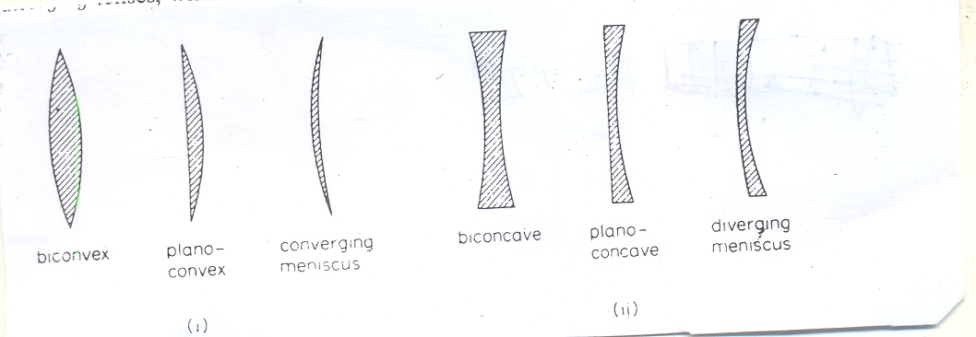

**Fig. 5.2** (i) Converging lens, (ii) Diverging lens

Now, a special case of lens is that of a *thin lens*: this is a lens in which the thickest part is thin compared to the object distance (let us call it *p*), and the image distance (let us call it *i*), and the radii of curvature (let us call them r1 and r2) of the two surfaces of the lens. The rays of light that are usually considered for thin lenses are the ones that make small angles with central axis. (Note that a thin lens has a focus (let us call the focal length *f*.)

## Experiments show that a thin converging lens brings an incident parallel beam of rays to a *principal focus*, F, on the other side of the lens when the beam is narrow and close to the principal axis, see Fig. 5.3.

## C:\Documents and Settings\KINGSPLAZA\My Documents\My Scans\2012-08 (Aug)\scan0034.jpg

## Fig. 5.3 Focus of a converging lens

## When a narrow parallel beam, close to the principal axis, is incident on a thin diverging lens, experiments also show that a beam is obtained which appears to diverge from a point F on the same side as the incident beam, see Fig. 5.4. F is known as the principal *focus* of the diverging lens. See also Fig. 5.5.

## C:\Documents and Settings\KINGSPLAZA\My Documents\My Scans\2012-08 (Aug)\scan0032.jpg

## Fig. 5.4 Focus of a diverging lens



**Fig. 5.5** (Left) Cross sections of standard forms of common lenses. (Right) Refraction of light by converging and diverging lenses, showing the principal axis, the principal focus (or focal point) *F*, the focal length *f*, and the focal plane

Let us consider a further emphasis in the context of our present discussion. A lens produces its focusing effect because light travels more slowly in the lens than in the surrounding air, so that refraction, an abrupt bending, of a light beam occurs both where the beam enters the lens and where it emerges from the lens into the air. A single lens has two precisely regular opposite surfaces; either both surfaces are curved or one is curved and one is plane. Lenses may be classified according to their two surfaces as biconvex, plano-convex, concavo-convex (converging meniscus), biconcave, plano-concave, and convexo-concave (diverging meniscus). Because of the curvature of the lens surfaces, different rays of an incident light beam are refracted through different angles, so that an entire beam of parallel rays can be caused to converge on, or to appear to diverge from, a single point. This point is called the [*focal point*](ebcid:com.britannica.oec2.identifier.IndexEntryContentIdentifier?idxStructId=211822&library=EB), or principal focus, of the lens. Refraction of the rays of light reflected from or emitted by an object causes the rays to form a visual image of the object. This image may be either [real](ebcid:com.britannica.oec2.identifier.IndexEntryContentIdentifier?idxStructId=492982&library=EB) (photographable or visible on a screen) or [*virtual*](ebcid:com.britannica.oec2.identifier.IndexEntryContentIdentifier?idxStructId=630170&library=EB) (visible only upon looking into the lens), as in a microscope. The image may be much larger or smaller than the object, depending on the focal length of the lens and on the distance between the lens and the object. The focal length of a lens is the distance from the centre of the lens to the point at which the image of a distant object is formed. A long-focus lens forms a larger image of a distant object, while a short-focus lens forms a small image.

Usually the image formed by a single lens is not good enough for precise work in such fields as astronomy, microscopy, and photography; this is because the cone of rays emitted by a single point in a distant object is not united in a perfect point by the lens but instead forms a small patch of light. This and other innate imperfections in a lens's image of a single object point are known as aberrations. To correct such aberrations, it is often necessary to combine in one mount several lens elements (single lenses), some of which may be convex and some concave, some made of dense high-refractive or high-dispersive glass, and others made of low-refractive or low-dispersive glass. The lens elements may be cemented together or mounted at carefully calculated separations to correct the aberrations of the individual elements and obtain an image of acceptable sharpness. The precise mounting also ensures that all lenses are properly centred; that is, the centres of curvature of all the lens surfaces lie on a single straight line called the principal axis of the lens. A frequently used measure of the quality of any lens system is its ability to form an image that is sharp enough to separate, or resolve, two very close dots or lines in an object. Resolving power depends on how well the various aberrations in a lens system are corrected.

The simplest compound lens is a thin cemented combination of two single lenses, such as that used in the objective (the lens nearest the object) of a small refracting telescope. Microscope objectives may contain as many as eight or nine elements, some of which may be made of different materials in order to bring all colours of light to a common focus, and thus prevent chromatic aberration. The objective lenses used in cameras may contain from two to 10 elements, while a so-called zoom or variable-focal length lens may have as many as 18 or 20 elements in several groups, the different groups being movable along the axis by levers or cams in order to produce the desired change in focal length without a shift of the focal plane. Lenses also vary greatly in diameter, from as small as 0.16 cm (1/16 inch) for an element in a microscope objective to as large as 100 cm (40 inches) for an astronomical telescope objective. In reflectors and several other types of astronomical telescopes, concave mirrors are used for the objective instead of lenses.

**Self-Assessment Exercises**

1. When a converging lens is not really thin, do you think that rays of light incident on one side of the lens would converge to a focus?
2. How is a lens different from a spherical mirror?
3. Examine the situation and draw your conclusion, using a plane paper and a pencil, when you reverse the direction of ray travel in Fig. 5.3 and Fig. 5.4.

**3.2 Images from Thin Lenses:** Let us consider the types of images formed by converging and diverging lenses. Fig. 5.6 (a) shows an object *O* outside the focal point *F*, of a converging lens. The two rays drawn in the figure shows that the lens forms a real, inverted image I of the object on the side of the lens opposite the object.

When the object is placed inside the focal point F, as in Fig. 5.6 (b), the lens forms a virtual image I on the same side of the lens as the object and with the same orientation. Hence, a converging lens can from either a real image or a virtual image, depending on whether the object is outside or inside the focal point, respectively.

Fig. 5.6 (c) shows an object *O* in front of a diverging lens. Regardless of the object distance (regardless of whether *O* is inside or outside the virtual focal point), this lens produces a virtual image that is on the same side of the lens as the object and has the same orientation.

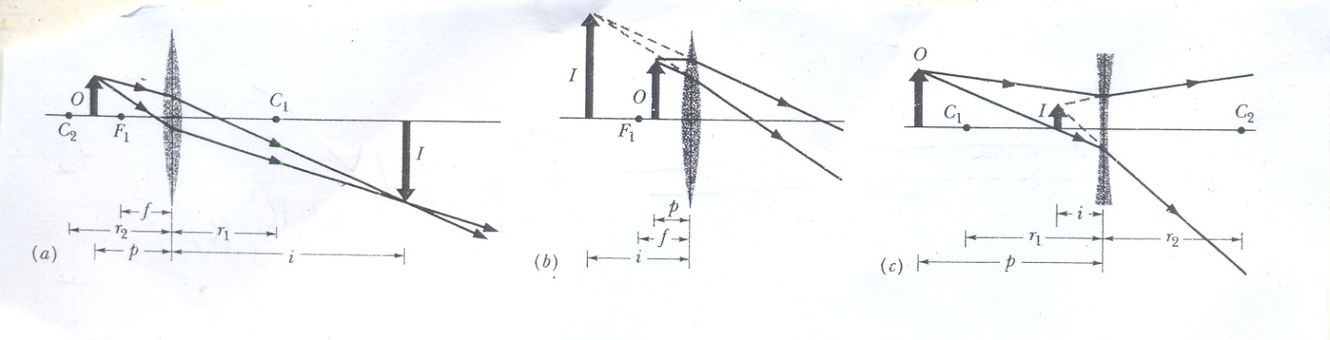

**Fig. 5.6** (a) A real, inverted image I is formed by a converging lens when the object is outside the focal point *F*, (b) The image I is virtual and has the same orientation as *O* when the object is inside the focal point, (c) A diverging lens forms a virtual image I, with the same orientation as the object *O*, whether the object is inside or outside the focal point of the lens

Note that, as with mirrors, we take the image distance, i, to be positive when the image is real and negative when the image is virtual. However, the locations of real and virtual images from lenses are the reverse of those from mirrors:

“Real images form on the side of a lens that is opposite the object, and virtual images form on the side where the object is.”

**Self-Assessment Exercises**

1. Consider the following statement: “When an object is a very long way from a converging lens, i.e. at infinity, the rays arriving at the lens from the object are parallel Thus the image is formed at the focus of the lens, and is real and inverted.” Attempt to illustrate this fact by geometrical ray-tracing technique.
2. Use a five-ray geometrical technique to illustrate the following facts:
3. When object is at a distance 2f from lens, image is real, inverted and same size as object

(b) When object is between 2f and f, image is real, inverted, and bigger than object

(c) When object is farther than 2f image is real, inverted, and smaller than object

(d) When object is nearer than f, image is upright, magnified, and virtual (this is the principle of the magnifying glass)

(e) When object is placed before a diverging lens so that the image is virtual (as always), erect, and diminished

**3.2 Locating Images of Extended Objects by Drawing Rays:** Fig. 5.7 (a) shows an object O outside the focal point, F, of a converging lens. We can graphically locate the image of any off-axis point on such an object [such as the tip of the arrow in Fig. 5.7 (a)] by drawing a ray diagram with any two of three special rays through the point. These special rays, chosen from all that pass through the lens to the image, are the following:

i. A ray that is initially parallel to the central axis of the lens will pass through focal point F2 [ray 1 in Fig. 5.7 (a)].

ii. A ray that initially passes through focal point F, will emerge from the lens parallel to the central axis [ray 2 in Fig. 5.7 (a)]

iii. A ray that is initially directed toward the centre of the lens will emerge from the lens with no change in its direction [ray 3 in Fig. 5.7 (a)] because the ray encounters the two sides of the lens where they are almost parallel.

The image of the point is located where the rays interact on the far side of the lens. The image of the object is found by locating the images of two or more of its points.

Fig. 5.7 (b) shows how the extensions of the three special rays can be used to locate the image of an object placed inside focal point F, of a converging lens. Note that the description of ray 2 requires modification (it is now a ray whose backward extension passes through F1.)

You need to modify the descriptions of rays 1 and 2 to use them to locate an image placed (anywhere) in front of a diverging lens. In Fig. 5.7 (c), for example, we find the intersection of ray 3 and the backward extensions of rays 1 and 2.

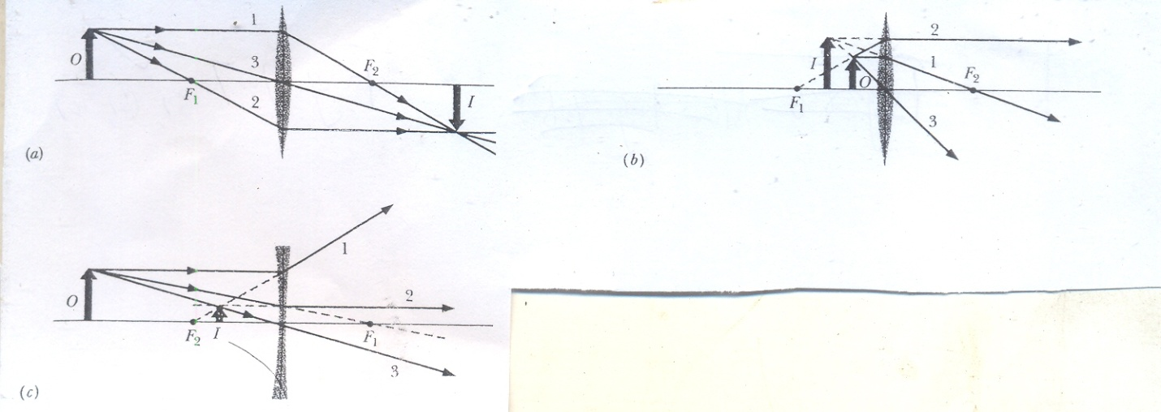

**Fig. 5.7** Three special rays allow us to locate an image formed by a thin lens whether the object O is (a) outside, or (b) inside the focal point of a converging lens, or (c) anywhere in front of a diverging lens

**Self-Assessment Exercises**

1. Of the three illustrations of Fig. 5.7, which one best describes the principle of a simple magnifying glass?
2. Based on your understanding of the situation of Qi above, how would you now describe what a magnifying glass is to someone who has no knowledge of science?

**4.0 Conclusion**

At the end of this study unit, your perception of the concept of “lens” should have broadened somewhat. You would note that neither face of a lens is coated, thus light rays from one end can be transmitted through the body of the lens material to emerge at the other end. You should also be able to make distinctions between a plane mirror, a curved mirror, and a typical mirror.

**5.0 Summary**

i. A *convex* lens has the property of *converging* rays of light to a common focus.

ii. A *concave* lens has the property of *diverging* rays of light from a common focus.

iii. When this lens is called “thin”, it means that its thickest part is thin compared to an object distance associated with the lens.

iv. Real images form on the side of a lens that is opposite the object, and virtual images form on the side where the object is.

**6.0 Tutor-Marked Assignments (TMAs)**

i. An object is 20cm to the left of a thin diverging lens having a 30cm focal length. What is the image distance? Find the image position with a ray diagram.

ii. Show that the distance between an object and its real image formed by a thin converging lens is always greater than or equal to four times the focal length of the lens.

iii. Used as a magnifying glass, the image of an object 4cm from a converging lens is five times the object length. What is the focal length of the lens?

**7.0 References**

**Anyakoha, M. W. 2010.** *New School Physics for Senior Secondary Schools (3ed.)*, Africana First Publishers Plc., Onitsha, Nigeria.

**Duncan, T. 1982.** *Physics: A Textbook for Advanced Level Students*, John Murray Publishers, London.

**Encyclopaedia Britannica, 2012.** *Encyclopaedia Britannica Ultimate Reference Suite*, Chicago: Encyclopædia Britannica.

**Halliday, D., Resnick, R., and Walker, J. 2001.** *Fundamentals of Physics (6 ed.),*John Wiley and Sons, New York.

**Nelkon, M. and Parker, P. 1995.** *Advanced Level Physics (7 ed.)*, CBS Publishers, New Delhi.

**Serway, R.A. and Faughn, J.S. 1992.** *College Physics (3ed.)*, Harcourt Brace Jovanovic Publishers, Florida.

**UNIT 6**

**LENS FORMULAE**

**Contents**

1. Introduction
2. Objectives
3. Lens Equations and Magnification Formula
   1. Signs of Focal Length, *f*
   2. Lens Equations
   3. Magnification Formula
   4. Applications of Lens Equations and Magnification Formula
      1. Converging Lens, Real Object
      2. Converging Lens, Virtual Object
      3. Converging Lens of Slide Protector
4. Conclusion
5. Summary
6. Tutor-Marked Assignment (TMAs)
7. References
8. **Introduction**

Analogous to the mirror formulae are formulae for the different type of lenses that show the relationship between the positions of an object, its image, and the focus of the lens under consideration. The magnification formula enables us to determine the relative size of the image formed of an object with respect to that object.

1. **Objectives**

At the conclusion of Unit 6, you would be able to apply the lens equations and the magnification formulae under appropriate defined conditions.

1. **Lens Equations and Magnification Formula**
   1. **Signs of Focal Length, *f***

A converging lens has a real focus. By convention, the focal length, f, of a *converging lens* is *positive* in sign. Since the focus of a *diverging lens* is virtual, the focal length of such a lens is negative in sign.

**Self- Assessment Exercises**

1. How could a converging lens be characterised by a real focus? Could you illustrate this fact by simple ray-tracing method?
2. How could a diverging lens be characterised by a virtual focus? Could you illustrate this fact by simple ray-tracing method?
   1. **Lens Equations**

The relationship between the object distance, *p*, the image distance, *i*, and the focal length, *f*, for a [thin] lens (provided a sign rule is used for distances) is expressed by the following equation:

$\frac{1}{f}=\frac{1}{p}+\frac{1}{i}$ 6.1

Eq. 1 is valid for a thin lens and it in the same as that for mirrors (that is, curved or spherical mirrors). Note that the “real is positive” sign rule which would be invoked for the use of Eq. 6.1 in the following: (a) give a *plus* (+) sign for *real* object and image distance, (b) give a *minus* (-) sign for *virtual* object and image distances. Once again, we note that the sign rule also applies to focal lengths. A converging lens has a real focus. So *f* = +10 cm for a converging lens of focal length 10 cm. A diverging lens has a virtual focus. So *f* = -20 cm for a diverging lens of focal length 20 cm.

If a thin lens, having index of refraction n is surrounded by air, then the focal length *f* is given by

$\frac{1}{f}=\left(n-1\right) (\frac{1}{r1}-\frac{1}{r2})$ 6.2

Eq. 6.2 in often called the *lens maker’s equation*. Here r1 is the radius of curvature of the lens surface nearer the object, and r2 is that of the other surface. Note that when the object faces a convex refracting surface, the radius of curvature r in positive. When it faces a concave surface, r is negative. Note also that if the lens is surrounded by some medium other than air with index of refraction nmedium, we replace n in Eq. 6.2 with n/nmedium.

Note especially that a lens can produce an image of an object only because it can bend light rays; but it can bend light rays only if its index of refraction differs from that of the surrounding medium.

**Self Assessment Exercises**

1. Could you discuss two or three similarities between spherical mirrors and thin lenses?
2. How is it possible that a lens could refract a ray of light?
   1. **Magnification Formula**

The linear (transverse) magnification, m, produced by a lens in defined as the ratio *height of image/height of object*. Numerically,

$m=\frac{i}{p}$ 6.3

**Self-Assessment Exercise**

1. What is the linear magnification if an object is one-fifth the height of its image produced by a lens?
2. What would a transverse magnification of unity mean in terms of the relationship between an object and an image?
   1. **Applications of Lens Equations and Magnification Formula**
      1. **Converging Lens, Real Object:** An object is placed 12 cm from a converging lens of focal length 18 cm. Find the position of the image.

**Solution**

Since the lens in converging, f = +18 cm. The object in real, and therefore p = +12 cm. Substituting in the expression $\frac{1}{i}+\frac{1}{p}=\frac{1}{f} leads to$

$$\frac{1}{i}+\frac{1}{(+12)}=\frac{1}{(+18)}$$

$$∴\frac{1}{i}=\frac{1}{18}-\frac{1}{12}=-\frac{1}{36}$$

$$∴i=-36cm$$

Since i is negative in sign the image in virtual, and it is 36 cm from the lens. The magnification is,

$$m=\frac{i}{p}=-\frac{36}{12}=-3$$

So the object is magnified three times and the minus shows it is upright (magnifying glass).

**3.4.2** **Converging Lens, Virtual Object:** A beam of light, converging to a point 10 cm behind a converging lens, is incident on the lens. Find the position of the point image if the lens has a focal length of 40 cm.

**Solution**

If the incident beam converges to the point *O*, then *O* is the *virtual object*, Fig. 6.1.

I

O

10

**Fig. 6.1** Virtual object

Thus p = -10cm. Also, f = +40cm, since the lens is converging.

Substituting in $\frac{1}{i}+\frac{1}{p}=\frac{1}{f} yields$

$$\frac{1}{i}+\frac{1}{(-10)}=\frac{1}{(+40)}$$

$$∴\frac{1}{i}=\frac{1}{40}+\frac{1}{10}=\frac{5}{40}$$

$$∴i=\frac{40}{5}=8$$

Since *i* is positive in sign the image is *real*, and it is 8 cm from the lens. The image is I in Fig. 6.1.

If the beam of light formed an object of finite size at *O*, and a real image of this object at I, then

magnification $\frac{i}{p}=\frac{8}{-10}=-0.8$

So the image is smaller than the object.

**Diverging lens**

Suppose a beam converges to a point 10 cm behind a diverging lens of focal length 40 cm, so f = +40 cm . Then p = -10 cm (virtual object).

So $\frac{1}{i}+\frac{1}{(-10)}=\frac{1}{(-40)}$

Solving, v = 40/3=13.3 cm. So real image is formed 13.3 cm behind the lens.

**3.4.3. Converging Lens of Slide Protector:** A slide protector has a converging lens of focal length 20.0 cm and is used to magnify the area of a slide, 5cm2, to an area of 0.8cm2 on a screen. Calculate the distance of the slide from the projector lens.

**Solution**

The ratio *area* of image/*area* of object = 0.8m2/5cm2

=

(Note that: 1m2=104cm2)

So the linear magnification m = square root of area ratio = 40

$∴\frac{i}{p}=40, and i=40$ p

From the lens equation $\frac{1}{i}+\frac{1}{p}=\frac{1}{f}$, since *i* and *p* are both real and positive.

Thus $\frac{1}{40p}+\frac{1}{p}=\frac{1}{+20}$

Solving, u = $\frac{41}{2}=20.5cm$

**4.0 Conclusion**

After studying Unit 6, you should be able to recall without error the different “sign rules” used as convention to correctly assign “direction” to either of object, image, or focal distances. The lens formulae and the magnification formula should now be familiar to you like other very common formulae of general physics.

1. **Summary**

*Lens*: f = +ve for converging (convex) lenses, f =-ve for diverging (concave) lenses

*Converging (convex) lens*: Real focus. Image is real if object *further* than *f* from lens. Nearer than *f*, image is larger than object, same way up and virtual (= magnifying glass). Image distance found from lens equation $\frac{1}{i}+\frac{1}{p}=\frac{1}{f}$. Linear magnification = image length/object length = *i*/*p*.

*For thin lens*: $\frac{1}{p}+\frac{1}{i}=\frac{1}{f}\left(n-1\right)(\frac{1}{r1}-\frac{1}{r2}$)

where f is the lens’s focal length, n is the index of refraction of the lens material, r and r2 are the radii of curative of the two sides of the lens, which are spherical surfaces.

*Lateral Magnification*: The *lateral magnification*, m, produced by a spherical mirror or a thin lens is

$m=-\frac{i}{p}$

The *magnitude* of m is given by

/m/ $=\frac{h^{'}}{h}$

where h and h1 are the heights (measured perpendicular to the central axis) of the object and image respectively.

**6.0 Tutor Marked Assignment**

i. An object is placed (i) 12 cm; (ii) 4 cm from a converging lens of focal length 6 cm. Calculate the image position and the magnification in each case.

ii. The image obtained with a converging lens is upright and three times the length of the object. The focal length of the lens is 20cm. Calculate the object and image distances.

iii. Used as a magnifying glass, the image of an object 4cm from a converging lens is five times the object length. What is the focal length of the lens?

**7.0 References**

**Anyakoha, M. W. 2010.** *New School Physics for Senior Secondary Schools (3ed.)*, Africana First Publishers Plc., Onitsha, Nigeria.

**Duncan, T. 1982.** *Physics: A Textbook for Advanced Level Students*, John Murray Publishers, London.

**Encyclopaedia Britannica, 2012.** *Encyclopaedia Britannica Ultimate Reference Suite*, Chicago: Encyclopædia Britannica.

**Halliday, D., Resnick, R., and Walker, J. 2001.** *Fundamentals of Physics (6 ed.),*John Wiley and Sons, New York.

**Nelkon, M. and Parker, P. 1995.** *Advanced Level Physics (7 ed.)*, CBS Publishers, New Delhi.

**Serway, R.A. and Faughn, J.S. 1992.** *College Physics (3ed.)*, Harcourt Brace Jovanovic Publishers, Florida.

**UNIT 7**

**COMBINATION OF LENSES**

**Contents**

1. Introduction
2. Objectives
3. Combination of Lenses
4. Conclusion
5. Summary
6. Tutor-Marked Assignment (TMAs)
7. References

**1.0 Introduction**

You may be wondering why it is even required to combine lens at all. Well, we know that a particular lens can be used as a magnifying glass but when two of these particular lenses are used together the overall magnification increased markedly. There are many practical situations where it is necessary to achieve improved magnification before the detail if an object can be made out.

**2.0 Objective**

At the end of this unit, you should know by what magnitude the overall lateral magnification of a two-lens system in expressed.

**3.0 Combination of Lenses**

When an object *O* is placed in front of a system of two lenses whose central axes coincide, we can locate the final image of the system (that is, the image produced by the lens farther from the object) by working in steps. Let lens 1 be the nearer lens and lens 2 be the farther lens.

**Step1.** We let p1 represent the distance of object O from lens 1. We then find the distance i1 of the image produced by lens 1, either by the use of Eq. 7.1, below, or by drawing rays:

$\frac{1}{f}= \frac{1}{p}+\frac{1}{i}$ 7.1

**Step2.** Now, ignoring the presence of Lens 1, we treat the image found in step 1 *as the object* for lens 2. If this new object is located beyond lens 2, the object distance p2 for lens 2 is taken to be negative. (Note this exception to the rule that says the object distance is positive; the exception occurs because the object here is on the same side opposite the source of light.) Otherwise, p2 is taken to be positive as usual. We then find the distance i2 of the (final) image produced by lens 2 by use of Eq. 7.1 or by drawing rays.

A similar step-by-step solution can be used for any number of lenses or if a mirror is substituted for lens 2. The overall lateral magnification M produced by a system of two lenses is the product of the lateral magnification m1 and m2 produced by the two lenses:

M = m1m2 7.2

**Self-Assessment Exercises**

1. Illustrate the situation of Step 1 above by the use of appropriate designations for lens and rays.
2. Show that the overall lateral magnification, M, produced by a system of two lenses is M = m1m2 where m1 and m2 are the lateral magnifications of the two lenses.

**4.0 Conclusion**

The use of a multiple-lens system improves the overall magnification of an optical unit built for that purpose. A two-lens system is the simplest of the lot.

**5.0 Summary**

i. The *lateral magnification*, m, produced by a thin lens in

$m=-\frac{i}{p}$ 7.3

ii. The magnitude of m is given by

$\left|m\right|= \frac{h^{1}}{h}$ 7.4

where h and h1are the heights (measured perpendicular to the central axis) of the object and image, respectively.

**6.0 Tutor-Marked Assignments (TMAs)**

i. A diverging lens with a focal length of -15 cm and a converging lens with a focal length of 12 cm have a common central axis. Their separation is 12 cm. An object of height 1.0 cm is 10 cm in front of the diverging lens, on the common central axis. (a) Where does the lens combination produce the final image of the object (the one produced by the second, converging lens)? (b) What is the height of that image? (c) Is the image real or virtual? (d) Does the image have the same orientation as the object or is it inverted?

ii. A converging lens with a focal length of +20 cm is located 10 cm to the left of a diverging lens having a focal length of – 15 cm. If an object is located 40 cm to the left of the converging lens, locate and describe completely the final image formed by the diverging lens.

**7.0 References**

**Anyakoha, M. W. 2010.** *New School Physics for Senior Secondary Schools (3ed.)*, Africana First Publishers Plc., Onitsha, Nigeria.

**Duncan, T. 1982.** *Physics: A Textbook for Advanced Level Students*, John Murray Publishers, London.

**Encyclopaedia Britannica, 2012.** *Encyclopaedia Britannica Ultimate Reference Suite*, Chicago: Encyclopædia Britannica.

**Halliday, D., Resnick, R., and Walker, J. 2001.** *Fundamentals of Physics (6 ed.),*John Wiley and Sons, New York.

**Nelkon, M. and Parker, P. 1995.** *Advanced Level Physics (7 ed.)*, CBS Publishers, New Delhi.

**Serway, R.A. and Faughn, J.S. 1992.** *College Physics (3ed.)*, Harcourt Brace Jovanovic Publishers, Florida.

**UNIT 8**

**SPHERICAL AND CHROMATIC ABERRATIONS**

**Contents**

1. Introduction
2. Objectives
3. Spherical and Chromatic Aberrations
4. Conclusion
5. Summary
6. Tutor-Marked Assignments (TMAs)
7. References

**1.0 Introduction**

An “aberration” is a situation or process that does not conform to the norm. Thus, intuitively, the idea of a spherical aberration situation should occur to us as one that involves the distortion in the images formed by objects having spherical surfaces. Since the word “chromatic” is an adjective that is connected with or related to colour or colour phenomena, it follows then that “chromatic aberration” would be associated with the situation when the different colours of a source of light from an object do not combine to form the image of the object at a defined focus.

In technical parlance, aberration in optical systems (such as lenses and curved mirrors) is the deviation of light rays through lenses, causing images of objects to be blurred. In an ideal system, every point on the object will focus to a point of zero size on the image. Practically, however, each image point occupies a volume of finite size and unsymmetrical shape, causing some blurring of the whole image. Unlike a plane mirror, which yields images free of aberrations, a [lens](ebcid:com.britannica.oec2.identifier.ArticleIdentifier?articleId=47770&library=EB&query=null&title=lens" \l "9047770.toc) is an imperfect image producer, becoming ideal only for rays passing through its centre parallel to the optical axis (a line through the centre, perpendicular to the lens surfaces). The equations developed for object-image relations in a lens having spherical surfaces are only approximate and deal only with paraxial rays—*i.e.,* rays making only small angles with the optical axis. When light of only a single wavelength is present, there are five aberrations to be considered, called spherical aberration, coma, astigmatism, curvature of field, and distortion. A sixth aberration found in lenses (but not mirrors)—namely, chromatic aberration—results when light is not monochromatic (not of one wavelength).

**2.0 Objectives**

At the end of this topic, the student should be familiar with the optical flaws called *spherical aberration* and *chromatic aberration*.

**3.0 Spherical and Chromatic Aberrations**

It is instructive to take into account the difference between real lenses and the ideal thin lenses that have been introduced in this course. A real lens with spherical surfaces does not form sharp images, a flaw called *spherical aberration*. Also, because refraction by the two surfaces of a real lens depends on the wavelength, a real lens does not focus light of different wavelengths to the same point, a flaw called *chromatic aberration*.

In *[spherical aberration](ebcid:com.britannica.oec2.identifier.IndexEntryContentIdentifier?idxStructId=559630&library=EB)*, rays of light from a point on the optical axis of a lens having spherical surfaces do not all meet at the same image point. Rays passing through the lens close to its centre are focused farther away than rays passing through a circular zone near its rim. For every cone of rays from an axial object point meeting the lens, there is a cone of rays that converges to form an image point, the cone being different in length according to the diameter of the circular zone. Wherever a plane at right angles to the optical axis is made to intersect a cone, the rays will form a circular cross section. The area of the cross section varies with distance along the optical axis, the smallest size known as the *circle of least confusion*. The image freest of spherical aberration is found at this distance, see Fig. 8.1.



**Fig. 8.1** Spherical aberration: Light rays form a circular cross section that varies with distance along the optical axis; the smallest size is known as the circle of least confusion. The image with the least spherical aberration is found at this distance

Chromatic aberration is colour distortion in an image viewed through a glass lens. Because the [*refractive index*](ebcid:com.britannica.oec2.identifier.ArticleIdentifier?articleId=63034&library=EB&query=null&title=refractive%20index#9063034.toc) of glass varies with wavelength, every property of a lens that depends on its refractive index also varies with wavelength, including the focal length, the image distance, and the image magnification. The change of image distance with wavelength is known as *chromatic aberration*, and the variation of magnification with wavelength is known as *chromatic difference of magnification*, or *lateral colour*.

**Correction of Chromatic Aberration**

Chromatic aberration can be eliminated by combining a strong lens of low-dispersion (crown) glass with a weaker lens made of high-dispersion (flint) glass. Such a combination is said to be *achromatic*. This method of removing chromatic aberration was discovered in 1729 by [Chester Hall](ebcid:com.britannica.oec2.identifier.ArticleIdentifier?articleId=38910&library=EB&query=null&title=Chester%20Hall#9038910.toc), an English inventor, and it was exploited vigorously in the late 18th century in numerous small [*telescopes*](ebcid:com.britannica.oec2.identifier.ArticleIdentifier?articleId=111077&library=EB&query=null&title=telescopes#9111077.toc). Chromatic variation of magnification can be eliminated by achromatizing all the components of a system or by making the system symmetrical about a central diaphragm. Both chromatic aberration and lateral colour are corrected in every high-grade optical system. Fig. 8.2 illustrates the situation of chromatic aberration.



**Fig. 8.2** Chromatic aberration: Different wavelengths of light have different focal points

**Self-Assessment Exercises**

1. If you are challenged by a secondary school student to distinguish between spherical aberration and chromatic aberration, how would you handle this?
2. Is there some other means you could devise by which the phenomenon of chromatic aberration would be eliminated?

**4.0 Conclusion**

Always keep in mind that an imperfect lens is the one that exhibits chromatic aberration. This is the situation associated with “practical” lenses. The perfect lens, that would not exhibit chromatic aberration, is the ideal “thin lens” that was introduced earlier on. Thus, for an imperfect lens, different colours of light are focused on to different positions in the image. If this chromatic aberration is detected and processed, it provides more information about the colours in an image than we would otherwise have.

**5.0 Summary**

i. A real lens does not focus lights of different wavelengths to the same point.

ii. The ideal lens is the “thin lens.”

**6.0 Tutor-Marked Assignments (TMAs)**

i. Use the ray-tracing technique to illustrate the phenomenon of chromatic aberration.

ii. By further use of the ray-tracing technique, illustrate how chromatic aberration may be corrected.

**7.0 References**

**Anyakoha, M. W. 2010.** *New School Physics for Senior Secondary Schools (3ed.)*, Africana First Publishers Plc., Onitsha, Nigeria.

**Duncan, T. 1982.** *Physics: A Textbook for Advanced Level Students*, John Murray Publishers, London.

**Encyclopaedia Britannica, 2012.** *Encyclopaedia Britannica Ultimate Reference Suite*, Chicago: Encyclopædia Britannica.

**Halliday, D., Resnick, R., and Walker, J. 2001.** *Fundamentals of Physics (6 ed.),*John Wiley and Sons, New York.

**Nelkon, M. and Parker, P. 1995.** *Advanced Level Physics (7 ed.)*, CBS Publishers, New Delhi.

**Serway, R.A. and Faughn, J.S. 1992.** *College Physics (3ed.)*, Harcourt Brace Jovanovic Publishers, Florida.

**UNIT 9**

**OPTICAL INSTRUMENTS**

**Contents**

1. Introduction
2. Objectives
3. Optical instruments

3.1 Overview

3.2 Simple Magnifying Glass

3.3 Compound Microscope

3.4 Refracting Telescope

4.0 Conclusion

5.0 Summary

6.0 Tutor-Marked Assignments (TMAs)

7.0 References

1. **Introduction**

What would the term “optical instrument” invoke in your mind? Obviously, this must be an instrument that operates on the principles of “optics” that you have learnt in physics. Could you still recall these topics? From reflection, refraction mirrors, etc., all the way to the idea of chromatic aberration. It should be obvious that any optical instrument must incorporate any one of the aspects of optical units like mirrors, lenses, etc.

1. **Objectives**

Upon completing a study of this unit, you should know how mirrors and lenses could be properly oriented so that the effective range of the human vision can be markedly extended. You would also be able to distinguish the various optical instruments based on their operational modes.

1. **Optical Instruments**

**3.1 Overview**: The human eye is a remarkably effective organ, but the range can be extended in many ways by optical instruments such as eyeglasses, simple magnifying lenses, motion picture projectors, cameras (including TV cameras), microscopes, and telescopes. Many such devices extend the scope of our vision beyond the visible range; satellite-borne infrared cameras and x-ray microscopes are just two examples.

### Optical systems

#### System components

An optical system consists of a succession of elements, which may include lenses, mirrors, light sources, detectors, projection screens, reflecting prisms, dispersing devices, filters and thin films, and fibre-optics bundles.

##### **Lenses**

All optical systems have an aperture stop somewhere in the system to limit the diameter of the beams of light passing through the system from an object point. By analogy with the human eye, this limiting aperture stop is called the iris of the system, its images in the object and image spaces being called the entrance [pupil](ebcid:com.britannica.oec2.identifier.ArticleIdentifier?articleId=61931&library=EB&query=null&title=pupil#9061931.toc) and exit pupil, respectively. In most photographic lenses the iris is inside the objective, and it is often adjustable in diameter to control the image illumination and the depth of field. In telescope and microscope systems the cylindrical mount of the objective lens is generally the limiting aperture or iris of the system; its image, formed behind the eyepiece where the observer's eye must be located to see the whole area being observed, called the field, is then the exit pupil.

The pupils of a lens system can be regarded as the common bases of oblique beams passing through the system from all points in an extended object. In most systems, however, the mounts of some of the lens elements cut into the oblique beams and prevent the beams from being perfectly circular, and the pupils are then not fully filled with light. This effect is known as *vignetting* and leads to a reduction in illumination in the outer parts of the field of view.

A common feature of many optical systems is a relay lens, which may be introduced to invert an image or to extend the length of the system, as in a military periscope. An example of the use of a relay lens is found in the common rifle sight shown diagrammatically in Fig. 9.1. Here the front lens *A* is the objective, forming an inverted image of the target on the cross wire or reticle at *B*. The light then proceeds to the relay lens *C*, which forms a second image, now erect, at *D*. Beyond this image is the eyepiece *E* to render the light parallel so that the image may be seen sharply by the observer. Unfortunately, the oblique beam from the objective will usually miss the relay lens, and so a field lens must be inserted at or near the first image *B* to bend the oblique beams around and redirect them toward the relay lens. The power of the field lens is chosen so that it will form an image of the objective lens aperture on the relay lens aperture. The iris and entrance pupil of this system coincide at the objective; there is an internal pupil at the relay lens, and the exit pupil lies beyond the eyepiece as shown in [Fig.](ebcid:com.britannica.oec2.identifier.AssemblyIdentifier?assemblyId=3023&type=A) 9.1.



[**Fig.**](ebcid:com.britannica.oec2.identifier.AssemblyIdentifier?assemblyId=3023&type=A) **9.1** Operating principle of the telescopic rifle sight (see text)

##### [**Mirrors**](ebcid:com.britannica.oec2.identifier.ArticleIdentifier?articleId=52946&library=EB&query=null&title=Mirrors#9052946.toc)

Mirrors are frequently used in optical systems. Plane mirrors may be employed to bend a beam of light in another direction, either for convenience or to yield an image reversed left for right if required. Curved mirrors, concave and convex, may be used in place of lenses as image-forming elements in reflecting telescopes. All of the world's largest telescopes and many small ones are of the reflecting type. Such telescopes use a concave mirror to produce the main image, a small secondary mirror often being added to magnify the image and to place it in a convenient position for observation or photography. Telescope mirrors are commonly made parabolic or hyperbolic in section to correct the aberrations of the image. Originally telescope mirrors were made from polished “speculum metal,” an alloy of copper and tin, but in 1856 [Justus von Liebig](ebcid:com.britannica.oec2.identifier.ArticleIdentifier?articleId=48177&library=EB&query=null&title=Justus%20von%20Liebig#9048177.toc), a German chemist, invented a process for forming a mirror-like layer of silver on polished glass, which was applied to telescope mirrors by the German astronomer [C.A. von Steinheil](ebcid:com.britannica.oec2.identifier.ArticleIdentifier?articleId=104863&library=EB&query=null&title=C.A.%20von%20Steinheil#9104863.toc). Today most mirrors are made of glass, coated with either a chemically deposited silver layer or more often one made by depositing vaporized aluminum on the surface. The aluminum surface is as highly reflective as silver and does not tarnish as readily.

A large astronomical mirror presents many problems to the optical engineer, mainly because even a distortion of a few microns of the mirror under its own weight will cause an intolerable blurring of the image. Though many schemes for supporting a mirror without strain have been tried, including one to support it on a bag of compressed air, the problem of completely eliminating mirror distortion remains unsolved. A metal mirror, if well ribbed on the back, may be lighter than a glass mirror and therefore easier to handle, but most metals are slightly flexible and require just as careful support as glass mirrors. Since temperature changes can also cause serious distortion in a mirror, astronomers try to hold observatory temperatures as constant as possible.

**Light sources**

Many types of optical instruments form images by natural light, but some, such as microscopes and projectors, require a source of artificial light. Tungsten filament lamps are the most common, but if a very bright source is required, a carbon or xenon arc is employed. For some applications, mercury or other gas discharge tubes are used; a [laser](ebcid:com.britannica.oec2.identifier.ArticleIdentifier?articleId=47248&library=EB&query=null&title=laser#9047248.toc) beam is often employed in scientific applications. Laser light is brilliant, monochromatic, collimated (the rays are parallel), and coherent (the waves are all in step with each other), any or all of these properties being of value in particular cases.

##### **Detectors**

The image formed by an optical system is usually received by the eye, which is a remarkably adaptable and sensitive detector of radiation within the visible region of the electromagnetic spectrum. A photographic film, another widely used detector, has the advantage of yielding a permanent record of events. Since about 1925 many types of electrical detectors of radiation, both within the visible region and beyond it, have been developed. These include photoelectric cells of various kinds in which either a voltage or a resistance is modified by light falling on the device. Many new types of detectors are sensitive far into the [infrared](ebcid:com.britannica.oec2.identifier.IndexEntryContentIdentifier?idxStructId=287958&library=EB) spectrum and are used to detect the heat radiated by a flame or other hot object. A number of image intensifiers and converters, particularly for X-ray or infrared radiation, which have appeared since World War II, embody a radiation detector at one end of a vacuum tube and an electron lens inside the tube to relay the image on to a phosphor screen at the other end. This arrangement produces a visible picture that may be observed by eye or photographed to make a permanent record.

Television camera tubes detect real images by electronic scanning, the picture on the viewing tube being a replica of the image in the original [camera](ebcid:com.britannica.oec2.identifier.ArticleIdentifier?articleId=18803&library=EB&query=null&title=camera#9018803.toc). The combined application of electronics and optics has become common. An extreme example of electro-optics appears in some space cameras, in which the film is exposed, processed, and then scanned by a tiny point of light; the light passing through the film is picked up by a photocell and transmitted to Earth by radio, where it is made to control the brightness of another point of light scanning a second piece of film in exact synchronism with the scanning spot in the camera. The whole system thus produces a picture on Earth that is an exact replica of the picture photographed in space a few minutes earlier.

##### [**Projection screens**](ebcid:com.britannica.oec2.identifier.ArticleIdentifier?articleId=61514&library=EB&query=null&title=Projection%20screens#9061514.toc)

The simplest screen for the projection of slides or motion pictures is, of course, a matte white surface, which may be on a hard base as in outdoor theatres or on a stretched cloth indoors. A theatre screen is often perforated to transmit sound from loudspeakers placed behind it.

Improved screen materials have been developed to increase the brightness of the picture to suit the particular shape of the auditorium. A screen covered with tiny beads tends to send the light back in the general direction of the projector, and is suitable for use at one end of a long, narrow auditorium. Another type of screen is covered with fine embossed vertical grooves; this tends to distribute the light in a horizontal band across the audience with little or no vertical spread. A real advantage of these highly reflective screens is that they tend to reflect ambient room light away from the viewer as by a mirror, so that the pictures appear almost as bright and clear by day as in a darkened room.

##### **Reflecting** [**prisms**](ebcid:com.britannica.oec2.identifier.ArticleIdentifier?articleId=61433&library=EB&query=null&title=prisms#9061433.toc)

Reflecting prisms are pieces of glass bounded by plane surfaces set at carefully specified angles. Some of these surfaces transmit light, some reflect light, while some serve both functions in succession. A prism is thus an assembly of plane reflectors at relatively fixed angles, which are traversed in succession by a beam of light. The simplest prism is a triangular block of glass with two faces at right angles and one at an angle of 45°. The face at 45° deflects a beam of light through a right angle. The common [Porro prism](ebcid:com.britannica.oec2.identifier.IndexEntryContentIdentifier?idxStructId=470772&library=EB) used in a pair of [binoculars](ebcid:com.britannica.oec2.identifier.ArticleIdentifier?articleId=79240&library=EB&query=null&title=binoculars#9079240.toc) contains four 45° reflecting surfaces, two to reverse the beam direction in the vertical plane and two in the horizontal plane [(see [Fig.](ebcid:com.britannica.oec2.identifier.AssemblyIdentifier?assemblyId=3023&type=A) 9.2)](ebcid:com.britannica.oec2.identifier.AssemblyIdentifier?assemblyId=3024&type=A). These reflecting faces could be replaced by pieces of mirror mounted on a metal frame, but it is hard to hold mirrors rigidly and harder still to keep them clean. Some microscopes are equipped with a 45° deflection prism behind the eyepiece; this prism may provide two or three reflections depending on the type of image inversion or left-for-right reversal required.

Prisms containing a semireflecting, semitransmitting surface are known as [beam splitters](ebcid:com.britannica.oec2.identifier.IndexEntryContentIdentifier?idxStructId=57258&library=EB) and as such have many uses. An important application is found in some colour television cameras, in which the light from the lens is divided by two beam splitters in succession to form red, green, and blue images on the faces of three image tubes in the camera.



[**Fig.**](ebcid:com.britannica.oec2.identifier.AssemblyIdentifier?assemblyId=3023&type=A) **9.2** Porro prism

##### **Dispersing devices**

There are two forms of dispersing element used to spread out the constituent colours of a beam of light into a “spectrum,” namely a prism and a [grating](ebcid:com.britannica.oec2.identifier.ArticleIdentifier?articleId=30420&library=EB&query=null&title=grating#9030420.toc). The prism, known to Newton, is the older; it separates the colours of the spectrum because the refractive index of the glass is lowest for red light and progressively increases through the yellow and green to the blue, where it is highest. Prism spectroscopes and spectrographs are made in a variety of forms and sizes, but in all cases the blue end of the [spectrum](ebcid:com.britannica.oec2.identifier.ArticleIdentifier?articleId=69040&library=EB&query=null&title=spectrum#9069040.toc) is greatly spread out while the red end is relatively compressed.

A diffraction grating is a ruled mirror or transparent plate of glass having many thousands of fine parallel grooves to the inch. It separates the colours of the spectrum by a process of diffraction. Each groove diffracts, or scatters, light in all directions and in the case of light of one particular wavelength, there will be one direction in which the light wave from one groove lags behind the light wave from the next groove by precisely one or more whole wavelengths. This results in a strong beam of diffracted light in that direction and darkness in all other directions. Since each spectral colour corresponds to a different wavelength, the grating spreads out the spectrum into a fan where it can be observed or photographed. The red rays are bent most and the blue rays least, the opposite of the situation with a prism.

Although a prism or grating is the essential dispersing element in a spectrograph, a fine slit and additional lenses or focusing mirrors must be used to form a sharply defined spectrum. Prism spectroscopes are, of course, limited to those wavelengths for which the prism material is transparent; a reflecting grating can be used for any wavelength that the material will reflect.

**Filters and thin films**

A colour filter is a sheet of transparent material that modifies a light beam by selective absorption of some colours in relation to others. A neutral filter absorbs all wavelengths equally and merely serves to reduce the intensity of a beam of light without changing its colour.

Filters may be made from sheets of coloured glass, plastic, or dyed gelatin, and in some cases glass cells filled with liquid have been used. Since World War II, another type of filter depending on the interference of light has been developed in which one or more metallic or other types of films of controlled thickness have been deposited on a glass plate, the layers being so thin as to cause selective interference of some wavelengths in relation to others and thus act as a nonabsorbing filter. In this case the rejected colours are reflected instead of being absorbed.

[Polarizing filters](ebcid:com.britannica.oec2.identifier.IndexEntryContentIdentifier?idxStructId=467160&library=EB) have the property of transmitting light that vibrates in one direction while absorbing light that vibrates in a perpendicular direction. These filters are used extensively in scientific instruments. In sunglasses and when placed over a camera lens, polarizing filters reduce unwanted reflections from nonmetallic surfaces. Polarizing spectacles have been used to separate the left-eye and right-eye beams in the projection of stereoscopic pictures or movies.

##### **Fibre-optics bundles**

As noted earlier, a thin rod or fibre of glass or other transparent material transmits light by repeated internal reflections, even when the rod is somewhat curved. An ordered bundle of rods or [fibres](ebcid:com.britannica.oec2.identifier.ArticleIdentifier?articleId=34170&library=EB&query=null&title=fibres#9034170.toc) is thus capable of taking an image projected upon one end of the bundle and reproducing it at the other end. A fibre-optics bundle can be fused together into a rigid channel, or it may be left flexible, only the ends being rigidly fastened together. Because a fibre bundle is exceedingly delicate, it must be handled with care; breaking a fibre would cause a black dot to appear in the reproduced image, see [Fig.](ebcid:com.britannica.oec2.identifier.AssemblyIdentifier?assemblyId=3023&type=A) 9.3.



[**Fig.**](ebcid:com.britannica.oec2.identifier.AssemblyIdentifier?assemblyId=3023&type=A) **9.3** Light ray passing through an optical fibre

**3.2 Simple Magnifying Glass**

The normal human eye can focus a sharp image of an object on the retina (at the rear of the eye) if the object is located anywhere from infinity to a certain point called the *near point Pn*. If you move the object closer to the eye than the near point, the perceived retinal image becomes fuzzy (i.e. unclear or confused). The location of the near point normally varies with age. To find your own near point, remove your glasses or contact lenses if you wear any, close one eye, and then bring the page of the material you are currently reading closer to your open eye until it becomes indistinct. The typical value of the near point for people in their 20s is in the neighbourhood of 25 cm.

Fig. 9.4 (a) shows an object *O* placed at the neat point Pn of an eye. The size of the image of the object produced on the retina depends on the angle θ that the object occupies in the field of view from that eye. By moving the object closer to the eye, as in Fig. 9.4 (b), you can increase the angle and, hence, the possibility of distinguishing details of the object. However, because the object is then closer than the near points, it is no longer *in focus*; that is, the image is longer clear. You can restore the clarity by looking at *O* through a converging lens, placed so that *O* is just inside the focal point *F1* of the lens, which is at focal length *f*, see Fig. 9.4 (c). What you then see is the virtual image of *O* produced by the lens. That image is farther away than the near point; thus, the eye can see it clearly.

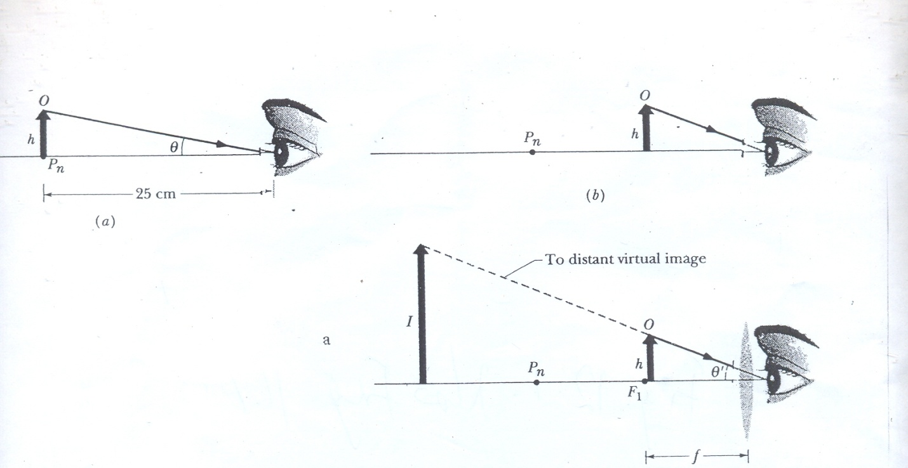

**Fig 9.4** (a) An object *O* of height h, placed at the near point of a human eye, occupies angle $θ$ in the eye’s view. (b) The object is moved closer to increase the angle, but now the observer cannot bring the object into focus. (c) A converging lens is placed between the object and the eye, with the object just inside the focal point *F1* of the lens. The image produced by the lens is then far enough away to be focused by the eye, and the image occupies a larger angle $θ^{'}$ than object *O* does in (a)

**Self Assessment Exercise**

Normally, the location of the near point for a person varies with age. If some people claim that they do not need glasses to read as they grow older but it is observed that when they read books or newspapers they hold these farther and farther from their eyes. What conclusion can you draw about their near points in this case? Would you say that their near points are constant, receding, or improving?

* 1. **Compound Microscope**

Fig. 9.5 shows a thin-lens version of a compound microscope. The instrument consists of an *objective* (the front lens) of focal length *fob* and an *eyepiece* (the lens near the eye) of focal length *fey*. It is used for viewing small objects that are very close to the objective. The object *O* to be viewed is placed just outside the first focal point *F1* of the objective, close enough to *F1* that we can approximate its distance *p* from the lens as being *fob*. The separation between the lenses is then adjusted so that the enlarged, inverted, real image *I* produced by the objective is located just inside the first focal point F11 of the eyepiece. The *tube length s* shown in Fig. 9.5 is actually large relative to *fob*,and we can approximate the distance *i* between the objective and the image *I* as being length *s*.

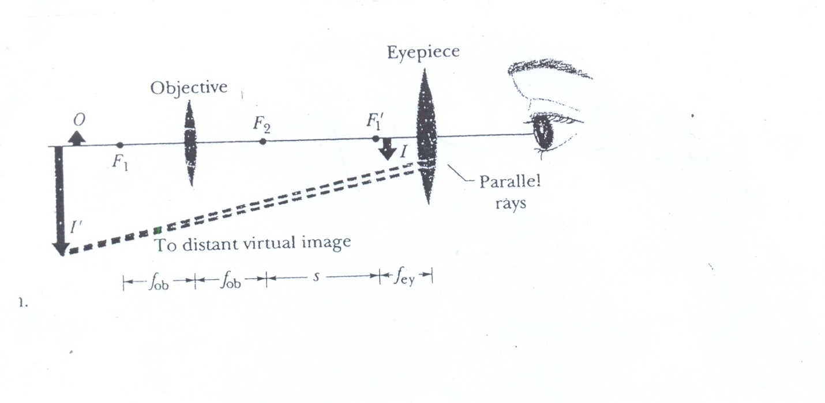

**Fig. 9.5** A thin-lens representation of a compound microscope. The objective produces a real image *I* of object *O* just inside the focal point F11 of the eyepiece. Image *I* then acts as an object for the eyepiece, which produces a virtual final image *I1*that is seen by the observer. The objective has focal length *fob*; the eyepiece has focal length *fey*; and *s* is the tube length

**Self Assessment Exercise**

Considering Fig.9.5, could you design an optical system based on this figure so that the image *I1* is *inside the focal point* of another lens? What would you call your new system?

**3.4 Refracting Telescope**

Telescopes come in a variety of forms. The form that is described here is the simple refracting telescope that consists of an objective and en eyepiece; both are represented in Fig. 9.6 with simple lenses, although in practice, as is true for most microscopes, each lens is actually a compound lens system. The lens arrangements for telescopes and for microscopes are similar, but telescopes are designed to view large objects, such as galaxies, stars, and planets, at large distances, whereas microscopes are designed for just the opposite purpose. The difference requires that in the telescope of Fig. 9.6 the second focal point of the objective F2 coincide with the first focal point of the eyepiece *F11*, whereas in the microscope of Fig. 9.5 these points are separated by the tube length *s*. In Fig. 9.6 (a), parallel rays from a distant object strike the objective, making an angle *θob* with the telescope axis and forming a real, inverted image at the common focal point *F2*, *F11*. This image *I* acts as an object for the eyepiece, through which an observer sees a distant (still inverted) virtual image *I1*. The rays defining the image make an angle θey with the telescope axis.

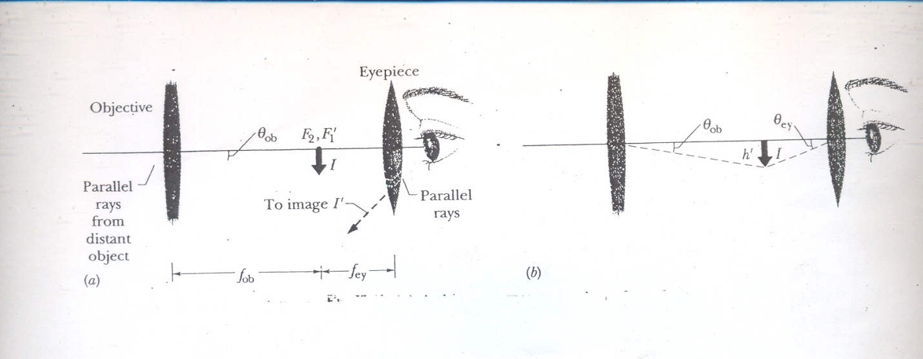

**Fig. 9.6** (a) A thin-lens representation of a refracting telescope. The objective produces a real image *I* of a distant source of light (the object), with approximately parallel light rays at the objective. (One end of the object is assumed to lie on the central axis.) Image *I*, formed at the common focal points *F2* and *F11* acts as an object for the eyepiece, which produces a virtual final image *I1* at a great distance from the observer. The objective has focal length *fob*; the eyepiece has focal length *fey*. (b) Image *I* has height *h1* and takes up angle θob measured from the objective and angle θey measured from the eyepiece.

**Self Assessment Exercise**

Compare and contrast the design characteristics of the refracting telescope and the compound microscope.

**4.0 Conclusion**

The magnifying glass, the compound microscope, and the refracting telescope are optical systems that extend the vision capability of the human eye. These optical systems operate on the principles of light propagation through a single or a set of optical systems like lenses and mirrors.

**5.0 Summary**

i.The *simple magnifying lens* produces an *angular magnification $m_{θ}$*  given by

$m_{θ}= \frac{25cm}{f}$ 9.1

where f is the focal length of the magnifying glass

ii. The *compound microscope* produces an *overall magnification* M given by

$M= {mm}_{θ}= -\frac{s}{F_{ob}} \frac{25cm}{F_{ey}}$ 9.2

where *m* is the lateral magnification produced by the objective, $m_{θ}$ is the angular magnification produced by the eyepieces, *s* is the tube length and *fob* and *fey* are the focal lengths of the objective and eyepiece, respectively.

1. The *refracting telescope* produces an *angular magnification mθ* given by

$m_{θ}= -\frac{F_{ob}}{F_{ey}}$ 9.3

**6.0 Tutor-Marked Assignments (TMAs)**

*Multiple choice questions*

1. With an astronomical telescope in normal adjustment and used for looking at the moon.
2. the final image of the moon is upright (erect)
3. the objective forms an image of the moon in front of the eyepiece focus
4. the final image is seen by the relaxed eye
5. the final image is seen at the near point of the eye
6. the angular magnification only depends on the eyepiece focal length.
7. An astronomical telescope X has an objective of focal length 100m and diameter 10cm and an eyepiece of focal length 5cm and diameter 4 cm. With the telescope in normal adjustment, the angular magnification is

A 2.5 B 14 C 20 D 25 E 119

1. If the angular magnification of an astronomical telescope is 36 and the diameter of the objective is 75mm, what is the minimum diameter of the eyepiece required to collect all the light entering the objective from a distant point source on the telescope axis?
2. A simple magnifying lens of focal length *f* is placed near the eye of someone whose near point *Pn* is 25 cm from the eye. An object is positioned so that the image in the magnifying lens appears at *Pn*. (a) What is the lens’s angular magnification? (b) What is the angular magnification if the object is moved so that the image appears at infinity? (c) Evaluate the angular magnifications of (a) and (b) for f = 10cm. (Viewing an image at *Pn* requires effort by muscles in the eye, whereas for many people viewing an image at infinity requires no effort.)
3. An object is 10.0 mm from the objective of a certain compound microscope. The lenses are 300 mm apart and the intermediate image is 50.0mm from the eyepiece. What overall magnification is produced by the instrument?

**7.0 References**

**Anyakoha, M. W. 2010.** *New School Physics for Senior Secondary Schools (3ed.)*, Africana First Publishers Plc., Onitsha, Nigeria.

**Duncan, T. 1982.** *Physics: A Textbook for Advanced Level Students*, John Murray Publishers, London.

**Encyclopaedia Britannica, 2012.** *Encyclopaedia Britannica Ultimate Reference Suite*, Chicago: Encyclopædia Britannica.

**Halliday, D., Resnick, R., and Walker, J. 2001.** *Fundamentals of Physics (6 ed.),*John Wiley and Sons, New York.

**Nelkon, M. and Parker, P. 1995.** *Advanced Level Physics (7 ed.)*, CBS Publishers, New Delhi.

**Serway, R.A. and Faughn, J.S. 1992.** *College Physics (3ed.)*, Harcourt Brace Jovanovic Publishers, Florida.

**UNIT 10**

**MEASUREMENT OF THE SPEED OF LIGHT**

**Contents**

1. Introduction
2. Objective
3. The Speed of Light and its Measurements

3.1 Introduction

3.2 Description of the Fizeau’s and other Methods Adopted to Measure the Speed of Light

1. Conclusion
2. Summary
3. Tutor-Marked Assignments (TMAs)
4. References
5. **Introduction**

Light travels so fast that there is nothing in our daily experience to suggest that its speed in not finite. It calls for considerable insight even to ask, “How fast does light travel?” Galileo asked himself this question and actually tried to answer it experimentally. His book, Two New Sciences, published in 1638, is written in the form of a conversation among three persons called Salviati, Sagredo, and Simplicio. Here is part of what they say about the speed of light.

*Simplicio*: Everyday experience shows that the propagation of light is instantaneous, for when we see a piece of artillery fire, at a great distance, the flash reaches our eyes without lapse of time; but the sound reaches the ear only after a noticeable interval.

*Sagredo*: Well, Simplicio, the only thing I am able to infer from this familiar bit of experience in that sound, in reaching our ear, travels more slowly than light; it does not inform me whether the coming of the light is instantaneous or whether, although extremely rapid, it still occupies time…

Salvati, who speaks with Galileo’s voice, then describes a possible method (actually carried out) for measuring the speed of light. He and an assistant stand facing each other some distance apart, at night. Each carries a lantern which can be covered or uncovered at will. Galileo started the experiment by uncovering his lantern. When the light reached the assistant he uncovered his own lantern, whose light was seen by Galileo. Galileo tried to measure the time between the instant at which he uncovered his own lantern and the instant at which the light from his assistant’s lantern reached him. For a one-mile separation we now know that the round trip travel time would be only $11μs$. This is much less than human reaction times, so the method fails.

To measure a large velocity directly, we must either measure a small time interval or use a long base line. This situation suggests that astronomy, which deals with distances, might be able to provide an experimental value for the speed of light; this proved to be true. Although it would be desirable to time the light from the sun as it travels to the earth, there is no way of knowing when the light that reaches us at any instant left the sun; we must use subtler astronomical methods.

Note, however, that microwave pulses are quite regularly reflected from the moon; this gives a 7.68x108 m base line (there and back) for timing purpose. The speed of light (and of microwaves) is so well kwon now from other experiments that we use these measurements to measure the lunar distance accurately. Microwave signals have also been reflected from Venus.

1. **Objective**

At the completion of Unit 10, the student should be able to describe at least one method for the determination of the speed of light.

1. **The Speed of Light and its Measurements**

**3.1 Introduction:** Measurements of the speed of light have challenged scientists for centuries. The assumption that the speed is infinite was dispelled by the Danish astronomer [Ole Roemer](ebcid:com.britannica.oec2.identifier.ArticleIdentifier?articleId=83854&library=EB&query=null&title=Ole%20R%C3%B8mer#9083854.toc) in 1676. In that year Roemer, a Danish astronomer working in Paris, made some observations of the moons of Jupiter from which a speed of light of *2 x108* m/s may be deduced (his value is not quite correct, but close somewhat). About thirty years later James Bradley, an English astronomer, made some astronomical observations of an entirely different kind from which a value of *3 x108* m/s may be deduced.

French physicist [Armand-Hippolyte-Louis Fizeau](ebcid:com.britannica.oec2.identifier.ArticleIdentifier?articleId=34454&library=EB&query=null&title=Armand-Hippolyte-Louis%20Fizeau#9034454.toc) was the first to succeed in a terrestrial measurement in 1849, sending a light beam along a 17.3-km round-trip path across the outskirts of Paris. At the light source, the exiting beam was chopped by a rotating toothed wheel; the measured rotational rate of the wheel at which the beam, upon its return, was eclipsed by the toothed rim was used to determine the beam's travel time, see Fig. 10.1. Fizeau reported a light speed that differs by only about 5 percent from the currently accepted value. One year later, French physicist [Jean-Bernard-Léon Foucault](ebcid:com.britannica.oec2.identifier.ArticleIdentifier?articleId=35012&library=EB&query=null&title=Jean-Bernard-L%C3%A9on%20Foucault#9035012.toc) improved the accuracy of the technique to about 1 percent. In the same year, Foucault showed that the speed of light in water is less than its speed in air by the ratio of the indices of refraction of air and water:



This measurement established the index of refraction of a material as the ratio of the speed of light in vacuum to the speed within the material. The more general finding, that light is slowed in transparent media, directly contradicted Isaac Newton's assertion that light corpuscles travel faster in media than in vacuum and settled any lingering 19th-century doubts about the corpuscle–wave debate.



**Fig. 10.1** In 1849 Armand Fizeau sent light pulses through a rotating toothed wheel. A distant mirror on the other side reflected the pulses back through gaps in the wheel. By rotating the wheel at a certain speed, each light pulse that went through a gap on the way out was blocked by the next tooth as it came around. Knowing the distance to the mirror and the speed of rotation of the wheel enabled Fizeau to obtain one of the earliest measurements of the speed of light.

**3.2 Description of the Fizeau’s and other Methods Adopted to Measure the Speed of Light**

Fizeau (1819-1896), the French Physicist, was the first to measure the speed of light by a nonastronomical method, obtaining a value of *3.13x108* m/s. Fig. 10.2 shows, again, Fizeau’s apparatus.

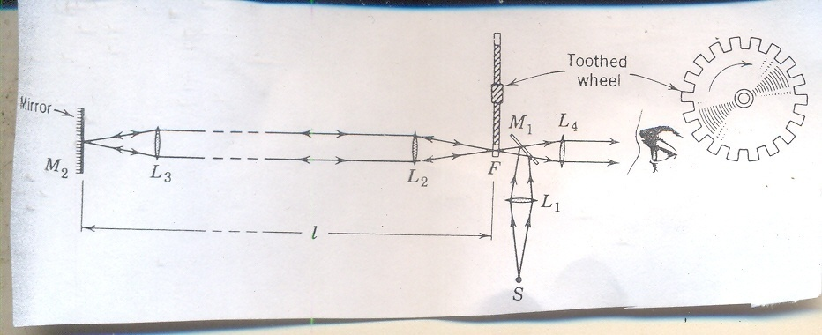

**Fig. 10.2** Fizeau’s apparatus for measuring the speed of light

Let us first ignore the toothed wheel. Light from source S is made to converge by lens L1, is reflected from mirror M1, and forms in space at F an image of the source. Mirror M1 is a so-called “half-silvered mirror”; its reflecting coating is so thin that only half the light that falls on it is reflected, the other half being transmitted. Light from the image at F enters lens L2 and emerges as a parallel beam; after passing through lens L3 it is reflected back along its original direction by mirror M2. in Fizeau’s experiment the distance L between was 8630 metres or 5.36 miles (about 17.3-km round trip). When the light strikes mirror M1 again, some will be transmitted, entering the eye of the observer through lens L4.

The observer will see an image of the source formed by light that has traveled a distance 2l between the wheel and mirror M2 and back again. To time the light beam a marker of some sort must be put on it. This done by “chopping” it with a rapidly rotating toothed wheel. Suppose that during the round-trip travel time of 2l/c the wheel has turned just enough so that, when the light from a given “burst” returns to the wheel, point F is covered by a tooth. The light will hit the face of the tooth that is toward M2 and will not reach the observer’s eye.

If the speed of the wheel is exactly right, the observer will not see any of the bursts because each will be screened by a tooth. The observer measures c by increasing the angular speed ω of the wheel from zero until the image of source S disappears. Let θ be the angular distance from the centre of a gap to the centre of a tooth. The time needed for the wheel to rotate a distance θ is the round-trip travel time 2l/c. In equation form,

$\frac{θ }{ω}= \frac{2l}{c} or c=\frac{2ωl}{θ}$ 10.1

The “chopped beam” technique, suitably modified, is used today to measure the speeds of neutrons and other particles.

The French physicist Foucault (1819-1868) greatly improved Fizeau’s method by substituting a rotating mirror for the toothed wheel. The American physicist Albert A. Michelson (1852-1931) conducted an extensive series of measurements of c, extending over a fifty-year period, using this technique. We must view the speed of light within the larger framework of the speed of electromagnetic radiation in general. It is a significant experimental confirmation of Maxwell’s theory of electromagnetism that the speeds in free space of waves in all parts of the electromagnetic spectrum have the same value c.

The German-born American physicist [A.A. Michelson](ebcid:com.britannica.oec2.identifier.ArticleIdentifier?articleId=52478&library=EB&query=null&title=A.A.%20Michelson#9052478.toc) set the early standard for measurements of the speed of light in the late 1870s, determining a speed within 0.02 percent of the modern value. Michelson's most noteworthy measurements of the speed of light, however, were yet to come. From the first speculations on the wave nature of light by Huygens through the progressively more refined theories of Young, Fresnel, and Maxwell, it was assumed that an underlying physical medium supports the transmission of light, in much the same way that air supports the transmission of sound. Called the [*ether*](ebcid:com.britannica.oec2.identifier.ArticleIdentifier?articleId=33121&library=EB&query=null&title=ether#9033121.toc), or the luminiferous ether, this medium was thought to permeate all of space. The inferred physical properties of the ether were problematic (to support the high-frequency transverse oscillations of light, it would have to be very rigid, but its lack of effect on planetary motion and the fact that it was not observed in any terrestrial circumstances required it to be tenuous and chemically undetectable.) While there is no reference to the properties of a supporting medium in the mathematics of Maxwell's electromagnetic theory, even he subscribed to the ether's existence in the 1870s. In 1887 Michelson, in collaboration with American chemist [Edward Morley](ebcid:com.britannica.oec2.identifier.ArticleIdentifier?articleId=53766&library=EB&query=null&title=Edward%20Morley#9053766.toc), completed a precise set of optical measurements designed to detect the motion of the Earth through the ether as it orbited the Sun.

The measurements in the [Michelson-Morley experiment](ebcid:com.britannica.oec2.identifier.ArticleIdentifier?articleId=52479&library=EB&query=null&title=Michelson-Morley%20experiment#9052479.toc) were based on the assumption that an observer at rest in the ether would determine a different speed from an observer moving through the ether. Because the Earth's speed relative to the Sun is about 29,000 metres per second, or about 0.01 percent of the speed of light, the Earth provides a convenient vantage point for measuring any change in the relative speed of light due to motion. Using a Michelson [optical interferometer](ebcid:com.britannica.oec2.identifier.ArticleIdentifier?articleId=57230&library=EB&query=null&title=optical%20interferometer#9057230.toc) (see Fig. 10.3), interference effects between two light beams traveling parallel to, and perpendicular to, the Earth's orbital motion were monitored during the course of its orbit. The instrument was capable of detecting a difference in light speeds along the two paths of the interferometer as small as 5,000 metres per second (less than 2 parts in 100,000 of the speed of light). No difference was found. If the Earth indeed moved through the ether, that motion seemed to have no effect on the measured speed of light. What is now known as the most famous experimental null result in physics was reconciled in 1905 when [Albert Einstein](ebcid:com.britannica.oec2.identifier.ArticleIdentifier?articleId=106018&library=EB&query=null&title=Albert%20Einstein#9106018.toc), in his formulation of [special relativity](ebcid:com.britannica.oec2.identifier.ArticleIdentifier?articleId=109465&library=EB&query=null&title=special%20relativity#252878.toc), postulated that the speed of light is the same in all [reference frames](ebcid:com.britannica.oec2.identifier.ArticleIdentifier?articleId=63015&library=EB&query=null&title=reference%20frames#9063015.toc); i.e., the measured speed of light is independent of the relative motion of the observer and the light source. The hypothetical ether, with its preferred reference frame, was eventually abandoned as an unnecessary construct.



**Fig. 10.3** The Michelson interferometer consists of a half-transparent mirror oriented at a 45° angle to a light beam so that the light is divided into two equal parts (*A* and *B*), one of which is transmitted to a fixed mirror and the other of which is reflected to a movable mirror. The half-transparent mirror has the same effect on the returning beams, splitting each of them into two beams. Thus, two diminished light beams reach the screen, where interference patterns can be observed by varying the position of the movable mirror

Since Einstein's work, the speed of light is considered a fundamental constant of nature. Its significance is far broader than its role in describing a property of electromagnetic waves. It serves as the single limiting velocity in the universe, being an upper bound to the propagation speed of signals and to the speeds of all material particles. In the famous relativity equation, *E* = *mc*2, the speed of light (*c*) serves as a constant of proportionality linking the formerly disparate concepts of mass (*m*) and energy (*E*).

It is now clear that the best measurements of c are *not* made by timing the passage of light over a measured distance, as by Fizeau in 1849 and Michelson et al in 1932. They are made by measuring the frequency ν and the wavelength λ of the light and computing c from c = λν. This holds true for other traveling waves or for standing waves. We describe here the “microwave cavity method” used by Essen in England and by Bol and Hansen in the USA. It employs standing electromagnetic waves confined to a cavity rather than traveling waves in free space. It is possible to convert a section of waveguide into a resonant cavity by closing it with two metal caps. The pattern of oscillations in the cavity is closely related to that in the guide and exhibits the same “guide wavelength” 2g. The guide wavelength is related to the cavity length l by

$λ_{g}=\frac{2l}{n} n=1,2,3,…,$ 10.2

which is the same relationship used for acoustic waves in closed pipes. The procedure is to measure $λ_{g}$ for such a cavity, which has been tuned to resonance, and then, using the relationship

$λ_{g}=\frac{λ}{\sqrt{1-{\left(\frac{λ}{2a}\right)}^{2}}}$ 10.3

calculate the free-space wavelength λ. From the measured resonant frequency, the speed c can be found from c = λν.

Measurements of the speed of light were successively refined in the 20th century, eventually reaching a precision limited by the definitions of the units of length and time (i.e. the metre and the second.) In 1983 the 17th General Conference on Weights and Measures fixed the speed of light as a defined constant at exactly 299,792,458 metres per second. The metre became a derived unit, equaling the distance traveled by light in 1/299,792,458 of a second.

**Self-Assessment Exercises**

1. How could the Fizeau’s method for measurement of the speed of light be improved by substituting a rotating mirror for the toothed wheel? Note: Describe the Foucault’s method.

ii. What are the principles of optics that you have learnt that are in operation in Fig. 10.1?

**4.0 Conclusion**

The task of arriving at a single “best” value for any physical quantity, such as c, from many independent measurements is usually difficult because it involves a careful evaluation of each measurement and a complex averaging process, which takes into account other physical quantities with which the quantity in question may be associated. In the case of c, however, the matter is straightforward. All past measurements of c have been bested by the result announced in 1983 at the 17th General Conference on Weights and Measures.

**5.0 Summary**

Galileo’s attempt to measure c was inconclusive; he used lanterns and shutters and the prevailing feeling about c was, “if not instantaneous, it is extraordinarily rapid.” Roemer’s approach involved the moons of Jupiter and a value of 200,000 km/s was obtained for c. Bradley used the method of aberration of starlight and obtained 304,00 km/s for c. Fizeau used the toothed wheel method and obtained a value of 313,300 km/s for c. Foucault used the rotating mirror method and obtained a value of 298,000 km/s for c. Michelson’s first reported result using the rotating mirror was a value of 299, 910 km/s for c. Evenson, Wells, Peterson, Danielson, and Day used the laser techniques and obtained 299,792.4574 kmls for c.

1. **Tutor-Marked Assignments (TMAs)**
2. The common expression of the value for c is 3x108mls. Why it is so?
3. The wheel used by Fizeau had 720 teeth. While is the smallest angular speed at which the image of the source will vanish? The angle θ is 1/1440 revolutions.
4. Essen of the National Physical Laboratory in England made a resonant cavity measurement of the speed of electromagnetic waves in 1950. His cavity was made of a circular waveguide rather than a rectangular one; it can be shown that, for the oscillation pattern used by him, the geometrical factor 2a in the expression

$λ_{g}=\frac{λ}{\sqrt{1-{\left(\frac{λ}{2a}\right)}^{2}}}$

must be replaced by 1.64062R, where R is the guide radius. The cavity radius was 3.25876cm; the cavity length was 15.64574cm and it proved to resonate at 9.498300 x 109 Hz. At resonance it was determined that there were eight half-waves in the cavity. What value of c results?

1. **References**

**Anyakoha, M. W. 2010.** *New School Physics for Senior Secondary Schools (3ed.)*, Africana First Publishers Plc., Onitsha, Nigeria.

**Duncan, T. 1982.** *Physics: A Textbook for Advanced Level Students*, John Murray Publishers, London.

**Encyclopaedia Britannica, 2012.** *Encyclopaedia Britannica Ultimate Reference Suite*, Chicago: Encyclopædia Britannica.

**Halliday, D., Resnick, R., and Walker, J. 2001.** *Fundamentals of Physics (6 ed.),*John Wiley and Sons, New York.

**Nelkon, M. and Parker, P. 1995.** *Advanced Level Physics (7 ed.)*, CBS Publishers, New Delhi.

**Serway, R.A. and Faughn, J.S. 1992.** *College Physics (3ed.)*, Harcourt Brace Jovanovic Publishers, Florida.