The Marquardt-Lavenberg Algorithm for Estimation of Analytical Covariance Parameters
Odumosu, J. O. ^{1*}, Opaluwa, Y. D. ¹ and Idowu. T. O. ²

¹ Department of Surveying and Geoinformatics, Federal University of Technology, Minna, Nigeria
² Department of Surveying and Geoinformatics, Federal University of Technology, Akure, Nigeria
*Corresponding author: joseph.odumosu@futminna.edu.ng; odumossu4life@yahoo.com

Abstract: Gravity prediction for filling of gravity voids is an essential task in countries with sparse gravity data. The least squares collocation (LSC) has been a preferred prediction tool for geodesists over the years for predicting gravity values at unsampled locations. However, the accuracy of the LSC depends on the covariance function used and by extension the method of estimating the parameters of such analytical covariance function. This study presents a novel approach for the estimation of analytical covariance parameters by implementation of the Marqurdt-Lavenberg (ML) algorithm in a non-linear programming (NLP) optimization approach. The suitability of the ML algorithm for estimating the essential parameters of a covariance matrix is tested within a 1 degree by 1 degree grid within Ondo state (typifying a sparse data region). Results obtained when analyzed by Leave out (LO) validation show that the ML algorithm is efficient for estimating essential covariance parameters with a RMSE 1.196mgals. Furthermore, statistical analysis of the result indicate that there exists a very strong correlation (near perfect relationship) with a Pearson correlation value of 0.93 between the predicted values and the known gravity values of the LO points. It is therefore concluded that the ML method is a reliable method for estimating covariance parameters for geodetic application even in regions with sparse gravity data.
Keywords: Covariance Function; Least Squares Collocation; Marqurdt-Lavenberg (ML) algorithm; Non-linear programming (NLP)

1. Introduction
Scientific probe of the local gravity signature have served several useful purposes in different fields of application which include geodesy (Torge, 2001), geophysics (Idowu, 2007), geology (Telford, 1990) and geodynamics (Ekman, 1989). Unfortunately, the dense spatial gravity data coverage required for most of these applications is often expensive to attain by field observations (Ulotu, 2009; Klu, 2015); thereby necessitating the need for spatial interpolation of gravity data at unobserved locations. However, due to the anomalous behavior of the local gravity field, gravity data interpolations by mathematical techniques have been studied by geodesists over the years with the Least Squares Collocation (LSC) being the most preferred method for gravity prediction in flat and gently sloping areas (Kassim, 1980; Morrison and Doughlas, 1984).
The computational jinx of the LSC relies on the availability of the covariance matrix (for the random part) and cross covariance matrix of the signals and observations. Solving this covariance matrix has been a major research area of geodesy (Goad, 1984; Bamsal and Dimri, 2005) and many researchers have presented methods for estimating the essential parameters of a covariance matrix. Earlier works on methods for estimating covariance parameters include determination of empirical covariance (Rapp, 1974; Moritz, 1976), fitting empirical covariance with analytical functions via anomaly degree variance modeling (Scharwz and Lachapelle, 1980; Fashir et al, 1998), least squares approximation methods (Paciorek, 2003), optimizing least squares by objective functions (Fajemirokun and Orupabo, 1987; Idowu, 2007), Maximum Likelihood estimators (MLE) (Jarmilowski, 2013) and linear programming (LP) optimization approach (Gaetani, 2016).
Gaetani (2016) reduced the covariance fitting problem into an optimization problem in Linear programming and solved for the covariance parameters by the simplex method. Unfortunately, the simplex solution algorithm searches for solutions at the extremes of the feasible region. This mathematical limitation of the simplex method increases the chances for the solution to be trapped in a local minimum hence a global solution might not be obtained. Therefore, the non-linear optimization problem is herein proposed in this study as a solution for fitting of empirical covariance with analytical functions.

2 NLP for covariance parameters estimation
Non-linear optimization solutions are often more robust and as such are well suited for areas with rapidly anomalous gravity field. Unlike linear programming problems whose optimal solutions are either located at an interior point or on the boundary or at an extreme point of the feasible region (Bohme and Frank, 2017), NLP solutions are based on the assumption that the optimal solution is continuously differentiable by the individual independent variable (Madsen and Nielsen, 2010). The NLP approach has not been used in any geodetic literature for estimating the essential parameters of a covariance matrix.
Some mathematical methods have been developed for solving NLP problems. Amongst these methods, Marquardt-Lavenberg’s (LM) method is theoretically considered the most optimal method compared to the Gauss Newton’s or the steepest descent methods. The steepest descent method is often considered as an inefficient optimization method because the method involves many iteration steps before a global/local minimum is reached. This characteristic makes the steepest descent method not recommended for large works. The Gauss Newton method on the other hand disregards all higher-order derivatives and approximates
the Hessian matrix using the first-order derivatives only. Consequently, the Marquardt–Levenberg method (a compromise between the inverse Hassien and steepest descent methods) has been chosen in this study being the most optimal solution for non-linear programming problems (Simunek and hopmans, 2000).The Marquardt–Levenberg method uses the inverse-Hessian when several iterations are still required and switches to the steepest descent method when the minimizing solution is approached.

2.1 The Marquardt-Lavenberg Algorithm for estimating essential covariance parameters
Given the solution to the empirical covariance at the various distances, the covariance parameter fitting by the chosen analytical function reduces into a curve fitting problem. The objective function given in equation (1) is herein presented for determination of a global optimum of the required covariance parameters using the NLP approach by the ML solution algorithm.
(1)
Subject to
,b
where:
= Empirical covariance
= variance
= correlation length
= curvature parameter
The solution of equation (1) by the Marquardt–Levenberg method is presented as follows:
The ML method like all other non-linear problems is an iterative method which begins with an initial guess.
Given the objective function as specified in equation (1) and re-written as equation (2)
(2)
where
=
= variance
= correlation length
= curvature parameter
Therefore, (2) can be re-expressed as (2b)
(2b)
To estimate the values of , let there be an initial guess such that
(3)
(4)
where
= Jacobian matrix which could be expressed mathematically as (5)
= 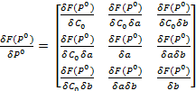 (5)
At each step of the iteration, the LM algorithm is required to find the values of () that minimizes equation (3) by finding the corresponding appropriate Jacobian matrix as given by equation (5).
Equation (3) can be expressed as sum of absolute residuals rather than merely as sum of residuals. To achieve this, equation (3) becomes equation (6):
(6)
(7)
(8)
(9)
where:
= Estimated value of difference between the empirical covariance and analytical covariance at each step of the LM iteration.
= is the solution to the linear least squares problem wherein the minimization is obtained when is orthogonal to the column space of J.
Equation (9) can be re written as (10)
(10)
Recall that equation (10) is a solution to the normal equation of ordinary least squares.
(11)
where
= Hessian matrix
The ML solution is given by equation (12)
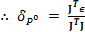 (12)
3 Study Area
The suitability of the ML method for estimating essential parameters of a covariance matrix has been tested within a 1 degree by 1 degree grid within Ondo State (Figure 1). The selected grid size was chosen in-order to get a well determined estimate of the correlation length based on the maximum spherical distance consideration as earlier discussed by Schwarz and Lachapelle (1980). Despite the sparse nature of gravity data across South Western Nigeria, the selected grid consists of a total of 31 homogenous gravity anomaly data points (shown in red dots in Figure 1) at average data spacing of about one gravity point at every 20km interval.
Furthermore, considering the correlation between gravity and heights, the selected study area (part of Ondo state) also affords the opportunity of determining the suitability of the presented method in hilly or mountainous terrain (Featherstone and Kirby, 2000).
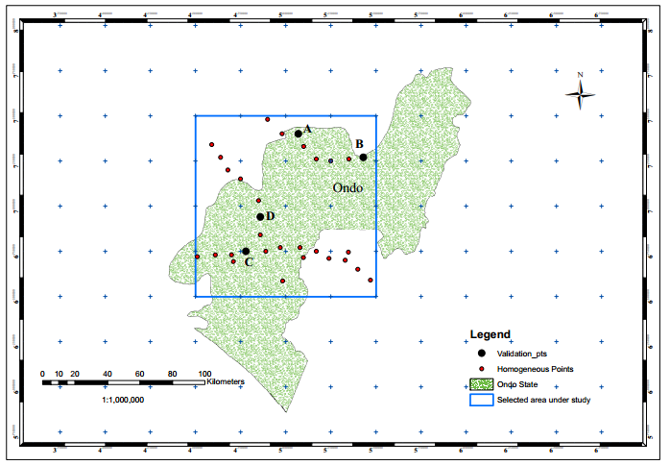
Figure 1 Study area
4 Materials and Methods
Archived gravity data from the Bureau Gravimetric International (BGI) collected by various agencies were used for this study. The archived data had varied levels of accuracy and were heterogeneous across the country having different parametric and gravimetric datum. A total of 2634 heterogeneous gravity data points are located across the country. The data were therefore homogenized before they could be used for this study. Three steps were involved in the gravity data homogenization process which were:
Step 1: Cross over adjustment for removal of observational (gravimetric) and parametric inconsistencies (Odumosu et al, 2017).
Step 2: Outlier detection and removal (Data snooping) for elimination of computational inconsistency and undetected observational spikes that sneak through the first step.
Step 3: Ordinary Least Squares adjustment for removal of possible random errors and determination of statistical accuracies of the resulting homogenized data.
After data homogenization a total of 1340 homogeneous data points were identified across Nigeria with 212 of the points located in South Western Zone of Nigeria. Post adjustment characteristics of the 212 points are as presented in Table 1.
Table 1 Post adjustment statistics of the data used
S/No | Parameter | Value
1 | Standard Deviation () | 0.0002mgals
2 | Total Number of gravity data | 212
3 | Sum of squares of Resi. (SSR) | 0.341
4 | Minimum Residual | -0.093mgals
5 | Maximum Residual | 0.084mgals
6 | Gravimetric datum | IGSN 71
7 | Parametric datum | WGS 84
Sixteen (16) 1 degree by 1 degree grid network (about 12,000 sq km per grid) was formed across the South Western Zone of Nigeria and the grid that falls within part of Ondo state was selected for this study for reasons earlier identified in section 4.0. Four of the gravity anomaly points (shown in black dots in Figure 1) were left out in the estimation process and were used for model validation.
Given gravity anomaly at these 27 points (the four validation points already removed from the data used for the estimation process), the local characteristic of the gravity field was determined by removing the long and intermediate wavelength effects from the measured gravity anomaly using EGM96 coefficients and a 30 arc sec digital elevation model from Shuttle Radar Topographic Mission (SRTM) covering the study area respectively. The long wavelength effect of the Earth’s gravity field is computed using coefficients of the series expansion as amplitudes of the long spectral parts. The spherical harmonic coefficients of the global gravity field model was obtained from EGM96 while the quantities of the long wavelength gravity anomalies are computed within the geographical distribution using equation (13) (Lambeck, 1990; Kaula, 1996).
 (13)
where:
= long wavelength gravity anomaly as a function of r,
r, = spherical co-ordinates (radial, azimuth and polar)
a = semi major axis
and= fully normalized harmonic coefficients or Stokes coefficients
= Associated Legendre polynomial
= degree and order of Legendre function respectively
Terrain corrections for removal of the intermediate portion of the gravity field was done using the SRTM digital elevation model by implementing the Hammer chart correction with inner and outer zone distances of 1km and 166km respectively and a constant density value of .
Removal of the intermediate portion serves as a means of removing the problem of terrain aliasing (topographic trend) between free-air anomalies and the topography. The alternative approach of converting free-air anomalies to their Bouguer equivalent has been found not to completely eliminate the problem of terrain aliasing therefore substantiating the choice of this approach (Janak and Vanicek, 2005). After removal of the long and intermediate portions from the measured gravity field, the residual gravity field (depicting the local gravity field and represented by equations (14a &14b) was used for determining the empirical covariance parameters using standard procedures presented by (Knusden 1988) as given by equation (15).
(14a)
(14b)
where
= Faye anomalies
= measured gravity on the Earth surface
= Normal gravity
= Orthometric Height
= Long wavelength geoid
= Residual gravity anomaly
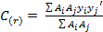 (15)
where
A = Size of the area on a unit sphere
= product of corresponding pairs of anomaly values
The computed empirical covariance values are then fitted into the analytical covariance function given by equation (16a and b). Equation (16b) is a polynomial function that is used to represent the analytical covariance function as given by Fashir et. al (1998). A sequential description of the computational steps (methods) adopted in this study is presented in Table 2.
(16a)
(16b)
where
r = horizontal distance between gravity stations in km
a = correlation length
b = curvature parameter
= variance
= analytical covariance function
Table 2 Summary of methods used for the study
 | Computational Step | Reference
Step 1 | Remove Long wavelength portion from observed gravity data | Kaula(1996)
Step 2 | Remove intermediate wavelength portion from observed gravity data | Nowell (1999)
Step 3 | Compute Empirical covariance | Knusden (1987)
Step 4 | Choose appropriate analytical function | Fashir et al (1998)
Step 5 | Determine essential analytical covariance parameters | ML approach
Step 6 | Predict gravity anomaly values at desired interval | Idowu (2005)
Step 7 | Statistical analysis of prediction results by LO validation approach | Jarmilowski (2013)
5 Results and discussion
As earlier discussed in section 4, the ML method of NLP was used to estimate the essential covariance parameters of the local gravity field within the study area. The parameters obtained from the estimation were thereafter used in gravity prediction and the prediction results compared with known values at Leave Out (LO) validation points. The empirical covariance parameters and some characteristic features of the selected grid under study are given in Table 3. Table 4 also presents a comparison of the essential parameters as determined from both the empirical and analytical functions. The fit-plot of the empirical with the analytical covariance as obtained using the ML method is presented in Figure 2.

Table 3 Extract of results of empirical covariance modeling
S/No | Parameter | Value
1 | Grid Area | 12,345 sqKms
2 | Grid dimension
3 | No of points | 31 points (4 were left out for LO validation)
4 | Latitude range
5 | Longitude range
6 | Mean value of local anomaly | 0.169 mgals
7 | Variance factor | 44.04mgals
8 | Correlation length | 22.02km

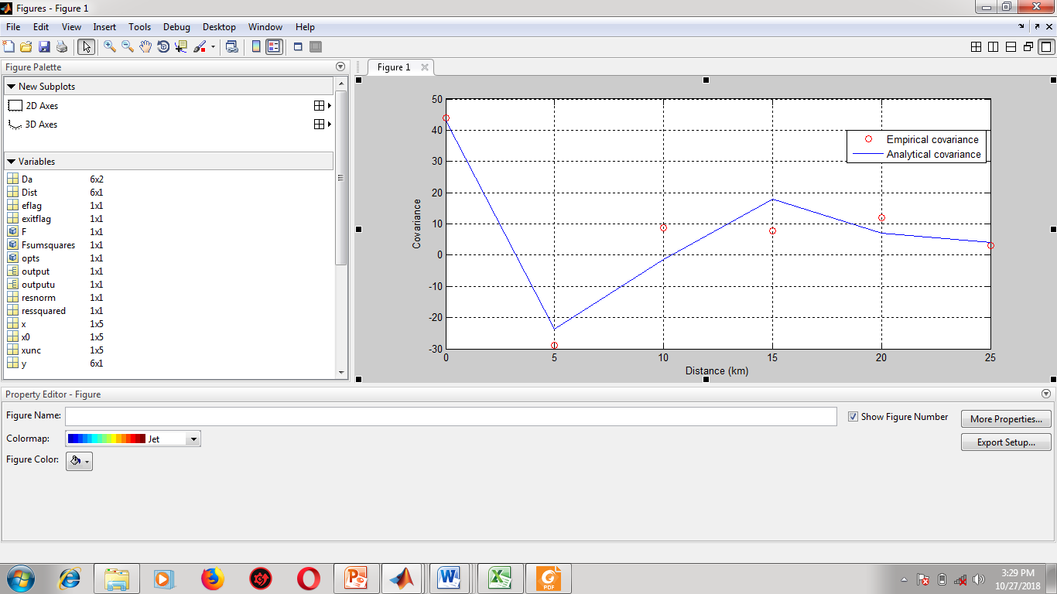
Figure 2 Fit-plot of empirical and analytical co-variances using ML method

The covariance plot presented in Figure 2 reveals certain important facts and characteristics about the structure and behavior of the gravity field. One of such important characteristics that can be deduced from the plot is that the local gravity field within the study area is relatively smooth with scanty anomalies. This is seen by sharp fluctuation noticed between the covariance values from 5km to 10km followed by the near straight observed between 10km – 25km. The anomalous gravity behavior noticed suggests the likely presence of gravity-sensitive geological features. However, firm conclusions cannot be made on this unless further investigations are conducted.
Besides, the gentle curve observed between the 10km – 25km distance range confirms that the rugged effects of topography on the free-air anomalies have been removed from the observed gravity data. Furthermore, the discrepancies observed between the empirical and analytical covariance suggests that LSC would produce maximum prediction errors of about 8mgals for prediction points that are 10km away from the nearest sampled point.
Table 4 Comparison of empirical and analytical covariance parameters
S/No | Parameter | Empirical covariance | Analytical covariance
1 | Variance factor | 44.04 mgals | 42.99 mgals
2 | Correlation Length | 22.02km | 31.01km
Table 5 presents a comparison between the predicted points and the LO validation points. The observed residuals range between -2.02mgals to 1.24mgals. The maximum residuals were observed at points B and D which were located at 10km away from sampled points. This observed points with high residuals confirms the fit –plot presented in Figure 2. It is seen that due to the presence of multiple sample points around the validation point, the residual values obtained at the validation points that were located 10km away from sample points was not up to 8mgals. This confirms known claims that the accuracy of any predictive model improves with increasing number of input data. Figure 3 presents the error histogram of the predicted values at each of the four LO validation points.
Table 5 Analysis of residuals of predicted values
S/N | Dist. to control (km) | Actual Value (mgals) | Predicted Value (mgals) |  | Std. dev | Residual (mgals)
1 | 7.6 | -4.28 |  | -4.41 | 0.0028 |  | 0.13
2 | 10.01 | 2.96 |  | 1.72 | 0.0014 |  | 1.24
3 | 8.6 | -3.17 |  | -2.87 | 0.0033 |  | -0.31
4 | 10.8 | 1.51 |  | 3.53 | 0.0029 |  | -2.02
RMSE of pred= |  | 1.196

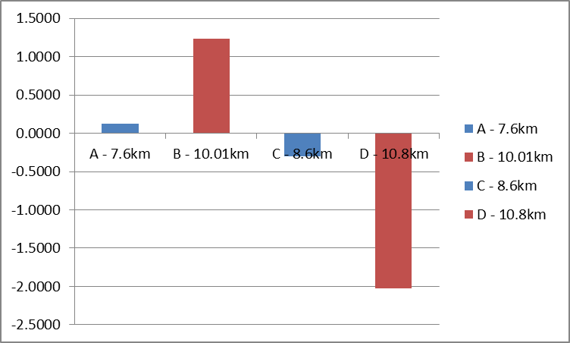
Prediction Error (mgals)
Validation points / Distance from farthest controls

Figure 3 Histogram of prediction errors at the validation points

The value of the RMSE (1.196 mgals) obtained confirm the erratic behavior of gravity anomaly especially in areas with sparse gravity data. Furthermore, this RMSE value shows that the presented method is of a more refined accuracy with the earlier works of Jarmilowski (2013). It is expected that a denser gravity network would produce more optimal results as the data spacing and cluster would make obtained results better. In addition, Table 6 presents a student-t test conducted which indicates that there is no significant difference between the means of the observed and predicted values at 99% confidence interval. Given that:
The Null Hypothesis : There is no significant difference between the means of both samples
Alterntive Hypothesis : There is significant difference between the means of both samples

Table 6 Results of student-t test (Paired two samples for means)
 | Observed | Predicted
Mean | -0.7463 | -0.5064
Variance | 12.3874 | 14.0055
Observations | 4 | 4
Pearson Correlation | 0.9324
Hypothesized Mean Difference | 0
Df | 3
t Stat | -0.3544
P(T<=t) one-tail | 0.3732
t Critical one-tail | 4.5407
P(T<=t) two-tail | 0.7465
t Critical two-tail | 5.8409
With a t statistic of -0.3544 which is less than the t-critical (4.5407), we can conclude that the predicted values do not differ significantly from the observed values at 99% confidence level therefore we accept the null hypothesis. Besides, the P-value of 37% for the one-tailed and 75% for the two-tailed statistical acceptability level further confirms the acceptance of the null hypothesis. Furthermore, the Pearson correlation value of 0.93 suggests a near perfect relationship between the predicted and the observed values.

6 Conclusions
The ML method has been utilized in this study for estimation of essential parameters of the covariance function for gravity field of an area within Ondo state. The estimated parameters have thereafter been utilized in the standard LSC along with a 3rd degree polynomial analytical function to predict gravity values at unsampled locations within the study area. The overall RMSE of 1.196mgals obtained by LO validation indicate that the adopted method of essential parameter estimation is reliable since the RMSE value obtained is suitable for geoid modeling and other geodetic applications (Bruton, 2000). Statistical analysis of the prediction results further substantiate the suitability of the ML method for determination of essential parameters of the covariance function of the gravity field even in areas with sparse gravity data.

References
Bamsal A. R. and V.P. Dimri (2005) Self affine gravity covariance model for the bay of Bengal, Geophysical Journal International, 161 (1), 21 - 30.
Bohme, T. J. and B. Frank (2017). Hybrid Systems; Optimal control and hybrid vehicles.Springer international publishing.
Ekman, M. (1989). Impact of Geodynamics on Systems for height and gravity.Bulletin Geodesique 63: 281. https://doi.org/10.1007/BF02520477.
Fajemirokun, F. A. and Orupabo, S. (1987). Residual anomalies computations.International workshop on the stability of the western sector of African plate, University of Ibadan, Nigeria.
Fashir, H. H., Majid, A. and Kadir, A. (1998). Gravity prediction from anomaly degree variance. Buletin Geoinformasi, Vol 2, No 2, pgs. 230 – 240.
Featherstone, W. E. and Kirby, J. F. (2000). The reduction of aliasing in gravity anomalies and geoid heights using digital terrain data, Geophysical Journal International, 141 (1), 204-212, doi: 10.1046/j.1365-246x.2000.00082
Gaetani, C. L. (2016). Covariance function modeling in local geodetic applications using the simplex method.Boletim de ciencias geodesicas. http://dx.doi.org/10.1590/S1982-21702016000200019. ISSN 1982-2170
Goad, C. C., Tscherning, C. C. and Chin, M. M. (1984). Gravity empirical covariance values for the continental United States. Journal of Geophysical Research 89 (B9), 7962–7968.
Idowu T. O (2005). Determination and utilization of optimum residual gravity anomalies for mineral utilization. Unpublished PhD dissertation of the department of surveying and Geoinformatics, University of Lagos, Nigeria.
Idowu, T. O (2007) Prospective Areas of Mineral accumulation in Adamawa state of Nigeria.African Geodetic Journal. 1(1)
Janák, J. and Vanícek, P. (2005). Mean free-air gravity anomalies in the mountains, Studia Geophysia et Geodaetica, 49 (1), 31-42. doi: 10.1007/s11200-005-1624-6
Jarmołowski, W. (2013). A priori noise and regularization in least squares collocation of gravity anomalies, Geodesy and Cartography, 62 (2), 199-216
Kassim, F. A. (1980). An evaluation of three techniques for the prediction of gravity anomalies in Canada.Ohio, U.S.A. Department of geodesy and geodetic engineering, University of New Brunswick.
Kaula, W. M., (1996). Theory of Satellite Geodesy, Blaisdell Publ. Company, Waltham, Mass.
Klu, M (2015). Determination of a geoid model for Ghana using the Stokes-Helmerts method. Ohio, U.S.A. Department of geodesy and geodetic engineering, University of New Brunswick
Knudsen, P (1987). Estimation and modeling of the Local Empirical Co-variance function using gravity and satellite altimeter data.Bulletin Geodesic, 61, 145–160.
Lambeck, K., 1990. Aristoteles – An ESA Mission to Study the Earth’ s Gravity Field.ESA Journal 14, 1-21
Madsen K. and Nielsen H. B (2010). Introduction to optimization and data fitting. DTU Informatics-IMM, Richard PatersonsPlads, Curtins University, Denmark
Moritz, H. (1972). Advanced least squares methods, Department of Geodetic Science Report 175, Ohio State University, Columbus, OH.Ruffhead, 1987
Moritz, H. (1976). Covariance functions in Least squares collocation. Reports of the department of Geodetic Science. Report No. 240.
Morrison, F.F. and B.C. Douglas (1984). A comparison of gravity prediction methods on actual and simulated data.In Exploration Geophysics.15 (3), 196 - 196.
Nowell, D. (1999). Gravity Terrain Corrections.Journal of applied Geophysics 42 (1999), 117 – 134.
Odumosu, J. O, Musa, A. A, Onuigbo, I. C and Ojigi, L. M (2017). Crossover analysis of BGI gravity datasets across Nigeria.Nigerian Journal of Geodesy. Volume 1, No. 1, 105 – 112. Special Issue
Paciorek, C. J (2003), “Nonstationary covariance functions for Gaussian process regression and spatial modeling. PhD Thesis, Carnegie Mellon University, Pittsburgh, Pennsylvania.
Rapp, R. H (1974). The geoid: definition and determination. EOS Transactions, 55 (3), 106 – 155.
Schwarz, K. P and G. Lachapelle (1980). Local characteristics of the gravity anomaly covariance function. Bulletin Geodesic (54) 1980. Pgs. 21 – 36.
Simunek, J. and J. W. hopmans (2002).Parameter Optimization and Nonlinear fitting. In: methods of soil analysis, Part 1 Physical methods, chapter 1.7. Editors J. H. Danie and G. C. Topp. Third edition, SSSA Madison, WI. Pgs 139 – 157.
Telford, W. M, Gedart, L. P, Sheriff, R. E and Keys, D. A (1990): Applied Geophysics. 2nd Edition, Cambridge University Press.
Torge, W. (2001). Geodesy. Third Edition. Walter de Gruyter GmbH & Co. KG, 10785 Berlin, Germany
Tscherning, C. C and Rapp, R. H. (1974). Closed covariance expression for gravity anomalies, geoid undulations and deflection of the vertical implied by anomaly degree variance models. Report of the department of Geodetic Science. Report No 208.

Ulotu, P. E (2009).Geoid model of Tanzania from sparse and varying gravity data density by the KTH method. A PhD thesis submitted to the department of Transport and economics, division of Geodesy, Royal Institute of Technology (KTH) Stolksham, Sweden

