VEHICLE ROUTE OPTIMIZATION FOR STUDENT TRANSPORTATION IN A GIS AND PROGRAMMING ENVIRONMENT: CASE STUDY OF MAWO SECONDARY SCHOOL, MINNA.

ABSTRACT:
Route optimization in Vehicle Routing Problem (VRP) is an age long field of research that has attracted interest amidst most professionals in the built environment because of its many variants and types. It often becomes confusing as to which solution approach is best suited for certain VRP at hand. This paper has presented a brief theoretical description aimed at enhancing easy discrimination of the difference between the major variants of the Capacitated VRP (CVRP) and their solution algorithms using the conventional dikjstra’s algorithm for the Chinese Postman’s Problem (CPP) and the generic algorithm for the Travelling Salesman’s Problem (TSP) in ArcView and MATLAB respectively. Analysis of the results obtained within the study area show that the CPP (with a realistic path distance of 38.772Km) is better suited for CVRP in existing road networks than the TSP (with an unrealistic path distance of 19.165Km)
Keywords: Route Optimization, Vehicle Routing Problem (VRP), Chinese Postman’s Problem (CPP), travelling salesman’s Problem (TSP), Dijkstra’s algorithm, Generic Algorithm
INTRODUCTION:
As complexity of the interconnection of urban road networks increases, the need for road commuters to traverse various activity nodes along routes with the shortest delay factor (time or distance) commonly called optimal route analysis becomes more obvious. Service delivery officers are often faced with this problem of searching for the shortest distance connecting them from the office to the various delivery points. The above stated scenario is similar for planning the required logistics in school bus transit for primary and secondary school students; as the school bus takes off in the morning from the school premises to go around and pick students from their respective homes and bring them back to school. Typically, problems of this sort are called Vehicle Routing Problems (VRP).

The VRP optimization problem is often used in the design and management of distribution systems (Chipumoro et. al, 2014), optimal routes with minimum cost in vehicle fleet management (Dantzing and Ramster (1959), Toth and Vigo (2001)) and such other route optimization applications. The basic version of the VRP problem, known as Capacitated VRP (CVRP) considers only the capacity restrictions for the vehicles thus having its objective function as minimizing the total cost (or length) of the routes.In most cases, in order to obtain optimum solution to specific user desired tasks, there is the need to effect modifications to the existing VRP algorithm (Toth and Vigo, 2001).

Commonly divided into two kinds; Arc Routing Problems (ARP) and Node Routing Problems (NRP), the Chinese Postman’s Problem (CPP) and the Travelling Salesman Problem (TSP) respectively are two common examples of each category of VRP (Chipumoro et al, 2014).
All route optimization problems and their variants are commonly referred to as “shortest path problems” and the commonest mathematical solution algorithms for solving them are the Dijkstra’s algorithm and the generic algorithm.The Dijkstra’s algorithm has provided optimum solution to several shortest path problems inplant and facility layout, robotic navigation, telecommunication messaging routing andtransportation, among others (Ahuja et al, 1993).

Prior to the advent of routing intelligence (Network Analyst) in GIS basedsoftware such as ArcGIS and QGIS, VRP were solved strictly by the use of programming packages such as the Turbo Basic (TB), Visual Basic (VB), Formula Translator (FORTRAN), Matrix Laboratory (MATLAB) and the likes, all of which have now been mostly replaced by the Network Analysist except in reserved cases where the problem requires specific user defined alteration of solution parameters.
The Network Analyst operates using the Dijkstra’s algorithm implemented for the CPP (a variant of the ARP) since the routes are arcs along which the user must traverse to serve each demand point along it and the TSP on the other hand is a NRP which could also be solved via the Dijkstra’s algorithm using programming Language (MATLAB), this paper provides a brief theoretical overview of the CVRP, CPP, TSP and their implementation using the Dijkstra’s algorithm (for the CPP) and a generic algorithm (for the TSP) after which a simple case of optimal school-bus route for MAWO Secondary School pupils in Minna town of Niger state was examined to test the performance of the generic algorithm in the implementation of the TSP in programming environment (using MATLAB) and the Dijkstra’s algorithm for CPP in a GIS environment (using ArcGIS Network Analyst).
THEORETICAL BACKGROUND:
This section briefly examines the problem definition and basic concept of each of the proposed route optimization solutions and the intended solution algorithm.
CAPACITATED VEHICLE ROUTING PROBLEM (CVRP):
The VRP searches for a set of least cost vehicle routes such that each destination is visited exactly once and by only one vehicle and all vehicle routes start and end from same origin with certain side constrains satisfied (Larporte, 1992). When the side constrain involved is capacity restriction (distance)and all weights are non-negative, the resulting VRP is called a Capacitated VRP (CVRP).
Routing problems are usually treated either as arc-routing problem (ARP) where all of the arcs (lines or roads) of the network must be traversed or as node routing problem (NRP) where all nodes (points or places) on the network must be visited (Chipumoro et al, 2014). School bus transit route optimization can be solved using either the ARP or the NRP as the vehicles are constrained to serve all nodes of interest as it traverseseither along certain arcs (in the case of the ARP) or links (in the case of NRP) within a graph.
Common examples of ARP include the Chinese Postman’s Problem (CPP) and the Rural Postman’s Problem (RPP) (Eiseltet al, 1995), while examples of the NRP include the Travelling Salesman Problem (TSP) and the Minimum Connector Problem (MCP).
From existing literature, route planning algorithms for planning road networksinclude (i) Dijkstra’s Algorithm (ii) A* Algorithm (iii) Tabu Search (iv) ANT based Colony (v) Generic Algorithms (vi) Hybrid generic algorithms (vii) fuzzy logic (viii) Floyd-Warshall Algorithm (ix) Bellman Ford Algorithm (Nha et al (2012), Chipumoro et al (2014), Pillac et al (2011), Kairanbay and Hajar (2003)). The conventional method however for solving the VRP especially when all weights are positive is the Dijkstra’s algorithm.
The ArcView software is used in this study to solve the CPP using the Dijkstra’s algorithm while a generic algorithm (Kirk, 2007) is used herein in the MATLAB software to solve the TSP.
2.2 CHINESE POSTMAN’S PROBLEM (CPP):
The CPP was first studied by a Chinese Mathematician Meiko Kwan in 1960. It concerns a Postman who is to deliver mails to each house along the streets of an estate and wants to minimize the total distance he has to walk. Because most graphs are not Eularian in nature as links are straight edges between nodes, the CPP becomes a rather complex problem to solve by using the conventional graph theory.
Since an arc is composed of several nodes, the CPP can be solved using an integration of the TSP (Hamiltonian cycle) with the Eularian trail (Skeina, 1990). An Eularian graph is one in which the vertices have degrees, thus determining the degree of each vertex is the first task in the solution algorithm after which a route search is performed by Dijkstra’s algorithm along all paths to select the most optimal.
Owing to the complexity of determining vertex degree then searching for shortest combination of paths between pairs, the CPP is very difficult to solve. The advent of the network analyst extensionin GIS software has therefore simplified the solution process wherein the software follows the Eularian trail to determine shortest path along the arcs.
TRAVELLING SALESMAN’S PROBLEM (TSP):
Travelling Salesman Problem (TSP) depicts a situation wherein the salesman travels from an origin and visits all the specified destinations exactly once to sell his products and return to the origin covering the total minimum distance thus saving time and cost (Maredia, 2010). The VRP is a generalization of the TSP especially when one vehicle with no limits is involved (Gambardella, 2000)
Unlike the CPP, the TSP is solved using a Hamiltonian Cycle since node pairs are simply connected by links. Because of the rather simplified nature of the graph, programme codes are easier to write for its implementation by Dijkstra’s algorithm and generic algorithm using programming Languages like the VB, TB and MATLAB.

Two special variants of the TSP are the TSP with Backhauls (TSPB) and the Travelling Salesman Problem with Deliveries and Collections (TSPDC) (Baldacci et. al, 2003). In the TSPDC, the vehicle leaves the depot with a load equal to the total demand of the delivery customers andreturns to the depot with a load equal to the total demand of the collection customers. This therefore requires that a capacity equalization number (between deliveries and collections) is first determined after which a tour route starting and ending at the depot is also determined, serving each customer exactly once, and having minimum length. The total load of the vehicle along the tour should never exceed the vehicle capacity while in the TSPB all delivery customers are first served before the collection customers (Golden et al, 2002, Baldacci et al, 2003).

DIJKSTRA’S ALGORITHM:

Classical Dijkstra algorithm seeks for the path with the lowest cost (usuallyreferred to as the shortest path) from the origin (node or vertex) to all destination nodes (vertices). It is a graph search algorithm which solves for single-source shortest path problem on a graph with non-negative edge path costs, producing a shortest path tree (Shaikh and Dhale, 2013). Therefore,given source vertex (origin node) in the graph, the algorithm finds the path with lowest cost (i.e. the shortest path) from that vertex to every other vertex.
Depending on the problem at hand, several variants of the Dijkstra’s algorithm exist with each having certain advantages over the other. However, the Dijkstra’s implementation with double buckets is the best algorithm for networks with nonnegative arc lengths (Faramroze, 2001 and Srivastava, 2012).
The implementation of the algorithm is such that an array d[] is declared to store the lengths between the origin and all destinationssuch that each vertex within the graph is assigned a label. The algorithm then works sequentially, and in each step it tries to decrease the value of the label of the vertices. The algorithm stops when all vertices have been visited (Magzhan and Jani, 2013). The label at the starting point s is equal to zero (d[s] =0); however, labels in other vertices v are equal to infinity (d[v] =∞), which means that the length from the starting point s to other vertices is unknown.

GENERIC ALGORITHM:
Genetic algorithms are stochastic search algorithms that work based on biological evolution (Negnevissky, 2011).They are intelligent algorithms for finding optimal shortest paths in systems with a very large search space in a dynamic environment within a limited time frame (Magzhan and Jani, 2013).Generic algorithms serve as an efficient search strategy for global optimization. The computation is usually iterativeby simulating the genetic selection andnatural elimination in biologic evolution. Eachiteration retains certain candidate solution and ranks the retained solution according to theirquality before using such genetic operators as crossover, mutation, translocation and inversion to estimate new candidate solutions of thenext generation. The above process is carried out repeatedlyuntil certain convergent condition is met.The stages in a Generic algorithm are as given by Magzhan and Jani, 2013:
- Determine the fitness function; (2) create an initial population; (3) selection using the Roulette Wheel selection method for shortest path; (4) Cross overs (using single point cross-over method); (5) Mutation to keep the genetic diversity.

STUDY AREA:
The study area is part of Minna metropolis (Fig. 2) with the take-off and return point being MAWO School located along Dutsen-Kura, Western Bye-passRoad, Minna. With an estimated student population of 840, many of who come from dispersed locations across Minna town via public transportation. This therefore necessitates the need for an efficient school bus system for transporting the students to and fro school.
At present, the School has only one coaster bus used for transporting the students that subscribe to the school’s transit plan and the bus route is scheduled manually based on the driver’s discretion.Based on the driver’s discretional transit path, the bus covers a total of 46.598 km per trip as shown in Figure 1.
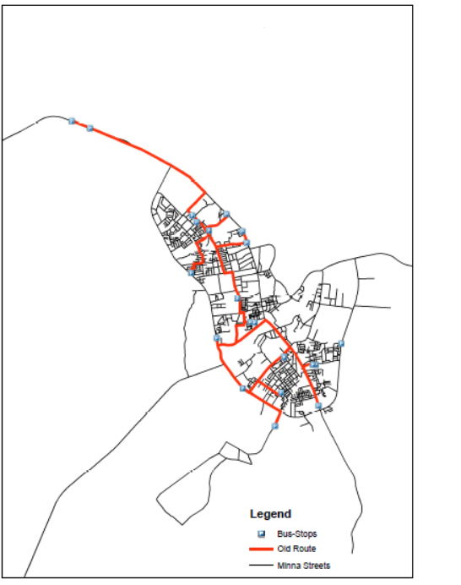
Figure 1: Bus Stops and Previous discretional Route used by Driver for students’ transit (with Total distance covered as 46.598Km).

METHODOLOGY:
The data used in this research work were collected on-site using the Garmin 52s hand-held GPS receiver to obtain the WGS-84 projected co-ordinates of the School (Depot) and each students’ house (nodes/vertices). Other information (aspatial) about the bus stops and the students were obtained via oral interview with each student.
The steps followed in this study are as follow:
- Obtain Spatial information of depot and customer locations
- With MATLAB, carry out a route optimization for selected locations using TSP.
- With ArcGIS, carry out a route optimization for same selected locations as in step 2 using the Chinese Postman’s Problem
- Conduct a comparative performance evaluation of the ARP (using CPP) and the NRP (using TSP).
After the data collection, certain assumptions were made to allow for full scale implementation of the ideal CPP and TSP respectively.
Spatial Data: Co-ordinates of the school and the students pick / stop locations (Table 1).
Map of Minna metropolis in ESRI shapefile (Figure 1)
Aspatial Data: Name of all students that use the Bus Transit.
Number of student’s that are picked / dropped at each Bus stop and
Names of student’s that are picked / dropped at each Bus stop

Table 1: Co-ordinates of Students’ Bus-Stops.
Busstop Name | Eastings | Northings
MAWO SCHOOLS | 227950.10 | 1065472.65
OKADA ROAD | 228657.78 | 1067151.95
GIDAN MATASSA | 228172.18 | 1067493.58
GOLDEN PALACE | 227994.00 | 1067740.77
AIRFORCE JUNCTION | 223931.81 | 1071191.68
MAIKUNKELE | 223210.97 | 1071470.59
AISHI BOSSO (OppositeAngwanbiri) | 229351.81 | 1067792.42
PEUGEOT ROAD(Before Bahago roundabout) | 229984.47 | 1067114.71
ZARUMAI JUNCTION | 230155.13 | 1066667.79
1,2,3 QUARTERS | 229787.43 | 1064470.68
KWANGLIA | 230300.50 | 1063546.92
HOSPITAL ROAD | 230468.51 | 1063516.45
MOBIL | 230862.71 | 10636668.92
BAY CLINICROAD | 231638.89 | 1062138.83
TUNGA LOW- COST | 231528.30 | 1060747.23
MANDELLA ROAD | 231277.89 | 1059427.33
FARM CENTER THUNGA | 233010.46 | 1060232.64
MOBILE QUARTERS | 232896.80 | 1061847.11
TOP MEDICAL ROAD(Inner part) | 232777.85 | 1061851.03
BARKIN- SALE | 230004.03 | 1060914.87
WESTERN BYE-PASS(Opp. Fed.High Court) | 228965.76 | 1062904.88

5.1 ASSUMPTIONS:
1. One school bus suffices to meet the School’s student transportation demand i.e a single trip of the school bus suffices to pick / drop all the students’ that subscribed to the school bus transit system.
2. All roads traversed during the vehicle transit are of same condition therefore the vehicle speed, fuel consumption and subsequently, cost do not vary during the transit.
3. U-turns are allowed along all the routes in the network
4. The School bus burns fuel at 0.5 litres per km.
5. Fuel cost is 87 Naira per litre.
RESULTS:
The results obtained are presented in two formats; the first is obtained by performing the route optimization using the TSP implemented via a generic algorithm in the MATLAB environment. The source codes (tsp_ga.m) used for the implementation are as given by Kirk (2007), while the network analyst tool extension’s best route analysis was used to evaluate the CPP in the ArcGIS environment. Results of both processes are presented as follow:
EVALUATING THE TSP USING MATLAB:
Figures2 and 3 show the suggested travel route for the school bus to efficiently pick all the students at least cost considering a node to node (TSP) factor. In this solution the total distance covered is 19.164 km to traverse round the entire customer locations.
The suggested optimal route by the TSP is therefore as follows:
- Take-off from school and pick students at Peugeot Road – Zarumai Junction – AhmaduBahago – Okada Road – GidanMatasa – Golden Palace – Air force Base – Maikunkele.
- Then go to M. I. Wushishi – Farm Centre – Top Medical – Mobile Quarters – Bay Clinic – Western Bye-pass – Kwangila – Hospital Road
- Then go to Barkin Sale – Tunga Low-cost – Mandella Road
- Go back to school
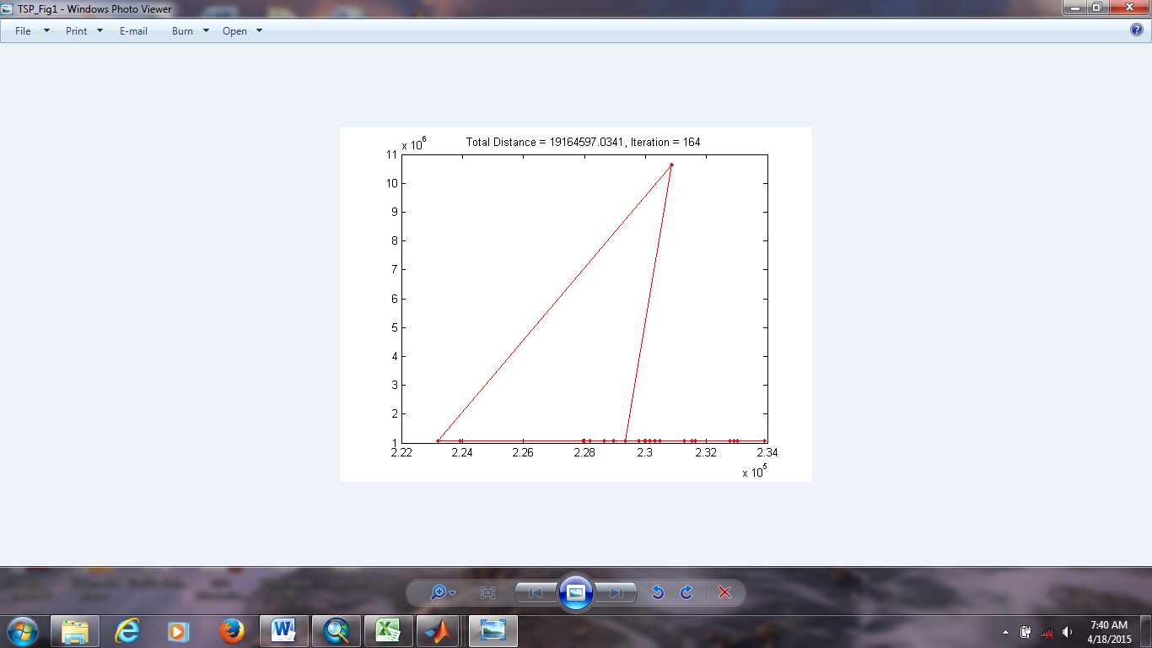
Figure. 2: Sketch of TSP generated optimal route (with Total distance covered as 19.165Km).
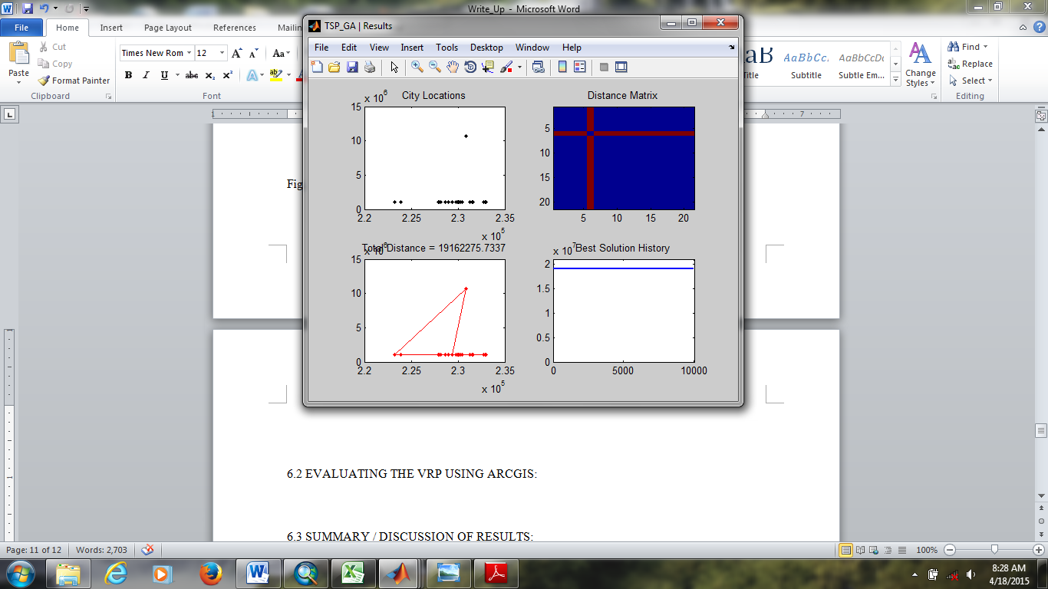
Figure.3: Sketch of City Locations, TSP generated optimal route, distance Matrix and best solution History.
EVALUATING THE CPP USING ARCGIS
The CPP was then solved using the ArcView network analyst toolbox extension. The “best route analysis” tool was employed by selecting the School (MAWO schools) as the depot and the bus stops as the stop locations. Based on earlier stated assumptions of no turning restrictions, the result obtained is as shown in Figure 4.
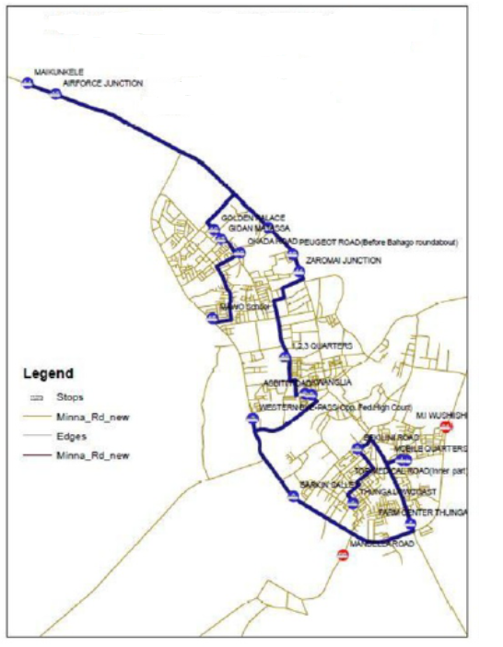
Figure. 4: Best route analysis using the CPP (with Total Distance Covered as 38.722 Km).

DISCUSSION OF RESULTS
The results presented above justify the need for mathematical and generic based solution algorithms for route optimization as the driver’s discretional daily transit path increases the travel distance by an additional 7.826 km when compared with the CPP based network analyst solution.
Besides, a ridiculous difference has been seen in the results obtained by the CPP (a variant of the ARP) and the TSP (a variant of the NRP). This difference accounts for the failure of the NRP to effectively model the precise travel path (which is actually an arc and not a straight). The TSP though provides the shortest path gave an unrealistic (non-existing) route.
Since GIS software are best suited for drawing of Eularian graphs, it is therefore inferable that route optimization of VRP is best solved using GIS software rather than the conventional programming software packages (TB, VB, MATLAB) which are best for drawing Hamiltonian graphs. As a rule of thumb it is herein thus recommended that VRP are best solved using ARP.
It must be noted however that in cases where new roads are to be created that will link specific demand points with minimum cost, the TSP becomes highly relevant.
Table 2 shows a summary of the route parameters for the entire three scenarios under study.
Table 2: Showing summary of route parameters obtained from the ARP and NRP
ITEM NO | SOLUTION TYPE | DISTANCE COVERED | ROUTE DESCRIPTION | FUEL CONSUMPTION | TOTAL COST
1 | Manual Discretion | 46.598 Km | Longest Route | 32.62 litres | N 2,837.94
2 | TSP (NRP) | 19.165 Km | Not Realistic | 13.42 litres | N 1,167.54
3 | CPP (ARP) | 38.772 Km | Optimal Route | 27.14 litres | N 2,361.18

CONCLUSION
As an outcome of this research, the following claims are postulated:
- CVRP within existing road networks are best solved using the ARP solutions.
- The CPP (a variant of ARP) gives a better solution than the TSP (a variant of the NRP).

REFERENCES

Ahuja, R. K, Magnanti, T. L and Orlin, J. B. (1993).Network Flows. Prentice Hall, Englewood Cliffs, NJ

Baldacci, R., E. Hadjiconstantinouet and A. Mingozi (2003). An Exact Algorithm for the Traveling Salesman Problemwith Deliveries and Collections. Networks Vol. 42(1), Pgs. 26–41.

Chipumuro M., Mawonike R, and Makoni T. (2014).Optimizing Routing Of Residential Solid Waste Collection: Case Study of Chikova Residential Area In Zimbabwe. International Research Journal of Mathematics, Engineering & IT.Vol. 1, Issue-3 (June).

Dantzig, G., Ramser, J. H. (1959).The Truck Dispatching Problem.Management Science.Vol 6.No. 1.Pg80–91. Stable URL http://www.jstor.org/stable/2627477. Accessed:28/09/2008.

Eiselt, H.A., Gendreau, M. and Laporte, G. (1995). Arc Routing Problems, Part 2: The Rural Postman Problem. Operations Research, 43(3):399414.

Faramroze, E. (2001) Fast Shortest Path Algorithms for Large Road Networks”, Proceedings of 36th annual ORSNZ Conference.

Gambardella L. M. (2000) Vehicle Routing Problems. Available online at: http://people.idsia.ch/~luca/abstracts/papers/corso_vrp_metanet.pdf. Retrieved 15th August 2015.

Golden, B. L, A.A. Assad, and E.A. Wasil, (2002) “Routing vehicles in the real world: Applications in the Solid Waste, Beverage, Food, Dairy and Newspaper Industries,” In Toth P. and D. Vigo (Editors)The Vehicle Routing Problem. SIAM, Philadelphia, pp. 245–286.

Kairanbay, M and Hajar, M. J (2013).A Review and Evaluations of Shortest Path Algorithms.International Journal of Scientific & Technology Research. Volume 2, Issue 6, June 2013. ISSN 2277-8616. Pg. 99 – 104.

Kirk, J. (2007). http://www.mathworks.com/matlabcentral/fileexchange/13680-traveling-salesman-problem-genetic-algorithm/content/tsp_ga.m. Retrieved 22nd August 2015.

Laporte, G. (1992). The vehicle routing problem: an overview of Exact and Approximate Algorithms. European Journal of Operational Research

Maredia, A. (2010) History, Analysis, and Implementation of Traveling Salesman Problem (TSP) and Related Problems.Available online at http://cms.uhd.edu/faculty/redlt/annemseniorproject.pdf.Retrieved 22nd August 2015.

Magzhan, K. and Jani, H. M. (2013).A Review and Evaluations of Shortest Path Algorithms.International Journal of Scientific & Technology Research. Volume 2, Issue 6, June 2013. ISSN 2277-8616. Pg. 99 – 104.

Nha, V. T. N, S. Djahel and J. M. Lero (2012). A comparative Study of Vehicles’ Routing Algorithms for Route Planning in Smart cities. 1st International workshop on Vehicular Traffic Management for Smart Cities, UCD School of Computer Science and Informatics, Ireland. Available online @ http://ulir.ul.ie/handle/10344/2697#sthash.HVWRMba9.dpuf

Negnevissky, M. (2011).Artificial Intelligence: A Guide to Intelligent Systems.Third Edition, Addison-Wesley.

Pillac, V, M. Gendreau, C. Gueret and A. Medaglia (2011).A Review of Dynamic Vehicle Routing Problems.CIRRELT-2011-62. Available online at https://www.cirrelt.ca/DocumentsTravail/CIRRELT-2011-62.pdf

Shaikh, E. A. and Dhale, A. D (2013). AGV routing using Dijkstra’s Algorithm – A review.International Journal of Scientific & Engineering Research. Volume 4, Issue 7, ISSN 2229-5518. Pg. 1665 – 1670.

Skeina, S. (1990).Implementing Discrete Mathematics: Combinatorics and Graph Theory with Mathematica. Reading, MA: Addison-Wesley.

Srivastava, S. (2012).Comparative Analysis of Algorithms for Single Source shortest Path Problem”, International Journal of Computer Science and Security (IJCSS). Volume (6): Issue (4)

Toth, P. and Vigo, D. (2001). The Vehicle Routing Problem. Monographs on Discrete Mathematics and applications. SIAM, Philadelphia.

